**Chapter 2**

2.2) The main benefit of a relocatable assembler is that programs can be assembled in modules and put together using a linker.

2.3) A microcontroller memory map refers to the layout of resources in memory. For instance, the address associated with a given register is defined by the memory map.

2.7)

1. A data bus is a means of communication between resources in a microprocessor. Typically used for sending and receiving data between the components.
2. An address decoder is used in I/O interfaces to essentially incorporate the I/O into the memory map, so that reading/writing from/to those devices looks the same (to the microprocessor) as interfacing with any other internal resource.
3. An information source is interfaced to a data bus using tri-states with enables controlled by a read control signal and when the address of the input device is put on the address bus.
4. To latch data from data bus into output interface at correct time, we would need a write_control and clock signal to generate such at the right time.
5. During a read cycle the CPU will: send the address to the address bus, assert a READ signal, receive data from the data bus, then decode the received data and execute necessary instructions.

2.12) A tri-state gate must be used to interface an input device to the data bus because multiple input devices may be connected at the same location, so by enabling the gates using the address assigned to a given device, we can control which devices data will actually be read.

2.13) A latch must be used to interface an output device to the data bus because the data bus is always active, but we don’t always want to output the data flowing from memory and I/O devices; instead, we want to use a write control signal in tandem with the correct address to choose where and when data is output.

2.17

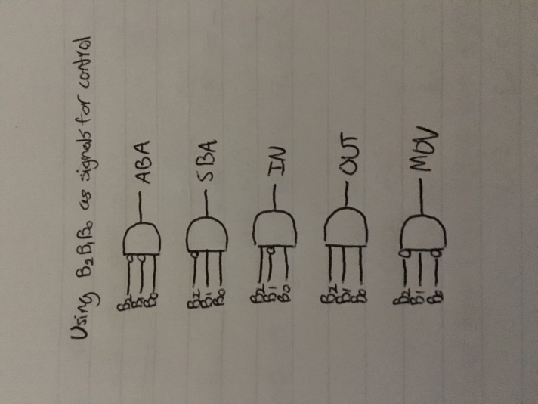

**Chapter 3**

3.2) The three basic elements of structured programming are:

1. Sequence
2. Decision
3. Repetition

3.3)

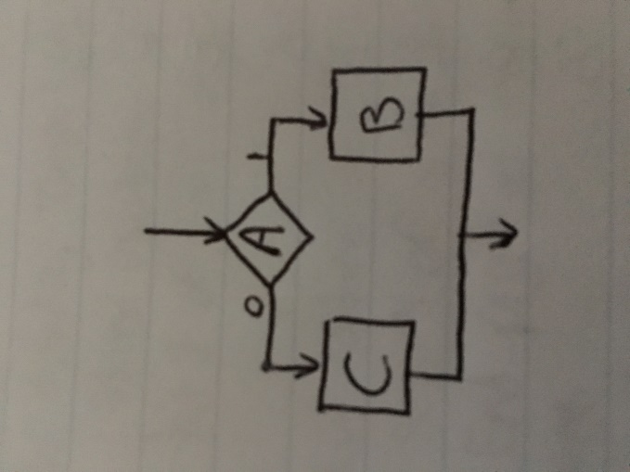

IF A true THEN

B

ELSE

C

ENDIF

3.7)

DO

Output prompt

Input character (ch)

IF ch is alphabetic THEN

IF ch is uppercase

Change to lowercase

ELSE

Change to uppercase

ENDIF

Output ch

ELSE IF ch is numeric THEN

Output ch

ELSE

Beep the bell

ENDIF

ENDDO

WHILE ch is not ESC

**Chapter 4**

4.5) The sign bit = 1 when unsigned binary coded numbers are added means the MSB is 1 (sign bit for unsigned #)

4.6) The sign bit indicates that the result is negative, and the correct number can be achieved by performing the 2’s complement on the result.

4.7) The carry bit = 1 when unsigned binary #’s are added indicates that the addition resulted in a number too large to represent with that number of bits, so the result had an overflow.

4.11) 2’s complement overflow bit = 1 has no meaning for the addition of unsigned binary numbers.

4.12) 2’s complement overflow bit = 1 for addition of 2’s complement binary numbers indicates the answer is wrong because either 2 positive numbers were added and resulted in negative, or 2 negative numbers were added and resulted in a positive.

**Chapter 5**

5.1) Addressing types in XMEGA: Data Direct, Data Indirect, Data Indirect with Displacement, Program Memory Constant, Direct Program, Indirect Program Memory, Relative Program, Extended

5.2) Physical Address – The actual chunk of RAM/memory referred to when data is transferred.

Effective Address – The value used by a fetch/store operation from the perspective of the requester.

Memory Map – The memory map is what connects effective addresses to the corresponding physical addresses.

5.9) To increase the memory address space in a computer system, one must **(c)** increase the number of address lines.

5.10) A pointer is **(b)** a memory address held in a register.

5.11) A register indirect address instruction **(b)** has the address of the operand in a register.