**b) Prelab Questions**

None.

**c) Problems Encountered**

I lost some hours understanding the pin configuration of the keypad, and then more figuring out how to properly handle waiting until the key is released.

**d) Future Work/Applications**

The most profound application from this lab is the use of the keypad as an input device. Since we have full control over how the input is handled, we can configure it as an interface to any program we can support on the processor.

**e) Schematics**

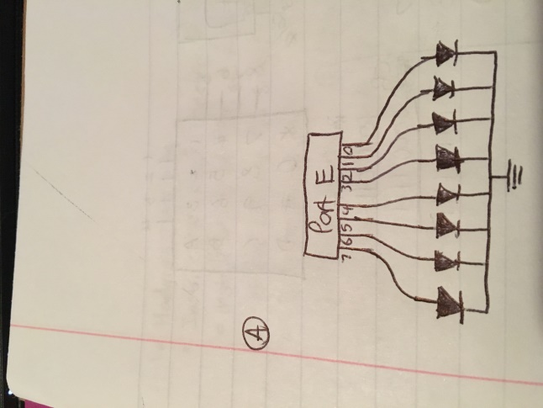

Port E connection to LED schematic

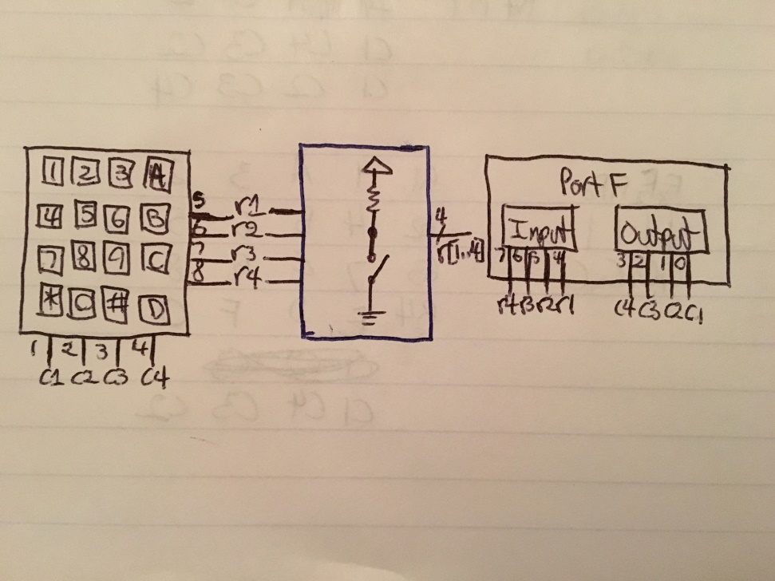

Keypad -> Pull-up Resistors -> Port F

**f) Decoding Logic**

**g) Pseudocode/Flowcharts**

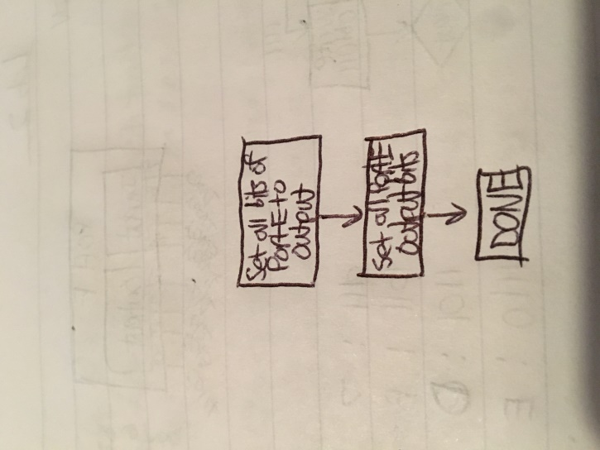

Part (a) LED test program flowchart

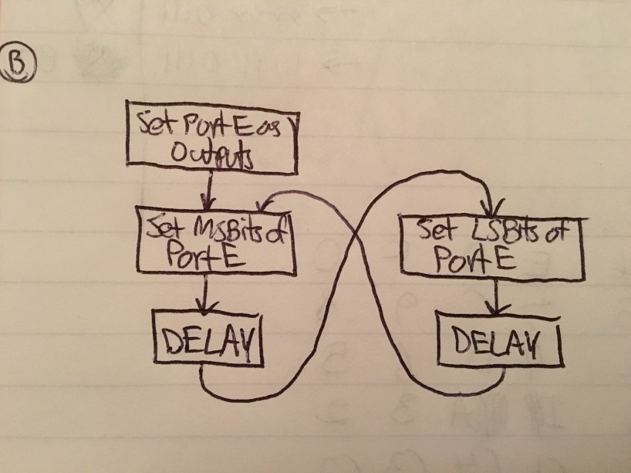

Part (b) Alternating LEDs flowchart

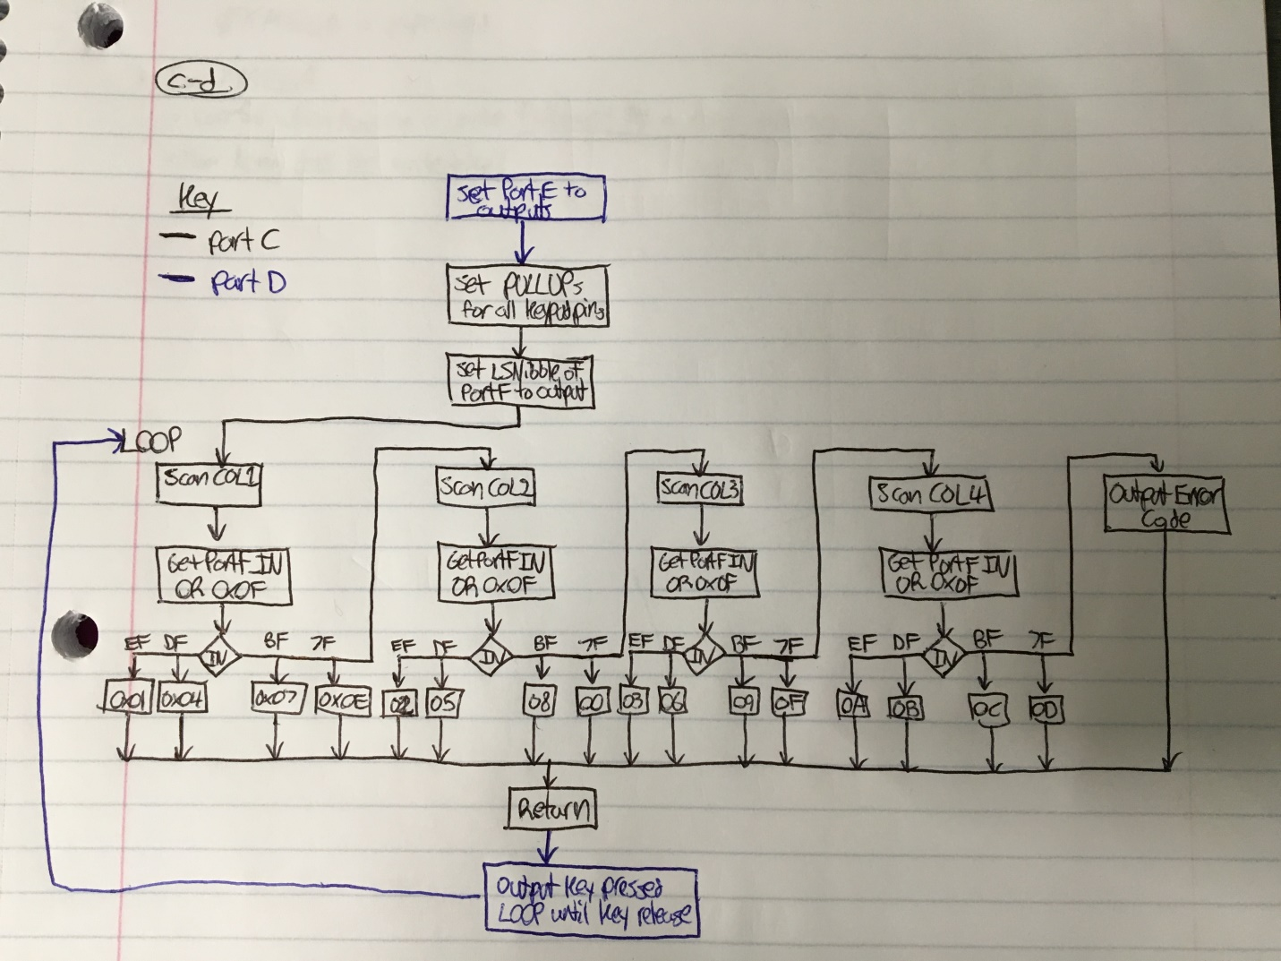

Part (c-d) Keypad interface flowchart and wrapping subroutine call

**h) Program Code**

**Part A**

/*

* lab2a.asm

*

* Lab 2 Part A

* Name: Nicholas Imamshah

* Section: 6957

* TA Name: Daniel Gonzalez

* Description: The purpose of this program is to test the LED circuits of the uPAD.

*/

.nolist ; This works, but the below file can't be removed for lss file.

.include "ATxmega128A1Udef.inc"

.list

.org 0x0000

rjmp MAIN

.org 0x0100

MAIN:

ldi r16, 0xFF ;load 0xFF to r16

sts PORTE_DIRSET, r16 ;set all of PortE to outputs

sts PORTE_OUT, r16 ;set all bits of PortE (Turn on all LEDs)

LOOP:

rjmp LOOP

**Part B**

/*

* lab2c.asm

*

* Lab 2 Part B

* Name: Nicholas Imamshah

* Section: 6957

* TA Name: Daniel Gonzalez

* Description: The purpose of this program is to alternate the nibbles of the LED array.

*/

.nolist ; This works, but the below file can't be removed for lss file.

.include "ATxmega128A1Udef.inc"

.list

.def lower = r18

.def upper = r19

.org 0x0000

rjmp MAIN

.org 0x0100

MAIN:

ldi r16, 0xFF ;set all bits of PortE to outputs

sts PORTE_DIRSET, r16

ldi lower, 0x0F ;load named registers with corresponding bits

ldi upper, 0xF0

MSB:

sts PORTE_OUT, upper ;set MSBits and delay

rcall DELAY

LSB:

sts PORTE_OUT, lower ;set LSBits and delay

rcall DELAY

rjmp MSB

;Contents of delay.inc

;DELAY:

; ldi r16, 111 ;load the count(r16) with the number of cycles we need to loop

;

;DELAY_LOOP:

; dec r16 ;decrement our count

; brne DELAY_LOOP ;if count != 0, repeat

;

; ret

.include "delay.inc"

**Part C**

/*

* lab2c.asm

*

* Lab 2 Part C

* Name: Nicholas Imamshah

* Section: 6957

* TA Name: Daniel Gonzalez

* Description: The purpose of this program is to interface with a keypad.

*/

KEYPAD:

ldi r16, 0xFF

sts PORTE_OUT, r16

rcall KEYSCAN ;call the Keypad Scanning subroutine

sts PORTE_OUT, r16 ;output result of KEYSCAN to LEDs

rjmp KEYPRESSED

rjmp KEYPAD

KEYPRESSED:

lds r16, PORTF_IN ;check PortF's input again

cpi r16, 0xF0 ;if it is < 0xF0, then one of the keys are pressed

brlo KEYPRESSED ;loop until this is not the case

rjmp KEYPAD

KEYSCAN:

ldi r19, 0x18 ;Need OPC set to PULLUP for all Keypad pins

sts PORTF_PIN7CTRL, r19

sts PORTF_PIN6CTRL, r19

sts PORTF_PIN5CTRL, r19

sts PORTF_PIN4CTRL, r19

sts PORTF_PIN3CTRL, r19

sts PORTF_PIN2CTRL, r19

sts PORTF_PIN1CTRL, r19

sts PORTF_PIN0CTRL, r19

ldi r16, 0x0F ;set the LSNibble of PORTF to output

sts PORTF_DIRSET, r16

rcall COL1 ;call to the first column to scan

ret

INIT:

sts PORTF_OUT, r16 ;initiates the bits for each columns scan

nop

lds r17, PORTF_IN ;get the input bits from PortF

ori r17, 0x0F ;bit mask the input to simplify code

ret

COL1:

ldi r16, 0x0E ;column 1 is 0b1101

rcall INIT ;check for pressed key

cpi r17, 0xEF ;check if row 1

breq PRESS_1

cpi r17, 0xDF ;check if row 2

breq PRESS_4

cpi r17, 0xBF ;check if row 3

breq PRESS_7

cpi r17, 0x7F ;check if row 4

breq PRESS_ST

rjmp COL2 ;move on to column 2

PRESS_1: ;load value corresponding to key pressed

ldi r16, 0x01

ret

PRESS_4:

ldi r16, 0x04

ret

PRESS_7:

ldi r16, 0x07

ret

PRESS_ST:

ldi r16, 0x0E

ret

COL2:

ldi r16, 0x0D ;column 2 is 0b1011

rcall INIT ;check for pressed key

cpi r17, 0xEF ;check if row 1

breq PRESS_2

cpi r17, 0xDF ;check if row 2

breq PRESS_5

cpi r17, 0xBF ;check if row 3

breq PRESS_8

cpi r17, 0x7F ;check if row 4

breq PRESS_0

rjmp COL3 ;move on to column 3

PRESS_2: ;load value corresponding to key pressed

ldi r16, 0x02

ret

PRESS_5:

ldi r16, 0x05

ret

PRESS_8:

ldi r16, 0x08

ret

PRESS_0:

ldi r16, 0x00

ret

COL3:

ldi r16, 0x0B ;column 3 is 0b0111

rcall INIT ;check for pressed key

cpi r17, 0xEF ;check if row 1

breq PRESS_3

cpi r17, 0xDF ;check if row 2

breq PRESS_6

cpi r17, 0xBF ;check if row 3

breq PRESS_9

cpi r17, 0x7F ;check if row 4

breq PRESS_NUM

rjmp COL4 ;move on to column 4

PRESS_3: ;load value corresponding to key pressed

ldi r16, 0x03

ret

PRESS_6:

ldi r16, 0x06

ret

PRESS_9:

ldi r16, 0x09

ret

PRESS_NUM:

ldi r16, 0x0F

ret

COL4:

ldi r16, 0x07 ;column 4 is 0b1110

rcall INIT ;check for pressed key

cpi r17, 0xEF ;check if row 1

breq PRESS_A

cpi r17, 0xDF ;check if row 2

breq PRESS_B

cpi r17, 0xBF ;check if row 3

breq PRESS_C

cpi r17, 0x7F ;check if row 4

breq PRESS_D

rjmp COL1

PRESS_A: ;load value corresponding to key pressed

ldi r16, 0x0A

ret

PRESS_B:

ldi r16, 0x0B

ret

PRESS_C:

ldi r16, 0x0C

ret

PRESS_D:

ldi r16, 0x0D

ret

**Part D**

/*

* lab2d.asm

*

* Lab 2 Part D

* Name: Nicholas Imamshah

* Section: 6957

* TA Name: Daniel Gonzalez

* Description: The purpose of this program is to use the keypad interface developed previously.

*/

.nolist

.include "ATxmega128A1Udef.inc"

.list

.org 0x0000

rjmp MAIN

.org 0x0100

.include "keypad.inc"

MAIN:

ldi r17, 0xFF ;set PortE as all OUTPUT

sts PORTE_DIRSET, r17

rcall KEYPAD ;jump to LOOP to begin repeated scanning

**i) Appendix**

**Part B Screenshot**

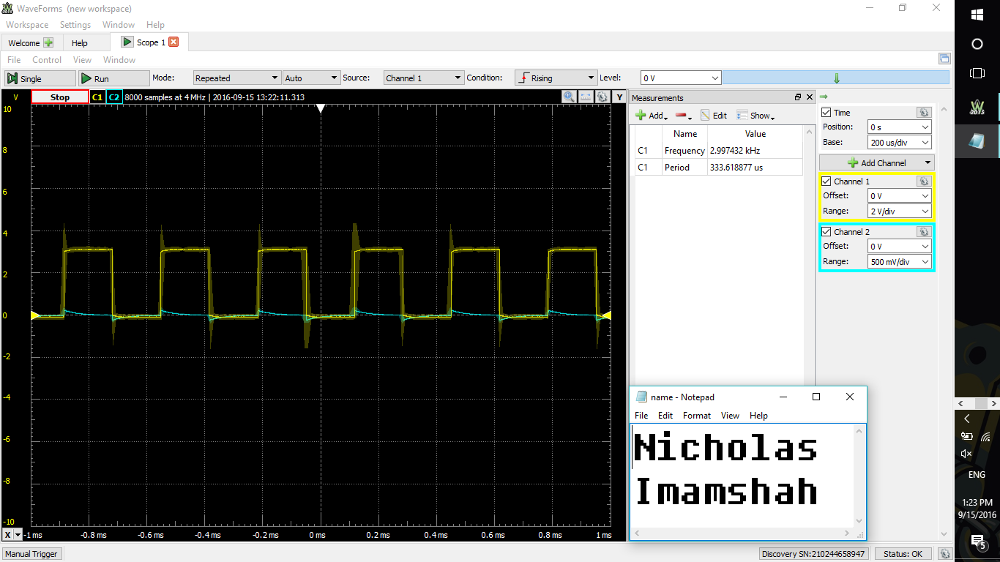

**Delay**/*

* delay.asm

*

* Lab 2 Part B

* Name: Nicholas Imamshah

* Section: 6957

* TA Name: Daniel Gonzalez

* Description: The purpose of this program is to create a delay.

*/

.equ cycles = 111

.def count = r17

DELAY:

ldi count, cycles ;load the count(r17) with the number of cycles we need to loop

DELAY_LOOP:

dec count ;decrement our count

brne DELAY_LOOP ;if count != 0, repeat

ret