**b) Prelab Questions**

1. What is the advantage of mirroring the input and output ports to $28 8000 - $28 9FFF (also known as partial address decoding)? What would be necessary if you wanted to only place the ports at 0x28 8000 and no place else?
   1. Partial address decoding allows us to have simpler address decode equations, which is particularly ideal when we do not anticipate needing every possible address available; it allows us to trade efficiency of space, with simplicity of implementation. In order to place the ports at 0x288000 and nowhere else, we would need to include use the address bits for decoding in addition to the chip select (CS0).
2. Write the address decode equation to put the input and output ports at addresses 0x4000 – 0xCFFF.
   1. A15⊕A14 + A14/A13/A12
3. What is the complete range of external memory on the XMEGA?
   1. 0x3000 – 0xFF FFFF (16MB)
4. The uPAD Proto Base is configured to use the EBI in SRAM ALE1 mode, which does not give us address bits A23:16. Which mode(s) can be used to access all of these higher address bits? Describe the change(s) necessary to use one of these modes. What additional hardware is needed, if any?
   1. SRAM 3PORT ALE12, SRAM 4PORT ALE2, and in general most of the configurations that require ALE2, excluding those for SRAM LPC. In the 4PORT cases, we would need an additional port to use such a configuration, as our processor only uses Ports H-K for the EBI configuration.

**c) Problems Encountered**

The biggest problem I encountered was in understanding the layout of the architecture; this difficulty led to an initial wrong wire-wrapping of the pins for the input port IC. Following this initial issue, I had a slight confusion understanding how the EBI actually worked. I thought it required more manual control, where we would choose which values to output to Port H as a means of choosing read and write enables, where of course we only need to configure it initially and it manages the signals internally according to loads and stores.

**d) Future Work/Applications**

The techniques learned in this lab could be broadly applied to expanding any compatible device’s I/O ports, which then allows for connection of various other components to the device. In this lab we connected switches and input and used the LED bank as output, but these are general I/O ports as any other on our microprocessor.

**e) Schematics**

Connections for 74573 and 74574 (pin numbers corresponding to those chips)

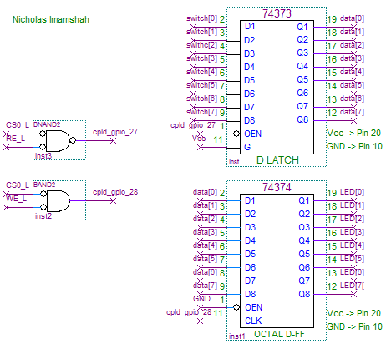

**f) Decoding Logic**

Control Equations for R/W

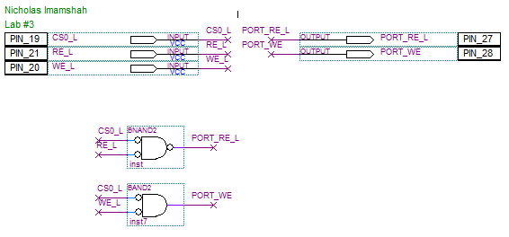

**g) Pseudocode/Flowcharts**

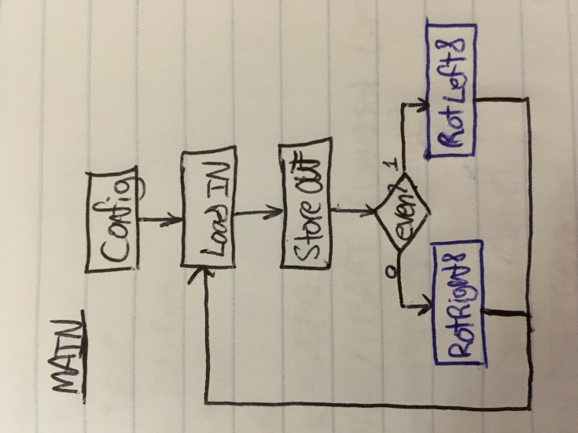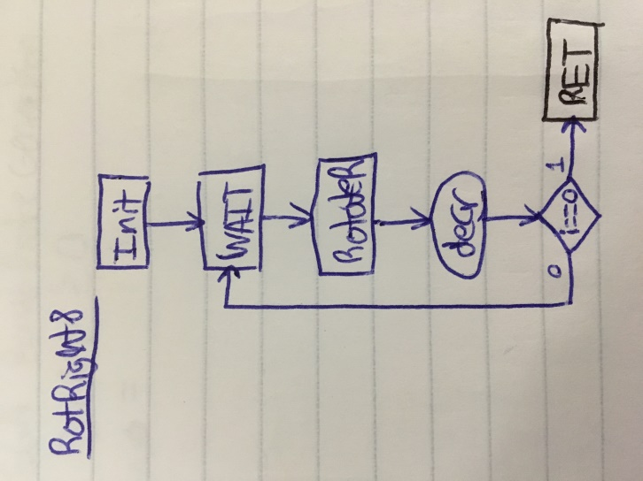

**h) Program Code**

/* lab3.asm

*

* Lab 3

* Name: Nicholas Imamshah

* Section: 6957

* TA Name: Daniel Gonzalez

* Description: The purpose of this program is to use EBI and expansion ports to read input and conditionally control output.

*/

.nolist

.include "ATxmega128A1Udef.inc"

.list

.set PORT = 0x288000

.set PORT_END = 0x289FFF

.equ jcycles = 20

.equ kcycles = 246

.org 0x0000

rjmp MAIN

.org 0x200

MAIN:

ldi r18, 0x00 ;register holding 0 for later adc

ldi r16, 0x17 ;Configure PORTH bits 4, 2, 1, and 0 as outputs.

sts PORTH_DIRSET, r16 ; These are the CS0(L), ALE1(H), RE(L), and WE(L) outputs.

; (CS0 is bit 4; ALE1 is bit 2; RE is bit 1; WE is bit 0)

ldi r16, 0x13 ;Default CS0(L), RE(L), and WE(L) to H = false.

sts PORTH_OUTSET, r16 ; ALE defaults to 0 = L = false.

ldi r16, 0xFF ;Set all PORTK pins (A15-A0) to be outputs.

sts PORTK_DIRSET, r16

ldi r16, 0xFF ;Set all PORTJ pins (D7-D0) to be outputs.

sts PORTJ_DIRSET, r16

ldi r16, 0x41 ;Store 0x41 in EBI_CTRL reg to select 3 port EBI(H,J,K)

sts EBI_CTRL, r16 ; mode and SRAM ALE1 mode

;Initialize the Z pointer to point to the base address for CS0 in memory

ldi ZH, high(EBI_CS0_BASEADDR)

ldi ZL, low(EBI_CS0_BASEADDR)

;Load the middle byte (A15:8) of the three byte addr into a reg and store it as the

; LOW byte of the Base Address, BASEADDRL.

ldi r16, byte2(PORT)

st Z+, r16

;Load the highest byte (A23:16) of the three byte addr into a reg and store it as the

; HIGH byte of the Base Address, BASEADDRH.

ldi r16, byte3(PORT)

st Z, r16

ldi r16, 0x15 ;Set to 8KB CS space and turn on SRAM mode, 0x288000 - 0x289FFF

sts EBI_CS0_CTRLA, r16

;Steps for using the port expansion

ldi r16, byte3(PORT) ;initialize a pointer to point to the base addr of the PORT

sts CPU_RAMPX, r16 ;use the CPU_RAMPX reg to set the third byte of the pointer

ldi XH, high(PORT) ;set the middle (XH) and low (XL) bytes of the pointer as usual

ldi XL, low(PORT)

LOAD:

ld r16, X ;read the input port into r16

nop

nop

STORE:

st X, r16 ;write the input stored in r16 to the outport

nop

ldi r17, 8

sbrc r16, 0

rjmp ODD

EVEN:

;delay

ldi r20, 50

rcall DELAY_X_MS

lsl r16

adc r16, r18

st X, r16

dec r17

breq LOAD

rjmp EVEN

ODD:

;delay

ldi r20, 50

rcall DELAY_X_MS

lsr r16

brcs ODD_CARRY

ODD_STORE:

st X, r16

dec r17

breq LOAD

rjmp ODD

ODD_CARRY:

ori r16, 0x80

rjmp ODD_STORE

DELAY_X_MS:

dec r20

rcall JLOOP_INIT

cpi r20, 0

brne DELAY_X_MS

ret

JLOOP_INIT:

push r20

ldi r20, jcycles

JLOOP:

dec r20

rcall KLOOP_INIT

cpi r20, 0

brne JLOOP

pop r20

ret

KLOOP_INIT:

push r20

ldi r20, kcycles

KLOOP:

dec r20

nop

brne KLOOP

pop r20

ret

;.include "delayx10ms.inc"

**i) Appendix**

Screenshot to verify the frequency of rotation in lab3.asm

