**b) Prelab Questions**

1. What is the difference between synchronous and asynchronous communication?
   1. With synchronous communication, an external clock is used to synchronize sending and receiving. With asynchronous communication, special signals such as “DREIF” on the XMEGA are used to synchronize sending and receiving.
2. What is the difference between serial and parallel communication?
   1. Serial communication uses a single transmission medium, and transmits data one bit at a time. Parallel communication uses multiple transmission mediums simultaneously to transmit multiple bits at once.
3. List the XMEGA’s USART registers used in your programs and briefly describe their functions.
   1. USARTp#_STATUS: Provides the current status of the Rx/Tx. Checking appropriate values allows for receiving or transmitting at the right times.
   2. USARTp#_DATA: Register to check when it is time to transmit or receive.
   3. USARTp#_CTRLA: Controls USART interrupt levels.
   4. USARTp#_CTRLB: Configures USART, enables Rx/Tx.
   5. USARTp#_CTRLC: Configures USART’s communication mode, parity mode, stop bit mode, character size, and data order.
   6. USARTp#_BAUDCTRLA: Holds the lower 8 bits of the BSel.
   7. USARTp#_BAUDCTRLB: Holds the BScale and upper 4 bits of the BSel.
4. List the number of bounces from part A of this lab. How long (in ms) is your delay routine for debouncing?
   1. Variable from 0 to ~8. My delay routine is approximately 10ms.
5. What is the maximum possible baud you can use for asynchronous communication if your board runs at 2MHz? Support your answer with the values you would place in any special registers that are needed.
   1. Max Baud = 125000Hz; BSel = 0; BScale = 0

**c) Problems Encountered**

1. Initially I forgot to include the null character at the end of my strings, so I was having trouble debugging the OUT_STRING method in part E.
2. I did not understand how to verify the baud rate initially; mainly I misunderstood what was meant by the lab document when it mentioned using Port E or Port F for the USART.

**d) Future Work/Applications**

In the lab we used serial communication to transmit ASCII characters from our processor to our computer; this concept represents the much more general process of sending a stream of data between devices. Such a configuration is reminiscent of a networking scenario, where there is a sending a receiving device, the receiving device constantly accepting packets of some sort from the sending device.

**e) Schematics**

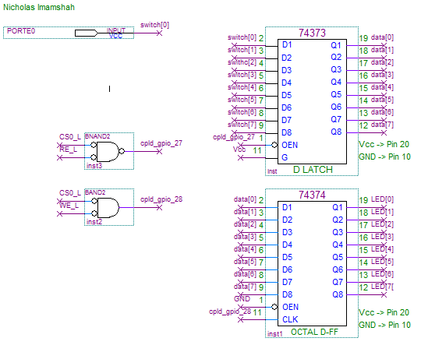

**f) Decoding Logic**

N/A

**g) Pseudocode/Flowcharts**

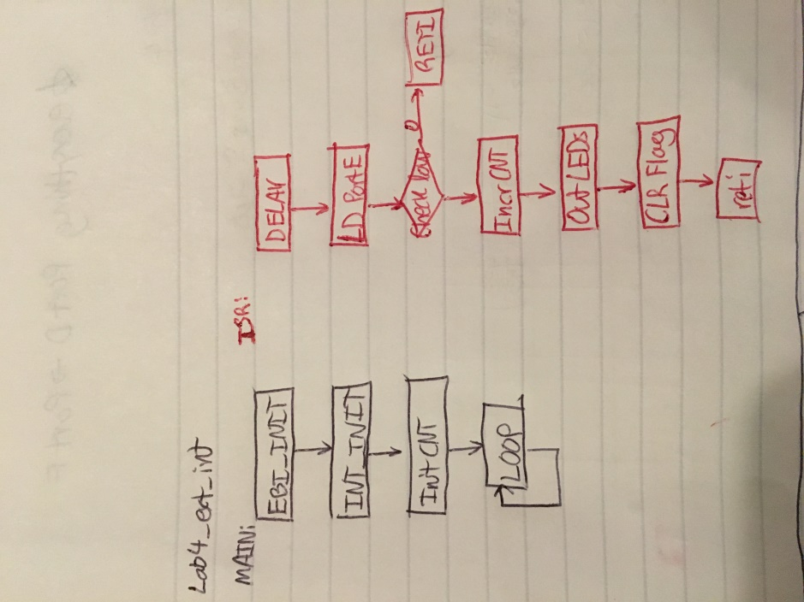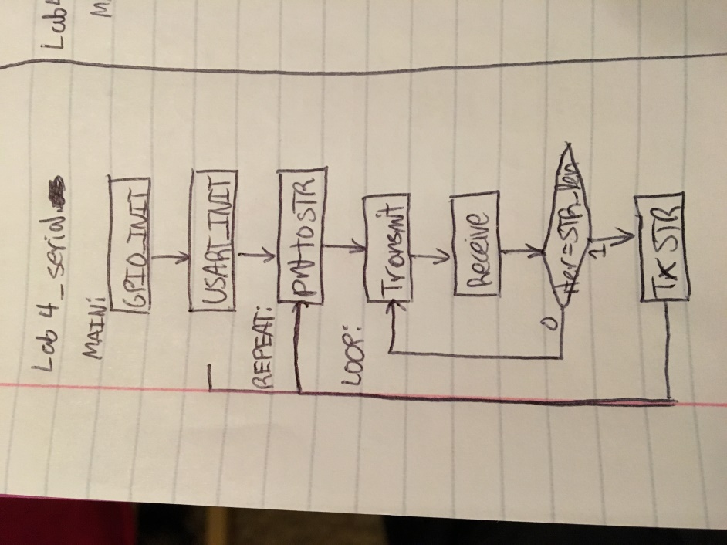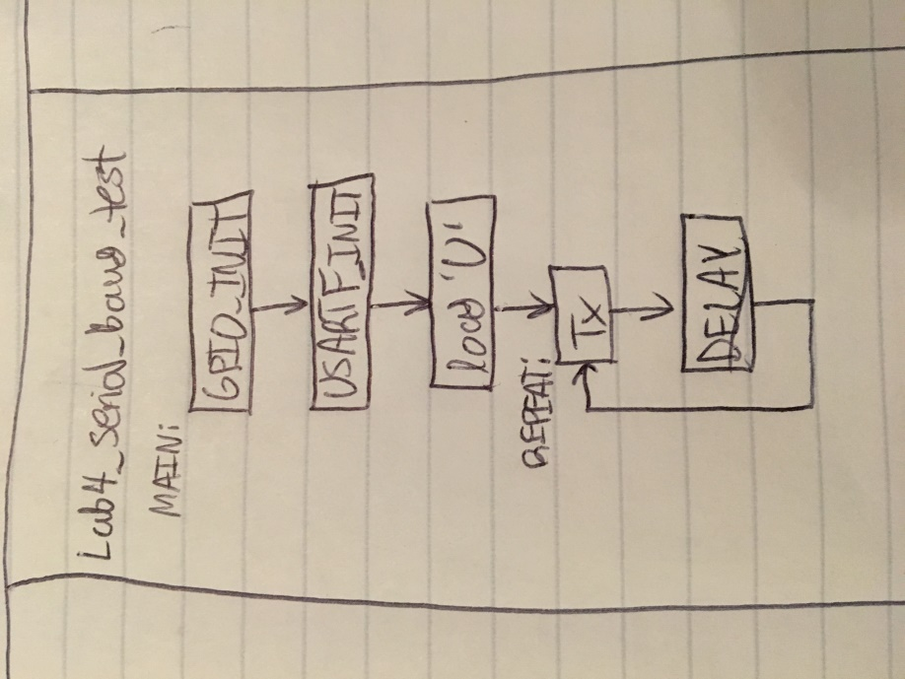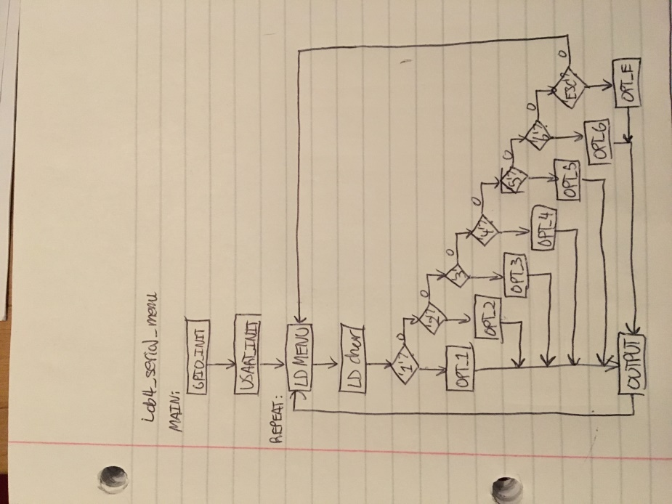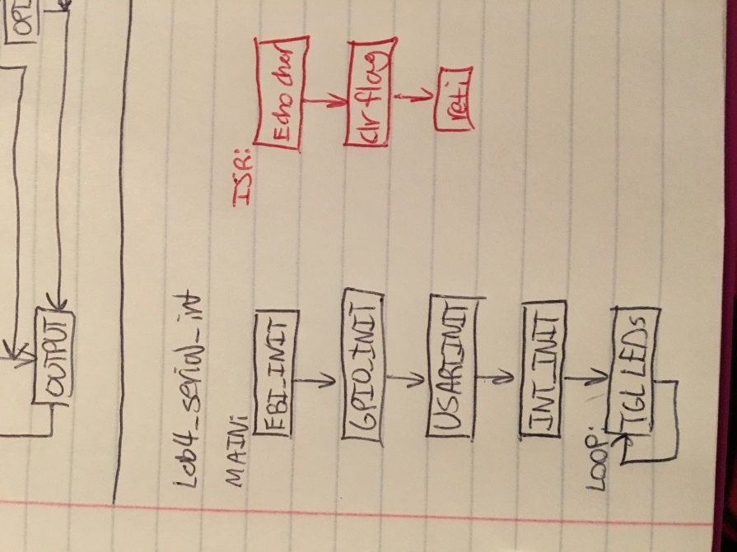

**h) Program Code**

Lab4_ext_int.asm

/* Lab4_ext_intr.asm

*

* Lab 4 External Interrupt

* Name: Nicholas Imamshah

* Section: 6957

* TA Name: Daniel Gonzalez

* Description: The purpose of this program is to configure an interrupt on the XMEGA that will watch for a falling edge.

*/

.nolist

.include "ATxmega128A1Udef.inc"

.list

.org 0x0000

rjmp MAIN

.org PORTE_INT0_VECT ;place code at the interrupt vector for the PORTE_INT0 interrupt

jmp ISR_LED_COUNT ;jump to our interrupt routine

;must org program at 0x0200 so it doesn't conflict with interrupt vectors that are at 0x0000-0x00FE

.org 0x0200

MAIN:

rcall CONFIG_EBI

nop

rcall INIT_INTERRUPT

nop

ldi r18, 0 ;initialize count

LOOP:

rjmp LOOP

/************************************************************************************

* Name: INIT_INTERRUPT

* Purpose: Subroutine to initialize the PortE external pin interrupt PE0 using INT0

* Inputs: None

* Outputs: None

* Affected: r16, PMIC_CTRL, PORTE: _INT0MASK_OUT, _DIRCLR, _INTCTRL, _PIN0CTRL

***********************************************************************************/

INIT_INTERRUPT:

ldi r16, 0x01 ;set output to default to '1'.

sts PORTE_OUT, r16

sts PORTE_DIRCLR, r16 ;Set external interrupt pin (PE0) as an input

ldi r16, 0x01 ;select the external interrupt as a low-level priority

sts PORTE_INTCTRL, r16

ldi r16, 0x01 ;select PORTE_PIN0 as the interrupt source

sts PORTE_INT0MASK, r16

ldi r16, 0x02 ;select falling edge for external interrupt

sts PORTE_PIN0CTRL, r16

ldi r16, 0x01 ;enable low-level interrupts

sts PMIC_CTRL, r16

sei ;set global interrupt flag LAST!

ret

/************************************************************************************

* Name: ISR_LED_COUNT

* Purpose: Interrupt service routine to increment the count of executions on LEDs

* Inputs: None

* Outputs: None

* Affected: r17, r18

***********************************************************************************/

ISR_LED_COUNT:

ldi r16, 255

rcall DELAY

nop

lds r16, PORTE_IN

nop

sbrc r16, 0 ;if bit0 is cleared, then continue

reti ;else, we got a rising edge

inc r18 ;inc each time ISR runs

st X, r18 ;store to LEDs

ldi r17, 0x01

sts PORTE_INTFLAGS, r17 ;clear the PORTE_INTFLAGS

reti ;return from the interrupt service routine

DELAY:

ldi r17, 50

rcall DELAY_INNER

dec r16

nop

brne DELAY

ret

DELAY_INNER:

dec r17

nop

brne DELAY_INNER

ret

/************************************************************************************

* Name: CONFIG_EBI

* Purpose: Subroutine to initialize Ports H,J,K/EBI for additional Input/Output ports

* Inputs: None

* Outputs: None

* Affected: R16, X, Z, EBI_CTRL, PORTH,J,K,

***********************************************************************************/

.set PORT = 0x288000

.set PORT_END = 0x289FFF

CONFIG_EBI:

ldi r16, 0x17 ;Configure PORTH bits 4, 2, 1, and 0 as outputs.

sts PORTH_DIRSET, r16 ; These are the CS0(L), ALE1(H), RE(L), and WE(L) outputs.

; (CS0 is bit 4; ALE1 is bit 2; RE is bit 1; WE is bit 0)

ldi r16, 0x13 ;Default CS0(L), RE(L), and WE(L) to H = false.

sts PORTH_OUTSET, r16 ; ALE defaults to 0 = L = false.

ldi r16, 0xFF ;Set all PORTK pins (A15-A0) to be outputs.

sts PORTK_DIRSET, r16

ldi r16, 0xFF ;Set all PORTJ pins (D7-D0) to be outputs.

sts PORTJ_DIRSET, r16

ldi r16, 0x01 ;Store 0x41 in EBI_CTRL reg to select 3 port EBI(H,J,K)

sts EBI_CTRL, r16 ; mode and SRAM ALE1 mode

;Initialize the Z pointer to point to the base address for CS0 in memory

ldi ZH, high(EBI_CS0_BASEADDR)

ldi ZL, low(EBI_CS0_BASEADDR)

;Load the middle byte (A15:8) of the three byte addr into a reg and store it as the

; LOW byte of the Base Address, BASEADDRL.

ldi r16, byte2(PORT)

st Z+, r16

;Load the highest byte (A23:16) of the three byte addr into a reg and store it as the

; HIGH byte of the Base Address, BASEADDRH.

ldi r16, byte3(PORT)

st Z, r16

ldi r16, 0x15 ;Set to 8KB CS space and turn on SRAM mode, 0x288000 - 0x289FFF

sts EBI_CS0_CTRLA, r16

;Steps for using the port expansion

ldi r16, byte3(PORT) ;initialize a pointer to point to the base addr of the PORT

sts CPU_RAMPX, r16 ;use the CPU_RAMPX reg to set the third byte of the pointer

ldi XH, high(PORT) ;set the middle (XH) and low (XL) bytes of the pointer as usual

ldi XL, low(PORT)

ret

Lab4_serial.asm

/* Lab4_serial.asm

*

* Lab 4 XMEGA USART System

* Name: Nicholas Imamshah

* Section: 6957

* TA Name: Daniel Gonzalez

* Description: The purpose of this program is to configure the XMEGA USART for communication with a terminal program.

*/

.nolist

.include "ATxmega128A1Udef.inc"

.list

.equ BSel = 289

.equ BScale = -7

.equ Prompt = '?'

.equ StringLength = 10

.dseg

.org 0x2000 ;where inputs will be stored, outputs written to

STRING: .byte StringLength

.cseg

.org 0x0000

rjmp MAIN

.org 0x0200

MAIN:

rcall GPIO_INIT

rcall USART_INIT

REPEAT:

ldi r16, Prompt ;load Prompt character

ldi r17, StringLength

ldi ZL, low(STRING)

ldi ZH, high(STRING)

LOOP:

rcall OUT_CHAR ;echo character

rcall IN_CHAR

st Z+, r16 ;store input char

dec r17

brne LOOP

rcall OUT_CHAR ;echo last entered char

ldi r16, '!'

rcall OUT_CHAR ;signify end of string

rcall OUT_STRING

rjmp REPEAT

/************************************************************************************

* Name: USART_INIT

* Purpose: Subroutine to initialize the XMEGA USART system

* Inputs: None

* Outputs: None

* Affected: r16, USARTD0_CTRLB, USARTD0_CTRLC, USARTD0_BAUDCTRLA, USARTD0_BAUDCTRLB

***********************************************************************************/

USART_INIT:

ldi r16, 0x18

sts USARTD0_CTRLB, r16 ;turn on TXEN and RXEN lines

ldi r16, 0x23

sts USARTD0_CTRLC, r16 ;Parity = even, 8 bit frame, 1 stop bit

ldi r16, (BSel & 0xFF) ;select only lower 8 bits of BSel

sts USARTD0_BAUDCTRLA, r16 ;set BAUDCTRLA to lower 8 bits of BSel

ldi r16, ((BScale << 4) & 0xF0) | ((BSel >> 8) & 0x0F)

sts USARTD0_BAUDCTRLB, r16 ;set BAUDCTRLB to BScale | Bsel.

; Lower 4 bits are upper 4 bits of BSel.

; Upper 4 bits are upper 4 bits of BScale.

ret

/************************************************************************************

* Name: GPIO_INIT

* Purpose: Subroutine to initialize the XMEGA GPIO for use with the USART System

* Inputs: None

* Outputs: None

* Affected: r16, PORTD_DIR, PORTD_OUT, PORTQ_DIR, PORTQ_OUT

***********************************************************************************/

GPIO_INIT:

ldi r16, 0x08

sts PORTD_DIRSET, r16 ;set PORTD_PIN3 as output for TX pin of USARTD0

sts PORTD_OUTSET, r16 ;set the TX line to default to '1'

ldi r16, 0x04

sts PORTD_DIRCLR, r16 ;set RX pin for input

ldi r16, 0xA

sts PORTQ_DIRSET, r16 ;set pins 1 and 3 of PORTQ to output

sts PORTQ_OUTCLR, r16 ;set USB_SW_EN = '0', USB_SW_SEL = '0'

ret

/************************************************************************************

* Name: OUT_CHAR

* Purpose: Subroutine to output a single character to the transmit pin of the USART

* Inputs: None

* Outputs: Transmits data via USART

* Affected: USARTD0_STATUS, USARTD0_DATA

***********************************************************************************/

OUT_CHAR:

push r17

TX_POLL:

lds r17, USARTD0_STATUS ;load status register

sbrs r17, 5 ;proceed to writing out the char if

; the DREIF flag is set

rjmp TX_POLL ;else go back to polling

sts USARTD0_DATA, r16 ;send the character out over the USART

pop r17

ret

/************************************************************************************

* Name: OUT_STRING

* Purpose: Subroutine to output character strings stored in memory

* Inputs: None

* Outputs: Transmits data via USART

* Affected: r16

***********************************************************************************/

OUT_STRING:

ldi ZL, low(STRING)

ldi ZH, high(STRING)

PRINT_CHAR:

ld r16, Z+ ;load char pointed to by Z, POST-increment

cpi r16, 0x00 ;check if char is null

breq PRINT_DONE ; if null -> DONE printing string

rcall OUT_CHAR ; else OUTPUT that char

rjmp PRINT_CHAR ;repeat

PRINT_DONE:

ret

/************************************************************************************

* Name: IN_CHAR

* Purpose: Subroutine to receive a single character from receiver pin of the USART

* Inputs: None

* Outputs: r16 loaded with input from SCI

* Affected: r16, USARTD0_STATUS, USARTD0_DATA

***********************************************************************************/

IN_CHAR:

RX_POLL:

lds r16, USARTD0_STATUS ;load the status register

sbrs r16, 7 ;proceed to reading in a char if

; the RXB8 flag is set

rjmp RX_POLL ;else continue polling

lds r16, USARTD0_DATA ;read the character into r16

ret

Lab4_serial_baud_test.asm

/* Lab4_serial_baud_test.asm

*

* Lab 4 XMEGA USART Baud Rate Test

* Name: Nicholas Imamshah

* Section: 6957

* TA Name: Daniel Gonzalez

* Description: The purpose of this program is to test the Baud Rate of the XMEGA's USART System.

*/

.nolist

.include "ATxmega128A1Udef.inc"

.list

.equ BSel = 289

.equ BScale = -7

.org 0x0000

rjmp MAIN

.org 0x0200

MAIN:

rcall GPIO_INIT

rcall USART_INIT

ldi r16, 0x55 ;load U

REPEAT:

rcall OUT_CHAR ;echo U to console

rcall DELAY_1MS ;delay 1000us

rjmp REPEAT

/************************************************************************************

* Name: USART_INIT

* Purpose: Subroutine to initialize the XMEGA USART system

* Inputs: None

* Outputs: None

* Affected: r16, USARTE0_CTRLB, USARTE0_CTRLC, USARTE0_BAUDCTRLA, USARTE0_BAUDCTRLB

***********************************************************************************/

USART_INIT:

ldi r16, 0x18

sts USARTE0_CTRLB, r16 ;turn on TXEN and RXEN lines

ldi r16, 0x23

sts USARTE0_CTRLC, r16 ;Parity = even, 8 bit frame, 1 stop bit

ldi r16, (BSel & 0xFF) ;select only lower 8 bits of BSel

sts USARTE0_BAUDCTRLA, r16 ;set BAUDCTRLA to lower 8 bits of BSel

ldi r16, ((BScale << 4) & 0xF0) | ((BSel >> 8) & 0x0F)

sts USARTE0_BAUDCTRLB, r16 ;set BAUDCTRLB to BScale | Bsel.

; Lower 4 bits are upper 4 bits of BSel.

; Upper 4 bits are upper 4 bits of BScale.

ret

/************************************************************************************

* Name: USART_INIT

* Purpose: Subroutine to initialize the XMEGA USART system

* Inputs: None

* Outputs: None

* Affected: r16, PORTE_DIR, PORTE_OUT, PORTQ_DIR, PORTQ_OUT

***********************************************************************************/

GPIO_INIT:

ldi r16, 0x08

sts PORTE_DIRSET, r16 ;set PORTE_PIN3 as output for TX pin of USARTE0

sts PORTE_OUTSET, r16 ;set the TX line to default to '1'

ldi r16, 0x04

sts PORTE_DIRCLR, r16 ;set RX pin for input

ldi r16, 0xA

sts PORTQ_DIRSET, r16 ;set pins 1 and 3 of PORTQ to output

sts PORTQ_OUTCLR, r16 ;set USB_SW_EN = '0', USB_SW_SEL = '0'

ret

/************************************************************************************

* Name: OUT_CHAR

* Purpose: Subroutine to output a single character to the transmit pin of the USART

* Inputs: None

* Outputs: Transmits data via USART

* Affected: USARTE0_STATUS, USARTE0_DATA

***********************************************************************************/

OUT_CHAR:

push r17

TX_POLL:

lds r17, USARTE0_STATUS ;load status register

sbrs r17, 5 ;proceed to writing out the char if

; the DREIF flag is set

rjmp TX_POLL ;else go back to polling

sts USARTE0_DATA, r16 ;send the character out over the USART

pop r17

ret

/************************************************************************************

* Name: OUT_STRING

* Purpose: Subroutine to output character strings stored in memory

* Inputs: None

* Outputs: Transmits data via USART

* Affected: r16

***********************************************************************************/

OUT_STRING:

PRINT_CHAR:

ld r16, Z+ ;load char pointed to by Z, POST-increment

cpi r16, 0x00 ;check if char is null

breq PRINT_DONE ; if null -> DONE printing string

rcall OUT_CHAR ; else OUTPUT that char

rjmp PRINT_CHAR ;repeat

PRINT_DONE:

ret

/************************************************************************************

* Name: IN_CHAR

* Purpose: Subroutine to receive a single character from receiver pin of the USART

* Inputs: None

* Outputs: r16 loaded with input from SCI

* Affected: r16, USARTE0_STATUS, USARTE0_DATA

***********************************************************************************/

IN_CHAR:

RX_POLL:

lds r16, USARTE0_STATUS ;load the status register

sbrs r16, 7 ;proceed to reading in a char if

; the RXCIF flag is set

rjmp RX_POLL ;else continue polling

lds r16, USARTE0_DATA ;read the character into r16

ret

/************************************************************************************

* Name: DELAY_1MS

* Purpose: Subroutine to delay for X*10ms

* Inputs: X stored in r20

* Outputs: None

* Affected: r20

***********************************************************************************/

.equ jcycles = 2

.equ kcycles = 246

DELAY_1MS:

dec r20

rcall JLOOP_INIT

cpi r20, 0

brne DELAY_1MS

ret

JLOOP_INIT:

push r20

ldi r20, jcycles

JLOOP:

dec r20

rcall KLOOP_INIT

cpi r20, 0

brne JLOOP

pop r20

ret

KLOOP_INIT:

push r20

ldi r20, kcycles

KLOOP:

dec r20

nop

brne KLOOP

pop r20

ret

Lab4_serial_menu.asm

/* Lab4_serial_menu.asm

*

* Lab 4 Serial Menu

* Name: Nicholas Imamshah

* Section: 6957

* TA Name: Daniel Gonzalez

* Description: The purpose of this program is to provide a menu with responses by using the XMEGA USART System.

*/

.nolist

.include "ATxmega128A1Udef.inc"

.list

.equ BSel = 289

.equ BScale = -7

.equ Prompt = '?'

.equ CR = 0x0D

.equ LF = 0x0A

.equ ESC = 0x1B

.equ TAB = 0x09

.equ NUL = 0x00

.org 0x100

MENU: .db "Nick's favorite:", CR, LF

.db "1.", TAB, "OS/Computer (Mac or PC)", CR, LF

.db "2.", TAB, "EE/CE Course ", CR, LF

.db "3.", TAB, "Hobby", CR, LF

.db "4.", TAB, "Quote", CR, LF

.db "5.", TAB, "Movie", CR, LF

.db "6.", TAB, "Re-display menu", CR, LF

.db "ESC: exit", CR, LF, CR, LF, NUL

FAV_OS: .db "Windows, unless Danny is looking, then Linux ", CR, LF, CR, LF, NUL

FAV_CE: .db "Design Patterns", CR, LF, CR, LF, NUL

FAV_HO: .db "Gaming with friends", CR, LF, CR, LF, NUL

FAV_QT: .db "From an archery instructor: 'The reason you are missing, is because you are focusing on the target and not on your actions.' ", CR, LF, CR, LF, NUL

FAV_MV: .db "Kung Fury", CR, LF, CR, LF, NUL

PR_ESC: .db "Done!", CR, LF, CR, LF, NUL

.org 0x0000

rjmp MAIN

.org 0x0200

MAIN:

rcall GPIO_INIT

rcall USART_INIT

REPEAT:

ldi r16, Prompt ;load Prompt character

ldi ZL, low(MENU << 1)

ldi ZH, high(MENU << 1)

rcall OUT_STRING

rcall IN_CHAR ;read input

rcall OUT_CHAR ;echo to console

push r16 ;push to stack

ldi r16, CR ;CRLF

rcall OUT_CHAR

ldi r16, LF

rcall OUT_CHAR

pop r16 ;pop input off stack

cpi r16, '1'

breq OPT_1 ;option 1 chosen

cpi r16, '2'

breq OPT_2 ;option 2 chosen

cpi r16, '3'

breq OPT_3 ;option 3 chosen

cpi r16, '4'

breq OPT_4 ;option 4 chosen

cpi r16, '5'

breq OPT_5 ;option 5 chosen

cpi r16, '6'

breq REPEAT ;option 6 chosen

cpi r16, ESC

breq OPT_E ;option ESC chosen

rjmp REPEAT

OUTPUT:

rcall OUT_STRING

rjmp REPEAT

OPT_1:

ldi ZL, low(FAV_OS << 1)

ldi ZH, high(FAV_OS << 1)

rjmp OUTPUT

OPT_2:

ldi ZL, low(FAV_CE << 1)

ldi ZH, high(FAV_CE << 1)

rjmp OUTPUT

OPT_3:

ldi ZL, low(FAV_HO << 1)

ldi ZH, high(FAV_HO << 1)

rjmp OUTPUT

OPT_4:

ldi ZL, low(FAV_QT << 1)

ldi ZH, high(FAV_QT << 1)

rjmp OUTPUT

OPT_5:

ldi ZL, low(FAV_MV << 1)

ldi ZH, high(FAV_MV << 1)

rjmp OUTPUT

OPT_E:

ldi ZL, low(PR_ESC << 1)

ldi ZH, high(PR_ESC << 1)

rcall OUT_STRING

rjmp DONE

DONE:

rjmp DONE

/************************************************************************************

* Name: USART_INIT

* Purpose: Subroutine to initialize the XMEGA USART system

* Inputs: None

* Outputs: None

* Affected: r16, USARTD0_CTRLB, USARTD0_CTRLC, USARTD0_BAUDCTRLA, USARTD0_BAUDCTRLB

***********************************************************************************/

USART_INIT:

ldi r16, 0x18

sts USARTD0_CTRLB, r16 ;turn on TXEN and RXEN lines

ldi r16, 0x23

sts USARTD0_CTRLC, r16 ;Parity = even, 8 bit frame, 1 stop bit

ldi r16, (BSel & 0xFF) ;select only lower 8 bits of BSel

sts USARTD0_BAUDCTRLA, r16 ;set BAUDCTRLA to lower 8 bits of BSel

ldi r16, ((BScale << 4) & 0xF0) | ((BSel >> 8) & 0x0F)

sts USARTD0_BAUDCTRLB, r16 ;set BAUDCTRLB to BScale | Bsel.

; Lower 4 bits are upper 4 bits of BSel.

; Upper 4 bits are upper 4 bits of BScale.

ret

/************************************************************************************

* Name: GPIO_INIT

* Purpose: Subroutine to initialize the XMEGA GPIO for the USART System

* Inputs: None

* Outputs: None

* Affected: r16, PORTD_DIR, PORTD_OUT, PORTQ_DIR, PORTQ_OUT

***********************************************************************************/

GPIO_INIT:

ldi r16, 0x08

sts PORTD_DIRSET, r16 ;set PORTD_PIN3 as output for TX pin of USARTD0

sts PORTD_OUTSET, r16 ;set the TX line to default to '1'

ldi r16, 0x04

sts PORTD_DIRCLR, r16 ;set RX pin for input

ldi r16, 0xA

sts PORTQ_DIRSET, r16 ;set pins 1 and 3 of PORTQ to output

sts PORTQ_OUTCLR, r16 ;set USB_SW_EN = '0', USB_SW_SEL = '0'

ret

/************************************************************************************

* Name: OUT_CHAR

* Purpose: Subroutine to output a single character to the transmit pin of the USART

* Inputs: None

* Outputs: Transmits data via USART

* Affected: USARTD0_STATUS, USARTD0_DATA

***********************************************************************************/

OUT_CHAR:

push r17

TX_POLL:

lds r17, USARTD0_STATUS ;load status register

sbrs r17, 5 ;proceed to writing out the char if

; the DREIF flag is set

rjmp TX_POLL ;else go back to polling

sts USARTD0_DATA, r16 ;send the character out over the USART

pop r17

ret

/************************************************************************************

* Name: OUT_STRING

* Purpose: Subroutine to output character strings stored in memory

* Inputs: Z pointing to desired output string

* Outputs: Transmits data via USART

* Affected: r16

***********************************************************************************/

OUT_STRING:

;push r16

PRINT_CHAR:

lpm r16, Z+ ;load char pointed to by Z, POST-increment

cpi r16, NUL ;check if char is null

breq PRINT_DONE ; if null -> DONE printing string

rcall OUT_CHAR ; else OUTPUT that char

rjmp PRINT_CHAR ;repeat

;pop r16

PRINT_DONE:

ret

/************************************************************************************

* Name: IN_CHAR

* Purpose: Subroutine to receive a single character from receiver pin of the USART

* Inputs: None

* Outputs: r16 loaded with input from SCI

* Affected: r16, USARTD0_STATUS, USARTD0_DATA

***********************************************************************************/

IN_CHAR:

RX_POLL:

lds r16, USARTD0_STATUS ;load the status register

sbrs r16, 7 ;proceed to reading in a char if

; the RXCIF flag is set

rjmp RX_POLL ;else continue polling

lds r16, USARTD0_DATA ;read the character into r16

ret

Lab4_serial_int.asm

/* Lab4_serial_int.asm

*

* Lab 4 Serial Interrupt

* Name: Nicholas Imamshah

* Section: 6957

* TA Name: Daniel Gonzalez

* Description: This is an interrupt driven echo program.

*/

.nolist

.include "ATxmega128A1Udef.inc"

.list

.equ BSel = 289

.equ BScale = -7

.org 0x0000

rjmp MAIN

.org USARTD0_RXC_VECT

jmp ISR_ECHO

.org 0x0200

MAIN:

rcall EBI_INIT

rcall GPIO_INIT

rcall USART_INIT

rcall INTERRUPT_INIT

ldi r16, 0x55

st X, r16

ldi r17, 0xFF ;for XORing to create a toggle

LOOP:

EOR r16, r17 ;toggle r16

st X, r16 ;output to LEDs

ldi r20, 50

rcall DELAY_X_MS

rjmp LOOP

/************************************************************************************

* Name: OUT_CHAR

* Purpose: Subroutine to output a single character to the transmit pin of the USART

* Inputs: None

* Outputs: Transmits data via USART

* Affected: USARTD0_STATUS, USARTD0_DATA

***********************************************************************************/

OUT_CHAR:

push r17

TX_POLL:

lds r17, USARTD0_STATUS ;load status register

sbrs r17, 5 ;proceed to writing out the char if

; the DREIF flag is set

rjmp TX_POLL ;else go back to polling

sts USARTD0_DATA, r16 ;send the character out over the USART

pop r17

ret

/************************************************************************************

* Name: USART_INIT

* Purpose: Subroutine to initialize the XMEGA USART system

* Inputs: None

* Outputs: None

* Affected: r16, USARTD0_CTRLB, USARTD0_CTRLC, USARTD0_BAUDCTRLA, USARTD0_BAUDCTRLB

***********************************************************************************/

USART_INIT:

ldi r16, 0x10

sts USARTD0_CTRLA, r16 ;enable low-level interrupts on USART receive

ldi r16, 0x18

sts USARTD0_CTRLB, r16 ;turn on TXEN and RXEN lines

ldi r16, 0x23

sts USARTD0_CTRLC, r16 ;Parity = even, 8 bit frame, 1 stop bit

ldi r16, (BSel & 0xFF) ;select only lower 8 bits of BSel

sts USARTD0_BAUDCTRLA, r16 ;set BAUDCTRLA to lower 8 bits of BSel

ldi r16, ((BScale << 4) & 0xF0) | ((BSel >> 8) & 0x0F)

sts USARTD0_BAUDCTRLB, r16 ;set BAUDCTRLB to BScale | Bsel.

; Lower 4 bits are upper 4 bits of BSel.

; Upper 4 bits are upper 4 bits of BScale.

ret

/************************************************************************************

* Name: GPIO_INIT

* Purpose: Subroutine to initialize the XMEGA GPIO for the USART System

* Inputs: None

* Outputs: None

* Affected: r16, PORTD_DIR, PORTD_OUT, PORTQ_DIR, PORTQ_OUT

***********************************************************************************/

GPIO_INIT:

ldi r16, 0x08

sts PORTD_DIRSET, r16 ;set PORTD_PIN3 as output for TX pin of USARTD0

sts PORTD_OUTSET, r16 ;set the TX line to default to '1'

ldi r16, 0x04

sts PORTD_DIRCLR, r16 ;set RX pin for input

ldi r16, 0xA

sts PORTQ_DIRSET, r16 ;set pins 1 and 3 of PORTQ to output

sts PORTQ_OUTCLR, r16 ;set USB_SW_EN = '0', USB_SW_SEL = '0'

ret

/************************************************************************************

* Name: EBI_INIT

* Purpose: Subroutine to initialize Ports H,J,K/EBI for additional Input/Output ports

* Inputs: None

* Outputs: None

* Affected: R16, X, Z, EBI_CTRL, PORTH,J,K,

***********************************************************************************/

.set PORT = 0x288000

.set PORT_END = 0x289FFF

EBI_INIT:

ldi r16, 0x17 ;Configure PORTH bits 4, 2, 1, and 0 as outputs.

sts PORTH_DIRSET, r16 ; These are the CS0(L), ALE1(H), RE(L), and WE(L) outputs.

; (CS0 is bit 4; ALE1 is bit 2; RE is bit 1; WE is bit 0)

ldi r16, 0x13 ;Default CS0(L), RE(L), and WE(L) to H = false.

sts PORTH_OUTSET, r16 ; ALE defaults to 0 = L = false.

ldi r16, 0xFF ;Set all PORTK pins (A15-A0) to be outputs.

sts PORTK_DIRSET, r16

ldi r16, 0xFF ;Set all PORTJ pins (D7-D0) to be outputs.

sts PORTJ_DIRSET, r16

ldi r16, 0x01 ;Store 0x41 in EBI_CTRL reg to select 3 port EBI(H,J,K)

sts EBI_CTRL, r16 ; mode and SRAM ALE1 mode

;Initialize the Z pointer to point to the base address for CS0 in memory

ldi ZH, high(EBI_CS0_BASEADDR)

ldi ZL, low(EBI_CS0_BASEADDR)

;Load the middle byte (A15:8) of the three byte addr into a reg and store it as the

; LOW byte of the Base Address, BASEADDRL.

ldi r16, byte2(PORT)

st Z+, r16

;Load the highest byte (A23:16) of the three byte addr into a reg and store it as the

; HIGH byte of the Base Address, BASEADDRH.

ldi r16, byte3(PORT)

st Z, r16

ldi r16, 0x15 ;Set to 8KB CS space and turn on SRAM mode, 0x288000 - 0x289FFF

sts EBI_CS0_CTRLA, r16

;Steps for using the port expansion

ldi r16, byte3(PORT) ;initialize a pointer to point to the base addr of the PORT

sts CPU_RAMPX, r16 ;use the CPU_RAMPX reg to set the third byte of the pointer

ldi XH, high(PORT) ;set the middle (XH) and low (XL) bytes of the pointer as usual

ldi XL, low(PORT)

ret

/************************************************************************************

* Name: INTERRUPT_INIT

* Purpose: Subroutine to initialize the PortE external pin interrupt PE0 using INT0

* Inputs: None

* Outputs: None

* Affected: r16, PMIC_CTRL, PORTE: _INT0MASK_OUT, _DIRCLR, _INTCTRL, _PIN0CTRL

***********************************************************************************/

INTERRUPT_INIT:

ldi r16, 0x01 ;enable low-level interrupts

sts PMIC_CTRL, r16

sei ;set global interrupt flag LAST!

ret

/************************************************************************************

* Name: ISR_ECHO

* Purpose: Interrupt service routine to echo char on USART receive pin to transmit

* Inputs: None

* Outputs: None

* Affected: USARTD0_STATUS

***********************************************************************************/

ISR_ECHO:

push r16 ;push any registers used to ensure they can be used after

lds r16, USARTD0_DATA ;read character into r16

rcall OUT_CHAR ;echo character

ldi r16, 0x80

sts USARTD0_STATUS, r16 ;ensure RXCIF is cleared

pop r16 ;restore registers used in ISR

reti

/************************************************************************************

* Name: DELAY_X_MS

* Purpose: Subroutine to delay for X*10ms

* Inputs: X stored in r20

* Outputs: None

* Affected: r20

***********************************************************************************/

.equ jcycles = 20

.equ kcycles = 246

DELAY_X_MS:

dec r20

rcall JLOOP_INIT

cpi r20, 0

brne DELAY_X_MS

ret

JLOOP_INIT:

push r20

ldi r20, jcycles

JLOOP:

dec r20

rcall KLOOP_INIT

cpi r20, 0

brne JLOOP

pop r20

ret

KLOOP_INIT:

push r20

ldi r20, kcycles

KLOOP:

dec r20

nop

brne KLOOP

pop r20

ret

**i) Appendix**

Low-to-High Bouncing

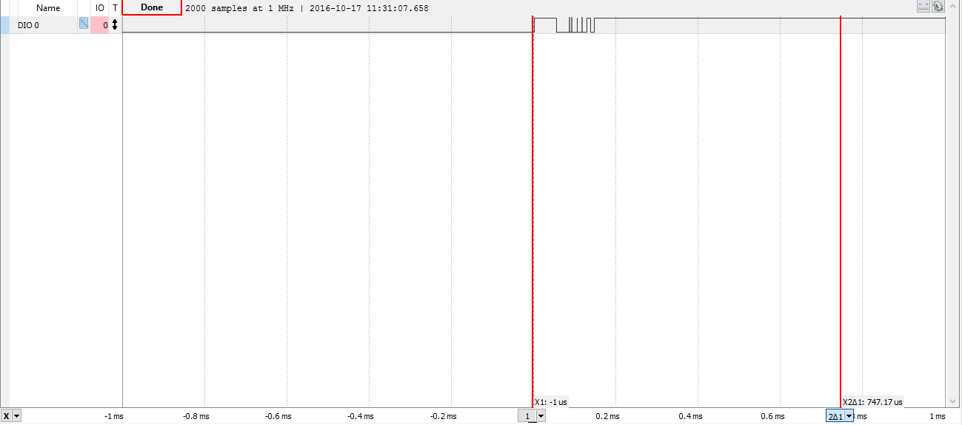

High-to-Low Bouncing

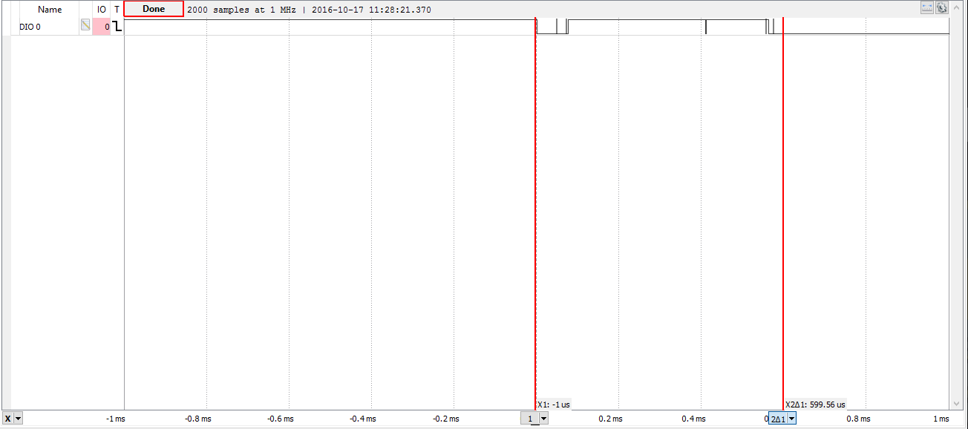

Baud Rate Verification

