**b) Prelab Questions**

1. Draw a 30 kHz square wave with 35% duty cycle. What is the period in ms?
   1. Period = 1/30kHz = 0.0333 ms

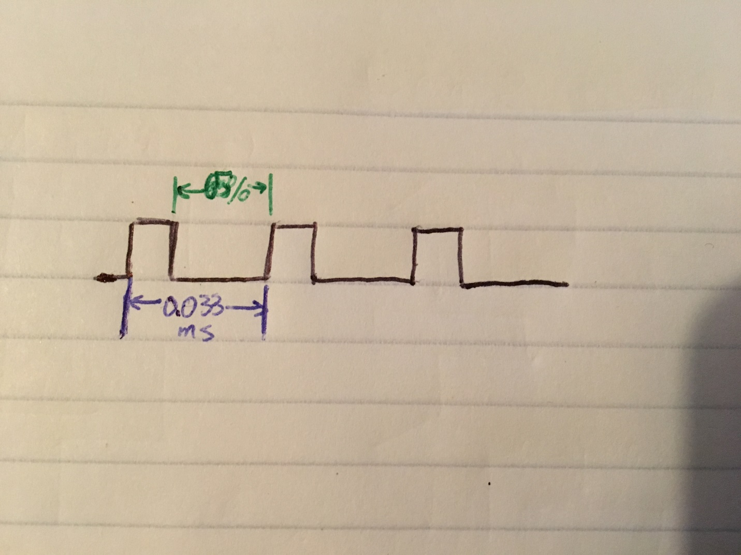

1. How does the prescaler affect the way the TC system counts per clock cycle? Where are the counts stored?
   1. The prescaler specifies when to increment the count for a given TC; for example, if the prescaler is set to CLK/64, then every 64th CLK tick will increment the TC’s count which is stored in the respective CNT registers (CNTH, CNTL).
2. For part A, what is the limiting factor for the precision of your frequency generation? Can your XMEGA generate some frequency ranges with higher precisions than other frequency ranges? Explain.
   1. The size of the CNT registers is the limiting factor on the precision of the frequency generation. Since we have two 8-bit registers, we get 16 bits dedicated for counting, giving us a maximum count of 65,535. Using the prescaler allows for bigger ranges of frequencies, but also reduces precision since the CNT is only incremented every Nth iteration (N = prescaler value), as result the XMEGA can generate lower frequency ranges with higher precision.
3. Describe the difference(s) between the TC’s Frequency Generation mode and its Single/Dual Slope PWM modes. Which mode(s) can be used to emulate the other(s)? How could you make a sine wave or other waveform using your XMEGA by using the timer system? Do you need to add any extra hardware? How can you produce these waveforms without extra hardware?
   1. From an implementation standpoint, the TC’s FRQ mode uses CCA for match conditions, while the two slope modes use PER. The Single-slope PWM mode could be used to emulate the FRQ mode and vice versa, since each case counts up to a value, then resets to BOTTOM. FRQ mode could also be used to emulate Dual-slope PWM if on each match condition with CNT == CCA, the direction is changed to then count down.
   2. To make a Sine wave or similar waveform using the XMEGA timer system, we do not need any extra hardware, we would need a table of sine values that could be iterated through while scaling up/down PWM duty cycle in accordance.

**c) Problems Encountered**

The most time consuming error I encountered in this lab was figuring out how to set the period for note durations, since the timers are only 16-bits and set millisecond durations. Eventually, I realized I needed to add a constant 1000 denominator to provide a range that would span into seconds.

**d) Future Work/Applications**

Using the timer/counter system to output a PWM could be used to control a motor/servo in designing a robot or similar mechanism.

**e) Schematics**

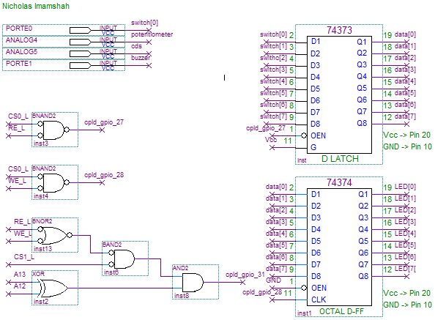

**f) Decoding Logic**

No new additions.

**g) Pseudocode/Flowcharts**

**Part A**

Inits

While (1)

If (switch TRUE)

Play(C6)

Else

// do nothing

END While

**Part B**

Inits

While (1)

Key = keyscan()

If key in 1 to D

Play(key)

Else if key == *

Play_sequence(song1)

Else

Play_sequence(song2)

END While

**h) Program Code**

**Part A**

/* Lab6_PartA.c

*

* Lab 6 Part A

* Name: Nicholas Imamshah

* Section: 6957

* TA Name: Daniel Gonzalez

* Description: The purpose of this program is to generate the C6 note using the XMEGA's TC system.

*/

//////////////////////////////////////INCLUDES///////////////////////////////////////

#include <avr/io.h>

#include "ebi_init.h"

#include "ebi_driver.h"

//////////////////////////////////INITIALIZATIONS////////////////////////////////////

#define F_CPU 2000000

/////////////////////////////////////PROTOTYPES//////////////////////////////////////

void tc_init(void);

void play(*uint16_t* freq);

///////////////////////////////////MAIN FUNCTION/////////////////////////////////////

int main(void)

{

ebi_init();

tc_init();

while (1)

{

play(1046.50);

if (__far_mem_read(IO_PORT) & 0x01) // If Switch0 True, play note

{

TCE0.CTRLB |= TC0_CCBEN_bm;

}

else // Else, turn off

{

TCE0.CTRLB = TC_WGMODE_FRQ_gc;

}

}

}

/////////////////////////////////////FUNCTIONS///////////////////////////////////////

void tc_init(void)

{

PORTE.DIRSET = 0x02; // Set Port E Pin 2 as output

TCE0.CTRLA = TC_CLKSEL_DIV1_gc; // Prescaler: CLK

TCE0.CTRLB = TC0_CCBEN_bm | // Enable CCB, FRQ mode

TC_WGMODE_FRQ_gc;

TCE0.CTRLE = TC_BYTEM_NORMAL_gc;

}

void play(*uint16_t* freq)

{

*uint16_t* cca = (F_CPU / (freq * 2)) - 1; // Uses fFRQ formula from doc8331

TCE0.CCA = cca;

}

**Part B**

/* Lab6_PartB.c

*

* Lab 6 Part B

* Name: Nicholas Imamshah

* Section: 6957

* TA Name: Daniel Gonzalez

* Description: The purpose of this program is to provide a keypad interface mapped to various sounds.

*/

//////////////////////////////////////INCLUDES///////////////////////////////////////

#include <avr/io.h>

#include <avr/interrupt.h>

#include "ebi_driver.h"

#include "ebi_init.h"

#include "lcd_init.h"

#include "keypad.h"

//////////////////////////////////INITIALIZATIONS////////////////////////////////////

#define F_CPU 2000000

#define SCALE 128000

typedef struct note {

char *name;

char *ascii_freq;

*uint16_t* freq;

} note;

typedef struct beat {

note n;

*uint16_t* d;

} beat;

#define w 4000

#define h 2000

#define q 1000

#define e 500

#define k0 { "A6", "1760.00 Hz", 1760.00 }

#define k1 { "C6", "1046.50 Hz", 1046.50 }

#define k2 { "C#6/Db6", "1108.73 Hz", 1108.73 }

#define k3 { "D6", "1174.66 Hz", 1174.66 }

#define k4 { "D#6/Eb6", "1244.51 Hz", 1244.51 }

#define k5 { "E6", "1318.51 Hz", 1318.51 }

#define k6 { "F6", "1396.91 Hz", 1396.91 }

#define k7 { "F#6/Gb6", "1479.98 Hz", 1479.98 }

#define k8 { "G6", "1567.98 Hz", 1567.98 }

#define k9 { "G#6/Ab6", "1661.22 Hz", 1661.22 }

#define ka { "A#6/Bb6", "1864.66 Hz", 1864.66 }

#define kb { "B6", "1975.53 Hz", 1975.53 }

#define kc { "C7", "2093.00 Hz", 2093.00 }

#define kd { "C#7/Db7", "2217.46 Hz", 2217.46 }

#define knull { "0", "0", 0 }

#define e7 { "E7", "2637.02 Hz", 2637.02 }

#define d7 { "D7", "2349.32 Hz", 2349.32 }

#define wa { "W", "0", 1 }

note notes[] = { k0, k1, k2, k3, k4 , k5, k6, k7, k8, k9, ka, kb, kc, kd, knull };

beat arp_beats[] =

{

{ k1, q },

{ k5, q },

{ k8, q },

{ kc, q },

{ k8, q },

{ k5, q },

{ k1, q },

{ knull, w }

};

beat lavender[] =

{

{ k1, q },

{ k8, q },

{ kb, q },

{ k7, q },

{ k1, q },

{ k8, q },

{ kb, q },

{ k7, q },

{ k1, q },

{ k8, q },

{ kb, q },

{ k7, q },

{ knull, w }

};

beat green_hill[] =

{

{ kc, e },

{ k0, q },

{ kc, e },

{ kb, q },

{ kc, e },

{ kb, e },

{ kb, e },

{ k8, q },

{ k8, e },

{ k5, e },

{ k8, e },

{ e7, e },

{ d7, q },

{ kc, e },

{ kb, q },

{ kc, e },

{ kb, e },

{ kb, e },

{ k8, q },

{ k8, e },

{ kc, e },

{ k0, q },

{ kc, e },

{ kb, q },

{ kc, e },

{ kb, e },

{ kb, e },

{ k8, q },

{ k8, e },

{ k0, e },

{ k0, e },

{ k6, q },

{ k0, e },

{ k8, q },

{ k0, e },

{ k8, e },

{ k8, e },

{ k1, q },

{ k1, e },

{ knull, w }

};

/////////////////////////////////////PROTOTYPES//////////////////////////////////////

void play(note n);

void play_note(note n, *uint16_t* d);

void play_sequence(char *name_top, char *name_bottom, beat *b);

void tc_init(void);

*uint16_t* calc_ffrq(*uint16_t* freq);

void calc_per(*uint16_t* period);

///////////////////////////////////MAIN FUNCTION/////////////////////////////////////

int main(void)

{

ebi_init();

lcd_init();

keypad_init();

tc_init();

*uint8_t* key;

while (1)

{

do

{

key = keyscan(); // Get Key press

} while (key == 0xFF);

keyhold();

TCE1.CTRLFSET = TC_CMD_RESTART_gc;

if (key <= 0x0D) // Keys 0-D

{

calc_per(567.8);

note n = notes[key];

play(n);

}

else if (key == 0x0E) // Key *

{

play_sequence("Sonic", "Green Hill Zone", green_hill);

}

else // Key #

{

play_sequence("Pokemon", "Lavender Town", lavender);

}

}

}

/////////////////////////////////////FUNCTIONS///////////////////////////////////////

void play(note n)

{

CLEAR_SCREEN();

OUT_STRING(n.name); // Print note and frequency

OUT_COMMAND(0xC0);

OUT_STRING(n.ascii_freq);

TCE0.CCA = calc_ffrq(n.freq); // Calculate CCA for given note frequency

TCE0.CTRLB |= TC0_CCBEN_bm; // Enable TCs

TCE1.CTRLB |= TC1_CCAEN_bm;

}

void play_note(note n, *uint16_t* d)

{

calc_per(d); // Set PER register for note duration

if (n.freq > 1) // If freq < 1, do not play (used for waits)

{

TCE0.CCA = calc_ffrq(n.freq);

TCE0.CTRLB |= TC0_CCBEN_bm;

}

TCE1.CTRLB |= TC1_CCAEN_bm;

}

void play_sequence(char *name_top, char *name_bottom, beat *b)

{

CLEAR_SCREEN();

OUT_STRING(name_top); // Print name of song selection

OUT_COMMAND(0xC0);

OUT_STRING(name_bottom);

int i = 0;

while (b[i].n.freq != 0) // Loop until end of sequence reached (knull)

{

TCE1.CTRLFSET = TC_CMD_RESTART_gc;

play_note(b[i].n, b[i].d);

while(TCE1.CTRLB & TC1_CCAEN_bm);

i++;

}

}

void tc_init(void)

{

PORTE.DIRSET = 0x12;

TCE0.CTRLA = TC_CLKSEL_DIV1_gc; // Prescaler: CLK

TCE0.CTRLB = TC_WGMODE_FRQ_gc; // FRQ Mode

TCE0.CTRLE = TC_BYTEM_NORMAL_gc;

TCE1.CTRLA = TC_CLKSEL_DIV64_gc; // Prescaler: CLK/64

TCE1.CTRLB = TC_WGMODE_NORMAL_gc; // Normal Mode

TCE1.CTRLE = TC_BYTEM_NORMAL_gc;

TCE1.INTCTRLA = TC_OVFINTLVL_LO_gc; // Enable low-level interrupts on overflow

calc_per(567.8);

PMIC.CTRL |= PMIC_LOLVLEN_bm;

sei();

}

*uint16_t* calc_ffrq(*uint16_t* freq)

{

return (F_CPU / (freq * 2)) - 1; // Formula from Doc 8331.

}

void calc_per(*uint16_t* period)

{

TCE1.PER = ((period * F_CPU) / SCALE) - 1; // Formula for FRQ from Doc 8331,

// rearranged to determine PER.

}

////////////////////////////////////////ISRs/////////////////////////////////////////

ISR(TCE1_OVF_vect)

{

TCE1.INTFLAGS = TC1_OVFIF_bm; // Clear interrupt flag

TCE1.CTRLB = TC_WGMODE_NORMAL_gc; // Disable CCs

TCE0.CTRLB = TC_WGMODE_FRQ_gc;

}

**i) Appendix**

**DAD Frequency Verification**

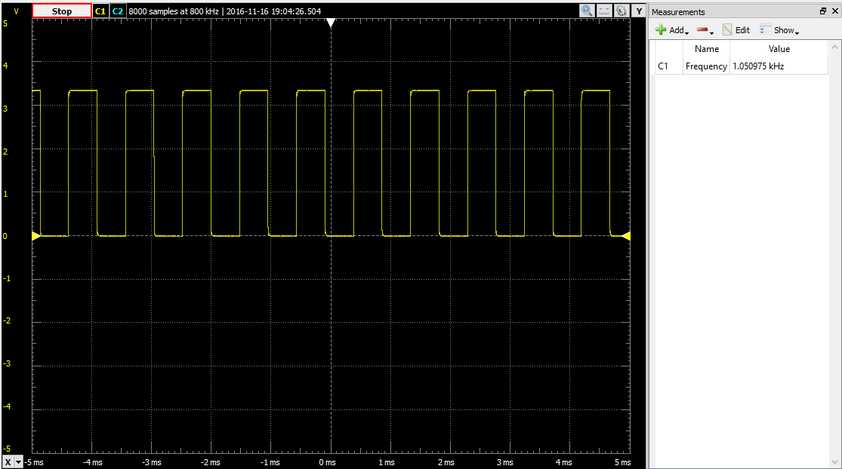

**keypad.h**

/* keypad.c

*

* Keypad in C

* Name: Nicholas Imamshah

* Section: 6957

* TA Name: Daniel Gonzalez

* Description: The purpose of this program is to interface the XMEGA processor

* with an external Keypad.

*/

//////////////////////////////////////INCLUDES///////////////////////////////////////

#include <avr/io.h>

//////////////////////////////////INITIALIZATIONS////////////////////////////////////

#define F_CPU 2000000

*uint8_t* keys[] = {0x1, 0x4, 0x7, 0xE, 0x2, 0x5, 0x8, 0x0, 0x3, 0x6, 0x9, 0xF, 0xA, 0xB, 0xC, 0xD};

/////////////////////////////////////PROTOTYPES//////////////////////////////////////

void keypad_init(void);

*uint8_t* keyscan(void);

void keyhold(void);

/////////////////////////////////////FUNCTIONS///////////////////////////////////////

void keypad_init(void)

{

PORTF.PIN7CTRL = PORT_OPC_PULLUP_gc; // Set OPC to Pull-Up for all Keypad pins

PORTF.PIN6CTRL = PORT_OPC_PULLUP_gc;

PORTF.PIN5CTRL = PORT_OPC_PULLUP_gc;

PORTF.PIN4CTRL = PORT_OPC_PULLUP_gc;

PORTF.PIN3CTRL = PORT_OPC_PULLUP_gc;

PORTF.PIN2CTRL = PORT_OPC_PULLUP_gc;

PORTF.PIN1CTRL = PORT_OPC_PULLUP_gc;

PORTF.PIN0CTRL = PORT_OPC_PULLUP_gc;

PORTF.DIRSET = 0x0F; // Set LSNibble of PortF as Output

}

*uint8_t* keyscan(void)

{

*uint8_t* input, index, line, key = 0xFF, i = 0;

for (i = 0; i < 4; i++) // Iterate columns

{

line = ~(0x01 << i) & 0x0F; // Iterate shift 0x08 by i and not to hit each col

PORTF.OUT = line; // Output value for col

asm volatile ("nop");

input = PORTF.IN & 0xF0; // Read Input and bitmask off Output bits

if (input < 0xF0)

{

switch (input)

{

case 0xE0:

index = 0x00;

break;

case 0xD0:

index = 0x01;

break;

case 0xB0:

index = 0x02;

break;

case 0x70:

index = 0x03;

break;

}

key = keys[index+4*i];

return key;

}

}

return key;

}

void keyhold(void)

{

while ((PORTF.IN & 0xF0) < 0xF0);

}

**ebi_init.h**

/* ebi_init.h

*

* EBI Initialization Header

* Name: Nicholas Imamshah

* Section: 6957

* TA Name: Daniel Gonzalez

* Description: The purpose of this program is to configure the EBI for I/O Ports and LCD.

*/

//////////////////////////////////////INCLUDES///////////////////////////////////////

#include <avr/io.h>

//////////////////////////////////INITIALIZATIONS////////////////////////////////////

#define F_CPU 2000000

#define CS0_Start 0x288000

#define CS0_End 0x289FFF

#define IO_PORT 0x288000

#define CS1_Start 0x394000

#define CS1_End 0x397FFF

/////////////////////////////////////PROTOTYPES//////////////////////////////////////

void ebi_init();

/////////////////////////////////////FUNCTIONS///////////////////////////////////////

void ebi_init()

{

PORTH.DIR = 0x37;

PORTH.OUT = 0x33;

PORTK.DIR = 0xFF;

EBI.CTRL = EBI_SRMODE_ALE1_gc | EBI_IFMODE_3PORT_gc;

EBI.CS0.BASEADDRH = (*uint8_t*) (CS0_Start>>16) & 0xFF;

EBI.CS0.BASEADDRL = (*uint8_t*) (CS0_Start>>8) & 0xFF;

EBI.CS0.CTRLA = EBI_CS_MODE_SRAM_gc | EBI_CS_ASPACE_8KB_gc;

EBI.CS1.BASEADDR = (*uint16_t*) (CS1_Start>>8) & 0xFFFF;

EBI.CS1.CTRLA = EBI_CS_MODE_SRAM_gc | EBI_CS_ASPACE_16KB_gc;

}

**lcd_init.h**

/* lcd_init.h

*

* LCD Initialization Header

* Name: Nicholas Imamshah

* Section: 6957

* TA Name: Daniel Gonzalez

* Description: The purpose of this program is to initialize the LCD.

*/

//////////////////////////////////////INCLUDES///////////////////////////////////////

#include <avr/io.h>

//////////////////////////////////INITIALIZATIONS////////////////////////////////////

#define F_CPU 2000000

#define LCD_BASEADDR 0x395000

/////////////////////////////////////PROTOTYPES//////////////////////////////////////

void lcd_init();

void wait_busy();

void OUT_CHAR(char character);

void OUT_STRING(char *string);

void OUT_COMMAND(char command);

void CLEAR_SCREEN(void);

void lcd_toggle(void);

*uint8_t* lcd_disp = 0x07;

/////////////////////////////////////FUNCTIONS///////////////////////////////////////

void lcd_init()

{

wait_busy();

__far_mem_write(LCD_BASEADDR, 0x38); // Two lines

asm volatile ("nop");

asm volatile ("nop");

wait_busy();

__far_mem_write(LCD_BASEADDR, 0x0F); // Display on; Cursor on; Blink on

asm volatile ("nop");

asm volatile ("nop");

wait_busy();

__far_mem_write(LCD_BASEADDR, 0x01); // Clear screen; Cursor home

asm volatile ("nop");

asm volatile ("nop");

wait_busy();

}

void wait_busy()

{

*uint8_t* result = 0;

do

{

result = __far_mem_read(LCD_BASEADDR);

} while (result & 0x80); // Poll the BF of the LCD

}

void OUT_CHAR(char character)

{

wait_busy();

__far_mem_write(LCD_BASEADDR+1, character);

asm volatile ("nop");

asm volatile ("nop");

wait_busy();

}

void OUT_STRING(char *string)

{

while (*string != '\0') // Loop until null character is encountered

{

OUT_CHAR(*string);

string++;

}

}

void OUT_COMMAND(char command)

{

wait_busy();

__far_mem_write(LCD_BASEADDR, command);

asm volatile ("nop");

asm volatile ("nop");

wait_busy();

}

void CLEAR_SCREEN(void)

{

wait_busy();

__far_mem_write(LCD_BASEADDR, 0x01);

asm volatile ("nop");

asm volatile ("nop");

wait_busy();

}

void lcd_toggle(void)

{

lcd_disp = lcd_disp ^ 0x07;

*uint8_t* disp_comm = 0x08 | lcd_disp;

wait_busy();

OUT_COMMAND(disp_comm);

}