Banknote Recognition
In this project, we have two goals:
- Classify fake and real banknotes
- Determine the amount of banknote
Note: Banknote recognition of dollar currency is our priority for now but we might aware that after a short or long time, we need to recognize other currency banknotes with our system. So, we have to prepare an appropriate architecture for future use for different currencies.
We can consider two approaches to achieve our goals in this project.
- Parallel
In parallel, we can process both of the goals simultaneously.
- Sequential
In sequential, we first detect if the banknote is real or not. If it was real, then we’ll continue to determine the amount of the correlated banknote.
Both of the approaches have some advantages and disadvantages. Therefore, we need to move on and implement them and we’ll find out which one is better to use according to our needs and expectations in testing and evaluation step.
Fig. 1, 2 both display a simple flowchart of these two approaches. Now let’s see what the role of each step is and how they help us in this task.
Object Detection
In object detection, we can detect objects and separate them in the images. But here we have only one object here which it is banknote. So we have to detect edges of the banknote and crop the image in order to have a solid image of the correlated banknote. By solid I mean that the banknote will cover the whole image. Since we don’t want to use AI models due to its high computational cost, the challenge of this step is detecting edges via only Image processing techniques in order to reach a lightweight and efficient algorithm.
Pre-processing
This step is very important and plays a crucial role in this task. We need to resize, visualize, normalize, etc the images for having a fair and robust evaluation. For example if we want to use grid evaluation mechanism, it’s very important to resize all images to the same width and height to be able to evaluate grid regions of the images properly.
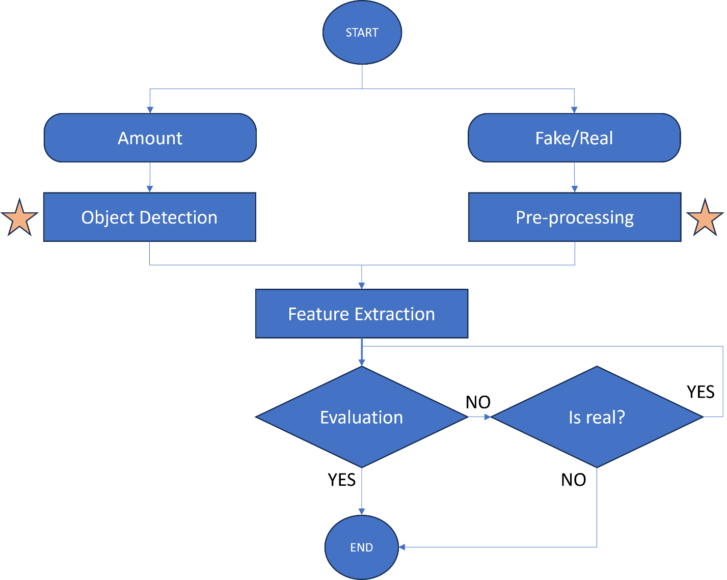
Fig. 1 Flowchart of parallel approach
Feature Extraction
There are different features that can be used to recognize banknotes such as grayscale histogram, hsv histogram and etc. But the main concern here is that how we should extract features and concatenate them to a single feature tensor and how to use them for evaluating the image with predefined dataset.
Similarity Evaluation
There are also some different evaluation mechanisms for evaluating the similarity between images such as Euclidean distance, Cosmine similarity, etc. But I want to use our novel similarity evaluation here which I call it “Grid Evaluation Mechanism”. This mechanism includes different approaches altogether and it discovered by myself.
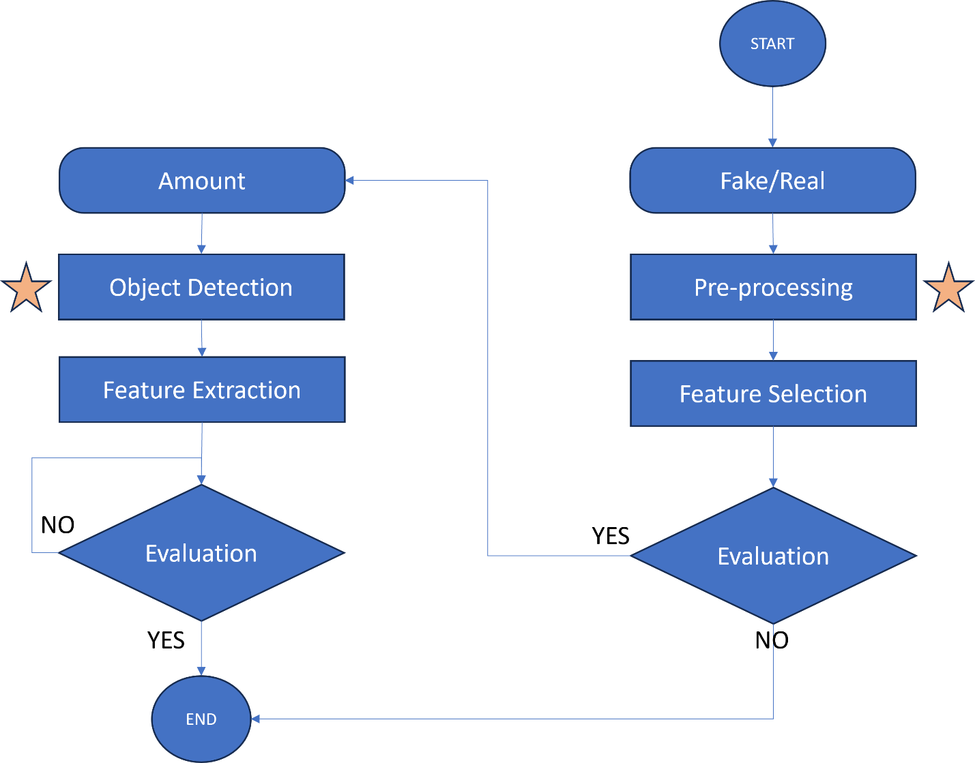
Fig. 2 Flowchart of sequential approach
Methodology
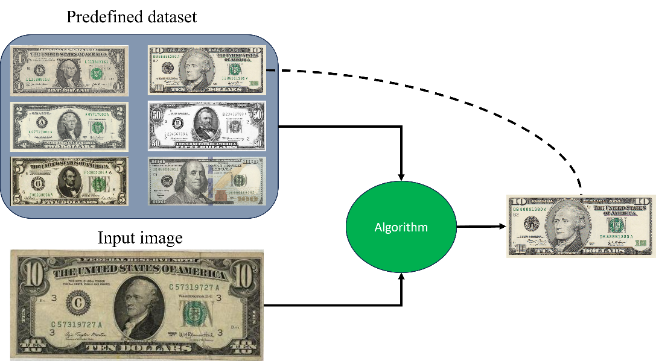
At the end, I want to include my overall pipeline below for this project according to prior information. As you can see, the algorithm takes a dataset and an input image as inputs and returns the recognized banknote as output if the banknote of input image is not fake.
Fig. 3 Diagram of proposed method

