SwarmOps Cloud
  - C4 Architecture Model
September 2026
Abstract
This document describes the architecture of SwarmOps Cloud with the C4 model. The C4 model presents software architecture as a hierarchy of four levels of abstraction — system context, containers, components and code — supplemented by dynamic and deployment diagrams. Each diagram below is rendered from a C4-PlantUML source file kept in the repository, so the diagrams change together with the code they describe. For every level, a catalogue table states each element’s responsibility and technology.
Table of Contents

1 The C4 model
The C4 model, introduced by Simon Brown [1], describes a software system at four levels of zoom:
- System context — the system as a box, the people who use it and the other systems it depends on.
- Containers — the separately running or deployable units inside the system (applications, databases, services) and how they communicate.
- Components — the major structural building blocks inside one container and their responsibilities.
- Code — the classes, types and interfaces that implement a component.
Two supplementary diagram types are used here. Dynamic diagrams show how elements collaborate at run time for one scenario. Deployment diagrams show how containers map onto infrastructure.
Notation. People are drawn as person shapes, the system under discussion and its parts in blue, and external systems in grey. Databases are drawn as cylinders. Arrows are one-directional and labelled with the intent of the interaction and, where useful, the protocol. Each diagram includes a legend.
Sources. The diagrams are kept in docs/cloud/diagrams/*.puml and use the C4-PlantUML library bundled with PlantUML. The documentation build renders them to PNG and SVG.

2 Level 1 — System context
Figure 1 shows SwarmOps Cloud in its environment.
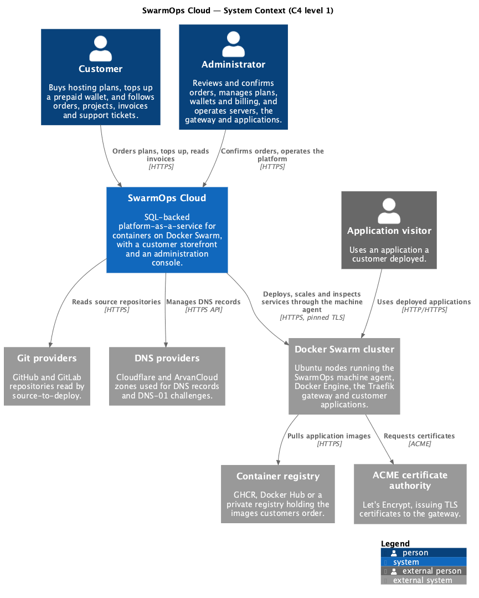
System context diagram
Elements of the system context
Element | Kind | Responsibility
Customer | Person | Buys hosting plans, tops up a prepaid wallet, follows orders and projects, reads invoices and opens support tickets.
Administrator | Person | Confirms or rejects orders; manages plans, wallets, billing and tickets; operates servers, the gateway and applications.
Application visitor | External person | Uses an application that a customer deployed.
SwarmOps Cloud | Software system | The system described here: storefront, administration console and SwarmOps Core with its database.
Docker Swarm cluster | External system | The servers that run the machine agent, Docker Engine, the Traefik gateway and customer applications.
Container registry | External system | Holds the images customers order.
Git providers | External system | Repositories read by the source-to-deploy feature SwarmOps already had.
DNS providers | External system | Cloudflare and ArvanCloud zones used for records and DNS-01 certificate challenges.
ACME certificate authority | External system | Issues TLS certificates to the gateway.
Boundary decisions. The Swarm cluster is outside the system boundary because customers’ workloads run there and it is operated through a narrow interface: fixed-shape operations sent to the machine agent. A payment gateway does not appear: top-ups are simulated in this release (Proposal, section 6).

3 Level 2 — Containers
Figure 2 opens the SwarmOps Cloud box.
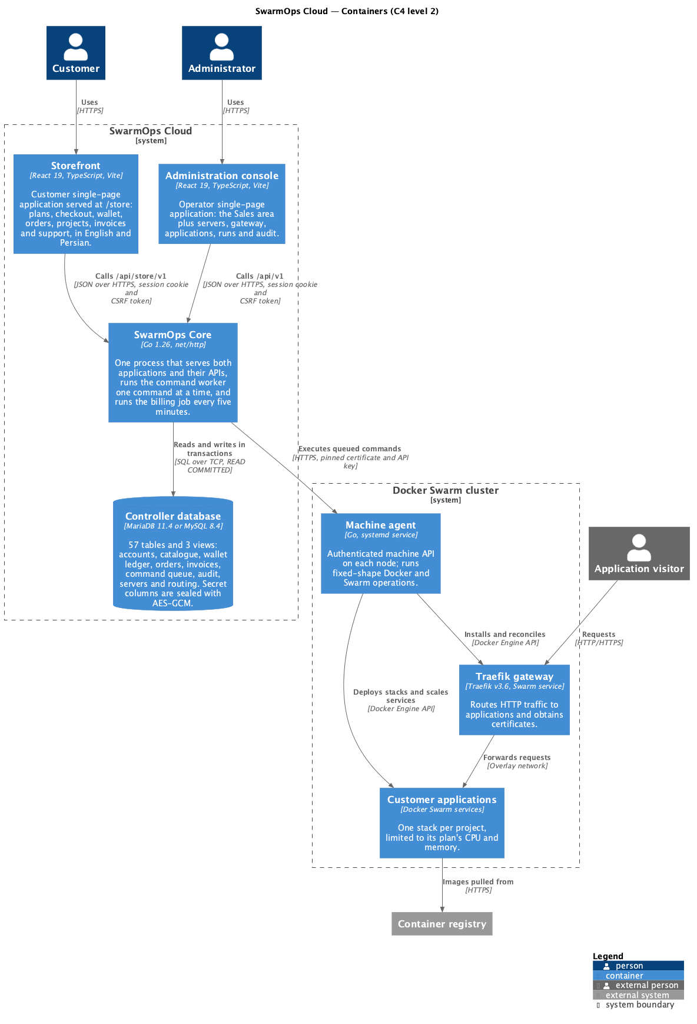
Container diagram
Containers
Container | Technology | Responsibility
Storefront | React 19, TypeScript, Vite; served at /store | Customer single-page application in English and Persian: plans, checkout, wallet, orders, projects, invoices, support.
Administration console | React 19, TypeScript, Vite; served at / | Operator single-page application: the Sales area plus servers, gateway, applications, runs and audit.
SwarmOps Core | Go 1.26, net/http | Serves both applications and their JSON APIs; authenticates users; runs the command worker and the billing job.
Controller database | MariaDB 11.4 or MySQL 8.4 | Holds all state: 57 tables and 3 views across nine migrations. Secret columns are encrypted.
Machine agent | Go, systemd service on each node | Performs Docker and Swarm operations requested by Core.
Traefik gateway | Traefik v3.6, Swarm service | Routes HTTP traffic to applications and obtains certificates.
Customer applications | Docker Swarm services | One stack per project, limited to its plan’s CPU and memory.
Why the worker and billing job are not separate containers. Both run inside the Core process. Only the active core may execute commands or charge wallets (constraint C-3 of the SRS). Keeping them in the same process means the check that decides whether this core is active is the same check the API uses, so a standby core cannot bill or deploy by accident. They appear as components at level 3.
Why one database for both platform and commerce. Confirming an order must charge the wallet and queue the deployment atomically. Because the command queue and the wallet ledger live in the same database, a single local transaction achieves this without a distributed protocol. Section 6 describes the pattern.

4 Level 3 — Components

4.1 SwarmOps Core
Figure 3 shows the components inside SwarmOps Core.
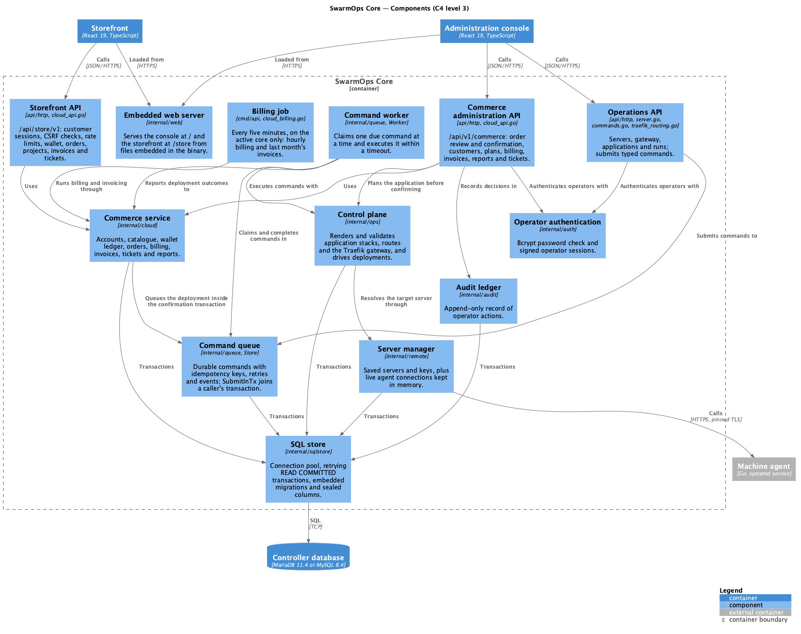
Components of SwarmOps Core
Components of SwarmOps Core
Component | Code | Responsibility
Embedded web server | internal/web | Serves the console and the storefront from files embedded in the binary.
Storefront API | api/http/cloud_api.go | /api/store/v1: customer session cookie, CSRF check, sign-in rate limiting, and the customer’s wallet, orders, projects, invoices and tickets.
Commerce administration API | api/http/cloud_api.go | /api/v1/commerce: order review and confirmation, customers, plans, billing, invoices, reports and tickets, behind operator authentication.
Operations API | api/http (server.go, commands.go, traefik_routing.go and others) | The existing SwarmOps operations; each change is submitted as a command.
Operator authentication | internal/auth | Checks the operator password and signs operator sessions.
Commerce service | internal/cloud | Business rules for accounts, catalogue, wallet, orders, billing, invoices, tickets and reports.
Billing job | cmd/api/cloud_billing.go | Every five minutes on the active core: hourly billing, then last month’s invoices.
Command queue | internal/queue (Store) | Durable commands with idempotency keys, retries, events and outputs; SubmitInTx joins a caller’s transaction.
Command worker | internal/queue (Worker) | Claims one due command at a time and executes it within a timeout; reports transitions.
Control plane | internal/ops | Renders and validates application stacks, routes and the gateway; drives deployments.
Server manager | internal/remote | Saved servers and keys in SQL; live agent connections in memory.
Audit ledger | internal/audit | Append-only record of operator actions.
SQL store | internal/sqlstore | Connection pool, retrying transactions, embedded migrations and sealed columns.

4.2 Commerce service
Figure 4 opens the commerce service. Each component corresponds to one source file in internal/cloud, and all share one Service value.
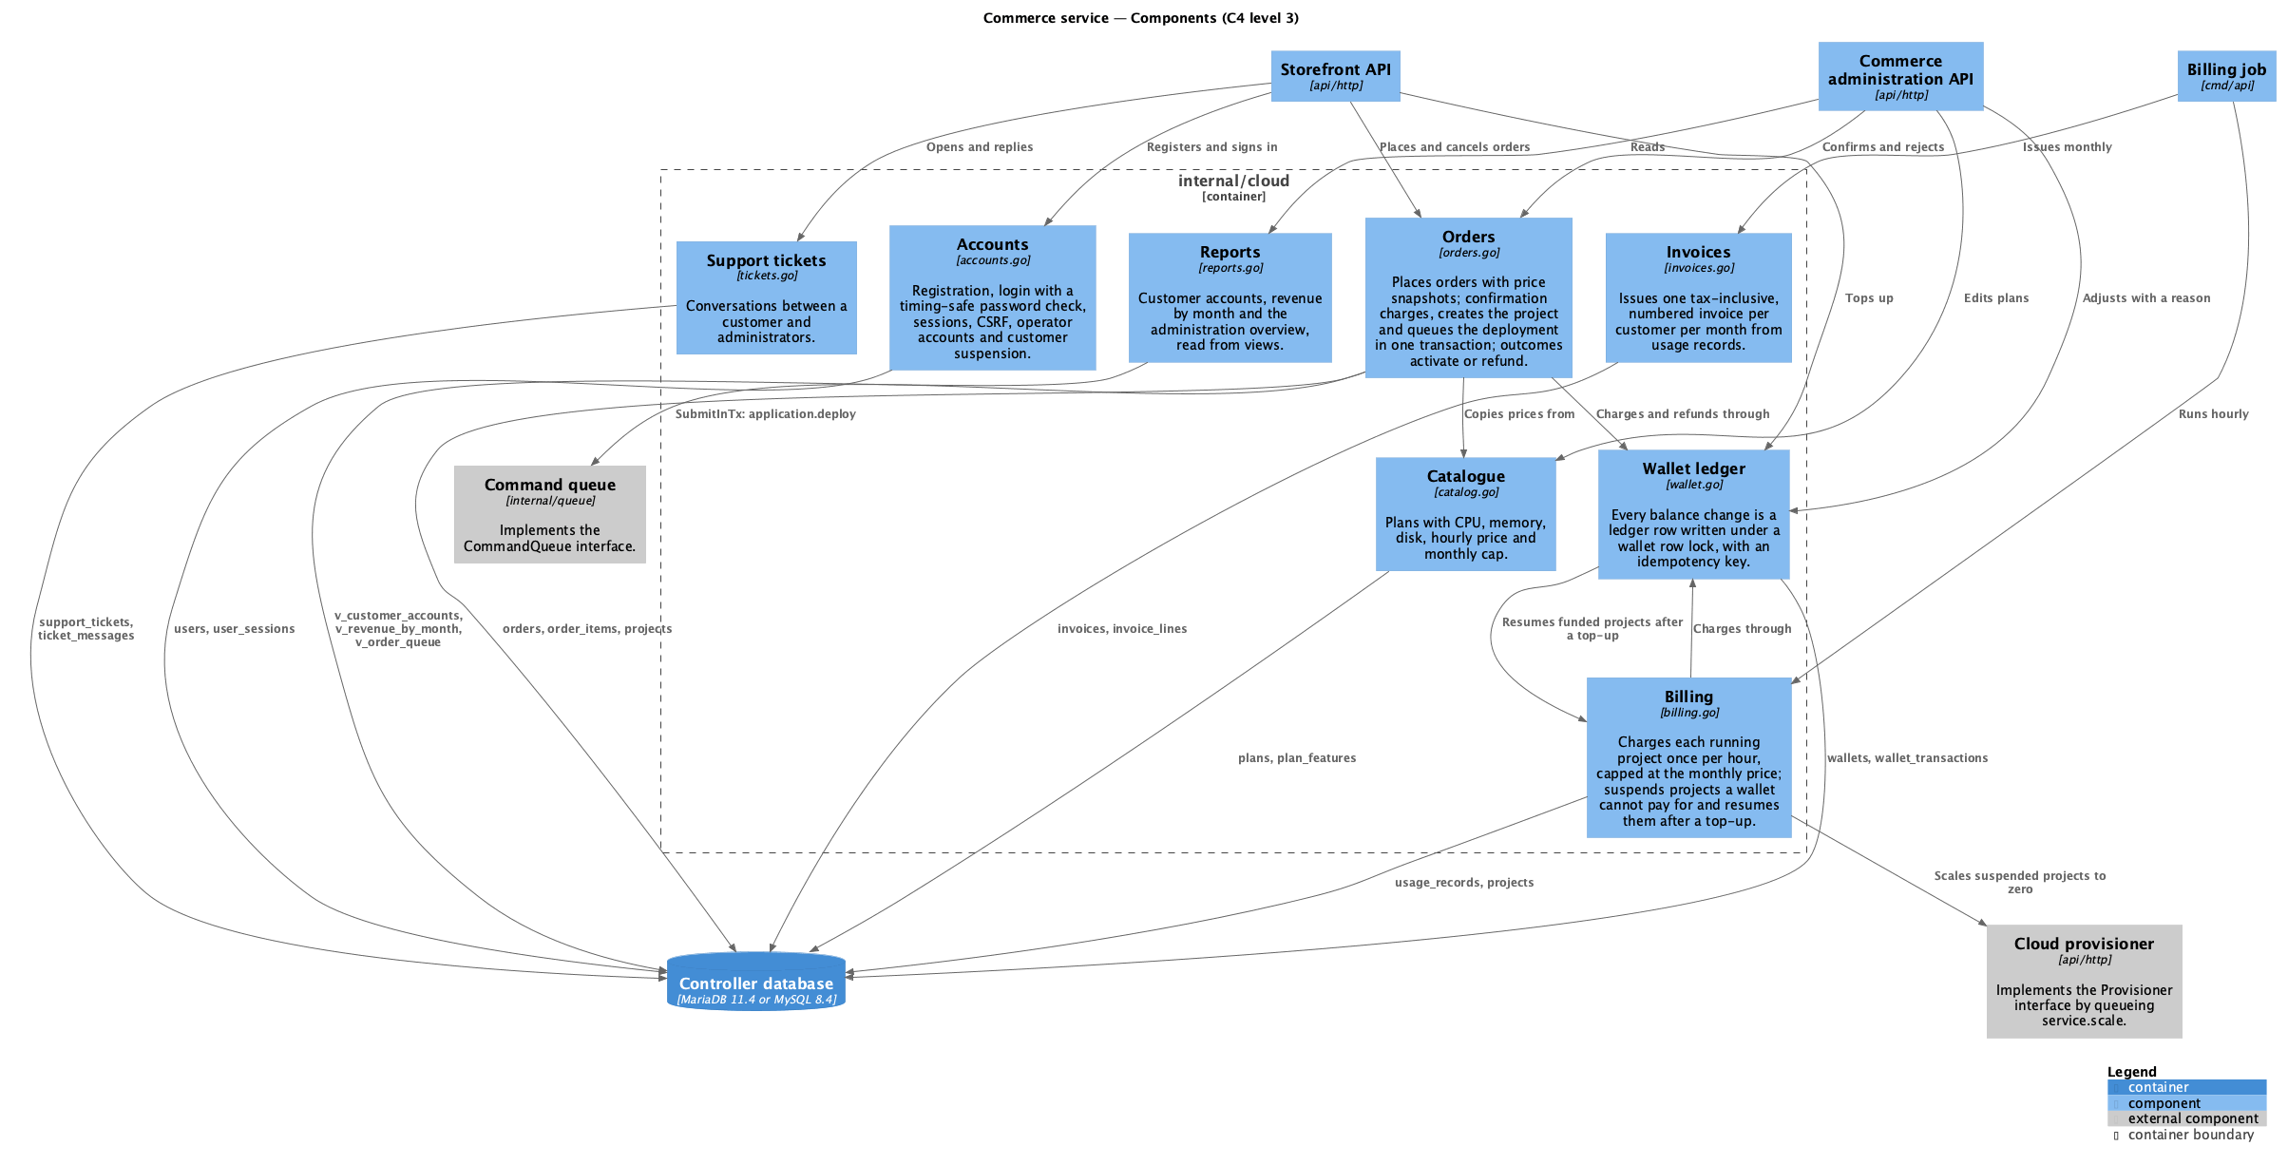
Components of the commerce service
Components of the commerce service
Component | File | Responsibility | Tables
Accounts | accounts.go | Registration, sign-in with a timing-safe check, sessions and CSRF tokens, operator accounts, customer suspension. | users, user_sessions
Catalogue | catalog.go | Plans and their features. | plans, plan_features, product_categories
Wallet ledger | wallet.go | Applies every balance change as a ledger row under a wallet row lock, with an idempotency key. | wallets, wallet_transactions
Orders | orders.go | Places orders with price snapshots; confirmation charges, creates the project and queues the deployment in one transaction; outcomes activate or refund. | orders, order_items, projects, usage_records
Billing | billing.go | Hourly charges capped monthly; suspension and resumption through the provisioner. | usage_records, projects
Invoices | invoices.go | Monthly, tax-inclusive, numbered invoices from usage records. | invoices, invoice_lines
Support tickets | tickets.go | Customer–administrator conversations. | support_tickets, ticket_messages
Reports | reports.go | Customer accounts, revenue by month and the overview, read from views. | v_customer_accounts, v_revenue_by_month, v_order_queue
The service depends on two interfaces rather than on concrete packages. CommandQueue is implemented by the command queue’s Store. Provisioner is implemented in the HTTP layer by queueing a service.scale command. This keeps internal/cloud testable with fakes and free of HTTP and Swarm details.

5 Level 4 — Code
Figure 5 shows the principal types behind orders, the wallet and the command queue.
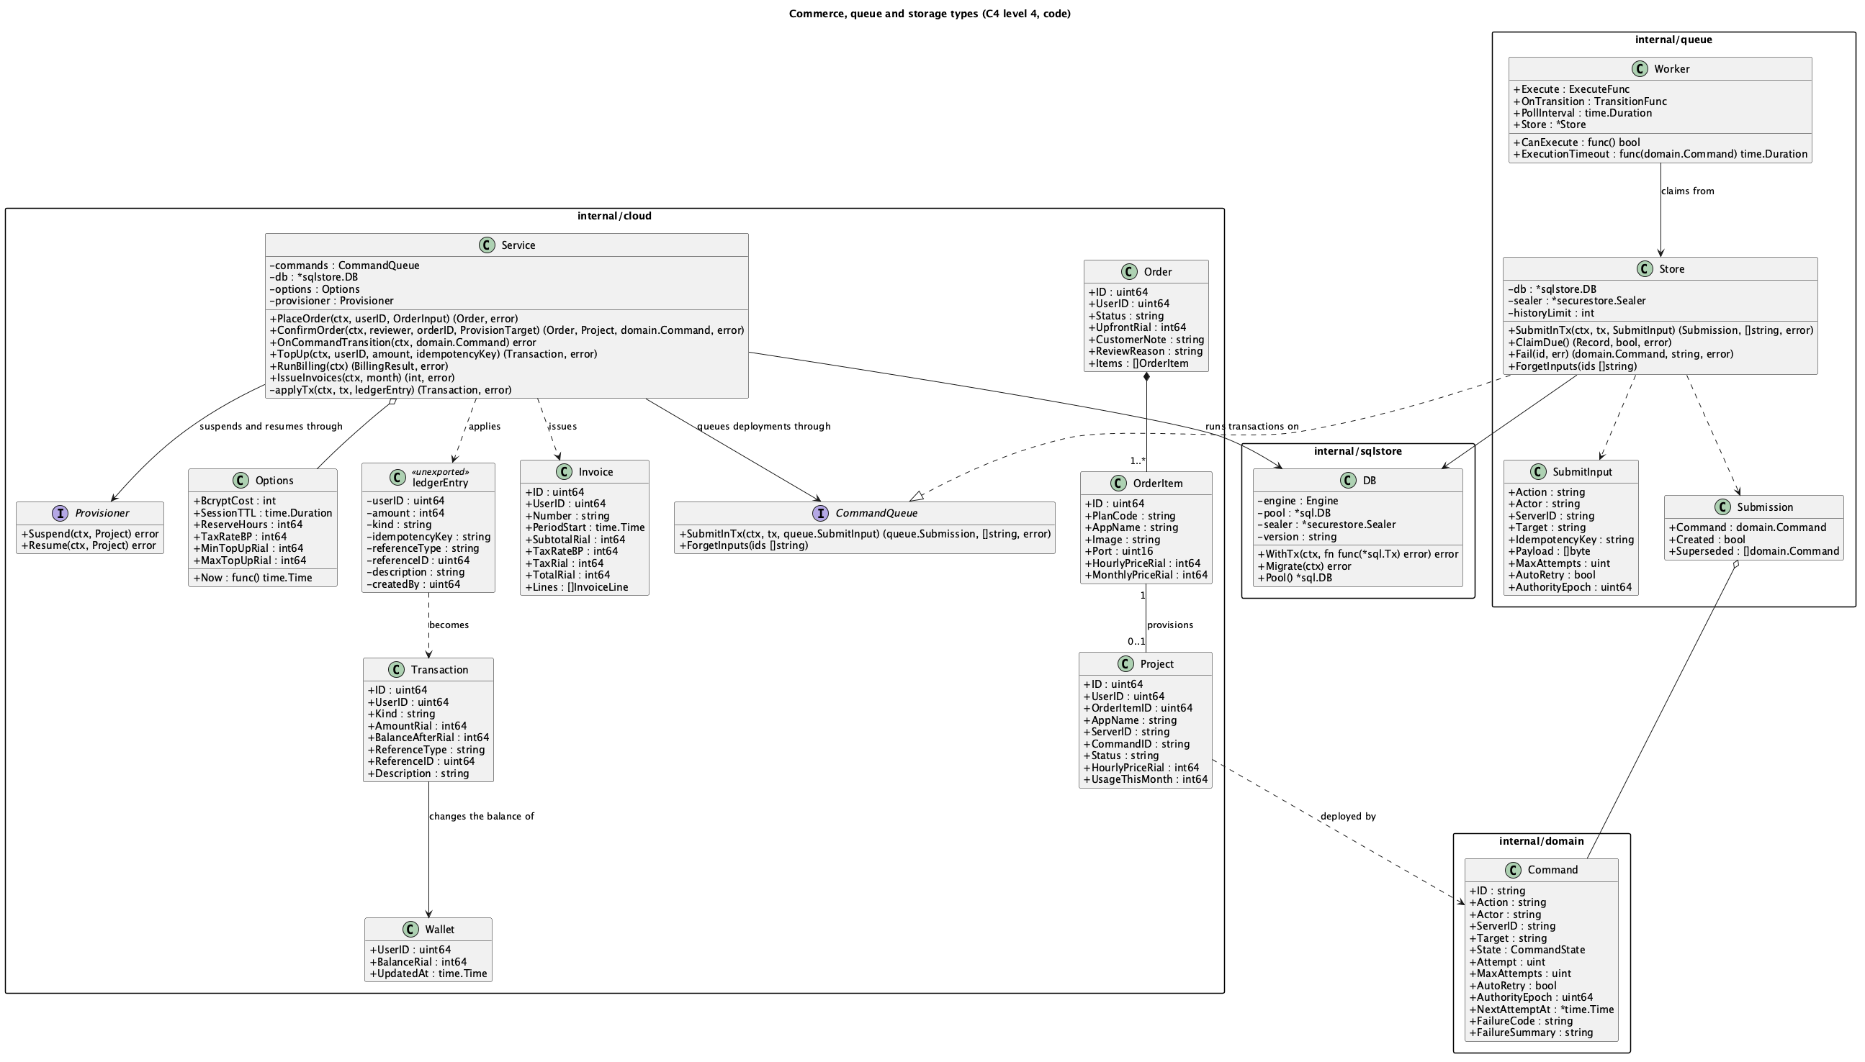
Principal types of commerce, the queue and storage
Four points in this diagram carry the design:
- Service.applyTx is the only code that changes a balance. It takes an unexported ledgerEntry, locks the wallet row with SELECT … FOR UPDATE, and returns the existing transaction if the idempotency key was already used. Otherwise it inserts the ledger row and updates the cached balance. A CHECK constraint on wallets.balance_rial >= 0 rejects any overdraft the code might miss.
- Service.ConfirmOrder runs inside sqlstore.DB.WithTx. It calls applyTx and inserts the project and usage rows. It then calls CommandQueue.SubmitInTx with the same *sql.Tx, so the deployment command is committed with the charge.
- Service.OnCommandTransition receives the final state of an application.deploy command. It activates the project and order, or fails them, deletes the refunded usage row and refunds the charge with a fixed idempotency key.
- queue.Worker claims one Record at a time with Store.ClaimDue, which locks the next due row with FOR UPDATE SKIP LOCKED. It executes the command within ExecutionTimeout, and Store.Fail schedules a retry with backoff unless the error is permanent.

6 Dynamic view — from order to running application
Figure 6 shows the scenario that ties the system together. The numbered steps are explained in the table.
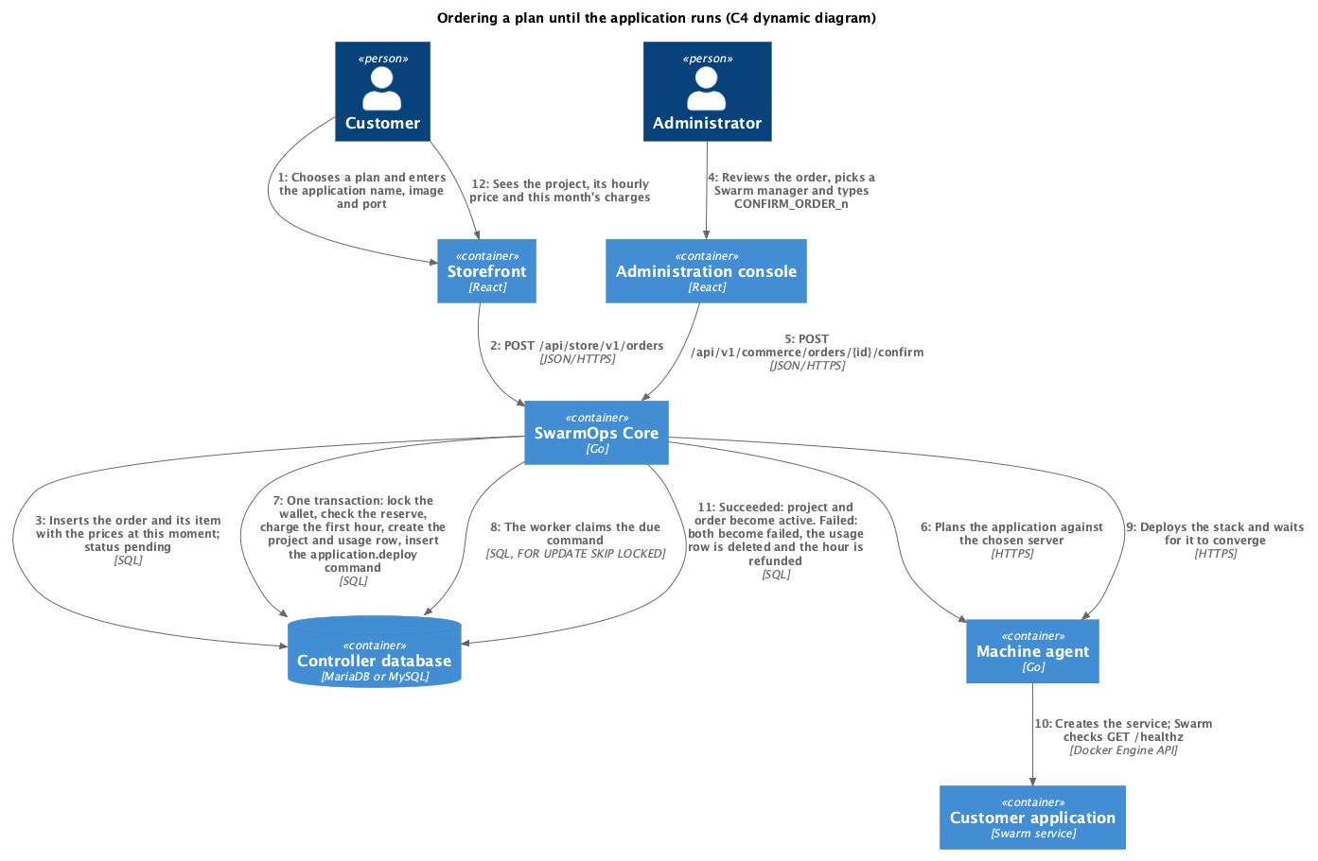
Dynamic diagram: ordering a plan until the application runs
Steps of the order-to-deploy scenario
Step | What happens | Guarantee
1–3 | The customer orders; Core stores the order and its item with the current prices. | Later price changes do not affect the order.
4–5 | The administrator reviews the order, picks a Swarm manager and confirms with a typed phrase. | Accidental confirmation is prevented.
6 | Core plans the application against the chosen server before touching money. | An application that cannot run is refused without a charge.
7 | One transaction locks the wallet, checks the 24-hour reserve, charges the first hour, creates the project and usage row, and inserts the deployment command. | Charge and deployment request commit together or not at all.
8 | The command worker claims the command. | Only the active core executes; a crash before completion leaves the command to be retried.
9–10 | The agent deploys the stack; Swarm waits for the health check. | The plan’s CPU and memory limits apply.
11 | The outcome activates the order and project, or fails them and refunds the hour. | The refund happens exactly once.
12 | The customer sees the project and its charges. | —
This scenario was run end to end during verification. Order 1 failed because the gateway was not yet installed. Order 2 failed because its image did not answer the health check. Both were refunded. Order 3 became active (Test Plan and Report, section 5).

7 Deployment view

7.1 Intended production deployment
Figure 7 shows the deployment the design targets.
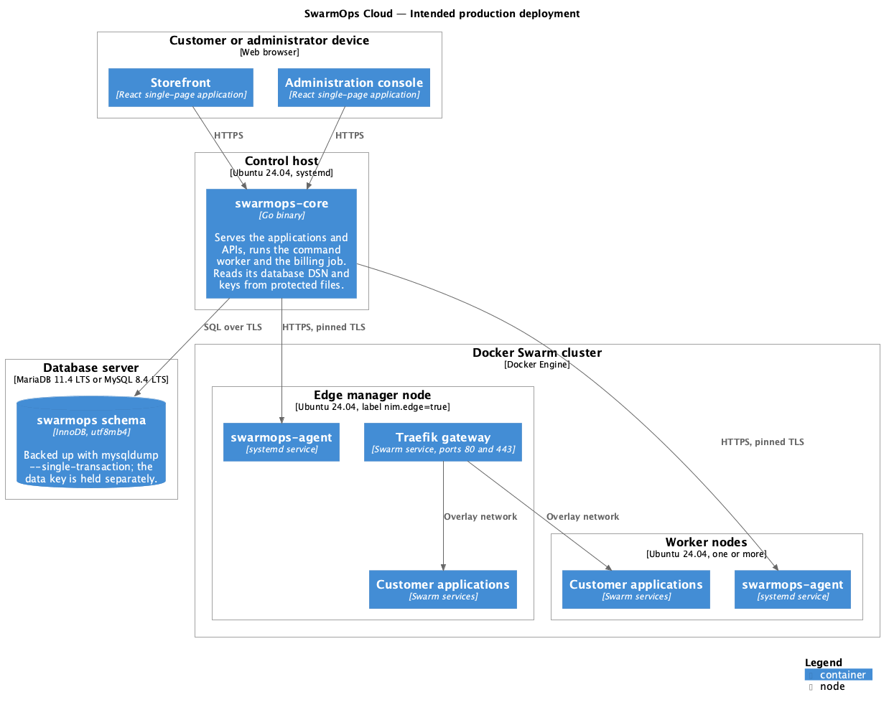
Intended production deployment
Nodes of the production deployment
Node | Runs | Notes
Customer or administrator device | Storefront, console | Any current browser.
Control host | swarmops-core | Ubuntu 24.04 with systemd. Reads the database DSN and keys from protected files.
Database server | The swarmops schema | MariaDB 11.4 LTS or MySQL 8.4 LTS. Backed up with mysqldump --single-transaction; the data key is kept separately.
Edge manager node | Agent, Traefik, applications | Labelled nim.edge=true; publishes ports 80 and 443.
Worker nodes | Agent, applications | One or more.

7.2 Environment used for verification
Figure 8 shows the environment in which the system was actually run and verified on 15 September 2026. It differs from production in the ways listed after the figure.
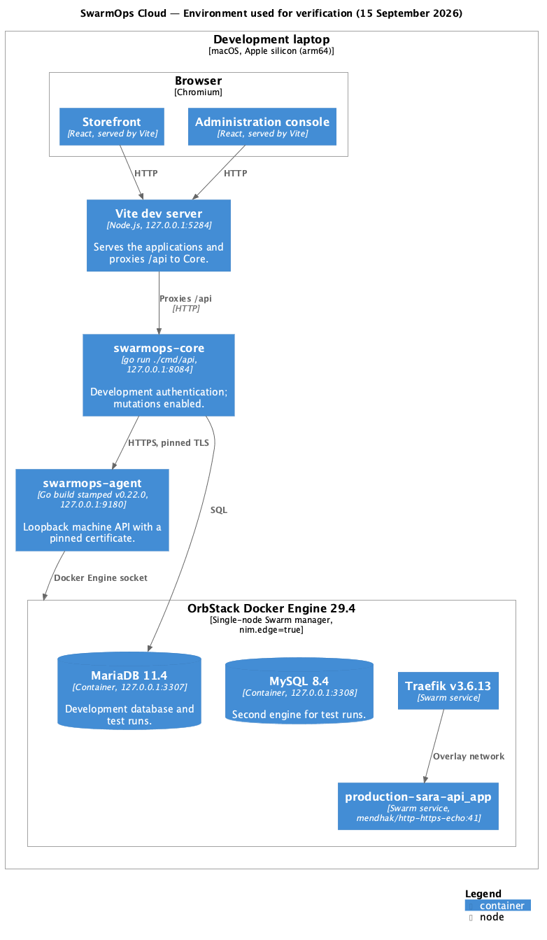
Environment used for verification
- Core and the agent ran as processes on a macOS laptop rather than as systemd services on Ubuntu.
- The Swarm had a single node, the laptop’s Docker Engine, which served as both manager and edge.
- The agent was a source build stamped with version v0.22.0, the version of this code base.
- The browser reached the applications through the Vite development server rather than through Core’s embedded files.
- Certificates were not issued, because the gateway had no public hostname.

8 References
[1] S. Brown, “The C4 model for visualising software architecture.” [Online]. Available: https://c4model.com. Accessed: Sep. 2026.
[2] R. Nordmann and contributors, “C4-PlantUML.” [Online]. Available: https://github.com/plantuml-stdlib/C4-PlantUML. Accessed: Sep. 2026.
[3] PlantUML. [Online]. Available: https://plantuml.com. Accessed: Sep. 2026.

