SwarmOps

Durable Command Queue

STATUS  PROPOSED |  | OWNER  Platform Operations |  | LAST UPDATED  August 24, 2026

Authors | SwarmOps maintainers
Reviewers | Platform and SRE review
Related docs | apps/swarmops/README.md; deploy/ansible/README.md
Scope | Durable execution for approved SwarmOps mutations and reviewed fleet jobs.

1. Abstract
Every approved SwarmOps mutation is accepted only after a durable command record exists. The API validates a fixed action, stores protected command metadata and payload, then returns a command ID for the console to track. A single worker executes one command at a time through the existing pinned SSH and Docker adapters; retryable failures use bounded exponential backoff, while ambiguous outcomes require operator attention rather than an unsafe replay.
This covers authenticated console and CLI mutations: service actions, stack deploys, image builds, observability controls, Traefik reconciliation, node operations, and reviewed fleet jobs. It assumes one active SwarmOps controller and a writable local data volume. It intentionally does not create an arbitrary-job runner, persist remote credentials, provide controller HA, or promise exactly-once remote effects.

2. Goals and Non-Goals
Goals | Non-goals
Persist accepted command intent before a remote side effect. | Generic task scheduler or arbitrary command runner.
Bound retryable failures with visible state and backoff. | Exactly-once remote Docker or host effects.
Keep credentials, raw payload, source, and output private. | Controller-side credential persistence or log streaming.
Require explicit attention for ambiguous execution. | Automatic replay after deadline, shutdown, or crash.

3. Background and Problem Statement
A synchronous remote Docker or Ansible call can fail after the client has sent an approved mutation but before the outcome is visible. Retrying blindly risks duplicate deploys, restarts, rollbacks, or builds; not retrying risks an operator losing the command altogether. SwarmOps needs a durable, inspectable lifecycle that preserves the intent before execution and makes ambiguity explicit.
The API owns admission, durable persistence, and safe acknowledgements. The worker owns serialized execution and terminal-state handling. Fixed remote adapters own the actual approved operation; Ansible owns host-local fleet execution. The guiding invariant is simple: no accepted mutation may execute before its command record has been written and can be recovered after a process restart.

4. Proposed Architecture

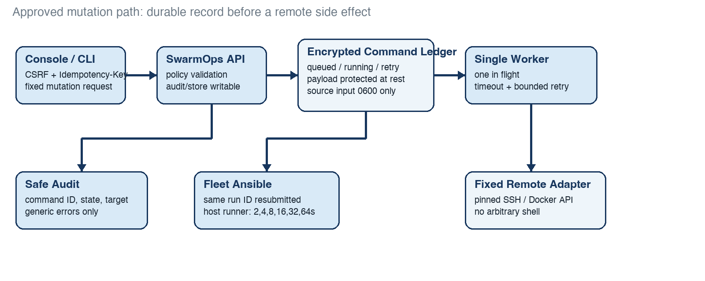
Figure 1. Durable command admission, serialized execution, and fleet retry boundaries.

Core components

Component | Responsibility | Primary storage | Failure behavior
Console / API | Authenticates, validates fixed mutations, and writes before acknowledgement. | Local profiles + command ledger | Rejects when audit or ledger is not writable.
Command store | Seals lifecycle metadata and private payload; recovers running records safely. | Encrypted local files | Restart changes uncertain running work to needs attention.
Single worker | Claims one due command and applies timeout/backoff policy. | In-memory lease + ledger | Retries only classified transport failures; otherwise attention.
Remote adapters | Run approved Docker, SSH, build, or service operations. | Live in-memory connection | Never accepts arbitrary shell; errors are classified.
Fleet Ansible | Resubmits one run ID; host runner persists status and retries. | Fleet run/status files | Reports retrying or failed state for operator review.

5. Request Lifecycle
- Authenticated console or CLI submits CSRF, an Idempotency-Key, a saved profile, and fixed action input.
- The API checks session, profile, policy, action shape, and audit/store writes; invalid input is rejected before it becomes a command.
- It normalizes to an allow-listed action; a build validates before source archive spools owner-only.
- It atomically seals queued state, then returns HTTP 202 and the command ID. An equivalent key returns the retained command.
- The single worker claims one due command, resolves the live connection, and invokes the fixed ControlPlane, build, or fleet path.
- Transport failures wait 2, 4, 8, 16, 32, then 64 seconds (eight attempts). Deadline, shutdown, or restart becomes needs attention; it never auto-replays.
- Success deletes raw input. API and audit expose safe metadata, state, attempts, next retry, and generic error; an operator can retry attention manually.

6. API and Data Contracts

Primary data contract

Field | Type | Required | Description
id | UUID | Yes | Stable identifier returned with HTTP 202.
action | enum | Yes | Allow-listed operation; never free-form instruction.
serverId | string | Yes | Saved profile resolved at execution time.
state | enum | Yes | queued, running, retry scheduled, succeeded, or attention.
attempt | integer | Yes | Current bounded attempt and maximum.
idempotency | string | Yes | Equivalent request returns record; conflict rejects.
payload/artifact | private | No | Protected input; never API response or audit.

Contract guarantees

- An accepted command is durably written before a worker may claim it or the API returns success to the caller.
- The idempotency key identifies equivalent admission requests; the command ID identifies the retained lifecycle. One worker owns at most one running command.
- The record captures action, target, profile, actor, attempts, safe timestamps, and state. Raw payloads and source archives stay out of API responses and audit output.
- The ledger is the source of truth for SwarmOps command intent and local lifecycle, not proof of an exactly-once remote Docker effect.
The versioned schema or interface definition is published at
the authenticated SwarmOps API under /api/v1/commands and the Go Command type; update both with each contract release.

7. Consistency, Idempotency, and Replay

A client gets a durable acknowledgement, not a promise that the remote side effect happened exactly once. Equivalent idempotency keys return the original command; conflicting reuse is rejected. The worker serializes high-trust mutations. Retry is reserved for clearly retryable remote transport failures. If a deadline, shutdown, or crash makes the remote result uncertain, the command remains visible as needs attention and can only be retried deliberately.
Scenario | Expected behavior | Reasoning
Duplicate submission | Equivalent idempotency key returns the existing command. | Prevents a second local admission record.
Ledger or audit write fails | Reject before HTTP 202 and before execution. | No accepted command can be missing.
Timeout, shutdown, or crash | Keep visible as needs attention; do not auto-replay. | Remote outcome may be uncertain.
Profile changes while queued | Resolve current live connection at execution; failure remains retryable or attention. | Intent persists without persisted credentials.

8. Security and Privacy Considerations

- Existing authenticated-session authorization, CSRF validation, and saved-profile ownership rules remain at the API boundary. Commands carry fixed action shapes; they never carry arbitrary shell or file paths.
- Command metadata and payload are sealed at rest. Source build archives are owner-only while waiting and are removed after success. API responses, browser views, and audit events expose no raw payload, source content, output, or secret.
- Remote credentials remain in process memory only. The command-store encryption key is supplied by configuration; it is never placed in the command record, audit trail, browser, or logs.
- Store or audit write failure fails closed before submission. Recovery changes a formerly running command to needs attention. Manual retry starts a new bounded attempt sequence only after explicit operator action.
- The initial implementation retains safe lifecycle metadata locally; retention and pruning policy remain an operational decision. Raw build input is minimized and removed on success. Audit records retain only safe transition metadata.

9. Operational Readiness
Signal | SLO or alert | Owner | Launch gate
Ledger write error | Reject the mutation and alert immediately. | Platform/SRE | Required
Needs-attention count | Investigate every terminal ambiguous record. | Platform/SRE | Required
Retry backlog | Alert on stale due/retry-scheduled records. | Platform/SRE | Required
Worker health | Stop admission if the worker cannot make transitions. | Platform/SRE | Required
Fleet retry status | Read run status after submit and escalation. | Platform/SRE | Recommended
Rollout constraint: complete local failure injection and authenticated queue verification before any rollout; production use needs approved operating procedures, alert ownership, and recovery evidence.

10. Alternatives Considered

Alternative | Why it was considered | Why it was not selected
Direct synchronous calls | Smallest implementation and immediate response. | Can lose the operator-visible outcome after a transport failure.
Generic broker | Mature queue semantics and horizontal scale. | Expands operational scope before a single-controller need is proven.
Auto-retry every action | More apparent completion without operator work. | Unsafe for uncertain deploy, restart, rollback, and build effects.
Persist remote credentials | Could execute while disconnected from a UI session. | Violates the in-memory credential boundary and raises risk.

11. Open Questions
- 1. What lifecycle retention and pruning window should apply to completed and needs-attention records?
- 2. Should source artifacts receive streaming encryption before an HA controller design is considered?
- 3. What shared-store and fencing design is required before more than one controller can be active?
- 4. Which alert thresholds and incident owner will govern queued and needs-attention commands?

12. Decision and Next Steps
Adopt the durable command ledger and bounded-retry worker for all approved SwarmOps mutations, and use the reviewed Ansible fleet runner where it is the fixed implementation path. Complete local failure-injection and authenticated UI verification before any rollout. Production use requires an approved operating plan, retention policy, alert ownership, and evidence that recovery produces explicit operator-visible outcomes.
Milestone | Deliverable | Exit criteria
M1 | Queue, worker, and fleet backoff implementation | Local unit, type, build, syntax, and docs checks pass.
M2 | Failure injection and queue console validation | Durability and needs-attention paths are visually verified.
M3 | Approved limited rollout | Runbook, retention, alerts, and recovery evidence are accepted.
M4 | Broader operational use | Observed operations meet agreed gates; rollback is rehearsed.

Use footnotes for definitions, assumptions, or terms that need precision without interrupting the main narrative.

