SwarmOps

Control-Plane Recovery

STATUS  IMPLEMENTED (LOCAL) |  | OWNER  SwarmOps maintainers |  | LAST UPDATED  Aug 26, 2026

Authors | Nima Sarayan
Reviewers | Operator review required
Related docs | SwarmOps README · deployment runbook
Scope | Core/agent separation and fenced standby recovery; no automatic HA.

1. Abstract
SwarmOps separates the API control plane from the managed-server inventory. The active core owns the console, encrypted state, audit record, and command worker; it reaches hosts only through independently enrolled native agents. An API host is not a managed server unless its own agent is enrolled normally.
The design supports a planned core move or a failed-primary recovery without pretending that a local Docker volume is replicated. It records public placement metadata and gates activity locally. It does not copy state, start remote services, elect a leader, or use a shared live filesystem.

2. Goals and Non-Goals
Goals | Non-goals
Keep core membership separate from the agent/server inventory. | Do not make the API host implicitly manageable or local-Docker capable.
Promote a restored standby only through a durable, explicit transition. | Do not provide automated election, failover, or a multi-writer quorum.
Pause new agent contact and queue claims on standby or fenced core. | Do not cancel or replay a command with an unknown remote outcome.
Keep moves auditable and reversible before fencing. | Do not transfer encrypted state or its key over a peer connection.

3. Background and Problem Statement
A singleton API task on a labelled manager owns a local encrypted volume. The earlier model correctly avoided a Docker socket, but did not make core identity, recovery candidate, or promotion boundary explicit. Treating the API host as a normal managed node would weaken that boundary.
The core-topology store holds public member IDs, endpoints, optional links to already-enrolled agents, restore verification, and a handoff record. The remote-manager store remains the only source for agent profiles. A core can manage only when sealed state declares its exact ID active; otherwise actions and worker claims fail closed.

4. Proposed Architecture

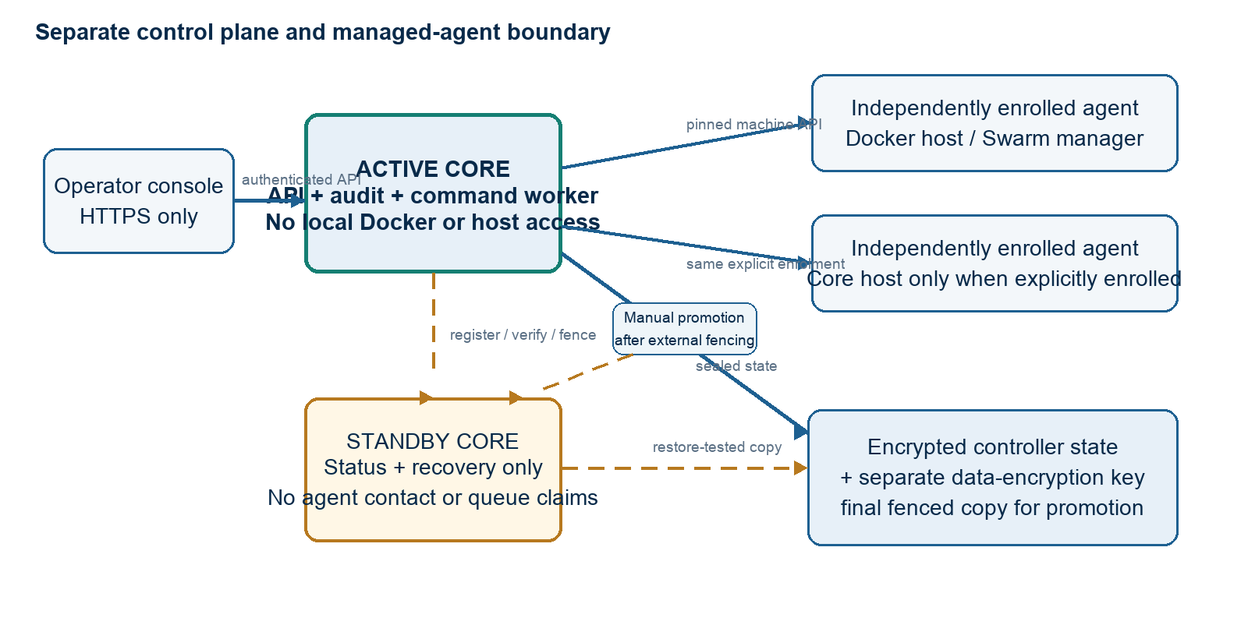
Figure 1. Separate control plane, independently enrolled agents, and a manual fenced recovery path.

Core components

Component | Responsibility | Primary storage | Failure behavior
Active core API | Serves console/API; enables remote actions only when locally active. | Encrypted state | Fails closed when not active.
Core-topology store | Stores member, restore, and handoff metadata. | core-topology.sealed | Write failure rolls back.
Remote manager | Resolves enrolled pinned machine APIs. | servers.sealed | No implicit profile.
Command queue | Writes bounded mutations; active core claims work. | commands.sealed | Running work stays visible.
Recovery workflow | Restores state/key and fences old primary. | Reviewed backup | Explicit promotion only.

5. Request Lifecycle
- An operator reads non-secret topology from Control plane.
- Core mutations require login, CSRF, and an active local role.
- A standby is registered with a stable ID and optional enrolled-agent link.
- The operator restores complete encrypted state and its separate key, then attests verification.
- Planned handoff records a target, then the primary writes a fenced state after the final copy.
- The target promotes from fenced state; emergency promotion confirms old-primary fencing.
- Each topology mutation is audited; a fence never cancels a running remote command.

6. API and Data Contracts

Primary data contract

Field | Type | Required | Description
localId | string | Yes | Stable ID of serving API.
activeId | string? | No | Managing core; empty if fenced.
members[] | CoreMember[] | Yes | Public members; separate from /servers.
agentServerId | string? | No | Optional enrolled-server link.
replicaState | enum | Yes | awaiting_restore or verified.
handoff | object? | No | Source, target, state, timestamps.
controlEnabled | boolean | Yes | True only for active local core.

Contract guarantees

- Seal a topology mutation before its HTTP success response or audit event.
- Remote actions require sealed active-core state; mode alone cannot activate a copy.
- Audit IDs, target, phrase, and mode; never audit credentials, state, or output.
- Topology is placement metadata, not host health, backup, or secret truth.
The typed /api/v1/core routes and console client implement this contract.
Evidence: internal/coretopology, api/http/core.go, and recovery runbooks.

7. Consistency, Idempotency, and Replay

Sealed local state determines authority. A standby never changes server profiles. Fencing clears authority before success; planned promotion needs fenced state, and emergency recovery is audited after external fencing. This mitigates split brain; it is not consensus.
Scenario | Expected behavior | Reasoning
Repeated standby | Reject ID; no profile. | Core differs from agent.
Topology write fails | Keep prior state. | No durable authority.
Fence during run | Block claims; retain run. | Do not replay unknown effect.
Mode changes | Persisted state wins. | Env cannot activate copy.

8. Security and Privacy Considerations

- Login and CSRF protect changes; every core action is audited.
- Topology returns public IDs/state only; no keys, files, or output.
- State is AES-256-GCM sealed; its key restores outside the UI.
- No socket, shell, files, or peer transfer; host operations need an agent.
- Use existing encrypted-state and audit retention policy.

9. Operational Readiness
Signal | SLO or alert | Owner | Launch gate
Core role | Visible before action | SwarmOps operator | Required
Agent boundary | No implicit profile | SwarmOps operator | Required
Queue gate | No claim on standby | SwarmOps operator | Required
Handoff state | Sealed + audited | SwarmOps operator | Required
Restore evidence | Tested state/key restore | Infrastructure operator | Required
Rollout: one active core; test restore/fence/promotion before production; no automatic-HA claim.

10. Alternatives Considered

Alternative | Why it was considered | Why it was not selected
Scale existing API | Smallest-looking replica path. | Local volume is not shared; both tasks could manage agents.
Health-based failover | Reduces human recovery time. | No consensus or fencing authority prevents split brain.
Shared NFS/S3-FUSE volume | Makes local state visible to both hosts. | Unsafe live ledger substrate; weakens recovery guarantees.
Unrecorded runbook | Avoids product work. | Hides authority, fencing, restore proof, and audit state.

11. Open Questions
- Which backup workflow proves complete state/key restore for a standby?
- Which external fencing mechanism is authoritative before emergency promotion?
- Should future HA add consensus and a real lease/fencing primitive?
- Which monitor should report core reachability without conflating agent health?

12. Decision and Next Steps
Adopt explicit core topology: one active core, independently enrolled agents, and manual restored-standby handoff. Validate locally, then run an operator-owned restore/fencing drill before deployment. No automatic-HA claim.
Milestone | Deliverable | Exit criteria
M1 | Identity, separation, active/standby gate | Focused checks show standby cannot manage or claim work.
M2 | Console, audit events, recovery docs | Register, verify, fence, and promote states are visible.
M3 | Controlled recovery rehearsal | Operator tests full state/key restore and external fencing.
M4 | Production readiness decision | Backup owner and fencing authority are accepted; no HA claim.

Use footnotes for definitions, assumptions, or terms that need precision without interrupting the main narrative.

