SwarmOps

Docker-Free Controller

STATUS  Implemented locally |  | OWNER  Nim platform maintainer |  | LAST UPDATED  August 24, 2026

Authors | Nim platform
Reviewers | Ops and security review pending
Related docs | ADR-0003; SwarmOps README; deploy README
Scope | Standalone direct-TLS SwarmOps controller.

1. Abstract
This design adds a single-host SwarmOps controller that serves the embedded Go/React control-plane UI and API directly over TLS on a random high port bound to a selected local server IP. The controller is independent from managed Docker/Swarm clusters: it has no Docker socket and reaches targets only through pinned SSH after sign-in. Local encrypted state holds non-secret profiles, audit, command data, and pending build inputs.
The bootstrap supports a freshly installed Debian/Ubuntu host when dependencies must be installed. It produces a self-signed IP-SAN certificate whose fingerprint must be verified out of band, requires explicit client CIDRs, uses a dedicated systemd identity, and starts builds and mutations disabled. It does not establish firewall rules, deploy a cluster, or provide high availability.

2. Goals and Non-Goals
Goals | Non-goals
Serve the API and embedded GUI directly from a standalone controller over TLS. | No Docker daemon, Docker socket, or Swarm membership on the controller.
Seal durable state and pending build input with AES-256-GCM, atomically. | No firewall or security-group changes; the operator retains the outer boundary.
Keep SSH credentials memory-only and require pinned host keys for targets. | No arbitrary shell, file, or socket-proxy API.
Fail closed on invalid keys, unsafe secret files, legacy conflicts, or disallowed clients. | No HA, shared state, or automated production deployment.

3. Background and Problem Statement
SwarmOps normally runs as a singleton on a designated Swarm manager. That topology is unsuitable when the control plane must live on a fresh, separate machine with no relationship to the clusters it manages. The requirement is a direct, server-local GUI/API endpoint without installing Docker, exposing a local socket, or persisting remote credentials.
The bootstrap builds the embedded web/API from the reviewed checkout, starts it under a dedicated systemd account, and binds it to a literal local IP and random high port. The controller admits only source addresses in an explicit CIDR allowlist; it reaches managed hosts only by authenticated, host-key-pinned SSH. The invariant is: encrypted controller state is local, while cluster authority and Docker sockets remain remote.

4. Proposed Architecture

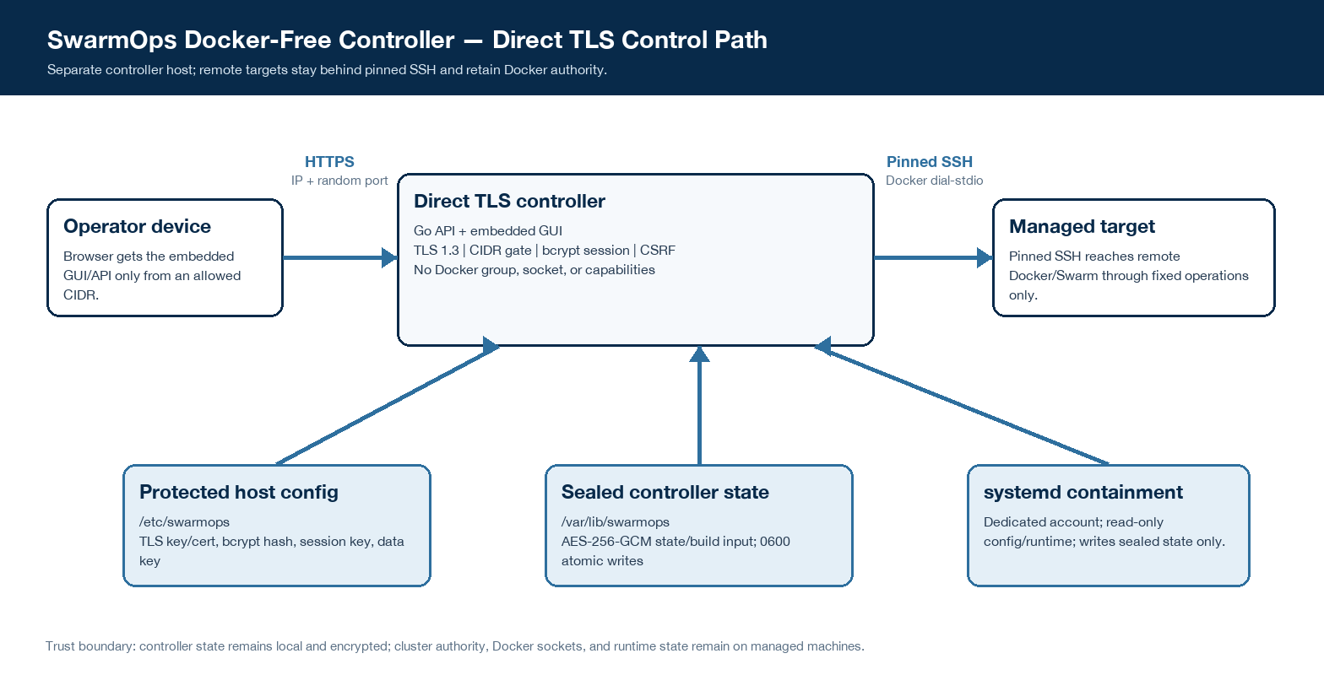
Figure 1. Docker-free direct-TLS SwarmOps controller.

Core components

Component | Responsibility | Primary storage | Failure behavior
Bootstrap script | Generates keys/cert, chooses port, and installs the restricted service. | /etc/swarmops | Refuses existing state; stops before overwrite.
systemd controller | Serves UI/API; enforces TLS, CIDR gate, auth, and CSRF. | Process memory; read-only runtime | Fails on invalid config, certificate, key, or state.
SSH target adapter | Pins host key; holds credentials only while connected; dials remote Docker. | Sealed profile metadata | Safe error; no local Docker action.
Secure store + queue | AES-GCM seals state/input; atomic writes and migration. | /var/lib/swarmops | Wrong key, tamper, or legacy conflict fails closed.
Managed Docker/Swarm | External target executes only selected fixed-shape operations. | Remote cluster | Separate authority; no controller socket mount or shell.

5. Request Lifecycle
- An operator opens https://<controller-ip>:<random-port>; the embedded GUI and API share the same origin. The socket peer must fall in configured allowed CIDRs.
- TLS 1.3 terminates at the Go server. Login verifies a bcrypt hash, creates a Secure/HttpOnly session cookie, applies source-socket rate limiting, and mutations require CSRF validation.
- At startup, protected config provides the session key, AES-256-GCM key, IP-SAN certificate, state directory, and feature switches. Requests read sealed controller state only after successful decryption.
- Adding or reconnecting a target validates host, port, username, SSH fingerprint, and authentication mode. The connector verifies the pinned host key, then exposes only the Docker stdio tunnel and constrained operations.
- Before success returns, controller state changes are purpose-bound AES-GCM encrypted, atomically replaced through 0600 temporary files, and synced; build input is sealed in authenticated chunks and verified before remote use.
- SSH probing uses a bounded 12-second context. A reachable SSH host without Docker remains a bootstrap candidate; Docker/Swarm operations require a separately connected ready target.
- The API returns a scoped success or safe error. Audit-storage preflight blocks a protected operation; request IDs and JSON logs aid diagnosis without emitting SSH secrets.

6. API and Data Contracts

Controller profile contract

Field | Type | Required | Description
id | string | Yes | Generated profile ID; stored only in sealed state.
endpoint | host + port | Yes | Validated SSH host and TCP port for a remote target.
username | string | Yes | Validated remote login name; non-secret metadata.
authentication | enum | Yes | password or private_key; the credential itself is never serialized.
hostKeyFingerprint | SHA256 string | Yes | Mandatory pin; mismatches reject the connection.
runtimeStatus | derived object | No | Last Docker/Swarm facts; reset disconnected on restart.
credentials | memory only | No | Password, key, and passphrase exist only for a connect operation.

Contract guarantees

- A state mutation succeeds only after its sealed write completes; AES-GCM authenticates ciphertext and binds the file purpose as associated data.
- State writers serialize local mutations under a mutex. Audit IDs use random 128-bit values and timestamps are assigned when absent.
- Sealed files use versioned headers; profile and audit payloads have version 1. Audit content excludes SSH credentials.
- Controller state is local metadata, audit, and queued work, not the source of truth for remote Docker or Swarm state.
The versioned schema and HTTP handler definitions are maintained in
apps/swarmops/api/http and ADR-0003; update both when persistence or direct-controller contracts change.

7. Consistency, Idempotency, and Replay

The controller offers single-process serialization and durable local commits, not distributed transactions or cross-controller consistency. Repeating a browser mutation is not automatically idempotent; clients must observe the returned state or command result before retrying. Remote Docker effects can be partial and remain subject to the selected target state.
Scenario | Expected behavior | Reasoning
Repeated server add | No automatic deduplication; retry only after listing profiles. | Each add generates a new ID; it avoids guessing caller intent.
Sealed state write fails | Return an error; in-memory profile/audit mutation is rolled back. | No success is reported when durable evidence is unavailable.
SSH/Docker probe fails | Bounded probe returns a safe error or SSH-only bootstrap candidate. | No local Docker action, shell command, or secret persistence occurs.
Configuration changes | Configuration loads at startup; restart is required to apply it. | In-flight work uses the process snapshot, not mid-request config.

8. Security and Privacy Considerations

- The direct endpoint requires TLS 1.3, an IP-SAN certificate, Secure cookies, explicit allowed CIDRs, bcrypt administrator verification, rate limiting, and CSRF for mutations. The API trusts the socket peer, not forwarded client-IP headers.
- Only non-secret metadata, audit data, command data, and build input are durable. SSH passwords, private keys, and passphrases are excluded from audit details and never written to controller state.
- The data key is a base64-encoded random 32-byte key in a protected owner-only file or Swarm secret. It is separate from /var/lib/swarmops; keys, session material, admin hash, and TLS private key need separate protected backup.
- Mutations and remote image builds default to disabled. The service account has no Docker-group membership, no Linux capabilities, no Docker socket, read-only system/config paths, and writes only sealed state. Legacy plaintext coexistence fails closed.
- AES-GCM protects data at rest against storage disclosure without the key; it does not protect a host-root compromise. No retention or HA policy is introduced—operators must define backup, key custody, retention, and recovery before production use.

9. Operational Readiness
Signal | SLO or alert | Owner | Launch gate
Controller availability | systemctl active + /healthz reachable | Controller operator | Required
TLS/CIDR boundary | Trusted device succeeds; out-of-CIDR request is denied | Controller operator | Required
State confidentiality | Sealed files reopen; no plaintext marker | Controller operator | Required
Containment drift | No Docker group/socket; builds and mutations remain false | Controller operator | Required
Recovery evidence | Separate key backup and restore drill before production | Controller operator | Required
Rollout constraint: no automatic firewall or production deployment. Install only after confirming the IP/CIDR, validating the self-signed fingerprint out of band, verifying service health, and protecting a separate data-key backup.

10. Alternatives Considered

Alternative | Why it was considered | Why it was not selected
Manager-bound Swarm stack | Existing default topology behind Traefik. | Controller must be independent of clusters and Docker.
Local Docker/socket | Direct Engine access is simple. | It defeats least privilege and host separation.
Loopback API + proxy | Useful in reviewed reverse-proxy deployments. | It does not provide the requested direct IP/random-port bootstrap.
HA controller / external KMS | Could improve resilience and key custody. | Needs separate availability, backup, and operations design.

11. Open Questions
- Will direct IP/TLS remain self-signed, or will a trusted CA/DNS path be approved?
- Which firewall or security-group rule will enforce the same operator CIDR outside the process?
- Who owns data-key backup, restore drills, retention, and controller replacement?
- Is future HA or external key management required, and what RPO/RTO must it meet?

12. Decision and Next Steps
Choose the Docker-free controller only for an independent host; it is an alternative to the manager-bound stack, not a concurrent controller. Local validation is complete. Promote only after isolated-host, authenticated-browser, target-connection, firewall, and backup evidence.
Milestone | Deliverable | Exit criteria
M1 | Local implementation | Tests, web build, stack render, and shell checks pass.
M2 | Isolated bootstrap | URL/fingerprint, health, restart, and sealed-state persistence proven.
M3 | One controlled target | Pinned SSH and allowed-device browser flow pass.
M4 | Production authorization | Firewall, backup, live evidence, approval, and rollback plan complete.

In this document, controller means the standalone host running SwarmOps; it is not a Docker Swarm manager.

