SwarmOps

Platform Expansion

STATUS  Proposed |  | OWNER  Nim Platform |  | LAST UPDATED  August 23, 2026

Authors | Nima Sarayan
Reviewers | Platform operations reviewers
Related docs | apps/swarmops/README.md; deploy/README.md; docs/deploy.md
Scope | Admission, resilient fleet operations, provider-aware TLS, S3-compatible volume backup, and platform readiness.

1. Abstract
SwarmOps extends the manager-scoped Docker Swarm control plane with a reviewed platform admission gate, durable all-node operations, and host-volume backup installation. The design keeps secrets and arbitrary command execution outside the browser while producing a repeatable pre-deployment decision.
Inputs are public topology, versioned secret names, measured capacity, registry policy, DNS resolver choice, and S3 provider references. The design does not provision databases from placeholders, mutate providers during preflight, or prove production without restore and service verification.

2. Goals and Non-Goals
Goals | Non-goals
Reject unsafe build/deploy requests before side effects by validating names, domains, ingress, topology, and reservations. | No arbitrary browser shell, file-read, Docker socket proxy, or command API.
Keep an accepted all-node operation running through SSH loss and expose status without host output. | No automatic S3 initialization, DNS change, image push, or deployment in preflight.
Use versioned secret references for DNS, S3-compatible backup, and private registry use. | No claim that raw volume snapshots are database-consistent backups.
Make capacity and recovery gates explicit before stateful profiles or global observability. | No HA claim for the current 8 GB reference topology or single-replica control plane.

3. Background and Problem Statement
The repository already deploys image-only Swarm stacks through a reviewed Makefile and exposes SwarmOps as an audited manager API plus a read-only global agent. Operators still needed one all-inventory process that survives control-channel loss, checks a cluster's fit before a change, and handles shared DNS and backup policy without exposing credentials.
Plans and secret references stay on the trusted workstation; Ansible installs host-local runners and backup timers; SwarmOps reads Docker and agent status through bounded APIs. Invariant: a browser cannot submit a command, provider credential, filesystem path, or mutable deployment topology.

4. Proposed Architecture

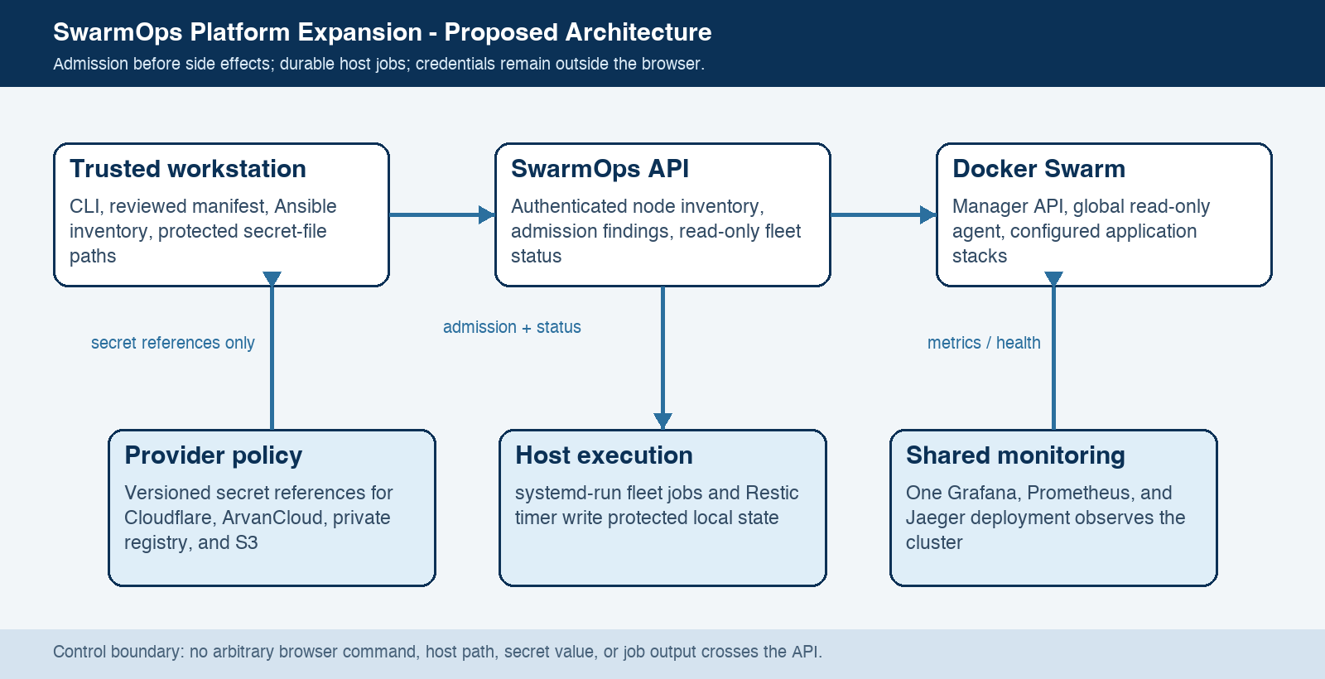
Figure 1. SwarmOps platform expansion architecture.

Core components

Component | Responsibility | Primary storage | Failure behavior
SwarmOps API / CLI | Admission and authenticated, read-only fleet status. | Docker API and local audit volume. | No mutation; report unavailable control plane.
Platform manifest | Non-secret uniqueness, topology, and capacity validation. | Reviewed YAML and versioned secret names. | Validation errors block the next change.
Ansible plus systemd | Queue allow-listed job and retry host submission. | Root-owned fleet status directory. | Accepted job continues; missed host resumes by run ID.
Traefik / DNS | Resolver choice for Cloudflare, ArvanCloud, or HTTP-01. | ACME volume and external Swarm secrets. | Certificate issuance fails closed; no secret enters a plan.
Restic / S3 | Back up named-volume paths and retention on each host. | S3-compatible repository. | Timer failure is visible; restore remains required.

5. Request Lifecycle
- Operator creates a non-secret platform manifest and invokes the local preflight before a build or deployment request.
- The CLI strictly parses the manifest; live mode authenticates to GET /api/v1/nodes and checks state, labels, agent health, memory, and disk.
- Registry mode, DNS resolver, S3 provider reference, ingress IP, reservations, and profile placement are evaluated without provider calls.
- A valid plan permits the existing reviewed build/deploy workflow; an invalid plan exits non-zero with sorted findings.
- For fleet work, the CLI validates the allow list and run ID, then asks Ansible to submit systemd-run on each selected host.
- Each host writes a fixed status record; HTTP retries the internal agent path and falls back to SSH inventory only when supplied.
- Backups are installed only by an opt-in Ansible role; separate initialization and a tested restore are required before protection is claimed.

6. API and Data Contracts

Primary data contract

Field | Type | Required | Description
apiVersion | string | Yes | swarmops.nim.zone/v1alpha1; strict YAML version.
namespace | DNS name | Yes | DNS-safe prefix; plan-local workload names are checked.
nodes | array | Yes | Measured physical/free capacity and expected labels.
workloads | array | Yes | Profile, replicas, reservation, domain/resolver, optional S3 provider.
dns.resolvers | array | Yes | Named DNS or HTTP challenge and provider selection.
storage | array | Conditional | HTTPS endpoint, bucket, versioned credential secret name.
fleet run | status | Conditional | ID, host, operation, state, timestamps, exit result; no output.

Contract guarantees

- Unknown YAML fields and unsafe names are rejected before policy evaluation.
- A fleet run ID is bounded and idempotent per host after its status exists.
- Audit excludes credentials, Compose input, build contexts, registry config, and job output.
- The manifest is an admission input, not a database or live credential source.
The versioned interface is implemented by
deploy/swarmops/platform.example.yml and GET /api/v1/fleet/runs/{id}.

7. Consistency, Idempotency, and Replay

Platform admission is deterministic over the reviewed manifest. Fleet submission is at-least-once across inventory but per-host idempotent after a status file exists. A network drop may leave a host pending; the same run ID can be replayed safely. Status is eventually observable through agent or SSH fallback and is complete only when every node reports a terminal state.
Scenario | Expected behavior | Reasoning
Same fleet run ID | Existing status prevents another systemd-run. | Keeps the per-host action idempotent.
Admission dependency fails | No mutating step is accepted; return failure. | Prevents an untracked side effect.
Agent or network unavailable | HTTP retries; CLI reads fixed SSH status if inventory is supplied. | Fallback is read-only and bounded.
Cache image list changes | Accepted run keeps its operation and ID; next run reads current list. | No arbitrary input crosses the boundary.

8. Security and Privacy Considerations

- One SwarmOps operator signs in through HTTPS. Mutations stay disabled by default; fleet status is authenticated read-only.
- Browser and audit paths receive status, not provider keys, registry JSON, Compose, build contexts, or host output.
- DNS, dashboard, registry, and S3 values are versioned external secrets or root-only host files; manifests name references only.
- Allow lists constrain fleet operations. The agent reads a validated status path only; SSH fallback reads the same file.
- Retain audit JSONL and backup data by approved policy. Rotate exposed ACME material and never copy it into this design.

9. Operational Readiness
Signal | SLO or alert | Owner | Launch gate
Admission pass/fail | 100% pass before build/deploy; any error blocks. | Platform ops | Required
Node-agent freshness | Every declared node healthy and current at live check. | Platform ops | Required
Fleet fallback rehearsal | HTTP retry then SSH status path exercises successfully. | Platform ops | Required
DNS/TLS readiness | Resolver secret, domain, and ingress verified in canary. | Platform ops | Required
Backup recovery | Restore named volume and DB-aware backup rehearsal. | Platform ops | Required
Rollout constraint: no live cutover until capacity labels, external secrets, DNS/ACME, S3 restore, and service-specific smoke tests pass.

10. Alternatives Considered

Alternative | Why it was considered | Why it was not selected
Arbitrary remote shell | Fast all-node commands. | Violates the control/API boundary.
SSH-only status | Minimal dependencies. | Loses normal overlay-agent visibility; kept only as fallback.
Raw S3 copy only | Simple volume export. | No scheduling, retention, or database-consistency proof.
Deploy every stateful profile now | Immediate feature coverage. | 8 GB topology and absent recovery proof make it unsafe.

11. Open Questions
- Which capable nodes and exact labels will support each stateful profile?
- Which Mongo/Postgres backup and restore contract will be approved?
- Which domains use Cloudflare, ArvanCloud, or HTTP-01, and who owns DNS changes?
- Which private registry endpoint/auth secret is selected if GHCR is not used?

12. Decision and Next Steps
Approve the foundation as a guarded operating model, then pilot it on capacity-qualified non-production nodes. First build the secret/label inventory, run offline and live preflight, install the backup timer and restore a test volume, exercise fleet loss/fallback, and deploy only the existing Traefik/SwarmOps stacks. Promote stateful profiles only after checked-in service definitions, service-specific recovery tests, DNS, and monitoring evidence are approved.
Milestone | Deliverable | Exit criteria
M1 | Manifest, live admission, fleet runner/status, backup role, resolver config. | Local checks pass; no live change executed.
M2 | Qualified inventory, secret references, restore and fallback rehearsal. | All selected hosts/agents report; test restore and DNS canary pass.
M3 | Non-production platform pilot. | Traefik/SwarmOps converge; no critical error during observation.
M4 | Service-by-service stateful or product rollout. | Capacity, recovery, rollback, and owner approvals are evidenced.

Admission findings distinguish local validation from external checks; live deployment evidence is required separately.

