SwarmOps

Server Readiness and Queue Safety

STATUS  Proposed |  | OWNER  SwarmOps platform |  | LAST UPDATED  Aug 26, 2026

Authors | SwarmOps platform
Reviewers | Platform operator review
Related docs | apps/swarmops/README.md; docs/architecture.md; docs/deploy.md
Scope | A safe console-led readiness path for one pinned Debian/Ubuntu host and durable supersession of duplicate, unstarted intent.

1. Abstract
This design adds a console-led readiness path for a freshly enrolled host before Docker or Swarm is available. The controller submits a typed plan, stores it durably, and reaches a separate local helper through a pinned agent; the helper can only update OS packages, install or update Docker, initialize an inactive single-node Swarm, and apply a CIDR-scoped UFW baseline.
The path supports one selected native agent at a time and assumes pinned TLS, an authenticated operator, and Debian or Ubuntu. It does not provide a browser shell, arbitrary package manager input, Docker socket proxy, multi-manager join, or a claim that UFW alone governs Docker-published workload ports.

2. Goals and Non-Goals
Goals | Non-goals
Let a connected native agent become ready before Docker is installed. | Do not accept an arbitrary executable, package, script, or SSH command.
Write the exact plan before any remote side effect begins. | Do not cancel or hide running or needs-attention work.
Keep host-write powers behind a local Unix-socket helper. | Do not expose raw command output, host files, or a socket proxy.
Limit UFW rules to reviewed controller and Swarm-peer CIDRs. | Do not represent Docker-published workload ports as UFW-protected.

3. Background and Problem Statement
Existing cluster operations correctly require a connected remote Swarm manager, but a new host needs a narrow path before it reaches that state. Queueing repeated desired state without replacement also leaves older unstarted work in front of the most recent operator intent. A generic remote command interface would solve neither problem safely.
The React console reads readiness from a selected pinned agent and submits a closed request to the control API. The API validates the plan, creates an encrypted command record, and a single worker sends it back to that exact agent. The sandboxed agent revalidates it and forwards it to the root-only local helper. The invariant is durable, validated intent before execution; newest unstarted work for the same server, action, and target becomes authoritative.

4. Proposed Architecture

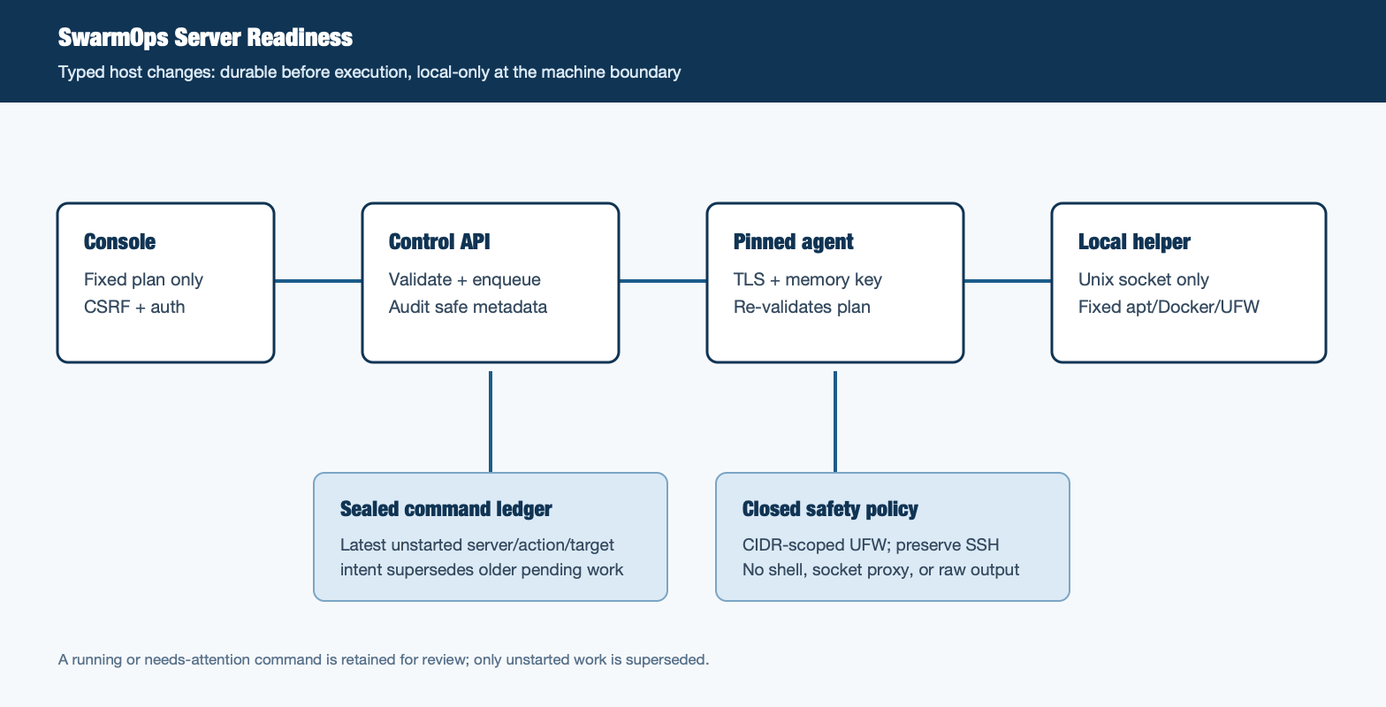
Figure 1. SwarmOps server readiness architecture.

Core components

Component | Responsibility | Primary storage | Failure behavior
Console + API | Shows observed readiness and validates the fixed plan. | Pinned agent profile; auth and CSRF | Fail closed; no command is accepted.
Durable command queue | Persists plan, idempotency key, and safe audit metadata. | AES-GCM sealed controller volume | Save failure returns an error before execution.
Pinned machine agent | Reads status and relays only typed local helper requests. | Pinned HTTPS; memory-only API key | Provisioning is one-attempt; uncertain work needs attention.
Local provisioning helper | Runs fixed apt, Docker, Swarm, and UFW operations. | Root-only Unix socket on the host | Generic failure only; no raw output reaches the browser.
Console and command ledger | Shows safe state, attempt count, and generic failure guidance. | Existing audit and observability stack | Operator reviews blockers or needs-attention state.

5. Request Lifecycle
- An authenticated operator selects a connected native agent and chooses one or more fixed readiness operations.
- The API enforces CSRF, idempotency, the path server identity, exact confirmation, valid local address, and bounded CIDR lists.
- The worker resolves the saved server profile, pinned transport, and typed command payload; the agent checks host readiness.
- The queue removes matching unstarted queued or retry-scheduled work, then appends the new command and returns its public ID.
- The sealed command record and supersession result must be saved before the worker can claim the command.
- The worker gives readiness work a bounded 50-minute controller window and no automatic replay; failures become needs attention.
- The ledger records succeeded or needs-attention state and audit-safe metadata. Host command output and sensitive plan data are withheld.

6. API and Data Contracts

Primary data contract

Field | Type | Required | Description
serverId | string | Yes | Path-derived saved server identity; never inherited from UI manager state.
action | enum | Yes | Fixed value: server.readiness; not browser-defined.
target | string | Yes | Fixed target: server/<id>/readiness; scopes supersession.
plan | object | Yes | Booleans only: OS, Docker, Swarm, and UFW operations.
confirmation | literal | Yes | Exact PREPARE_SERVER literal; required at both control boundaries.
controllerCidrs | string[] | If UFW | One to eight parsed controller networks; only for UFW.
swarmPeerCidrs | string[] | If UFW | One to eight parsed peer networks; only for Swarm ports.

Contract guarantees

- The complete typed plan is sealed before the worker can claim it.
- Idempotency keys prevent same-key drift; one worker executes at a time.
- Safe command metadata, server ID, action, target, actor, and request ID are retained; secrets and raw output are not.
- The command ledger is the source of intent and execution state, not a host inventory or shell transcript.
The versioned schema or interface definition is published at
Go agentcontrol.ProvisioningRequest and the web ServerReadiness contract evolve together with this API.

7. Consistency, Idempotency, and Replay

A repeated idempotency key returns its original command only when the semantic request matches. A newly accepted plan supersedes older unstarted work for the same server, action, and target. It never cancels running or ordinary needs-attention work because the host side effect may already exist.
Scenario | Expected behavior | Reasoning
Same idempotency key | Return original command when actor and payload match. | Different semantics with the same key return conflict.
Sealed write fails | Reject the request before it can execute. | No durable acknowledgement without state.
Host helper times out or fails | Mark needs attention; do not auto-replay. | Operator sees retained command and reviews target.
New matching plan arrives | Newest unstarted intent replaces older pending intent. | Running work is never removed or altered.

8. Security and Privacy Considerations

- Only an authenticated console request with CSRF and a saved server profile can submit a plan.
- Browser and audit paths expose only readiness facts and safe command metadata; no host output, files, or secrets.
- The controller uses pinned TLS and a memory-only machine API key; the helper has no TCP listener.
- No operation runs on connection. UFW requires controller and peer CIDRs; OpenSSH is allowed before enable.
- The bounded encrypted ledger retains active work; terminal history is pruned only after a successful sealed write.

9. Operational Readiness
Signal | SLO or alert | Owner | Launch gate
Readiness command result | Define rollout threshold before any live use | Platform operator | Required
Execution duration | Observe first; set maintenance-window alert | Platform operator | Required
Needs-attention count | No automatic replay; operator review | Platform operator | Required
Agent/helper availability | Block readiness changes until restored | Platform operator | Required
Queue supersession test | Local test suite before release | Platform operator | Required
Roll out first to a non-critical Debian/Ubuntu machine during a maintenance window. Verify state, command ledger, Docker and Swarm status, firewall reachability, and recovery path before broader use.

10. Alternatives Considered

Alternative | Why it was considered | Why it was not selected
Browser SSH or shell | Would make any bootstrap action available. | Breaks the fixed-shape, auditable control boundary.
Give the normal agent root host access | Avoids a second local service. | Expands the exposure of the reachable network agent.
Keep every pending command | Preserves an exhaustive intent history. | Executes stale desired state after the operator changed it.
Treat UFW as workload firewall | Appears to offer one simple firewall control. | Docker-published ports can bypass UFW; ingress policy remains separate.

11. Open Questions
- Which explicit maintenance-window and rollback evidence must precede first live Server readiness use?
- Should Docker repository version pinning be exposed as a future reviewed policy rather than a free-form field?
- Which controller and Swarm-peer CIDR catalog should be approved for each region and host class?
- Who may approve the first UFW baseline when access-recovery evidence is incomplete?

12. Decision and Next Steps
Adopt the closed readiness plan and latest-intent queue rule. First validate locally, then run a maintenance-window trial on a non-critical Debian/Ubuntu host with out-of-band access. Broader use requires verified agent/helper reachability, Docker and Swarm state, CIDR-scoped firewall reachability, a command-ledger review, and a documented recovery outcome.
Milestone | Deliverable | Exit criteria
M1 | Closed API, agent helper, queue supersession, and console flow | Unit and integration tests pass; rendered console shows blockers and boundaries
M2 | Maintenance-window host trial with out-of-band access | Verify package, Docker, Swarm, UFW, ledger, and recovery evidence
M3 | One non-critical supported host | Operator review of every command; no unresolved critical failure
M4 | Approved server classes and CIDR catalog | Explicit platform approval and documented access-recovery path

Use footnotes for definitions, assumptions, or terms that need precision without interrupting the main narrative.

