SwarmOps

Source-to-Deploy

STATUS  Proposed |  | OWNER  SwarmOps |  | LAST UPDATED  August 25, 2026

Authors | Nima Sarayan; SwarmOps maintainers
Reviewers | Nima Sarayan (final approval)
Related docs | ADR-0004, ADR-0005, and ADR-0006
Scope | Private Git to policy-approved Swarm deployment.

1. Abstract
SwarmOps adds an import plane that converts a least-privilege Git connection and pinned commit into a deterministic deployment plan. It discovers Compose files and Dockerfiles across monorepos, maps supported databases to managed services and observability components to shared stacks, then emits only closed ApplicationSpec inputs.
The flow supports private repositories, image-backed or Dockerfile-backed services, and policy-approved domain assignment or removal while preserving selected-manager, admission, queue, build, and audit controls. Source manifests are evidence: secrets are not imported, ambiguity blocks deployment, and database data is never changed automatically.

2. Goals and Non-Goals
Goals | Non-goals
One authenticated flow connects a provider, lists accessible repositories, and analyzes a chosen immutable revision. | Automatically support an unknown forge API without a reviewed adapter or direct repository contract.
Find every bounded Compose/Dockerfile candidate in a monorepo and explain each inclusion, replacement, warning, or blocker. | Migrate existing database contents, rotate application secrets, or perform destructive storage cutovers.
Reuse managed databases and one global observability/edge plane while generating only policy-admitted application specs. | Execute source Compose, arbitrary CI scripts, shell commands, hooks, or repository-supplied control-plane code.
Require a readable plan and explicit deploy action; write queued side effects durably and make domain removal reversible. | Claim live DNS, certificate, registry, build, database, or Swarm success from local analysis and tests.

3. Background and Problem Statement
Today SwarmOps deploys one approved application from an immutable image. In a monorepo, the operator must locate the right Compose or Dockerfile, build externally, translate data dependencies, exclude duplicated platform services, and choose a predeclared domain. This is slow and leaves uncertainty until deploy time.
The new boundary is a normalized plan backed by bounded evidence at one pinned commit. Provider adapters read repositories; the scanner and planner map evidence to reviewed capabilities; existing build, ApplicationSpec, admission, and queue code owns every side effect. Untrusted source may describe a candidate, but only SwarmOps-generated fixed-shape operations can change a cluster.

4. Proposed Architecture

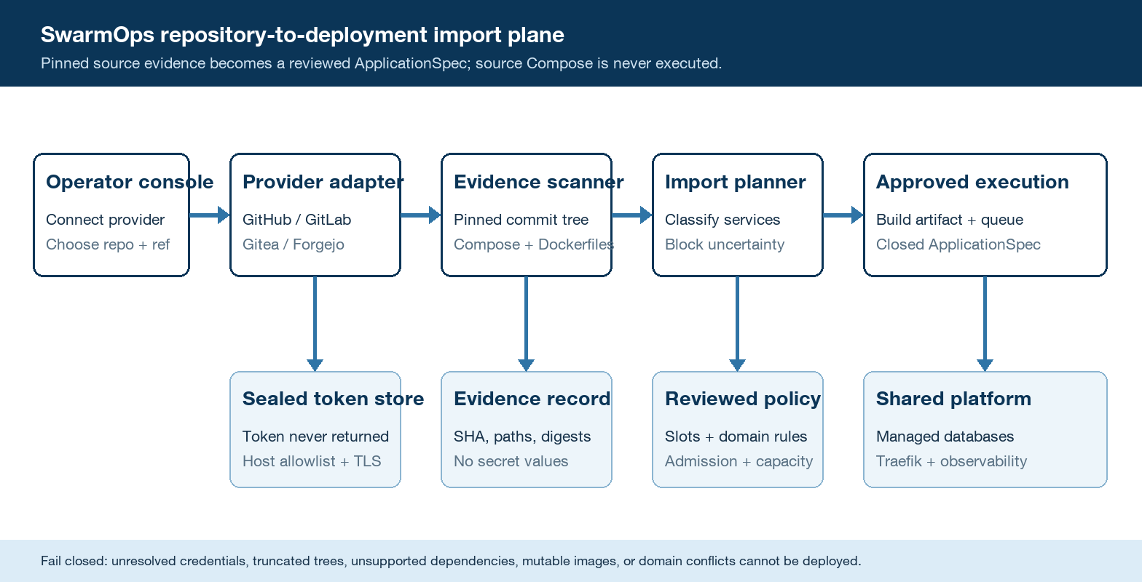
Figure 1. SwarmOps repository-to-deployment trust and data flow.

Core components

Component | Responsibility | Primary storage | Failure behavior
Provider connections | Validate provider kind/base host, verify a read token, and expose masked connection metadata. | AES-256-GCM sealed controller file | Fail closed; no repository request runs and no token appears in logs, audit, or responses.
Provider adapters | List repositories and read commit trees/blobs through bounded GitHub, GitLab, or Gitea/Forgejo APIs. | Fixed public endpoints plus configured private-host allowlist | Timeout, truncation, cross-host redirect, or unsupported API becomes an explicit analysis error.
Evidence scanner and planner | Discover manifests, classify services, produce candidates, substitutions, warnings, blockers, and digests. | Pinned commit tree and bounded blob reads | Read retries are bounded; ambiguity is needs-review and never guessed into deployable state.
Build and deploy execution | Export a regular-file build context, queue fixed builds, then deploy a validated ApplicationSpec. | Encrypted command ledger and artifact spool | No side effect before durable command write; uncertain execution becomes needs_attention.
Platform integrations | Attach managed data, shared metrics/tracing networks, Traefik routes, and domain ownership rules. | Shared Prometheus, Grafana, Jaeger, Alertmanager, Loki | Missing shared prerequisites block or warn in the plan; deployment never creates duplicate stacks.

5. Request Lifecycle
- The authenticated operator creates a provider connection with kind, display name, approved base URL, and read-only access token.
- CSRF and session checks run first; the API normalizes the endpoint, enforces HTTPS/host policy and limits, verifies the token, then seals it and returns only masked metadata.
- The operator selects a repository and ref; the adapter resolves it to a commit SHA and loads the bounded tree, provider capabilities, approved application slots, domain rules, managed databases, and shared-stack policy.
- The scanner reads only candidate manifests and required metadata, classifies application/data/platform services, and produces a deterministic plan with file digests, build contexts, suggested specs, substitutions, warnings, and blockers.
- Analysis is read-only. After review, every build or deploy request records the provider/repository/revision digest and writes its command plus any encrypted artifact before Docker receives work.
- A build exports regular files from the pinned context under file/count/byte limits and uses the existing capped Docker build. Database, application, and domain changes use fixed queue actions, selected-manager routing, admission, bounded retries, and needs_attention for uncertain effects.
- The console follows command state, then reads deployed applications and routes. Audit stores safe IDs, commit SHA, classification counts, and outcomes; it never stores tokens, source bodies, Compose bodies, build output, or secret-like environment values.

6. API and Data Contracts

Primary data contract

Field | Type | Required | Description
schema_version | integer | Yes | Version of the normalized import-plan contract; rejected when unsupported.
connection_id | string | Yes | Opaque ID of one sealed provider connection; token is never embedded.
repository | object | Yes | Provider-stable repository ID plus display name; no credential-bearing URL.
revision_sha | string | Yes | Required immutable commit that binds tree, blobs, build context, and audit evidence.
evidence | object | Yes | Paths, modes, sizes, and digests only; no source bodies or environment values in durable records.
candidates | array | Yes | Compose/Dockerfile candidates with app, managed-data, shared-platform, and unsupported service classifications.
decision | object | Yes | Approved slot, image/build choice, databases, observability, domain, warnings accepted, and blockers resolved.

Contract guarantees

- A deployable plan is derived from one pinned commit and passes source limits, ApplicationSpec validation, Compose validation, platform admission, and live capacity admission in that order.
- Each side effect uses the existing Idempotency-Key plus selected server ID; the durable queue serializes attempts and records every state transition.
- Provider kind, connection ID, repository stable ID, revision SHA, manifest path, evidence digest, plan version, target server ID, and generated application identity are captured without secret values.
- The import plan is a review artifact. The provider commit is source truth for code, the platform manifest for policy, sealed stores for controller state, and the selected Swarm manager for runtime state.
The versioned schema or interface definition is published at
ADR-0006 and the versioned /api/v1/sources contract and update it with each contract release.

7. Consistency, Idempotency, and Replay

Repeated analysis of the same provider, repository, commit, and scanner version must produce the same normalized evidence and plan. Repository reads may be retried because they are side-effect free. Builds and deployments retain the queue's write-before-execute invariant; a changed branch head never changes an already-approved commit, and uncertain remote effects are surfaced rather than replayed blindly.
Scenario | Expected behavior | Reasoning
Same analysis or Idempotency-Key | Return the same digest or existing command; do not create a second effect. | Commit-bound analysis is deterministic and the queue rejects key/payload conflicts.
Sealed store or command write fails | Fail the request before provider retention, build, database, route, or stack mutation. | No acknowledged state exists without a durable record; readiness and safe audit expose storage failure.
Provider, registry, or Docker timeout | Retry reads within a short budget; build is single-attempt; reconcilable deploys use bounded queue retry; uncertainty needs attention. | The command retains target, revision digest, attempts, and terminal state without raw remote output.
Branch, token, or platform policy changes | The pinned commit and admitted plan snapshot remain authoritative for that command. | Execution revalidates current safety policy and refuses drift; it never silently substitutes a newer branch head.

8. Security and Privacy Considerations

- All source APIs require the existing authenticated session and CSRF protection. Provider connections are controller-wide administrative state; cluster mutations additionally require an explicit selected manager.
- Return repository metadata and normalized findings only. Never log, audit, persist in plaintext, or return tokens, source bodies, Compose content, build logs, or secret-like environment values.
- Seal access tokens with the controller data key, inject them only in provider-specific authorization headers, clear request copies, and delete sealed material when a connection is removed. Recommend read-only scopes.
- Require HTTPS and an exact host allowlist for private forges; pin redirects to the same host; cap pages, files, blobs, time, and bytes; reject symlinks/special files; expose no shell, hook, or arbitrary HTTP proxy.
- Keep only masked connection metadata and sealed tokens until explicit deletion. Evidence records use digests and short metadata with a bounded retention policy; private repository names are excluded from broad operational metrics.

9. Operational Readiness
Signal | SLO or alert | Owner | Launch gate
Supported repository analysis success | Proposed >=99% excluding provider denial, invalid token, truncation, or explicit unsupported evidence; page after sustained breach. | SwarmOps | Required
Analysis and plan latency | Proposed p95 <=30 s for <=10,000 entries and <=20 manifests; warn on limit pressure. | SwarmOps | Required
Provider throttling and needs-review rate | Track by provider and finding code; no retry storm; page only for systemic adapter failure. | SwarmOps | Recommended
Plan-to-execution digest mismatch | Any revision, scanner-version, admission, or generated-spec mismatch blocks execution. | SwarmOps | Required
Sealed-store and deterministic fixture check | Startup store validation plus CI fixtures for each adapter/classifier; 100% digest repeatability. | SwarmOps | Required
Rollout constraint: ship analysis-only first; enable source builds and domain mutation separately; canary against synthetic/private test repositories and a non-production Swarm; require rollback, DNS/TLS, restore, and token-revocation evidence before production promotion.

10. Alternatives Considered

Alternative | Why it was considered | Why it was not selected
Clone repositories with git on the controller | Universal Git semantics and efficient local tree access. | Adds credential-helper, subprocess, filesystem, protocol, and cleanup risk to the control plane.
Deploy the discovered Compose directly | Maximum compatibility with existing projects and minimal translation work. | Lets untrusted labels, mounts, networks, commands, and state bypass SwarmOps' closed policy model.
Provider-specific logic inside HTTP handlers | Fewer packages and fast delivery for one forge. | Duplicates pagination/auth behavior, prevents private-forge extension, and makes tests and security review harder.
Require hosted CI/webhooks for every deploy | Mature source checkout/build tooling and natural push automation. | Creates external setup and callback dependencies before SwarmOps can provide a simple self-hosted first deploy.

11. Open Questions
- Production provider set: start with GitHub, GitLab, and Gitea/Forgejo adapters; add other forges only with protocol fixtures and an explicit owner.
- Domain delegation: use exact domains for existing slots and optional reviewed suffix policies with runtime uniqueness; production suffix ownership needs approval.
- Large monorepos: initial hard limits must be measured against the largest real repository before raising entry/blob/byte budgets.
- Token lifecycle: choose the production rotation cadence and whether connection creation later needs a second administrative role beyond the current SwarmOps administrator.

12. Decision and Next Steps
Adopt an adapter-based, evidence-gated import plane that converts a pinned repository revision into closed SwarmOps operations. Deliver source connection and analysis before mutation, reuse the existing capped build and durable queue, and add managed-service substitution plus policy-bounded domain updates only after deterministic fixtures pass. The first live audience is one non-production Swarm and one private monorepo; broader rollout requires verified token revocation, registry build/push, database reachability, shared metrics/tracing, domain removal, DNS/TLS issuance, rollback, and recovery evidence.
Milestone | Deliverable | Exit criteria
M1 | Sealed connections, GitHub/GitLab/Gitea adapters, repository listing, pinned-tree scan, and read-only import plan. | Adapter fixtures, secret-non-disclosure tests, complete monorepo discovery, deterministic digest, and blocker classification pass.
M2 | Bounded source-context export, image-build handoff, managed database/shared observability mapping, dynamic-domain admission, and API contract tests. | Same commit reconstructs the same plan; generated specs pass Compose and platform admission; no source-controlled platform service deploys.
M3 | Console wizard plus one non-production repository-to-build-to-deploy canary. | Live registry, Swarm, data-network, metrics/traces, DNS/TLS, removal, and rollback checks pass with no unresolved high-severity finding.
M4 | Enable additional repositories, provider hosts, and approved domain pools through reviewed configuration. | Operational targets hold, token rotation/revocation and restore drills pass, and Nima Sarayan approves expansion.

Evidence-gated import means every generated decision is traceable to bounded source metadata at one immutable commit, and uncertainty blocks deployment rather than being guessed away.

