SwarmOps

Docker Swarm Control Plane

STATUS  Code ready; rollout pending |  | OWNER  Nima Sarayan |  | LAST UPDATED  August 23, 2026

Authors | Nima Sarayan
Reviewers | Platform operators
Related docs | ADR-0002
Scope | An audited, manager-scoped control plane for the nim.zone Docker Swarm.

1. Abstract
SwarmOps replaces the active Portainer path with a Go control plane and React console for audited Docker Swarm visibility and bounded operations. It exposes node inventory, image-only Compose deployment, fixed service actions, local-context builds, Traefik controls, and optional shared observability without forwarding arbitrary Docker commands.
The design targets a three-manager nim.zone Swarm behind Traefik. Docker socket access stays manager-only; secrets stay in versioned Swarm secrets; mutations and builds default to disabled. Live DNS, ACME, host reachability, recovery, and production cutover require a separate controlled rollout.

2. Goals and Non-Goals
Goals | Non-goals
Inspect node, service, task, and agent state from one authenticated console. | No arbitrary Docker socket proxy, shell, or browser-supplied command.
Deploy bounded image-only Compose stacks with explicit CPU/RAM definitions. | No host binds, direct ports, custom drivers, build stanzas, or inline secrets.
Control Traefik, certificates, metrics, logs, traces, and dashboards through reviewed assets. | No claim of live DNS, ACME, recovery, or production validation before rollout.
Keep actions CSRF-protected, audited, capped, and disabled by default. | No HA promise for manager-local audit, ACME, or stateful observability volumes.

3. Background and Problem Statement
The platform needs a single operating surface for Docker Swarm without making Docker root access available through a general browser console. Existing host-by-host workflows and a Portainer migration path lack the repository’s Git-aligned policy, constrained mutation surface, and explicit evidence gates for a small three-manager cluster.
SwarmOps reads Docker Engine state and node-agent snapshots, then permits only fixed operation shapes after authentication, CSRF validation, Compose policy checks, and audit-destination checks. Git-managed stack assets and versioned secrets remain the source of deployment configuration; the console is an operator control surface, not a second source of truth.

4. Proposed Architecture

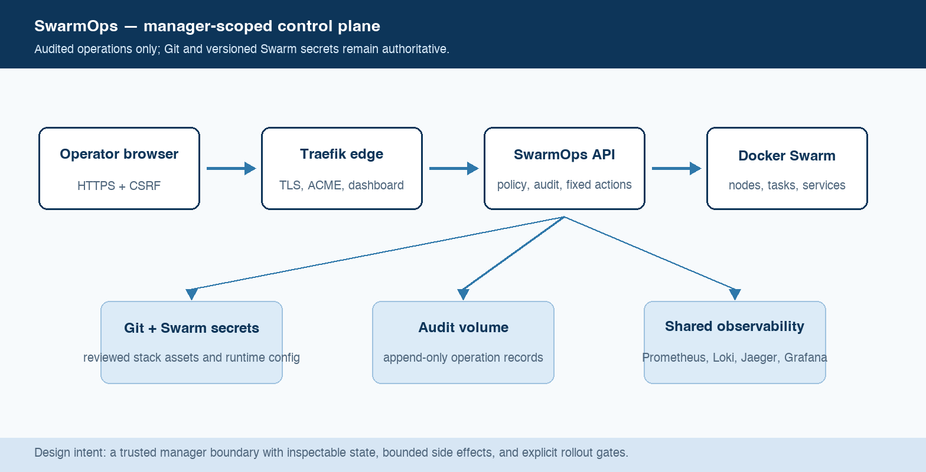
Figure 1. SwarmOps manager-scoped control plane.

Core components

Component | Responsibility | Primary storage | Failure behavior
SwarmOps API | Auth, policy, API/UI, and bounded Docker actions. | Manager socket; audit volume | Fails closed if Docker or audit is unavailable.
Node agent | Read-only OS, engine, and capacity snapshots. | Overlay and agent token | No snapshot; no guessed state.
Docker CLI and Engine | Deploy, restart, rollback, scale, logs, and builds in fixed shapes. | Docker API; tmpfs CLI config | Output is capped; builds use a 30-minute context.
Traefik edge | HTTPS, ACME, protected dashboard, and internal metrics. | Secrets; local ACME volume | Dashboard and metrics remain private.
Shared observability | Grafana, Prometheus, Jaeger, and optional Loki/Alloy. | Internal overlay; stateful volumes | Explicit lifecycle; recovery is operator-owned.

5. Request Lifecycle
- An operator reaches the React console over Traefik HTTPS, or uses swarmopsctl to stream a tarred local build context.
- The API verifies the HMAC session cookie and CSRF token; login is throttled locally and rate-limited at Traefik.
- Startup reads versioned secret files; each action loads the checked-in policy, runtime flags, Docker state, and writable audit destination.
- Compose is constrained to safe image-only resources, then staged and rendered before a fixed Docker stack deploy; other actions use explicit command shapes.
- The audit destination must be openable before a sensitive operation; the completed outcome is appended with actor, target, request ID, and non-sensitive details.
- Engine and agent calls have bounded clients; CLI output is capped; build input size, CPU, RAM, image prefix, and 30-minute context are enforced.
- The API returns Docker-derived state or a bounded result, records the operation, increments HTTP metrics, and leaves trace/log collection as an explicit platform lifecycle.

6. API and Data Contracts

Primary data contract

Field | Type | Required | Description
compose | String | Yes | Image-only Compose source, capped at 512 KiB and policy validated.
targetNodeId | String | No | Optional Docker node ID; injects node.id placement and refuses conflicts.
stackName | String | Yes | Lowercase 1-63 character deploy target accepted by stack policy.
serviceId | String | Yes | Validated fixed-action/log target; never interpreted as shell text.
build caps | CPU + MiB | No | Optional CPU and MiB caps for an uploaded tar build; no source path reaches the manager.
confirmation | String | Conditional | Exact typed phrase required for Traefik or observability removal/reconcile actions.
requestId | String | Yes | Correlates the operation and audit record; it is not a deployment idempotency key.

Contract guarantees

- Compose policy must pass before staging; stack config must render before deploy.
- Each completed action records a timestamped audit event with actor, target, request ID, outcome, and safe detail.
- The effective Compose digest, target node, action, and request ID are captured; secrets, build contexts, and logs are excluded.
- Docker Engine remains runtime truth; Git and reviewed assets remain configuration truth; audit records describe operations, not workload state.
The versioned schema or interface definition is published at
apps/swarmops/api/http/server.go; update the route contract with each release.

7. Consistency, Idempotency, and Replay

SwarmOps does not promise exactly-once deployment semantics. It makes each operation explicit, validates before side effects, and records outcomes. Docker Swarm owns convergence; operators use immutable image tags, audit records, and rollback commands to reconcile partial results.
Scenario | Expected behavior | Reasoning
Repeated deploy or action | A new bounded operation is evaluated against current Docker state and produces its own audit event. | No browser-supplied shell exists; immutable images and staged manifests make repeated intent inspectable.
Audit, Docker, or policy dependency fails | The API returns a failure; mutations, log reads, and enabled builds are denied when the audit destination is unavailable. | The control plane avoids guessed state and records failure when the audit write succeeds.
Engine/agent timeout or task failure | Short Docker/agent clients bound read paths; builds use their dedicated 30-minute context; operators inspect task state before retrying. | Responses reflect Docker errors; no background retry invents a successful outcome.
Runtime or secret changes | The API loads its secret/config at startup; staged Compose is the exact deployment input for that request. | Policy and mutation flags are process-local; secret rotation is versioned and applied through a controlled redeploy.

8. Security and Privacy Considerations

- The initial production model has one operator account. HMAC cookies are HTTP-only and SameSite=Strict; mutations require a CSRF token.
- The browser never receives Docker socket access, registry config, passwords, session keys, agent tokens, Compose secrets, build contexts, or service-log content in the audit file.
- bcrypt hash, session key, agent token, registry config, DNS token, dashboard auth, and Grafana password are versioned Swarm secrets mounted as files.
- Mutations and image builds are false by default. Compose blocks privileged features, host binds, direct ports, custom storage/network drivers, and latest images.
- Audit JSONL is local to the control manager; its backup, retention, and recovery require an approved operational plan before claiming HA.

9. Operational Readiness
Signal | SLO or alert | Owner | Launch gate
Docker readiness | Check /readyz after Docker ping. | Nima Sarayan | Required
Agent freshness | Current signed snapshot required. | Nima Sarayan | Required
Traefik + dashboard | Check DNS/ACME, dashboard, and private metrics. | Nima Sarayan | Required
Observability core | Check Grafana, Prometheus, and Jaeger after deployment. | Nima Sarayan | Required
Logs + state recovery | Approve backup and retention before enabling logs. | Nima Sarayan | Required
Rollout constraint: Build immutable images, render stacks, deploy Traefik then SwarmOps, verify HTTPS/login/agents, then deliberately enable mutation, builds, monitoring, or logs.

10. Alternatives Considered

Alternative | Why it was considered | Why it was not selected
Portainer | Familiar Swarm UI. | Policy/lifecycle mismatch.
Nomad | Mature scheduler. | Requires scheduler migration.
Direct Docker CLI only | Small surface; native access. | No unified console.
Generic Docker socket proxy | Quick broad Docker access. | Root-equivalent access.

11. Open Questions
- Approve backup/restore for audit, ACME, and observability.
- Set the RBAC/SSO adoption trigger.
- Set the capacity and retention budget.
- Assign DNS, signing, and change approval ownership.

12. Decision and Next Steps
Adopt SwarmOps. Keep Git and the root Makefile authoritative; keep mutations/builds disabled until live gates pass.
Milestone | Deliverable | Exit criteria
M1 | M1 — Local proof | Tests, builds, rendering, and docs checks.
M2 | M2 — Preflight | Managers, overlay, secrets, and immutable images.
M3 | M3 — Deploy | Traefik, SwarmOps, and live validation.
M4 | M4 — Enable | Capacity, backup, rollback, and approval.

Production readiness requires live evidence; local validation is a prerequisite, not proof.

