SwarmOps Cloud
  - Software Architecture Document
September 2026
Abstract
This document explains how SwarmOps Cloud is built and why. It follows the arc42 template: goals and constraints, context, solution strategy, building blocks, runtime scenarios, deployment, cross-cutting concepts, decisions, quality scenarios, and risks. The structural views are drawn with the C4 model and given in full in the separate C4 Architecture Model; this document refers to them and adds the behaviour, the rationale and the trade-offs. The central architectural idea is that the command queue and the wallet ledger share one relational database. That makes paying for an application and requesting its deployment a single local transaction.
Table of Contents

1 Introduction and goals

1.1 Requirements overview
SwarmOps Cloud sells container hosting. Customers top up a wallet and order plans; administrators confirm orders; the platform deploys each application to Docker Swarm and bills it hourly. The Software Requirements Specification states the requirements in full.

1.2 Quality goals
Quality goals
Priority | Quality goal | Motivation
1 | Integrity of money | A balance must never be negative or drift from its ledger, and no request may charge or credit twice.
2 | Atomic provisioning | A customer must never pay for a deployment that was not requested, nor receive one that was not paid for.
3 | Security | Customers must be isolated from each other and from administration; secrets must stay encrypted.
4 | Portability | The system must run on both MariaDB 11.4 and MySQL 8.4.
5 | Operability | Failures must be visible, explained and recoverable by an administrator, and every change must be audited.

1.3 Stakeholders
Stakeholder | Expectation
Reviewer | A complete, correct system using SQL, with an administration panel and a storefront, documented thoroughly.
Customers | A simple, trustworthy way to run an image and pay only for what runs.
Administrators | Control over orders, prices, money and the platform, with evidence for every decision.
Developers | Clear module boundaries, tests on both engines, and diagrams that match the code.

2 Constraints

2.1 Technical constraints
- TC-1 Go for the server, React with the existing component kit for the interfaces.
- TC-2 MySQL or MariaDB for all controller state, restricted to features both engines share.
- TC-3 The existing public interfaces of the SwarmOps stores are preserved.
- TC-4 The data-encryption key is never stored in the database.
- TC-5 One active core acts on the cluster at a time.

2.2 Organisational constraints
- OC-1 One developer, within a single development cycle.
- OC-2 Everything must be demonstrable on a laptop: a single-node Swarm, local databases, a loopback machine agent.
- OC-3 No real payment provider may be contacted.

2.3 Conventions
- Go code follows the repository’s existing style and is checked with go vet.
- The console follows its information-architecture rules, enforced by operator-workflows.test.mjs. There is one navigation registry, every page has a route, destructive actions need a typed confirmation phrase, and dates and money are formatted in one module.
- Money is stored as whole rials in BIGINT columns and never as floating-point numbers.

3 Context and scope

3.1 Business context
Figure 1 of the C4 Architecture Model shows the business context. Customers and administrators use SwarmOps Cloud. It deploys to a Docker Swarm cluster, which pulls images from registries and obtains certificates from an ACME authority.

3.2 Technical context
Technical context
Channel | Protocol and format | Authentication
Browser → Core (storefront) | HTTPS, JSON, /api/store/v1 | Session cookie swarmops_store_session and X-CSRF-Token header
Browser → Core (console) | HTTPS, JSON, /api/v1 | Operator session cookie and CSRF token
Core → database | MySQL protocol over TCP | DSN from a protected file
Core → machine agent | HTTPS, JSON | Pinned TLS certificate and API key
Agent → Docker Engine | Docker Engine API over a local socket | Local socket permissions
Visitor → gateway → application | HTTP/HTTPS through Traefik | Application-defined

4 Solution strategy
Solution strategy
Goal or constraint | Approach | Where
Integrity of money | An append-only ledger is the source of truth; a cached balance is locked and updated with each row; a CHECK constraint forbids a negative balance; idempotency keys are unique per user. | Section 8.3; ADR-0008
Atomic provisioning | The deployment command is inserted by SubmitInTx inside the confirmation transaction (transactional outbox). | Section 6.1
One owner for background work | Only the active core runs the command worker and billing. Singleton rows are locked with FOR UPDATE. | Section 8.5
Portability | Shared SQL subset; the full test suite runs on both engines. | Section 8.2
Preserve SwarmOps | Stores keep their interfaces; only constructors change. | ADR-0008
Billing like Heroku and Liara | Hourly charges, one row per project per hour, capped monthly, with suspension and resumption. | Section 6.3
Security | Bcrypt, HttpOnly SameSite=Strict cookies, CSRF tokens, rate-limited sign-in, sealed columns with associated data, and audit. | Section 8.4

5 Building block view

5.1 Level 1: containers
The system consists of the storefront, the administration console, SwarmOps Core and the controller database. The machine agent, gateway and applications run in the cluster. See Figure 2 of the C4 Architecture Model.

5.2 Level 2: Core’s components
Figures 3 and 4 of the C4 Architecture Model show Core and the commerce service. The packages that matter to this project are:
Packages
Package | Responsibility
internal/sqlstore | Pool, WithTx with retries, migrations, sealed columns, error classification.
internal/sqlstore/migrations | 0001_audit.sql to 0009_plan_text.sql.
internal/cloud | Commerce business rules.
internal/queue | Command store (Store) and worker (Worker).
internal/audit, internal/ops, internal/source, internal/remote, internal/coretopology, internal/agentpull | The SwarmOps stores, now on SQL, and the control plane.
api/http | HTTP routing, authentication, the storefront and commerce APIs.
cmd/api | Process wiring, migrate-state, the billing loop.
web/src/store | Storefront.
web/src/screens/sales | Sales area of the console.

5.3 Mapping of the former snapshot files to tables
Where each former store’s data now lives
Former snapshot | Tables
audit.sealed | audit_events, audit_event_details
applications.sealed | applications, application_env, application_health_command, application_databases, application_database_env, application_outcomes
database-credentials.sealed | database_credentials, application_database_credentials
source-connections.sealed, source-settings.sealed | source_connections, source_settings, source_private_hosts
servers.sealed, server-keys.sealed | servers, server_agent_events, server_keys
core-topology.sealed | core_authority, core_members, core_handoffs
agent-pull-registry.sealed | agent_ca, agents, agent_enrollment_tokens, agent_claims
traefik-routing.sealed | routing_clusters, routes, route_hosts, dependency_bindings, service_route_declarations, routing_domains, dns_credential_versions, dns_records, route_certificates, route_certificate_domains, route_runtime, route_runtime_entry_points, route_runtime_errors
commands/commands.sealed | commands, command_payloads, command_events, command_outputs, command_locks

6 Runtime view

6.1 Confirming an order
Figure 1 shows the confirmation and what follows it.
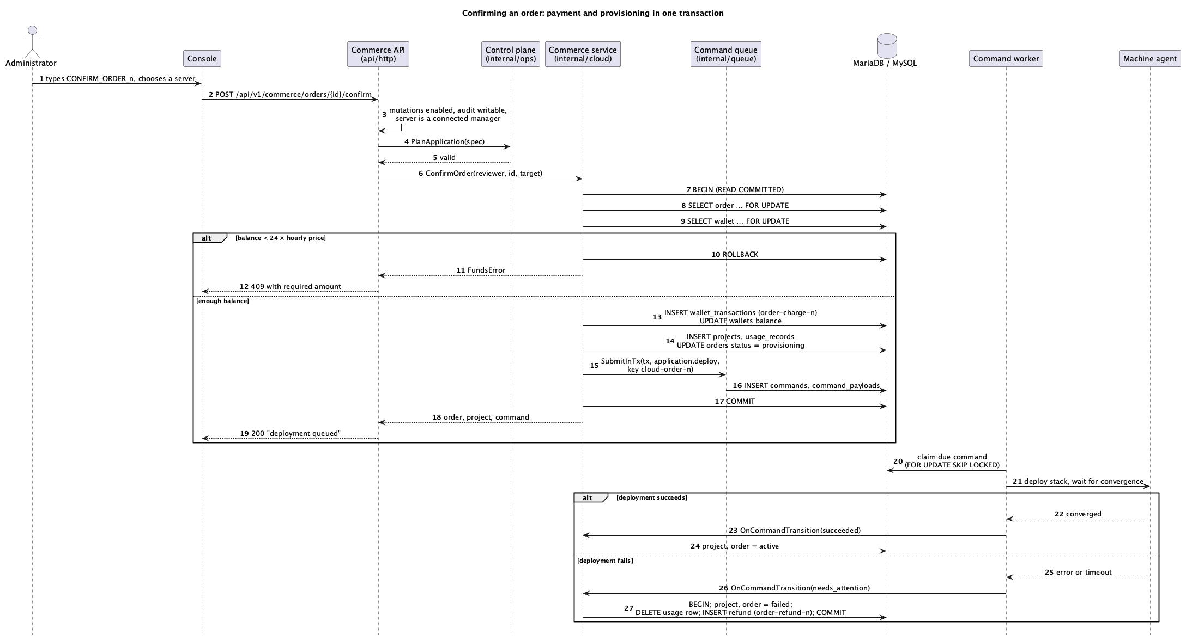
Sequence of an order confirmation
Every check that can fail without cost runs before the transaction opens: whether mutations are enabled, whether the audit ledger and command store can be written, whether the server is a connected manager, and whether the application passes planning. Inside the transaction, lockPendingOrder locks the order row and checks it is still pending, and only then is the wallet row locked. Every path that changes money follows the same rule: lock its own business row first, then the wallet row last. That row is the order when confirming, the project when refunding, and the new usage row when billing. Two such transactions may wait for the same wallet but do not hold each other’s rows; if the server aborts one anyway, WithTx repeats it. The charge uses the idempotency key order-charge-<id> and the command uses cloud-order-<id>, so a repeated confirmation neither charges nor queues twice.

6.2 Command execution and retries
The worker polls every 250 milliseconds. ClaimDue claims nothing while another command is running. Otherwise it locks the oldest due command, ordered by created_at and seq, with FOR UPDATE SKIP LOCKED. The worker executes it within a timeout: ten minutes for ordinary actions such as application.deploy, 35 minutes for image builds, and 50 minutes for source deployments and server readiness.
A failure that is not marked permanent is retried with backoff until max_attempts (three for deployments). After that the command moves to needs_attention with a failure code, summary and recovery hint. Each transition is recorded as a command_events row and passed to RecordCommandTransition, which informs the commerce service.

6.3 Hourly billing, suspension and resumption
Figure 2 shows billing.
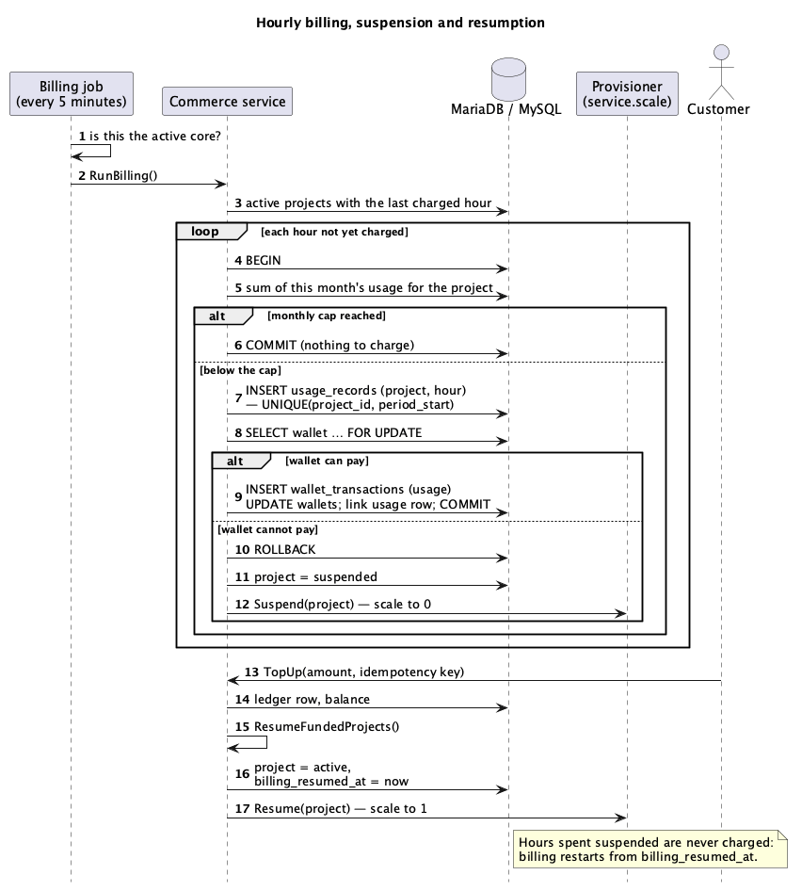
Sequence of hourly billing
The unique key on usage_records(project_id, period_start) makes a second charge for the same hour impossible, even if two billing runs overlap. The monthly cap is checked against the sum of the month’s usage inside the same transaction. When a wallet cannot pay, the charge is rolled back, the project is suspended and a service.scale command stops it. A top-up calls ResumeFundedProjects. That sets billing_resumed_at, so billing restarts from the resumption and never charges the suspended hours.

6.4 Storefront sign-in and request protection
Sign-in creates a session row holding the SHA-256 hash of the session token and a random CSRF token. The browser receives the token only in the HttpOnly cookie and the CSRF token in the response body. Every change sends the CSRF token in a header, compared in constant time. After eight failed attempts for a key within fifteen minutes, sign-in is refused. If a change is refused because the page holds an outdated CSRF token (for example after signing in from another tab), the storefront reads the current session once and repeats the change with the same idempotency key.

6.5 Start-up and schema migration
At start-up Core opens the database and runs Migrate. It takes the named lock swarmops_schema_migrations with GET_LOCK (waiting up to 60 seconds), checks that applied versions are contiguous and that their checksums match the embedded files, and applies the missing migrations in order. Only then are the stores constructed. The active core recovers interrupted commands and starts the worker and the five-minute billing loop.

7 Deployment view
Figures 7 and 8 of the C4 Architecture Model show the intended production deployment and the environment used for verification. Production configuration is read from files:
Deployment configuration
Setting | Purpose
SWARMOPS_DATABASE_DSN_FILE | Protected file holding the DSN.
SWARMOPS_DATABASE_MAX_OPEN_CONNS | Upper bound of the connection pool.
Data-key and session-key files | Encryption of secret columns and signing of operator sessions.
swarmops_database_dsn Swarm secret | The same DSN when Core runs as a Swarm service (deploy/stacks/swarmops.yml).
Backups are taken with mysqldump --single-transaction, which gives a consistent InnoDB snapshot without blocking writers. Because secret columns are encrypted with a key that is not in the database, a backup must be stored together with a separately protected copy of that key. The Installation and Operations Guide describes backup, restore and upgrade.

8 Cross-cutting concepts

8.1 Persistence and transactions
All writes that belong together run in sqlstore.DB.WithTx, at READ COMMITTED isolation. READ COMMITTED was chosen over the InnoDB default of REPEATABLE READ because the code locks the rows it reads for update explicitly. It avoids REPEATABLE READ’s gap locks on range reads, which would serialise unrelated inserts such as usage rows for different projects. A transaction aborted with error 1213 (deadlock) or 1205 (lock-wait timeout) is re-run up to four attempts in total, waiting attempt² × 15 ms between attempts; the whole function is repeated, so partial effects cannot leak.

8.2 Portability between MariaDB and MySQL
Only features present in both engines are used. Two differences affected the implementation:
- sensitive is a reserved word in both, so the column is named is_sensitive.
- The CHECK-violation error number differs (3819 in MySQL, 4025 in MariaDB), so sqlstore.IsCheckViolation recognises both.
Datetimes are stored as DATETIME(6) in UTC, and imported times are truncated to microseconds so values compare equal on both engines.

8.3 Money
- Units. Amounts are integers in rials, shown in tomans.
- The ledger. Every change is a wallet_transactions row carrying a kind, signed amount, resulting balance, reference and optional idempotency key. UNIQUE(user_id, idempotency_key) makes retries safe. The cached wallets.balance_rial is updated in the same transaction as the row, under the wallet row lock, and CHECK (balance_rial >= 0) forbids overdraft. The console verifies that the balance equals the sum of the ledger.
- Denormalisation. Keeping a cached balance is a deliberate step away from strict normal form. It keeps the balance check a single-row read under a lock, instead of a sum over a growing ledger. The ledger remains the authority.
- Tax. Prices include tax. The tax in a total T at rate r basis points is T·r/(10000 + r), rounded down, and the invoice’s subtotal is T minus that tax.

8.4 Security
- Customers. Passwords are stored as bcrypt hashes (cost 12). An unknown email is checked against a dummy hash so its response time matches a wrong password. Sessions are stored as token hashes, never tokens. Cookies are HttpOnly, SameSite=Strict and Secure when configured. Changes require a CSRF token.
- Isolation. Every customer query is scoped by the session’s user id. Administration routes accept only operator sessions.
- Secrets. Secret columns are sealed with AES-GCM. The associated data swarmops-sql:<table>.<column>:<keys> binds each ciphertext to its row, so a value copied elsewhere fails to open.
- Audit. Commerce events are written to the audit ledger with the actor:
  - by customers: registrations, top-ups and placed orders;
  - by administrators: order confirmations (with the queued command) and rejections, wallet adjustments, customer status changes, plan changes, invoice issuing and on-demand billing runs.
- Confirmations. Costly or destructive console actions require typing a phrase such as CONFIRM_ORDER_3.

8.5 Concurrency and ownership
Row locks replace the in-process mutexes the snapshot stores used, so correctness no longer depends on there being one process. Work with a single owner locks a singleton row: core_authority for the core topology and its authority epoch, and agent_ca for the agent certificate authority. Named commands are serialised by upserting a row in command_locks. Only the active core recovers commands, executes them and bills.

8.6 Error handling
Commerce errors are mapped to HTTP responses in one place (cloudError):
Error mapping
Error | Status | Body
Validation | 422 | error and the offending field
Insufficient reserve | 409 | error, balanceRial, requiredRial
Insufficient funds, conflict (for example a taken name) | 409 | error
Not found | 404 | error
Invalid credentials, expired session | 401 | error
Forbidden, invalid CSRF token | 403 | error
Anything else | 500 | a generic message and the request id; the cause is logged

8.7 Internationalisation
The storefront keeps English and Persian dictionaries with the same keys; the type system rejects a key missing from either. Choosing Persian switches the component kit to right-to-left layout and the fa-IR locale, which formats digits and dates in Persian. Server validation messages are in English only.

8.8 Testing
sqltest gives each test a throwaway schema on a real server. Tests cover:
- concurrency: fifty parallel charges against one wallet;
- idempotency;
- atomicity: a confirmation whose command cannot be queued charges nothing;
- billing caps and suspension;
- invoices;
- authorisation over HTTP;
- migrations, including a forced deadlock that WithTx must survive.
CI runs the suite on MariaDB and on MySQL. The Test Plan and Report gives the results.

9 Architecture decisions
Architecture decisions
Decision | Summary | Record
Controller state in MySQL or MariaDB | All eleven stores move to one relational database with migrations and sealed columns. | ADR-0008 (docs/adr/ADR-0008-sql-controller-state.md)
Transactional outbox for provisioning | The deployment command is inserted in the confirmation transaction rather than sent after it. | This document, section 6.1
Append-only ledger with cached balance | The ledger is the authority; the balance is a locked cache protected by a CHECK constraint. | Section 8.3
Wallet and administrator confirmation | Prepaid wallet with simulated top-ups; each order is confirmed by an administrator, who chooses the server. | Proposal, section 6
Hourly billing with a monthly cap | One usage row per project per hour; suspension instead of debt. | Section 6.3
Storefront as a second Vite entry | Separate store.html sharing the component kit and served by the same binary. | C4 Architecture Model, section 3

10 Quality requirements

10.1 Quality scenarios
Quality scenarios
Quality | Scenario | Expected response | Evidence
Integrity | Fifty concurrent charges of 30,000 rials hit a wallet holding 1,000,000 rials. | Exactly 33 succeed, 17 are refused, the balance is 10,000 and equals the ledger. | TestConcurrentChargesNeverOverdrawAndMatchTheLedger
Integrity | A top-up request is sent twice with the same idempotency key. | The wallet is credited once. | TestATopUpIsCreditedOncePerIdempotencyKey
Atomicity | The command queue refuses the deployment during confirmation. | Nothing is charged and the order stays pending. | TestAConfirmationThatCannotQueueItsDeploymentChargesNothing
Reliability | A deployment fails after the charge. | The order fails and one refund is recorded, even if the outcome is reported twice. | TestTheDeploymentOutcomeActivatesOrFailsAndRefundsOnce; orders 1 and 2 in the end-to-end run
Security | A customer requests another customer’s order. | 404, and nothing is revealed. | HTTP tests in api/http/cloud_api_test.go
Security | A change is sent with an outdated CSRF token. | 403; the storefront recovers once with the current token. | End-to-end ticket scenario
Portability | The full test suite runs against each engine. | All tests pass on MariaDB 11.4 and MySQL 8.4. | Test Plan and Report

11 Risks and technical debt
Risks and technical debt
Risk or debt | Effect | Possible remedy
The worker runs one command at a time, and a deployment waits for its service to converge. | An image that never becomes healthy blocks all other commands until its ten-minute timeout. This was observed with order 2. | Fail deployments early on repeated health-check failures, or run commands for different servers concurrently.
A failed project keeps its application name. | The customer cannot reorder under the same name. | Release names of failed projects, or let customers delete them.
Billing follows the project’s status, not observed running time. | Hours during which the host was down are charged (defect D-10). | Charge only hours in which Swarm reports a running task.
No public default domain. | Customers cannot reach their applications from the internet. | A platform wildcard domain with DNS-01 certificates.
Payments are simulated. | Not usable commercially as is. | Integrate a gateway; the idempotency key is ready for its reference.
Billing runs every five minutes. | An hour’s charge can appear up to five minutes after the hour begins. | Acceptable; shorten the interval if needed.
Server messages are English only. | Persian customers see English validation errors. | Return message keys and translate them in the storefront.
The database is a single instance. | It is a single point of failure. | A replicated MariaDB or MySQL deployment.
A ticket cannot be opened from its address. | Links to a single ticket open the ticket list. | Parse the ticket id in the storefront route.

12 Glossary
The terms used here are defined in section 1.3 of the Software Requirements Specification.

