SwarmOps Cloud
  - User Manual — Customers and Administrators
Nima Sarayan
September 2026
Abstract
This manual explains how to use SwarmOps Cloud. Part I is for customers: creating an account, topping up the wallet, ordering a plan, following orders and projects, and reading invoices and support replies. Part II is for administrators: preparing the platform, reviewing and confirming orders, managing customers, wallets and plans, running billing and invoicing, and answering support tickets. The screenshots are of the real application, taken during the end-to-end test on 15 September 2026 with a fictitious customer, Sara Ahmadi.
Table of Contents

1 About this manual
SwarmOps Cloud runs container applications on Docker Swarm and bills them by the hour from a prepaid wallet. Customers use the storefront, at /store on the platform’s address. Administrators use the administration console, at /.
Amounts are shown in tomans. Internally the platform counts rials (10 rials = 1 toman), so API responses and database reports show ten times the toman figure.
Button and field names are shown in bold. A path such as Sales › Orders means “open Sales in the side bar, then Orders”.

2 Part I — Customers

2.1 The storefront at a glance
The storefront’s header holds three controls:
- the language switch (English / فارسی);
- Sign in or Sign out;
- once signed in, the tabs Plans, Dashboard, Wallet, Orders, Projects, Invoices and Support.
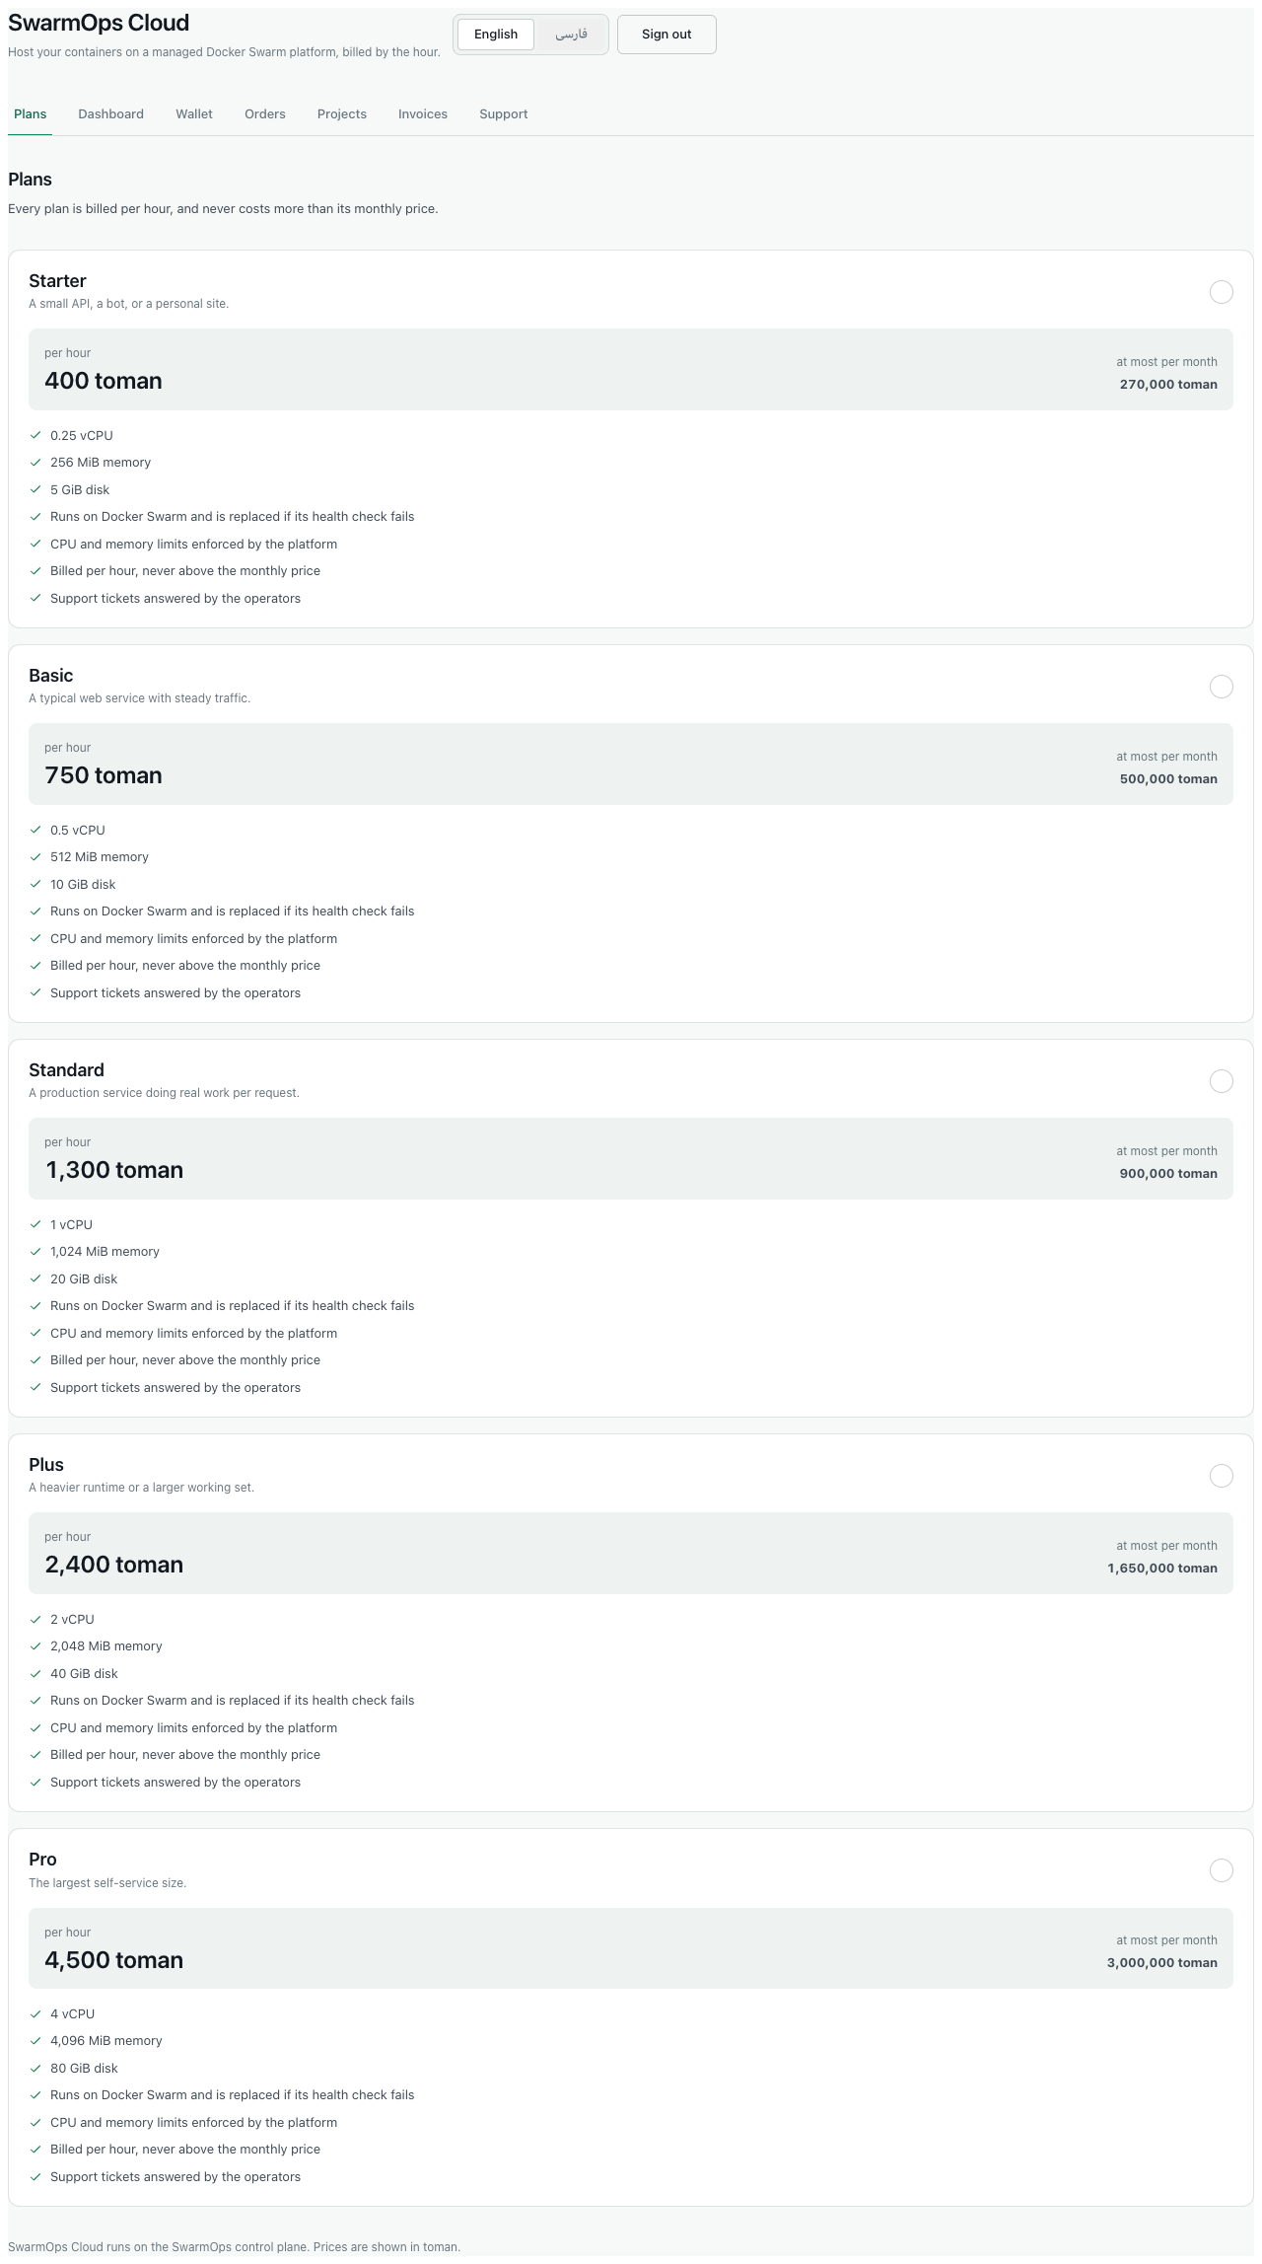
The plan catalogue
The storefront follows your device’s light or dark setting, and works on a phone as well as on a computer.
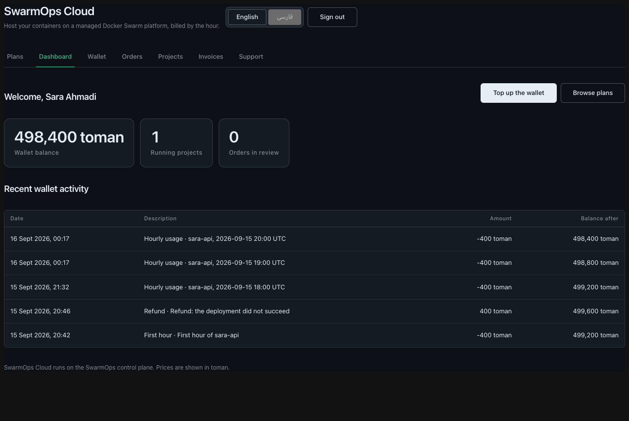
The dashboard in the dark theme

2.2 Choosing the language
Press فارسی for Persian or English for English. In Persian the whole page runs right to left, and numbers, dates and amounts use Persian digits. Your choice is remembered on that device.
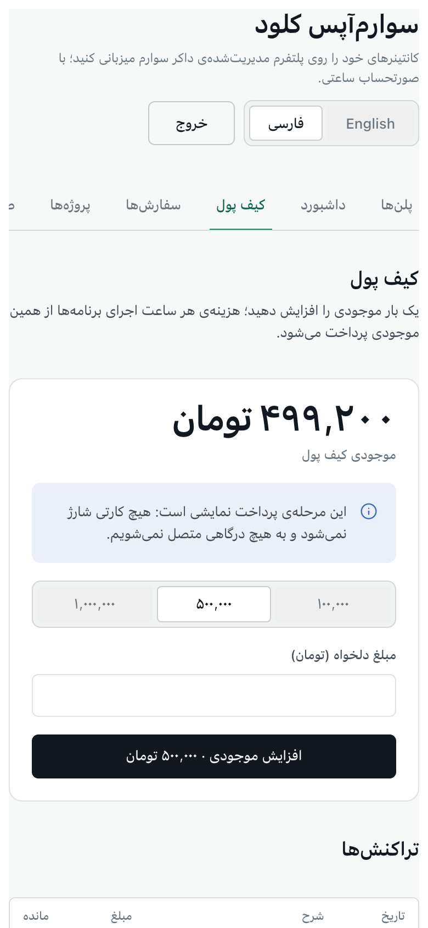
The Persian storefront on a phone

2.3 Creating an account
- Press Sign in, then Already have an account? Sign in or the registration link, to reach Create your account.
- Enter your Full name, Email and a Password of 10 to 72 characters.
- Press Create account.
You are signed in and taken to your wallet. Each email address can hold one account.
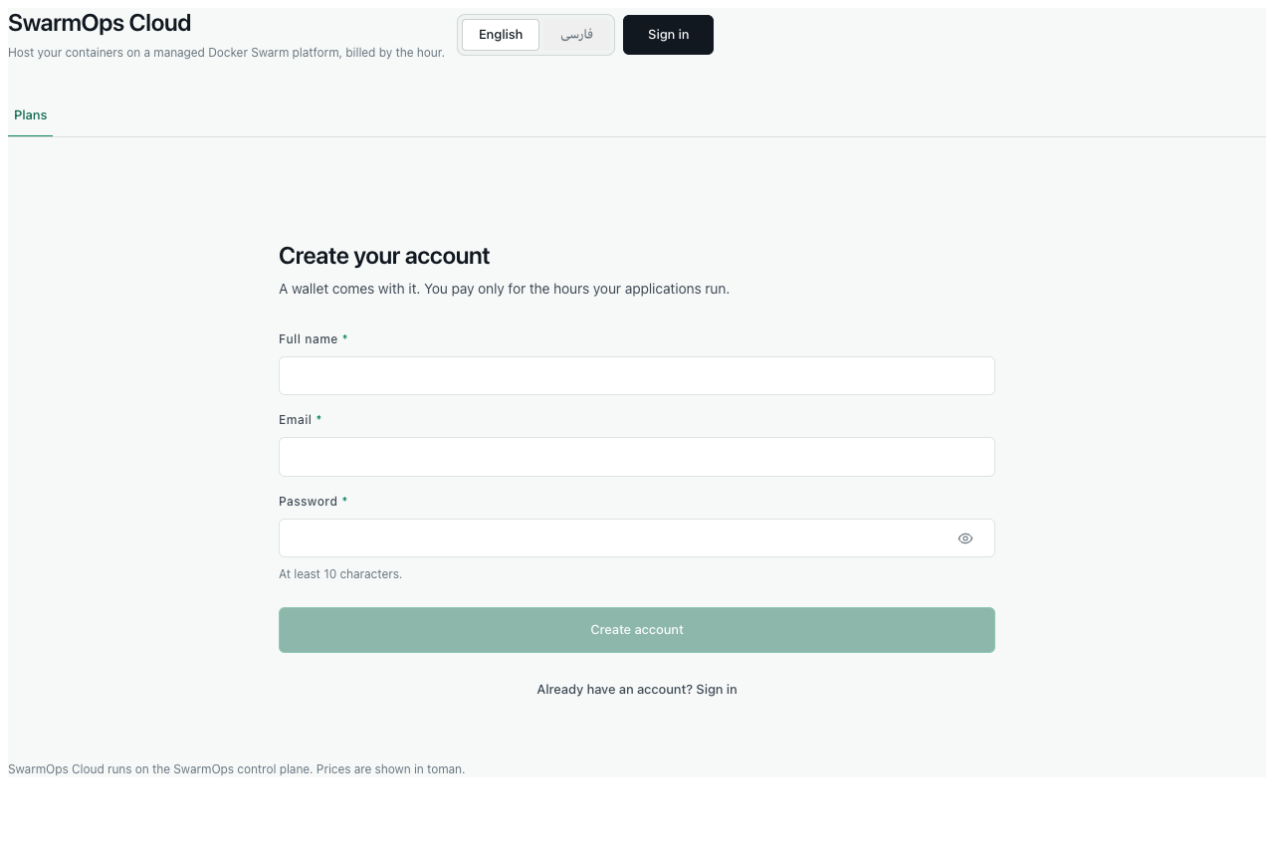
Creating an account
After several failed attempts in a short time, the storefront asks you to wait a few minutes before trying again. This protects your account from password guessing.

2.4 Topping up the wallet
Your applications are paid for from the wallet, so it must hold money before an order can be approved.
- Open Wallet.
- Choose a preset amount — 100,000, 500,000 or 1,000,000 toman — or type another amount under Another amount (toman). One top-up may be between 10,000 and 200,000,000 toman.
- Press Top up · … toman.
The balance rises, and the top-up appears under Transactions with the balance after it.
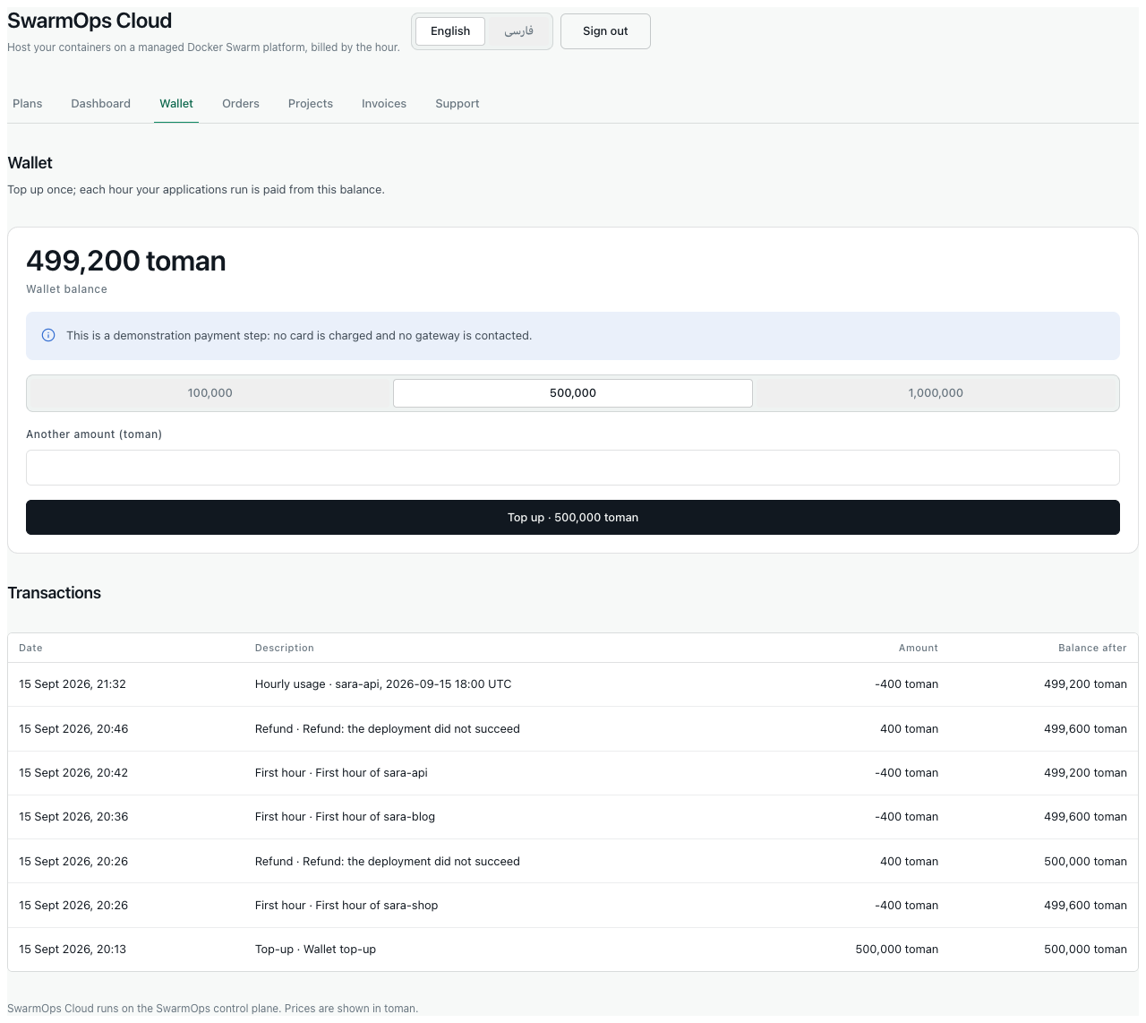
The wallet
Demonstration payment. This installation does not contact a payment gateway, and no card is charged. The page says so in a blue notice. If a top-up request is sent twice, for example after a network error, the wallet is credited only once.

2.5 Ordering a plan
Each plan gives your application a fixed amount of CPU, memory and disk. It has a price per hour and a most you can pay in a month.
- Open Plans and choose a plan.
- The checkout shows the plan’s Price per hour, Most you can pay in a month and Required wallet balance at approval, which is 24 hours of the plan’s price.
- Fill in the form:
  - Application name — a lowercase letter followed by lowercase letters, digits or hyphens, at most 41 characters. The name must not be in use.
  - Container image — an image already published to a registry, with a tag other than latest (for example ghcr.io/acme/shop:1.0.0).
  - Port the application listens on.
  - Note for the reviewer — optional.
- Press Place order.
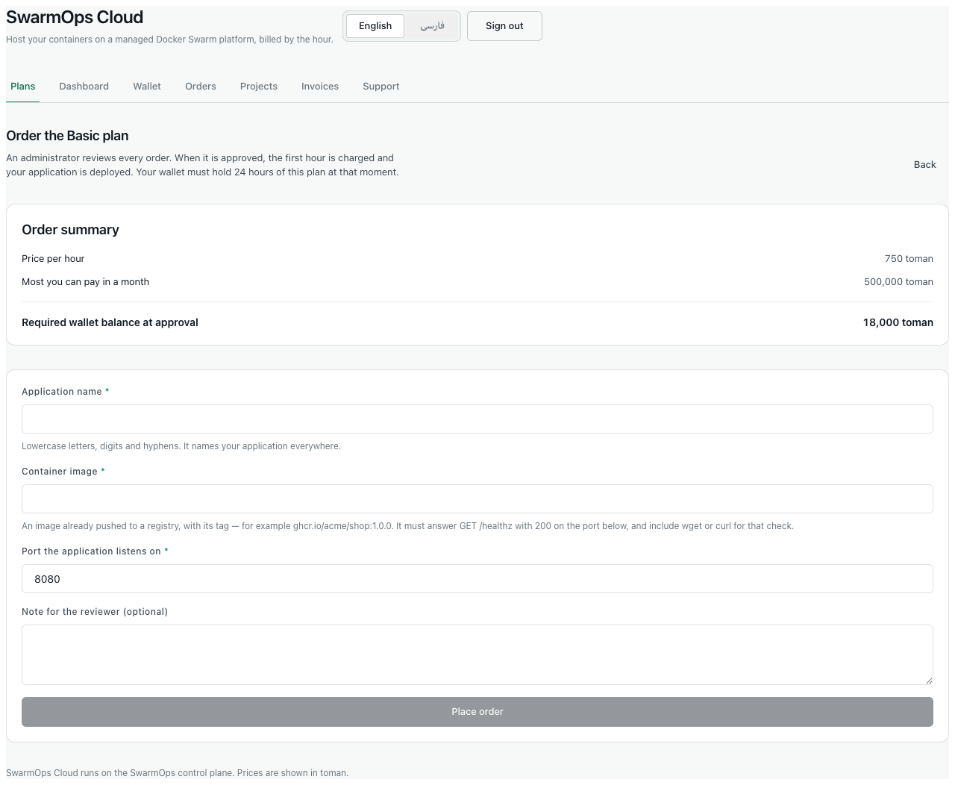
Checkout
Before you order, check your image. The platform starts your application only when it is healthy. Your image must answer GET /healthz with status 200 on the port you give, and it must contain wget or curl, which the health check uses. An image that does not meet these requirements will fail to start, and the charge is refunded.
No money moves when you place an order. An administrator reviews it first.

2.6 Following your orders
Orders lists every order with its status.
Order statuses
Status | Meaning | What you can do
In review | Waiting for an administrator. | Cancel order.
Deploying | Approved; the first hour has been charged and the application is starting. | Wait.
Active | Your application is running and billed by the hour. | See Projects.
Failed | The application did not start. The first hour was refunded automatically. | Check the image requirements and order again under a new name.
Rejected | An administrator declined the order; the reason is shown. | Correct the problem and order again.
Cancelled | You cancelled the order. | —
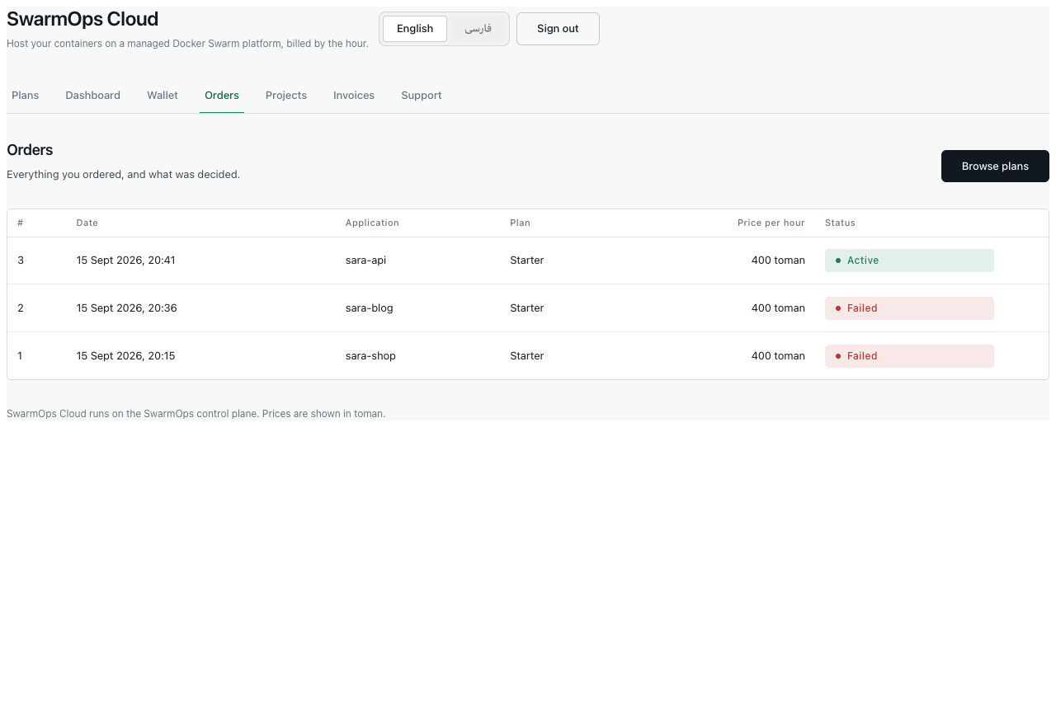
Orders

2.7 Your projects
A project is an application created by an approved order. Projects shows, for each one:
- its status;
- its plan and price per hour;
- the amount Charged this month;
- when it has been Running since.
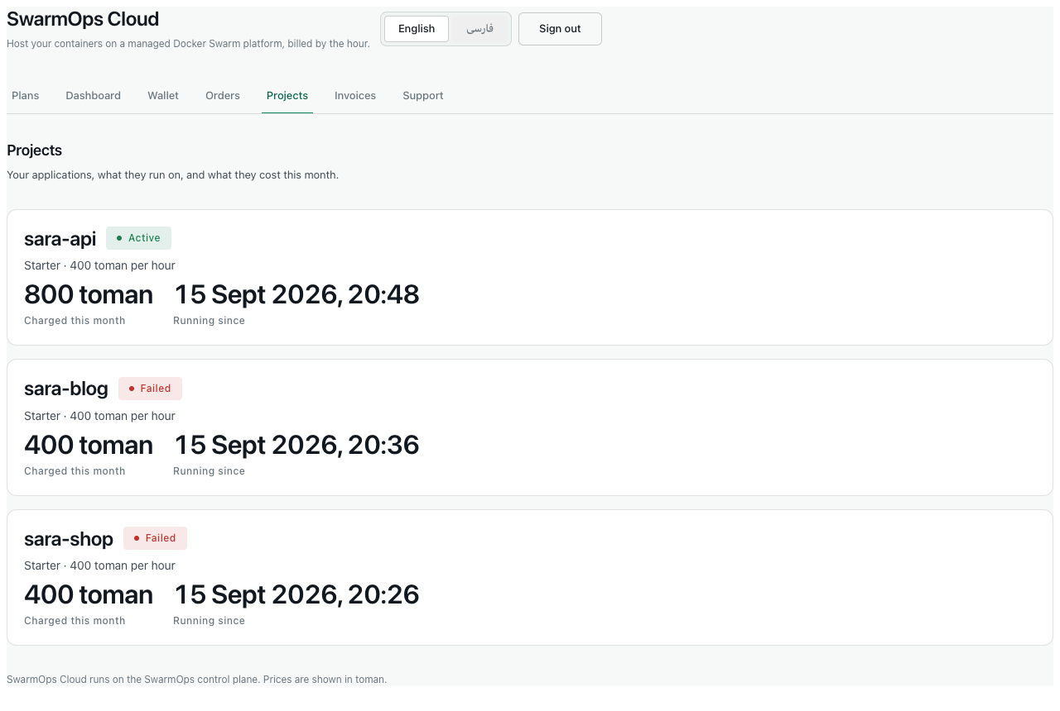
Projects
How charging works.
- A running project is charged its hourly price once for each hour. The platform checks every few minutes, so a charge can appear a few minutes after the hour begins.
- In one calendar month a project is never charged more than its plan’s monthly price.
- If the wallet cannot pay for the next hour, the project is suspended: it stops running and is not charged. A banner offers Top up.
- As soon as a top-up covers the next hour, the project starts again. The hours it spent suspended are never charged.

2.8 Invoices
At the end of each month you receive one invoice for your usage. It lists each project with its hours and amount. Prices include value-added tax (10 %), and the invoice states the tax contained in the total. Because charges are paid from the prepaid wallet, every invoice is marked paid. Open an invoice to see its lines.
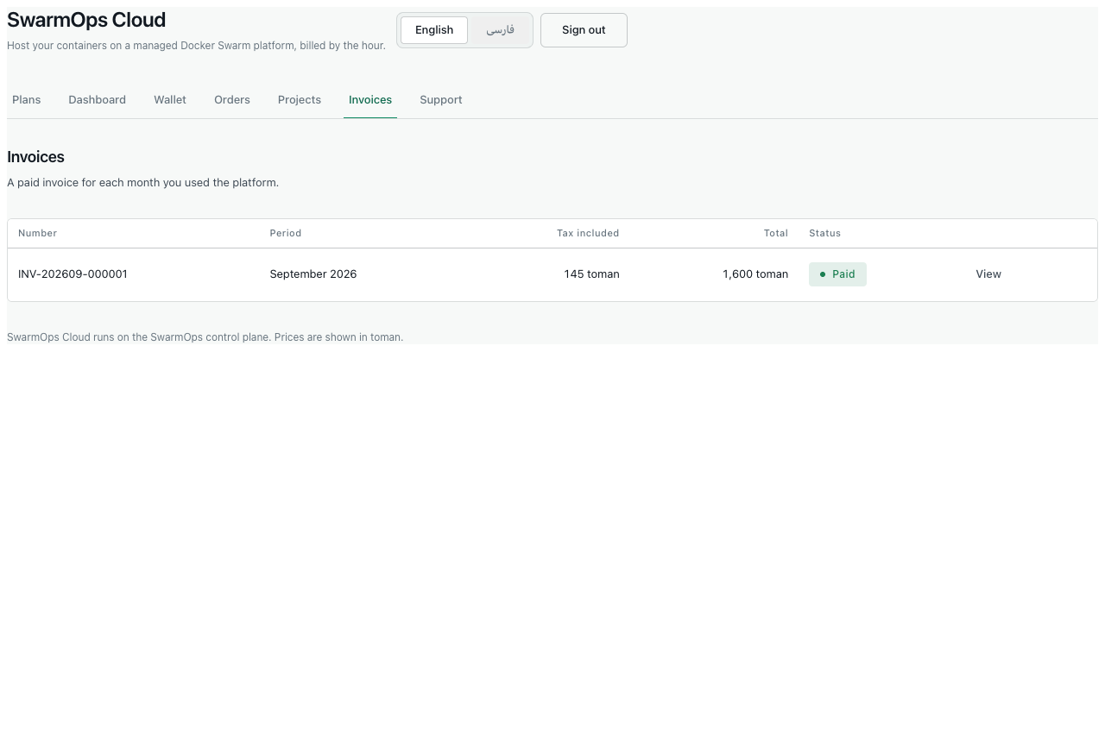
Invoices
The invoice in this screenshot comes from the test run. It includes two first hours that were refunded before a defect was corrected (Test Plan and Report, defect D-2). On an installation with the correction, refunded hours never appear on an invoice.

2.9 Support
- Open Support.
- Under New ticket, enter a Subject (3–160 characters) and a Message (under 5,000 characters). Optionally choose About a project and a Priority (low, normal or high).
- Press Open ticket.
Replies from administrators appear in the conversation, and the ticket’s status changes from Open to Answered. You can reply again or close the ticket.
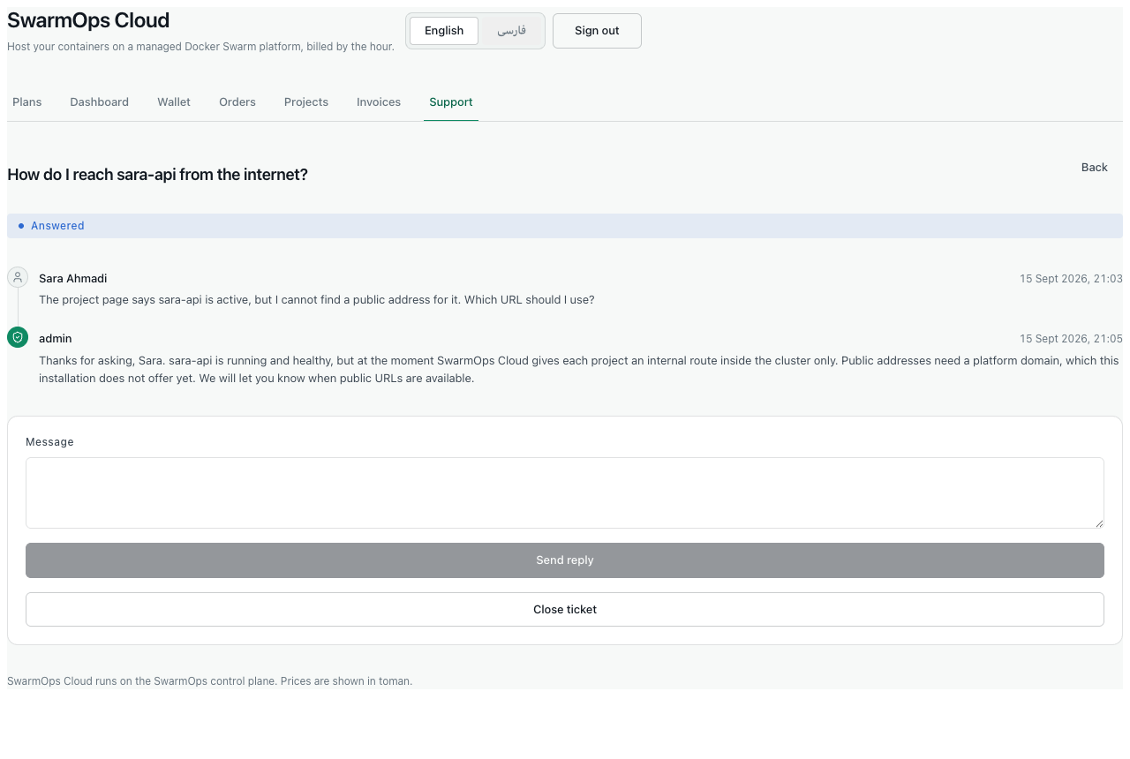
A support conversation

2.10 Signing out and security
Press Sign out to end your session on that device. A session also ends by itself after 12 hours. If you sign in from another tab, the storefront continues to work in the first tab without reloading.

2.11 Messages you may see
Storefront messages
Message | Meaning and remedy
use between 10 and 72 characters | The password is too short or too long.
an account with this email already exists | Sign in instead, or use another email address.
the application name “…” is already taken | Choose another name.
image must not use the latest tag / image must use a non-latest tag or digest | Give the image a version tag, such as :1.0.0.
top up between … and … rials | The amount is outside the allowed range (10,000 to 200,000,000 toman).
Too many sign-in attempts; wait a few minutes | Wait, then try again.
Your session has expired | Sign in again.
Validation messages from the server are in English, including on the Persian storefront.

3 Part II — Administrators

3.1 Signing in and the Sales area
Open the console at the platform’s address and sign in with the operator account. The side bar’s Sales area has five pages: Orders, Customers, Plans, Billing and Support. The rest of the console — Apps, Machines, Traffic, Activity and Control — operates the platform itself.

3.2 Preparing the platform
An order can be confirmed only on a connected Swarm manager, and an application can be deployed only when the managed Traefik gateway is installed.
- Connect a server. Use Connect a server and follow the installation command, or use the development machine agent on a local installation. The header shows Agent connected when it is reachable.
- Install the gateway. Open Traffic › Gateway. The Installation prerequisites list states what is missing: the external traefik network, a manager labelled nim.edge=true, the dynamic configuration, the dashboard login secret, the ACME contact email and the dashboard hostname.
  - Enter the ACME email and dashboard hostname under Traffic › Gateway settings.
  - When every missing item can be created automatically, press Fix all N prerequisites. Save the dashboard login it shows once.
  - Press Install gateway, type DEPLOY_TRAEFIK, and press Install gateway again.
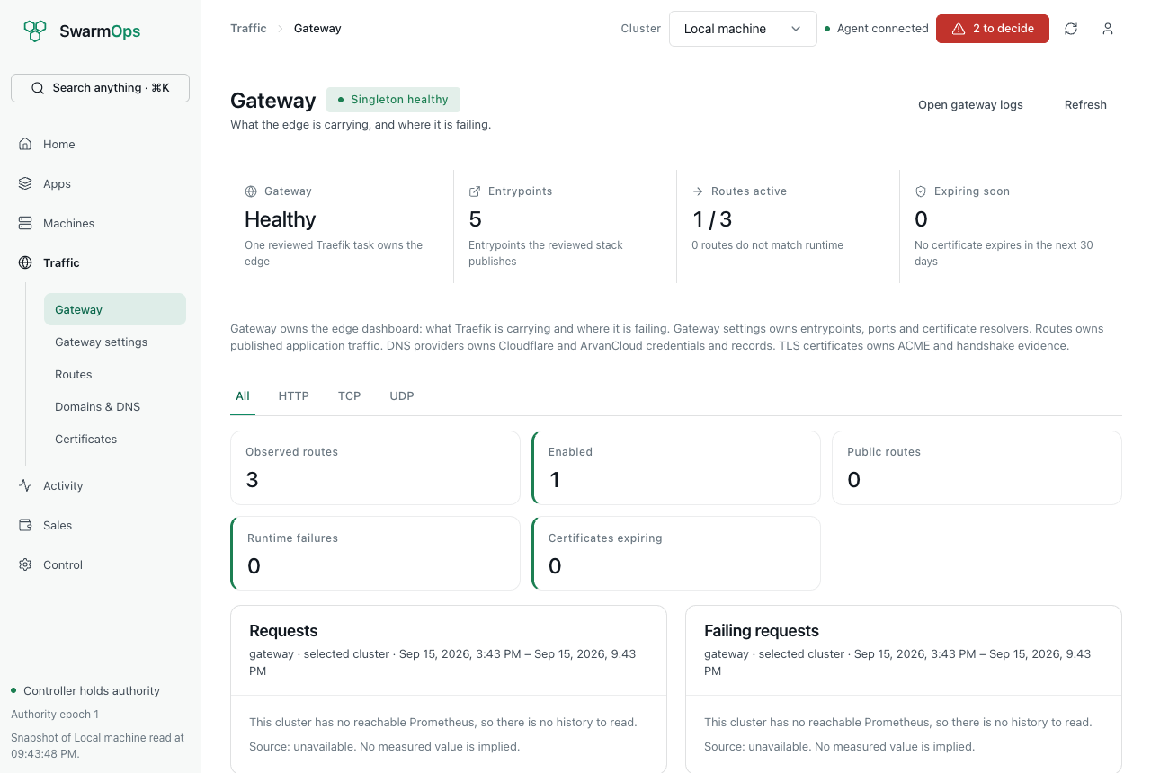
Gateway prerequisites

3.3 Reviewing orders
Sales › Orders shows how many orders are pending, deploying, active and failed. The list can be filtered by status.
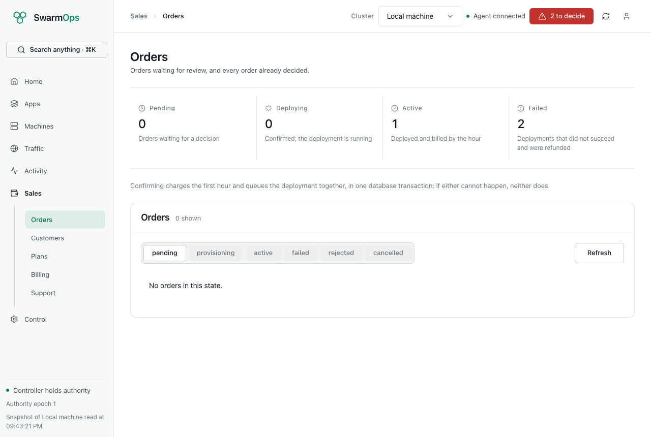
The order queue
To decide an order:
- Press Review on a pending order. The panel shows the customer, application, image, port, plan and the customer’s note.
- To confirm:
  - Choose the server under Deploy on; only connected Swarm managers are offered.
  - Type the phrase shown, for example CONFIRM_ORDER_3.
  - Press Confirm and deploy.
- To reject: enter Reason for rejecting (sent to the customer) and press Reject order.
Confirming charges the first hour, creates the project and queues the deployment in one step. If any part cannot happen — the wallet holds less than 24 hours of the price, the server is not a manager, or the application is invalid on that server — nothing is charged and the console explains why.
After confirmation the order is provisioning until the deployment finishes. If the deployment succeeds, the order becomes active. If it fails, the order becomes failed and the first hour is refunded automatically. Activity › Runs shows the deployment’s steps and, for a failure, its cause.
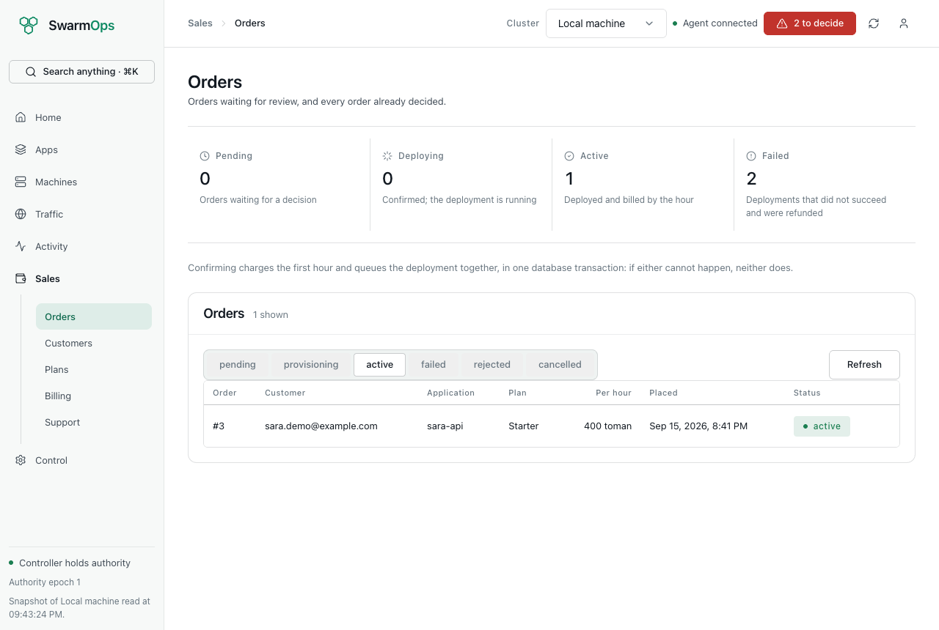
Decided orders
A deployment that never becomes healthy occupies the command queue until its ten-minute timeout, and other commands wait meanwhile. When a deployment stays in provisioning, check its run in Activity and the application’s health endpoint.

3.4 Customers and wallets
Sales › Customers lists every storefront account with its balance, live projects, pending orders and status. Press Wallet to open a customer’s ledger.
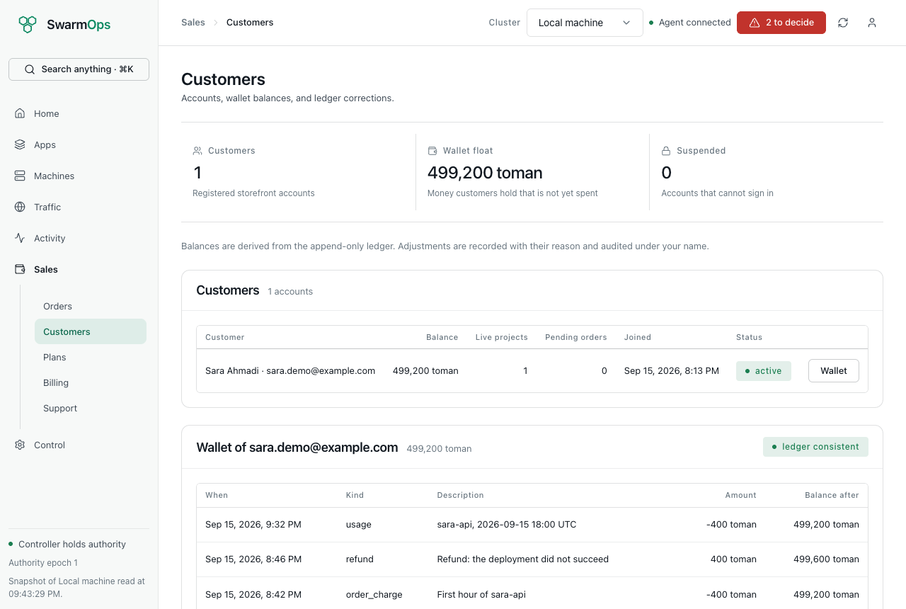
A customer’s wallet
- ledger consistent confirms that the balance equals the sum of the ledger. If it ever shows ledger mismatch, stop and investigate before any adjustment.
- To correct a balance, enter an Adjustment (toman) — negative to deduct — and a Reason (kept in the ledger) of at least a few words, then press Record adjustment. An adjustment is a new ledger row; existing rows are never edited, and a balance cannot become negative.
- To suspend a customer, type the phrase shown (for example SUSPEND_CUSTOMER_1) and confirm. Every session of the customer ends and they cannot sign in. Their running projects are not stopped. Reactivate the same way.
Every adjustment and status change is recorded in the audit log under your name.

3.5 Plans
Sales › Plans lists the catalogue. Press New plan or Edit to open the editor:
Plan fields
Field | Rule
Code | 2–32 lowercase letters, digits or hyphens; cannot be changed after creation.
Name | Required.
Description, Description (Persian) | Each under 255 characters. The Persian text is shown on the Persian storefront.
CPU (millicores) | 100–64,000 (1,000 millicores = 1 vCPU).
Memory (MiB) | 128–262,144.
Disk (GiB) | —
Price per hour (rial), Monthly cap (rial) | The hourly price must be positive; the cap at least one hour’s price. The hint shows each in tomans.
Features, Features (Persian) | One per line; at most 12 in each language, each under 160 characters.
Storefront availability | Offered or Withdrawn.
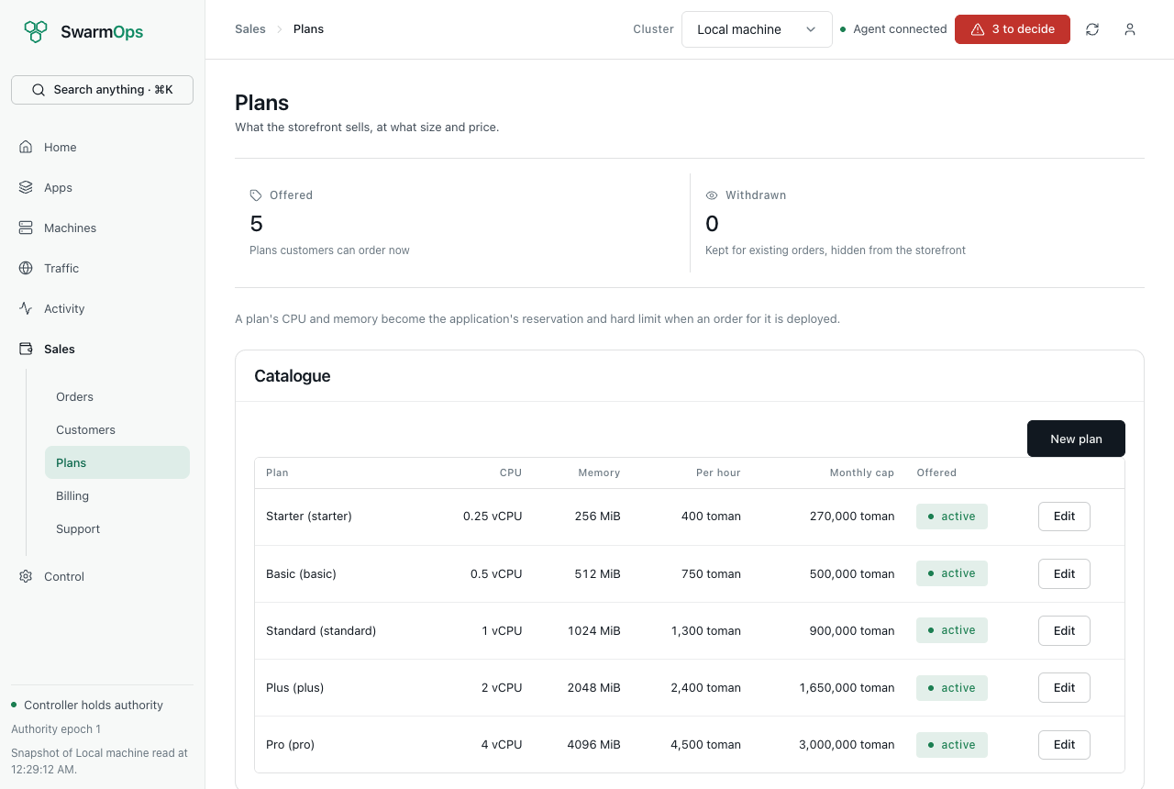
The plan catalogue in the console
A price change applies to new orders only; existing orders and projects keep the prices they were placed at. Withdrawing a plan hides it from the storefront without affecting existing projects. Only list features the platform actually provides.

3.6 Billing and invoices
Sales › Billing shows:
- this month’s revenue (charges less refunds);
- the active and suspended projects;
- the wallet float, meaning the money customers hold but have not spent;
- the projects with their charges this month;
- revenue by month;
- the invoices.
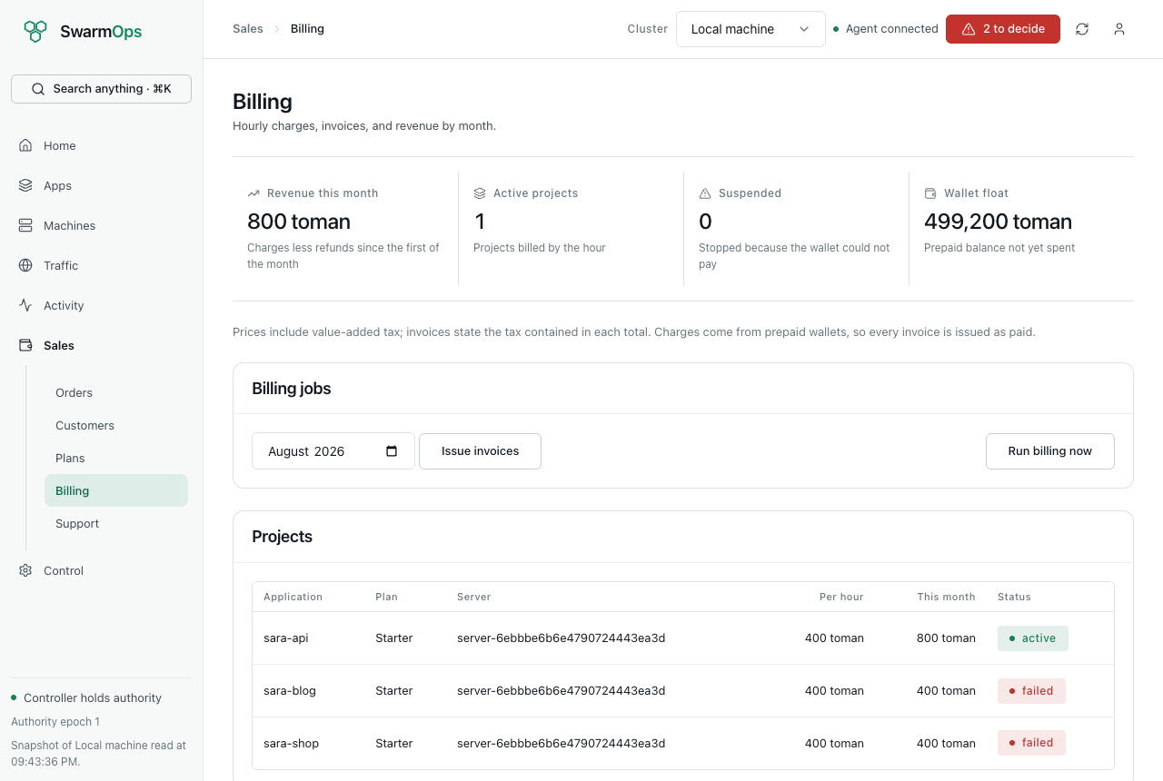
Billing
Billing runs by itself every five minutes on the active controller. Use the two buttons only when you need them:
- Run billing now charges any hours not yet charged. Running it twice charges nothing twice.
- Issue invoices for the chosen month. Issuing a month twice creates no duplicate invoices. The previous month’s invoices are also issued automatically.
Press Lines on an invoice to see its projects, hours and amounts, with the tax it contains.
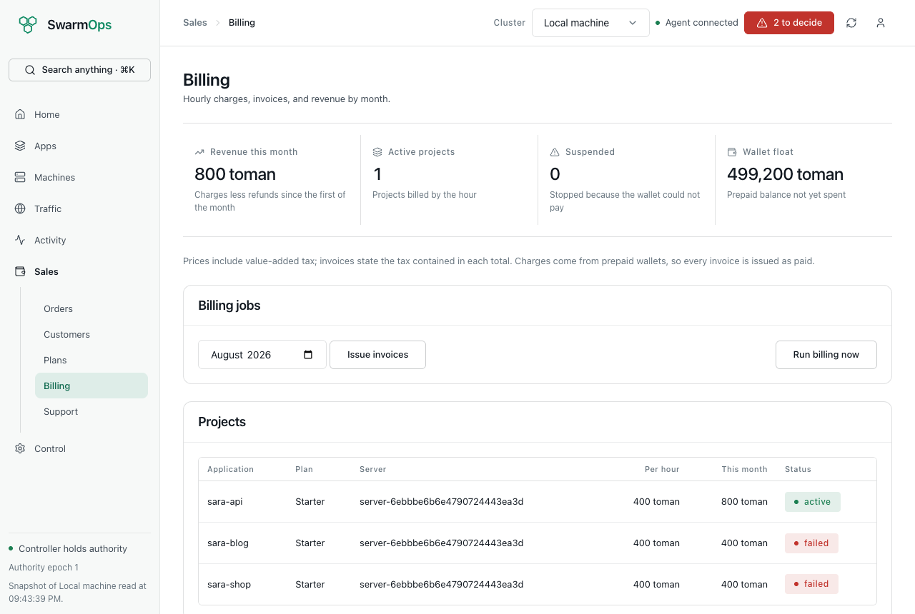
Invoice lines

3.7 Support
Sales › Support lists tickets by status: open (waiting for you), answered and closed. Press Open to read a conversation. Type your answer under Reply and press Send reply; the ticket becomes answered. Press Close ticket when the matter is resolved.
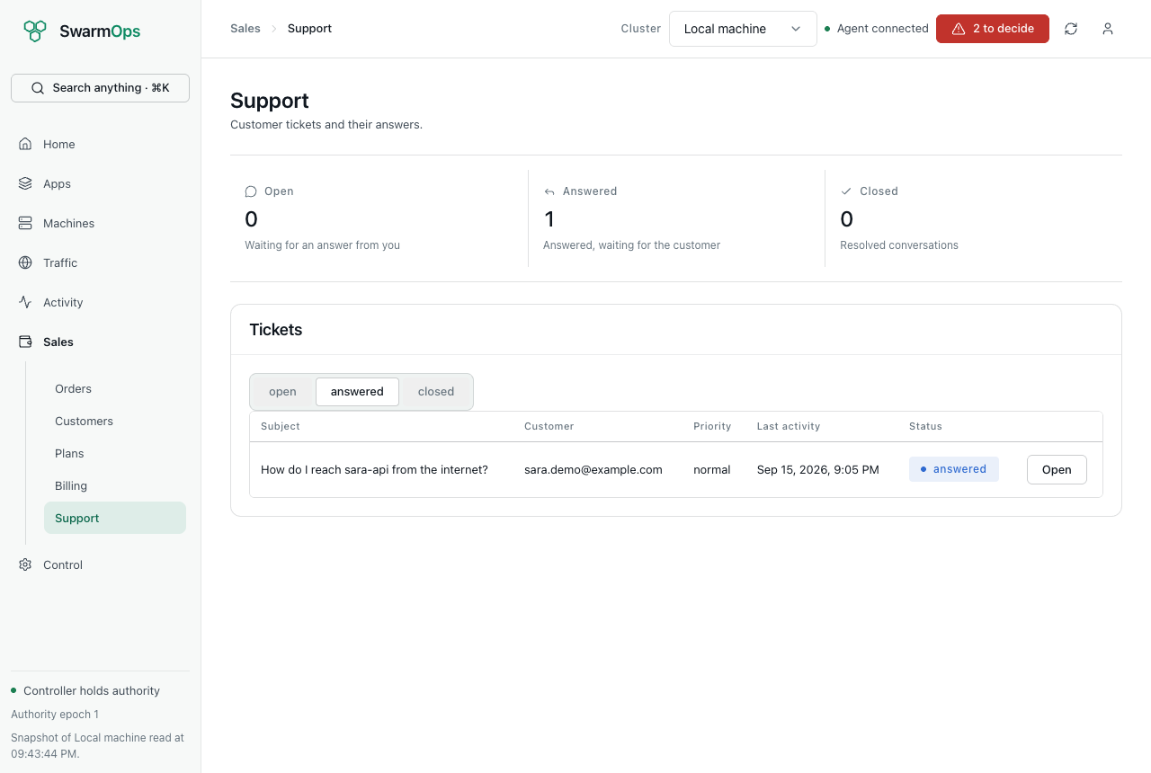
Support tickets

3.8 Messages you may see
Console messages
Message | Meaning and remedy
The customer’s wallet does not hold the required reserve | The wallet holds less than 24 hours of the plan’s price. Ask the customer to top up.
The selected server is not connected to a Swarm manager | Choose a connected manager, or connect one first.
Choose a saved server to deploy on | No server was chosen.
This order is …, not pending | Someone else has already decided the order. Refresh the list.
This control-plane replica is standby… | This controller is not the active one. Use the active controller.
Remote mutations are disabled on this control plane | The controller was started without mutations enabled.
Deployment failure gateway_required | Install the gateway (see Preparing the platform).

