CMPT 225 - Rubiks Cube Solver Project

Name: Nima Salehirad
Professor: Igor Shinkar

Summary

This project solves a 3x3x3 rubiks cube using IDA* algorithm and sub-goal states. The algorithm uses a simple heuristic function to estimate how close the current state is to the final state; it iteratively compares the current state against an array of goals until it arrives at a solution.

- An example of a rubiks cube used in this project:
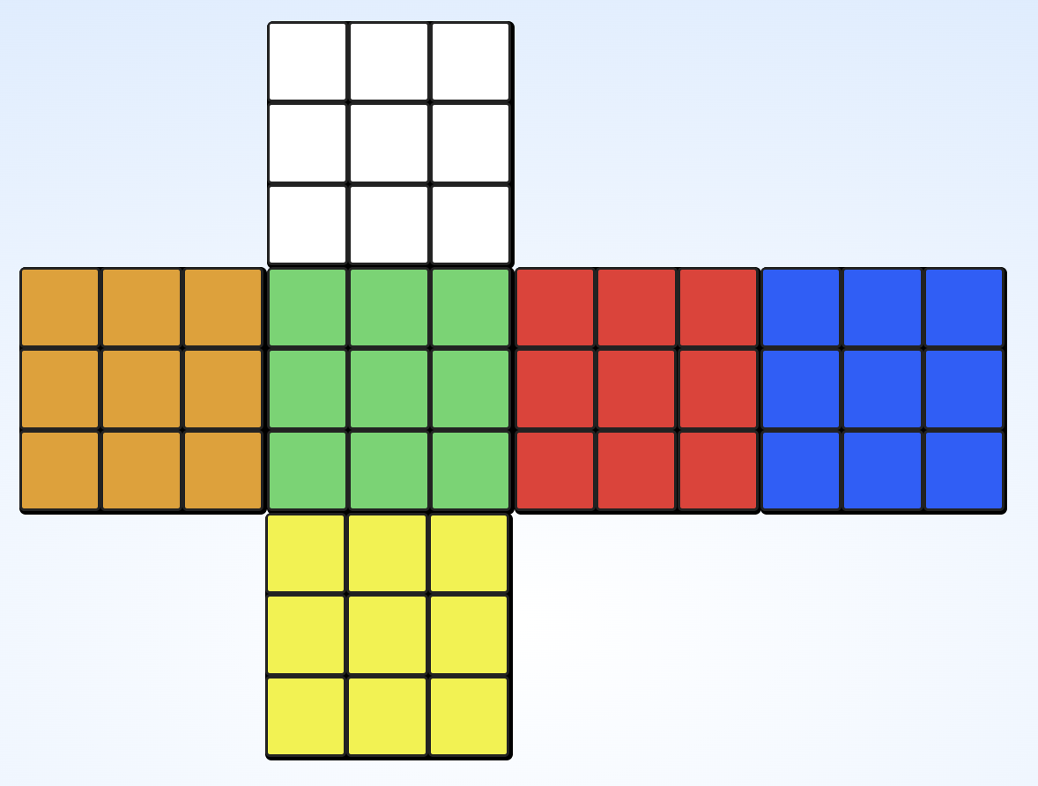
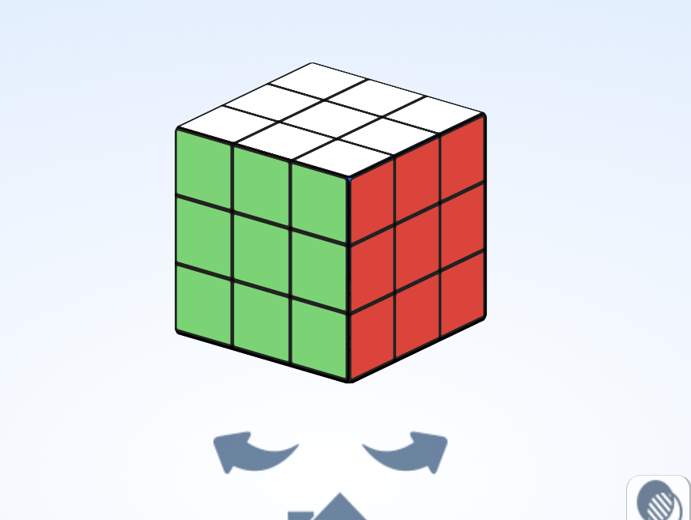
Layer 1

Layer 2

Layer3

sub-goals

The algorithm compares the current state with sub-goal states, which are themselves derived from a beginner friendly method explained in the article below, beginners method (how most cubers first learn to solve it) is a relatively good method to be implemented.

https://ruwix.com/the-rubiks-cube/how-to-solve-the-rubiks-cube-beginners-method/

This project uses a series of goal states which are sub-goals of the final solved state of the cube. I implemented an auxiliary algorithm that takes the current state of the rubik's cube to one of the solved states and “bridges” between that goal state and the final solved state.

A list of goals is implemented and each goal must analyze the cube to find if it is consistent with the previous goal checks. This means the current goal is only passed if all previous goals have passed the check.

In order to implement a beginner solve method, the steps include checks of:

- Solve the white cross (all 4 white edge pieces in correct position forms a cross)
- Solve at least one white corner.
- Solve at least two white corners.
- Solve at least three white corners.
- Solve all four white corners (the entire white layer is solved).
- Move ion to the second layer
- Solve one edge piece in the second layer.
- Solve two second-layer edges.
- Solve three second-layer edges.
- Solve all four edges in the second layer (the whole second layer is done).
- Make all yellow edges face the yellow side correctly.
- Solve the yellow cross (all yellow edges correctly placed).
- At least one yellow corner is in the correct position (orientation doesn’t matter yet).
- All yellow corners are in the correct positions.

Heuristic
IDA* search uses a heuristic function to estimate f(n), how close we are to obtaining a solution from the current state. This helps the algorithm to skip paths that are not likely to produce a solved state.

The heuristic used here simply counts how many pieces are not yet solved.
If we want the heuristic to be admissible (never overestimating the remaining cost), we divide this value by 8. The reason is that a single cube turn affects 8 pieces, and in the best-case scenario, one move could solve all 8 of those pieces at once. Because of this, we can’t safely assume that “x unsolved pieces = x moves,” since that would overestimate the true cost.

However, while dividing by 8 makes the heuristic admissible, it also makes it less accurate. In practice, it’s extremely rare for a single move to fix 8 pieces, so the admissible heuristic becomes too weak to guide the search efficiently.

The effect is significant:

With the admissible heuristic, IDA* can search only about 8 moves deep before hitting the limit of 1 billion states.

With the non-admissible (but stronger) heuristic, it can reach about 12 moves deep.

In short, making the heuristic admissible improves correctness guarantees but greatly reduces search efficiency.

