CMPT 225 - Rubiks Cube Solver Project

Name: Nima Salehirad
Professor: Igor Shinkar

Summary

This project solves a 3x3x3 rubiks cube using IDA* algorithm and sub-goal states. The algorithm uses a simple heuristic function to estimate how close the current state is to the final state; it iteratively compares the current state against an array of goals until it arrives at a solution.

- An example of a rubiks cube used in this project:
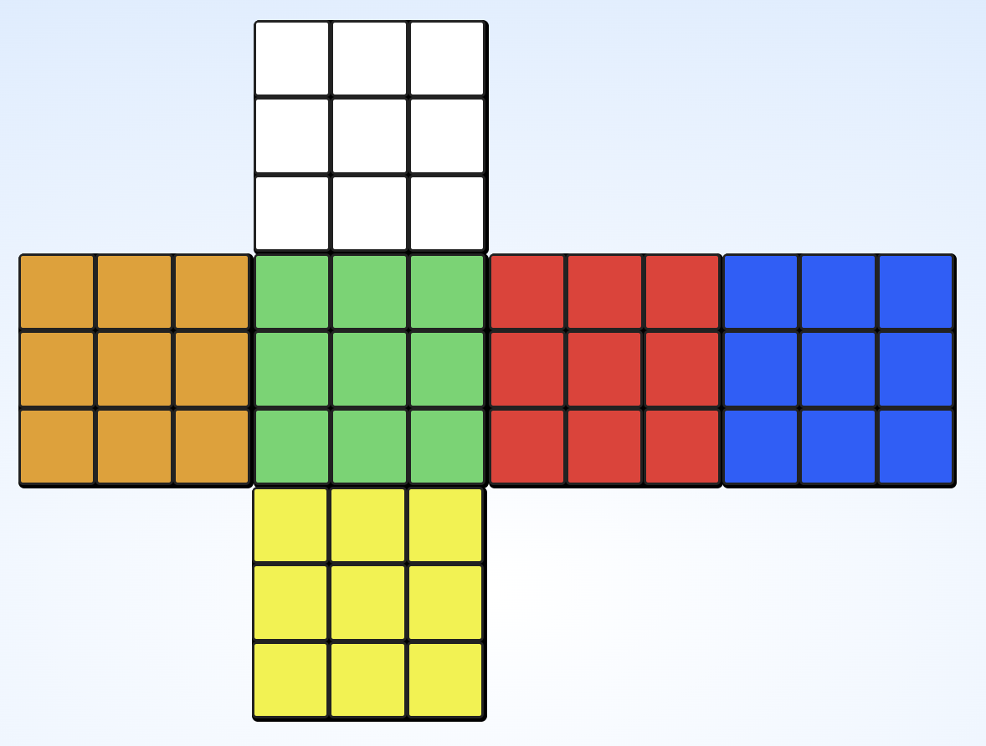
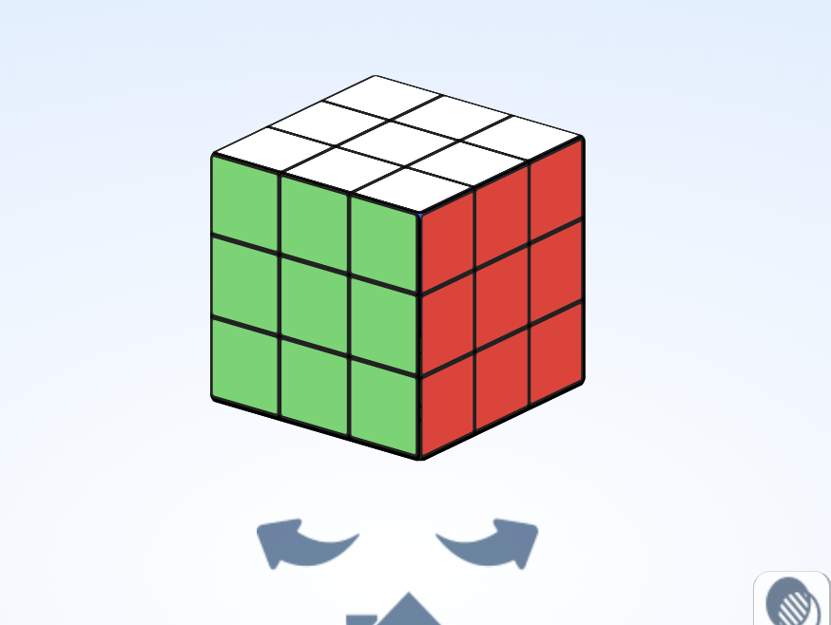
Layer 1

Layer 2

Layer3

sub-goals

The algorithm compares the current state with sub-goal states, which are themselves derived from a beginner friendly method explained in the article below, beginners method (how most cubers first learn to solve it) is a relatively good method to be implemented.

https://ruwix.com/the-rubiks-cube/how-to-solve-the-rubiks-cube-beginners-method/

This project uses a series of goal states which are sub-goals of the final solved state of the cube. I implemented an auxiliary algorithm that takes the current state of the rubik's cube to one of the solved states and “bridges” between that goal state and the final solved state.

A list of goals is implemented and each goal must analyze the cube to find if it is consistent with the previous goal checks. This means the current goal is only passed if all previous goals have passed the check.

In order to implement a beginner solve method, the steps include checks of:

- Solve the white cross (all 4 white edge pieces in correct position forms a cross)
- Solve at least one white corner.
- Solve at least two white corners.
- Solve at least three white corners.
- Solve all four white corners (the entire white layer is solved).
- Move ion to the second layer
- Solve one edge piece in the second layer.
- Solve two second-layer edges.
- Solve three second-layer edges.
- Solve all four edges in the second layer (the whole second layer is done).
- Make all yellow edges face the yellow side correctly.
- Solve the yellow cross (all yellow edges correctly placed).
- At least one yellow corner is in the correct position (orientation doesn’t matter yet).
- All yellow corners are in the correct positions.

Heuristic
IDA* search uses a heuristic function to estimate f(n), how close we are to obtaining a solution from the current state. This helps the algorithm to skip paths that are not likely to produce a solved state.

The heuristic used in this project checks how many pieces are not in the current place. Also in order to make the heuristic admissible (we never want to overestimate the cost of solving the cube) the value is finally divided by 8. Because a single cube turn directly changes 8 pieces (4 corner and 4 edges) that single move could solve all 8 of the pieces at once.

However, by doing some experiments, I realized that not using an admissible heuristic increases the odds of finding a solution. I believe the underlying reason is that admissible heuristic becomes small and is not able to guide the search to a good path.

1st Attempt (failed)
I tried to solve this project using a bidirectional BFS at first, however I was only able to solve the first three scrambles under the time limit. So then I moved to A* and finally IDA* algorithm which was harder to implement compared to two concurrent BFS.

I have included the codes from Bidirectional BFS project in the files as well.

In the Bidirectional BFS method, we start the BFS from the solved state and the current scramble and increase the breadth of the search level by level until we find a state of the cube that is
- Present in the visited states list of the BFS of the scramble
- Present in the visited states list of the scramble
After generating some possible states of scramble, we move on to the solved state and produce some possible states again and search for one state that exists in both trees.

This way, it's possible to construct a path from scramble to solution by :

PATH 1 + INVERSE(PATH2)

BFS tree of possible
States of solved
BFS tree of possible
states of scramble

Path 1
Path 2

