CASE STUDY / N. JAIN / ML_PROJECTS
DIGIT MEMORY
A study in retrieval as classification.
Built three ways. No model trained.

98.4%
HELD-OUT ACCURACY
1-NN on a stratified 75/25 split of the sklearn digits dataset.

01 THE HYPOTHESIS
Hypothesis
The fastest model is the one you don't need. Most ML projects start with what model to use. This one started with a different question.
What if you just stored the data, organized it well, and looked things up? For a dataset of 1797 small samples in 64 dimensions, the answer turns out to be: that's enough.
Two query patterns drive the design. An exact match — the input is byte-identical to something seen — wants a hash table. O(1) lookup. There is no smarter answer.
An approximate match — the input is close but not identical — wants a spatial index. Hashing breaks: change one bit and the hash changes completely. We need a structure that knows about geometric closeness.
The combined system tries the cheap lookup first and falls back to the expensive one only when needed. That is the entire idea.
02 ARCHITECTURE
Two-tier lookup
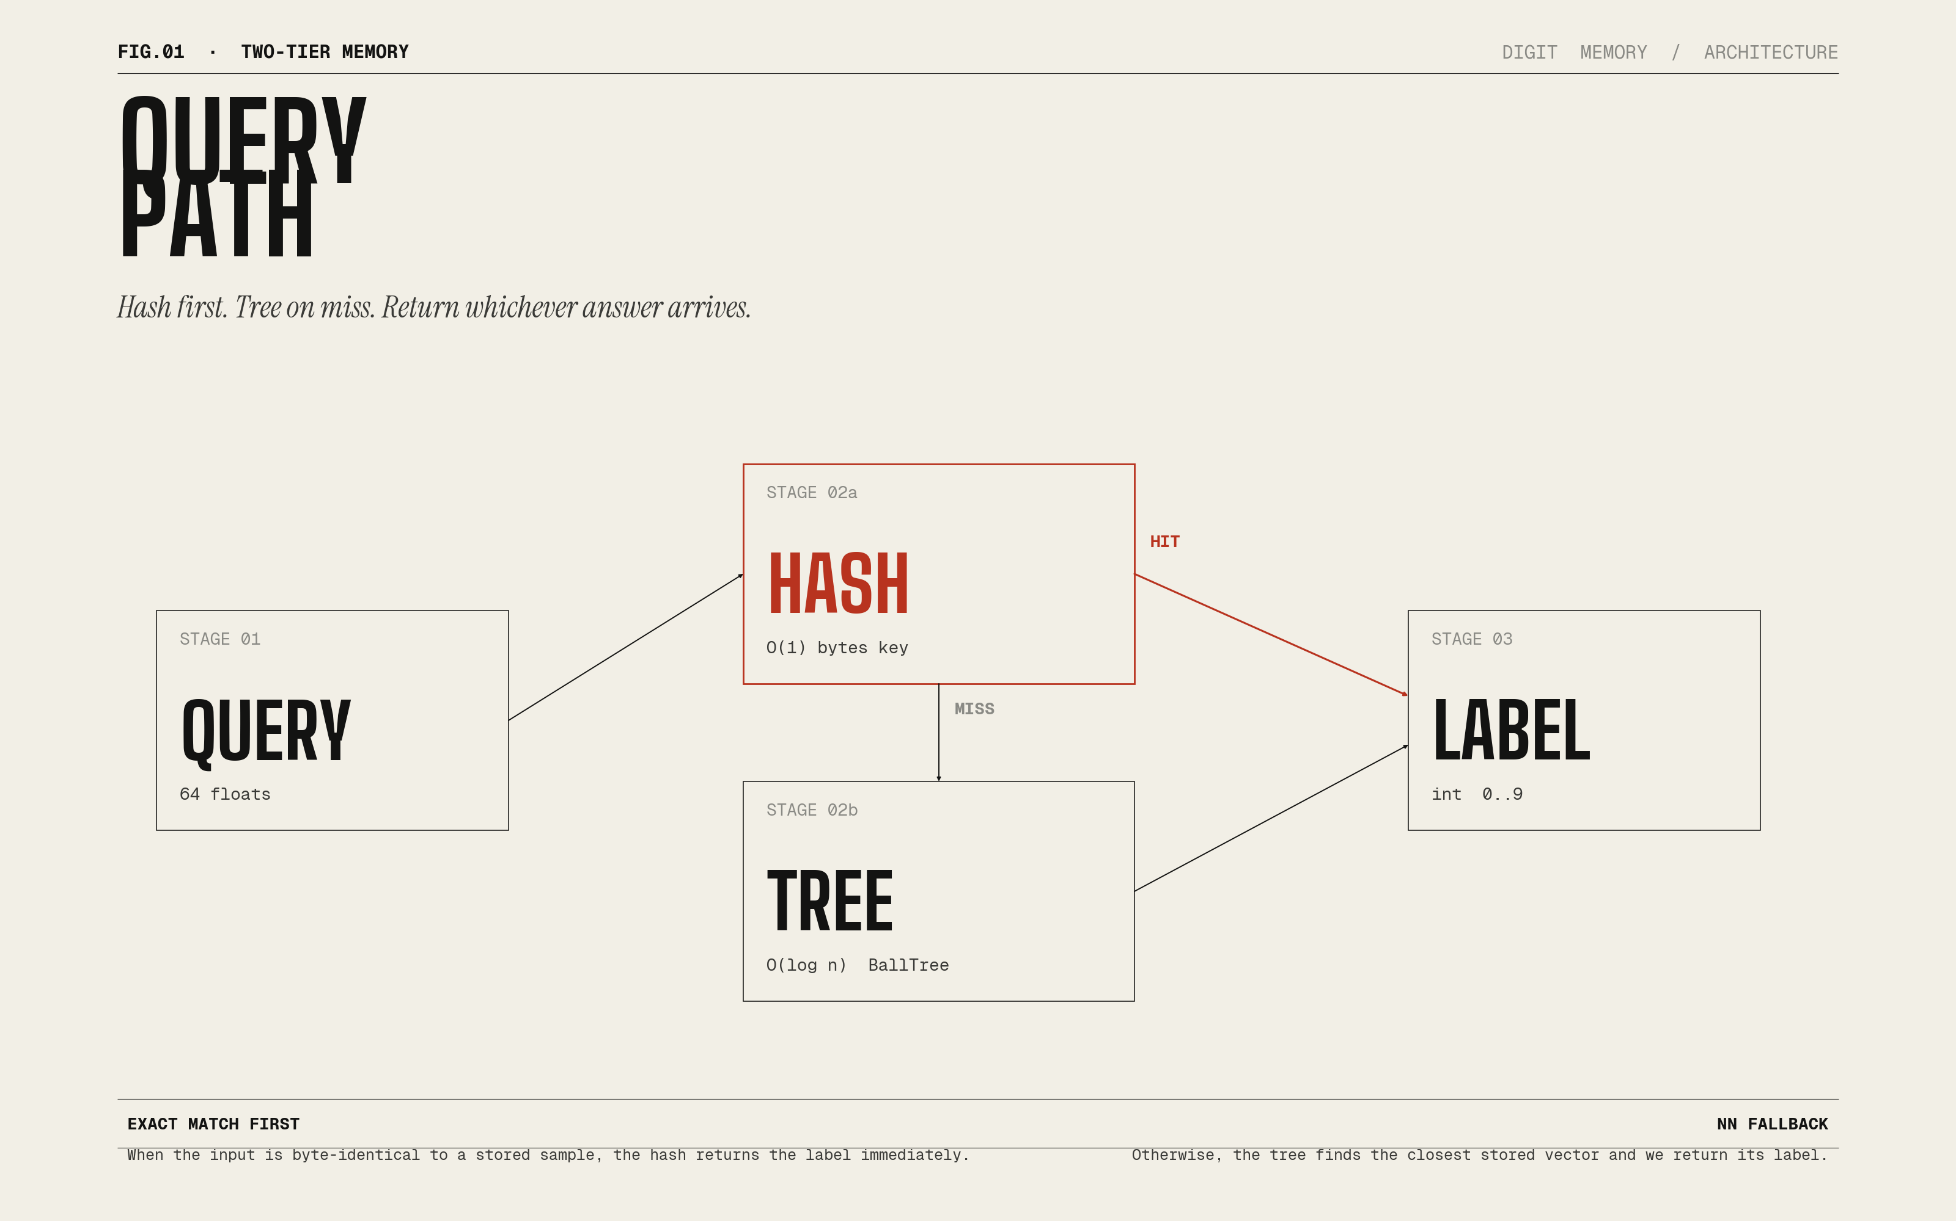
FIG.01 HASH FIRST · TREE ON MISS
Most production lookup systems quietly do this — caches in front of expensive indexes, content-addressed stores in front of full-text search. The same pattern applies cleanly to classification when the data fits in memory.
03 NUMBERS
Numbers
HELD-OUT ACCURACY
98.4%
stratified 75/25 split · 1-NN · no training
EXACT LOOKUP
~3 microseconds
Python dict, bytes(features) -> label
NEAREST NEIGHBOR
~50 microseconds
BallTree query, k=1, 1797 samples
04 ROBUSTNESS
Robustness
Accuracy on the held-out test set with injected Gaussian noise.
Noise sigma (pixel units) | Held-out accuracy
0.0 | 98.4%
0.5 | 98.2%
1.0 | 98.2%
2.0 | 98.4%
3.0 | 97.3%
4.0 | 96.4%
5.0 | 93.8%
7.0 | 84.7%
10.0 | 67.1%

Smooth degradation, no cliff. That is what robust retrieval looks like.
05 THREE IMPLEMENTATIONS
Three ways
Writing the same system three times is the closest I have found to actually understanding it.
PYTHON
digits_memory.py
Production-style. SQLite persistence. sklearn KDTree.
Use when you want the cleanest summary.
JUPYTER
digits_study_guide.ipynb
43 cells. Pandas DataFrames. Three NN backends benchmarked.
Use when you want to learn the project hands-on.
C
digits_memory.c
Zero dependencies. FNV-1a open-addressed hash. Brute-force NN.
Use when you want to understand every byte.
06 TAKEAWAYS
What I learned
01. Retrieval is a criminally underused baseline.
Before tuning a model, ask whether you can just remember the answer. On small-to-medium data the answer is often yes.
02. Match the structure to the query distribution.
Exact lookups want a hash. Approximate lookups want a tree. Production systems should usually do both.
03. Tree NN is not always faster than brute force.
At 1797 samples and 64 dimensions, vectorized numpy beat KDTree and BallTree. Asymptotics flip at larger N. Always benchmark.
04. Hash key choice matters.
`array.tobytes()` is the right key for numpy arrays. `tuple(array)` is slower. The difference is measurable.
05. Writing the same system three ways compounds understanding.
Python lets you build it. C makes you understand it.
07 COLOPHON
Colophon
Design philosophy Computational Quiet
Display typeface Big Shoulders Bold (Helvetica in this DOCX)
Body typeface Instrument Sans (Helvetica in this DOCX)
Mono typeface Geist Mono (Menlo in this DOCX)
Repository github.com/nimb-ou/ML_projects
License MIT
Author Nimit Jain

