1.INDEX.HTML
<!DOCTYPE html>
<html lang="en">
<head>
<meta charset="UTF-8">
<title>Student Portfolio - Home</title>
<link rel="stylesheet" href="style.css">
</head>
<body>

<!-- =========================
NAVIGATION BAR (COMMON)
========================== -->
<header>
<nav class="navbar">
<div class="logo">Student Portfolio</div>

<ul class="nav-links">
<li><a href="index.html" class="active">Home</a></li>
<li><a href="about.html">About</a></li>
<li><a href="skills.html">Skills</a></li>
<li><a href="contact.html">Contact</a></li>
</ul>
</nav>
</header>

<!-- =========================
HOME SECTION
========================== -->
<section class="home-section">
<div class="welcome-box">
<h1>Welcome to My Portfolio</h1>
<p>
This website showcases my personal details, academic skills, projects, and
a contact form to reach out to me. Scroll through the website to explore
everything about my student journey and achievements.
</p>
</div>

<!-- Float example (required) -->
<img src="https://c8.alamy.com/comp/2M7JAAR/personal-website-icon-simple-line-element-recruitment-symbol-for-templates-web-design-and-infographics-2M7JAAR.jpg" class="home-image" alt="Profile Image">
<div class="clear"></div>
</section>

</body>
</html>

2.ABOUT.HTML
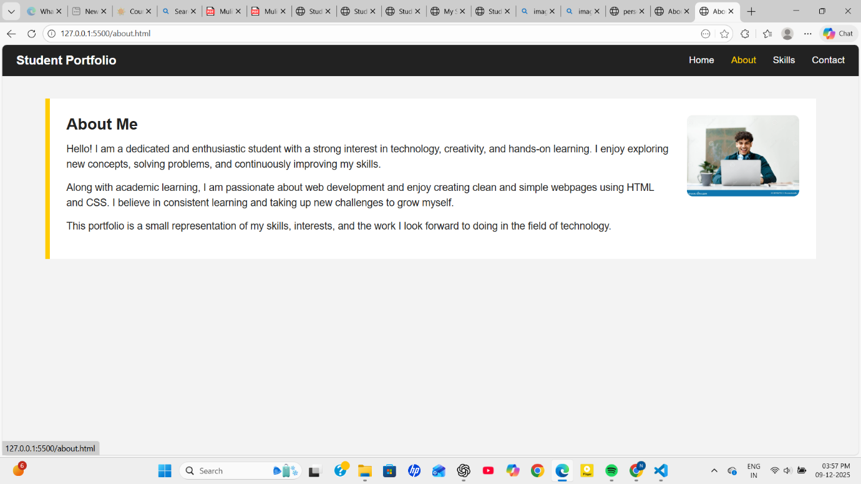
<!DOCTYPE html>
<html lang="en">
<head>
<meta charset="UTF-8">
<title>About Me</title>
<link rel="stylesheet" href="style.css">
</head>
<body>

<!-- =========================
NAVIGATION BAR (COMMON)
========================== -->
<header>
<nav class="navbar">
<div class="logo">Student Portfolio</div>

<ul class="nav-links">
<li><a href="index.html">Home</a></li>
<li><a href="about.html" class="active">About</a></li>
<li><a href="skills.html">Skills</a></li>
<li><a href="contact.html">Contact</a></li>
</ul>
</nav>
</header>

<!-- =========================
ABOUT ME SECTION
========================== -->
<section class="about-section">

<!-- FLOAT IMAGE -->
<img src="https://thumbs.dreamstime.com/z/happy-european-freelancer-man-working-laptop-wearing-headphones-neck-smiling-sitting-light-office-student-using-computer-287980722.jpg?ct=jpeg" alt="Profile Photo" class="about-img">

<h2>About Me</h2>

<p>
Hello! I am a dedicated and enthusiastic student with a strong interest in
technology, creativity, and hands-on learning. I enjoy exploring new concepts,
solving problems, and continuously improving my skills.
</p>

<p>
Along with academic learning, I am passionate about web development and enjoy
creating clean and simple webpages using HTML and CSS. I believe in
consistent learning and taking up new challenges to grow myself.
</p>

<p>
This portfolio is a small representation of my skills, interests, and the
work I look forward to doing in the field of technology.
</p>

<!-- Clear float -->
<div class="clear"></div>

</section>

</body>
</html>

3.skills.html
<!DOCTYPE html>
<html>
<head>
<title>My Skills & Projects</title>
<link rel="stylesheet" href="style.css">
</head>
<body>

<!-- Navigation -->
<nav>
<div class="logo">Student Portfolio</div>
<ul>
<li><a href="index.html">Home</a></li>
<li><a href="about.html">About</a></li>
<li><a href="skills.html">Skills</a></li>
<li><a href="contact.html">Contact</a></li>
</ul>
</nav>

<!-- SKILLS CONTENT -->
<div class="skills-container">
<h2>My Skills & Projects</h2>

<div class="skills-flex">

<!-- Card 1 -->
<div class="skill-card">
<h3>Web Development</h3>
<p>I create responsive web pages using HTML and CSS.</p>
</div>

<!-- Card 2 -->
<div class="skill-card">
<h3>C Programming</h3>
<p>Experience in building small programs and solving logic problems.</p>
</div>

<!-- Card 3 -->
<div class="skill-card">
<h3>Mini Projects</h3>
<p>Worked on academic mini-projects using basic coding and design.</p>
</div>

</div>
</div>

</body>
</html>

4.contact.html
<!DOCTYPE html>
<html lang="en">
<head>
<meta charset="UTF-8">
<title>Contact Me</title>
<link rel="stylesheet" href="style.css">
</head>
<body>

<!-- =========================
NAVIGATION BAR (COMMON)
========================== -->
<header>
<nav class="navbar">
<div class="logo">Student Portfolio</div>

<ul class="nav-links">
<li><a href="index.html">Home</a></li>
<li><a href="about.html">About</a></li>
<li><a href="skills.html">Skills</a></li>
<li><a href="contact.html" class="active">Contact</a></li>
</ul>
</nav>
</header>

<!-- =========================
CONTACT FORM SECTION
========================== -->
<section class="contact-section">
<h2>Contact Me</h2>

<form class="contact-form">

<!-- Name -->
<label>Your Name</label>
<input type="text" name="name" placeholder="Enter your name" required>

<!-- Email -->
<label>Your Email</label>
<input type="email" name="email" placeholder="Enter your email" required>

<!-- Subject -->
<label>Subject</label>
<input type="text" name="subject" placeholder="Enter subject" required>

<!-- Message -->
<label>Message</label>
<textarea name="message" rows="5" placeholder="Write your message..." required></textarea>

<!-- Submit Button -->
<button type="submit">Send Message</button>

</form>
</section>

</body>
</html>

/* ==================================
GLOBAL RESET + BASIC STYLES
================================== */

* {
margin: 0;
padding: 0;
box-sizing: border-box;
font-family: Arial, Helvetica, sans-serif;
}

body {
background: #f3f3f3;
color: #222;
}

/* ==================================
NAVIGATION BAR (COMMON)
================================== */

.navbar {
background: #222;
color: white;
padding: 15px 25px;

display: flex; /* Flexbox */
justify-content: space-between;
align-items: center;
}

.logo {
font-size: 22px;
font-weight: bold;
}

.nav-links {
list-style: none;
display: flex;
gap: 30px;
}

.nav-links li a {
color: white;
text-decoration: none;
font-size: 17px;
}

.nav-links li a:hover,
.nav-links .active {
color: #ffcc00;
}

/* ==================================
HOME PAGE
================================== */

.home-section {
width: 90%;
margin: 40px auto;
}

.welcome-box {
background: white;
padding: 30px;
border-left: 8px solid #ffcc00;
margin-bottom: 20px;
}

.welcome-box h1 {
font-size: 35px;
margin-bottom: 15px;
}

.welcome-box p {
font-size: 18px;
line-height: 1.5;
}

/* Float image (Required) */
.home-image {
width: 260px;
float: right;
margin-left: 25px;
border-radius: 10px;
}

.clear {
clear: both;
}

/* ==================================
ABOUT PAGE
================================== */

.about-section {
width: 90%;
margin: 40px auto;
background: white;
padding: 30px;
border-left: 8px solid #ffcc00;
}

.about-section h2 {
font-size: 28px;
margin-bottom: 15px;
}

.about-section p {
font-size: 18px;
line-height: 1.5;
margin-bottom: 15px;
}

/* Float image (Required) */
.about-img {
width: 200px;
float: right;
margin-left: 25px;
border-radius: 10px;
}

/* ==================================
SKILLS & PROJECTS PAGE
================================== */

.skills-section {
width: 90%;
margin: 40px auto;
}

.skills-section h2 {
font-size: 28px;
margin-bottom: 20px;
}

/* Flexbox layout for cards */
.skills-flex {
display: flex; /* Flexbox (Required) */
gap: 20px;
}

.skill-card {
background: white;
padding: 20px;
width: 30%;
border: 2px solid #ddd;
border-radius: 10px;
}

.skill-card h3 {
font-size: 22px;
margin-bottom: 10px;
}

.skill-card p {
font-size: 17px;
line-height: 1.4;
}

/* ==================================
CONTACT PAGE
================================== */

.contact-section {
width: 90%;
margin: 40px auto;
background: white;
padding: 30px;
border-left: 8px solid #ffcc00;
}

.contact-section h2 {
font-size: 28px;
margin-bottom: 20px;
}

.contact-form label {
font-size: 17px;
margin-top: 10px;
display: block;
}

.contact-form input,
.contact-form textarea {
width: 100%;
margin: 10px 0 20px 0;
padding: 12px;
border-radius: 5px;
border: 1px solid #aaa;
font-size: 16px;
}

.contact-form button {
background: #5d10f7;
color: rgb(222, 253, 23);
padding: 12px 20px;
border: none;
font-size: 16px;
border-radius: 5px;
cursor: pointer;
}

.contact-form button:hover {
background: #08df0b;
}
Style.css code above

