**Lesson 4 Demo 2**

**Configuring Bucket Versioning**

|  |
| --- |
| **Objective:** To configure versioning for an S3 bucket  **Tools required:** Linux, AWS account  **Prerequisites:** None |

Steps to be followed:

1. Enabling bucket versioning for an S3 bucket
2. Uploading files to an S3 bucket
3. Re-uploading the same files to check the enabled versioning

**Step 1: Enabling bucket versioning for an S3 bucket**

1. Go to the **AWS Management Console,** and navigate to **S3 Management Console**
2. From the **Bucket name** list, select a bucket where versioning needs to be enabled
3. Go to the **Properties** tab
4. Choose **Versioning,** select **Enable versioning**, and then click on the **Save** button
5. This will enable the versioning for the selected S3 bucket

**Step 2: Uploading files to an S3 bucket**

1. From the **Bucket name** list, select the bucket with versioning enabled
2. Select **Upload** in the **Upload** dialog box, and then click on the **Add files** button



1. Select one or more files to upload, and then click **Open**
2. Once the files are added, either click **Upload** to immediately upload the files or click **Next** to set permissions for the files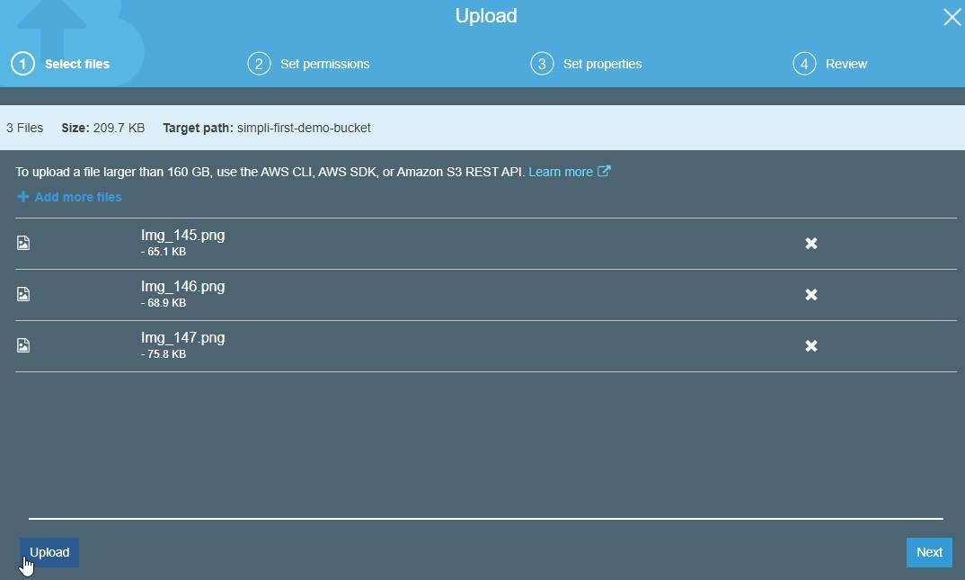
3. Once the upload is complete, the newly uploaded files will be displayed

**Step 3:** Re-uploading the same files to check the enabled versioning

1. Follow all the steps from Step 4.2.2 to re-upload all the files
2. Select the **Show** tab next to **Versions** to show multiple versions of the files