**Lesson 11 Demo 5**

**CloudFormation**



Steps to be followed:

1. Create a Stack
2. In the sample template, choose LAMP Stack and click on View template in Designer
3. Upload the design to the stack
4. Define the parameters.
5. Check whether the LAMP server is working

**Step 1: Create a Stack**

1. In your AWS Management Console, search for and select **CloudFormation**
2. Now, click on **Create Stack**

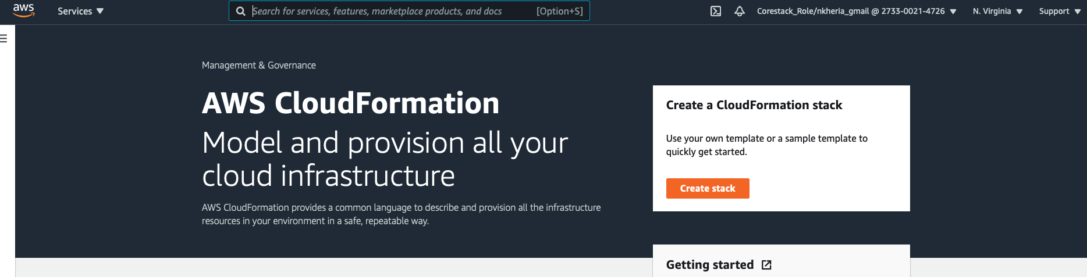

**Step 2: In the sample template, choose LAMP Stack and click on View template in Designer.**

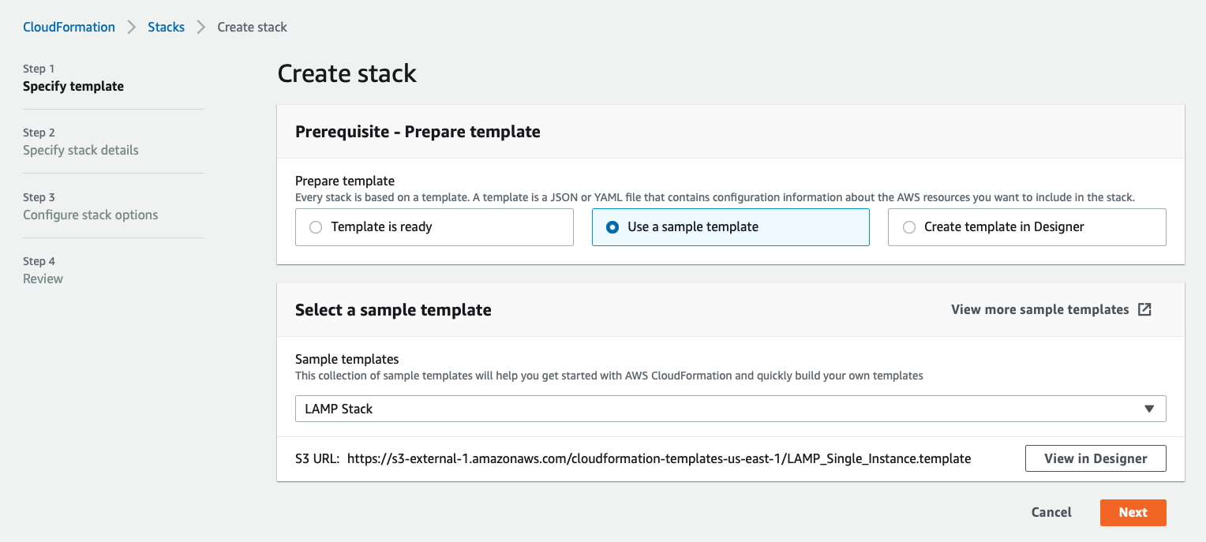

**Step 3: Upload the design to the stack.**

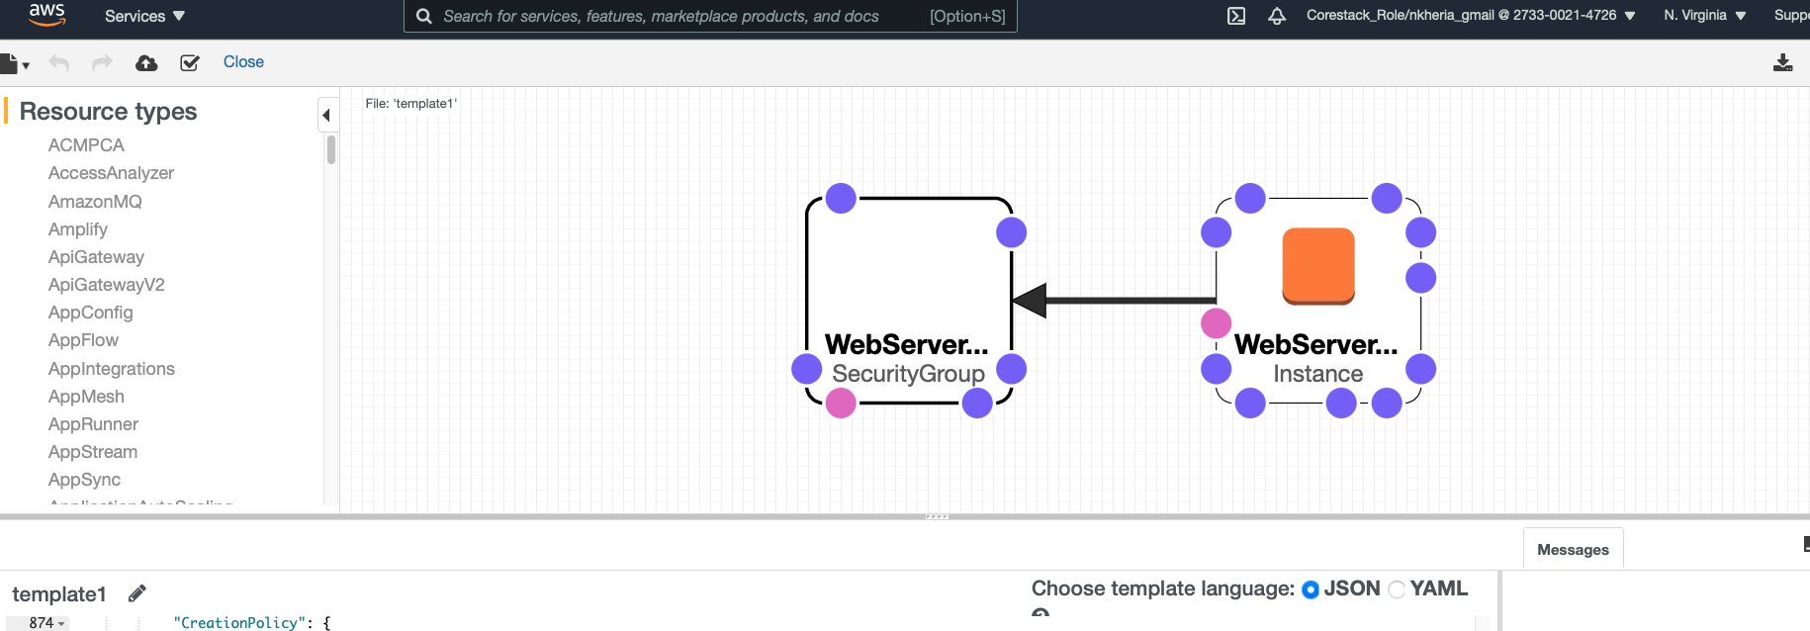

1. Click on **Next**.

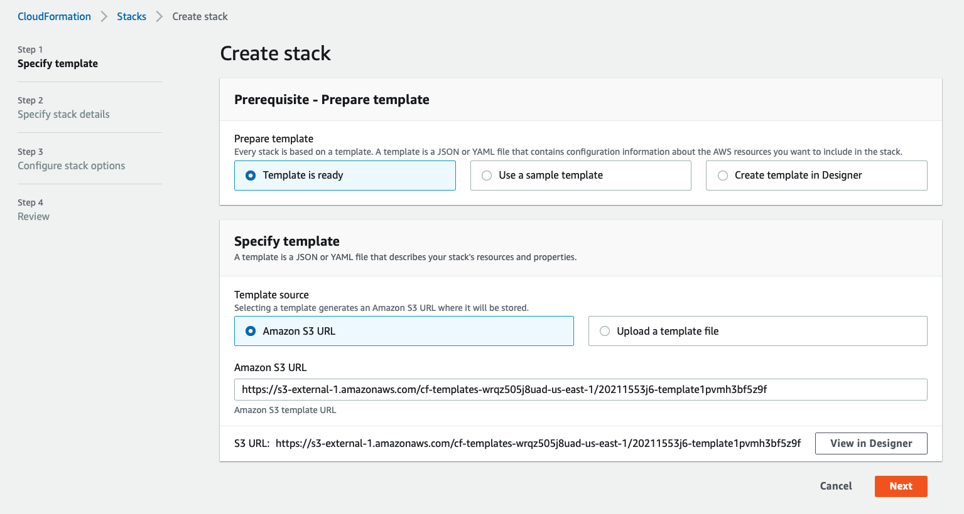

**Step 4: Define the parameters.**

1. Click on **Next**

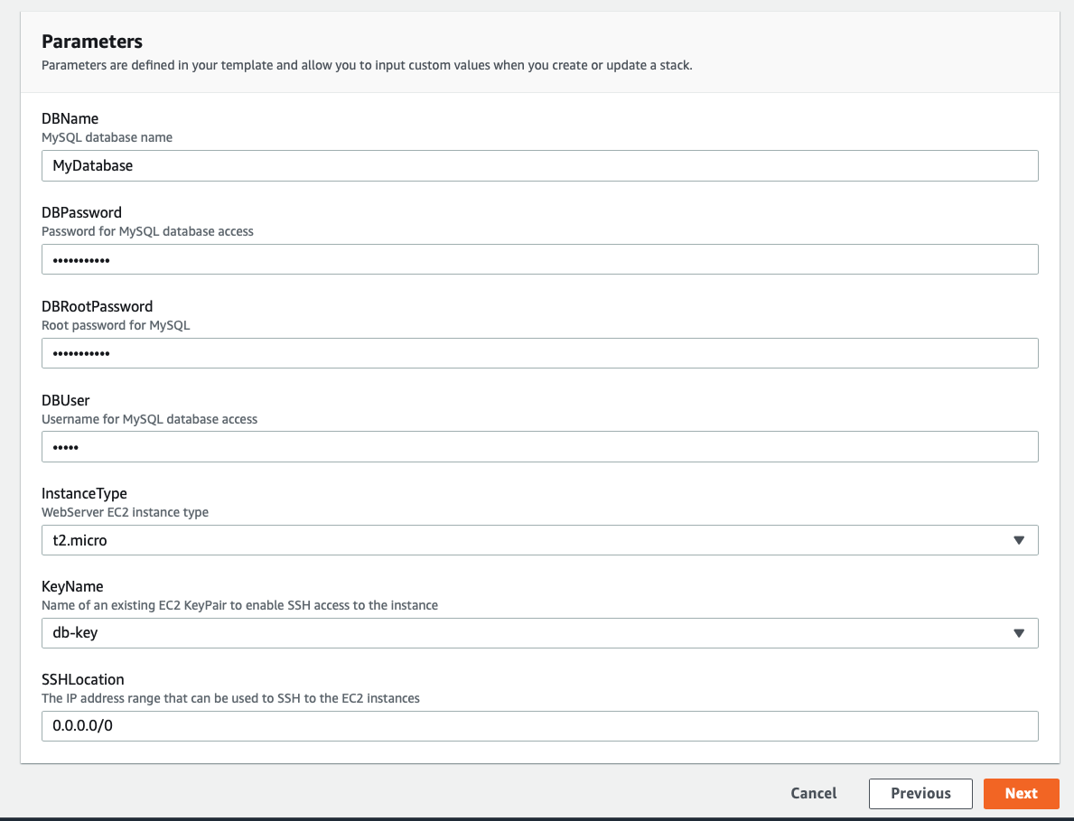

1. Again, click on **Next**
2. Finally, click on **Create** 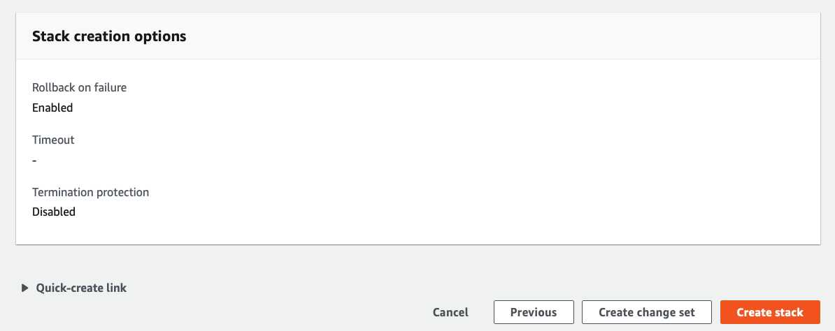
3. Check whether your stack is created in CloudFormation dashboard

