**Lesson 11 Demo 2**

**CodeCommit**



Step to be followed:

1. Create an AWS CodeCommit Repository
2. Create a file
3. Create a Branch
4. Now set your default branch to developer
5. Restrict your user from accessing the master branch
6. Add files to your developer branch through the IAM user.
7. View your commits
8. Merge the branch
9. Accept the merge request

**Step 1: Create an AWS CodeCommit Repository**

1. In your AWS Management Console, search for and select CodeCommit
2. Click on **Create Repository**

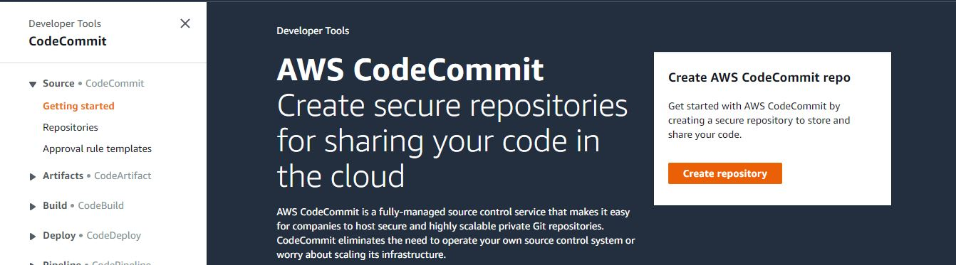

1. Write a name and description for your Repository
2. Then, click on **Create**

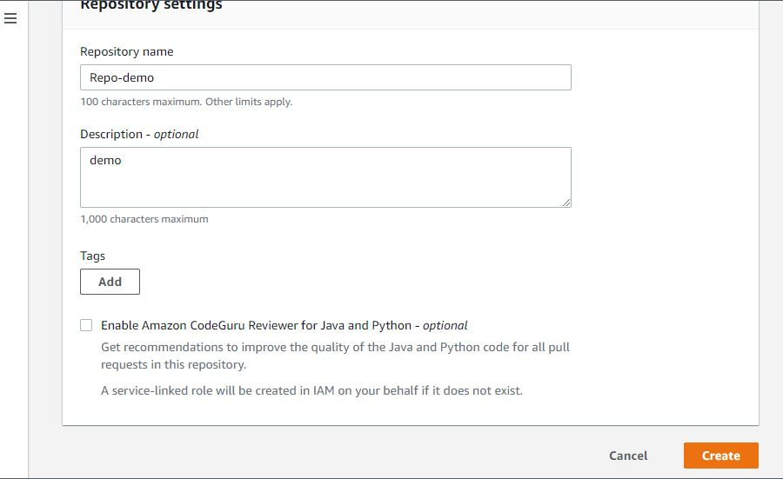

**Step 2: Create a file**

1. In your navigation tab, go to **Code** and click on **Create file**

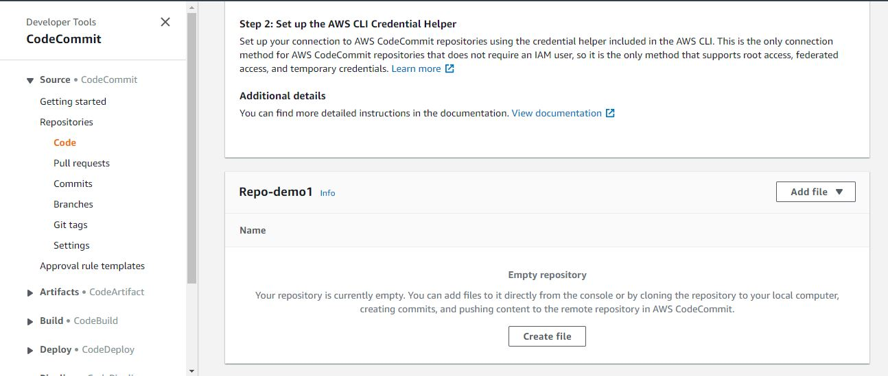

<html>  
<header><title>This is title</title></header> <body>  
Hello world  
</body>  
</html>

1. Give a file name as **hello.txt**
2. Draft the author’s name and assign an email address to your file
3. Click on **Commit changes**

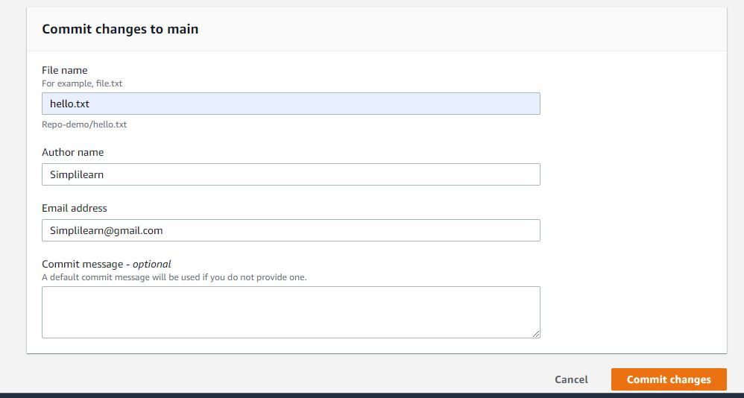

1. Your file will always be committed to the master branch, which is not secure
2. To ensure the security of your file, create a separate branch

**Step 3: Create a Branch**

1. In your navigation tab, go to the branch and click on **Create branch**

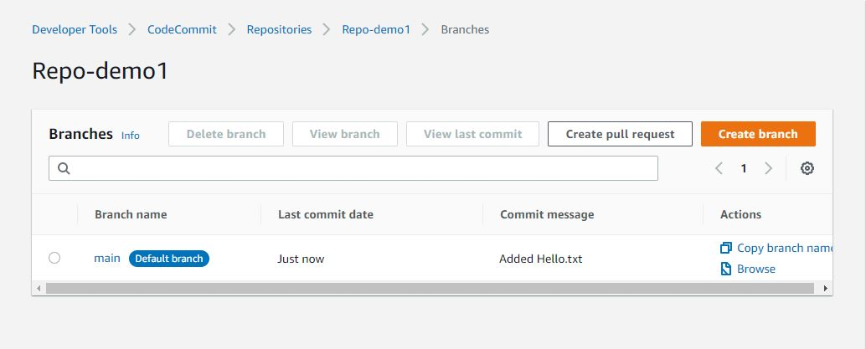

1. Write your branch name as **developer**
2. Choose the **branch from** as main

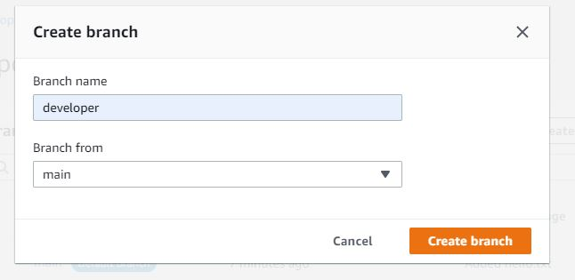

**Step 4: Now set your default branch to developer**

1. In your navigation tab, go to **Settings**
2. In the default branch, choose the branch as **developer**
3. Click on **Save**

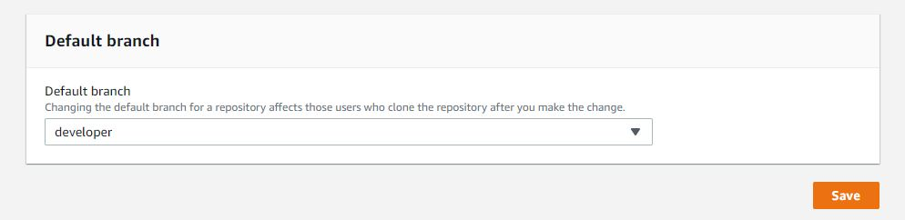

**Step 5: Restrict your user from accessing the master branch**

1. Go to your AWS Management Console, search for and select **IAM**
2. Create a policy to restrict the user from accessing the master branch

{

"Version": "2012-10-17",

"Statement": [

{

"Effect": "Deny",

"Action": [

"codecommit:GitPush",

"codecommit:DeleteBranch",

"codecommit:PutFile",

"codecommit:MergePullRequestByFastForward"

],

"Resource":

"arn:aws:codecommit:us-east-1:658604086198:Repo-demo1",

"Condition": {

"StringEqualsIfExists": {

"codecommit:References": [

"refs/heads/master"

]

},

"Null": {

"codecommit:References": false

}

}

}

]

}

1. Attach it to the users, who you don’t want to have the master branch access

**Step 6: Add files to your developer branch through the IAM user.**

1. In the navigation bar, Choose **Code**
2. Create a file in the name of **hello.txt**

<!DOCTYPE html>  
<html>  
<body>  
<h1> Welcome to CodeCommit </h1> </body>

</html>

1. Give the author’s name and email address
2. Click on **Commit changes**

**Step 7: View your commits**

1. In your navigation tab, go to commits to see all the commits you have done
2. Click on **Compare commits** to check for the changes made

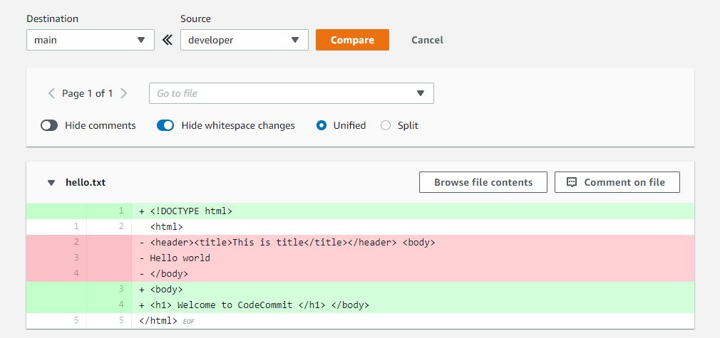

**Step 8: Merge the branch**

1. In your navigation tab, go to **Pull request** and click on **Create a pull request**
2. Choose the source branch as **developer** and destination branch as **master**
3. Click on **Compare**
4. Write a title name
5. Then, click on **Create**

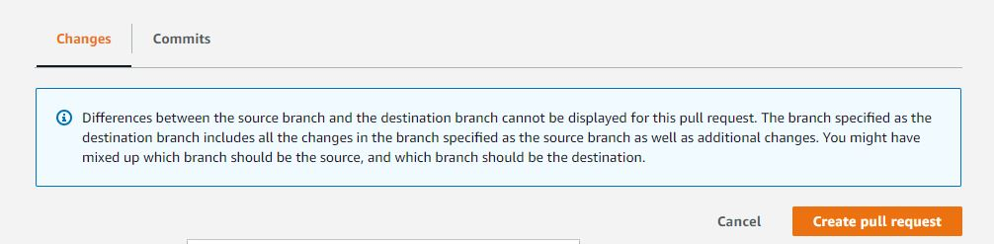

**Step 9: Accept the merge request**

1. Now, through another user to whom you have given master branch access, accept the request
2. Now, you can see the changes in your repository

