**Lesson 3 Demo 3**

**Create a Linux-Based EC2 Instance and Install a Web Server Using User Data**



Steps to be followed:

1. Opening the Amazon EC2 console
2. Configuring an EC2 instance and launching that instance
3. Using the Public IP to check if the web server is accessible

**Step 1: Open the Amazon EC2 console**

1. In the console navigation pane, choose **EC2 Dashboard**

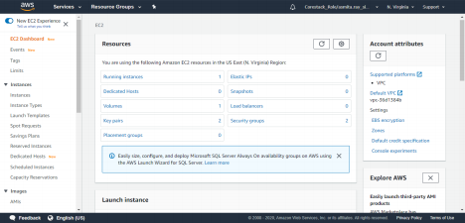



**Step 2: Configuring an EC2 instance and launching that instance**

1. In the **Launch instance section** of the console, choose **Launch instance**

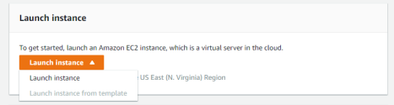

1. On the ​**Step 1: Choose an Amazon Machine Image (AMI)​** page, find the Amazon Linux AMI Free tier eligible AMI, and then click on ​**Select**
2. On the ​**Step 2: Choose an Instance Type​** page, accept the default General

Purpose t2.micro Instance type, and then click on ​**Next: Configure Instance Details**



1. On the ​**Step 3: Configure Instance Details​** page, accept the following default selections or configure them, and then choose ​**Next: Add Storage**

2.4.1 **Number of Instances​**: 1 (default)

2.4.2 **Purchasing option​**: By default, the Request Spot Instances are unchecked.

Spot Instances are not covered under the Free tier option.

2.4.3 **Network​**: Select an existing VPC, or create a new one to determine where to launch the instance

2.4.4 **Subnet​**: Select the default option

2.4.5 **Auto-assign Public IP​**: Select Enable

2.4.6 **IAM role​**: None (default)

2.4.7 **Shutdown behavior​**: Stop (default)

2.4.8 **Enable termination protection​**: Mark the Protect against accidental termination as checked

2.4.9 **Monitoring​**: Mark the Enable CloudWatch detailed monitoring as unchecked **Tenancy​**: By default, the tenancy will be ​**Shared - Run a shared hardware instance​**. Dedicated servers are not covered under the Free tier option.

2.4.10 **User Data​**:

#!/bin/bash

# Use this for your user data (script without newlines)

# install httpd (Linux 2 version) yum update -y yum install -y httpd.x86_64 systemctl start httpd.service systemctl enable httpd.service echo "Hello World from $(hostname -f)" > /var/www/html/index.html





2.5 On the ​**Step 4: Add Storage​** page, enter the following options, and then choose​ **Next: Add Tags**

2.5.1 **Size (GiB)​**: 20

2.5.2 **Volume Type​**: General Purpose (SSD)

2.5.3 **Delete on Termination​**: Unchecked



2.6 On the ​**Step 5: Add Tags​** page, and click on ​**Next: Configure Security Group**



2.7 On the​ **Step 6: Configure Security Group​** page, add the below rules, and then click on ​**Review and Launch**

**SSH : ​**Port 22

**HTTP: ​**Port 80

**HTTPS: ​**Port 443



2.8 On the ​**Step 7: Review Instance Launch​** page, review your instance launch details, and then click on ​**Launch**



2.9 Select an existing key pair or create a new key pair dialog box, create a new key pair from the drop-down list that will be used to access the instance. Give the name of the key pair, download it in your system, and then click on **Launch Instances**

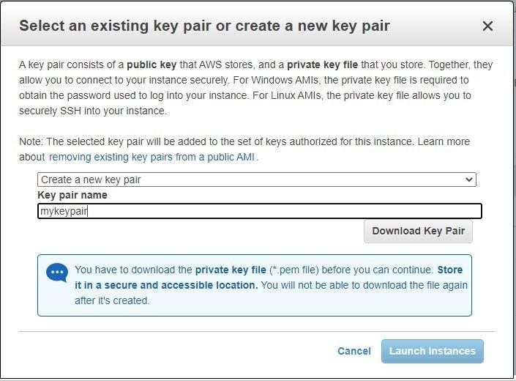

2.10 Your instances are now launching





**Step 3:​ Copy the ​*public IP address,​* and paste it in a new tab of your browser.**

The Web Server is accessible now.

