**Lesson 5 Demo 2**

**Create a Table Using the DynamoDB Console**

|  |
| --- |
| **Objective:** To create a DynamoDB table and perform CRUD operations  **Tools required:** Linux, AWS account  **Prerequisites:** None |

Steps to be followed:

1. Go to the AWS Management Console and click on DynamoDB service
2. Click on Create table under DynamoDB Dashboard
3. Enter the Table name and primary key and click on Create
4. When the table is created, you can check the Table details
5. To insert data in the table, go to Items and click on Create item
6. Check the format of writing, insert the data, and click on the Save button
7. Once data is inserted successfully, you can read it on the dashboard
8. To delete or remove the item, click on Remove, and if you want to add an item, click on Insert
9. To delete a table, click Delete Table

**Step 1: Go to the AWS Management Console and click on DynamoDB service**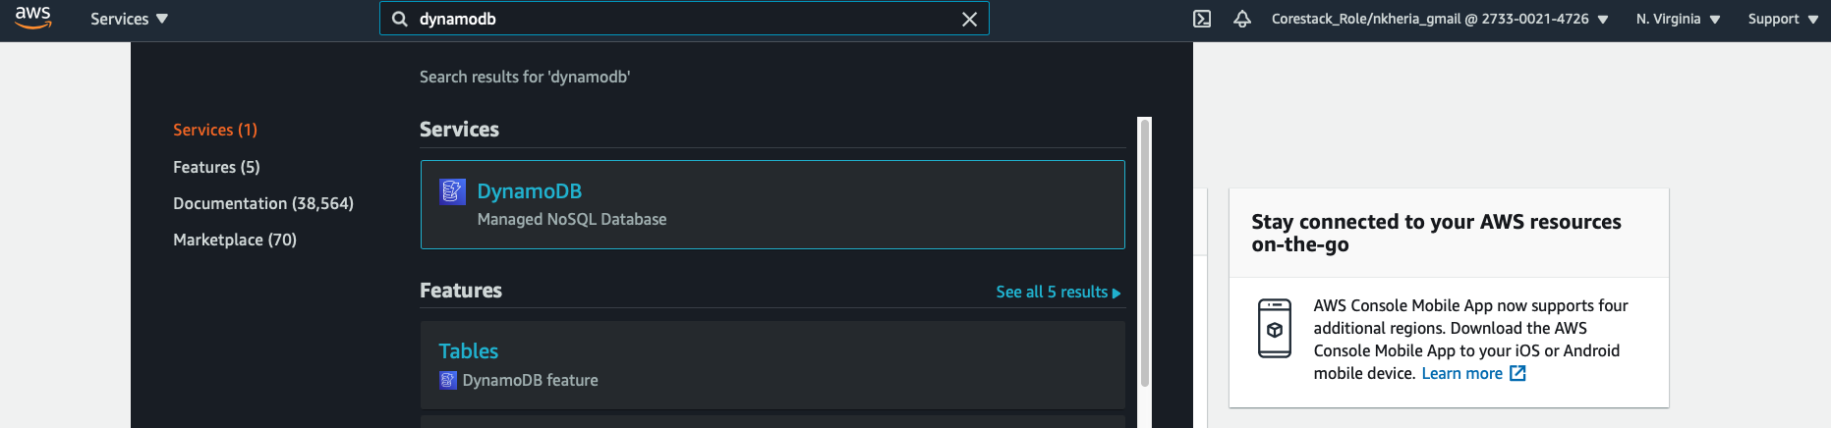

**Step 2: Click on Create table under DynamoDB Dashboard**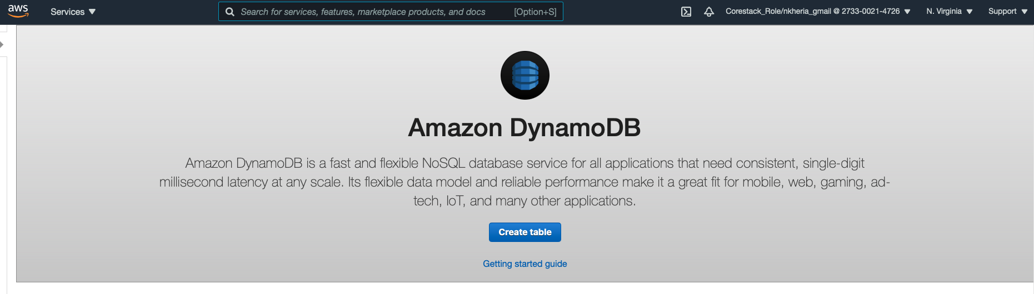

**Step 3: Enter the Table name and primary key and click on Create**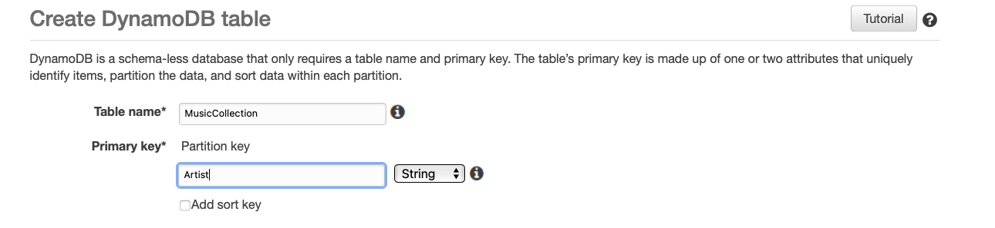

**Step 4: When the table is created, you can check the Table details**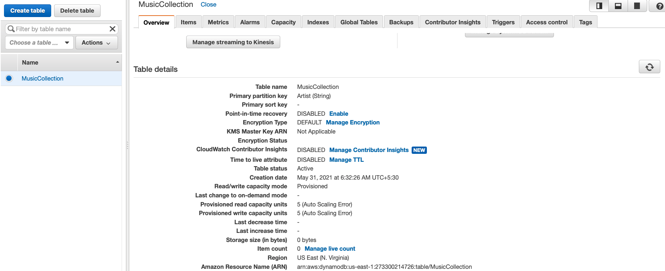

**Step 5: To insert data in the table, go to Items and click on Create item**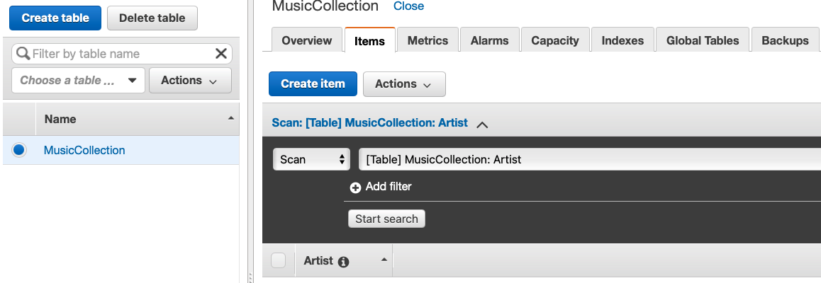

**Step 6: Check the format of writing, insert the data, and click on the Save button**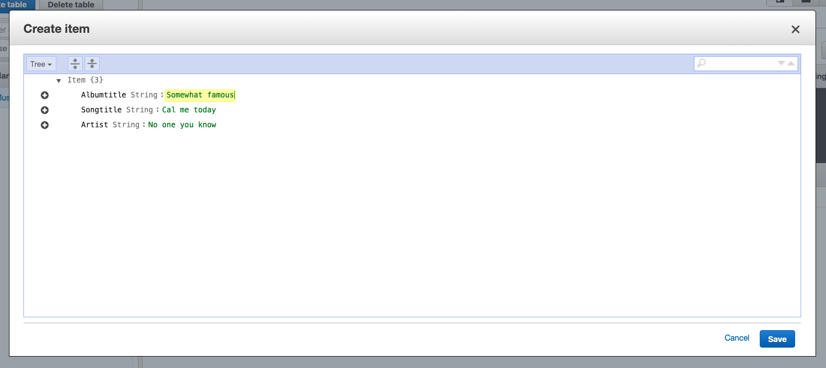

**Step 7: Once data is inserted successfully, you can read it on the dashboard**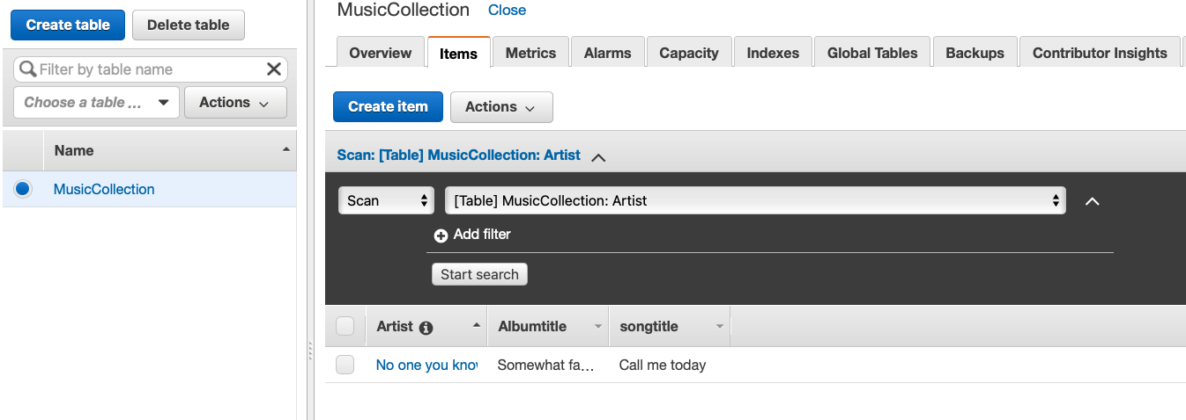

**Step 8: To delete or remove the item, click on Remove, and if you want to add an item, click on Insert**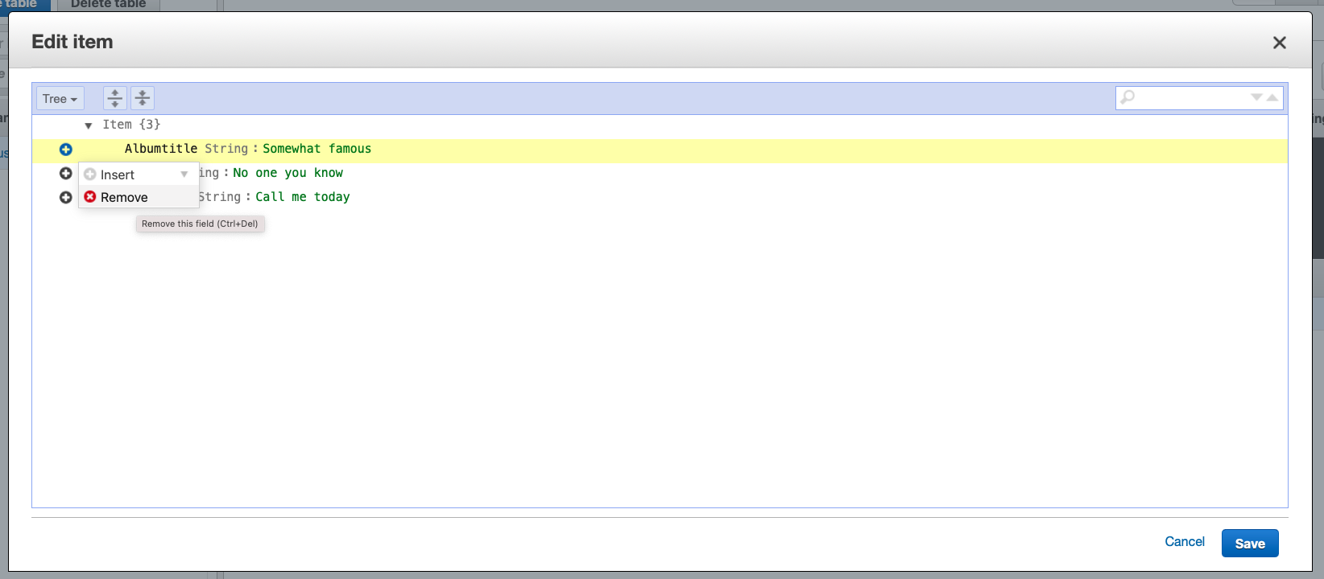

**Step 9: To delete a table, click Delete Table**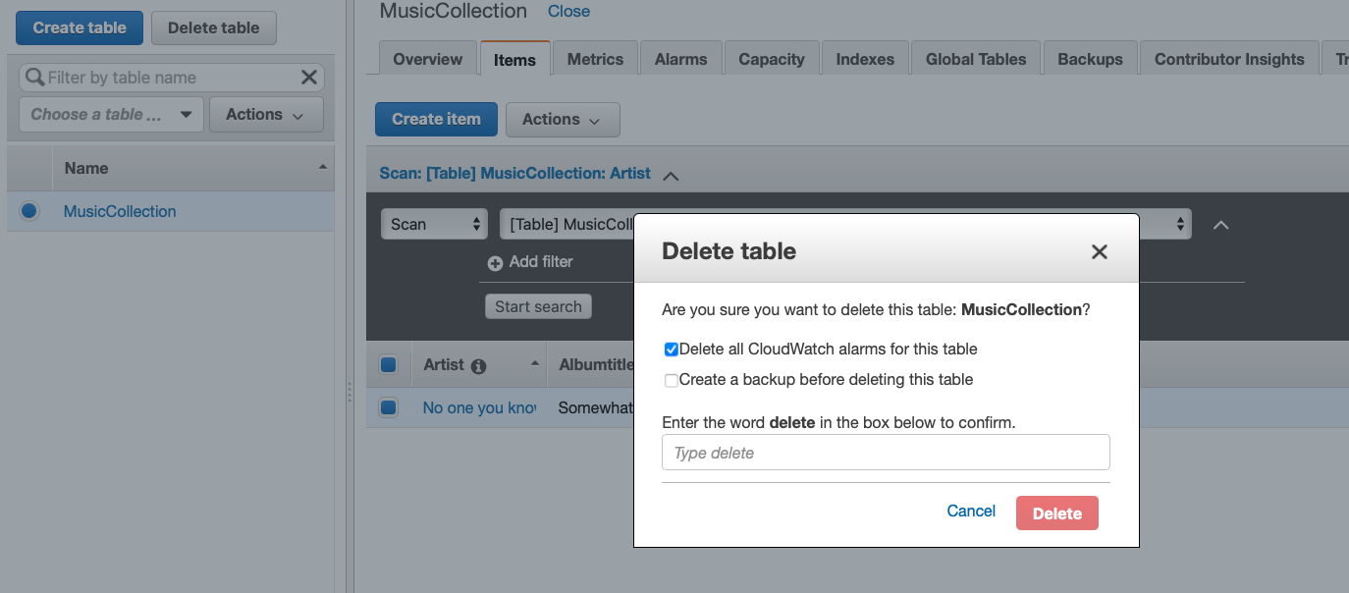

**Conclusion:**

We have successfully created a table in DynamoDB and performed CRUD operations in it.