**Lesson 8 Demo1**

**Creating an IAM User**

**Objective:** Create a custom IAM user

**Expected Deliverables:**

Screenshot of your IAM user in the dashboard

**Steps to be followed:**

1. Creating an IAM user

**Step 1:** Creating an IAM user

1.1 Go to your Amazon console

1.2 Search for IAM in the search bar

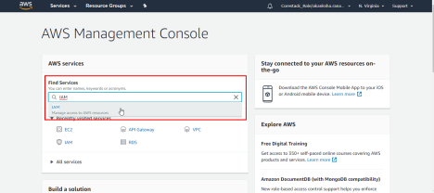

1.3 In the IAM dashboard, click on **Users** as shown in the following screenshot:

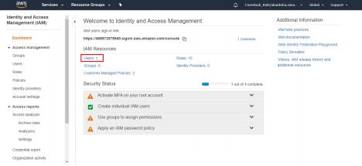1.4 Click on the **Add user** button

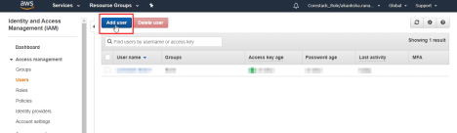

1.5 Fill in the details as shown in the following screenshot:

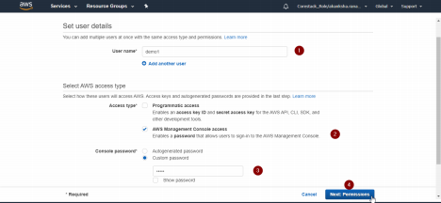

1.6 Go to **Next:Tags** > **Next:Review**

1.7 Go through the user details on the review page, and then click on the **Create user** button

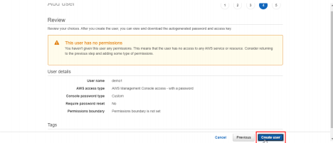

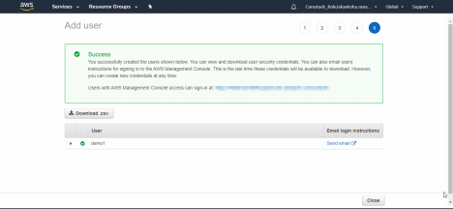

1.8 Copy the AWS sign-in URL, and keep it handy. You will need it to log in using the credentials of the newly created user.

1.9 Go to the IAM user dashboard to view the newly created user as shown in the following screenshot: