**Lesson 8 Demo****2**

**Adding User to the Group**

**Objective:** Create an IAM group and add the custom IAM user in the group

**Expected Deliverables:**

Screenshot of your IAM user in the group in the dashboard

Steps to be followed:

1. Creating an IAM group Adding
2. IAM users to the IAM group

**Step 1:​** Creating an IAM group

1.1 Go to your Amazon console

1.2 Search for IAM in the search bar

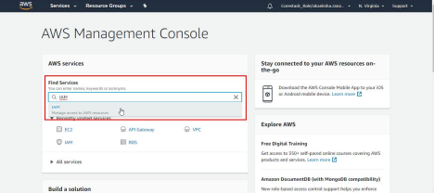

1.3 In the IAM dashboard, click on ​**Users, ​**and create multiple users; create at least two users that you will be adding to the IAM group later

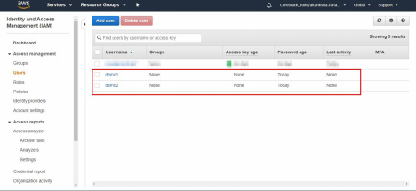

1.4 Click on the ​**Groups ​**option in the left panel. In the IAM group dashboard, click on the ​**Create New Group ​**button as shown in the following screenshot:

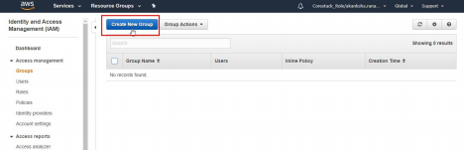

1.5 Fill in the name for the group in the given text field, and then click on the **Next Step ​**button

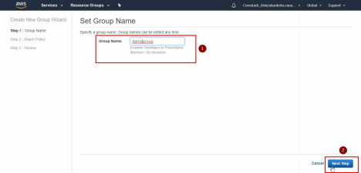

1.6 Skip to the review page and click on the ​**Create Group ​**button. Go back to the

IAM group dashboard. You will be able to see the newly created group as shown in the following screenshot:

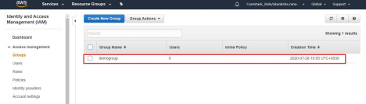

**Step 2:​** Adding IAM users to the IAM group

2.1 Click on the newly created group in the IAM group dashboard

2.2 Click on the ​**Add Users to Group ​**button as shown in the following screenshot:

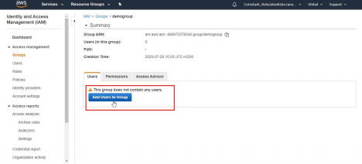

2.3 Select the users that you want to add to the group from the list of users, and then click on the ​**Add Users ​**button

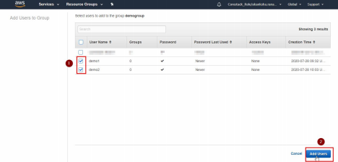

2.4 Go back to the IAM group dashboard. The user count in the newly created group will show the total number of users that you have added to the group