**Lesson 8 Demo** **3**

**IAM role for IAM user**

**Objective:** Create an IAM role and add it the custom IAM user

**Expected Deliverables:**

Screenshot of your IAM user in the group in the dashboard

Steps to be followed:

1. Creating an IAM role

**Step 1:** Creating an IAM role

1.1 Go to Amazon console

1.2 Search for IAM in the search bar

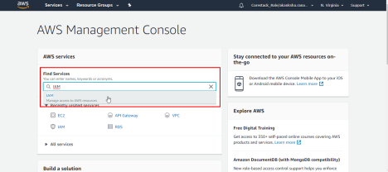

1.3 In the IAM dashboard, select **Roles** from the left menu panel, and then click on the **Create Role** button as shown in the following screenshot:

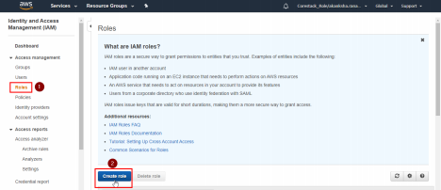

1.4 Click on the **Another AWS Account** tab, and fill in the Account ID of the IAM user to which you want to assign the role. Choose the **Next: Permissions** button as shown in the following screenshot:

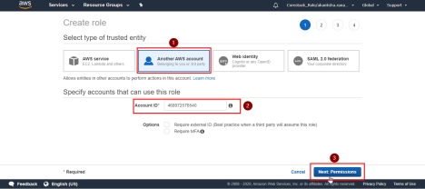

1.5 Select a permission from the list of predefined permissions, and click on the **Next: Tags** button

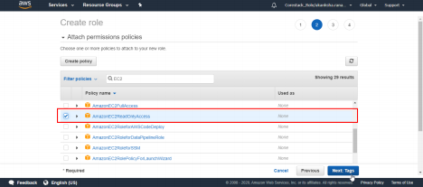

1.6 Click on **Next: Review** button

1.7 On the review page, provide a name for the role, and click on the **Create role** button as shown in the following screenshot:

