**Lesson 8 Demo** **4**

**IAM role for EC2**

**Objective:** Create an IAM role for EC2

**Expected Deliverables:**

Screenshot of your EC2 instance with your IAM role

Steps to be performed:

1. Creating and assigning an IAM role to Amazon EC2 service

**Step 1:** Creating and assigning an IAM role to Amazon EC2 Service

1.1 Go to Amazon console

1.2 Search for IAM in the search bar

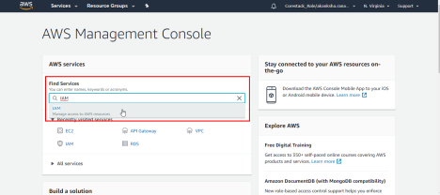

1.3 In the IAM dashboard, select **Roles** from the left menu panel, and then click on the **Create Role** button as shown in the following screenshot:

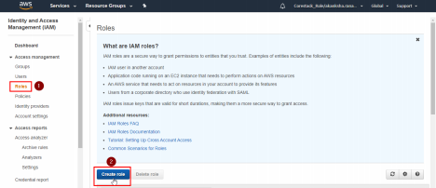

1.4 Click on the **AWS Service** tab, select **EC2**, and then click on the **Next: Permissions** button as shown in the following screenshot:

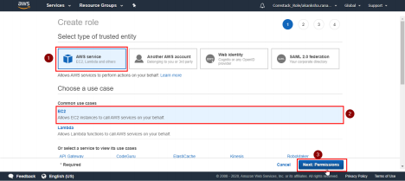

1.5 Select a permission from the list of predefined permissions, and click on the **Next: Tags** button

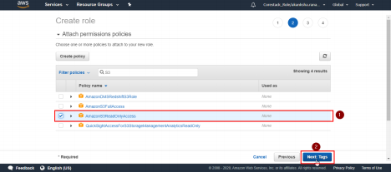

1.6 Click on the **Next: Review** button

1.7 On the review page, provide a name for the role, and click on the **Create role** button as shown in the following screenshot:

