2.1: Install Docker CE for Linux

This section will guide you to:

* Install Docker CE from the Docker repository
* Verify the correctly installed Docker engine
* Uninstall Docker CE using the **purge** command

**Please Note:** Docker Community Edition is already installed in the lab. This document can be used in case your lab does not have Docker CE. If you want an updated version of Docker CE, follow step 3 to remove all the docker related image files followed by step 1 and step 2.

**Step 1:** Install the Docker Engine CE by setting up the Docker repository

* Use the following command to update the apt package:

*sudo apt-get update*

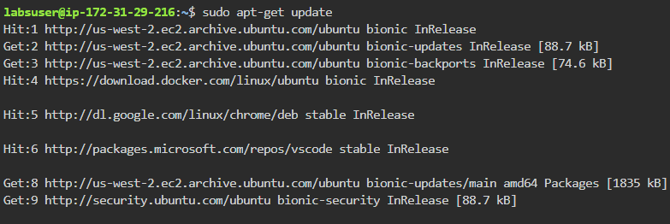

* Use the following command to install packages to allow the apt to use a repository over HTTPS:

*sudo apt-get install apt-transport-https ca-certificates curl software-properties-common*

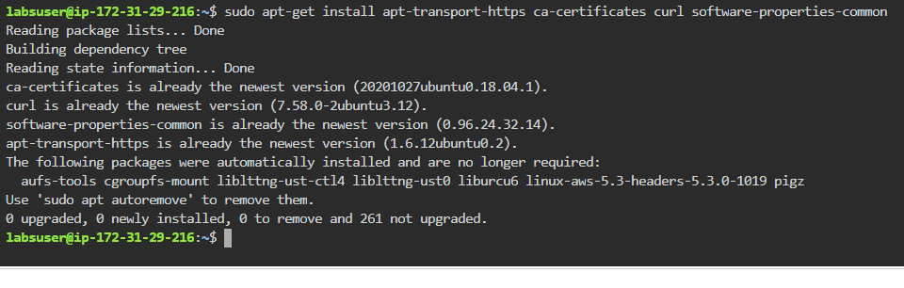

* Use the following curl command to add Docker’s official GPG key:

*curl -fsSL https://download.docker.com/linux/ubuntu/gpg | sudo apt-key add -*

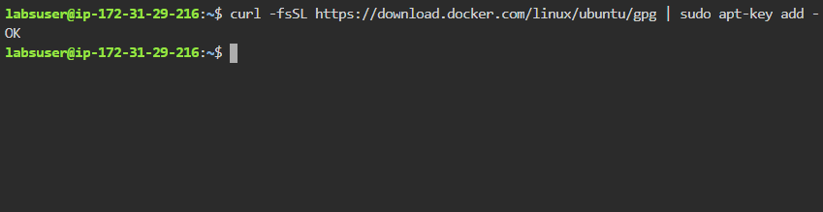

* Use the following command to set up a stable repository:

*sudo add-apt-repository "deb [arch=amd64] https://download.docker.com/linux/ubuntu $(lsb_release -cs) stable"*

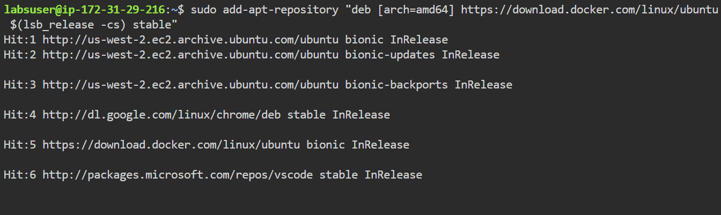

* Use the following commands to install the latest version of Docker CE and check the version:

*sudo apt-get install docker-ce*

*docker –version*

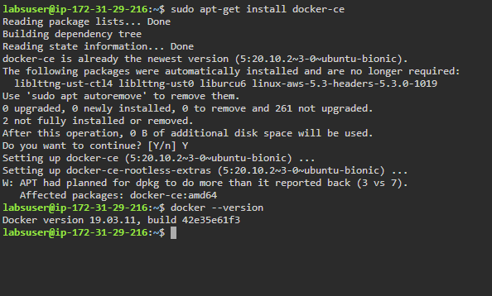

**Step 2:** Verify the correctly installed Docker engine

* Use the following command to verify the Docker engine:

*sudo docker run hello-world*

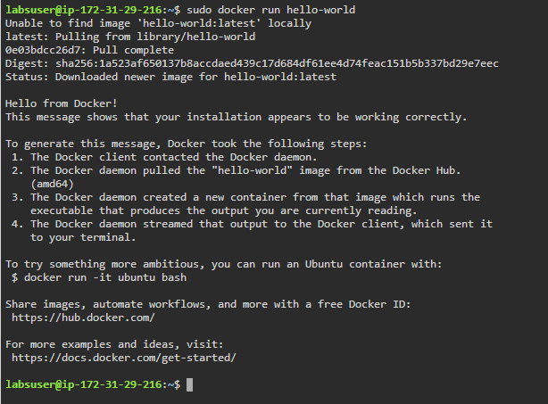

**Step 3:** Uninstall the Docker Engine Community package using the ***purge*** command

* Use the following command to uninstall Docker Engine:

*sudo apt-get purge docker-ce docker-ce-cli containerd.io*

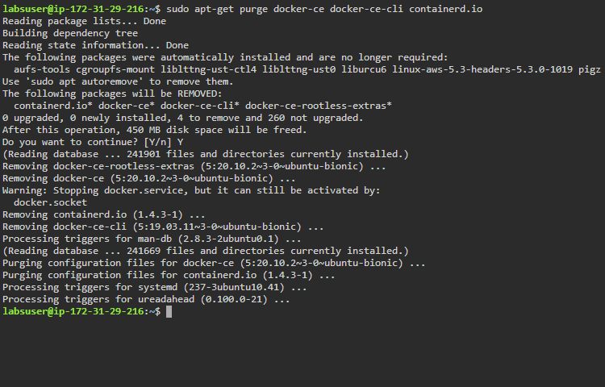

* Delete all images, containers, and volumes

*sudo rm -rf /var/lib/docker*

