**Problem:**

To create and configure a simple CI/CD pipeline using Jenkins or any other open source automation tool.

**Solution:**

Components used-

1. Google Kubernetes Engine (GKE)- Deployment, services
2. Jenkins- [Jenkins Kubernetes Plugin](https://wiki.jenkins-ci.org/display/JENKINS/Kubernetes+Plugin), [Jenkins Pipelines](https://jenkins.io/solutions/pipeline/) plugin.
3. Helm
4. Github
5. Google Cloud platform- [Compute Engine, Container Engine, and Container Builder APIs](https://console.cloud.google.com/flows/enableapi?apiid=compute_component,container,cloudbuild.googleapis.com)

The sample application hosted is written in Go and when it is run it displays the Google cloud instance's metadata in a card.

The following steps creates a cluster, hosts sample Go based application and Jenkins with Google Kubernetes Engine (GKE) on Google Cloud.

1. Create a Kubernetes Cluster

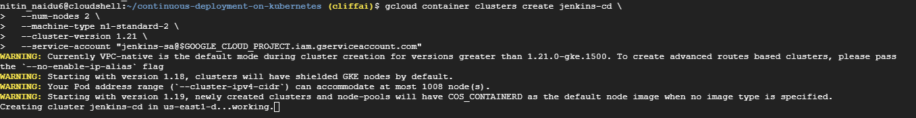

1. Install Helm

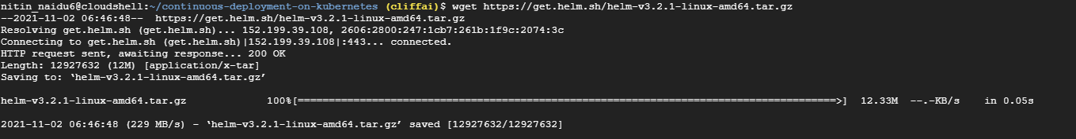

1. Configure and Install Jenkins

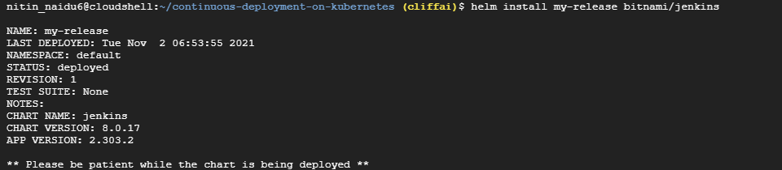

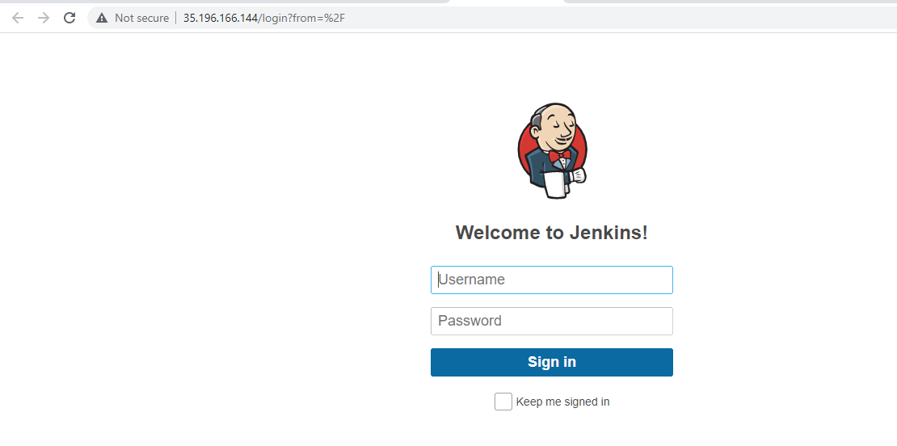

1. Deploy a sample app to Kubernetes

### Create the namespace for production:



### Create the production Deployments for frontend and backend:



### Create the canary Deployments for frontend and backend:



### Create the Services for frontend and backend:



### Scale the production, frontend service:



### Retrieve the External IP for the production services:



### Confirming that both services are working by opening the frontend EXTERNAL-IP in the browser

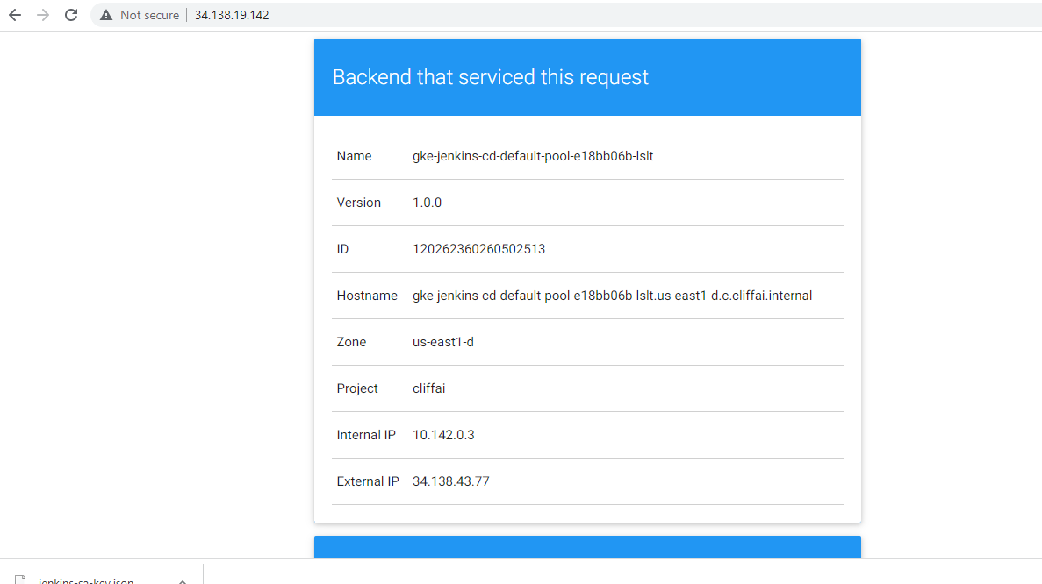

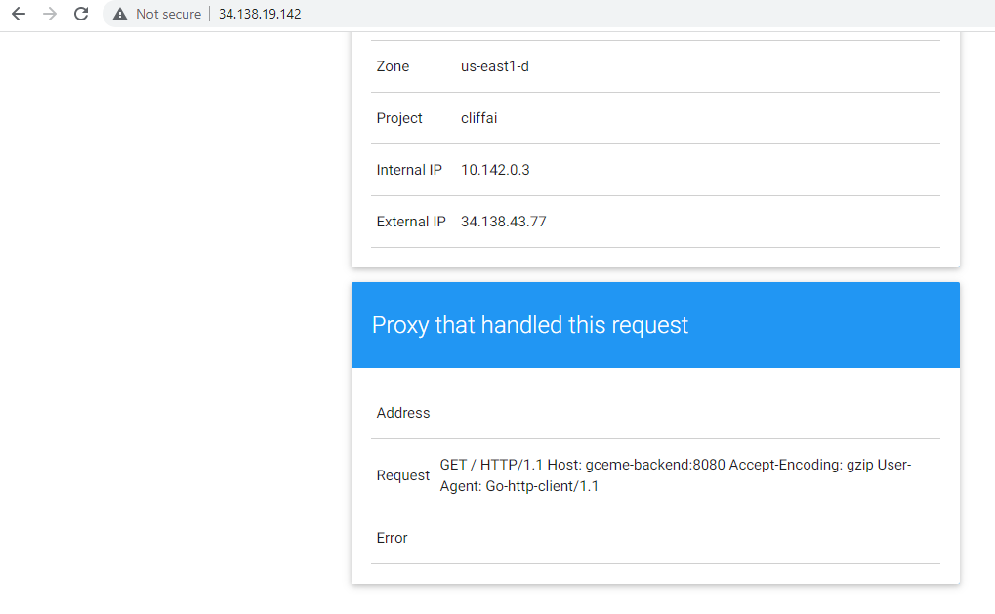

1. Create a repository for the sample app source

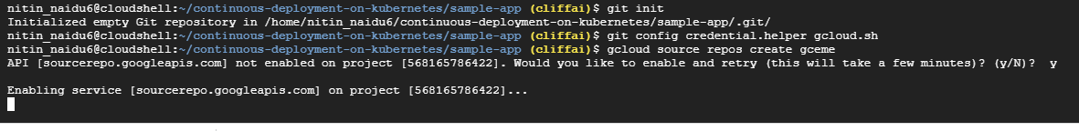

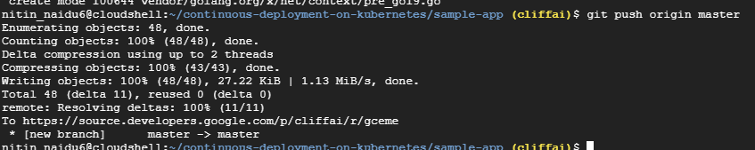

1. Create a pipeline

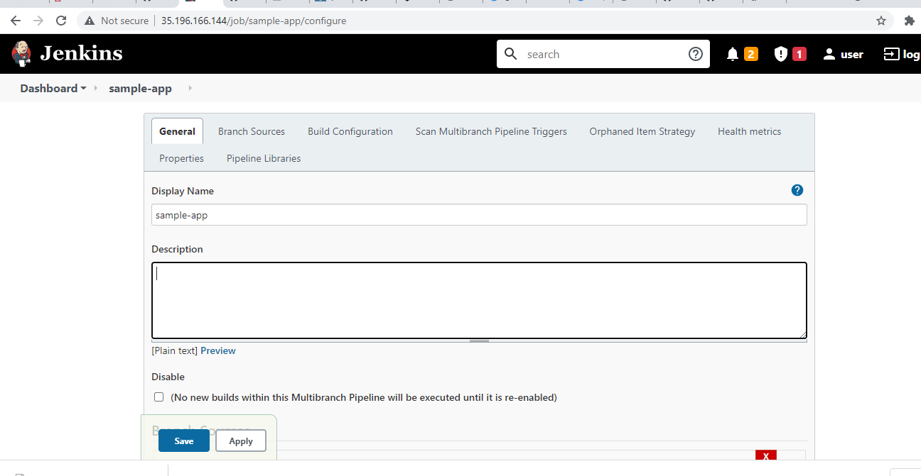

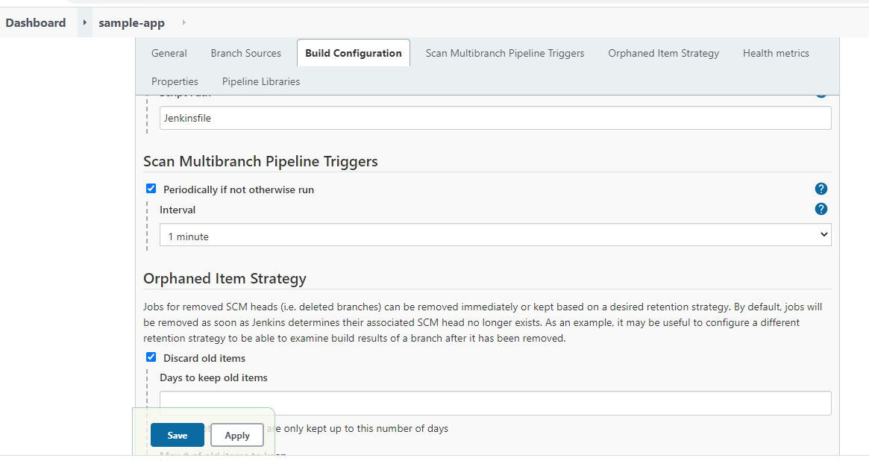

1. Modify Jenkinsfile, then build and test the app
2. Create a new branch



1. Adding project id in Jenkinsfile

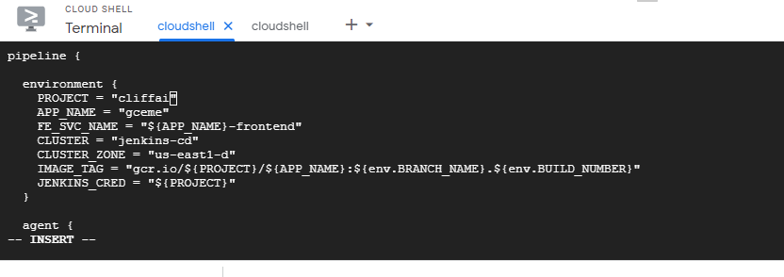

1. In the html.go file replacing the word blue with orange

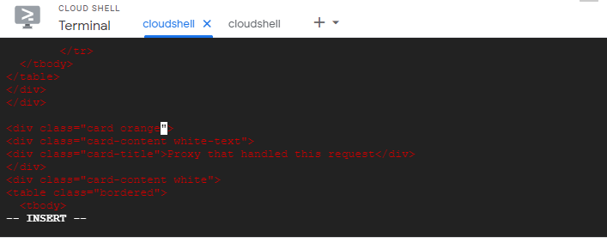

1. Pushing the *version 2* changes to the repo:

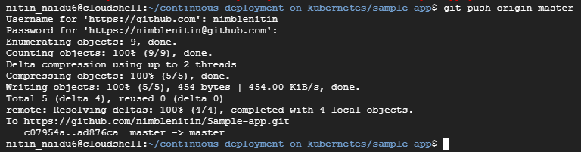

1. A new build is automatically triggered

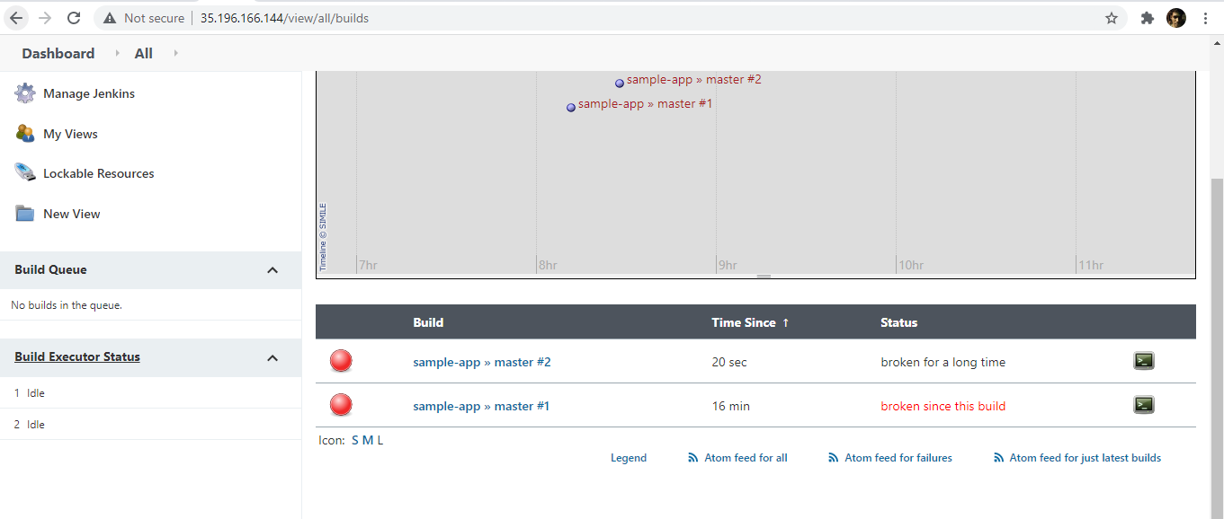

URL to access Jenkins hosted on Kubernetes-

<http://35.196.166.144/>

User ID - user

Password - OktrpuSaj6

URL to access Go Application hosted on Kubernetes-

<http://34.138.19.142/>

1. Steps towards creating a VPC on Google cloud-
2. Creating subnet for the VPC

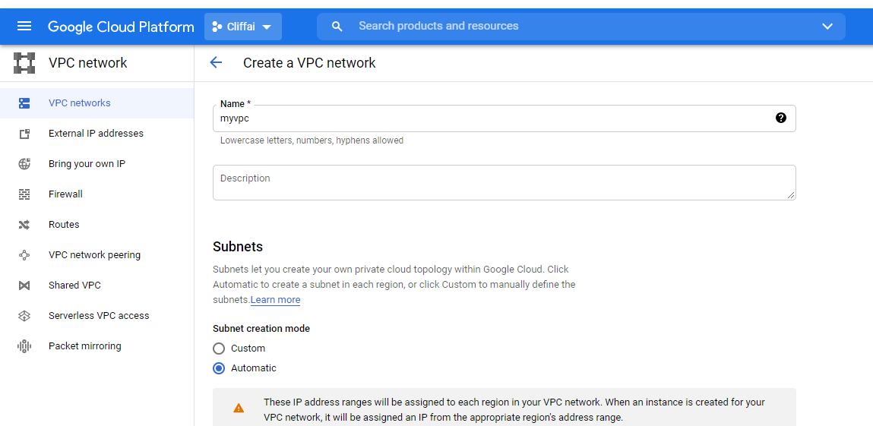

1. Adding firewall rules

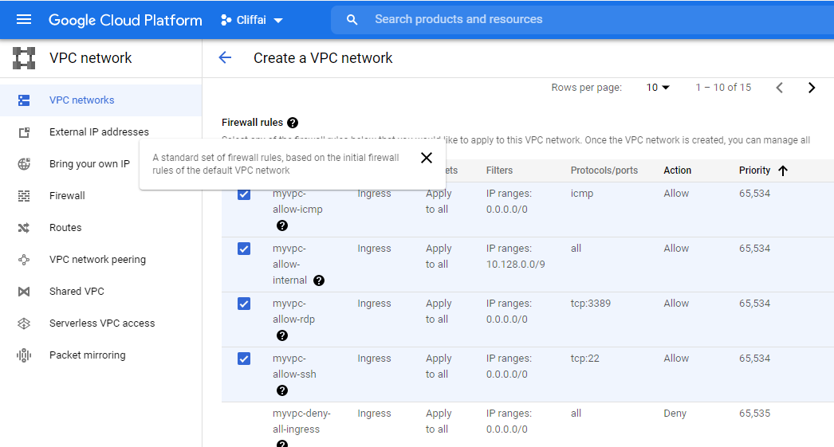

1. Desired VPC is created with subnets and is available for use-

