**Lesson 5 Demo 1**

**Create an RDS Database Instance**

|  |
| --- |
| **Objective:** To create the RDS database instance and connect to a CLI to perform CRUD operations  **Tools required:** Linux, AWS account  **Prerequisites:** None |

Steps to be followed:

1. Creating the RDS Database instance
2. Connecting your RDS Instance with your system

**Step 1: Creating the RDS Database instance**

1. Go to the **AWS console** and select **AWS services**. In the search tab, search for **RDS**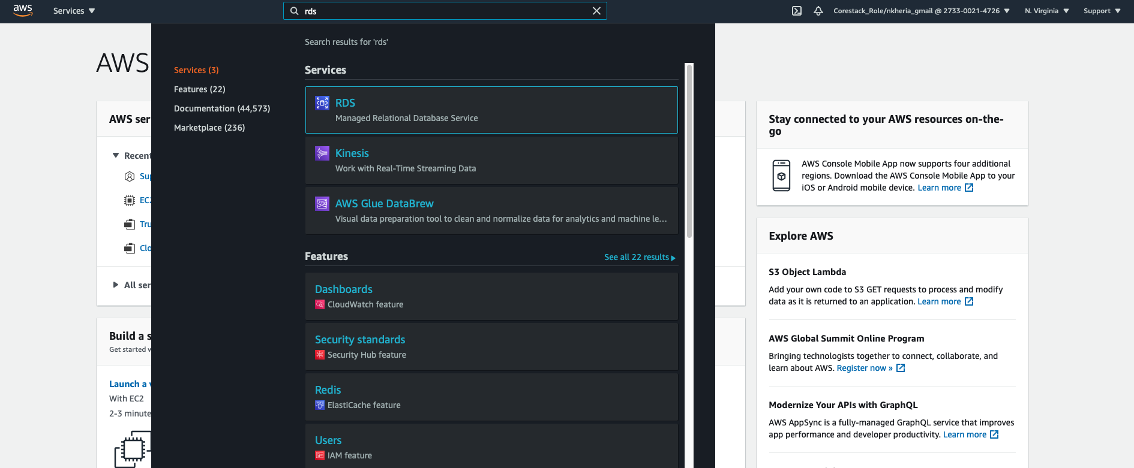

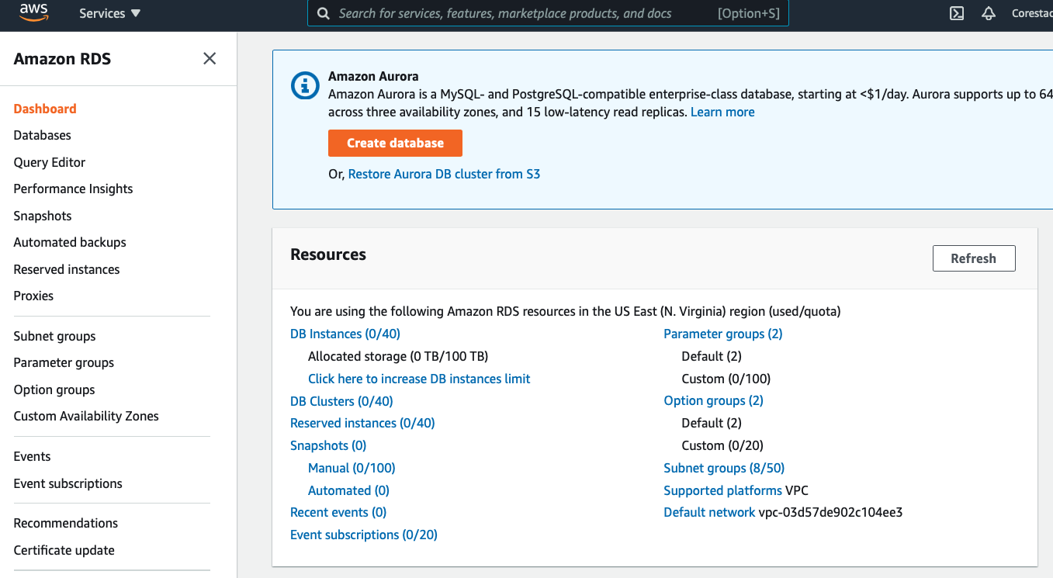

1. To create MySQL DB, set the following configurations:

Under Choose a database creation method, select Standard Create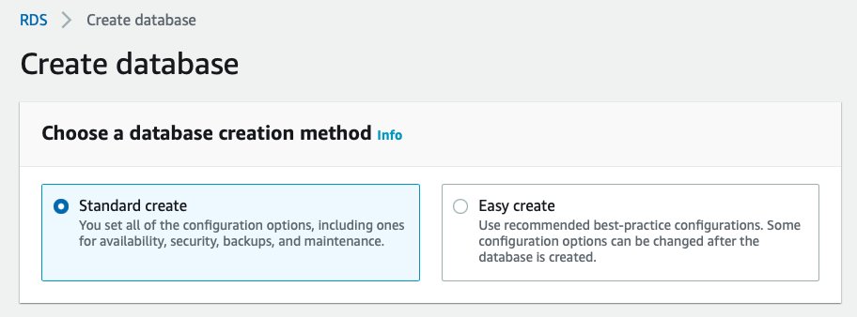

**Engine Type:** MySQL

**Edition:** MySQL Community

**Version:** Select the latest – MySQL 8.0.19 (make sure it matches with local system MySQL version) 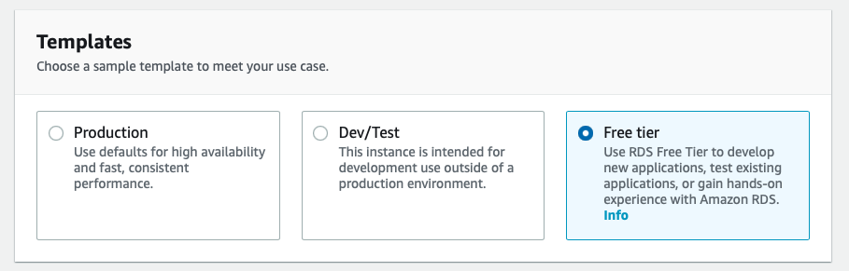

1. Specify DB Details and provide DB Instance, username and password for your DB Instance before clicking on **Next**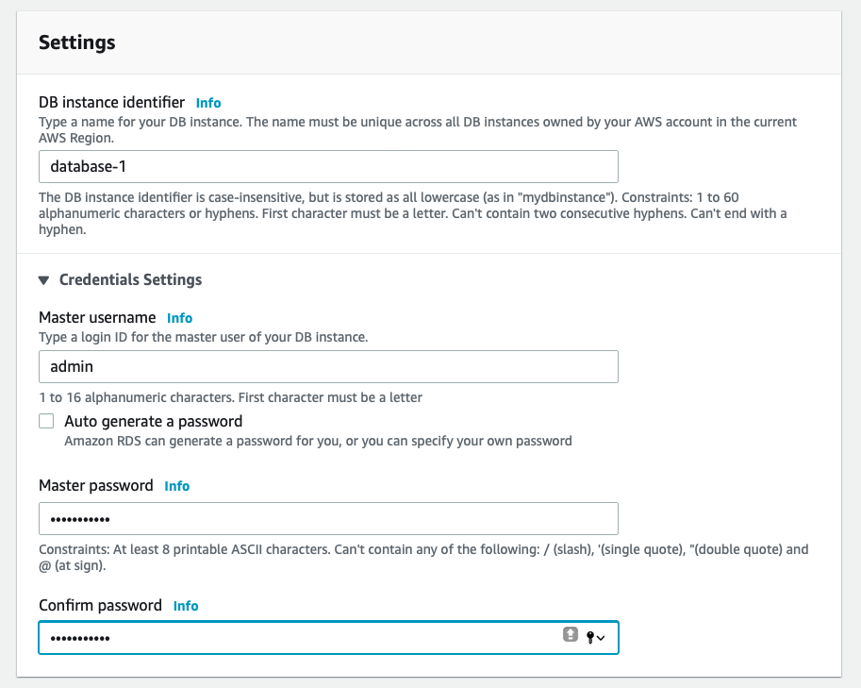
2. Under **Connective**, select the default VPC. In the advance settings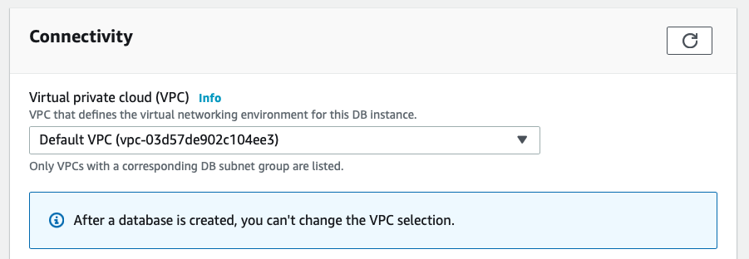
   1. Set subnet group to **default**
   2. Enable **Public accessibility**
   3. Under VPC security group, select **Create new**
   4. Set database port to **3306**

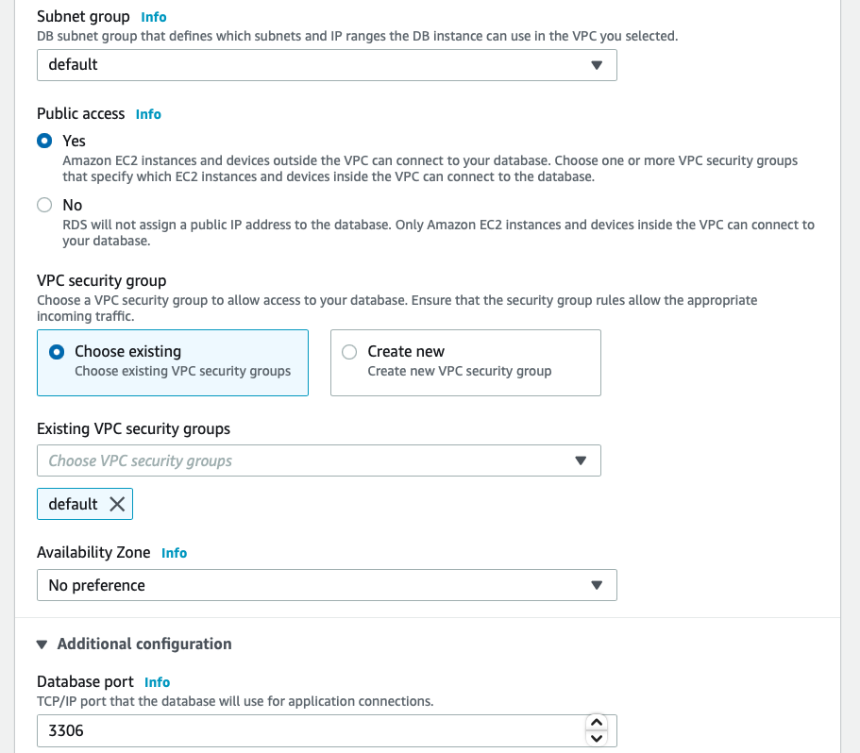

1. Under **Additional configuration,** configure the following details:

Initial database name

DB parameter group

Set the backup period to 7 days

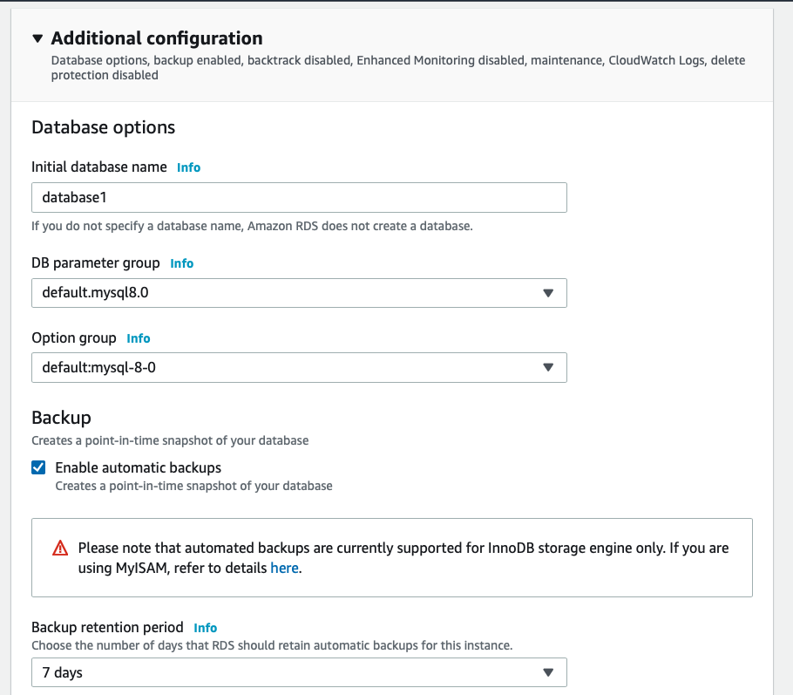

1. Keep all other options as default before launching DB instance

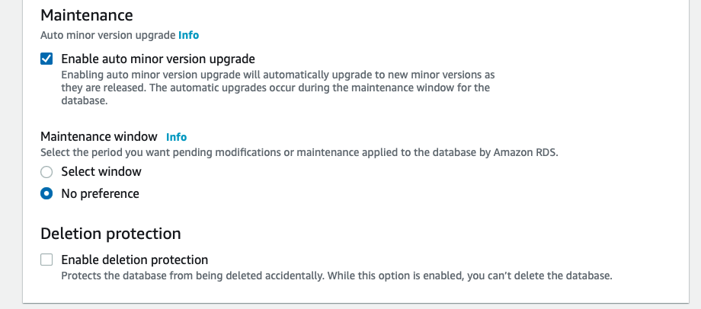

1. Once DB is launched, check DB instance details, scroll down, go to the **Security group,** and edit inbound rules and click on ***save rules***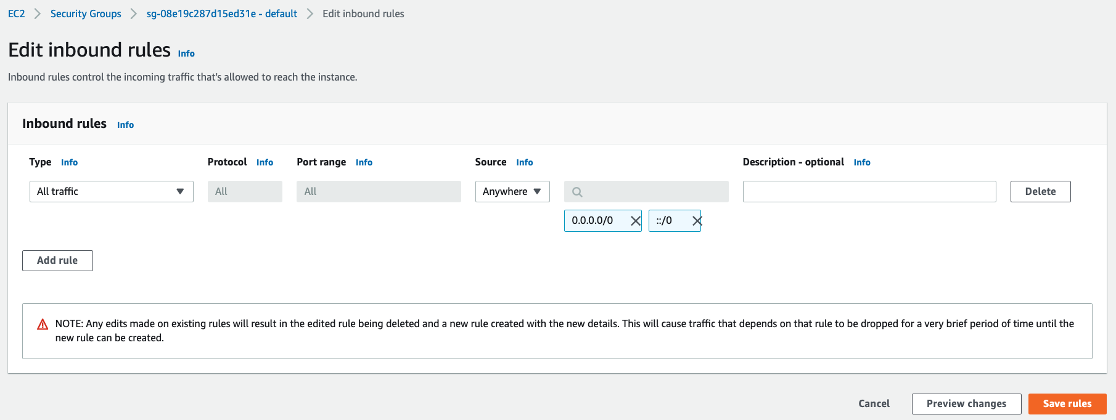
2. Copy the **Endpoint URL** and the **port number**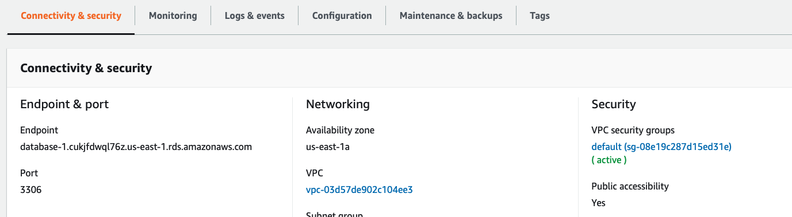

**Step 2: Connecting your RDS Instance with your system**

1. Go back to your command prompt, enter the following credentials- **endpoint, port, username,** and **password**

***mysql -h <endpoint> -P <port number>-u <user name> -p***

1. To view all the **databases** available, enter the following command: ***show databases;***
2. To select any database, enter the following command: ***use database-1***
3. To create a table, insert data and see the table, use the following commands:

***CREATE TABLE sample (firstname varchar(20), lastname varchar (20));***

page12image1310453952

