**Lesson 9 Demo 1**

**Demonstrate SQS**



Steps to be followed:

1. Create a Queue
2. Create an SNS topic
3. Create an email subscription for it.
4. Create a Lambda function to publish a message to the SNS topic
5. Create an email subscription for it.
6. Test the application

**Step 1: Create a Queue**

1. In your **AWS Management Console**, search for and select **SQS Service.**

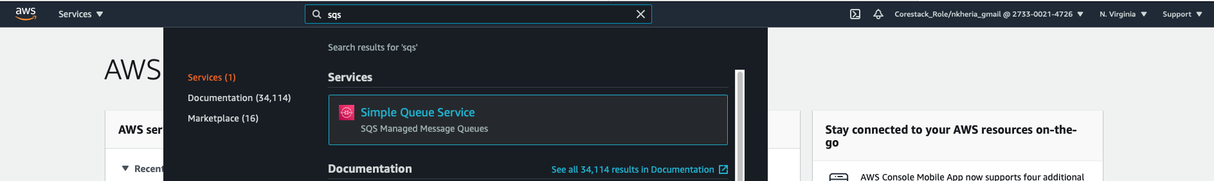

1. Click on **Create Queue.**

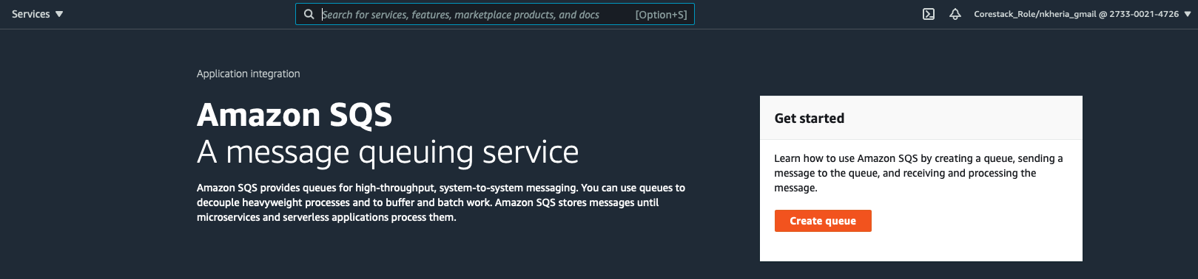

1. Choose Standard type and type a name under Queue Name.

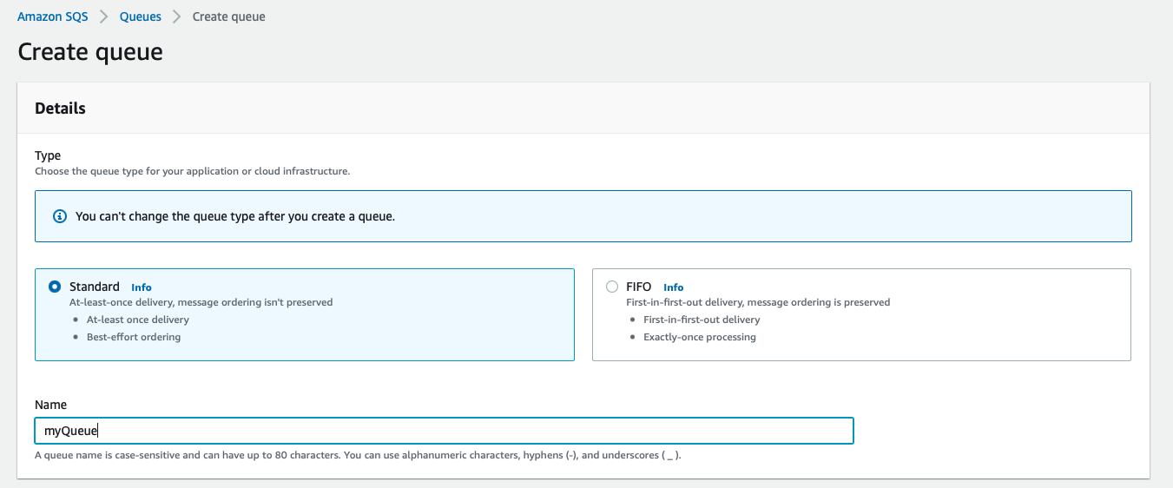

1. Make sure the configuration is set to the below default values under the configuration tab.

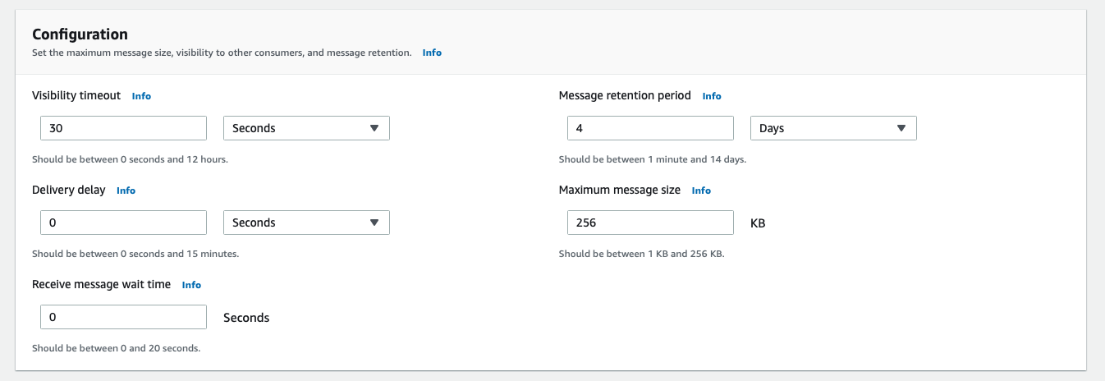

1. Choose access policy to be basic policy.

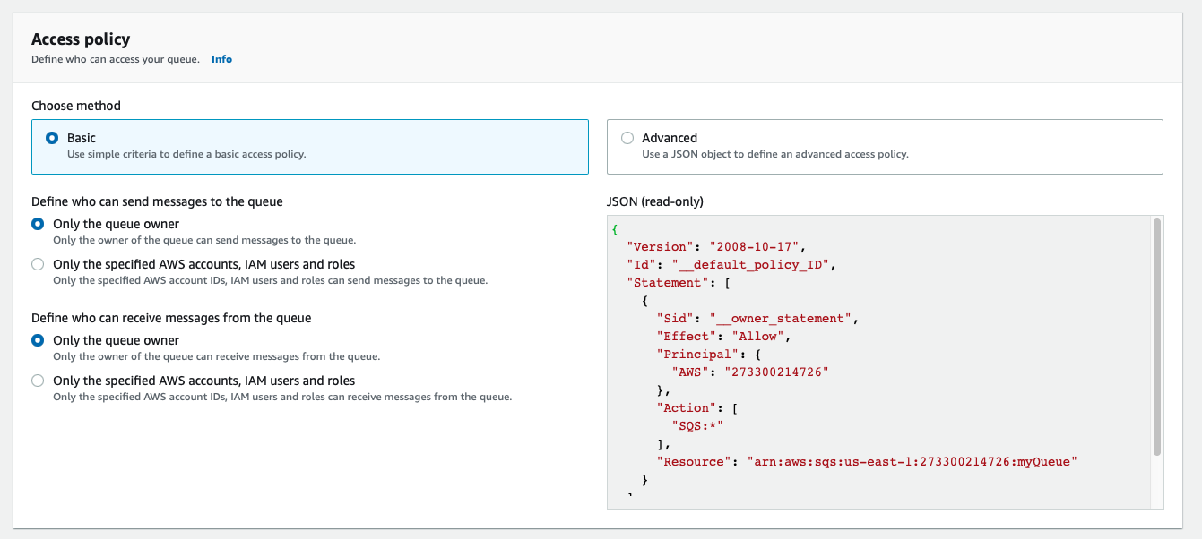

1. Click on create

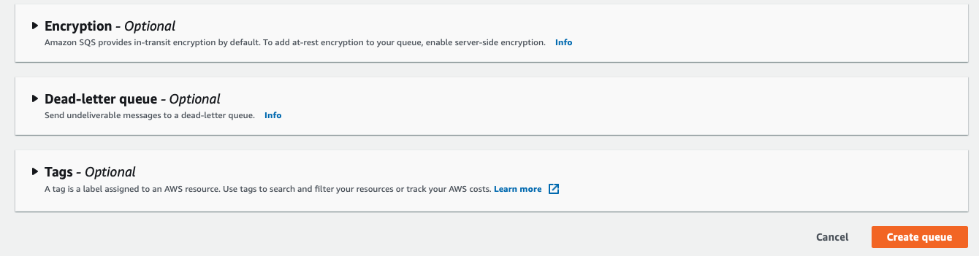

**Step 2: Create an SNS topic**

1. In your console, search for and select **SNS service**
2. Click on **Create topic**
3. Give a name for your topic and click on **Create**

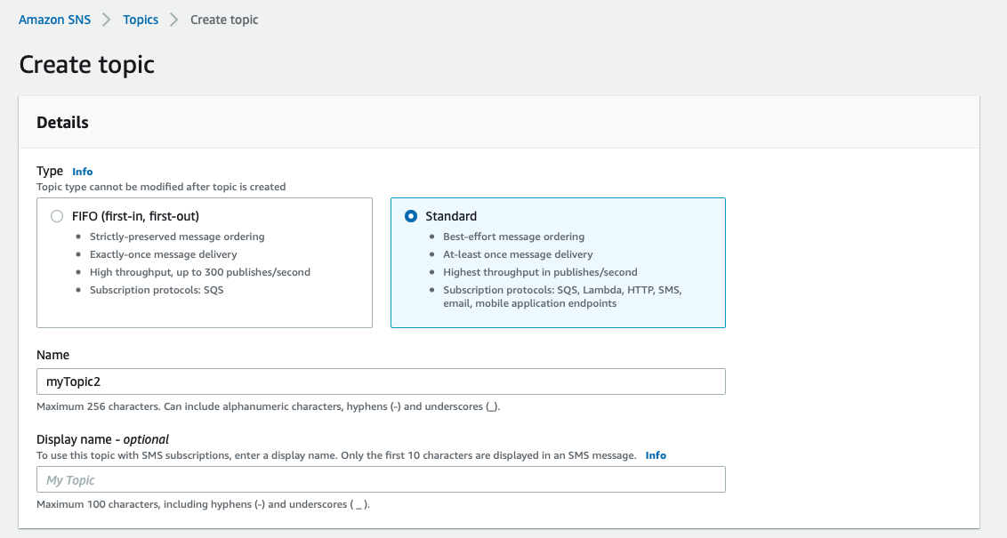

**Step 3: Create an email subscription for it.**

1. Click on **Create subscription.**
2. Give the protocol as e-mail and specify the e-mail id you want to receive the notification to.
3. Click on **Create subscription.**

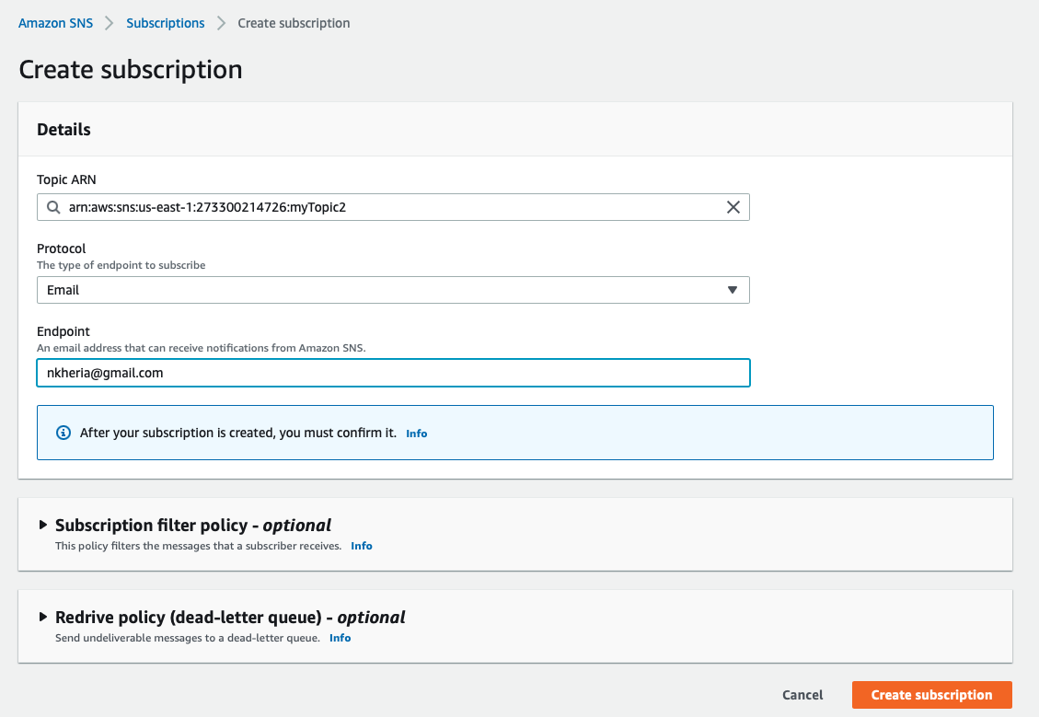

**Step 4: Create a Lambda function to publish a message to the SNS topic**

1. Navigate to Lambda function in the same region as the Queue.

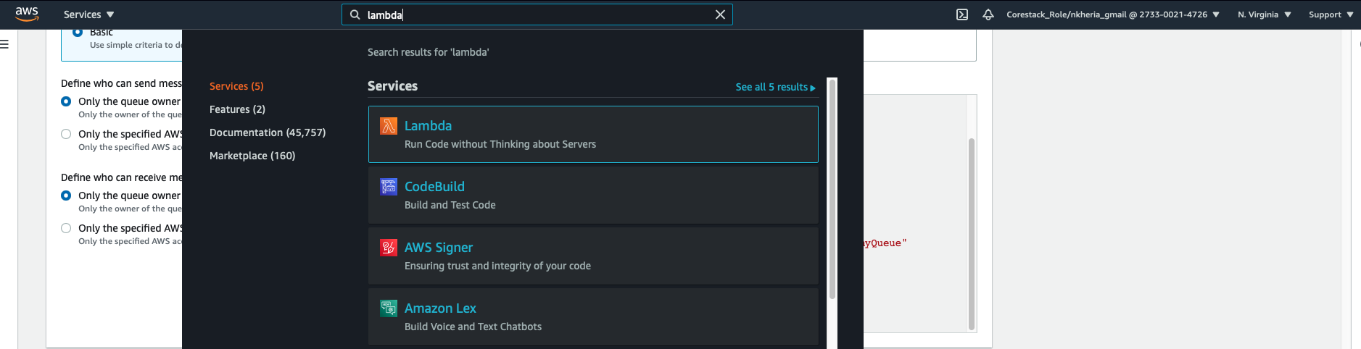

1. Click on **Create function**

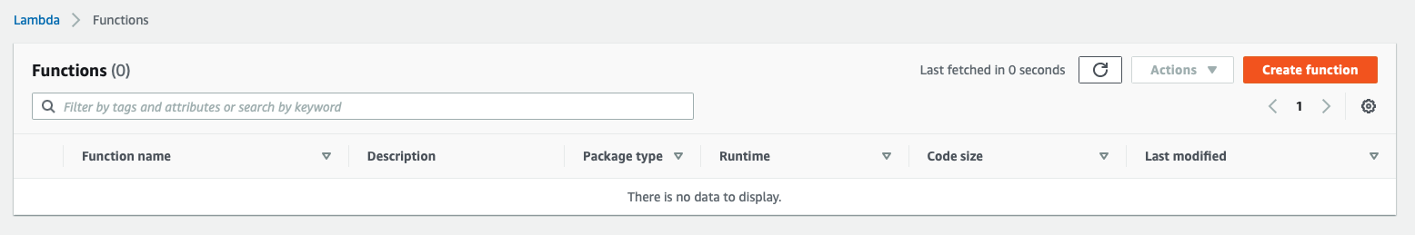

1. Select **Author from scratch**
2. Under **Author from scratch**, write a name for the Lambda function
3. Select the runtime to be **Node.js.14.x**

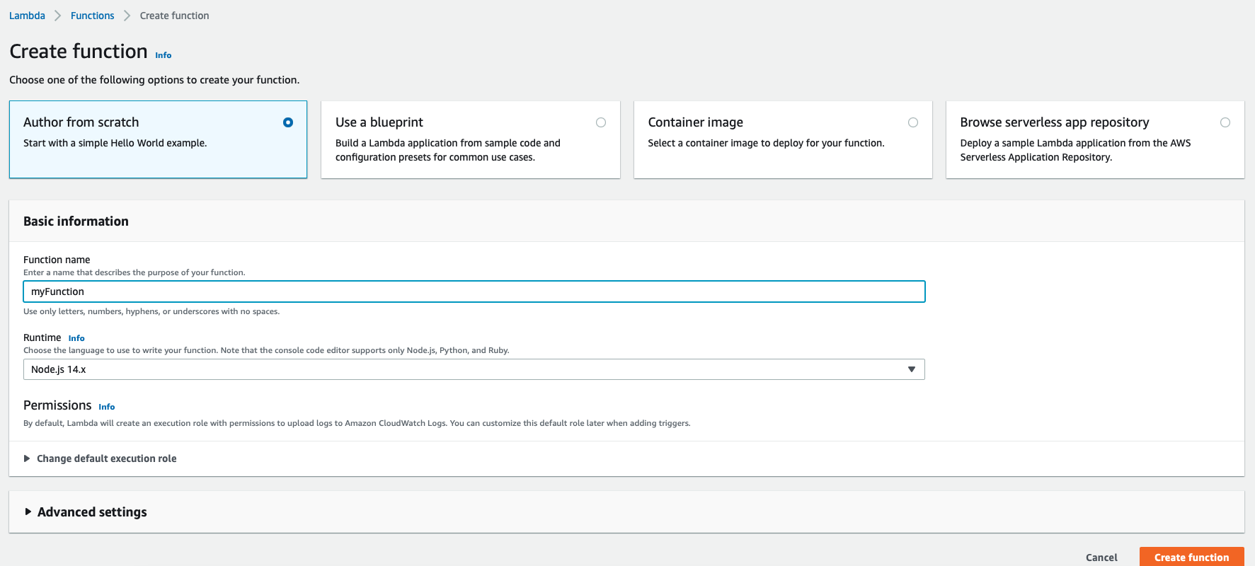

1. Select a role for the Lambda function(In case role doesn’t exists, go to IAM > Roles and create a role for Lambda service attaching default administrator policy to it)

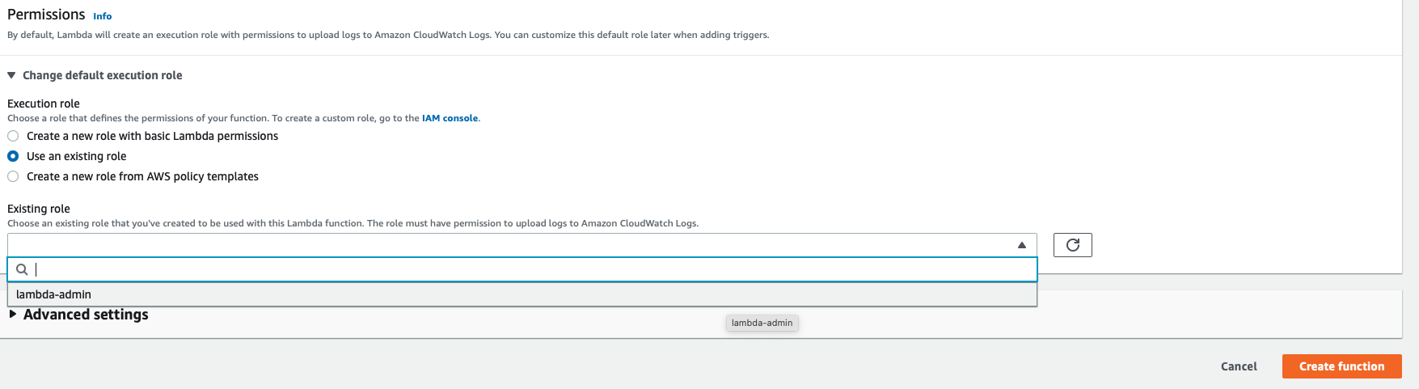

1. Please type the code given below and save it

***console.log("Loading function"); var AWS = require("aws-sdk");***

***exports.handler = function(event, context) { var eventText = JSON.stringify(event, null, 2); console.log("Received event:", eventText); var sns = new AWS.SNS();  
var params = {***

***Message: "An object is added in SQS",  
Subject: "Message from SNS",  
TopicArn: "arn:aws:sns:us-east-1:273300214726:myTopic2" // Give the ARN of your SNS Topic***

}; ***sns.publish(params, context.done); };***

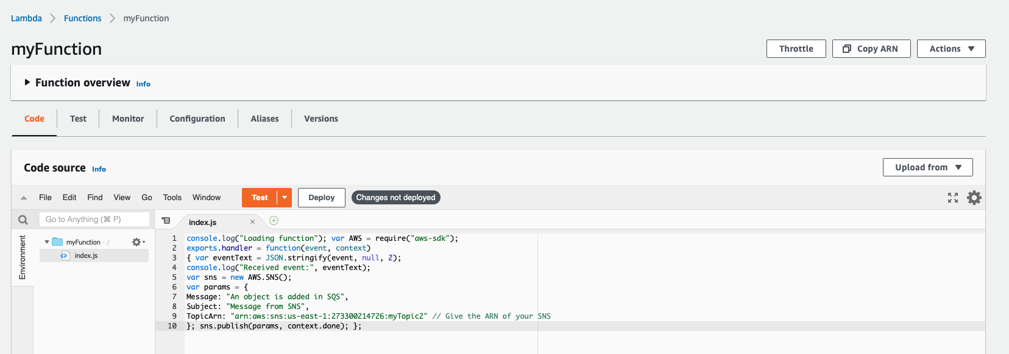

**Step 5: Configure a trigger for Lambda from SQS**

1. Under **Lambda triggers** tab**,**, click on **Configure Trigger for Lambda Function**

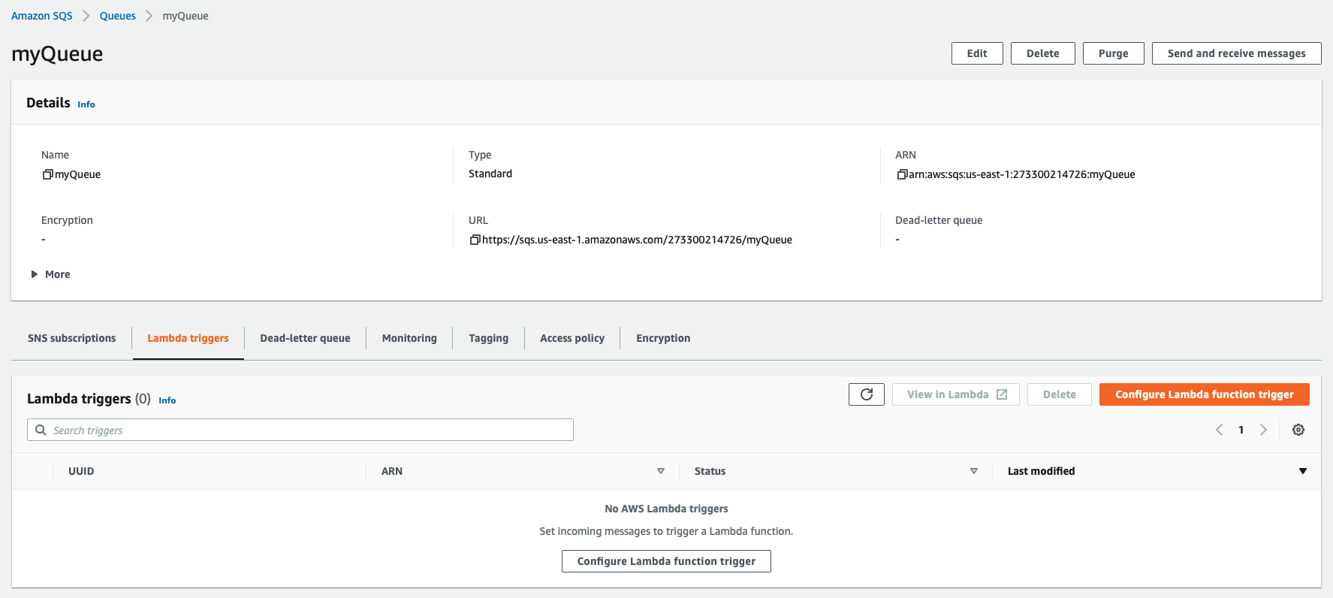

1. Select the Lambda function you have created and click on **Save**

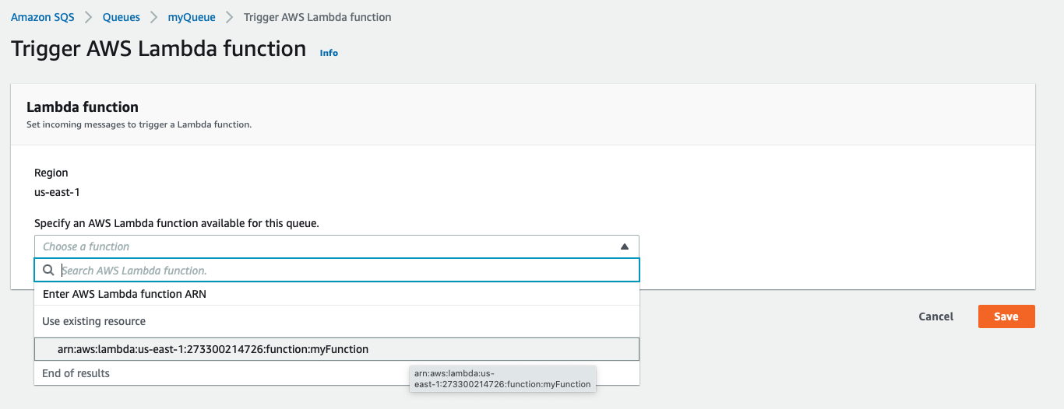

**Step 6: Test the application**

1. In Queue Actions, click on **Send and receive Message**



1. Write the message and click on **Send**

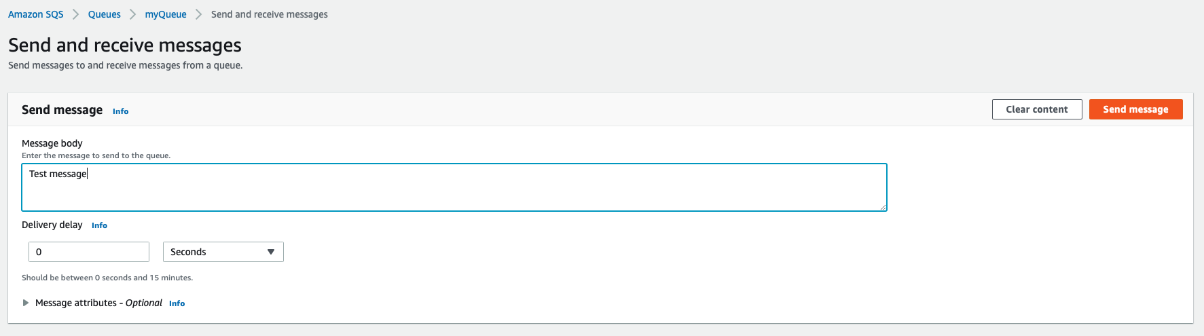

1. Now, check the email-id subscribed in SNS to see the notification

