**Lesson 9 Demo 2**

**Demonstrate SNS**



Steps to be followed:

1. Go to the AWS Management Console, select AWS Services, and under the Application Integration, click on Simple Notification Service.
2. To create a topic, click on Create Topic.
3. Enter the topic name followed by the display name and click on Create topic.
4. Click on Create Subscription.
5. Choose the protocol, enter your email address in the endpoint box and click on Create subscription.
6. When you receive a verification email, click on the Subscription URL to confirm the subscription.
7. Move back to the AWS Console and select the topic that you just created. You will find a Subscription ID. Now, publish the data by clicking on Publish to topic.
8. Enter the subject, type the message, and click on Publish message.
9. Check your mailbox.

**Step 1:** Go to the AWS Management Console, type SNS in search box and click on Simple Notification Service.

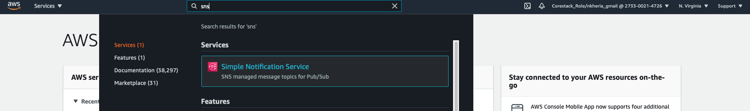

**Step 2:** To create a topic, click on Create Topic.

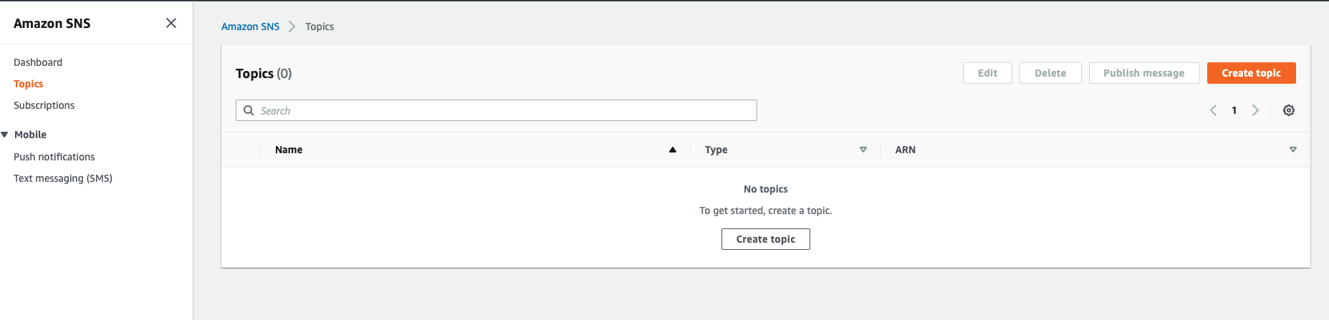

**Step 3:** Enter the topic name followed by the display name and click on Create topic.

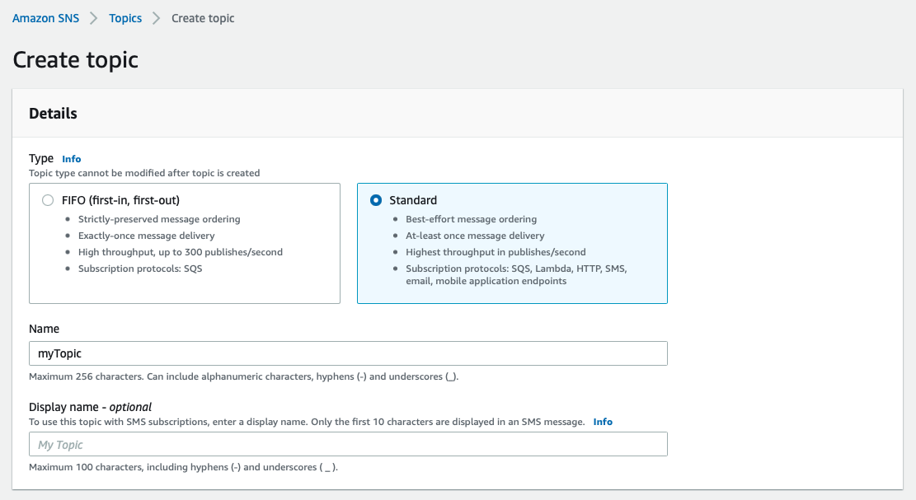

**Step 4:** Click on Create Subscription.

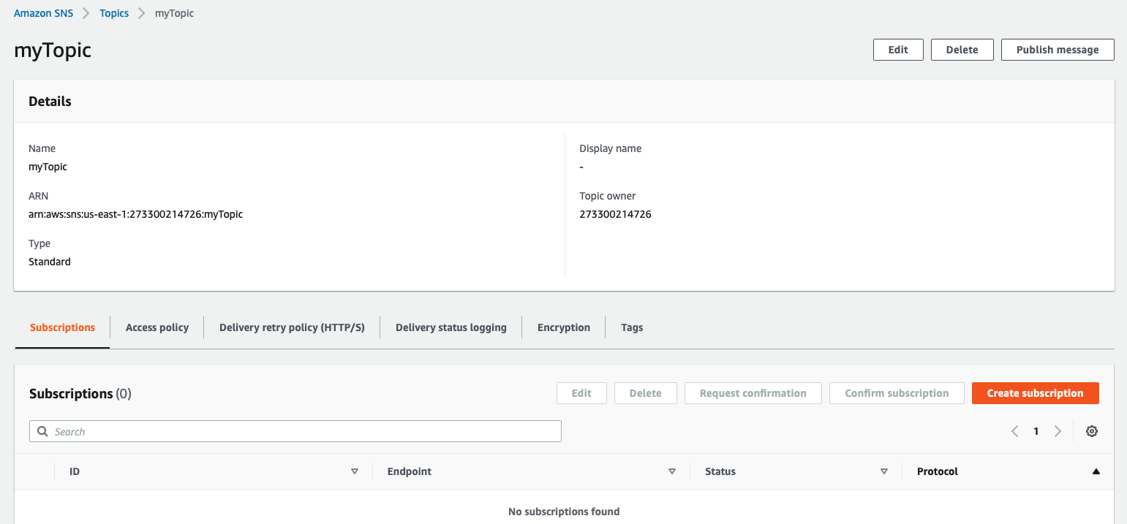

**Step 5:** Choose the protocol, enter your e-mail address in the endpoint box and click on Create subscription.

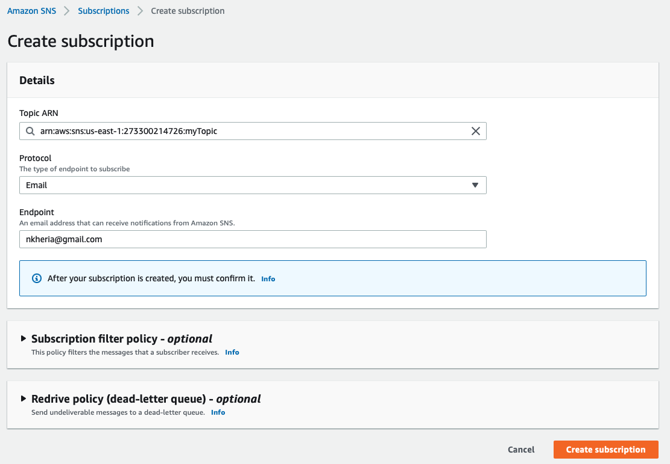

page4image1984903104

**Step 6:** When you receive a verification email, click on the Subscription URL to confirm the subscription.

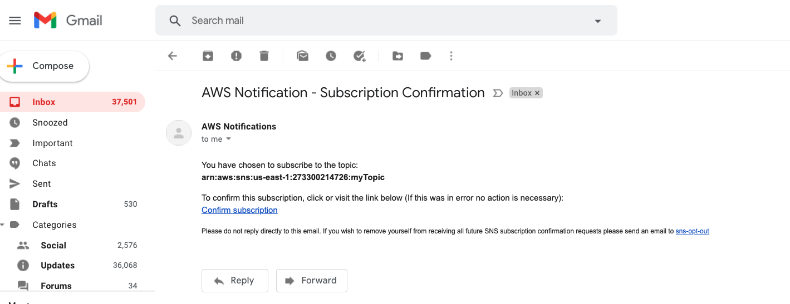

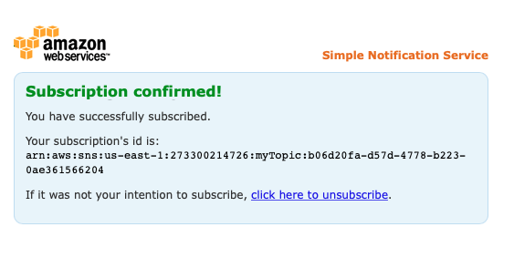

**Step 7:** Move back to the AWS Console and select the topic that you just created. You will find a Subscription ID. Now, publish the data by clicking on Publish to topic.

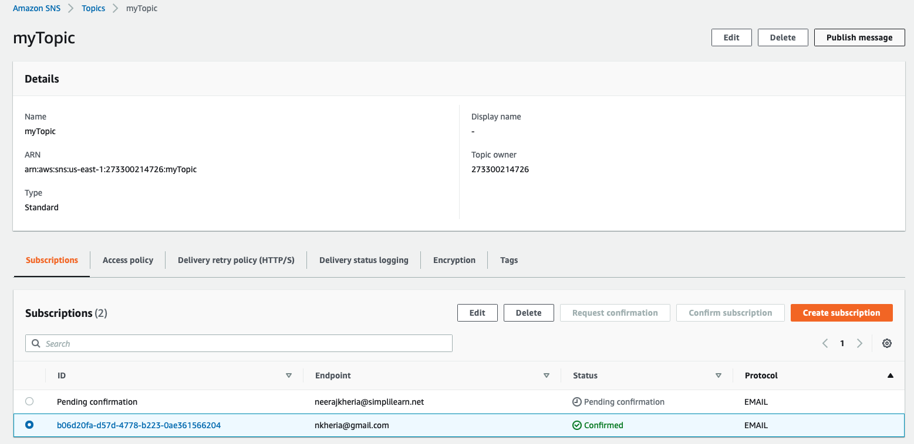

**Step 8:** Enter the subject, type the message, and click on Publish message*.*

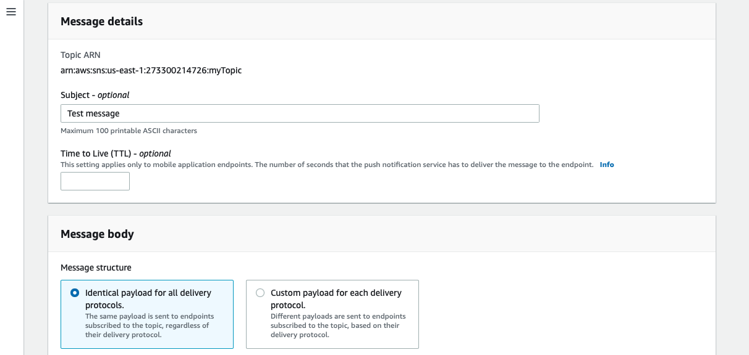

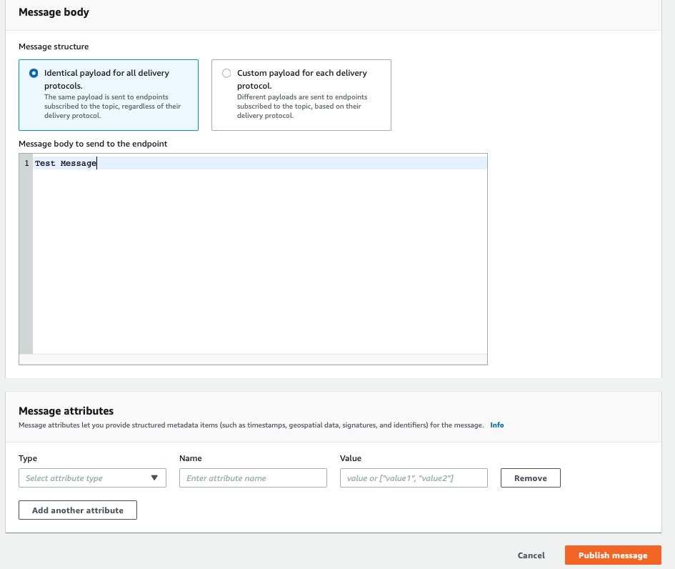

**Step 9:** Check your mailbox.

