**Lesson 6 Demo 2**

**Create and Accept a VPC Peering Connection**



Steps to be followed:

1. Create two VPCs in your AWS Account
2. Create a VPC Peering
3. Update the route table
4. Create a windows instance in each VPC

**Step 1: Create two VPCs in your AWS Account**

1. Create two VPCs in your AWS account which can be connected using VPC peering

**Step 2: Create a VPC Peering**

1. In your VPC dashboard, select the **Peering Connection**
2. Click on **Peering Connection**



1. Give the name for the peering
2. Select a VPC, which acts as a requester of the peering connection

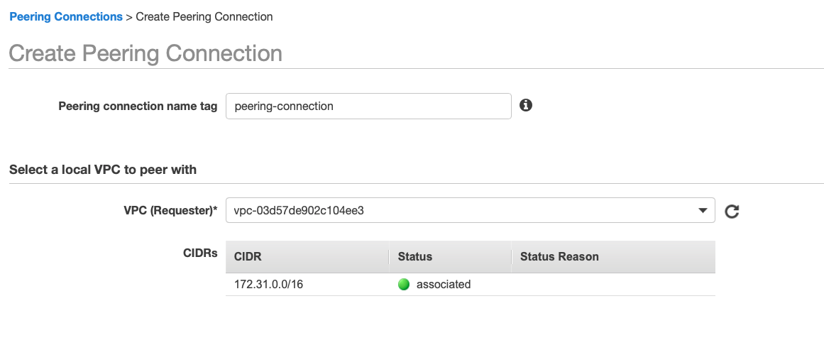

1. Select another VPC to peer with
2. Select My Account, in accounts and the region where you have created the VPC

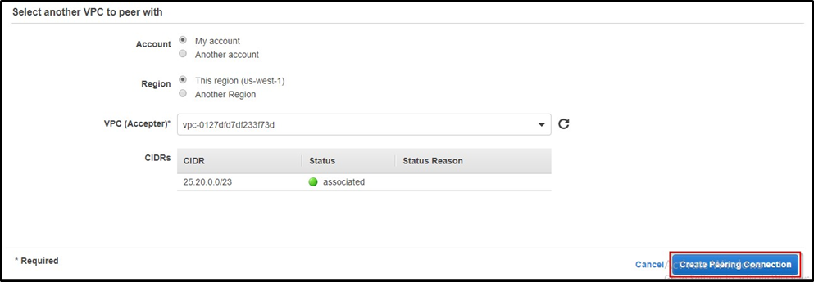

1. Select the peering you have created now
2. In actions, click on Accept Request
3. If yes, accept



**Step 3: Update the route table**

1. Update the public and private route table in the first VPC
2. Such that the traffic of the other VPC is always directed towards the VPC peering



1. Similarly, update the route tables of the another VPC



## **Step 4: Create a windows instance in each VPC**

1. Create a Windows instance in each VPC
2. Connect a Windows instance in the first VPC to your localhost through **Remote manager**
3. Once it gets connected, search for the remote manager in your Windows instance
4. In computer, type the private IP of the windows instance in the other VPC
5. Give the username as the **Administrator**



1. Give the password that was allotted to you while decrypting your **.pem** file
2. Now, the instance in different VPCs can communicate with each other through VPC peering

