Chapter 6: The Relational Model
How Connected Tables Replace Redundancy with Structure, Integrity, and Analytical Power
Chapter 4 introduced databases as structured systems for storing organizational data. Chapter 5 showed how SQL retrieves, filters, joins, and summarizes that data. Chapter 6 asks a deeper design question:

Core Concepts

2. What the Relational Model Does Differently
Before the relational model, databases used two main approaches: the hierarchical model and the network model. Both were navigational — to find data, application programs had to follow hard-coded paths through physical storage structures. If the database structure changed, programs broke. Data and programs were tightly coupled.
Edgar F. Codd, a researcher at IBM, saw the problem clearly. In his 1970 paper “A Relational Model of Data for Large Shared Data Banks,” he proposed a radical alternative: separate the logical view of data (what users see) from the physical storage (how the DBMS organizes it internally). This principle of data independence meant that queries could ask what data was needed rather than specifying how to navigate through pointers to find it. Applications no longer broke when storage details changed.
This shift from procedural navigation to declarative querying — from how to what — is the foundation of SQL and of every modern relational database. The relational model organizes data into relations (tables) where each relation represents one well-defined subject and relationships are represented through keys. It is the discipline behind the flat-table fix.
Characteristic | Hierarchical Model | Network Model | Relational Model
Data Structure | Tree (Parent-Child) | Graph (Owner-Member) | Tables (Relations)
Data Relationships | Pointers | Set Pointers | Values in Columns
Data Independence | Low | Low | High
Flexibility | Low | Medium | High

2.1 Definition
The relational model organizes data into tables called relations, where each relation represents one well-defined subject and relationships among subjects are represented through keys.
The model rests on three practical principles.
Principle | Meaning | Grading Database Example
Store data in tables | Each table represents one subject | STUDENT stores student identity
One occurrence per row | Each row is one instance of that subject | One row in STUDENT = one student
Use keys instead of duplication | Related tables connect through identifiers | STUDENT_GRADE.StudentID refers to STUDENT.StudentID
Instead of one large report-ready table, a relational database stores connected pieces. SQL joins reconstruct the view needed for any specific question.

2.2 The Relational Model Is Not a Software Product
The relational model is not Microsoft Access, SQLite, PostgreSQL, Oracle, or SQL Server. Those are database management systems that implement relational ideas. The same relational design can appear in any of them:
Concept | Access | SQLite | PostgreSQL
Table | Table object | Table | Table
Primary key | Primary Key field | PRIMARY KEY | PRIMARY KEY
Foreign key | Relationship window | FOREIGN KEY | FOREIGN KEY
Query | Query Design or SQL View | SQL statement | SQL statement
The interfaces differ. The relational logic stays the same.

2.3 Properties of a Formal Relation
Not every spreadsheet-like grid is a relation. A formal relation follows structural rules. Each rule exists because violating it causes a specific practical problem.
Property | Meaning | What Goes Wrong If Violated
One subject | The table represents one clear subject | Mixing students and grades causes modification anomalies (Section 1)
Rows are instances | Each row is one occurrence | Difficult to distinguish a “student” from a “grade event”
Columns are attributes | Each column describes one property | Ambiguity about what the data actually represents
Atomic values | Each cell holds one indivisible value | Storing "Quiz 1, Quiz 2" in one cell makes individual averages impossible
Consistent domain | Values in a column are the same kind | Text in a Score column breaks mathematical aggregations
Unique column names | Each column has a distinct name | Queries cannot distinguish between two columns named Date
Row order is irrelevant | Meaning does not depend on row position | Data becomes unreachable if the table is sorted or filtered
Column order is irrelevant | Meaning does not depend on column position | Programmatic queries break if a new column is inserted
No duplicate rows | Each row must be distinguishable | Duplicate records cause double-counting and unreliable reports
🔑 In short: Five rules for a true relation
Every cell must hold a single value.
Every column must have a unique name.
All values in a column must be of the same kind.
The order of columns and rows does not matter.
No two rows can be identical.
These five rules are the minimum contract. A table that breaks any of them is not a true relation and will cause trouble when you try to query, join, or analyze it.

2.4 Relational Vocabulary
Everyday term | Relational term | Legacy file term | Meaning
Table | Relation | File | Collection of related rows
Row | Tuple | Record | One occurrence or instance
Column | Attribute | Field | One property or characteristic
Cell | Attribute value | Field value | One stored value
This book usually uses table, row, and column. You should still recognize relation, tuple, and attribute because they appear in database theory and documentation.

2.5 Where This Chapter Is Going: The Seven-Table Schema
Before working through keys, relationships, and integrity, it helps to see where the chapter is heading. The redesigned Grading Database will use seven connected tables:
Table | Purpose
STUDENT | Student identities and contact information
ASSIGNMENT_TYPE | Category-level grading rules (Quiz, Exam, etc.)
DELIVERABLE | Specific graded items (Quiz 1, Exam 1)
STUDENT_GRADE | One student’s score on one deliverable
SCHEDULE | Class meetings
ATTENDANCE | Student attendance at class meetings
GRADE_SCALE | Letter-grade thresholds
graph LR
STUDENT --> STUDENT_GRADE
DELIVERABLE --> STUDENT_GRADE
ASSIGNMENT_TYPE --> DELIVERABLE
SCHEDULE --> ATTENDANCE
STUDENT --> ATTENDANCE
Keep this map in mind. Section 7 returns to it in full detail; the next several sections develop the vocabulary you need to read it.
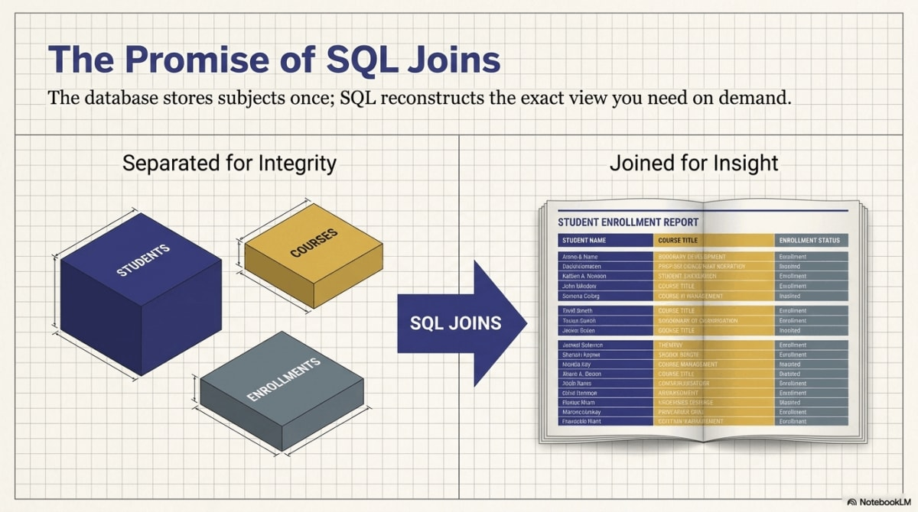
Before-and-after comparison: one wide flat table on the left, seven connected relational tables on the right linked by keys.
Figure 6.3 — Moving from one flat table to seven connected relational tables replaces redundancy with structure and integrity.

3. Entities, Attributes, Relationships, and Relations
Relational design starts by identifying what the database needs to represent.

3.1 Entities
An entity is a real-world object, person, place, concept, or event the database needs to store information about.
Entity | Why the database cares about it
Student | Students receive grades and attend class sessions
Deliverable | Deliverables are assignments students complete
Class meeting | Class meetings are sessions students may attend
Assignment type | Assignment types define grading rules
Grade scale | Grade scales convert final numeric results to letter grades
Entities become tables when they need to be represented in the database.

3.2 Attributes
An attribute is a property that describes an entity.
STUDENT -> StudentID, FirstName, LastName, Email, Birthday
DELIVERABLE -> DeliverableID, AssignmentType, DeliverableNumber, DueDate, Topic
The important design question is not “What attributes exist?” but “Which entity does each attribute describe?”
- Email describes a student → STUDENT.
- DueDate describes a deliverable → DELIVERABLE.
- Score describes one student’s result on one deliverable → STUDENT_GRADE.

3.3 Relationships
A relationship describes how entities are connected.
Relationship | Plain-English meaning | Relational representation
Student earns grade | One student can receive many grades | STUDENT.StudentID → STUDENT_GRADE.StudentID
Deliverable receives scores | One deliverable has many scores | DELIVERABLE.DeliverableID → STUDENT_GRADE.DeliverableID
Student attends class | One student has many attendance rows | STUDENT.StudentID → ATTENDANCE.StudentID
Class meeting has attendance | One meeting has many attendance rows | SCHEDULE.ClassNum → ATTENDANCE.ClassNum
Assignment type categorizes deliverables | One type covers many deliverables | ASSIGNMENT_TYPE.AssignmentType → DELIVERABLE.AssignmentType
Relationships are implemented with keys, especially foreign keys.

3.4 Relations
A relation is the formal table structure used to store data about an entity, relationship, event, or clearly bounded subject. Not every table represents a simple entity.
Table | What it represents
STUDENT | An entity: a student
ASSIGNMENT_TYPE | A lookup/category entity: a grading category
DELIVERABLE | An entity/event: a specific assignment item
STUDENT_GRADE | A relationship/event: a student receiving a score on a deliverable
ATTENDANCE | A relationship/event: a student attending a class meeting
SCHEDULE | An entity/event: one class session
GRADE_SCALE | A lookup table: letter-grade thresholds

3.5 Schema Notation
A schema is a formal description of database structure: table names, columns, keys, and relationships. In this book, schemas are written like this:
STUDENT(StudentID, FirstName, LastName, Email, Birthday)
DELIVERABLE(DeliverableID, AssignmentType, DeliverableNumber, DueDate, Topic)
STUDENT_GRADE(GradeID, StudentID, DeliverableID, Score)
Conventions:
- Table names are ALL CAPS and usually singular (STUDENT, not STUDENTS).
- Column names use readable capitalization, no spaces.
- The primary key is listed first.
- Foreign keys often reuse the name of the referenced primary key.
With data types (matching the Chapter 4/5 convention of StudentID as a text label, not a number):
STUDENT(
StudentID TEXT PRIMARY KEY, -- e.g., 'S1001'
FirstName TEXT,
LastName TEXT,
Email TEXT,
Birthday DATE
)
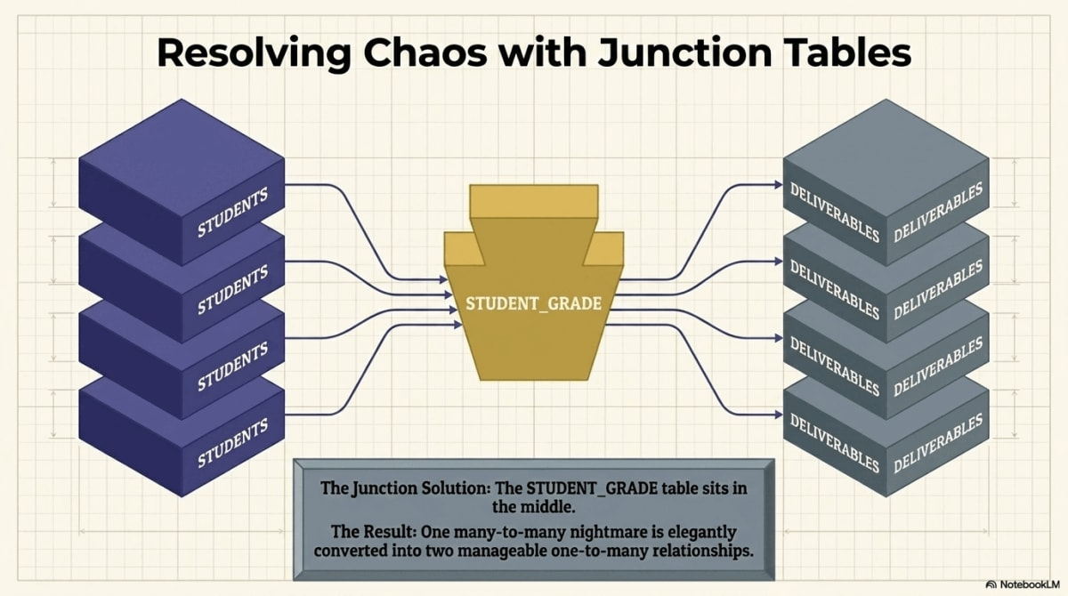
Four side-by-side cards labeled Entity, Attribute, Relationship, and Relation, each with a Grading Database example.
Figure 6.4 — Entity, Attribute, Relationship, and Relation are the four vocabulary cornerstones of relational design.

4. Keys: How Tables Identify Rows
Keys are the foundation of relational identity. They let the database know exactly which row is being referenced.

4.1 Why Keys Are Necessary
Names are not reliable identifiers. Two students may share a name. A student may change an email. A deliverable topic may be revised. A database needs stable identifiers that survive changes to descriptive details.

4.2 Candidate and Primary Keys
A candidate key is any column, or combination of columns, that could uniquely identify each row. A primary key is the candidate key chosen as the official unique identifier for the table. A primary key must be unique and must never be NULL — a rule called entity integrity.
Candidate key for STUDENT | Strength | Risk
StudentID | Stable institutional identifier | Requires system assignment
Email | Often unique | May change over time
(FirstName, LastName, Birthday) | Often distinguishes students | Not guaranteed unique
Phone number | Often unique | Can change or be shared
In STUDENT(StudentID, FirstName, LastName, Email), StudentID is chosen as the primary key. Every student has one, and no row can exist without it.

4.3 Composite Keys
A composite key is made from two or more columns. It is useful when no single column uniquely identifies a row, but a combination does.
COURSE_ENROLLMENT(StudentID, CourseID, Semester)
APARTMENT(BuildingNumber, ApartmentNumber, Rent)
A student can take many courses; a course runs many semesters. The combination (StudentID, CourseID, Semester) may uniquely identify one enrollment. Likewise, many buildings have Apartment 1, but (BuildingNumber, ApartmentNumber) identifies one apartment.

4.4 Natural Keys
A natural key is a real-world attribute that already has business meaning and could identify a row.
Natural key | Possible table | Risk
Email | STUDENT | Emails can change
ISBN | BOOK | Strong if carefully governed
State abbreviation | STATE | Stable in a controlled lookup
Letter grade | GRADE_SCALE | Stable inside a small course lookup
Natural keys are tempting because they carry meaning, but business values can change, be reused, or be entered inconsistently.

4.5 Surrogate Keys
A surrogate key is an artificial identifier created only for the database, with no business meaning. It is often an auto-incrementing integer, such as GradeID, DeliverableID, or AttendanceID.
Surrogate keys are short, stable, simple to join, and independent of changing business details. For example, identifying a property by street address is fragile: a renamed street or rezoned ZIP code can break references. A PropertyID surrogate stays the same:
PROPERTY(PropertyID, Street, City, State, ZIP, OwnerID)
Note that StudentID in this book is treated as a labeled identifier (values like S1001) rather than a pure surrogate integer. It still has no arithmetic meaning, but it follows the institutional convention that student IDs are short codes, not numbers.

4.6 Business-Rule Uniqueness
A surrogate primary key does not remove the need for business-rule constraints. STUDENT_GRADE uses GradeID as a surrogate primary key:
STUDENT_GRADE(GradeID, StudentID, DeliverableID, Score)
But the business rule may also say: a student should have only one score for each deliverable. That rule is captured by a unique constraint on (StudentID, DeliverableID). Similarly, (StudentID, ClassNum) should be unique in ATTENDANCE if a student can have only one attendance record per class meeting.

4.7 Key Types at a Glance
Key type | Definition | Grading Database Example
Candidate key | Any field or set of fields that could uniquely identify a row | StudentID, possibly Email
Primary key | The chosen official identifier | STUDENT.StudentID
Composite key | A key made of more than one column | (StudentID, DeliverableID) as a unique constraint
Natural key | A meaningful real-world identifier | GRADE_SCALE.LetterGrade
Surrogate key | An artificial system-generated identifier | STUDENT_GRADE.GradeID
Foreign key | A column that refers to a key in another table | STUDENT_GRADE.StudentID
🔑 Key Takeaway: Identity first, then connection
Primary keys give rows identity. Foreign keys use that identity to connect tables. Without keys, relational design collapses into guesswork.
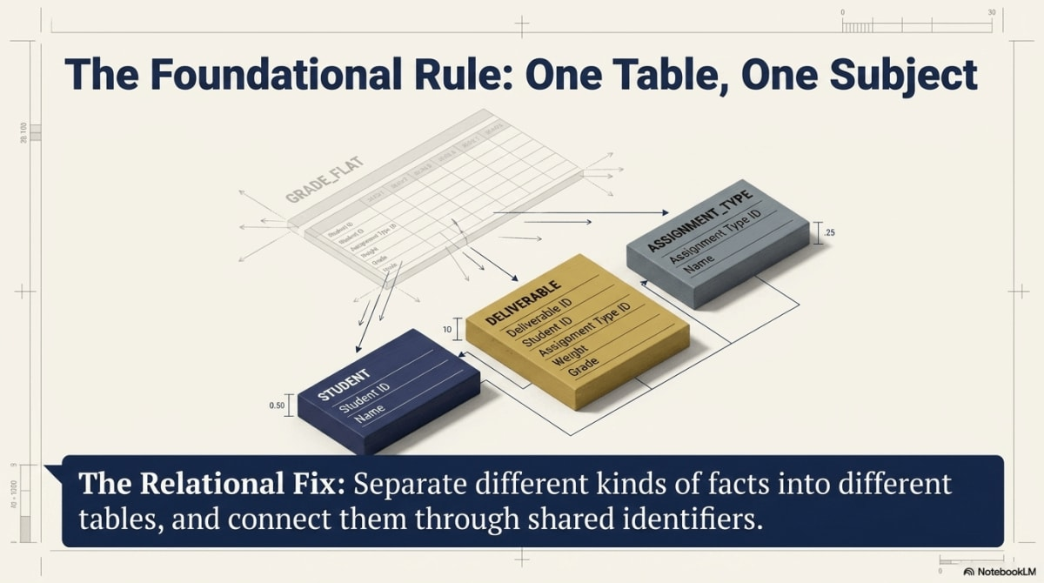
Primary key column highlighted in a parent table, with a foreign key arrow pointing to it from a child table, and candidate, natural, and surrogate key variations labeled below.
Figure 6.5 — Primary keys identify rows. Foreign keys connect tables. Candidate, natural, and surrogate keys serve different design roles.

5. Foreign Keys and Relationship Types
A primary key identifies a row. A foreign key connects one table to another.

5.1 Foreign Keys
A foreign key is a column in one table that references a key in another table.
STUDENT(StudentID, FirstName, LastName, Email)
STUDENT_GRADE(GradeID, StudentID, DeliverableID, Score)
STUDENT_GRADE.StudentID is a foreign key because it refers to STUDENT.StudentID. The student is stored once, and many grade records connect to that student.

5.2 One-to-One Relationships
A one-to-one relationship means one row in Table A relates to at most one row in Table B.
EMPLOYEE(EmployeeID, FirstName, LastName)
EMPLOYEE_PARKING(EmployeeID, ParkingSpotNumber)
One-to-one relationships are less common than one-to-many. They are often used to separate optional, sensitive, or rarely used information:
STUDENT(StudentID, FirstName, LastName)
STUDENT_PROFILE(StudentID, PreferredName, Pronouns, AccessibilityNotes)

5.3 One-to-Many Relationships
A one-to-many relationship means one row in one table can relate to many rows in another. This is the most common pattern in relational databases.
One side | Many side | Meaning
STUDENT | STUDENT_GRADE | One student has many grade records
DELIVERABLE | STUDENT_GRADE | One deliverable has many student scores
SCHEDULE | ATTENDANCE | One class meeting has many attendance rows
ASSIGNMENT_TYPE | DELIVERABLE | One type covers many deliverables
One-to-many relationships place the foreign key on the many side.

5.4 Many-to-Many Relationships
A many-to-many relationship means many rows in Table A can relate to many rows in Table B. One student completes many deliverables; one deliverable is completed by many students.
You should not store this as a comma-separated list:
STUDENT(StudentID, DeliverablesCompleted) -- bad: "Quiz1, Quiz2, Exam1"
That violates atomicity and breaks filtering, joining, and aggregation. Instead, relational databases resolve many-to-many relationships with a junction table:
STUDENT(StudentID, FirstName, LastName)
DELIVERABLE(DeliverableID, AssignmentType, DeliverableNumber)
STUDENT_GRADE(GradeID, StudentID, DeliverableID, Score)
GradeID | StudentID | DeliverableID | Score
1 | S1001 | 1 | 90
2 | S1001 | 2 | 95
3 | S1002 | 1 | 75
4 | S1003 | 1 | 100
STUDENT_GRADE is the junction table. It turns the many-to-many relationship into two one-to-many relationships:
STUDENT 1 ─── many STUDENT_GRADE
DELIVERABLE 1 ─── many STUDENT_GRADE

5.5 Relationship Types Summary
Relationship | Example | How it is represented
One-to-one | One student has one profile | Shared primary key or unique foreign key
One-to-many | One student has many grades | Foreign key on the many side
Many-to-many | Students complete many deliverables; deliverables have many students | Junction table such as STUDENT_GRADE
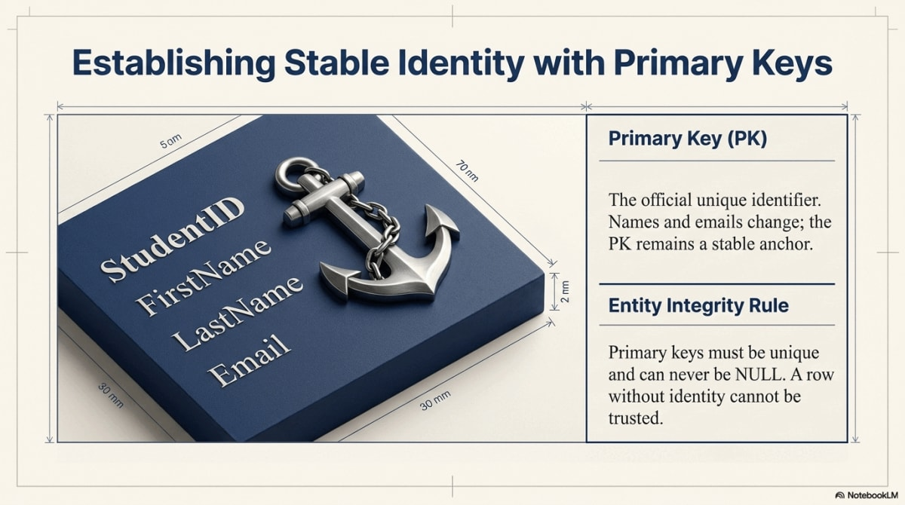
Three side-by-side mini-diagrams illustrating one-to-one, one-to-many, and many-to-many relationships using Grading Database examples.
Figure 6.6 — One-to-one, one-to-many, and many-to-many relationships each require a different structural representation in the schema.

6. Integrity Rules: Protecting Identity and Relationships
Relational databases do not rely on good intentions. They enforce rules. Two integrity rules matter most at this stage: entity integrity and referential integrity.

6.1 Entity Integrity
Entity integrity means every primary key value must be unique and not NULL. This protects row identity.
Invalid examples:
StudentID | FirstName | LastName
S1001 | Alice | Johnson
S1001 | Alicia | Jones
The database cannot accept both rows if StudentID is the primary key. A row with StudentID = NULL has no identity, and other tables cannot safely refer to it.

6.2 Referential Integrity
Referential integrity means every non-null foreign key value must match an existing key value in the referenced table.
STUDENT:
StudentID | FirstName | LastName
S1001 | Alice | Johnson
S1002 | Brian | Lee
STUDENT_GRADE:
GradeID | StudentID | DeliverableID | Score
1 | S1001 | 1 | 90
2 | S9999 | 1 | 80
The second row is invalid because no student has StudentID = S9999. It is an orphan record: a child row whose parent does not exist. A DBMS with referential integrity enabled rejects it.
The same rule applies in any business domain. Consider a membership database:
MEMBER:
MemberID | FirstName | LastName
101 | Maya | Chen
102 | Jordan | Smith
PAYMENT:
PaymentID | MemberID | Amount
1 | 101 | 50.00
2 | 105 | 25.00
The second payment is invalid because no member has MemberID = 105. You cannot record a payment from someone who does not exist in the system. And you cannot delete member 101 from MEMBER while payment 1 still references that member — the DBMS blocks the deletion to prevent an orphan payment. Referential integrity protects both directions: no orphan child records, and no deletion of a parent that is still in use.
This represents a fundamental shift in how data consistency is managed. In pre-relational systems, every application had to include its own logic to verify that a customer existed before creating an order. That approach was repetitive, inefficient, and error-prone. By defining referential integrity at the schema level, the database itself becomes an active guardian of its own consistency — enforced by the DBMS for every operation, regardless of which application or user initiates it. This centralization of business rules within the data layer is what makes relational databases more robust and trustworthy than the file-based systems they replaced.

6.3 SQL Example
CREATE TABLE STUDENT (
StudentID TEXT PRIMARY KEY,
FirstName TEXT NOT NULL,
LastName TEXT NOT NULL,
Email TEXT
);
CREATE TABLE STUDENT_GRADE (
GradeID INTEGER PRIMARY KEY,
StudentID TEXT NOT NULL,
DeliverableID INTEGER NOT NULL,
Score REAL,
FOREIGN KEY (StudentID) REFERENCES STUDENT(StudentID)
);
This insert is valid if student S1001 exists:
INSERT INTO STUDENT_GRADE (GradeID, StudentID, DeliverableID, Score)
VALUES (1, 'S1001', 1, 90);
This insert fails if student S9999 does not exist:
INSERT INTO STUDENT_GRADE (GradeID, StudentID, DeliverableID, Score)
VALUES (2, 'S9999', 1, 80);

6.4 Cascade Update and Cascade Delete
Some systems allow cascading actions. A cascading action automatically applies a parent-table change to related child rows.
Action | Meaning | Risk
Cascade update | If a parent key changes, child foreign keys change too | Usually safe, but primary keys should rarely change
Cascade delete | If a parent row is deleted, related child rows are deleted too | Dangerous if child records have independent value
⚠️ Warning: Be careful with cascade delete
Deleting a student should probably not automatically delete every grade and attendance record. Those records may be needed for audit, advising, grade appeals, or institutional reporting. Cascade delete is appropriate for things like temporary line items on an unsubmitted draft order, but it should be used carefully.
🔑 Key Takeaway: Two rules protect the model
Entity integrity protects row identity. Referential integrity protects relationships between tables. Together, they keep a relational database from drifting into contradiction.
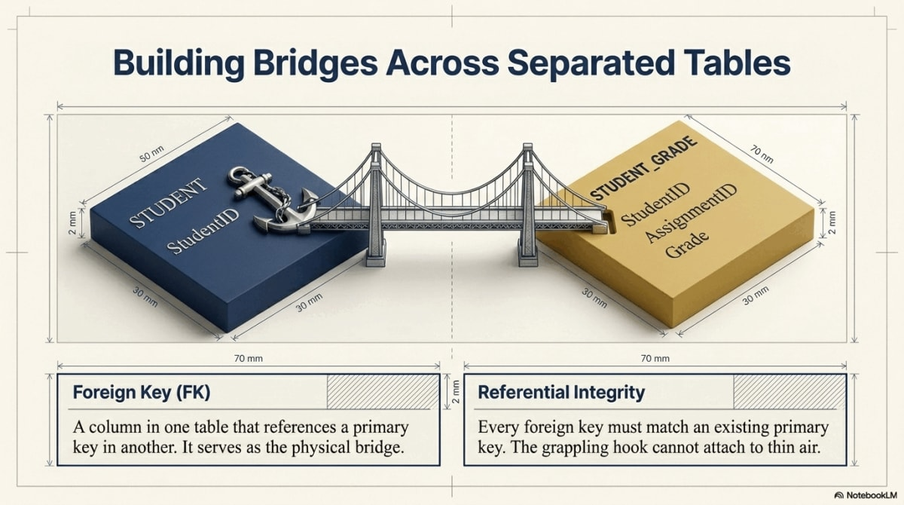
A parent-child table pair with a valid foreign key arrow and an orphan-row arrow visibly blocked by a referential-integrity X.
Figure 6.7 — Referential integrity blocks orphan records: every non-null foreign key must match an existing primary key in the referenced table.

7. Redesigning the Grading Database
The Grading Database is the main example in this chapter because it makes relational design visible. The flat table started with one row per student deliverable. The relational design separates the different subjects into connected tables.

7.1 Stage-by-Stage Progression
Stage | Added requirement | What happens in a flat table
1 | Store student identity | One student row may work temporarily
2 | Add deliverables and scores | Student data repeats across many rows
3 | Add assignment-type rules | Quiz, homework, exam rules repeat
4 | Add schedule and attendance | Class meetings mix with grades
5 | Add final letter-grade rules | Thresholds repeat or float outside the structure
6 | Redesign relationally | Each subject gets its own table

7.2 Final Seven-Table Schema
ℹ️ Canonical Grading Database keys (used throughout Chapters 6–10)
Table
Primary key
Type
STUDENT
StudentID
TEXT (e.g., S1001)
ASSIGNMENT_TYPE
AssignmentType
TEXT (natural key)
DELIVERABLE
DeliverableID
INTEGER (surrogate)
STUDENT_GRADE
GradeID
INTEGER (surrogate)
SCHEDULE
ClassNum
INTEGER
ATTENDANCE
AttendanceID
INTEGER (surrogate)
GRADE_SCALE
LetterGrade
TEXT (natural key)
Table | Purpose | Example columns
STUDENT | Student identities | StudentID, FirstName, LastName, Email, Birthday
ASSIGNMENT_TYPE | Category-level grading rules | AssignmentType, Quantity, PointsPerType, Weight, WeightPerItem
DELIVERABLE | Specific graded items | DeliverableID, AssignmentType, DeliverableNumber, DueDate, Topic
STUDENT_GRADE | Student performance on deliverables | GradeID, StudentID, DeliverableID, Score
SCHEDULE | Class meetings | ClassNum, Week, ClassDate, Topic, Format
ATTENDANCE | Student attendance at meetings | AttendanceID, ClassNum, StudentID, Attended
GRADE_SCALE | Letter-grade thresholds | LetterGrade, MinScore, MaxScore

7.3 Sample Rows
STUDENT stores student identity once, fixing the update anomaly:
StudentID | FirstName | LastName | Email | Birthday
S1001 | Alice | Johnson | alice@university.edu | 2004-05-14
S1002 | Brian | Lee | brian@university.edu | 2003-11-22
S1003 | Carla | Mendez | carla@university.edu | 2004-02-09
S1004 | Daniel | Kim | daniel@university.edu | 2004-08-17
ASSIGNMENT_TYPE stores category rules once. Weights match the locked Chapter 4/5 grading model (Quiz 20%, Homework 30%, Exam 40%, Project 10%). WeightPerItem is Weight divided by Quantity, stored once so queries do not need to recompute it:
AssignmentType | Quantity | PointsPerType | Weight | WeightPerItem
Quiz | 4 | 100 | 20 | 5
Homework | 3 | 100 | 30 | 10
Exam | 2 | 100 | 40 | 20
Project | 1 | 100 | 10 | 10
DELIVERABLE stores individual graded items. IDs start at 1 so the design matches what Access AutoNumber will actually produce in §9:
DeliverableID | AssignmentType | DeliverableNumber | DueDate | Topic
1 | Quiz | 1 | 2026-09-10 | Database Basics
2 | Quiz | 2 | 2026-09-17 | SQL Basics
3 | Exam | 1 | 2026-10-05 | Midterm
STUDENT_GRADE records one student’s score on one deliverable. Scores are 0–100, matching Chapters 4 and 5:
GradeID | StudentID | DeliverableID | Score
1 | S1001 | 1 | 90
2 | S1001 | 2 | 95
3 | S1001 | 3 | 87
4 | S1002 | 1 | 75
5 | S1003 | 1 | 100
SCHEDULE, ATTENDANCE, and GRADE_SCALE follow the same pattern: each stores one subject. Attendance resolves the many-to-many relationship between students and class meetings. The grade scale stores letter-grade thresholds in one place so a grading-policy change updates one row.

7.4 ERD Overview
erDiagram
STUDENT ||--o{ STUDENT_GRADE : earns
DELIVERABLE ||--o{ STUDENT_GRADE : receives
ASSIGNMENT_TYPE ||--o{ DELIVERABLE : categorizes
SCHEDULE ||--o{ ATTENDANCE : schedules
STUDENT ||--o{ ATTENDANCE : attends
STUDENT {
text StudentID PK
text FirstName
text LastName
text Email
date Birthday
}
ASSIGNMENT_TYPE {
text AssignmentType PK
int Quantity
int PointsPerType
int Weight
int WeightPerItem
}
DELIVERABLE {
int DeliverableID PK
text AssignmentType FK
int DeliverableNumber
date DueDate
text Topic
}
STUDENT_GRADE {
int GradeID PK
text StudentID FK
int DeliverableID FK
int Score
}
SCHEDULE {
int ClassNum PK
int Week
date ClassDate
text Topic
text Format
}
ATTENDANCE {
int AttendanceID PK
int ClassNum FK
text StudentID FK
int Attended
}
GRADE_SCALE {
text LetterGrade PK
int MinScore
int MaxScore
}

7.5 What the Redesign Solves
Flat-table problem | Relational solution
Student emails repeat in every grade row | Student data appears once in STUDENT
Assignment rules repeat across every student score | Category rules appear once in ASSIGNMENT_TYPE
Specific deliverables cannot exist independently | Deliverables appear once in DELIVERABLE
Scores are mixed with student identity | Scores live in STUDENT_GRADE
Attendance is mixed with grade records | Attendance lives in ATTENDANCE
Letter-grade thresholds float outside the structure | Thresholds live in GRADE_SCALE
The relational design is longer not because it is more complicated but because it separates meaning.
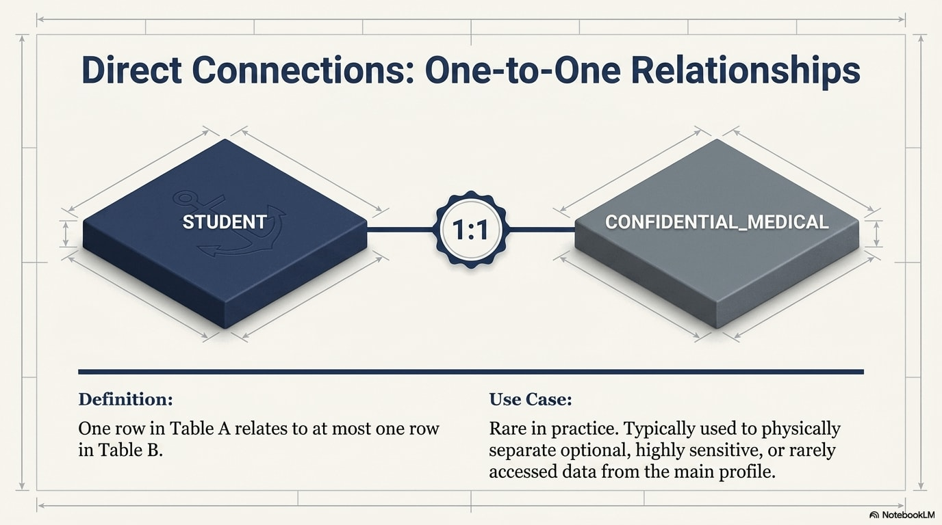
A full seven-table ERD for the Grading Database with crow’s-foot notation and color-coded entity, lookup, and junction tables.
Figure 6.8 — The full seven-table Grading Database ERD: each table represents one subject, and every relationship is enforced through keys.

8. Querying a Relational Design with Joins
Relational design separates data into tables. SQL joins put related data back together when a question requires it.
- Storage is separated to reduce redundancy.
- Queries are joined to reconstruct meaning.
Chapter 5 introduced the basic shape of an INNER JOIN as a preview. This section is the full treatment: it is where joins matter most, because the relational schema you just designed only becomes report-ready when joins reconstruct it.

8.0 Reading a Join
Every join answers four questions. Asking them before you write SQL keeps even a multi-table query manageable:
- What is the left table? The table you start from.
- What is the right table? The table you are pulling related data from.
- Which columns create the match? The shared key — usually a primary key on one side and a foreign key on the other.
- Which columns should appear in the output? The fields the question actually needs.
For the first query below, the answers are:
Question | Answer
Left table | STUDENT
Right table | STUDENT_GRADE
Matching columns | STUDENT.StudentID = STUDENT_GRADE.StudentID
Output columns | name fields, deliverable details, and Score
The match works because STUDENT_GRADE.StudentID is a foreign key that refers to STUDENT.StudentID — exactly the relationship defined in Section 5.

8.1 Basic Student Scores
What scores did each student receive, and on which deliverables?
SELECT s.FirstName,
s.LastName,
d.AssignmentType,
d.DeliverableNumber,
d.Topic,
sg.Score
FROM STUDENT AS s
JOIN STUDENT_GRADE AS sg ON s.StudentID = sg.StudentID
JOIN DELIVERABLE AS d ON sg.DeliverableID = d.DeliverableID
ORDER BY s.LastName, d.AssignmentType, d.DeliverableNumber;
The result looks like a report, but the database does not store it as one repeated table.

8.2 Adding Assignment Rules
How much is each deliverable worth toward the final grade?
SELECT s.FirstName,
s.LastName,
d.AssignmentType,
d.DeliverableNumber,
at.WeightPerItem,
sg.Score
FROM STUDENT AS s
JOIN STUDENT_GRADE AS sg ON s.StudentID = sg.StudentID
JOIN DELIVERABLE AS d ON sg.DeliverableID = d.DeliverableID
JOIN ASSIGNMENT_TYPE AS at ON d.AssignmentType = at.AssignmentType
ORDER BY s.LastName, d.DueDate;
The join works because DELIVERABLE.AssignmentType connects each specific deliverable to the category rules in ASSIGNMENT_TYPE.

8.3 Calculating Weighted Contribution
How much does each score contribute to the final grade?
Because Score is on a 0–100 scale and WeightPerItem is the points each individual deliverable contributes (Weight / Quantity), the weighted contribution is simply Score × WeightPerItem / 100:
SELECT s.FirstName,
s.LastName,
d.AssignmentType,
d.DeliverableNumber,
sg.Score,
at.WeightPerItem,
ROUND(sg.Score * at.WeightPerItem / 100.0, 2) AS WeightedContribution
FROM STUDENT AS s
JOIN STUDENT_GRADE AS sg ON s.StudentID = sg.StudentID
JOIN DELIVERABLE AS d ON sg.DeliverableID = d.DeliverableID
JOIN ASSIGNMENT_TYPE AS at ON d.AssignmentType = at.AssignmentType;
Score belongs to one student-deliverable result, while WeightPerItem belongs to the assignment category. A flat table would repeat those category rules in every row.

8.4 Attendance Summary
How many classes did each student attend?
SELECT s.StudentID,
s.FirstName,
s.LastName,
COUNT(a.AttendanceID) AS ClassesRecorded,
SUM(a.Attended) AS ClassesAttended
FROM STUDENT AS s
LEFT JOIN ATTENDANCE AS a ON s.StudentID = a.StudentID
GROUP BY s.StudentID, s.FirstName, s.LastName
ORDER BY s.LastName;
The LEFT JOIN keeps students even if they have no attendance rows yet, which is useful when looking for missing records.

8.5 Advanced Preview: Finding Missing Grades
Which student-deliverable combinations do not yet have a score?
This query is heavier than the others — it uses CROSS JOIN and an “anti-join” pattern with LEFT JOIN ... WHERE ... IS NULL. Treat it as a preview of the analytical payoff; the companion Let’s Build walks through it step by step.
SELECT s.StudentID,
s.FirstName,
s.LastName,
d.DeliverableID,
d.AssignmentType,
d.DeliverableNumber
FROM STUDENT AS s
CROSS JOIN DELIVERABLE AS d
LEFT JOIN STUDENT_GRADE AS sg
ON s.StudentID = sg.StudentID
AND d.DeliverableID = sg.DeliverableID
WHERE sg.GradeID IS NULL
ORDER BY s.LastName, d.DueDate;
The database generates the expected student-deliverable pairs and then identifies which expected records are missing. A flat table cannot answer this cleanly.

8.6 Join Types at a Glance
The queries above use the two joins you will reach for most often. It helps to see them alongside the others so you recognize the names when they appear:
Join Type | What It Keeps | Best Use
INNER JOIN | Only rows that match in both tables | Standard reporting when both tables should match
LEFT JOIN | All left-table rows, plus matching right-table data | Finding unmatched or incomplete related data
RIGHT JOIN | All right-table rows, plus matching left-table data | Same idea as LEFT JOIN, mirrored; support varies by tool
FULL OUTER JOIN | All rows from both tables | Comparing two sets for matches and gaps; support varies by tool
CROSS JOIN | Every possible row combination | Generating all pairings, as in the §8.5 missing-grades query
Master INNER JOIN and LEFT JOIN; recognize the rest. A CROSS JOIN multiplies rows: a 4-row table and a 6-row table produce 24 rows, which is occasionally useful (it builds the full set of expected student-deliverable pairs in §8.5) but easy to trigger by accident.
🔑 Key Takeaway: Joins are the payoff of relational design
Joins are not just SQL syntax. They are the practical consequence of separating subjects into tables. The database stores each subject once and reconstructs the exact view you need on demand.
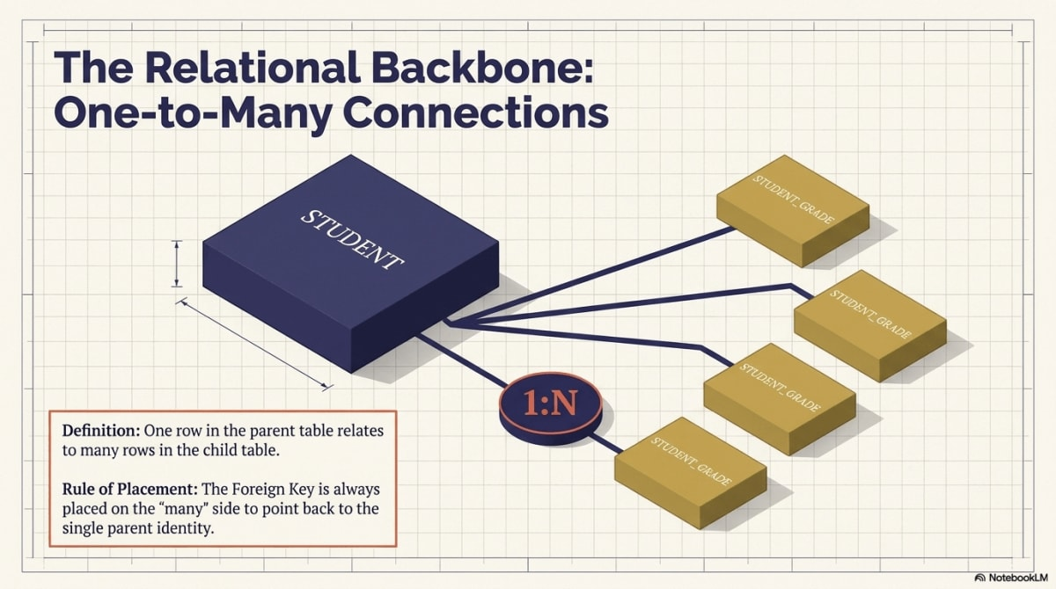
Three small tables flowing into one joined result set to show how relational storage rebuilds a report-ready view.
Figure 6.9 — SQL joins reconstruct a report-ready view by reconnecting tables that relational design intentionally separated for integrity.

9. Microsoft Access as a Visual Learning Tool
Microsoft Access makes relational structure visible. You can see tables, primary keys, relationship lines, and integrity rules in a graphical interface and inspect the SQL behind every visual query. This section walks through building the core of the Grading Database (STUDENT, DELIVERABLE, and STUDENT_GRADE) well enough to see the relational model at work. The companion Let’s Build extends this walkthrough to the full seven-table Grading Database, including ATTENDANCE, ASSIGNMENT_TYPE, SCHEDULE, and GRADE_SCALE.

9.1 What Access Makes Visible
A helpful way to think about referential integrity is to imagine a library database with an AUTHOR table and a BOOK table. Each book record stores an AuthorID that identifies the book’s author. That AuthorID should point to an author who actually exists. Without referential integrity, the database could end up with books that refer to deleted or nonexistent authors: orphan records. The same problem can happen in the Grading Database if a grade points to a student or deliverable that does not exist. Access makes these relationships visible and enforceable.
Access feature | What it helps students see
Table Design View | Field names, data types, primary keys, required fields
Relationships window | Primary-key / foreign-key links across tables
Enforce Referential Integrity checkbox | How the DBMS protects valid relationships
Query Design View | Joins as visible lines between tables
SQL View | The SQL statement behind the visual query
Access is not the relational model; it is one implementation that makes the model visible.

9.2 Building the Core Tables
Create three tables in Table Design View. Notice the key-type pattern: StudentID is a Short Text primary key (a labeled ID like S1001), while DeliverableID and GradeID are AutoNumber surrogate keys. Foreign keys must match the parent’s type exactly — so the StudentID foreign key in STUDENT_GRADE is also Short Text.
STUDENT
Field | Data Type | Notes
StudentID | Short Text | Primary key; enter values manually: S1001, S1002, S1003, S1004
FirstName | Short Text | Required
LastName | Short Text | Required
Email | Short Text | Indexed (no duplicates)
Birthday | Date/Time
DELIVERABLE
Field | Data Type | Notes
DeliverableID | AutoNumber | Primary key; Access assigns 1, 2, 3, … automatically
AssignmentType | Short Text | (Quiz, Homework, Exam, Project)
DeliverableNumber | Number
DueDate | Date/Time
Topic | Short Text
STUDENT_GRADE
Field | Data Type | Notes
GradeID | AutoNumber | Primary key
StudentID | Short Text | Foreign key → STUDENT.StudentID (must match parent’s text type)
DeliverableID | Number (Long Integer) | Foreign key → DELIVERABLE.DeliverableID (matches AutoNumber)
Score | Number | 0–100
For each table, set the primary key by selecting the field and clicking the key icon. Save with the table name in CAPS.
⚠️ Warning: Watch the data types
Access only allows a relationship between fields of compatible types. If STUDENT.StudentID is Short Text but STUDENT_GRADE.StudentID is a Number, Access will refuse to create the relationship. The fix is to make both Short Text.

9.3 Defining Relationships and Enforcing Integrity
- Close all open tables.
- Open Database Tools → Relationships.
- Add STUDENT, DELIVERABLE, and STUDENT_GRADE to the layout.
- Drag STUDENT.StudentID onto STUDENT_GRADE.StudentID. In the dialog:
  - check Enforce Referential Integrity
  - leave Cascade Update Related Fields off (primary keys should not change)
  - leave Cascade Delete Related Records off (see Section 6.4 warning)
- Drag DELIVERABLE.DeliverableID onto STUDENT_GRADE.DeliverableID and check Enforce Referential Integrity again.
In this chapter, all tables are local to the same Access database file, so Access can enforce the relationships directly. In a professional split-database design, some tables may be linked from a separate back-end source. In that situation, relationship enforcement must be configured in the back-end system, not in the front-end Access file alone.
You should now see two relationship lines, each labeled 1 on the parent side and ∞ on the STUDENT_GRADE side. Those symbols are Access’s way of showing one-to-many relationships.

9.4 Watching Referential Integrity Work
With the STUDENT table containing students S1001 (Alice) and S1002 (Brian), try to add this row directly to STUDENT_GRADE:
GradeID | StudentID | DeliverableID | Score
(auto) | S9999 | 1 | 90
Access refuses the insert because no student has StudentID = S9999. The relational logic from Section 6 is now visible and enforced by the DBMS.
You can also test referential integrity from the parent side. Try deleting Alice (StudentID = S1001) from the STUDENT table while she still has grade records in STUDENT_GRADE. Access refuses the deletion because those child records still depend on Alice’s row. Referential integrity protects both directions: it prevents orphan child records and protects parent rows that are still in use.

9.5 Inspecting the SQL Behind the Visual Query
- Open Create → Query Design.
- Add STUDENT, DELIVERABLE, and STUDENT_GRADE. Access draws the join lines automatically from the relationships you defined.
- Drag FirstName, LastName, AssignmentType, DeliverableNumber, and Score into the grid.
- Switch to SQL View (View → SQL View). You will see Access-generated SQL roughly equivalent to:
SELECT s.FirstName, s.LastName, d.AssignmentType, d.DeliverableNumber, sg.Score
FROM (STUDENT AS s
INNER JOIN STUDENT_GRADE AS sg ON s.StudentID = sg.StudentID)
INNER JOIN DELIVERABLE AS d ON sg.DeliverableID = d.DeliverableID;
The visual query, the relationship lines in the Relationships window, and the SQL statement are three views of the same relational design.
🔑 Key Takeaway: Access makes the model visible
Access does not replace the relational model. It shows it. Tables, keys, relationship lines, and the integrity checkbox are the relational concepts from Sections 2–6 made clickable.
The companion Let’s Build continues this build by adding ASSIGNMENT_TYPE, SCHEDULE, ATTENDANCE, and GRADE_SCALE, setting up their relationships, and writing the weighted-grade and attendance queries from Section 8 inside Access.
ℹ️ Sidebar: Local Tables and Linked Tables
In this chapter, the tables live directly inside the Access file. These are local tables, and they are ideal for learning because everything is visible in one place. In many professional Access applications, however, the file users see is only the front end. It contains forms, reports, queries, and interface logic, while the actual data lives in a separate back-end database. Tables that point to that external data source are called linked tables. You do not need to build a split database yet, but the idea matters: Access can be both a learning DBMS and the front end of a larger information system. The full treatment of multi-user database architecture comes later in Chapter 11.

10. Functional Dependencies and the Bridge to Normalization
Chapter 7 introduces normalization. The bridge from this chapter is the idea of a functional dependency: when one attribute, or set of attributes, determines another. In plain language, if I know A, I can determine B.
In the Grading Database:
StudentID -> FirstName, LastName, Email, Birthday
AssignmentType -> Quantity, PointsPerType, Weight, WeightPerItem
DeliverableID -> AssignmentType, DeliverableNumber, DueDate, Topic
(StudentID, DeliverableID) -> Score
The flat GRADE_FLAT table is troubled because different attributes depend on different determinants. Student attributes depend on StudentID, category attributes depend on AssignmentType, deliverable attributes depend on DeliverableID, and the score depends on the student-deliverable pair. Forcing all four into one table is what causes the anomalies in Section 1. Chapter 7 uses functional dependencies as the formal tool for checking each table and fixing the ones that mix determinants.
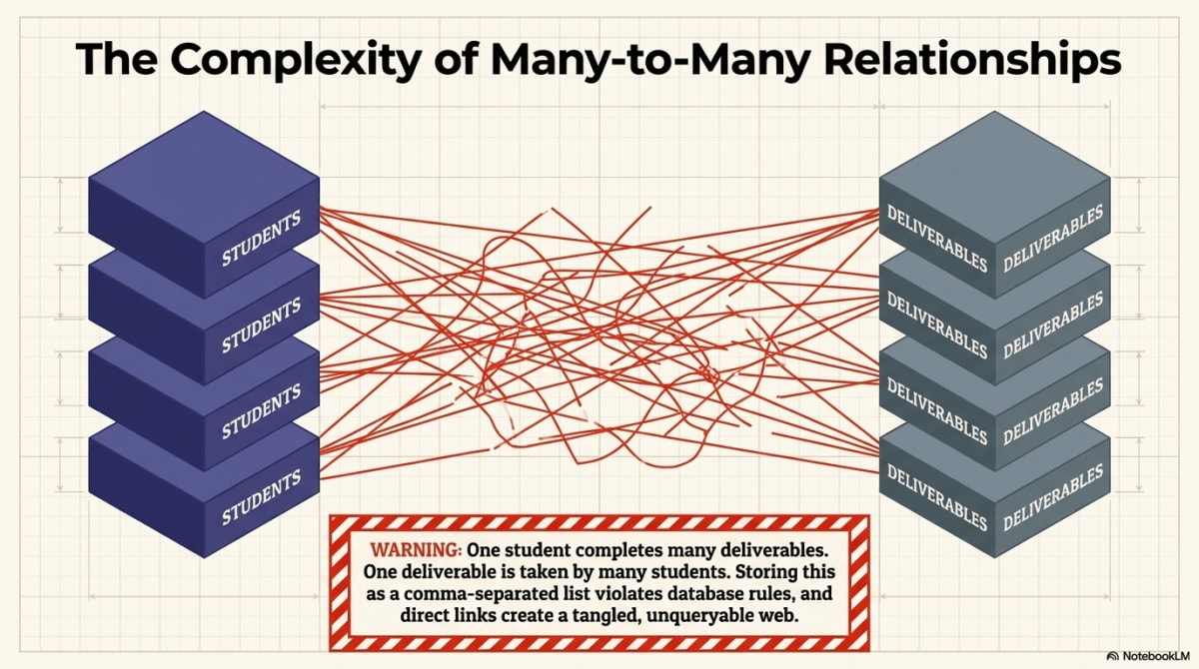
Functional dependencies: a bridge diagram showing how determinants map to their dependent attributes, previewing normalization.
Figure 6.10 — Functional dependencies reveal which attributes belong together because they share the same determinant, setting up the normalization work in Chapter 7.
🔑 The enduring legacy of the relational model
Codd’s 1970 paper transformed database management from an ad-hoc engineering task into a formal science grounded in set theory and predicate logic. The principles it established — uniqueness through keys, connections through foreign keys, consistency through referential integrity, and redundancy elimination through normalization — are not merely best practices. They are integral components of a cohesive, mathematically sound system. While NoSQL and other alternative models have emerged for specialized workloads, the relational model remains the bedrock for structured data worldwide, underpinning critical systems in finance, commerce, logistics, healthcare, and science. The skills you build in this chapter and the next transfer directly to every major relational database platform in use today.

Key Concepts
Foundational ideas
- The relational model stores different kinds of data in separate tables connected by keys.
- A relation is more than a spreadsheet-like grid; it follows formal structural rules.
- Flat tables fail when they mix multiple subjects and repeat the same facts.
- Modification anomalies (update, insertion, deletion) are symptoms of poor structure.
Keys and integrity
- A primary key uniquely identifies each row; a candidate key could.
- A composite key uses multiple columns; a natural key has business meaning; a surrogate key has none.
- Entity integrity: primary keys must be unique and never NULL.
- A foreign key connects one table to another; referential integrity prevents orphan records.
Relationship design
- 1:1 connects one row to at most one related row.
- 1:N places the foreign key on the many side.
- M:N requires a junction table. STUDENT_GRADE is a junction between STUDENT and DELIVERABLE; ATTENDANCE is a junction between STUDENT and SCHEDULE.
Application in practice
- The Grading Database moves from one flat table to seven connected tables.
- SQL joins reconstruct report-ready views from those tables.
- Access shows keys, relationships, and integrity in a visual interface.
- Functional dependencies set up normalization in Chapter 7.

Chapter Summary
This chapter explained the relational model as the foundation of modern database design. A flat table looks simple, but it becomes unreliable when it stores multiple kinds of facts in one structure. Student identities, assignment rules, deliverable details, attendance records, and scores have different meanings and different update patterns. When they are forced into one table, redundancy and anomalies appear.
The relational model solves this problem by giving each table one well-defined subject. Rows are instances; columns are attributes. Primary keys identify rows. Foreign keys connect related rows across tables. Entity integrity protects row identity, and referential integrity protects valid relationships.
The Grading Database made these ideas concrete. A flat GRADE_FLAT table was decomposed into STUDENT, ASSIGNMENT_TYPE, DELIVERABLE, STUDENT_GRADE, SCHEDULE, ATTENDANCE, and GRADE_SCALE. Each table has a clear purpose. Together they support cleaner updates, safer data entry, and more reliable SQL queries. The chapter also showed that relational design does not make reporting harder; it makes reporting more trustworthy. Joins reconstruct the exact view needed for a question without requiring duplicated storage.
The Access walkthrough connected the theory to a hands-on environment, and the companion Let’s Build extends that work to the full seven-table schema. Finally, functional dependencies served as the bridge to normalization: they reveal which attributes belong together and which should be separated, which is exactly the work Chapter 7 formalizes.
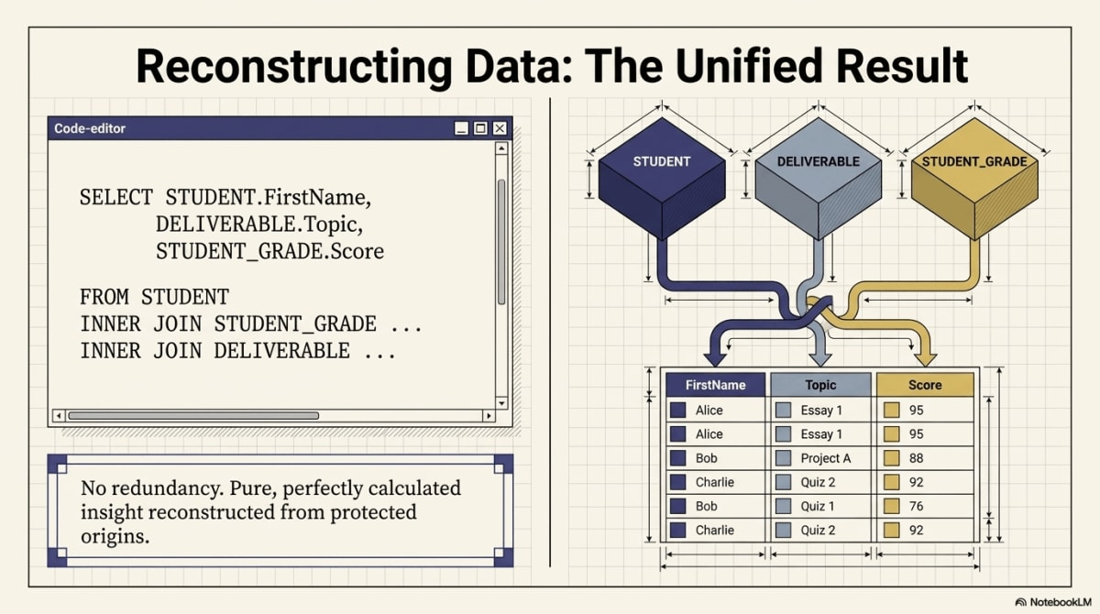
Chapter 6 concept map: the relational model replaces flat-table redundancy with connected tables, keys, integrity rules, and the analytical power of joins.
Figure 6.11 — Chapter 6 recap: the relational model replaces flat-table redundancy with structure, integrity, and analytical power.

References
Codd, E. F. (1970). A relational model of data for large shared data banks. Communications of the ACM, 13(6), 377–387.
Connolly, T., & Begg, C. (2015). Database systems: A practical approach to design, implementation, and management (6th ed.). Pearson.
Date, C. J. (2004). An introduction to database systems (8th ed.). Pearson.
Elmasri, R., & Navathe, S. B. (2016). Fundamentals of database systems (7th ed.). Pearson.
Hoffer, J. A., Venkataraman, R., & Topi, H. (2019). Modern database management (13th ed.). Pearson.
Laudon, K. C., & Laudon, J. P. (2024). Management information systems: Managing the digital firm (18th ed.). Pearson.
Silberschatz, A., Korth, H. F., & Sudarshan, S. (2020). Database system concepts (7th ed.). McGraw-Hill Education.

Let’s Build

The main chapter built the first three tables of the Grading Database in Access — STUDENT, DELIVERABLE, and STUDENT_GRADE — and showed how referential integrity stops orphan rows. This Let’s Build extends that work to the full seven-table schema, adds three new relationships (ASSIGNMENT_TYPE→DELIVERABLE, SCHEDULE→ATTENDANCE, STUDENT→ATTENDANCE), and then writes the three queries from §8 inside Access: a weighted-contribution join, an attendance summary with LEFT JOIN, and a missing-grades anti-join that uses CROSS JOIN and LEFT JOIN ... WHERE IS NULL. By the end you will have a complete relational Grading Database that mirrors the §7 ERD and three saved queries that prove the design works. There is no submission for this Let’s Build — the graded transfer happens in Lab 02 — SQL and Relational Database Foundations, where you apply the same logic to the PetVax clinic.

Purpose
Make the §7 seven-table Grading Database real in Access, enforce referential integrity on every parent-child link, and run the §8 queries against the live tables so the relational design pays off in front of you.

What You Will Practice
- Extending an existing Access database without breaking the relationships already drawn.
- Matching foreign-key data types to parent primary-key types (the most common Access error).
- Drawing one-to-many relationships and enforcing referential integrity in the Relationships window.
- Writing multi-table joins in Query Design View and inspecting the generated SQL.
- Using LEFT JOIN two different ways: to keep the left side, and as the core of an anti-join.
- Reading CROSS JOIN as the way to enumerate the universe of expected combinations.

Before You Begin
You should have the .accdb from the main chapter §9 walkthrough open, with three tables already created and populated:
- STUDENT with the four students S1001 Alice, S1002 Brian, S1003 Carla, S1004 Daniel. (Chapter 5 used five students for SQL practice; Chapter 6 uses four to keep the Access build manageable. The relational concepts work the same with four or five.)
- DELIVERABLE (empty or partly populated).
- STUDENT_GRADE (empty or partly populated).
- Two relationship lines already drawn: STUDENT → STUDENT_GRADE and DELIVERABLE → STUDENT_GRADE, both with Enforce Referential Integrity checked.
If your instructor provides gradingdb-ch06-starter.accdb, use that file — it already contains the three tables and two relationships above. Otherwise, complete the §9 walkthrough first. Save your working copy as gradingdb-ch06.accdb. Plan about 75–90 minutes; the four new tables and three queries can be split across two sittings if needed.
🔑 Key Takeaway: What changed from Chapter 4?
In Chapter 4, you used Access to create a working database. In Chapter 6, you use Access to create a relational design. The difference is not the software — it is that related facts now live in separate tables and are connected through enforced relationships.

Starting State Checklist
Before continuing, confirm your database matches every row below. Most later errors come from starting with mismatched field types.
Check | Expected
Table exists | STUDENT
Table exists | DELIVERABLE
Table exists | STUDENT_GRADE
STUDENT.StudentID data type | Short Text
DELIVERABLE.DeliverableID data type | AutoNumber
STUDENT_GRADE.StudentID data type | Short Text
STUDENT_GRADE.DeliverableID data type | Number / Long Integer
Relationship exists | STUDENT → STUDENT_GRADE
Relationship exists | DELIVERABLE → STUDENT_GRADE
Referential integrity | Enforced on both relationships
If any row does not match, fix it before continuing.

Seed the Deliverables and Grades
Before adding new tables, populate DELIVERABLE and STUDENT_GRADE so the later queries have data to work with. Open DELIVERABLE and enter five rows. DeliverableID is AutoNumber, so Access assigns 1–5 in order:
AssignmentType | DeliverableNumber | DueDate | Topic
Quiz | 1 | 2026-09-10 | Database Basics
Quiz | 2 | 2026-09-17 | SQL Basics
Homework | 1 | 2026-09-24 | Entity Design
Exam | 1 | 2026-10-05 | Midterm
Project | 1 | 2026-11-05 | Final Project
Then open STUDENT_GRADE and enter eight rows. Leave GradeID blank (AutoNumber):
StudentID | DeliverableID | Score
S1001 | 1 | 90
S1001 | 2 | 95
S1001 | 4 | 87
S1002 | 1 | 75
S1002 | 2 | 79
S1003 | 3 | 95
S1003 | 4 | 91
S1004 | 5 | 89
Expected state: 5 rows in DELIVERABLE, 8 rows in STUDENT_GRADE. Notice that not every student has a score on every deliverable — that gap is what the anti-join in the last query will surface.
✅ Good Practice: Add a validation rule for Score
In Design View for STUDENT_GRADE, select the Score field and set Validation Rule to Between 0 And 100 with Validation Text Score must be between 0 and 100. This prevents accidental out-of-range values from entering the database — a small rule that protects data quality.

Add the ASSIGNMENT_TYPE Table
Create a new table in Create → Table Design. This table stores category-level grading rules once, so they no longer repeat in every deliverable row.
Field | Data Type | Notes
AssignmentType | Short Text | Primary key (natural key — the category name itself)
Quantity | Number | Required
PointsPerType | Number | Required
Weight | Number | Required (percent of final grade)
WeightPerItem | Number | Required (Weight ÷ Quantity)
Select AssignmentType and click the key icon to set it as the primary key. Save as ASSIGNMENT_TYPE. Enter the four category rows from the chapter:
AssignmentType | Quantity | PointsPerType | Weight | WeightPerItem
Quiz | 4 | 100 | 20 | 5
Homework | 3 | 100 | 30 | 10
Exam | 2 | 100 | 40 | 20
Project | 1 | 100 | 10 | 10
Expected output: four rows. The category rules now live in exactly one place.

Add the SCHEDULE Table
Class meetings deserve their own table because attendance attaches to them. Create another table in Design View:
Field | Data Type | Notes
ClassNum | Number | Primary key (manually entered, not AutoNumber, so the values match what you reference in ATTENDANCE)
Week | Number | Required
ClassDate | Date/Time | Required
Topic | Short Text | Optional
Format | Short Text | Optional
Save as SCHEDULE and enter four meetings:
ClassNum | Week | ClassDate | Topic | Format
1 | 1 | 2026-09-01 | Course Introduction | In person
2 | 2 | 2026-09-08 | Data and Information | In person
3 | 3 | 2026-09-15 | SQL Basics | Online
4 | 4 | 2026-09-22 | Relational Design | In person
Expected output: four scheduled class meetings.

Add the ATTENDANCE Table
ATTENDANCE is a junction table. It resolves the many-to-many relationship between students and class meetings: one student attends many meetings, and one meeting is attended by many students. Create the table in Design View — and read the data-type warning carefully before saving.
Field | Data Type | Notes
AttendanceID | AutoNumber | Primary key (surrogate)
ClassNum | Number, Long Integer | Foreign key → SCHEDULE.ClassNum
StudentID | Short Text | Foreign key → STUDENT.StudentID — must match parent type
Attended | Yes/No | Required
⚠️ Warning: Foreign-key types must match the parent
STUDENT.StudentID is Short Text (values like S1001), so the StudentID foreign key in ATTENDANCE must also be Short Text. SCHEDULE.ClassNum is a Number, so the ClassNum foreign key in ATTENDANCE must be Number (Long Integer). If the types do not match, Access will refuse to draw the relationship in the next step.
Save as ATTENDANCE. Enter sixteen rows — every student against every meeting, with some marked absent so the data looks realistic. Leave AttendanceID blank:
ClassNum | StudentID | Attended
1 | S1001 | Yes
1 | S1002 | Yes
1 | S1003 | Yes
1 | S1004 | No
2 | S1001 | Yes
2 | S1002 | No
2 | S1003 | Yes
2 | S1004 | Yes
3 | S1001 | Yes
3 | S1002 | Yes
3 | S1003 | Yes
3 | S1004 | Yes
4 | S1001 | No
4 | S1002 | Yes
4 | S1003 | Yes
4 | S1004 | Yes
Expected output: sixteen attendance rows.

Add the GRADE_SCALE Lookup Table
The grade scale converts a final numeric grade into a letter. It is a small reference table that does not connect to anything yet — Chapter 12 will use it in range queries.
Field | Data Type | Notes
LetterGrade | Short Text | Primary key
MinScore | Number | Required
MaxScore | Number | Required
Save as GRADE_SCALE and enter five rows:
LetterGrade | MinScore | MaxScore
A | 90 | 100
B | 80 | 89
C | 70 | 79
D | 60 | 69
F | 0 | 59
Expected output: five letter-grade bands. Policy now lives in one place. This simplified scale uses five broad bands; a later chapter may refine it into plus/minus grades.

Wire the New Relationships
Close every open table — Access will not let you edit relationships while a child table is open. Then open Database Tools → Relationships and add ASSIGNMENT_TYPE, SCHEDULE, and ATTENDANCE to the layout next to your existing three tables.
Draw three new relationships. For each one, check Enforce Referential Integrity.
⚠️ Warning: Do not check Cascade Delete
Leave Cascade Update and Cascade Delete unchecked in this build. Deleting a student should not automatically delete their grade and attendance history — that data is needed for audits, appeals, and reporting (chapter §6.4).
- Drag ASSIGNMENT_TYPE.AssignmentType onto DELIVERABLE.AssignmentType. Access can enforce this relationship only because every AssignmentType already used in DELIVERABLE (Quiz, Homework, Exam, Project) exists in ASSIGNMENT_TYPE. If you typed Homework as Home Work or Project as Projects, the relationship will fail — fix the typo in DELIVERABLE first.
- Drag SCHEDULE.ClassNum onto ATTENDANCE.ClassNum.
- Drag STUDENT.StudentID onto ATTENDANCE.StudentID.
Expected output: five total relationship lines, each labeled 1 on the parent side and ∞ on the child side. GRADE_SCALE sits unconnected for now — that is fine.
Parent table | Child table | Relationship
STUDENT | STUDENT_GRADE | 1 → many
DELIVERABLE | STUDENT_GRADE | 1 → many
ASSIGNMENT_TYPE | DELIVERABLE | 1 → many (new)
SCHEDULE | ATTENDANCE | 1 → many (new)
STUDENT | ATTENDANCE | 1 → many (new)

Test Referential Integrity
The Relationships window is now doing work. Prove it with three insert attempts that should all fail. Open the target table, try to add the bad row, and watch Access reject it. Cancel each row after the error message.
Try inserting into | Bad value | Why it should fail
ATTENDANCE | ClassNum = 99, StudentID = S1001 | ClassNum 99 does not exist in SCHEDULE.
ATTENDANCE | ClassNum = 1, StudentID = 'S9999' | S9999 does not exist in STUDENT.
DELIVERABLE | AssignmentType = 'Lab' | Lab does not exist in ASSIGNMENT_TYPE.
Expected output: three “You cannot add or change a record because a related record is required…” error dialogs. The model from §6 is now enforced by the DBMS.

Query 1 — Weighted Contribution per Score
This is the four-table join from §8.3. It joins each grade to its student, to its deliverable, and to the deliverable’s category rules — then multiplies score by per-item weight to show how much each score contributes to the final grade.
Open Create → Query Design and add STUDENT, STUDENT_GRADE, DELIVERABLE, and ASSIGNMENT_TYPE. Access draws the join lines automatically from the relationships you defined. Drag these fields into the grid:
Table | Field
STUDENT | FirstName
STUDENT | LastName
DELIVERABLE | AssignmentType
DELIVERABLE | DeliverableNumber
STUDENT_GRADE | Score
ASSIGNMENT_TYPE | WeightPerItem
Add one calculated column in an empty Field cell:
WeightedContribution: Round([Score]*[WeightPerItem]/100,2)
Sort by LastName then DueDate. Save as qryWeightedContribution. Switch to SQL View and Access will show roughly:
SELECT STUDENT.FirstName, STUDENT.LastName,
DELIVERABLE.AssignmentType, DELIVERABLE.DeliverableNumber,
STUDENT_GRADE.Score, ASSIGNMENT_TYPE.WeightPerItem,
Round([Score]*[WeightPerItem]/100,2) AS WeightedContribution
FROM ASSIGNMENT_TYPE
INNER JOIN (DELIVERABLE
INNER JOIN (STUDENT
INNER JOIN STUDENT_GRADE ON STUDENT.StudentID = STUDENT_GRADE.StudentID)
ON DELIVERABLE.DeliverableID = STUDENT_GRADE.DeliverableID)
ON ASSIGNMENT_TYPE.AssignmentType = DELIVERABLE.AssignmentType;
Expected output: eight rows, one per recorded score. A few examples:
FirstName | LastName | AssignmentType | Score | WeightPerItem | WeightedContribution
Alice | Johnson | Quiz | 90 | 5 | 4.5
Alice | Johnson | Quiz | 95 | 5 | 4.75
Alice | Johnson | Exam | 87 | 20 | 17.4
Brian | Lee | Quiz | 75 | 5 | 3.75
Daniel | Kim | Project | 89 | 10 | 8.9
The category rule lives once in ASSIGNMENT_TYPE and is applied wherever it is needed. That is the payoff of separated storage.

Query 2 — Attendance Summary with LEFT JOIN
This is §8.4. It counts how many class meetings each student attended. The LEFT JOIN matters: it keeps students in the result even if they have no attendance rows yet — useful when looking for students whose attendance was never recorded.
Open Create → Query Design and add STUDENT and ATTENDANCE. Right-click the join line between them, choose Join Properties, and pick option 2: Include ALL records from STUDENT and only those records from ATTENDANCE where the joined fields are equal. That is a LEFT JOIN.
Add fields:
Table | Field
STUDENT | StudentID
STUDENT | FirstName
STUDENT | LastName
ATTENDANCE | Attended
Click the Totals (Σ) button on the ribbon. Set the first three fields to Group By. For Attended, switch the cell to Expression and replace the field with:
ClassesAttended: Nz(Sum(IIf([Attended]=Yes,1,0)),0)
📝 Note: Why the IIf and Nz wrappers
Access stores Yes internally as -1 and No as 0. A naked Sum([Attended]) returns a negative number, so IIf([Attended]=Yes,1,0) converts each Yes to +1. The outer Nz(…,0) turns a missing sum into 0, which is what you want for a student who has no attendance rows at all.
Save as qryAttendanceSummary. Expected output:
StudentID | FirstName | LastName | ClassesAttended
S1001 | Alice | Johnson | 3
S1002 | Brian | Lee | 3
S1003 | Carla | Mendez | 4
S1004 | Daniel | Kim | 3
One row per student, even though some students were marked absent for some meetings. If a student had zero attendance rows at all, the LEFT JOIN would still return their name with ClassesAttended = 0.

Query 3 — Find Missing Grades (CROSS JOIN + Anti-Join, Stretch)
Stretch query — read slowly. This is the most advanced query in Chapter 6. The chapter (§8.5) explicitly hands it off to this Let’s Build because it is the analytical payoff of separated storage. Take your time; the three-move breakdown below makes it readable.
This query answers: which student-deliverable combinations do not yet have a score? You cannot answer that by looking only at STUDENT_GRADE, because STUDENT_GRADE does not contain the missing rows; that is the whole point. You have to generate the expected universe first, then subtract what exists.
Build it in three moves.
Move 1 — Enumerate the universe with CROSS JOIN. A CROSS JOIN pairs every row of one table with every row of another. No ON clause, no matching condition — just every combination. STUDENT (4 rows) × DELIVERABLE (5 rows) = 20 expected pairs. That is the full set of scores that could exist.
Move 2 — Attach what’s actually there with LEFT JOIN. A LEFT JOIN keeps every row on the left and fills in NULL on the right where there is no match. Joining the 20 expected pairs to STUDENT_GRADE on both StudentID and DeliverableID attaches a GradeID where a score was recorded and leaves GradeID = NULL where it was not.
Move 3 — Keep only the empty ones with WHERE ... IS NULL. This flips the LEFT JOIN from “show everything” into “show only the gaps.” That pattern — LEFT JOIN ... WHERE right_side IS NULL — is called an anti-join. It returns “everything on the left that has no match on the right.”
Open Create → Query Design. Add STUDENT, DELIVERABLE, and STUDENT_GRADE. Delete the join lines Access draws automatically — you will write the joins yourself in SQL. Switch to SQL View and replace the query with:
SELECT STUDENT.StudentID,
STUDENT.FirstName,
STUDENT.LastName,
DELIVERABLE.DeliverableID,
DELIVERABLE.AssignmentType,
DELIVERABLE.DeliverableNumber
FROM (STUDENT, DELIVERABLE)
LEFT JOIN STUDENT_GRADE
ON STUDENT.StudentID = STUDENT_GRADE.StudentID
AND DELIVERABLE.DeliverableID = STUDENT_GRADE.DeliverableID
WHERE STUDENT_GRADE.GradeID IS NULL
ORDER BY STUDENT.LastName, DELIVERABLE.DueDate;
The FROM (STUDENT, DELIVERABLE) comma is Access’s way of writing a cross join. Standard SQL and SQLite prefer the explicit keyword CROSS JOIN — same result. Save as qryMissingGrades.
Expected output: 20 − 8 = 12 rows, one per missing pair. A few examples:
StudentID | LastName | AssignmentType | DeliverableNumber
S1001 | Johnson | Homework | 1
S1001 | Johnson | Project | 1
S1004 | Kim | Quiz | 1
S1004 | Kim | Quiz | 2
S1002 | Lee | Homework | 1
S1002 | Lee | Exam | 1
A flat single-table gradebook cannot answer this cleanly because the missing rows simply are not there. The relational design plus a cross join makes the gaps visible.

Check Your Work
Check | Expected
Tables in the database | 7
Rows in STUDENT / ASSIGNMENT_TYPE / DELIVERABLE / STUDENT_GRADE | 4 / 4 / 5 / 8
Rows in SCHEDULE / ATTENDANCE / GRADE_SCALE | 4 / 16 / 5
Relationship lines with RI enforced | 5
S9999 insert into ATTENDANCE | Rejected
ClassNum = 99 insert into ATTENDANCE | Rejected
AssignmentType = 'Lab' insert into DELIVERABLE | Rejected
qryWeightedContribution rows | 8
qryAttendanceSummary rows | 4
qryMissingGrades rows | 12

One Table, One Subject
Before the takeaway, look at what each table now stores. Every row in this map represents a different kind of fact, which is why each row earned its own table.
Table | One subject stored
STUDENT | Student identity
ASSIGNMENT_TYPE | Grading category rules
DELIVERABLE | Specific assignments
STUDENT_GRADE | Student scores on deliverables
SCHEDULE | Class meetings
ATTENDANCE | Student-class attendance records
GRADE_SCALE | Letter-grade policy

What This Shows
You did more than add tables. You separated subjects. Student identity lives in STUDENT, category rules in ASSIGNMENT_TYPE, deliverables in DELIVERABLE, scores in STUDENT_GRADE, meetings in SCHEDULE, attendance in ATTENDANCE, and grading policy in GRADE_SCALE. Two of those tables — STUDENT_GRADE and ATTENDANCE — are junction tables that resolve many-to-many relationships into pairs of one-to-many. The three saved queries prove the design works: INNER JOIN reconstructs a report from separated tables, LEFT JOIN keeps the left side when the right side is absent, and CROSS JOIN paired with an anti-join surfaces records that should exist but do not. None of those queries are easy to write against a flat table.

Common Mistakes
- Foreign-key type mismatch. STUDENT.StudentID is Short Text, so every StudentID foreign key must also be Short Text. DeliverableID and ClassNum follow the same rule. Access refuses to draw the relationship line if the types disagree.
- Trying to open Relationships with a table open. Close every datasheet first or some relationship changes will silently fail to save.
- Checking Cascade Delete by reflex. This is rarely what you want. Deleting a student should not erase their attendance and grade history.
- Naked Sum([Attended]) returning negatives. Access stores Yes as -1. Use Sum(IIf([Attended]=Yes,1,0)) instead.
- Missing a column from GROUP BY. When using the Totals row, every non-aggregated column must be set to Group By or Access will refuse to run the query.
- Expecting qryMissingGrades to return rows once every student has a score. It will return zero rows — that means the grading is complete, not that the query is broken.

Submit or Save
There is no graded submission for this Let’s Build. To preserve your work for Lab 02:
- Save the database as gradingdb-ch06.accdb.
- Export the Relationships window as a PDF: open Database Tools → Relationships → Relationship Report, then File → Save As → PDF as gradingdb-ch06-erd.pdf.
- Confirm the three saved queries are present: qryWeightedContribution, qryAttendanceSummary, qryMissingGrades.
The graded transfer of this design lives in Lab 02 — SQL and Relational Database Foundations, where you apply the same logic — SQL tables, relationships, enforced referential integrity, and join queries — to the PetVax veterinary clinic.

Peek Ahead — Chapter 7
The seven tables are well-separated, but separation alone is not the same as good design. Each table still needs a stricter check: does every non-key column depend on the whole primary key and nothing else? That check is normalization, and Chapter 7 walks the Grading Database through 1NF, 2NF, and 3NF using the functional dependencies introduced in §10 of this chapter. The relational model gives you tables and keys. Normalization tells you whether the tables and keys you chose are the right ones.

Review and Reflection Questions

Reflection GIF
Pause, review, and think more deeply about how relational structure turns scattered grading facts into a coherent system.

Questions

Review Questions
These questions help you review the chapter’s main ideas, terms, frameworks, and examples.
- Why does the chapter argue that a flat grading table becomes unreliable as requirements grow?
- What is the difference between an entity, a relation, and a relationship table in this chapter’s schema?
- Why does the chapter separate ASSIGNMENT_TYPE from DELIVERABLE?
- How do primary keys and foreign keys work together in the seven-table grading design?
- Why is STUDENT_GRADE described as a junction table?
- What does referential integrity protect in the grading database?
- Why can surrogate primary keys and business-rule uniqueness constraints exist at the same time?
- How does the chapter use functional dependency to preview normalization in Chapter 7?

Reflection Questions
These questions encourage you to interpret the chapter, connect ideas, and think critically about how they apply in practice.
- Why is ASSIGNMENT_TYPE a stronger teaching choice than naming the category-rules table WEIGHT?
- What does the chapter suggest about the risks of treating every table as if it were only an entity table?
- Why is it useful to describe GRADE_SCALE as a lookup or interpretation table instead of a normal transactional parent?
- How does the move from one flat row to several related tables improve the credibility of reports?
- When might a natural key be a good design choice, and when is a surrogate key safer?
- Why do JOINs become necessary in a relational design rather than feeling like an optional advanced technique?

Personal Reflection Questions
These questions help you connect the chapter to your own habits, goals, strengths, and developing professional skills.
- Where have you seen duplicated data create confusion or inconsistency in your own work, school, or daily life?
- Which anomaly from the chapter, update, insertion, or deletion, feels most dangerous to you, and why?
- Which Chapter 6 concept still feels least intuitive to you: keys, referential integrity, junction tables, or functional dependency?
- If you had to explain the relational model to a spreadsheet-heavy coworker or classmate, what example from this chapter would you use first?
- How might this chapter change the way you design a spreadsheet, form, or tracking system in the future?
- What habit do you want to build so you notice structural problems in data earlier instead of after errors appear?

Answer Key

Review Questions
Question 1: Why does the chapter argue that a flat grading table becomes unreliable as requirements grow? Suggested Answer: The chapter argues that a flat table becomes unreliable because it mixes several subjects at once, including student identity, assignment-type rules, deliverable details, and score outcomes. As those facts repeat across rows, the design creates data redundancy and leads to update, insertion, and deletion anomalies.
Question 2: What is the difference between an entity, a relation, and a relationship table in this chapter’s schema? Suggested Answer: An entity is the real-world thing being modeled, such as a student or a class session. A relation is the table structure used to represent one well-defined subject. A relationship table, such as STUDENT_GRADE, represents connections between subjects rather than storing one standalone entity by itself.
Question 3: Why does the chapter separate ASSIGNMENT_TYPE from DELIVERABLE? Suggested Answer: The chapter separates them because they store different kinds of facts. ASSIGNMENT_TYPE holds category-level grading rules such as quantity, points per type, and weight, while DELIVERABLE stores specific graded items such as Quiz 1 or Exam 2. Keeping them separate prevents repeating category rules inside every deliverable or score row.
Question 4: How do primary keys and foreign keys work together in the seven-table grading design? Suggested Answer: Primary keys uniquely identify rows inside their own tables, while foreign keys connect those rows across tables. For example, StudentID identifies a student in STUDENT, and that same key appears as a foreign key in STUDENT_GRADE and ATTENDANCE to link related facts without copying student names into every row.
Question 5: Why is STUDENT_GRADE described as a junction table? Suggested Answer: STUDENT_GRADE is a junction table because it resolves the many-to-many relationship between students and deliverables. Each row records one student’s result on one deliverable, which turns one many-to-many relationship into two one-to-many relationships.
Question 6: What does referential integrity protect in the grading database? Suggested Answer: Referential integrity protects the validity of relationships between tables. It ensures that non-null foreign key values, such as StudentID or DeliverableID, must point to existing rows in the related tables, preventing orphaned or logically impossible records.
Question 7: Why can surrogate primary keys and business-rule uniqueness constraints exist at the same time? Suggested Answer: A surrogate primary key gives a table a stable system-generated identifier, but business rules may still require certain combinations to remain unique. In this chapter, GradeID can be the primary key of STUDENT_GRADE while (StudentID, DeliverableID) still needs to stay unique if each student should have only one score per deliverable.
Question 8: How does the chapter use functional dependency to preview normalization in Chapter 7? Suggested Answer: The chapter uses functional dependency to show that some attributes belong together because they share the same determinant. In this schema, AssignmentType determines Quantity, PointsPerType, and Weight, so those values belong in ASSIGNMENT_TYPE. Chapter 7 formalizes that logic as normalization.

Reflection Questions
Question 1: Why is ASSIGNMENT_TYPE a stronger teaching choice than naming the category-rules table WEIGHT? Suggested Answer: ASSIGNMENT_TYPE is a stronger teaching choice because the table stores more than weight alone. It also stores quantity and points per type, so the name reflects the full business role of the table rather than one attribute inside it. That makes the schema easier to explain and less misleading.
Question 2: What does the chapter suggest about the risks of treating every table as if it were only an entity table? Suggested Answer: The chapter suggests that this oversimplification causes confusion when students meet relationship and event tables. Tables such as STUDENT_GRADE and ATTENDANCE are not just noun-like entity tables. Treating every table as an entity hides important relational design patterns and makes later topics harder to understand.
Question 3: Why is it useful to describe GRADE_SCALE as a lookup or interpretation table instead of a normal transactional parent? Suggested Answer: That wording is useful because GRADE_SCALE does not directly govern each raw score row. Instead, it is used after numeric results have been aggregated and interpreted. Calling it a lookup or interpretation table makes the chapter’s logic more precise and avoids implying a direct foreign-key-style parent-child relationship that the schema does not actually use.
Question 4: How does the move from one flat row to several related tables improve the credibility of reports? Suggested Answer: Reports become more credible because each fact is stored once in the right place and then reconstructed through joins. That reduces contradictions, prevents stale copies of the same fact, and allows integrity rules to block invalid references before they reach reports or dashboards.
Question 5: When might a natural key be a good design choice, and when is a surrogate key safer? Suggested Answer: A natural key is a good choice when the value is stable, meaningful, and truly unique in the business context, such as LetterGrade in a bounded grading scale. A surrogate key is safer when real-world values may change, be reused, or fail to stay unique over time.
Question 6: Why do JOINs become necessary in a relational design rather than feeling like an optional advanced technique? Suggested Answer: JOINs become necessary because relational design deliberately stores subjects separately instead of duplicating a report-ready view in one table. Once students, deliverables, category rules, and score rows are stored separately, joins are the normal way to reconstruct the exact view needed for a question.

Personal Reflection Questions
Question 1: Where have you seen duplicated data create confusion or inconsistency in your own work, school, or daily life? Suggested Answer: A strong personal reflection might describe repeated contact lists, duplicated schedule spreadsheets, or copied grade trackers that drift out of sync over time. The key idea is to connect the chapter’s data redundancy problem to a real situation where the same fact had to be updated in more than one place.
Question 2: Which anomaly from the chapter, update, insertion, or deletion, feels most dangerous to you, and why? Suggested Answer: A thoughtful response might choose deletion anomaly because it can silently erase important information, or update anomaly because it creates conflicting versions of the truth. The strongest answers explain why that risk matters in a real business or academic setting.
Question 3: Which Chapter 6 concept still feels least intuitive to you: keys, referential integrity, junction tables, or functional dependency? Suggested Answer: A good personal response would identify one concept honestly and explain where the confusion remains. For example, a student might say functional dependency feels abstract until tied to ASSIGNMENT_TYPE, or that junction tables became clearer only after seeing STUDENT_GRADE resolve a many-to-many relationship.
Question 4: If you had to explain the relational model to a spreadsheet-heavy coworker or classmate, what example from this chapter would you use first? Suggested Answer: A strong answer would likely use Alice’s repeated email updates or Bob’s deletion anomaly because those examples are concrete and easy to understand. They show that relational design is not theory for its own sake; it prevents real mistakes.
Question 5: How might this chapter change the way you design a spreadsheet, form, or tracking system in the future? Suggested Answer: A thoughtful response might explain that the student would stop mixing unrelated facts in one sheet, separate categories from transactions, or think more carefully about what each row actually represents. The most persuasive answers show a shift from convenience-first design to structure-first thinking.
Question 6: What habit do you want to build so you notice structural problems in data earlier instead of after errors appear? Suggested Answer: Good answers might mention asking what one row represents, checking whether a fact is stored more than once, or identifying which field really determines other attributes before building a table. The chapter encourages students to look for structural warning signs before they become reporting problems.

Chapter 6 — Term Treasury
Essential vocabulary for understanding the relational model, keys, integrity rules, and connected table design.

Terms and Concepts
Term / Concept | Definition | Business Significance | Examples
Attribute | The relational term for a column; one property or characteristic of a subject. | Knowing the correct term lets you communicate precisely with database professionals and documentation. | Email in STUDENT; Score in STUDENT_GRADE
Atomic Value | A cell value that holds one indivisible piece of data. | Storing multiple values in one cell breaks filtering, aggregation, and joins. | "Quiz 1, Quiz 2" in one cell violates atomicity; each should be a separate row.
Candidate Key | Any column or combination of columns that could uniquely identify each row in a table. | Identifying all candidate keys helps a designer choose the best primary key. | StudentID and Email are both candidate keys for STUDENT.
Composite Key | A key made from two or more columns that work together to identify a row uniquely. | Used when no single column is unique on its own; common in junction tables and enrollment-style records. | (StudentID, DeliverableID) as a unique constraint in STUDENT_GRADE; (BuildingNumber, ApartmentNumber) for apartments.
Data Redundancy | The repeated storage of the same fact in multiple rows or places. | Redundancy increases storage, creates conflicting values, and makes updates risky. | Alice’s email repeating in every grade row of a flat table.
Deletion Anomaly | Deleting one row unintentionally removes facts that should have remained. | Loss of student identity when the only grade row is deleted; loss of audit trail. | Deleting Carla’s only score row also removes her name and email from the flat table.
Entity | A real-world object, person, place, concept, or event that the database needs to store information about. | Identifying entities is the first step in designing a schema; each entity often becomes a table. | Student, Deliverable, Class Meeting, Assignment Type.
Entity Integrity | The rule that primary keys must be unique and never NULL. | Guarantees every row has a stable, reachable identity that other tables can reference. | A STUDENT row with StudentID = NULL violates entity integrity and cannot be referenced by foreign keys.
Foreign Key | A column in one table that references a primary key in another table to create a connection. | Foreign keys are the “connective tissue” that lets separated tables relate without duplicating data. | STUDENT_GRADE.StudentID references STUDENT.StudentID.
Functional Dependency | A relationship where the value of one attribute (or set of attributes) determines the value of another. | Formal tool for deciding which attributes belong together in a table; sets up normalization. | StudentID → FirstName, LastName, Email; AssignmentType → Quantity, Weight, WeightPerItem.
Insertion Anomaly | A fact cannot be added to the database because another, unrelated fact is not yet available. | New students cannot be stored until they have a grade; new deliverables cannot exist without a score. | Daniel cannot be added to the flat table without inventing a NULL score row.
Junction Table | A table that resolves a many-to-many relationship by storing one row for each valid pairing between related records. | Replaces comma-separated lists and repeated columns with a clean relational structure. | STUDENT_GRADE (between STUDENT and DELIVERABLE); ATTENDANCE (between STUDENT and SCHEDULE).
Modification Anomaly | A structural problem caused by poor table design; includes update, insertion, and deletion anomalies. | Signals that a table is mixing different subjects and needs to be decomposed. | All three anomalies appear in GRADE_FLAT because student, assignment, and score facts are forced together.
Natural Key | A real-world attribute that already has business meaning and could identify a row. | Tempting because meaningful, but risky because business values can change or be entered inconsistently. | LetterGrade in GRADE_SCALE; AssignmentType in ASSIGNMENT_TYPE; email addresses (risky).
Orphan Record | A child row in a table that references a non-existent parent row in another table. | Orphan records produce meaningless data and broken joins; referential integrity prevents them. | A STUDENT_GRADE row with StudentID = 'S9999' when no such student exists.
Primary Key | The candidate key chosen as the official unique identifier for a table. | Gives every row a stable address that foreign keys can point to. | STUDENT.StudentID; STUDENT_GRADE.GradeID; GRADE_SCALE.LetterGrade.
Referential Integrity | The rule that every non-null foreign key value must match an existing primary key in the referenced table. | Prevents orphan records and maintains valid connections between tables over time. | Access refuses an insert into STUDENT_GRADE with a StudentID not found in STUDENT.
Relation | The formal relational term for a table; a collection of related rows representing one subject. | Distinguishes a properly structured table from an arbitrary spreadsheet grid. | STUDENT is a relation; a CSV dump with mixed subjects is not.
Relational Model | A formal method of organizing data into tables (relations) where each represents one subject and connections are made through keys. | The theoretical foundation behind every modern DBMS; separates storage from reporting. | Introduced by E. F. Codd (1970); implemented in Access, SQLite, PostgreSQL, Oracle.
Schema | A formal description of a database’s structure, including table names, columns, keys, and relationships. | Serves as the blueprint that developers, analysts, and administrators share. | STUDENT(StudentID, FirstName, LastName, Email, Birthday) in notation form.
Surrogate Key | An artificial, system-generated identifier (often an integer) with no business meaning, used for stability. | Short, stable, and independent of changing business details; simplifies joins. | GradeID in STUDENT_GRADE; DeliverableID in DELIVERABLE; AttendanceID in ATTENDANCE.
Tuple | The relational term for a row or record; one occurrence or instance of a subject. | Recognizing formal terminology helps when reading database documentation and theory. | One row in STUDENT (Alice Johnson) is one tuple.
Update Anomaly | A single fact stored in multiple rows must be changed in every instance to avoid conflicting data. | Partial updates create contradictions; relational design eliminates the problem by storing facts once. | Alice’s email appears in 3 flat-table rows; updating only 2 creates conflicting addresses.

Acronyms and Abbreviations
Acronym | Full Form
DBMS | Database Management System
ERD | Entity-Relationship Diagram
FK | Foreign Key
PK | Primary Key
SQL | Structured Query Language

Readiness Assessment Test (RAT): Chapter 6 - The Relational Model

RAT

Questions
Part of: Chapter 6 – How Connected Tables Create Structure, Integrity, and Analytical Power
Main chapter file: ch06-main-edited-2026-05-18.md
Let’s Build file: ch06-lets-build-2026-03-22.md
Key terms: ch06-terms-2026-03-22.md

Remember Questions
1. In the Chapter 6 grading schema, which table stores category-level grading rules such as quantity, points per type, and weight?
A. STUDENT
B. ASSIGNMENT_TYPE
C. DELIVERABLE
D. GRADE_SCALE
2. Select ALL that apply: Which attributes belong in ASSIGNMENT_TYPE in the chapter’s revised schema?
A. AssignmentType
B. Quantity
C. PointsPerType
D. Score
E. Weight
3. Which table resolves the many-to-many relationship between students and deliverables in Chapter 6?
A. SCHEDULE
B. ATTENDANCE
C. STUDENT_GRADE
D. GRADE_SCALE
4. Select ALL that apply: Which of the following are foreign keys in the chapter’s grading design?
A. STUDENT_GRADE.StudentID
B. STUDENT_GRADE.DeliverableID
C. ATTENDANCE.ClassNum
D. STUDENT.Email
E. DELIVERABLE.AssignmentType
5. Which relational term is the formal equivalent of a row?
A. Attribute
B. Relation
C. Tuple
D. Domain
6. Select ALL that apply: Which signs in the flat grading example show data redundancy?
A. The same student email appears in multiple rows.
B. The same category weight appears in multiple rows.
C. Each row stores one score value.
D. The same deliverable details can repeat across student rows.
E. The final letter thresholds live in a separate lookup table.
7. What role does GRADE_SCALE play in the revised Chapter 6 schema?
A. It stores each raw score row before the score reaches STUDENT_GRADE.
B. It acts as a lookup or interpretation table after weighted averages are calculated.
C. It replaces ASSIGNMENT_TYPE for exams and projects.
D. It stores attendance codes for each class meeting.
8. Select ALL that apply: Which chapter examples can function as natural keys in this bounded schema?
A. LetterGrade in GRADE_SCALE
B. AssignmentType in ASSIGNMENT_TYPE
C. GradeID in STUDENT_GRADE
D. StudentID in STUDENT
E. AttendanceID in ATTENDANCE

Understand Questions
9. Why does the chapter separate ASSIGNMENT_TYPE from DELIVERABLE?
A. Because Access requires every table to have exactly three fields.
B. Because category rules and specific graded items are different kinds of facts.
C. Because DELIVERABLE is only used for attendance.
D. Because ASSIGNMENT_TYPE stores final letter grades.
10. Select ALL that apply: How does referential integrity improve the grading database?
A. It blocks a score row that points to a nonexistent student.
B. It blocks a deliverable row that references an assignment type that does not exist.
C. It guarantees that every score is academically fair.
D. It reduces orphaned records.
E. It automatically computes weighted averages.
11. Why does the chapter say a surrogate primary key does not eliminate business-rule uniqueness?
A. Because surrogate keys work only in SQL Server, not Access.
B. Because a table can still need unique combinations like (StudentID, DeliverableID) even when it has GradeID.
C. Because surrogate keys must always be paired with natural keys as composite primary keys.
D. Because surrogate keys are used only for temporary import tables.
12. Select ALL that apply: Why does the chapter avoid showing a direct transactional relationship from GRADE_SCALE to STUDENT_GRADE in the ERD?
A. GRADE_SCALE is used after aggregation and interpretation, not as the parent of each raw score row.
B. A raw score row can exist before any final letter-grade interpretation is applied.
C. Every score in STUDENT_GRADE must directly store a foreign key to GRADE_SCALE.
D. Drawing that line would overstate a dependency the schema does not actually use.
E. GRADE_SCALE stores assignment-type policy rather than final-grade policy.
13. Why do JOINs become necessary in the chapter’s relational design?
A. Because normalized designs store related facts in separate tables that must be reconnected for reports.
B. Because a JOIN is the only way to enforce primary keys.
C. Because Access cannot display more than one table at a time.
D. Because foreign keys remove the need for relationships.
14. Select ALL that apply: Which statements reflect the chapter’s principle that tables should represent well-defined subjects?
A. STUDENT should store one kind of fact: student identity.
B. STUDENT_GRADE should also store attendance notes for convenience.
C. ATTENDANCE should store attendance facts.
D. A table should avoid mixing multiple grains of data in one row.
E. Every table must describe only a physical person or object, never a relationship.
15. Why is SCHEDULE kept separate from ATTENDANCE in the chapter’s design?
A. Because class meetings and attendance events are different subjects with different rows.
B. Because schedule data cannot be stored in Access.
C. Because ATTENDANCE should contain all course policy rules.
D. Because SCHEDULE is only a temporary import table.
16. Select ALL that apply: What follows from the chapter’s functional dependency example AssignmentType -> Quantity, PointsPerType, Weight?
A. Those attributes belong together in ASSIGNMENT_TYPE.
B. Repeating those values inside every score row would create unnecessary redundancy.
C. The example previews the logic of normalization in the next chapter.
D. AssignmentType should be stored only in STUDENT.
E. Every deliverable of the same type must have the same due date.

Apply Questions
17. An instructor changes the Homework weight from 25 to 20. Which table should be updated in the revised schema?
A. STUDENT
B. ASSIGNMENT_TYPE
C. STUDENT_GRADE
D. ATTENDANCE
18. Select ALL that apply: Which values normally belong in a new STUDENT_GRADE row?
A. StudentID
B. DeliverableID
C. The student’s score value
D. Quantity
E. Weight
19. A report needs student name, deliverable title, assignment type, weight, and score. Which join path best fits the chapter’s design?
A. Join STUDENT_GRADE to STUDENT and DELIVERABLE, then join DELIVERABLE to ASSIGNMENT_TYPE.
B. Join GRADE_SCALE directly to STUDENT and ignore DELIVERABLE.
C. Join only STUDENT and ATTENDANCE because scores should already contain all other details.
D. Join SCHEDULE to GRADE_SCALE because both are lookup tables.
20. Select ALL that apply: Which operations would likely be blocked by referential integrity?
A. Inserting a STUDENT_GRADE row with a nonexistent DeliverableID
B. Deleting a STUDENT row that is still referenced by score rows
C. Updating DELIVERABLE.AssignmentType to a value not found in ASSIGNMENT_TYPE
D. Inserting a new ASSIGNMENT_TYPE row with a valid new category
E. Adding a student to STUDENT before any scores exist
21. A registrar wants a student identifier that will remain stable even if names or emails change. Which key choice best matches the chapter’s guidance?
A. Use StudentID as a surrogate key.
B. Use student name as the primary key.
C. Use email as the primary key because it is easier to remember.
D. Use letter grade as the primary key.
22. Select ALL that apply: Which fields from the flat grading example should be moved into ASSIGNMENT_TYPE rather than repeated in score rows?
A. AssignmentType
B. Quantity
C. PointsPerType
D. Weight
E. StudentEmail
23. Before any student submits Quiz 3, where should the new graded item be recorded?
A. STUDENT_GRADE
B. GRADE_SCALE
C. DELIVERABLE
D. ATTENDANCE
24. Select ALL that apply: Which design choices help enforce the rule that each student should have only one score per deliverable?
A. Add a unique constraint on (StudentID, DeliverableID).
B. Add form or application validation that blocks duplicate score entries.
C. Repeat student names in STUDENT_GRADE so duplicates are easier to spot visually.
D. Keep StudentID and DeliverableID as foreign keys in STUDENT_GRADE.
E. Use DeliverableName alone as the only key for the table.

Analyze Questions
25. A department changes the Project weight, but only some rows in the flat table are updated. Which problem does this reveal most directly?
A. Insertion anomaly
B. Update anomaly
C. Domain constraint
D. Outer join behavior
26. Select ALL that apply: Which observations show that a single mega-table violates single responsibility in Chapter 6?
A. One row stores student identity, deliverable details, and score results together.
B. The same assignment-type policy repeats across many rows.
C. One row may imply both a class meeting fact and a grading fact.
D. GRADE_SCALE exists as a separate table.
E. Different facts in the row change on different schedules.
27. Which key strategy best balances simple row identity with business-rule protection in STUDENT_GRADE?
A. Use only StudentName as the primary key.
B. Use only DeliverableName as the primary key.
C. Use surrogate GradeID as the primary key and also enforce uniqueness on (StudentID, DeliverableID).
D. Remove keys and rely on sorting to detect duplicates.
28. Select ALL that apply: Which tables are needed to reconstruct a report with student name, deliverable title, assignment-type weight, and score?
A. STUDENT
B. DELIVERABLE
C. ASSIGNMENT_TYPE
D. STUDENT_GRADE
E. SCHEDULE
29. If grade thresholds were copied into every score row instead of stored once in GRADE_SCALE, which structural problem would intensify?
A. Update anomaly caused by duplicated policy values
B. Stronger normalization
C. Fewer joins with no trade-off
D. Better referential integrity enforcement
30. Select ALL that apply: Which statements correctly compare transactional or event tables with lookup or reference tables in Chapter 6?
A. STUDENT_GRADE records score results.
B. GRADE_SCALE interprets final numeric ranges.
C. ASSIGNMENT_TYPE stores category policy values.
D. ATTENDANCE is only a lookup table.
E. GRADE_SCALE is the direct parent of each raw score row.
31. A team wants to delete a student’s last score row but keep the student enrolled in the system. Which design handles that goal better?
A. A flat table where student identity exists only inside score rows
B. A relational design where STUDENT is separate from STUDENT_GRADE
C. A design that stores all data in GRADE_SCALE
D. A design with no primary keys
32. Select ALL that apply: Which comparisons between the flat model and the relational model are accurate in Chapter 6?
A. The flat model can hide several different subjects inside one row.
B. The relational model uses keys and joins to reconnect separated facts.
C. The flat model automatically prevents orphaned references.
D. The relational model may use more tables but gives clearer responsibilities.
E. The relational model removes the need for queries.

Evaluate Questions
33. An instructor adds a new category called Lab with its own quantity, points per type, and weight. What is the best schema-level response?
A. Add a new row to ASSIGNMENT_TYPE, then create deliverables as needed.
B. Put the Lab weight directly into each student’s score row.
C. Replace DELIVERABLE with GRADE_SCALE.
D. Store Lab only in SCHEDULE.
34. Select ALL that apply: Which design choices best improve auditability and transparency in the chapter’s grading database?
A. Store assignment-type rules once in ASSIGNMENT_TYPE.
B. Keep final letter-grade thresholds in GRADE_SCALE.
C. Allow conflicting copies of weight values inside score rows.
D. Enforce relationships with primary keys and foreign keys.
E. Separate deliverables from score rows.
35. Which judgment about LetterGrade as the primary key of GRADE_SCALE best matches the chapter’s reasoning?
A. It is unacceptable because every primary key must be numeric.
B. It is acceptable in this bounded design because the value is meaningful and unique in that table.
C. It is acceptable only if copied into every score row.
D. It is weaker than having no key at all.
36. Select ALL that apply: Which proposed shortcuts should be rejected based on the chapter’s design logic?
A. Copy student email into every score row for convenience.
B. Store assignment-type weight on every STUDENT_GRADE row.
C. Merge SCHEDULE and ATTENDANCE just to reduce the number of tables.
D. Omit foreign keys because joins can reconnect rows later anyway.
E. Keep ASSIGNMENT_TYPE separate from DELIVERABLE.
37. A coworker says, “Let’s keep one mega-table because reporting will be easier.” Which response best fits Chapter 6?
A. Reporting becomes easier when all facts are duplicated in the same row.
B. Keep well-defined tables and use joins to reconstruct reports from cleaner underlying data.
C. Avoid queries by storing every possible report column in STUDENT.
D. Replace primary keys with descriptive text fields so reports look nicer.
38. Select ALL that apply: Which checks should be made before enabling cascade delete in a relational grading database?
A. Confirm that dependent rows should truly disappear with the parent row.
B. Understand the business meaning of the delete action.
C. Test the delete behavior on sample data first.
D. Assume cascade delete is always the safest default.
E. Verify whether audit or record-retention needs argue against cascade delete.
39. Which evaluation of using student email as the primary key in STUDENT best matches the chapter’s reasoning?
A. It is ideal because emails never change.
B. It is risky because descriptive business values can change and are not always ideal stable identifiers.
C. It is required whenever a table contains personal data.
D. It is stronger than a surrogate key in every case.
40. Select ALL that apply: Which teaching moves would best help spreadsheet-heavy learners understand the value of the relational model?
A. Start with flat-table anomalies such as repeated emails and deletion risk.
B. Show the principle that one table should represent one well-defined subject.
C. Use the Access Relationships window to visualize keys and one-to-many links.
D. Promise that joins are unnecessary once a schema is normalized.
E. Connect cleaner structure to more trustworthy reporting.
Assessment Design Notes
Bloom Level | Target Count
Remember | 8
Understand | 8
Apply | 8
Analyze | 8
Evaluate | 8

Design Criterion | Bloom Sections Used | Questions | Count
Application-based | Apply, Analyze, Evaluate | 17, 18, 19, 21, 22, 23, 24, 28, 31, 33, 34, 35, 38, 40 | 14
Scenario-based | Remember, Understand, Apply, Analyze, Evaluate | 6, 14, 20, 25, 26, 27, 29, 30, 32, 36, 37, 39 | 12
Definition-only | Remember, Understand | 1, 2, 3, 4, 5, 7, 8, 9, 10, 11, 12, 13, 15, 16 | 14
AI-resistance strategies used in this RAT:
- Questions are grounded in the chapter’s exact seven-table grading schema rather than generic database trivia.
- Distractors reuse nearby Chapter 6 ideas, such as lookup tables, surrogate keys, and convenience-driven duplication.
- Several items require reasoning about the chapter’s flat-to-relational progression and its specific anomaly examples.
- Multi-answer items force fine-grained discrimination among plausible options.
- Join questions require reconstructing reports from the chapter’s actual schema.
- Access workflow details are included so students must connect abstract design to implementation.

Answer Key

Remember Questions
1. In the Chapter 6 grading schema, which table stores category-level grading rules such as quantity, points per type, and weight?
Correct Answer: B
Explanation: Section reference: schema design and ERD discussion. The chapter explains that ASSIGNMENT_TYPE stores category-level policy values, including quantity, points per type, and weight, while DELIVERABLE stores specific assignments.
Option | Correct? | Reasoning
A | No | STUDENT stores student identity, not grading policy.
B | Yes | ASSIGNMENT_TYPE is the table for category-level rules.
C | No | DELIVERABLE stores specific graded items such as Quiz 1.
D | No | GRADE_SCALE interprets final numeric results into letter grades.
2. Select ALL that apply: Which attributes belong in ASSIGNMENT_TYPE in the chapter’s revised schema?
Correct Answers: A, B, C, E
Explanation: Section reference: flat-to-relational decomposition and functional dependency bridge. The chapter groups AssignmentType, Quantity, PointsPerType, and Weight together because those attributes are determined by assignment type.
Option | Correct? | Reasoning
A | Yes | AssignmentType identifies the category row.
B | Yes | Quantity is a category-level rule.
C | Yes | PointsPerType is also category-level policy.
D | No | A score belongs to a student’s result, not the type definition.
E | Yes | Weight belongs to the assignment-type policy.
3. Which table resolves the many-to-many relationship between students and deliverables in Chapter 6?
Correct Answer: C
Explanation: Section reference: relationship types and junction tables. The chapter states that STUDENT_GRADE acts as the junction table between STUDENT and DELIVERABLE.
Option | Correct? | Reasoning
A | No | SCHEDULE tracks class meetings.
B | No | ATTENDANCE records attendance events.
C | Yes | STUDENT_GRADE resolves the many-to-many relationship.
D | No | GRADE_SCALE is a lookup table for final-grade interpretation.
4. Select ALL that apply: Which of the following are foreign keys in the chapter’s grading design?
Correct Answers: A, B, C, E
Explanation: Section reference: primary keys, foreign keys, and relationships. The chapter uses foreign keys to connect related tables without copying descriptive data into every row.
Option | Correct? | Reasoning
A | Yes | STUDENT_GRADE.StudentID points to STUDENT.
B | Yes | STUDENT_GRADE.DeliverableID points to DELIVERABLE.
C | Yes | ATTENDANCE.ClassNum points to SCHEDULE.
D | No | STUDENT.Email is an attribute, not a foreign key in this design.
E | Yes | DELIVERABLE.AssignmentType points to ASSIGNMENT_TYPE.
5. Which relational term is the formal equivalent of a row?
Correct Answer: C
Explanation: Section reference: characteristics of a formal relation. The chapter pairs relation/table, tuple/row, and attribute/column as equivalent terms.
Option | Correct? | Reasoning
A | No | An attribute is a column.
B | No | A relation is a table.
C | Yes | A tuple is the formal term for a row.
D | No | A domain refers to the allowable set of values.
6. Select ALL that apply: Which signs in the flat grading example show data redundancy?
Correct Answers: A, B, D
Explanation: Section reference: flat-table example and anomaly discussion. The chapter shows redundancy when repeated student details, repeated policy values, and repeated deliverable details appear across multiple rows.
Option | Correct? | Reasoning
A | Yes | Repeated emails are a direct redundancy example.
B | Yes | Repeated weights show policy duplication.
C | No | One score per row is not the redundancy problem by itself.
D | Yes | Repeated deliverable details across multiple students are redundant.
E | No | A separate lookup table reduces duplication rather than showing it.
7. What role does GRADE_SCALE play in the revised Chapter 6 schema?
Correct Answer: B
Explanation: Section reference: seven-table schema and ERD clarification. The chapter reframes GRADE_SCALE as a lookup or interpretation table used after weighted averages are aggregated.
Option | Correct? | Reasoning
A | No | Raw scores live in STUDENT_GRADE, not GRADE_SCALE.
B | Yes | This is the chapter’s explicit framing for GRADE_SCALE.
C | No | GRADE_SCALE does not replace assignment-type policy.
D | No | Attendance codes belong to attendance logic, not grade-scale thresholds.
8. Select ALL that apply: Which chapter examples can function as natural keys in this bounded schema?
Correct Answers: A, B
Explanation: Section reference: natural keys versus surrogate keys. The chapter treats LetterGrade and AssignmentType as reasonable natural keys in bounded, stable contexts, while GradeID, StudentID, and AttendanceID are surrogate identifiers.
Option | Correct? | Reasoning
A | Yes | LetterGrade is meaningful and unique within GRADE_SCALE.
B | Yes | AssignmentType is meaningful and unique within ASSIGNMENT_TYPE.
C | No | GradeID is a surrogate key.
D | No | StudentID is treated as a surrogate key in the chapter.
E | No | AttendanceID is also a surrogate key.

Understand Questions
9. Why does the chapter separate ASSIGNMENT_TYPE from DELIVERABLE?
Correct Answer: B
Explanation: Section reference: decomposition from flat file to relational structure. The chapter separates the tables because category rules and specific graded items are different subjects and should not be stored at the same grain.
Option | Correct? | Reasoning
A | No | The separation is conceptual, not an Access limitation.
B | Yes | The two tables store different kinds of facts.
C | No | DELIVERABLE is part of grading, not attendance.
D | No | Final letter grades belong to GRADE_SCALE.
10. Select ALL that apply: How does referential integrity improve the grading database?
Correct Answers: A, B, D
Explanation: Section reference: referential integrity. The chapter states that every non-null foreign key must match an existing referenced key, which blocks invalid references and reduces orphaned records.
Option | Correct? | Reasoning
A | Yes | Invalid student references should be blocked.
B | Yes | Invalid assignment-type references should also be blocked.
C | No | Referential integrity does not judge academic fairness.
D | Yes | Preventing broken links reduces orphaned records.
E | No | Weighted averages are computed by logic or queries, not RI rules.
11. Why does the chapter say a surrogate primary key does not eliminate business-rule uniqueness?
Correct Answer: B
Explanation: Section reference: keys and business-rule uniqueness. The chapter explicitly distinguishes a surrogate key such as GradeID from a separate rule that (StudentID, DeliverableID) should remain unique.
Option | Correct? | Reasoning
A | No | The issue is design logic, not DBMS compatibility.
B | Yes | This is the chapter’s specific example.
C | No | Surrogate keys do not require composite primary keys.
D | No | Surrogate keys are not limited to temporary tables.
12. Select ALL that apply: Why does the chapter avoid showing a direct transactional relationship from GRADE_SCALE to STUDENT_GRADE in the ERD?
Correct Answers: A, B, D
Explanation: Section reference: ERD precision revision. The chapter clarifies that GRADE_SCALE is applied after aggregation and that showing a direct parent-child line to raw score rows would imply a dependency the design does not use.
Option | Correct? | Reasoning
A | Yes | GRADE_SCALE is an interpretation layer, not a raw-score parent.
B | Yes | Score rows can exist before final grade interpretation.
C | No | The chapter explicitly avoids implying this direct foreign key.
D | Yes | That line would misrepresent the design.
E | No | Assignment-type policy belongs to ASSIGNMENT_TYPE.
13. Why do JOINs become necessary in the chapter’s relational design?
Correct Answer: A
Explanation: Section reference: JOIN explanation and reporting logic. The chapter explains that once facts are stored once in separate tables, joins reconstruct the exact report view needed for analysis.
Option | Correct? | Reasoning
A | Yes | This is the central reason joins are needed.
B | No | Primary keys are enforced without using joins.
C | No | Access can work with multiple related tables.
D | No | Foreign keys create relationships; they do not remove the need for joins.
14. Select ALL that apply: Which statements reflect the chapter’s principle that tables should represent well-defined subjects?
Correct Answers: A, C, D
Explanation: Section reference: relational principles and single responsibility. The chapter argues that each table should represent one well-defined subject and avoid mixing multiple grains or topics in a single row.
Option | Correct? | Reasoning
A | Yes | STUDENT should contain student identity facts.
B | No | Attendance notes do not belong inside STUDENT_GRADE.
C | Yes | ATTENDANCE should store attendance facts.
D | Yes | Avoiding mixed grain is part of the chapter’s argument.
E | No | Relationship and event tables are valid parts of relational design.
15. Why is SCHEDULE kept separate from ATTENDANCE in the chapter’s design?
Correct Answer: A
Explanation: Section reference: schedule and attendance decomposition. The chapter treats class meetings and each student’s attendance at those meetings as different subjects that should be stored separately.
Option | Correct? | Reasoning
A | Yes | The tables represent related but different kinds of facts.
B | No | Access can store both kinds of data.
C | No | Attendance is not course policy.
D | No | SCHEDULE is not presented as temporary.
16. Select ALL that apply: What follows from the chapter’s functional dependency example AssignmentType -> Quantity, PointsPerType, Weight?
Correct Answers: A, B, C
Explanation: Section reference: functional dependency bridge to Chapter 7. The chapter uses this dependency to show why those attributes belong in ASSIGNMENT_TYPE and how this logic previews normalization.
Option | Correct? | Reasoning
A | Yes | The determinant and dependent values belong together.
B | Yes | Repeating them elsewhere would create redundancy.
C | Yes | The example is the chapter’s preview of normalization logic.
D | No | AssignmentType does not belong only in STUDENT.
E | No | Due dates belong to specific deliverables, not the assignment type itself.

Apply Questions
17. An instructor changes the Homework weight from 25 to 20. Which table should be updated in the revised schema?
Correct Answer: B
Explanation: Section reference: ASSIGNMENT_TYPE and policy storage. The chapter stores category-level weights once in ASSIGNMENT_TYPE, so that is the correct table to update.
Option | Correct? | Reasoning
A | No | STUDENT stores student facts.
B | Yes | Homework weight is a category-level rule.
C | No | STUDENT_GRADE stores individual results, not category policy.
D | No | ATTENDANCE is unrelated to assignment weight.
18. Select ALL that apply: Which values normally belong in a new STUDENT_GRADE row?
Correct Answers: A, B, C
Explanation: Section reference: scoring table and junction-table logic. The chapter describes STUDENT_GRADE as one student’s result on one deliverable, so the row needs student, deliverable, and score information rather than repeated category-policy values.
Option | Correct? | Reasoning
A | Yes | The score must identify the student.
B | Yes | The row must identify the deliverable.
C | Yes | The row stores the student’s result.
D | No | Quantity belongs in ASSIGNMENT_TYPE.
E | No | Weight also belongs in ASSIGNMENT_TYPE.
19. A report needs student name, deliverable title, assignment type, weight, and score. Which join path best fits the chapter’s design?
Correct Answer: A
Explanation: Section reference: JOIN example. The chapter shows that score rows connect to students and deliverables, and deliverables connect to assignment types for category-level policy values.
Option | Correct? | Reasoning
A | Yes | This path reconstructs the report from the relevant tables.
B | No | GRADE_SCALE is not the source of raw score detail.
C | No | Attendance does not replace deliverable and assignment-type data.
D | No | SCHEDULE is unrelated to the requested report.
20. Select ALL that apply: Which operations would likely be blocked by referential integrity?
Correct Answers: A, B, C
Explanation: Section reference: referential integrity and Access relationships. The chapter explains that invalid foreign-key references and unsafe deletes can be blocked when integrity is enforced.
Option | Correct? | Reasoning
A | Yes | A score row cannot point to a missing deliverable.
B | Yes | Deleting a referenced student would strand dependent rows.
C | Yes | A deliverable cannot reference a missing assignment type.
D | No | Adding a valid new parent row is allowed.
E | No | A student can exist before scores are entered.
21. A registrar wants a student identifier that will remain stable even if names or emails change. Which key choice best matches the chapter’s guidance?
Correct Answer: A
Explanation: Section reference: surrogate keys. The chapter prefers surrogate identifiers such as StudentID when descriptive business values may change.
Option | Correct? | Reasoning
A | Yes | StudentID is stable even if descriptive values change.
B | No | Names are not reliable unique identifiers.
C | No | Emails may change and are not always ideal keys.
D | No | Letter grade does not identify a student.
22. Select ALL that apply: Which fields from the flat grading example should be moved into ASSIGNMENT_TYPE rather than repeated in score rows?
Correct Answers: A, B, C, D
Explanation: Section reference: decomposition table and schema revision. The chapter moves assignment-type policy values out of flat rows and into ASSIGNMENT_TYPE so they are stored once.
Option | Correct? | Reasoning
A | Yes | AssignmentType identifies the policy category.
B | Yes | Quantity belongs with assignment type.
C | Yes | PointsPerType also belongs there.
D | Yes | Weight belongs there too.
E | No | StudentEmail belongs in STUDENT.
23. Before any student submits Quiz 3, where should the new graded item be recorded?
Correct Answer: C
Explanation: Section reference: deliverables versus score rows. The chapter treats a specific graded item such as Quiz 3 as a deliverable that can exist before any student scores are entered.
Option | Correct? | Reasoning
A | No | STUDENT_GRADE is for actual student results.
B | No | GRADE_SCALE is unrelated to creating a new quiz.
C | Yes | DELIVERABLE stores specific graded items.
D | No | ATTENDANCE stores attendance records.
24. Select ALL that apply: Which design choices help enforce the rule that each student should have only one score per deliverable?
Correct Answers: A, B, D
Explanation: Section reference: surrogate keys and business-rule uniqueness. The chapter’s logic supports a separate uniqueness rule on (StudentID, DeliverableID), along with the foreign keys and practical validation that keep score entries consistent.
Option | Correct? | Reasoning
A | Yes | A composite uniqueness rule directly enforces the business rule.
B | Yes | Validation can help prevent duplicate entry attempts.
C | No | Repeating names increases redundancy rather than enforcing the rule.
D | Yes | The foreign keys are part of the structural design that ties the row to the correct entities.
E | No | DeliverableName alone cannot identify one student’s unique score row.

Analyze Questions
25. A department changes the Project weight, but only some rows in the flat table are updated. Which problem does this reveal most directly?
Correct Answer: B
Explanation: Section reference: anomalies. The chapter uses repeated policy values to illustrate update anomalies, where one fact must be changed in many places and inconsistencies appear when some rows are missed.
Option | Correct? | Reasoning
A | No | Insertion anomaly is about being unable to add a fact cleanly.
B | Yes | This is the chapter’s update-anomaly pattern.
C | No | A domain constraint is a different concept.
D | No | Outer join behavior is unrelated.
26. Select ALL that apply: Which observations show that a single mega-table violates single responsibility in Chapter 6?
Correct Answers: A, B, C, E
Explanation: Section reference: single responsibility and decomposition. The chapter argues that overloaded rows mix facts that belong to different subjects and change on different schedules, which is why decomposition is needed.
Option | Correct? | Reasoning
A | Yes | One row mixes identity, deliverable, and score facts.
B | Yes | Repeated policy values show the table is carrying too much.
C | Yes | The row can blend different event types.
D | No | The existence of another table does not itself prove a violation.
E | Yes | Different update rhythms are a sign the row contains multiple subjects.
27. Which key strategy best balances simple row identity with business-rule protection in STUDENT_GRADE?
Correct Answer: C
Explanation: Section reference: key strategy around STUDENT_GRADE. The chapter keeps surrogate GradeID for row identity while also preserving the business-rule uniqueness of (StudentID, DeliverableID).
Option | Correct? | Reasoning
A | No | Student names are unstable and not unique enough.
B | No | Deliverable name alone cannot identify one student’s result.
C | Yes | This matches the chapter’s revised key logic.
D | No | Keys cannot be replaced by sorting.
28. Select ALL that apply: Which tables are needed to reconstruct a report with student name, deliverable title, assignment-type weight, and score?
Correct Answers: A, B, C, D
Explanation: Section reference: JOIN example and report reconstruction. The report requires the student table, the score table, the deliverable table, and the assignment-type table.
Option | Correct? | Reasoning
A | Yes | Needed for student name.
B | Yes | Needed for deliverable title.
C | Yes | Needed for assignment-type weight.
D | Yes | Needed for the score result.
E | No | SCHEDULE is not needed for this report.
29. If grade thresholds were copied into every score row instead of stored once in GRADE_SCALE, which structural problem would intensify?
Correct Answer: A
Explanation: Section reference: lookup-table logic and policy separation. Duplicating grade thresholds across many rows would create policy redundancy and make threshold changes vulnerable to update anomalies.
Option | Correct? | Reasoning
A | Yes | Duplicated policy values create update-risk.
B | No | Copying values around weakens normalization.
C | No | Fewer joins would come at the cost of poorer structure.
D | No | Referential integrity does not improve from that duplication.
30. Select ALL that apply: Which statements correctly compare transactional or event tables with lookup or reference tables in Chapter 6?
Correct Answers: A, B, C
Explanation: Section reference: schema responsibilities. The chapter treats STUDENT_GRADE as a results table, GRADE_SCALE as a lookup or interpretation table, and ASSIGNMENT_TYPE as the place for policy values.
Option | Correct? | Reasoning
A | Yes | STUDENT_GRADE stores scoring events or outcomes.
B | Yes | GRADE_SCALE interprets final numeric ranges.
C | Yes | ASSIGNMENT_TYPE stores category rules.
D | No | ATTENDANCE records events, not a simple lookup.
E | No | The chapter explicitly avoids this direct-parent framing.
31. A team wants to delete a student’s last score row but keep the student enrolled in the system. Which design handles that goal better?
Correct Answer: B
Explanation: Section reference: deletion anomaly and decomposition. The relational design keeps student identity in STUDENT, so deleting a score row does not erase the student’s existence.
Option | Correct? | Reasoning
A | No | That design risks a deletion anomaly.
B | Yes | Separate tables preserve the student record.
C | No | GRADE_SCALE is unrelated to enrollment storage.
D | No | Removing keys weakens structure further.
32. Select ALL that apply: Which comparisons between the flat model and the relational model are accurate in Chapter 6?
Correct Answers: A, B, D
Explanation: Section reference: flat versus relational comparison. The chapter presents the relational model as using more clearly defined tables, keys, and joins to replace duplication with structured relationships.
Option | Correct? | Reasoning
A | Yes | One flat row can hide several subjects at once.
B | Yes | Keys and joins reconnect facts for reporting.
C | No | Flat models do not automatically enforce foreign-key logic.
D | Yes | More tables can mean clearer responsibilities.
E | No | Queries remain essential in a relational design.

Evaluate Questions
33. An instructor adds a new category called Lab with its own quantity, points per type, and weight. What is the best schema-level response?
Correct Answer: A
Explanation: Section reference: schema extensibility and assignment-type logic. The chapter’s design supports growth by adding a new row to ASSIGNMENT_TYPE and then creating any needed deliverables.
Option | Correct? | Reasoning
A | Yes | This extends the schema without duplicating policy values.
B | No | Putting policy values into score rows recreates redundancy.
C | No | GRADE_SCALE is not a substitute for deliverables.
D | No | SCHEDULE does not define assignment categories.
34. Select ALL that apply: Which design choices best improve auditability and transparency in the chapter’s grading database?
Correct Answers: A, B, D, E
Explanation: Section reference: policy visibility and trustworthy reporting. The chapter values storing rules once, keeping thresholds visible, separating deliverables from results, and enforcing keys so reports remain credible and explainable.
Option | Correct? | Reasoning
A | Yes | One stored copy of policy is easier to audit.
B | Yes | Thresholds become visible and maintainable.
C | No | Conflicting copies reduce transparency.
D | Yes | Enforced keys make relationships reliable.
E | Yes | Separating deliverables from scores clarifies what each row means.
35. Which judgment about LetterGrade as the primary key of GRADE_SCALE best matches the chapter’s reasoning?
Correct Answer: B
Explanation: Section reference: natural keys. The chapter allows natural keys when the value is meaningful, stable, and unique enough within a bounded table like GRADE_SCALE.
Option | Correct? | Reasoning
A | No | Primary keys do not have to be numeric.
B | Yes | This matches the chapter’s bounded natural-key reasoning.
C | No | Copying it into every score row is not required.
D | No | A meaningful bounded key is stronger than no key.
36. Select ALL that apply: Which proposed shortcuts should be rejected based on the chapter’s design logic?
Correct Answers: A, B, C, D
Explanation: Section reference: redundancy, decomposition, and foreign keys. The chapter repeatedly rejects convenience-driven duplication and missing relationships because they weaken integrity and clarity.
Option | Correct? | Reasoning
A | Yes | Repeating email values recreates update-anomaly risk.
B | Yes | Repeating weight values in score rows recreates policy redundancy.
C | Yes | Merging unrelated subjects just to reduce table count weakens structure.
D | Yes | Foreign keys are essential to trustworthy relationships.
E | No | Keeping those tables separate follows the chapter’s logic.
37. A coworker says, “Let’s keep one mega-table because reporting will be easier.” Which response best fits Chapter 6?
Correct Answer: B
Explanation: Section reference: joins and trustworthy reporting. The chapter argues that cleaner underlying storage matters more than report convenience in the base table, because joins can reconstruct reports from well-structured data.
Option | Correct? | Reasoning
A | No | Duplication may look convenient but creates contradictions.
B | Yes | This is the chapter’s core trade-off.
C | No | Overloading STUDENT would not solve the structural problem.
D | No | Descriptive text fields are not better identifiers for this purpose.
38. Select ALL that apply: Which checks should be made before enabling cascade delete in a relational grading database?
Correct Answers: A, B, C, E
Explanation: Section reference: referential actions and delete caution. The chapter presents cascade behavior as something that must match the business meaning of the relationship rather than a default to enable automatically.
Option | Correct? | Reasoning
A | Yes | Cascade should be used only when dependent rows should truly disappear.
B | Yes | The meaning of the delete must be understood first.
C | Yes | Testing prevents accidental data loss.
D | No | Cascade delete is not always safest.
E | Yes | Audit needs may argue for preserving history instead.
39. Which evaluation of using student email as the primary key in STUDENT best matches the chapter’s reasoning?
Correct Answer: B
Explanation: Section reference: surrogate keys and stable identifiers. The chapter warns that descriptive values such as emails can change and are not always the best stable identifier for relational design.
Option | Correct? | Reasoning
A | No | Emails can change.
B | Yes | This is exactly why the chapter favors a surrogate StudentID.
C | No | Personal data does not have to be the primary key.
D | No | The chapter does not say descriptive keys are always stronger.
40. Select ALL that apply: Which teaching moves would best help spreadsheet-heavy learners understand the value of the relational model?
Correct Answers: A, B, C, E
Explanation: Section reference: chapter examples and Access implementation. The chapter’s strongest teaching path starts with concrete anomalies, then shows one-subject-per-table design, visual relationships, and the reporting benefits of cleaner structure.
Option | Correct? | Reasoning
A | Yes | Concrete anomaly examples make the problem visible.
B | Yes | The one-subject principle captures the structural shift clearly.
C | Yes | Visual relationship tools help students see keys and links.
D | No | Normalization does not remove the need for joins.
E | Yes | Trustworthy reporting is one of the chapter’s core outcomes.
Question Distribution Summary

Bloom Level
Bloom Level | Questions | Count
Remember | 1, 2, 3, 4, 5, 6, 7, 8 | 8
Understand | 9, 10, 11, 12, 13, 14, 15, 16 | 8
Apply | 17, 18, 19, 20, 21, 22, 23, 24 | 8
Analyze | 25, 26, 27, 28, 29, 30, 31, 32 | 8
Evaluate | 33, 34, 35, 36, 37, 38, 39, 40 | 8

Question Type
Question Type | Questions | Count
Single-answer MC | 1, 3, 5, 7, 9, 11, 13, 15, 17, 19, 21, 23, 25, 27, 29, 31, 33, 35, 37, 39 | 20
Select ALL | 2, 4, 6, 8, 10, 12, 14, 16, 18, 20, 22, 24, 26, 28, 30, 32, 34, 36, 38, 40 | 20

Design Criterion
Design Criterion | Questions | Count
Application-based | 17, 18, 19, 21, 22, 23, 24, 28, 31, 33, 34, 35, 38, 40 | 14
Scenario-based | 6, 14, 20, 25, 26, 27, 29, 30, 32, 36, 37, 39 | 12
Definition-only | 1, 2, 3, 4, 5, 7, 8, 9, 10, 11, 12, 13, 15, 16 | 14

