**pt-table-sync**

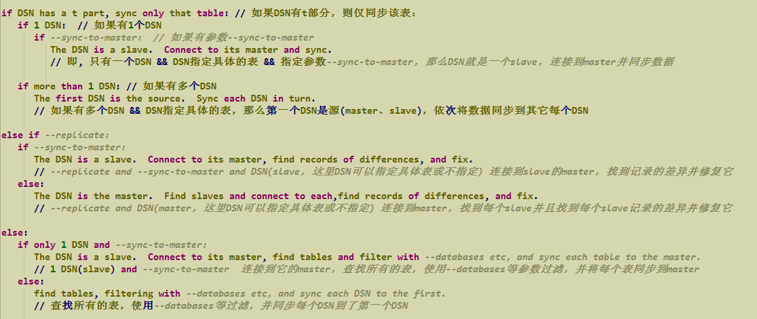

测试环境:

OS: CentOS 6.8 x64

MySQL: 5.7.25

PT: 3.0.13

单向主从复制正常，然后故意在slave上修改数据使其与master不同

Master：6667

Slave： 6668

重要参数:

--replicate：

指定pt-table-sync检查指定的表以查找主从不同的数据

--sync-to-master:

如果指定了--sync-to-master，该工具将假定您指定的服务器是从属服务器，并像往常一样连接到主服务器以进行同步

Master && slave：

create table t1(id int not null auto_increment primary key,name varchar(10));

insert into t1 set name='a';

insert into t1 set name='b';

insert into t1 set name='c';

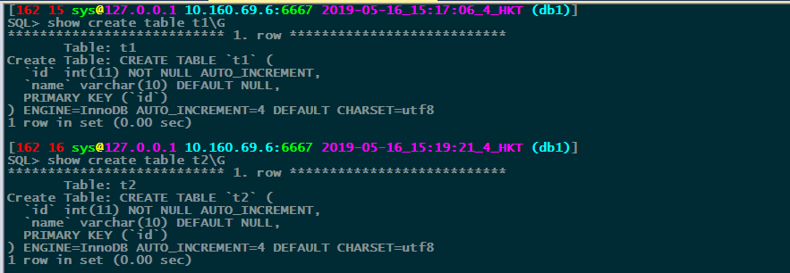

Master:

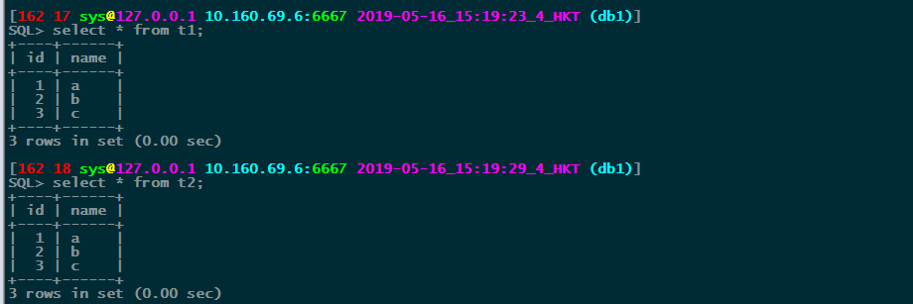

Slave：

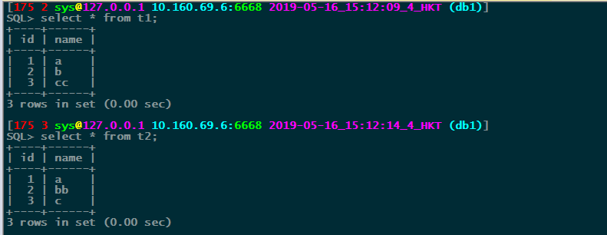

验证方法1:

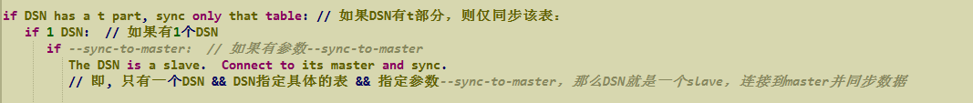

pt-table-sync \

h=127.0.0.1,P=6668,u=sys,p=abc123,D=db1,t=t1 \

--sync-to-master \

--verbose \

--print

$ pt-table-sync \

> h=127.0.0.1,P=6668,u=sys,p=abc123,D=db1,t=t1 \

> --sync-to-master \

> --verbose \

> --print

# Syncing D=db1,P=6668,h=127.0.0.1,p=...,t=t1,u=sys

# DELETE REPLACE INSERT UPDATE ALGORITHM START END EXIT DATABASE.TABLE

REPLACE INTO `db1`.`t1`(`id`, `name`) VALUES ('3', 'c') /*percona-toolkit src_db:db1 src_tbl:t1 src_dsn:D=db1,P=6667,h=127.0.0.1,p=...,t=t1,u=sys dst_db:db1 dst_tbl:t1 dst_dsn:D=db1,P=6668,h=127.0.0.1,p=...,t=t1,u=sys lock:1 transaction:1 changing_src:1 replicate:0 bidirectional:0 pid:11374 user:mysql host:hk02svr200032*/;

# 0 1 0 0 Chunk 15:23:08 15:23:08 2 db1.t1

pt-table-sync \

h=127.0.0.1,P=6668,u=sys,p=abc123,D=db1,t=t1 \

--sync-to-master \

--verbose \

--execute

$ pt-table-sync \

> h=127.0.0.1,P=6668,u=sys,p=abc123,D=db1,t=t1 \

> --sync-to-master \

> --verbose \

> --execute

# Syncing D=db1,P=6668,h=127.0.0.1,p=...,t=t1,u=sys

# DELETE REPLACE INSERT UPDATE ALGORITHM START END EXIT DATABASE.TABLE

# 0 1 0 0 Chunk 15:27:17 15:27:17 2 db1.t1

Master && slave数据校验:

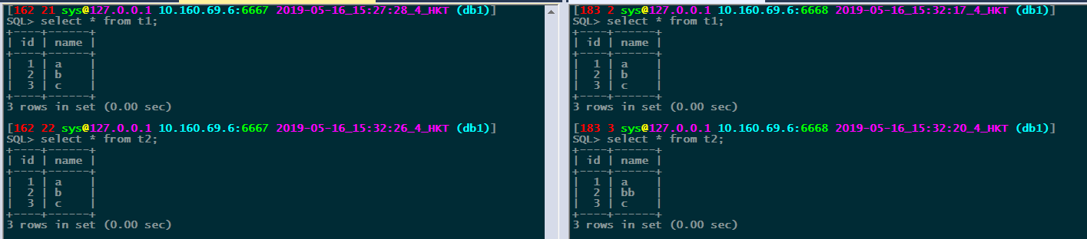

验证方法2:

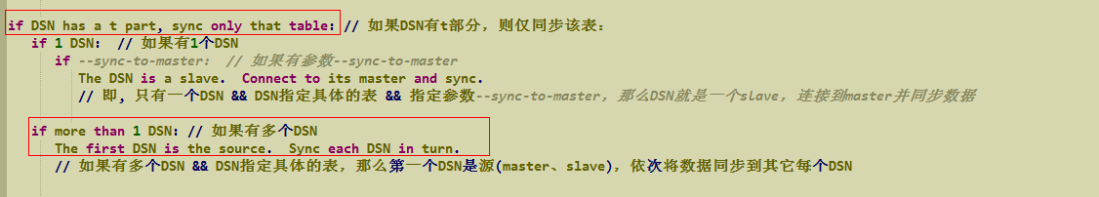

模拟主从数据不一致:

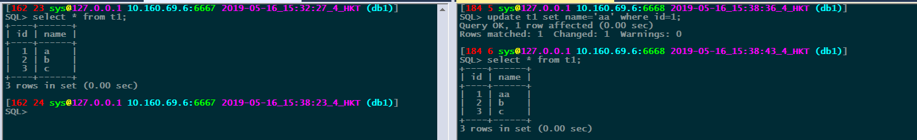

基于复制安全性考虑,不能在slave上做改变,解决方法:

如果表具有唯一键，则应使用--sync-to-master或--relicate选项将slave同步到其master。这通常会做正确的事情。当表上没有唯一键时，别无选择，只能更改从站上的数据，而pt-table-sync将检测到您正在尝试这样做。除非你指定--no-check-slave

pt-table-sync \

h=127.0.0.1,P=6667,u=sys,p=abc123,D=db1,t=t1 h=127.0.0.1,P=6668,u=sys,p=abc123 \

--verbose \

--print

$ pt-table-sync \

> h=127.0.0.1,P=6667,u=sys,p=abc123,D=db1,t=t1 h=127.0.0.1,P=6668,u=sys,p=abc123 \

> --verbose \

> --print

# Syncing D=db1,P=6668,h=127.0.0.1,p=...,t=t1,u=sys

# DELETE REPLACE INSERT UPDATE ALGORITHM START END EXIT DATABASE.TABLE

Can't make changes on D=db1,P=6668,h=127.0.0.1,p=...,t=t1,u=sys because it's a slave. See the documentation section 'REPLICATION SAFETY' for solutions to this problem. at /usr/local/pt_3.0.13/bin/pt-table-sync line 10878. while doing db1.t1 on 127.0.0.1

# 0 0 0 0 0 15:39:47 15:39:47 1 db1.t1

pt-table-sync \

h=127.0.0.1,P=6667,u=sys,p=abc123,D=db1,t=t1 h=127.0.0.1,P=6668,u=sys,p=abc123 \

--no-check-slave \

--verbose \

--print

$ pt-table-sync \

> h=127.0.0.1,P=6667,u=sys,p=abc123,D=db1,t=t1 h=127.0.0.1,P=6668,u=sys,p=abc123 \

> --no-check-slave \

> --verbose \

> --print

# Syncing D=db1,P=6668,h=127.0.0.1,p=...,t=t1,u=sys

# DELETE REPLACE INSERT UPDATE ALGORITHM START END EXIT DATABASE.TABLE

UPDATE `db1`.`t1` SET `name`='a' WHERE `id`='1' LIMIT 1 /*percona-toolkit src_db:db1 src_tbl:t1 src_dsn:D=db1,P=6667,h=127.0.0.1,p=...,t=t1,u=sys dst_db:db1 dst_tbl:t1 dst_dsn:D=db1,P=6668,h=127.0.0.1,p=...,t=t1,u=sys lock:0 transaction:1 changing_src:0 replicate:0 bidirectional:0 pid:12567 user:mysql host:hk02svr200032*/;

# 0 0 0 1 Chunk 15:48:41 15:48:41 2 db1.t1

pt-table-sync \

h=127.0.0.1,P=6667,u=sys,p=abc123,D=db1,t=t1 h=127.0.0.1,P=6668,u=sys,p=abc123 \

--no-check-slave \

--verbose \

--execute

$ pt-table-sync \

> h=127.0.0.1,P=6667,u=sys,p=abc123,D=db1,t=t1 h=127.0.0.1,P=6668,u=sys,p=abc123 \

> --no-check-slave \

> --verbose \

> --execute

# Syncing D=db1,P=6668,h=127.0.0.1,p=...,t=t1,u=sys

# DELETE REPLACE INSERT UPDATE ALGORITHM START END EXIT DATABASE.TABLE

# 0 0 0 1 Chunk 15:49:20 15:49:20 2 db1.t1

校验结果:

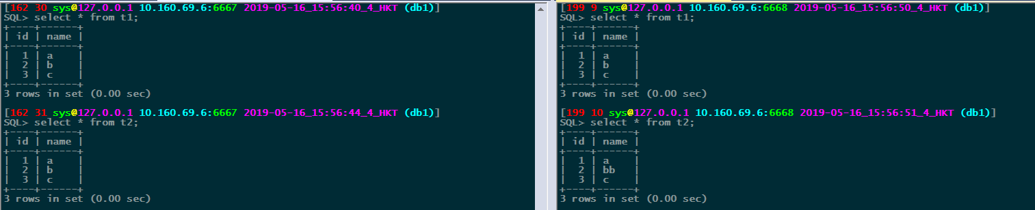

验证方法3:



模拟主从数据不一致:

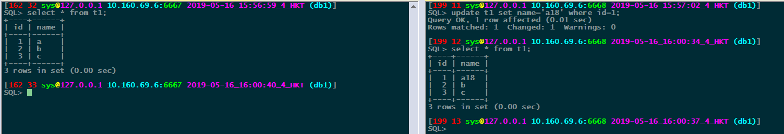

单表:

pt-table-sync \

h=127.0.0.1,P=6668,u=sys,p=abc123,D=db1,t=t1 \

--sync-to-master \

--replicate db1.checksums \

--verbose \

--print

$ pt-table-sync \

> h=127.0.0.1,P=6668,u=sys,p=abc123,D=db1,t=t1 \

> --sync-to-master \

> --replicate db1.checksums \

> --verbose \

> --print

# Syncing D=db1,P=6668,h=127.0.0.1,p=...,t=t1,u=sys

# DELETE REPLACE INSERT UPDATE ALGORITHM START END EXIT DATABASE.TABLE

REPLACE INTO `db1`.`t1`(`id`, `name`) VALUES ('1', 'a') /*percona-toolkit src_db:db1 src_tbl:t1 src_dsn:D=db1,P=6667,h=127.0.0.1,p=...,t=t1,u=sys dst_db:db1 dst_tbl:t1 dst_dsn:D=db1,P=6668,h=127.0.0.1,p=...,t=t1,u=sys lock:1 transaction:1 changing_src:db1.checksums replicate:db1.checksums bidirectional:0 pid:13629 user:mysql host:hk02svr200032*/;

# 0 1 0 0 Chunk 16:02:56 16:02:56 2 db1.t1

pt-table-sync \

h=127.0.0.1,P=6668,u=sys,p=abc123,D=db1,t=t1 \

--sync-to-master \

--replicate db1.checksums \

--verbose \

--execute

$ pt-table-sync \

> h=127.0.0.1,P=6668,u=sys,p=abc123,D=db1,t=t1 \

> --sync-to-master \

> --replicate db1.checksums \

> --verbose \

> --execute

# Syncing D=db1,P=6668,h=127.0.0.1,p=...,t=t1,u=sys

# DELETE REPLACE INSERT UPDATE ALGORITHM START END EXIT DATABASE.TABLE

# 0 1 0 0 Chunk 16:04:24 16:04:24 2 db1.t1

校验结果:

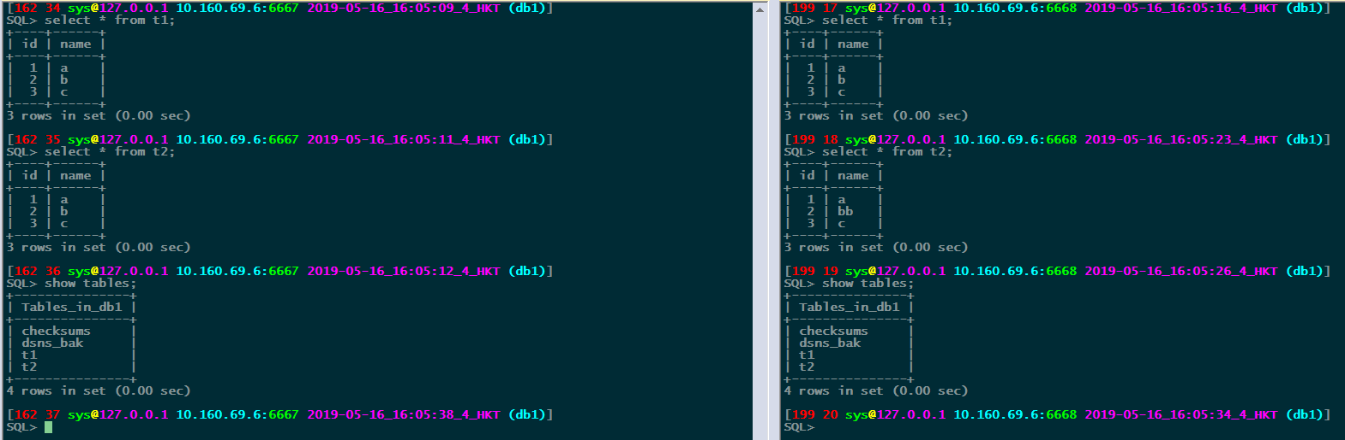

多表或整个库:

模拟主从数据不一致:

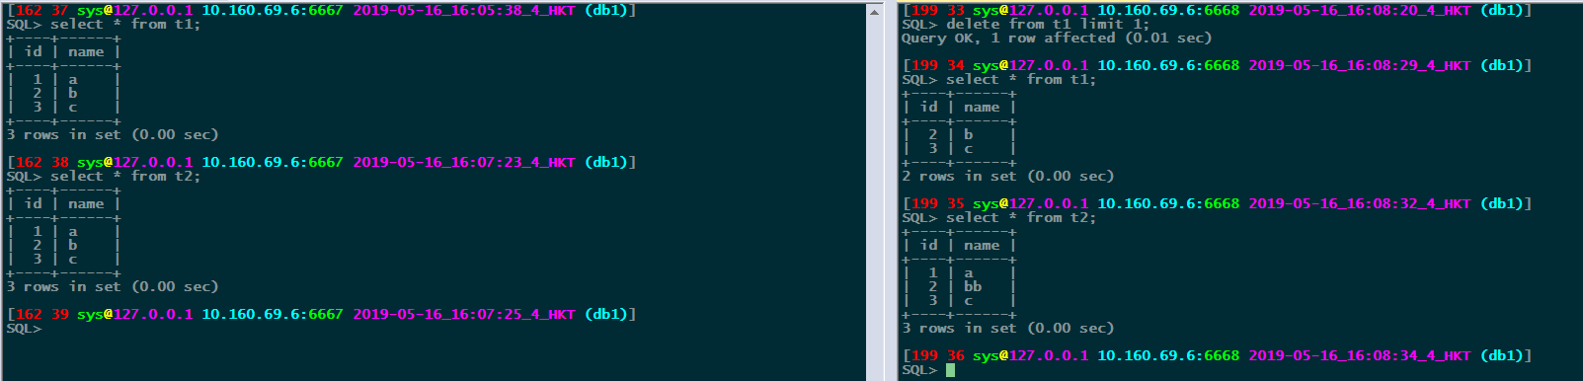

pt-table-sync \

h=127.0.0.1,P=6668,u=sys,p=abc123 --databases db1 \

--sync-to-master \

--replicate db1.checksums \

--verbose \

--print

$ pt-table-sync \

> h=127.0.0.1,P=6668,u=sys,p=abc123 --databases db1 \

> --sync-to-master \

> --replicate db1.checksums \

> --verbose \

> --print

# Syncing via replication P=6668,h=127.0.0.1,p=...,u=sys

# DELETE REPLACE INSERT UPDATE ALGORITHM START END EXIT DATABASE.TABLE

REPLACE INTO `db1`.`t1`(`id`, `name`) VALUES ('1', 'a') /*percona-toolkit src_db:db1 src_tbl:t1 src_dsn:P=6667,h=127.0.0.1,p=...,u=sys dst_db:db1 dst_tbl:t1 dst_dsn:P=6668,h=127.0.0.1,p=...,u=sys lock:1 transaction:1 changing_src:db1.checksums replicate:db1.checksums bidirectional:0 pid:13964 user:mysql host:hk02svr200032*/;

# 0 1 0 0 Chunk 16:10:09 16:10:09 2 db1.t1

REPLACE INTO `db1`.`t2`(`id`, `name`) VALUES ('2', 'b') /*percona-toolkit src_db:db1 src_tbl:t2 src_dsn:P=6667,h=127.0.0.1,p=...,u=sys dst_db:db1 dst_tbl:t2 dst_dsn:P=6668,h=127.0.0.1,p=...,u=sys lock:1 transaction:1 changing_src:db1.checksums replicate:db1.checksums bidirectional:0 pid:13964 user:mysql host:hk02svr200032*/;

# 0 1 0 0 Chunk 16:10:09 16:10:09 2 db1.t2

pt-table-sync \

h=127.0.0.1,P=6668,u=sys,p=abc123 --databases db1 \

--sync-to-master \

--replicate db1.checksums \

--verbose \

--execute

$ pt-table-sync \

> h=127.0.0.1,P=6668,u=sys,p=abc123 --databases db1 \

> --sync-to-master \

> --replicate db1.checksums \

> --verbose \

> --execute

# Syncing via replication P=6668,h=127.0.0.1,p=...,u=sys

# DELETE REPLACE INSERT UPDATE ALGORITHM START END EXIT DATABASE.TABLE

# 0 1 0 0 Chunk 16:11:31 16:11:31 2 db1.t1

# 0 1 0 0 Chunk 16:11:31 16:11:31 2 db1.t2

校验结果:

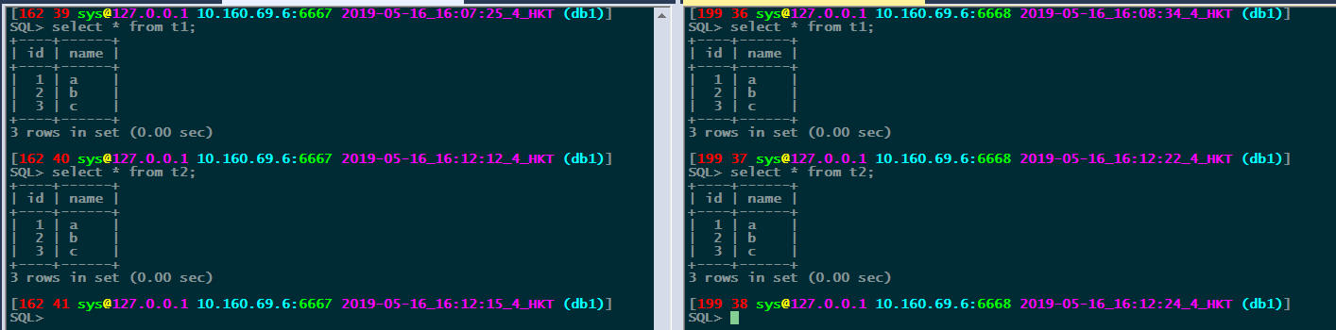

验证方法4:

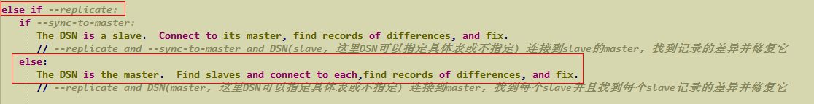

模拟主从数据不同:

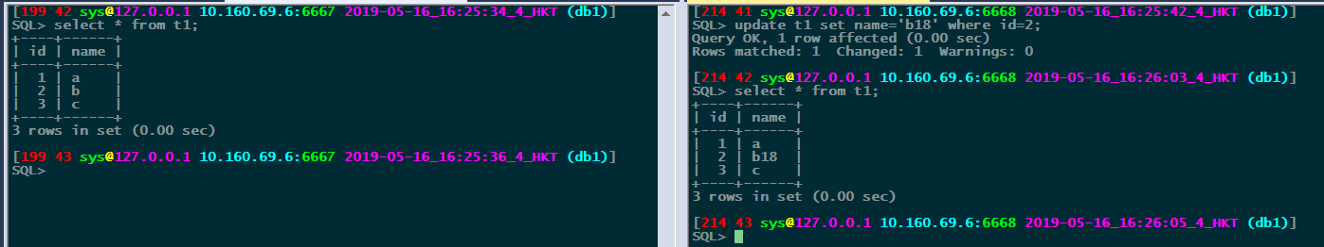

单表:

pt-table-sync \

h=127.0.0.1,P=6667,u=sys,p=abc123,D=db1,t=t1 h=127.0.0.1,P=6668,u=sys,p=abc123 \

--replicate db1.checksums \

--verbose \

--print

$ pt-table-sync \

> h=127.0.0.1,P=6667,u=sys,p=abc123,D=db1,t=t1 h=127.0.0.1,P=6668,u=sys,p=abc123 \

> --replicate db1.checksums \

> --verbose \

> --print

# Syncing D=db1,P=6668,h=127.0.0.1,p=...,t=t1,u=sys

# DELETE REPLACE INSERT UPDATE ALGORITHM START END EXIT DATABASE.TABLE

REPLACE INTO `db1`.`t1`(`id`, `name`) VALUES ('2', 'b') /*percona-toolkit src_db:db1 src_tbl:t1 src_dsn:D=db1,P=6667,h=127.0.0.1,p=...,t=t1,u=sys dst_db:db1 dst_tbl:t1 dst_dsn:D=db1,P=6668,h=127.0.0.1,p=...,t=t1,u=sys lock:1 transaction:1 changing_src:db1.checksums replicate:db1.checksums bidirectional:0 pid:14850 user:mysql host:hk02svr200032*/;

# 0 1 0 0 Chunk 16:29:11 16:29:11 2 db1.t1

pt-table-sync \

h=127.0.0.1,P=6667,u=sys,p=abc123,D=db1,t=t1 h=127.0.0.1,P=6668,u=sys,p=abc123 \

--replicate db1.checksums \

--verbose \

--execute

$ pt-table-sync \

> h=127.0.0.1,P=6667,u=sys,p=abc123,D=db1,t=t1 h=127.0.0.1,P=6668,u=sys,p=abc123 \

> --replicate db1.checksums \

> --verbose \

> --execute

# Syncing D=db1,P=6668,h=127.0.0.1,p=...,t=t1,u=sys

# DELETE REPLACE INSERT UPDATE ALGORITHM START END EXIT DATABASE.TABLE

# 0 1 0 0 Chunk 16:31:10 16:31:10 2 db1.t1

校验结果:

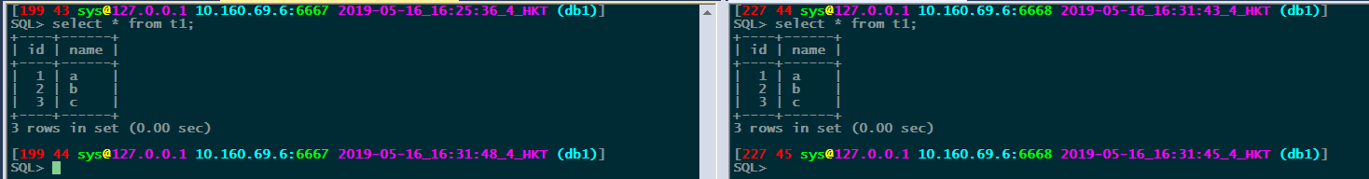

整库:

模拟主从数据不一致:

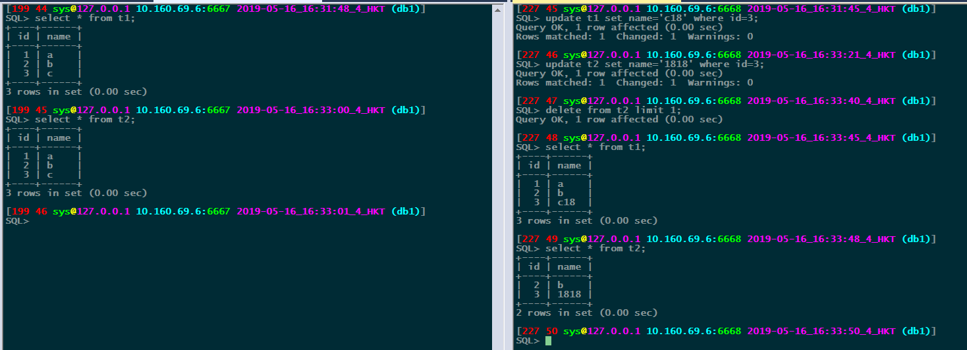

经测试发现这个方法不支持整个库,也许是我测试有问题,有知道的请告知,谢谢

pt-table-sync \

h=127.0.0.1,P=6667,u=sys,p=abc123 --databases db1 h=127.0.0.1,P=6668,u=sys,p=abc123 \

--replicate db1.checksums \

--verbose \

--print

pt-table-sync \

h=127.0.0.1,P=6667,u=sys,p=abc123 --databases=db1 h=127.0.0.1,P=6668,u=sys,p=abc123 \

--replicate db1.checksums \

--verbose \

--print

pt-table-sync \

h=127.0.0.1,P=6667,u=sys,p=abc123 --databases="db1" h=127.0.0.1,P=6668,u=sys,p=abc123 \

--replicate db1.checksums \

--verbose \

--print

pt-table-sync \

h=127.0.0.1,P=6667,u=sys,p=abc123 h=127.0.0.1,P=6668,u=sys,p=abc123 --databases db1 \

--replicate db1.checksums \

--verbose \

--print

报错均为无法连接到slave: Cannot connect to P=6668,h=,p=...,u=sys

6778 if ( $EVAL_ERROR ) {

6779 print STDERR "Cannot connect to ", $dp->as_string($slave_dsn), "\n"

6780 or die "Cannot print: $OS_ERROR";

6781 return;

6782 }

验证方法5:



主从数据:

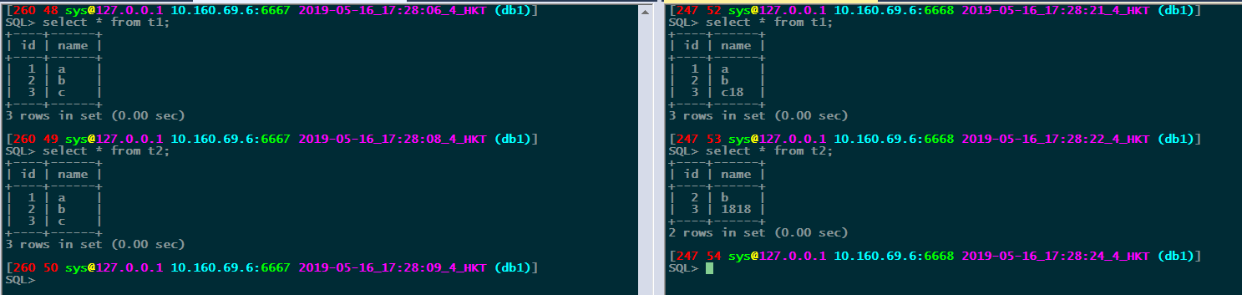

pt-table-sync \

h=127.0.0.1,P=6668,u=sys,p=abc123 --databases db1 \

--sync-to-master \

--verbose \

--print

$ pt-table-sync \

> h=127.0.0.1,P=6668,u=sys,p=abc123 --databases db1 \

> --sync-to-master \

> --verbose \

> --print

# Syncing P=6668,h=127.0.0.1,p=...,u=sys

# DELETE REPLACE INSERT UPDATE ALGORITHM START END EXIT DATABASE.TABLE

REPLACE INTO `db1`.`checksums`(`db`, `tbl`, `chunk`, `chunk_time`, `chunk_index`, `lower_boundary`, `upper_boundary`, `this_crc`, `this_cnt`, `master_crc`, `master_cnt`, `ts`) VALUES ('db1', 't1', '1', 0.005933, NULL, NULL, NULL, '523c3a6', '3', '523c3a6', '3', '2019-05-16 15:47:18') /*percona-toolkit src_db:db1 src_tbl:checksums src_dsn:P=6667,h=127.0.0.1,p=...,u=sys dst_db:db1 dst_tbl:checksums dst_dsn:P=6668,h=127.0.0.1,p=...,u=sys lock:1 transaction:1 changing_src:1 replicate:0 bidirectional:0 pid:17544 user:mysql host:hk02svr200032*/;

REPLACE INTO `db1`.`checksums`(`db`, `tbl`, `chunk`, `chunk_time`, `chunk_index`, `lower_boundary`, `upper_boundary`, `this_crc`, `this_cnt`, `master_crc`, `master_cnt`, `ts`) VALUES ('db1', 't2', '1', 0.004472, NULL, NULL, NULL, '523c3a6', '3', '523c3a6', '3', '2019-05-16 15:47:18') /*percona-toolkit src_db:db1 src_tbl:checksums src_dsn:P=6667,h=127.0.0.1,p=...,u=sys dst_db:db1 dst_tbl:checksums dst_dsn:P=6668,h=127.0.0.1,p=...,u=sys lock:1 transaction:1 changing_src:1 replicate:0 bidirectional:0 pid:17544 user:mysql host:hk02svr200032*/;

# 0 2 0 0 Nibble 17:24:11 17:24:11 2 db1.checksums

# 0 0 0 0 Chunk 17:24:11 17:24:11 0 db1.dsns_bak

REPLACE INTO `db1`.`t1`(`id`, `name`) VALUES ('3', 'c') /*percona-toolkit src_db:db1 src_tbl:t1 src_dsn:P=6667,h=127.0.0.1,p=...,u=sys dst_db:db1 dst_tbl:t1 dst_dsn:P=6668,h=127.0.0.1,p=...,u=sys lock:1 transaction:1 changing_src:1 replicate:0 bidirectional:0 pid:17544 user:mysql host:hk02svr200032*/;

# 0 1 0 0 Chunk 17:24:11 17:24:11 2 db1.t1

REPLACE INTO `db1`.`t2`(`id`, `name`) VALUES ('1', 'a') /*percona-toolkit src_db:db1 src_tbl:t2 src_dsn:P=6667,h=127.0.0.1,p=...,u=sys dst_db:db1 dst_tbl:t2 dst_dsn:P=6668,h=127.0.0.1,p=...,u=sys lock:1 transaction:1 changing_src:1 replicate:0 bidirectional:0 pid:17544 user:mysql host:hk02svr200032*/;

REPLACE INTO `db1`.`t2`(`id`, `name`) VALUES ('3', 'c') /*percona-toolkit src_db:db1 src_tbl:t2 src_dsn:P=6667,h=127.0.0.1,p=...,u=sys dst_db:db1 dst_tbl:t2 dst_dsn:P=6668,h=127.0.0.1,p=...,u=sys lock:1 transaction:1 changing_src:1 replicate:0 bidirectional:0 pid:17544 user:mysql host:hk02svr200032*/;

# 0 2 0 0 Chunk 17:24:11 17:24:11 2 db1.t2

pt-table-sync \

h=127.0.0.1,P=6668,u=sys,p=abc123 --databases db1 \

--sync-to-master \

--verbose \

--execute

$ pt-table-sync \

> h=127.0.0.1,P=6668,u=sys,p=abc123 --databases db1 \

> --sync-to-master \

> --verbose \

> --execute

# Syncing P=6668,h=127.0.0.1,p=...,u=sys

# DELETE REPLACE INSERT UPDATE ALGORITHM START END EXIT DATABASE.TABLE

# 0 2 0 0 Nibble 17:29:17 17:29:17 2 db1.checksums

# 0 0 0 0 Chunk 17:29:17 17:29:17 0 db1.dsns_bak

# 0 1 0 0 Chunk 17:29:17 17:29:17 2 db1.t1

# 0 2 0 0 Chunk 17:29:17 17:29:18 2 db1.t2

校验数据:

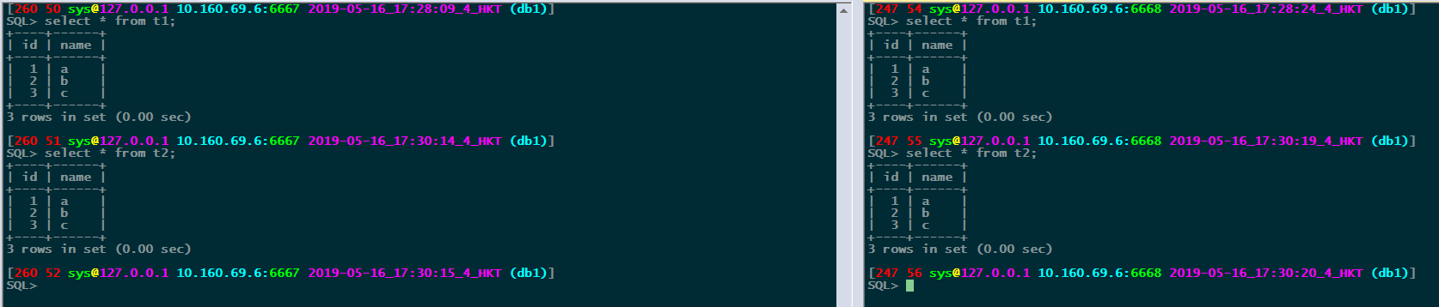

验证方法6:

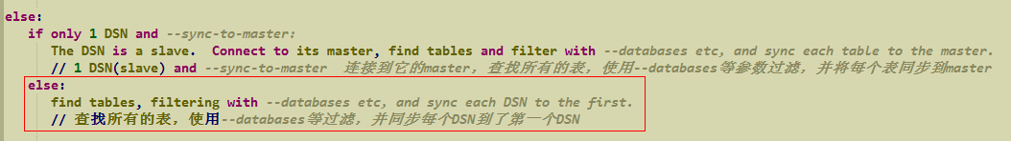

模拟主从数据不一致:

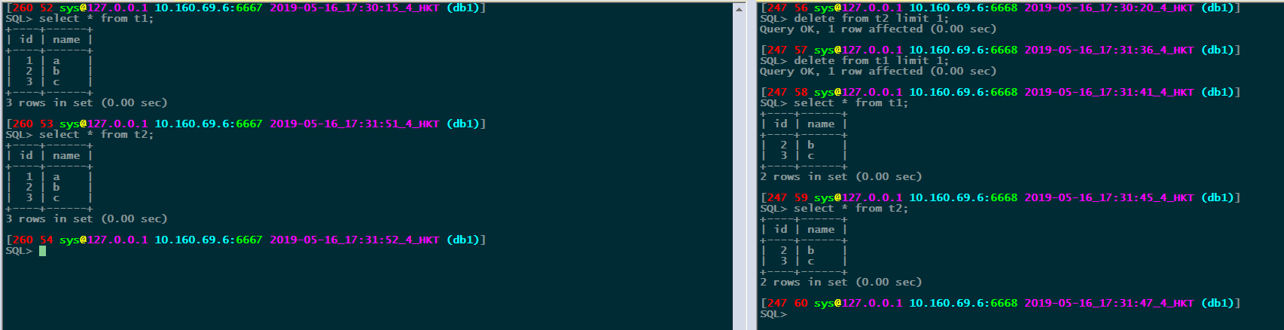

pt-table-sync \

h=127.0.0.1,P=6667,u=sys,p=abc123 --databases db1 h=127.0.0.1,P=6668,u=sys,p=abc123 \

--nocheck-slave \

--verbose \

--print

$ pt-table-sync \

> h=127.0.0.1,P=6667,u=sys,p=abc123 --databases db1 h=127.0.0.1,P=6668,u=sys,p=abc123 \

> --nocheck-slave \

> --verbose \

> --print

# Syncing P=6668,h=127.0.0.1,p=...,u=sys

# DELETE REPLACE INSERT UPDATE ALGORITHM START END EXIT DATABASE.TABLE

# 0 0 0 0 Nibble 17:33:04 17:33:04 0 db1.checksums

# 0 0 0 0 Chunk 17:33:04 17:33:04 0 db1.dsns_bak

INSERT INTO `db1`.`t1`(`id`, `name`) VALUES ('1', 'a') /*percona-toolkit src_db:db1 src_tbl:t1 src_dsn:P=6667,h=127.0.0.1,p=...,u=sys dst_db:db1 dst_tbl:t1 dst_dsn:P=6668,h=127.0.0.1,p=...,u=sys lock:0 transaction:1 changing_src:0 replicate:0 bidirectional:0 pid:17944 user:mysql host:hk02svr200032*/;

# 0 0 1 0 Chunk 17:33:04 17:33:04 2 db1.t1

INSERT INTO `db1`.`t2`(`id`, `name`) VALUES ('1', 'a') /*percona-toolkit src_db:db1 src_tbl:t2 src_dsn:P=6667,h=127.0.0.1,p=...,u=sys dst_db:db1 dst_tbl:t2 dst_dsn:P=6668,h=127.0.0.1,p=...,u=sys lock:0 transaction:1 changing_src:0 replicate:0 bidirectional:0 pid:17944 user:mysql host:hk02svr200032*/;

# 0 0 1 0 Chunk 17:33:04 17:33:04 2 db1.t2

pt-table-sync \

h=127.0.0.1,P=6667,u=sys,p=abc123 --databases db1 h=127.0.0.1,P=6668,u=sys,p=abc123 \

--nocheck-slave \

--verbose \

--execute

$ pt-table-sync \

> h=127.0.0.1,P=6667,u=sys,p=abc123 --databases db1 h=127.0.0.1,P=6668,u=sys,p=abc123 \

> --nocheck-slave \

> --verbose \

> --execute

# Syncing P=6668,h=127.0.0.1,p=...,u=sys

# DELETE REPLACE INSERT UPDATE ALGORITHM START END EXIT DATABASE.TABLE

# 0 0 0 0 Nibble 17:34:20 17:34:20 0 db1.checksums

# 0 0 0 0 Chunk 17:34:20 17:34:20 0 db1.dsns_bak

# 0 0 1 0 Chunk 17:34:20 17:34:20 2 db1.t1

# 0 0 1 0 Chunk 17:34:20 17:34:20 2 db1.t2

验证结果:

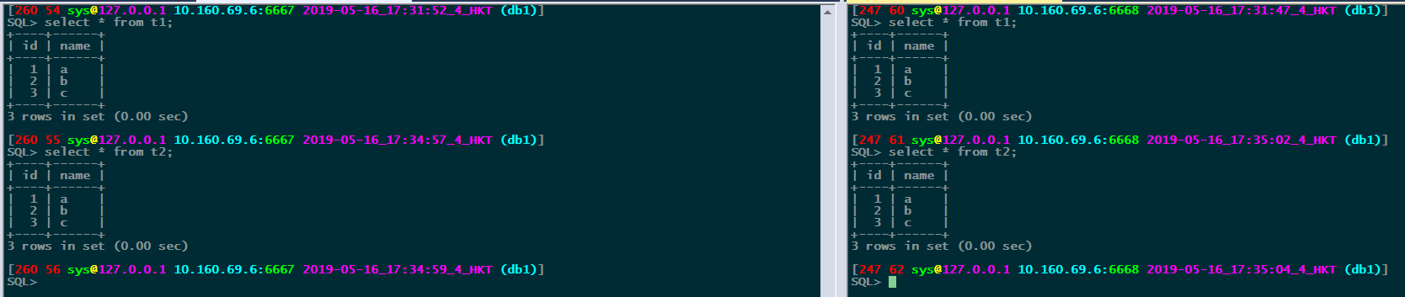

总结:

验证方法1: DSN is slave

验证方法2: DSN is source(master/slave) 不推荐

验证方法3: DSN is slave

验证方法4: DSN is master

验证方法5: 同方法1，区别是支持整库

验证方法6: 同方法2，区别是支持整库

原理:

$ pt-table-sync h=127.0.0.1,P=6668,u=sys,p=abc123,D=db1,t=t1 --sync-to-master --verbose --print

# Syncing D=db1,P=6668,h=127.0.0.1,p=...,t=t1,u=sys

# DELETE REPLACE INSERT UPDATE ALGORITHM START END EXIT DATABASE.TABLE

REPLACE INTO `db1`.`t1`(`id`, `name`) VALUES ('1', 'a') /*percona-toolkit src_db:db1 src_tbl:t1 src_dsn:D=db1,P=6667,h=127.0.0.1,p=...,t=t1,u=sys dst_db:db1 dst_tbl:t1 dst_dsn:D=db1,P=6668,h=127.0.0.1,p=...,t=t1,u=sys lock:1 transaction:1 changing_src:1 replicate:0 bidirectional:0 pid:21398 user:mysql host:hk02svr200032*/;

# 0 1 0 0 Chunk 18:37:21 18:37:21 2 db1.t1

MASTER：

2019-05-16T18:37:21.098893+08:00 286 Connect sys@127.0.0.1 on db1 using TCP/IP

2019-05-16T18:37:21.099113+08:00 286 Query set autocommit=0

2019-05-16T18:37:21.099310+08:00 286 Query SHOW VARIABLES LIKE 'wait\_timeout'

2019-05-16T18:37:21.101654+08:00 286 Query SET SESSION wait_timeout=10000

2019-05-16T18:37:21.101790+08:00 286 Query SELECT @@SQL_MODE

2019-05-16T18:37:21.101918+08:00 286 Query SET @@SQL_QUOTE_SHOW_CREATE = 1/*!40101, @@SQL_MODE='NO_AUTO_VALUE_ON_ZERO,STRICT_TRANS_TABLES,NO_ZERO_IN_DATE,NO_ZERO_DATE,ERROR_FOR_DIVISION_BY_ZERO,NO_AUTO_CREATE_USER,NO_ENGINE_SUBSTITUTION'*/

2019-05-16T18:37:21.102037+08:00 286 Query SHOW CREATE TABLE db1.t1

2019-05-16T18:37:21.102173+08:00 286 Query SET NAMES 'utf8'

2019-05-16T18:37:21.102278+08:00 286 Query /*!40101 SET @@SQL_MODE := CONCAT(@@SQL_MODE, ',NO_AUTO_VALUE_ON_ZERO')*/

2019-05-16T18:37:21.102456+08:00 286 Query SHOW VARIABLES LIKE 'version%'

2019-05-16T18:37:21.104758+08:00 286 Query SHOW ENGINES

2019-05-16T18:37:21.105180+08:00 286 Query SHOW VARIABLES LIKE 'innodb_version'

2019-05-16T18:37:21.107509+08:00 286 Query SELECT @@binlog_format

2019-05-16T18:37:21.107645+08:00 286 Query /*!50108 SET @@binlog_format := 'STATEMENT'*/

2019-05-16T18:37:21.107730+08:00 286 Query SET SESSION TRANSACTION ISOLATION LEVEL REPEATABLE READ

2019-05-16T18:37:21.107849+08:00 286 Query SHOW MASTER STATUS

2019-05-16T18:37:21.108285+08:00 286 Query SHOW GRANTS FOR CURRENT_USER()

2019-05-16T18:37:21.108447+08:00 286 Query SHOW FULL PROCESSLIST

2019-05-16T18:37:21.108677+08:00 286 Query SHOW VARIABLES LIKE 'port'

2019-05-16T18:37:21.110937+08:00 286 Query SELECT CONCAT(@@hostname, @@port)

2019-05-16T18:37:21.111656+08:00 287 Connect sys@127.0.0.1 on db1 using TCP/IP

2019-05-16T18:37:21.111776+08:00 287 Query set autocommit=0

2019-05-16T18:37:21.111942+08:00 287 Query SHOW VARIABLES LIKE 'wait\_timeout'

2019-05-16T18:37:21.114051+08:00 287 Query SET SESSION wait_timeout=10000

2019-05-16T18:37:21.114305+08:00 287 Query SELECT @@SQL_MODE

2019-05-16T18:37:21.114458+08:00 287 Query SET @@SQL_QUOTE_SHOW_CREATE = 1/*!40101, @@SQL_MODE='NO_AUTO_VALUE_ON_ZERO,STRICT_TRANS_TABLES,NO_ZERO_IN_DATE,NO_ZERO_DATE,ERROR_FOR_DIVISION_BY_ZERO,NO_AUTO_CREATE_USER,NO_ENGINE_SUBSTITUTION'*/

2019-05-16T18:37:21.114606+08:00 287 Query SHOW CREATE TABLE db1.t1

2019-05-16T18:37:21.114786+08:00 287 Query SET NAMES 'utf8'

2019-05-16T18:37:21.114918+08:00 287 Query /*!40101 SET @@SQL_MODE := CONCAT(@@SQL_MODE, ',NO_AUTO_VALUE_ON_ZERO')*/

2019-05-16T18:37:21.115107+08:00 287 Query SHOW VARIABLES LIKE 'version%'

2019-05-16T18:37:21.118326+08:00 287 Query SHOW ENGINES

2019-05-16T18:37:21.118713+08:00 287 Query SHOW VARIABLES LIKE 'innodb_version'

2019-05-16T18:37:21.121390+08:00 287 Query SELECT @@binlog_format

2019-05-16T18:37:21.121524+08:00 287 Query /*!50108 SET @@binlog_format := 'STATEMENT'*/

2019-05-16T18:37:21.121644+08:00 287 Query SET SESSION TRANSACTION ISOLATION LEVEL REPEATABLE READ

2019-05-16T18:37:21.130256+08:00 286 Query SELECT NOW()

2019-05-16T18:37:21.130443+08:00 286 Query /*!40101 SET @OLD_SQL_MODE := @@SQL_MODE, @@SQL_MODE := '', @OLD_QUOTE := @@SQL_QUOTE_SHOW_CREATE, @@SQL_QUOTE_SHOW_CREATE := 1 */

2019-05-16T18:37:21.130554+08:00 286 Query USE `db1`

2019-05-16T18:37:21.130694+08:00 286 Query SHOW CREATE TABLE `db1`.`t1`

2019-05-16T18:37:21.130841+08:00 286 Query /*!40101 SET @@SQL_MODE := @OLD_SQL_MODE, @@SQL_QUOTE_SHOW_CREATE := @OLD_QUOTE */

2019-05-16T18:37:21.137013+08:00 286 Query SET NAMES 'utf8'

2019-05-16T18:37:21.137105+08:00 287 Query SET NAMES 'utf8'

2019-05-16T18:37:21.137809+08:00 286 Query SELECT MIN(`id`), MAX(`id`) FROM `db1`.`t1` FORCE INDEX (`PRIMARY`)

2019-05-16T18:37:21.138121+08:00 286 Query EXPLAIN SELECT * FROM `db1`.`t1` FORCE INDEX (`PRIMARY`)

2019-05-16T18:37:21.138471+08:00 286 Query SELECT CRC32('test-string')

2019-05-16T18:37:21.138794+08:00 286 Query SELECT CRC32('a')

2019-05-16T18:37:21.138943+08:00 286 Query SELECT CRC32('a')

2019-05-16T18:37:21.139220+08:00 286 Query USE `db1`

2019-05-16T18:37:21.141317+08:00 286 Query SET @crc := '', @cnt := 0

2019-05-16T18:37:21.141683+08:00 286 Query commit

2019-05-16T18:37:21.141841+08:00 286 Query START TRANSACTION /*!40108 WITH CONSISTENT SNAPSHOT */

2019-05-16T18:37:21.141979+08:00 286 Query SELECT /*db1.t1:1/1*/ 0 AS chunk_num, COUNT(*) AS cnt, COALESCE(LOWER(CONV(BIT_XOR(CAST(CRC32(CONCAT_WS('#', `id`, `name`, CONCAT(ISNULL(`name`)))) AS UNSIGNED)), 10, 16)), 0) AS crc FROM `db1`.`t1` FORCE INDEX (`PRIMARY`) WHERE (1=1) FOR UPDATE

2019-05-16T18:37:21.142279+08:00 287 Query SHOW MASTER STATUS

2019-05-16T18:37:21.148200+08:00 286 Query SET @crc := '', @cnt := 0

2019-05-16T18:37:21.148480+08:00 286 Query SELECT /*rows in chunk*/ `id`, `name`, CRC32(CONCAT_WS('#', `id`, `name`, CONCAT(ISNULL(`name`)))) AS __crc FROM `db1`.`t1` FORCE INDEX (`PRIMARY`) WHERE (1=1) ORDER BY `id` FOR UPDATE

2019-05-16T18:37:21.149084+08:00 286 Query SELECT `id`, `name` FROM `db1`.`t1` WHERE `id`='1' LIMIT 1

2019-05-16T18:37:21.149390+08:00 286 Query commit

2019-05-16T18:37:21.149659+08:00 286 Query SELECT NOW()

2019-05-16T18:37:21.150312+08:00 286 Query commit

2019-05-16T18:37:21.150376+08:00 286 Quit

2019-05-16T18:37:21.150528+08:00 287 Query commit

2019-05-16T18:37:21.150597+08:00 287 Quit

打开2个连接286、287:

2019-05-16T18:37:21.099113+08:00 286 Query set autocommit=0

2019-05-16T18:37:21.107645+08:00 286 Query /*!50108 SET @@binlog_format := 'STATEMENT'*/

2019-05-16T18:37:21.107730+08:00 286 Query SET SESSION TRANSACTION ISOLATION LEVEL REPEATABLE READ

2019-05-16T18:37:21.141841+08:00 286 Query START TRANSACTION /*!40108 WITH CONSISTENT SNAPSHOT */

SQL> SELECT /*db1.t1:1/1*/ 0 AS chunk_num, COUNT(*) AS cnt, COALESCE(LOWER(CONV(BIT_XOR(CAST(CRC32(CONCAT_WS('#', `id`, `name`, CONCAT(ISNULL(`name`)))) AS UNSIGNED)), 10, 16)), 0) AS crc FROM `db1`.`t1` FORCE INDEX (`PRIMARY`) WHERE (1=1) FOR UPDATE;

+-----------+-----+---------+

| chunk_num | cnt | crc |

+-----------+-----+---------+

| 0 | 3 | 523c3a6 |

+-----------+-----+---------+

1 row in set (0.00 sec)

SQL> SELECT /*rows in chunk*/ `id`, `name`, CRC32(CONCAT_WS('#', `id`, `name`, CONCAT(ISNULL(`name`)))) AS __crc FROM `db1`.`t1` FORCE INDEX (`PRIMARY`) WHERE (1=1) ORDER BY `id` FOR UPDATE;

+----+------+------------+

| id | name | __crc |

+----+------+------------+

| 1 | a | 964788257 |

| 2 | b | 2087142568 |

| 3 | c | 1086654255 |

+----+------+------------+

3 rows in set (0.00 sec)

SQL> SELECT `id`, `name` FROM `db1`.`t1` WHERE `id`='1' LIMIT 1;

+----+------+

| id | name |

+----+------+

| 1 | a |

+----+------+

1 row in set (0.00 sec)

SQL> select * from checksums;

+-----+------+-------+------------+-------------+----------------+----------------+----------+----------+------------+------------+---------------------+

| db | tbl | chunk | chunk_time | chunk_index | lower_boundary | upper_boundary | this_crc | this_cnt | master_crc | master_cnt | ts |

+-----+------+-------+------------+-------------+----------------+----------------+----------+----------+------------+------------+---------------------+

| db1 | dsns | 1 | 0.003838 | NULL | NULL | NULL | 3cca55a5 | 1 | 3cca55a5 | 1 | 2019-05-16 15:47:18 |

| db1 | t1 | 1 | 0.005933 | NULL | NULL | NULL | 523c3a6 | 3 | 523c3a6 | 3 | 2019-05-16 15:47:18 |

| db1 | t2 | 1 | 0.004472 | NULL | NULL | NULL | 523c3a6 | 3 | 523c3a6 | 3 | 2019-05-16 15:47:18 |

+-----+------+-------+------------+-------------+----------------+----------------+----------+----------+------------+------------+---------------------+

3 rows in set (0.00 sec)

Slave：

2019-05-16T18:37:21.088443+08:00 278 Connect sys@127.0.0.1 on db1 using TCP/IP

2019-05-16T18:37:21.088653+08:00 278 Query set autocommit=0

2019-05-16T18:37:21.088887+08:00 278 Query SHOW VARIABLES LIKE 'wait\_timeout'

2019-05-16T18:37:21.091687+08:00 278 Query SET SESSION wait_timeout=10000

2019-05-16T18:37:21.091852+08:00 278 Query SELECT @@SQL_MODE

2019-05-16T18:37:21.091993+08:00 278 Query SET @@SQL_QUOTE_SHOW_CREATE = 1/*!40101, @@SQL_MODE='NO_AUTO_VALUE_ON_ZERO,STRICT_TRANS_TABLES,NO_ZERO_IN_DATE,NO_ZERO_DATE,ERROR_FOR_DIVISION_BY_ZERO,NO_AUTO_CREATE_USER,NO_ENGINE_SUBSTITUTION'*/

2019-05-16T18:37:21.092121+08:00 278 Query SHOW CREATE TABLE db1.t1

2019-05-16T18:37:21.092298+08:00 278 Query SET NAMES 'utf8'

2019-05-16T18:37:21.092418+08:00 278 Query /*!40101 SET @@SQL_MODE := CONCAT(@@SQL_MODE, ',NO_AUTO_VALUE_ON_ZERO')*/

2019-05-16T18:37:21.092639+08:00 278 Query SHOW VARIABLES LIKE 'version%'

2019-05-16T18:37:21.094989+08:00 278 Query SHOW ENGINES

2019-05-16T18:37:21.095402+08:00 278 Query SHOW VARIABLES LIKE 'innodb_version'

2019-05-16T18:37:21.097821+08:00 278 Query SELECT @@binlog_format

2019-05-16T18:37:21.097951+08:00 278 Query /*!50108 SET @@binlog_format := 'STATEMENT'*/

2019-05-16T18:37:21.098038+08:00 278 Query SET SESSION TRANSACTION ISOLATION LEVEL REPEATABLE READ

2019-05-16T18:37:21.098154+08:00 278 Query SHOW SLAVE STATUS

2019-05-16T18:37:21.107990+08:00 278 Query SHOW SLAVE STATUS

2019-05-16T18:37:21.111104+08:00 278 Query SELECT CONCAT(@@hostname, @@port)

2019-05-16T18:37:21.122029+08:00 279 Connect sys@127.0.0.1 on db1 using TCP/IP

2019-05-16T18:37:21.122151+08:00 279 Query set autocommit=0

2019-05-16T18:37:21.122320+08:00 279 Query SHOW VARIABLES LIKE 'wait\_timeout'

2019-05-16T18:37:21.124303+08:00 279 Query SET SESSION wait_timeout=10000

2019-05-16T18:37:21.124442+08:00 279 Query SELECT @@SQL_MODE

2019-05-16T18:37:21.124586+08:00 279 Query SET @@SQL_QUOTE_SHOW_CREATE = 1/*!40101, @@SQL_MODE='NO_AUTO_VALUE_ON_ZERO,STRICT_TRANS_TABLES,NO_ZERO_IN_DATE,NO_ZERO_DATE,ERROR_FOR_DIVISION_BY_ZERO,NO_AUTO_CREATE_USER,NO_ENGINE_SUBSTITUTION'*/

2019-05-16T18:37:21.124702+08:00 279 Query SHOW CREATE TABLE db1.t1

2019-05-16T18:37:21.124832+08:00 279 Query SET NAMES 'utf8'

2019-05-16T18:37:21.124931+08:00 279 Query /*!40101 SET @@SQL_MODE := CONCAT(@@SQL_MODE, ',NO_AUTO_VALUE_ON_ZERO')*/

2019-05-16T18:37:21.125076+08:00 279 Query SHOW VARIABLES LIKE 'version%'

2019-05-16T18:37:21.127189+08:00 279 Query SHOW ENGINES

2019-05-16T18:37:21.127581+08:00 279 Query SHOW VARIABLES LIKE 'innodb_version'

2019-05-16T18:37:21.129817+08:00 279 Query SELECT @@binlog_format

2019-05-16T18:37:21.129947+08:00 279 Query /*!50108 SET @@binlog_format := 'STATEMENT'*/

2019-05-16T18:37:21.130026+08:00 279 Query SET SESSION TRANSACTION ISOLATION LEVEL REPEATABLE READ

2019-05-16T18:37:21.131133+08:00 278 Query SHOW TABLES FROM `db1` LIKE 't1'

2019-05-16T18:37:21.131432+08:00 278 Query SHOW VARIABLES LIKE 'version%'

2019-05-16T18:37:21.133748+08:00 278 Query SHOW ENGINES

2019-05-16T18:37:21.134121+08:00 278 Query SHOW VARIABLES LIKE 'innodb_version'

2019-05-16T18:37:21.136312+08:00 278 Query /*!40101 SET @OLD_SQL_MODE := @@SQL_MODE, @@SQL_MODE := REPLACE(REPLACE(@@SQL_MODE, 'ANSI_QUOTES', ''), ',,', ','), @OLD_QUOTE := @@SQL_QUOTE_SHOW_CREATE, @@SQL_QUOTE_SHOW_CREATE := 1 */

2019-05-16T18:37:21.136472+08:00 278 Query SHOW TRIGGERS FROM `db1`

2019-05-16T18:37:21.136874+08:00 278 Query /*!40101 SET @@SQL_MODE := @OLD_SQL_MODE, @@SQL_QUOTE_SHOW_CREATE := @OLD_QUOTE */

2019-05-16T18:37:21.137198+08:00 278 Query SET NAMES 'utf8'

2019-05-16T18:37:21.137280+08:00 279 Query SET NAMES 'utf8'

2019-05-16T18:37:21.138618+08:00 278 Query SELECT CRC32('test-string')

2019-05-16T18:37:21.139316+08:00 278 Query USE `db1`

2019-05-16T18:37:21.141431+08:00 278 Query SET @crc := '', @cnt := 0

2019-05-16T18:37:21.141763+08:00 278 Query commit

2019-05-16T18:37:21.142474+08:00 278 Query SHOW SLAVE STATUS

2019-05-16T18:37:21.142862+08:00 278 Query SHOW VARIABLES LIKE 'version%'

2019-05-16T18:37:21.145037+08:00 278 Query SHOW ENGINES

2019-05-16T18:37:21.145421+08:00 278 Query SHOW VARIABLES LIKE 'innodb_version'

2019-05-16T18:37:21.147633+08:00 278 Query SELECT MASTER_POS_WAIT('mysql-bin.000004', 629727, 60 )

2019-05-16T18:37:21.147831+08:00 278 Query SELECT /*db1.t1:1/1*/ 0 AS chunk_num, COUNT(*) AS cnt, COALESCE(LOWER(CONV(BIT_XOR(CAST(CRC32(CONCAT_WS('#', `id`, `name`, CONCAT(ISNULL(`name`)))) AS UNSIGNED)), 10, 16)), 0) AS crc FROM `db1`.`t1` FORCE INDEX (`PRIMARY`) WHERE (1=1) LOCK IN SHARE MODE

2019-05-16T18:37:21.148304+08:00 278 Query SET @crc := '', @cnt := 0

2019-05-16T18:37:21.148686+08:00 278 Query SELECT /*rows in chunk*/ `id`, `name`, CRC32(CONCAT_WS('#', `id`, `name`, CONCAT(ISNULL(`name`)))) AS __crc FROM `db1`.`t1` FORCE INDEX (`PRIMARY`) WHERE (1=1) ORDER BY `id` LOCK IN SHARE MODE

2019-05-16T18:37:21.149473+08:00 278 Query commit

2019-05-16T18:37:21.149829+08:00 278 Query commit

2019-05-16T18:37:21.149964+08:00 278 Quit

2019-05-16T18:37:21.150077+08:00 279 Query commit

2019-05-16T18:37:21.150137+08:00 279 Quit

打开2个连接278、279:

set autocommit=0

/*!50108 SET @@binlog_format := 'STATEMENT'*/

SET SESSION TRANSACTION ISOLATION LEVEL REPEATABLE READ

SQL> SELECT MASTER_POS_WAIT('mysql-bin.000004', 629727, 60 );

+--------------------------------------------------+

| MASTER_POS_WAIT('mysql-bin.000004', 629727, 60 ) |

+--------------------------------------------------+

| 0 |

+--------------------------------------------------+

1 row in set (0.00 sec)

SQL> SELECT /*db1.t1:1/1*/ 0 AS chunk_num, COUNT(*) AS cnt, COALESCE(LOWER(CONV(BIT_XOR(CAST(CRC32(CONCAT_WS('#', `id`, `name`, CONCAT(ISNULL(`name`)))) AS UNSIGNED)), 10, 16)), 0) AS crc FROM `db1`.`t1` FORCE INDEX (`PRIMARY`) WHERE (1=1) LOCK IN SHARE MODE;

+-----------+-----+----------+

| chunk_num | cnt | crc |

+-----------+-----+----------+

| 0 | 3 | d84f6dc6 |

+-----------+-----+----------+

1 row in set (0.00 sec)

SQL> SELECT /*rows in chunk*/ `id`, `name`, CRC32(CONCAT_WS('#', `id`, `name`, CONCAT(ISNULL(`name`)))) AS __crc FROM `db1`.`t1` FORCE INDEX (`PRIMARY`) WHERE (1=1) ORDER BY `id` LOCK IN SHARE MODE;

+----+------+------------+

| id | name | __crc |

+----+------+------------+

| 1 | aaa | 3840749121 |

| 2 | b | 2087142568 |

| 3 | c | 1086654255 |

+----+------+------------+

3 rows in set (0.00 sec)

SQL> select * from checksums;

+-----+------+-------+------------+-------------+----------------+----------------+----------+----------+------------+------------+---------------------+

| db | tbl | chunk | chunk_time | chunk_index | lower_boundary | upper_boundary | this_crc | this_cnt | master_crc | master_cnt | ts |

+-----+------+-------+------------+-------------+----------------+----------------+----------+----------+------------+------------+---------------------+

| db1 | dsns | 1 | 0.003838 | NULL | NULL | NULL | 3cca55a5 | 1 | 3cca55a5 | 1 | 2019-05-16 15:47:18 |

| db1 | t1 | 1 | 0.005933 | NULL | NULL | NULL | 523c3a6 | 3 | 523c3a6 | 3 | 2019-05-16 15:47:18 |

| db1 | t2 | 1 | 0.004472 | NULL | NULL | NULL | 523c3a6 | 3 | 523c3a6 | 3 | 2019-05-16 15:47:18 |

+-----+------+-------+------------+-------------+----------------+----------------+----------+----------+------------+------------+---------------------+

3 rows in set (0.00 sec)