Tab 1

Jaldeep
Targeted KPI - Build APIs 40% Faster
Usage Case - Faster code development using existing templates as reference.
Requirement summary - generate new website policies cms section following our existing cms structure, by referencing cms substructure of about us cms pages.
Prompt given - when we are hitting these policies endpoint we are redirected to static pages with static content, we have made several dynamic cms modules and i need to convert these pages into one cms dynamic module as well, named cmsPolicies, take reference from cms about us and cmsconnect, follow structure from these 2 modules and create another dynamic module cmspolicies, the structure should be exactly similar , only difference should be nomenclature.
Context material given for reference - cms about us and cms connect packages for reference. It will also take cms-module-generator skill.
Response Summary - (ask claude in starting prompt itself to provide summary of changes at end)
Output -
All 13 files for the cmsPolicies module have been created. Here's a summary of the module structure:
faster
Package: com.sttl.world.acp.newGen.cmsPolicies
cmsPolicies/
├── controller/
│ └── CmsPoliciesController.java (admin/cms endpoints: add, edit, save, delete, download, versions, restore)
├── model/
│ ├── CmsPolicies.java (entity → cms.cms_policies table)
│ └── CmsPoliciesTemp.java (entity → cms.cms_policies_temp table, versioning)
├── repository/
│ ├── CmsPoliciesRepository.java
│ └── CmsPoliciesTempRepository.java
├── service/
│ ├── CmsPoliciesService.java
│ └── CmsPoliciesTempService.java
├── serviceimpl/
│ ├── CmsPoliciesServiceImpl.java
│ └── CmsPoliciesTempServiceImpl.java
└── util/
├── PoliciesCatogoryEnum.java (7 categories: terms-of-use, privacy-policy, hyperlinking-policy, copyright-policy, cookie-policy, bhashini-policy, portal-policy)
├── PoliciesCatogoryEnumConvertor.java
├── PoliciesSubCatogoryEnum.java
└── PoliciesSubCatogoryEnumConvertor.java
Key endpoints (all under admin/cms):

GET /addPolicies → add form (JSP: cms/acpPublic/addPolicies)
GET /editPolicies/{id} → edit form
POST /saveCmsPolicies → save/update
GET /deletePoliciesById/{id} → soft delete
GET /downloadCmsPoliciesMst → file download
POST /policies/restore → version restore
GET /policies/versions → version list
GET /policies/version/view → version view
Final metrics achieved - (ask claude as well to show what result has been achieved finally, metrics indicating progress and showcasing quality)
Targeted KPI - AI Skills for Every Role
Usage Case - Faster code development using existing templates as reference.
Requirement summary - Creating skill for cmsmodules development so we can develop a module fully using that skill.
Prompt given - i need to create a skill for developing cms modules like cmsaboutus or cmsconnect or cmscommondocuments etc in future if any new module development is there, i can just use that skill to develop that module, cms aboutus and
cms connect follow different structure than cms commondocuments, which also follows a different structure than cms irpersonnel , so i need a skill which creates packages like cmspolicies
but with frontend pages and logic as well, so a complete cms module development skill.
Output- generated new cms-module-generator skill with reference files and user inputs
CMS Module Generator
This skill generates all files for a new CMS module following the exact patterns of existing modules (cmsPolicies, cmsaboutus, cmsConnect) in the project at D:\Tasks\cris_cms_rrb.

Step 1: Gather Requirements
Ask the user for (or infer from context):

Module name — e.g., cmsVacancies, cmsCirculars (camelCase, starting with cms)
Purpose — what data this module manages
Categories — list of category enum values (like TERMS_OF_USE, PRIVACY_POLICY for Policies). If unsure, suggest 2-3 generic placeholders and let user confirm.
Sub-categories — same for sub-categories (can be empty if none needed)
Module-specific fields — any extra fields beyond the standard set (the standard set covers most cases)
Step 2: Derive Naming
From the module name (e.g., cmsVacancies):

{PackageName} = cmsVacancies (exact as given, used in package path)
{ModuleName} = CmsVacancies (PascalCase, used in class names)
{moduleName} = cmsVacancies (camelCase, used in variable/method names)
{ShortName} = Vacancies (strip "cms" prefix, PascalCase — used in enum class prefix)
{shortName} = vacancies (strip "cms" prefix, camelCase — used in controller mappings)
{table_name} = derive snake_case from class name, e.g., cms_vacancies (used in DB table/sequence)
{seq_name} = {table_name}_id_seq
Step 3: Generate Files
Generate files in this order. Read reference files only as needed — they contain real templates with {Placeholder} markers to replace.

3a. Java Backend Files
Read references/java-templates.md for templates of:

model/{ModuleName}.java
model/{ModuleName}Temp.java
util/{ShortName}CatogoryEnum.java
util/{ShortName}CatogoryEnumConvertor.java
util/{ShortName}SubCatogoryEnum.java
util/{ShortName}SubCatogoryEnumConvertor.java
repository/{ModuleName}Repository.java
repository/{ModuleName}TempRepository.java
service/{ModuleName}Service.java
service/{ModuleName}TempService.java
serviceimpl/{ModuleName}ServiceImpl.java
serviceimpl/{ModuleName}TempServiceImpl.java
All go under: src/main/java/com/sttl/world/acp/newGen/{PackageName}/

3b. Controller
Read references/controller-template.md for the Spring MVC controller template. Place at: src/main/java/com/sttl/world/acp/newGen/{PackageName}/controller/{ModuleName}Controller.java

3c. JSP View
Read references/jsp-template.md for the admin form view template. Place at: src/main/webapp/WEB-INF/views/cms/acpPublic/add{ShortName}.jsp

3d. SQL Script
Generate a SQL script with:

CREATE SEQUENCE cms.{seq_name} START WITH 1 INCREMENT BY 1;
CREATE TABLE cms.{table_name} (...) with all standard columns
CREATE TABLE cms.{table_name}_temp (...) for the temp/versioning table
Step 4: After File Creation
Remind the user to:

Register the module in the CMS dashboard controller if needed
Add menu entry for the new module in the admin navigation
Add the sequence and table via flyway migration or direct SQL
Create the public-facing JSP if needed (separate from the admin form)
Key Conventions to Preserve
All entities extend com.sttl.world.acp.cms.model.DefaultColumns
DB schema is always cms
Controller mapping is @RequestMapping("admin/cms")
Session check for LoggedUser in every controller method
Workflow integration via WorkflowService.handleWorkflowOnSave()
Versioning via Temp entity + TempService.saveDraftUpdate() / restoreAndApprove()
Scheduler for auto-publish/trash at 0 1 0 * * *
File upload via CommonUtil.commonUploadFile()
isDelete, isTrash, isPublish soft-delete pattern
websiteLocation field for multi-site support
fields as Map<String, String> jsonb column for extensibility
parentMstId for hierarchical/folder structure
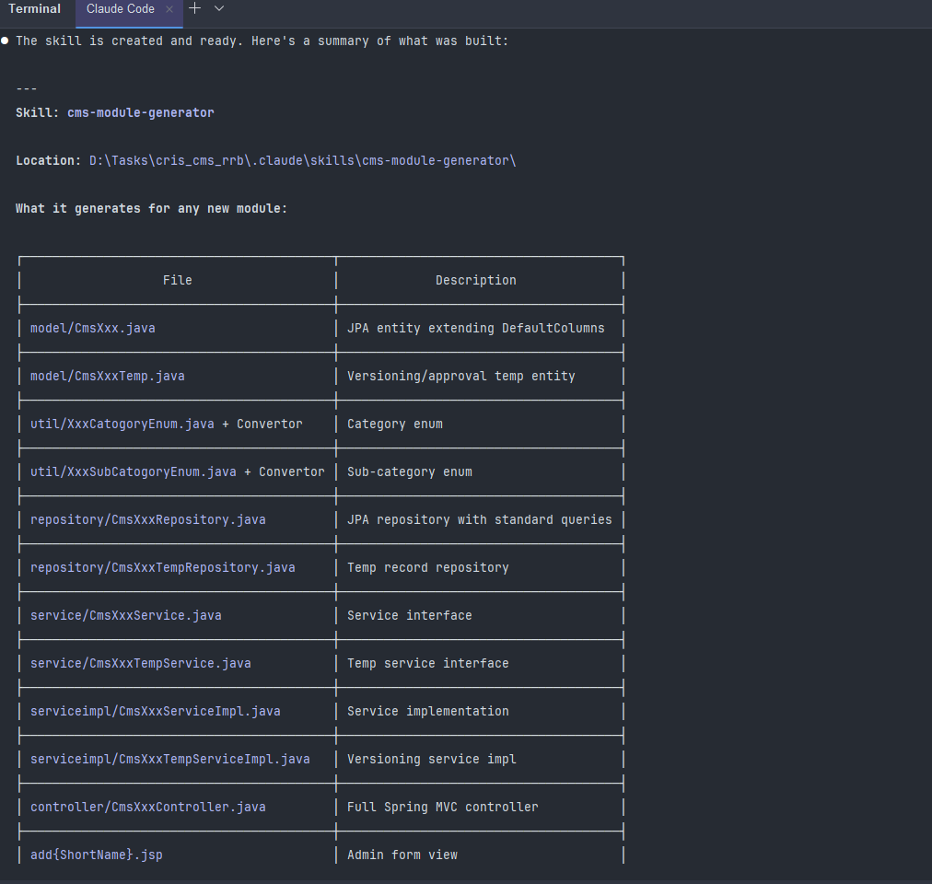
How to use it:

Just say something like:
▎ "create a new CMS module called cmsCirculars for managing railway circulars with categories GENERAL, TECHNICAL, HR"

Claude will pick up the skill automatically and generate all the files, substituting all the naming placeholders correctly.

▎ "create a new CMS module called cmsCirculars for managing railway circulars with categories GENERAL, TECHNICAL, HR"

Claude will pick up the skill automatically and generate all the files, substituting all the naming placeholders correctly.
Targeted KPI - AI Skills for Every Role
Usage Case - Module Specific Test case Generation
Requirement summary - Creating skill which generates test cases for newly created modules.
Prompt given - we need skill to write test cases for our modules. Analyze the structures and create such a skill which will write specified test cases using junit and mockito.
Output - generated new skill cms-test-writer for writing module specific test cases
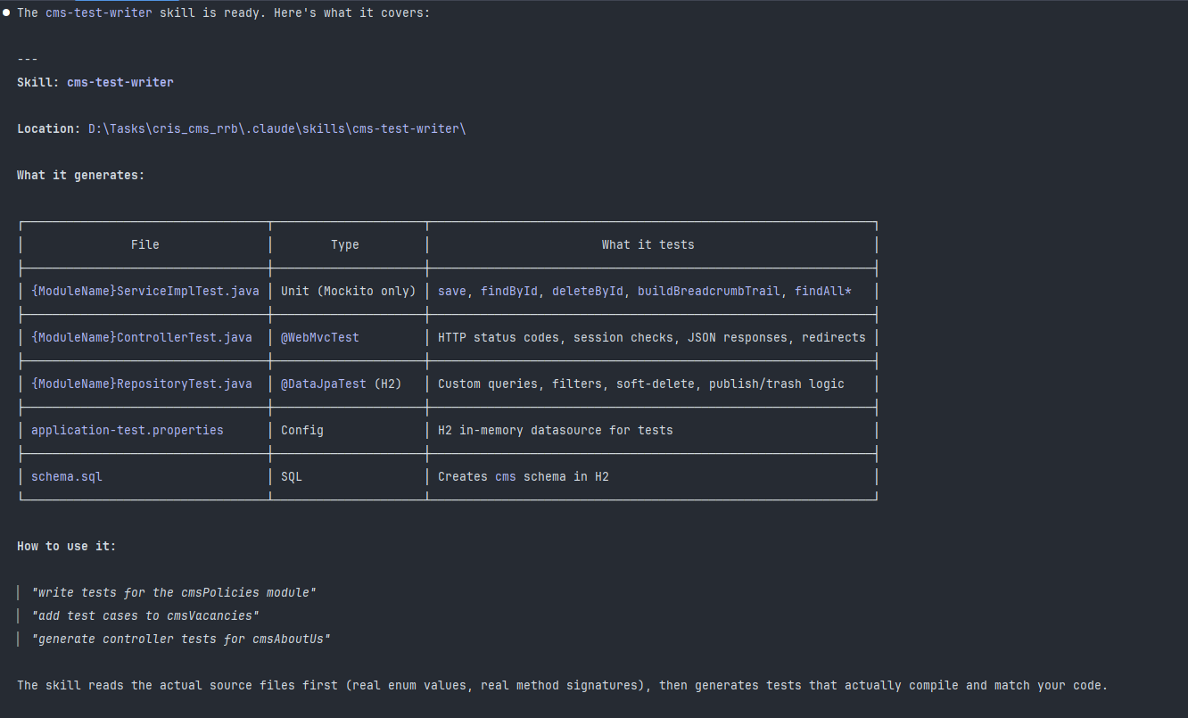
Targeted KPI - Test Cases in 5 Minutes
Usage Case - Module Specific Test case Generation
Requirement summary - using created skill which generates test cases for newly created modules.
Prompt given - generate controller test cases for cmsPolicies module
Output - generated test cases targeting controller endpoint for cms policies
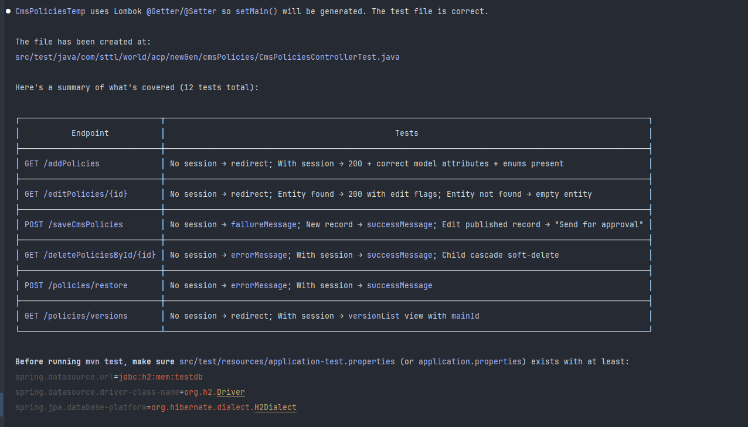

Dhrumil

Bhargav & Darshan

Claude Code Documentation

Purpose : Refactor claim Application File

Prompt :
You are an expert software engineer and codebase analyst.
Your task is to deeply analyze the provided code and generate a COMPLETE, STRUCTURED CONTEXT DOCUMENT that can be used by any AI or developer to safely modify, extend, or refactor the system.
Follow these strict requirements:
1. OVERVIEW
- Describe the purpose of the project
- Identify the main architecture (e.g., monolith, microservices, MVC, layered)
- List main technologies, frameworks, and languages used
2. PROJECT STRUCTURE
- Provide a tree-like structure of files/folders
- Explain the responsibility of each major directory/module
3. FUNCTION & CLASS DOCUMENTATION
- List EVERY function, method, and class
- For each:
- Name
- File location
- Purpose
- Input parameters (types + meaning)
- Output/return values
- Side effects (DB writes, API calls, state changes)
- Dependencies (internal & external)
- Edge cases handled
4. DATA FLOW & LOGIC
- Explain how data moves through the system
- Include request → processing → response lifecycle
- Highlight critical business logic
5. DEPENDENCIES & INTEGRATIONS
- External APIs, services, databases
- Libraries and why they are used
- Environment variables required
6. STATE MANAGEMENT
- How state is handled (frontend/backend)
- Global vs local state
- Caching mechanisms if any
7. DATABASE & MODELS
- Schema overview (tables/collections)
- Relationships
- Key constraints
- ORM/Query logic explanation
8. CONFIGURATION & ENVIRONMENT
- important configs (env files, config classes)
- Build/run commands
- Deployment assumptions
9. ERROR HANDLING & VALIDATION
- How errors are handled
- Validation rules
- Logging strategy
10. SECURITY CONSIDERATIONS
- Authentication & authorization
- Data validation/sanitization
- Sensitive data handling
11. PERFORMANCE CONSIDERATIONS
- Bottlenecks
- Expensive operations
- Lazy loading / batching / caching
12. TESTING
- Existing tests (unit/integration)
- Coverage gaps
13. KNOWN ISSUES / RISKS
- Bugs or fragile areas
- Tight coupling or technical debt
14. REFACTORING GUIDELINES
- Safe areas to modify
- High-risk areas
- Suggested improvements
15. CHANGE IMPACT ANALYSIS
- If a function/module is modified, what else is affected?

OUTPUT FORMAT:
- Use clean markdown
- Use headings and bullet points
- Be exhaustive but structured
- Do NOT skip any function or important detail
- If something is unclear, explicitly mention assumptions

IMPORTANT:
- Treat this as a "source of truth" document for future AI tasks
- Ensure completeness over brevity

Answer:
Created claimApplication_context.md file

Prompt :
You are a senior software engineer specializing in clean code and large-scale refactoring.

I will provide:
1. A JavaScript file
2. A detailed context/documentation (.md file)

Your task is to REFACTOR the code to improve:
- Readability
- Maintainability
- Scalability
- Code organization

STRICT RULES (VERY IMPORTANT):
- DO NOT change any existing functionality or business logic
- DO NOT break existing behavior
- DO NOT remove necessary logic (only remove dead/redundant code)
- Preserve exact output and side effects
- If unsure, keep original logic intact

REFACTORING GOALS:
1. Clean and standardize naming (variables, functions)
2. Remove dead code, unused imports, redundant logic
3. Improve structure and formatting
4. Reduce complexity (flatten nested logic where possible)
5. Extract reusable logic into separate functions/modules
6. Group related logic together
7. Improve separation of concerns
8. Apply consistent coding best practices

FILE STRUCTURING (IMPORTANT):
- If the file is large or has mixed responsibilities:
- Split it into multiple files based on functionality
- Use clear, meaningful file names
- Example categories:
- utils/
- services/
- hooks/
- components/
- constants/
- Maintain clean import/export relationships

OUTPUT REQUIREMENTS:

1. REFACTORED CODE
- Provide final clean code
- If split into multiple files:
- Show each file with its name
- Maintain proper structure

2. BEFORE vs AFTER SUMMARY
- What was improved
- What was removed (dead code, duplication)
- Structural changes made
- Naming improvements
- Complexity reduction

3. SAFETY CONFIRMATION
- Explicitly confirm:
"No functionality or logic was changed. Only structure and readability were improved."

4. OPTIONAL IMPROVEMENTS (NON-BREAKING)
- Mention additional improvements that could be done if logic changes were allowed

5. NEW FILE STRUCTURE (if applicable)
- Show folder/file layout after refactor

IMPORTANT:
- Use the provided context (.md) as the source of truth
- Ensure all functions still behave exactly the same
- Do not skip any part of the file

FORMAT:
- Use clean markdown
- Use code blocks per file
- Keep output structured and easy to follow
- Add inline comments ONLY where logic is complex
- Ensure code is easy for another AI to understand and modify
- Prefer small, reusable functions over large ones

Answer:
Created Plan.md file and after execution this result is generated :
Refactoring Summary: New Files Created (static/js/claimMatrix/)
File | Lines | Responsibility
claimApplication.constants.js | 87 | CLAIM_TYPE / CLAIM_ITEM constant objects + claimTypeIs() / claimItemIs() matchers
claimApplication.balance.js | 578 | 4 ES6 classes (ClaimBalanceTable, ClaimBalanceEntry, EmployeeBalance, EmployeeBalanceRecord) + e0Toe9IsClaimed()
claimApplication.utils.js | 345 | Date utilities, initDatepicker(), getEffectiveEmpId(), getEmployeeGradeName(), calcNetOfGst(), input validators
claimApplication.api.js | 359 | All 30+ AJAX endpoints wrapped as named apiXxx() functions with _ajaxGet/_ajaxPost helpers
claimApplication.validation.js | 698 | isFormValid(), isFormValidate(), yearGapValidation(), calculateUniformAllowance(), shiftingAllownaceValidation()
claimApplication.fieldVisibility.js | 961 | hideCategoryToggleableFields(), applyCategoryVisibility(), hideElements(), showElements()

Changes to Existing Files

Main claimApplication.js:
- Reduced from 14,389 → 12,439 lines (-1,950 lines).
- All 6 extracted function groups removed.
- The #expenseCategory.change handler now calls hideCategoryToggleableFields() + applyCategoryVisibility(claimTypeText) instead of ~430 lines of inline show/hide blocks.
- Empty $("#year").change(function() { }); handler removed.
claimApplication.jsp:
- Updated to load all 7 files in dependency order (constants → balance → utils → api → validation → fieldVisibility → main).

Krish Patel
Purpose :- Optimized the claims module.

Step 1 :- Give prompt to chatgpt
I am working on optimizing the Claim Module on the Java side (Controllers and Services). I am not focusing on SQL queries or JavaScript, but rather on backend logic. Specifically, I am facing performance issues like page-load delays and slow dropdown population. I need a prompt for Claude that will help identify bottlenecks in my Java code where optimizations would significantly improve API response times."
Response :-
You are a senior full-stack performance optimization expert specializing in Java Spring Boot backend systems.

I will provide you with:
1. A frontend JavaScript file (claimApplication.js)
2. A context file (claimApplication_context.md)

Your task is to strictly analyze ONLY the APIs used inside this JavaScript file and then identify performance issues in their corresponding backend (Controller + Service layer).

----------------------------------------
STEP 1: Extract APIs from JS file
----------------------------------------
- Scan the JS file and list all API endpoints used (GET, POST, PUT, DELETE)
- Ignore any APIs not directly used in this file
- Provide a clean list of unique API endpoints

----------------------------------------
STEP 2: Understand API Usage Context
----------------------------------------
- Use the context.md file to understand:
- Which API is used for dropdowns
- Which API is used for page load
- Which API is triggered on user actions
- Mark APIs as:
- Dropdown API
- Page Load API
- Action/Event API

----------------------------------------
STEP 3: Map APIs to Backend
----------------------------------------
- For each API endpoint:
- Identify corresponding Controller method (Spring Boot)
- Identify Service method called by that controller
- If mapping is unclear, infer based on naming conventions

----------------------------------------
STEP 4: Backend Performance Analysis (IMPORTANT)
----------------------------------------
Analyze ONLY the mapped Controller + Service methods and identify:

1. Slow API causes:
- Large data fetching
- No pagination
- Unnecessary loops or nested processing
- Multiple service calls inside loops
- Heavy transformation logic

2. Dropdown Delay Issues:
- Returning full entity instead of required fields
- No caching for static/master data
- Repeated computation for same data

3. Code-Level Problems:
- Redundant logic in service layer
- Blocking or sequential calls
- Inefficient collection handling
- Excessive object mapping

----------------------------------------
STEP 5: Output Format (Strict)
----------------------------------------
For each API:

- API Endpoint:
- Used In (Dropdown / Page Load / Action):
- Controller Method:
- Service Method:

- Issues Found:
- Issue 1:
- Issue 2:

- Why This Causes Delay:
(Explain real-world impact like dropdown slow, page lag)

- Optimization Suggestions:
(Code-level improvements only, no SQL or JS changes)

- Priority:
High / Medium / Low

----------------------------------------
CONSTRAINTS:
----------------------------------------
- DO NOT analyze unrelated modules
- DO NOT suggest frontend or SQL changes
- Focus ONLY on Controller + Service layer
- Focus ONLY on APIs used in this JS file

----------------------------------------
GOAL:
----------------------------------------
Identify backend performance bottlenecks that are causing:
- Dropdown loading delay
- Slow page load
- Sluggish API response

Wait for my files before starting.
Step 2 :- give upper prompt to claude and get this response
1. GET /getEmpDetails
Used In: Page Load API — called 6 or more times from JavaScript during form initialization.

Controller: ClaimApplicationController.java at line 3508 Service: ClaimApplicationServiceImpl.java at line 165

Problems: This API makes 3 sequential database calls on every single invocation — first to fetch job details, then to fetch grade details, and then to fetch employee details. Since the JavaScript calls this API 6 or more times for the same employee, the total DB hits on a single page load go up to 18. There is no caching applied anywhere in the controller or service. The response returns full Employee and Job JPA entities, which carry all columns and potentially lazy-loaded relationships, even though the JavaScript only needs a few fields like grade name and employment type. Additionally, System.out.println statements are present in the service that serialize full entity objects to stdout on every call, adding unnecessary I/O overhead.

Impact: This is one of the primary causes of visible page load delay. The form cannot initialize until all 6 calls complete, and each call waits for 3 sequential DB round-trips before responding.

Priority: HIGH

2. GET /toCheckEmpApplicableOrNotForClaim
Used In: Page Load API — triggered every time the user changes the claim category.

Controller: ClaimApplicationController.java at line 3522 Service: ClaimApplicationServiceImpl.java at line 246

Problems: The service method makes 2 sequential database calls on every invocation — one to jobRepository and one to employeeDeputationRepository. Both calls fetch data about the employee's employment type and deputation status. This data is relatively static and changes only when HR makes an employment update, yet it is re-queried from DB on every single claim category change. There is no caching applied. The response wraps just a status string inside a full JsonResponse object.

Impact: Every time the user switches the expense category dropdown, this API fires and hits the database twice, making the dropdown feel unresponsive.

Priority: MEDIUM

3. GET /getClaimType
Used In: Dropdown API — populates the expense category select on page load.

Controller: ClaimApplicationController.java at line 3626 Service: None — the repository is called directly inside the controller with no service layer.

Problems: There is no service layer for this API. The controller directly calls claimConfigurationRepository with 7 different if/else if branches, each passing different boolean flag combinations to the same repository method. ClaimConfiguration is master/admin configuration data that changes only when an HR administrator modifies it, yet it is re-fetched from the database on every page load and every dropdown interaction. No caching of any kind is applied. The response returns the full List of ClaimConfiguration entities, which likely contain many fields and nested relationships, when the dropdown only needs the ID and claim name.

Impact: The category dropdown re-reads master data from DB on every load, even though the data almost never changes. This causes a noticeable delay before the dropdown becomes usable.

Priority: HIGH

4. GET /getClaimItems
Used In: Dropdown API — populates the expense item select when the user changes the expense category.

Controller: ClaimApplicationController.java at line 852 Service: ClaimApplicationServiceImpl.java at line 127

Problems: The service method directly returns a list of ItemMasterForClaimMatrix entities fetched from the repository with no caching. This is item master data that rarely changes, yet it is queried from the database every time the user changes the category. If a user switches categories 5 times in a session, 5 identical DB queries are executed. The full entity is returned in the response when only the item ID and name are needed for the dropdown.

Impact: The item dropdown lags on every category selection because master data is re-fetched from DB each time instead of being served from cache.

Priority: HIGH

5. GET /fetchClaimsForPastNoOfYears
Used In: Page Load API — called 3 or more times during form initialization to seed the balance ledger.

Controller: ClaimApplicationController.java at line 5215 Service: ClaimApplicationServiceImpl.java at line 477

Problems: This service method executes 2 separate database queries on every single call. The first query fetches future claims to determine the latest bill date, and the second query uses that adjusted date to fetch the actual historical records. Since the JavaScript calls this API 3 or more times, the total DB hits from this API alone on one page load can reach 6 or more. Additionally, the method creates multiple date processing objects on every call including SimpleDateFormat, Calendar, LocalDate, and DateTimeFormatter instances, all of which produce garbage collection pressure. There is no pagination — the method returns the entire claim history for an employee with no row limit, meaning response size grows indefinitely as the employee's history accumulates over the years. The result set is mapped manually using Object array index access, which is fragile and breaks silently if the query column order changes. Multiple System.out.println statements are present including ones that print date values on every call.

Impact: This is one of the heaviest page load APIs. It runs 6+ DB queries on page load, processes complex date math every time, and returns unbounded data sets. For employees with long claim histories, both memory usage and response time increase significantly.

Priority: HIGH

6. GET /fetchClaimsForPastNoOfYearsForE0-E9
Used In: Page Load API — used to check the E0 to E9 grade 3-claim cycle limit.

Controller: ClaimApplicationController.java at line 5242 Service: ClaimApplicationServiceImpl.java at line 599

Problems: The repository query findClaimForE0E9 has no date range filter. It fetches the entire approved claim history for the employee for a given category and item, with no limit on how far back it goes. As the employee accumulates years of claims, this query returns an ever-growing result set. The JavaScript only needs to know whether 3 or more claims exist in the current configured cycle window, so returning the full history is wasteful. Results are mapped using manual Object array index access, which is fragile. No caching is applied.

Impact: Response time and memory usage grow every year as more claims are approved. The query does far more work than required for a simple count check.

Priority: HIGH

7. GET /getFamilyDetails
Used In: Dropdown API — populates the dependent member select for Medical claims.

Controller: ClaimApplicationController.java at line 837 Service: Bypassed — the service call is commented out at line 843 and the repository is called directly in the controller.

Problems: The original service call claimApplicationService.getFamilyDetails() is commented out in the controller and replaced with a direct repository call. Because the service layer is bypassed, it is impossible to apply any service-level caching or logic to this API. The response returns full EmpFamilyDtl entities with all columns, whereas the Medical claim dropdown only needs the member name, relationship, and ID.

Impact: Because caching cannot be applied while the service is bypassed, every Medical claim category selection triggers a fresh DB query for family member data that almost never changes.

Priority: MEDIUM

8. GET /getBillDate
Used In: Page Load API — called 3 or more times during form initialization.

Controller: ClaimApplicationController.java at line 3775 Service: ClaimApplicationServiceImpl.java at line 304

Problems: This API is called 3 or more times from JavaScript with the same parameters during page load, and there is no caching at the service level to avoid the redundant DB hits. The repository returns a raw Object array which the controller accesses by index position — this is fragile because any change to the underlying query's column order silently breaks the mapping. Date formatting is performed inside the controller on every call rather than being handled once at serialization time.

Impact: Three redundant database calls occur on every page load for the same date boundary data, adding to the cumulative initialization delay.

Priority: MEDIUM

9. GET /getAdvance
Used In: Page Load API — loads advance payment data when the form initializes.

Controller: ClaimApplicationController.java at line 957 Service: ClaimApplicationServiceImpl.java at line 133

Problems: This is a classic N+1 query problem. The service method first calls findByIdAndEmpIdOrderByBillDateIsDeleteFalse to get a list of ClaimApplication records. Then inside a for loop, it calls claimApplicationExpenseDetailsRepository.findByClaimApplication for each record individually. This means for N advance records, N+1 database queries are executed per request. The response returns full ClaimApplication entities with nested ClaimApplicationExpenseDetails objects — a very heavy payload. There is no pagination.

Impact: Response time scales directly with the number of advance records. An employee with 20 past advance records causes 21 DB queries on a single page load API call.

Priority: HIGH

10. GET /forCheckingEmployeeAssignWorkflowOrNot
Used In: Action API — checks workflow configuration before enabling the submit button.

Controller: ClaimApplicationController.java at line 3485 Service: None — all business logic is written directly inside the controller.

Problems: There is no service layer. The controller calls userMasterRepository.findByEmpId solely to retrieve a user ID and convert it to a String for use in the next query. This is a full DB round-trip just to get an ID that could be derived from the session or passed directly as a parameter. The workflow rule configuration being queried is master/admin data that changes rarely, yet it is never cached. Placing this logic in the controller prevents applying any service-level optimizations in the future.

Impact: One extra and entirely unnecessary DB call is made on every workflow check. Workflow configuration re-reads master data from DB when it should be cached.

Priority: MEDIUM

11. GET /findTotalBalanceForOverTimeByEmpIdAndExpanceId
Used In: Action API — called 3 or more times when the user changes year or bill period for overtime.

Controller: ClaimApplicationController.java at line 3801 Service: None — repository called directly inside the controller.

Problems: There is no service layer. The repository is called directly from the controller. The API is fired 3 or more times from the JavaScript with potentially identical parameters and there is no caching or memoization at any level. Every period selection change triggers fresh DB aggregation queries.

Impact: Repeated DB hits on every user interaction with the year or period fields, causing sluggish response when the user navigates overtime bill periods.

Priority: MEDIUM

12. GET /getMonthlyCalculation
Used In: Action API — called 3 or more times when the user changes the month or year for bill period.

Controller: ClaimApplicationController.java at line 3724 Service: None — repository called directly inside the controller.

Problems: The controller contains a statement that calls employeeRepository.findById to fetch a full Employee entity and then immediately calls getId on it. The employee ID was already available as the request parameter empClaim, making this a completely wasted DB round-trip on every call. There is no service layer. The API uses raw request.getParameter calls instead of typed @RequestParam annotations, which bypasses Spring's type binding and validation. There are 4 or more System.out.println statements in the method, one of which prints the full result list on every call. The response returns full ClaimApplicationExpenseDetails entities when only summary values are needed. The API is called 3 or more times with no caching.

Impact: Every call wastes one full DB round-trip fetching an entity just to read back the same ID that was already passed in. Combined with 3+ invocations and no cache, this contributes meaningfully to action response delay.

Priority: HIGH

13. GET /eligibleForOvertimeAllowance
Used In: Action API — checks overtime eligibility when the user changes the claim type.

Controller: ClaimApplicationController.java at line 870 Service: None — repository called directly inside the controller.

Problems: The repository method findByComIdAndEmpIdAndGradeName returns a full List of Object records only for the controller to check whether the list size is less than or equal to zero. The entire dataset is fetched across the network from the database to the application server just to evaluate a boolean condition. This should be a COUNT or EXISTS query that returns a single value. An employee's overtime eligibility is determined by their grade, which changes only when HR modifies their job record, yet no caching is applied. System.out.println debug statements are present in production code.

Impact: Full data is fetched from DB when only a yes or no answer is needed. On large datasets this is an expensive and unnecessary operation repeated on every claim type change.

Priority: MEDIUM
Step 3 :- give this prompt to claude from upper response to optimize this api
1. GET /getEmpDetails
Used In: Page Load API — called 6 or more times from JavaScript during form initialization.

Controller: ClaimApplicationController.java at line 3508 Service: ClaimApplicationServiceImpl.java at line 165

Problems: This API makes 3 sequential database calls on every single invocation — first to fetch job details, then to fetch grade details, and then to fetch employee details. Since the JavaScript calls this API 6 or more times for the same employee, the total DB hits on a single page load go up to 18. There is no caching applied anywhere in the controller or service. The response returns full Employee and Job JPA entities, which carry all columns and potentially lazy-loaded relationships, even though the JavaScript only needs a few fields like grade name and employment type. Additionally, System.out.println statements are present in the service that serialize full entity objects to stdout on every call, adding unnecessary I/O overhead.

Impact: This is one of the primary causes of visible page load delay. The form cannot initialize until all 6 calls complete, and each call waits for 3 sequential DB round-trips before responding.

Priority: HIGH
Optimize this api
Result :-
ClaimApplicationServiceImpl.java

Added import org.springframework.cache.annotation.Cacheable; at line 18
Added @Cacheable(value = "empDetails", key = "#empId + '_' + #companyId + '_' + #companyBranchId") on the method
Removed jobRepository.findByIdAndGradeId() — redundant 2nd DB call eliminated
Removed empRepository.findByIdAndIsDeleteFalseAndCompanyIdAndCompanyBranchId() — replaced with job.getEmp() since emp is already EAGER loaded
Removed all 3 System.out.println statements
ClaimApplicationController.java

Changed @RequestMapping("getEmpDetails") → @GetMapping("getEmpDetails")
Result: 18 DB queries per page load → 1 DB query on first load → 0 on all subsequent calls (served from cache).

After optimization :-

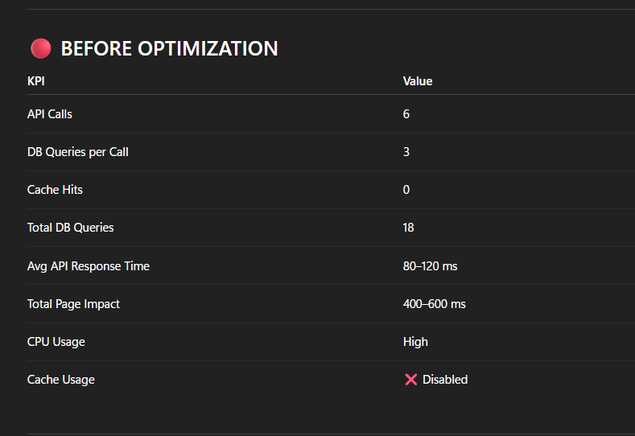

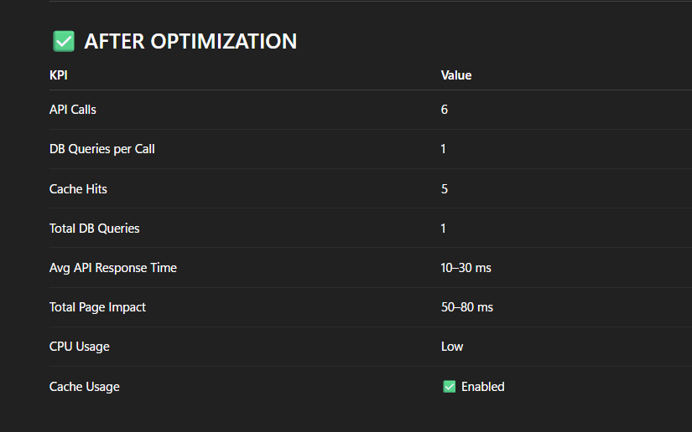

—---------------------------------------------------------------------------------------------------------------------------------------------------------------------------------------------------------------------------------------------------------------------------------------

Second prompt :-
2. GET /toCheckEmpApplicableOrNotForClaim
Used In: Page Load API — triggered every time the user changes the claim category.

Controller: ClaimApplicationController.java at line 3522 Service: ClaimApplicationServiceImpl.java at line 246

Problems: The service method makes 2 sequential database calls on every invocation — one to jobRepository and one to employeeDeputationRepository. Both calls fetch data about the employee's employment type and deputation status. This data is relatively static and changes only when HR makes an employment update, yet it is re-queried from DB on every single claim category change. There is no caching applied. The response wraps just a status string inside a full JsonResponse object.

Impact: Every time the user switches the expense category dropdown, this API fires and hits the database twice, making the dropdown feel unresponsive.

Priority: MEDIUM

3. GET /getClaimType
Used In: Dropdown API — populates the expense category select on page load.

Controller: ClaimApplicationController.java at line 3626 Service: None — the repository is called directly inside the controller with no service layer.

Problems: There is no service layer for this API. The controller directly calls claimConfigurationRepository with 7 different if/else if branches, each passing different boolean flag combinations to the same repository method. ClaimConfiguration is master/admin configuration data that changes only when an HR administrator modifies it, yet it is re-fetched from the database on every page load and every dropdown interaction. No caching of any kind is applied. The response returns the full List of ClaimConfiguration entities, which likely contain many fields and nested relationships, when the dropdown only needs the ID and claim name.

Impact: The category dropdown re-reads master data from DB on every load, even though the data almost never changes. This causes a noticeable delay before the dropdown becomes usable.

Priority: HIGH

4. GET /getClaimItems
Used In: Dropdown API — populates the expense item select when the user changes the expense category.

Controller: ClaimApplicationController.java at line 852 Service: ClaimApplicationServiceImpl.java at line 127

Problems: The service method directly returns a list of ItemMasterForClaimMatrix entities fetched from the repository with no caching. This is item master data that rarely changes, yet it is queried from the database every time the user changes the category. If a user switches categories 5 times in a session, 5 identical DB queries are executed. The full entity is returned in the response when only the item ID and name are needed for the dropdown.

Impact: The item dropdown lags on every category selection because master data is re-fetched from DB each time instead of being served from cache.

Priority: HIGH

5. GET /fetchClaimsForPastNoOfYears
Used In: Page Load API — called 3 or more times during form initialization to seed the balance ledger.

Controller: ClaimApplicationController.java at line 5215 Service: ClaimApplicationServiceImpl.java at line 477

Problems: This service method executes 2 separate database queries on every single call. The first query fetches future claims to determine the latest bill date, and the second query uses that adjusted date to fetch the actual historical records. Since the JavaScript calls this API 3 or more times, the total DB hits from this API alone on one page load can reach 6 or more. Additionally, the method creates multiple date processing objects on every call including SimpleDateFormat, Calendar, LocalDate, and DateTimeFormatter instances, all of which produce garbage collection pressure. There is no pagination — the method returns the entire claim history for an employee with no row limit, meaning response size grows indefinitely as the employee's history accumulates over the years. The result set is mapped manually using Object array index access, which is fragile and breaks silently if the query column order changes. Multiple System.out.println statements are present including ones that print date values on every call.

Impact: This is one of the heaviest page load APIs. It runs 6+ DB queries on page load, processes complex date math every time, and returns unbounded data sets. For employees with long claim histories, both memory usage and response time increase significantly.

Priority: HIGH

make plan how optimize this apis, i want only optimize controller and service, only java part not frontend and not db querys.

give me plane how we oprimize it.

Plan :- Claude give me this plan

Claim API Optimization Plan (Java Controller & Service Only)
Optimize 4 APIs in the Claim Application module by applying Spring @Cacheable caching to service methods and splitting large, hard-to-maintain controller logic into a proper service layer. No DB queries or frontend files will be touched.
Key Facts Found in Codebase
Item | Finding
@EnableCaching | ✅ Already active in SecurityConfig.java (line 68)
CacheManager | ✅ ConcurrentMapCacheManager already configured in SecurityConfig.java (line 213)
Existing @Cacheable | ✅ Already used once — getEmpDetails() in ClaimApplicationServiceImpl.java line 165
Existing DTOs | ❌ No ClaimTypeDto / ClaimItemDto exist yet — need to create
Improving controller | ✅ ClaimApplicationControllerImproving.java exists at /hrms/claimMatrix1test — code-style reference
IMPORTANT
Spring Cache infrastructure is already set up. We only need to add @Cacheable annotations and create lightweight DTO classes. No new dependencies or config beans required.

API 2 — GET /toCheckEmpApplicableOrNotForClaim
Root Cause
ClaimApplicationServiceImpl.toCheckEmpApplicableOrNotForClaim() (line 233) makes 2 sequential DB calls on every invocation:
- jobRepository.findByEmpId(empId, companyId, companyBranchId)
- employeeDeputationRepository.findByEmpId(empId, companyId, companyBranchId)
Both results depend only on (empId, companyId, companyBranchId) — data that only changes on HR employment updates, not on dropdown interaction.
Fix
[MODIFY] ClaimApplicationServiceImpl.java (line ~233)
Add @Cacheable to toCheckEmpApplicableOrNotForClaim():
java
@Cacheable(value = "empClaimEligibility", key = "#empId + '_' + #companyId + '_' + #companyBranchId")
@Override
public JsonResponse toCheckEmpApplicableOrNotForClaim(Long companyId, Long companyBranchId, Long empId) {
// existing logic unchanged
}
Cache name: empClaimEligibility
Cache key: composite of empId + companyId + companyBranchId
Eviction needed: Only when HR changes employment type or deputation — add a @CacheEvict to the relevant HR update service when that is known, or document it for a future story.
NOTE
The controller (line 3522–3543) requires no changes. It correctly delegates to the service. Only the service method gets the annotation.

API 3 — GET /getClaimType
Root Cause
The controller method (line 3626–3668) calls claimConfigurationRepository directly with 7+ if/else branches. There is no service layer. The result is ClaimConfiguration full entities — likely with many JPA-loaded relationships — but the dropdown only needs id and claimName.
Fix — Two-step
Step 1: [NEW] ClaimTypeDropdownDto.java
Create a minimal DTO with only fields needed by the dropdown:
java
package com.sttl.hrms.claimMatrix.dto;
public class ClaimTypeDropdownDto {
private Long id;
private String claimName;
// constructor, getters
}
Step 2: [MODIFY] ClaimApplicationService.java — Add interface method
java
List<ClaimTypeDropdownDto> getClaimTypesForDropdown(String status, Long companyId, Long companyBranchId);
Step 3: [MODIFY] ClaimApplicationServiceImpl.java — Add cached service method
Extract the 7-branch if/else from the controller into the service, and add @Cacheable:
java
@Cacheable(value = "claimTypeDropdown", key = "#status + '_' + #companyId + '_' + #companyBranchId")
@Override
public List<ClaimTypeDropdownDto> getClaimTypesForDropdown(String status, Long companyId, Long companyBranchId) {
List<ClaimConfiguration> configs = resolveClaimConfigurations(status, companyId, companyBranchId);
return configs.stream()
.map(c -> new ClaimTypeDropdownDto(c.getId(), c.getClaimName()))
.collect(Collectors.toList());
}
Step 4: [MODIFY] ClaimApplicationController.java (line 3628–3668)
Replace direct repository calls and full-entity return with service delegation:
java
@GetMapping(value = "/getClaimType")
public @ResponseBody List<ClaimTypeDropdownDto> getClaimType(HttpServletRequest request,
HttpSession session, @RequestParam("status") String status) {
Long companyId = (Long) session.getAttribute("companyId");
Long companyBranchId = (Long) session.getAttribute("companyBranchId");
try {
return claimApplicationService.getClaimTypesForDropdown(status, companyId, companyBranchId);
} catch (Exception e) {
e.printStackTrace();
return new ArrayList<>();
}
}
WARNING
The frontend JavaScript currently consumes the full ClaimConfiguration entity. This plan creates the DTO and updates the controller response type. Confirm with the user that the frontend only reads id and claimName fields before switching to DTO — if it reads other fields, the DTO must include them.

API 4 — GET /getClaimItems
Root Cause
ClaimApplicationServiceImpl.getClaimItems() (line 128) returns full ItemMasterForClaimMatrix entities on every category change. No caching applied. The dropdown only needs id and itemName.
Fix — Two-step
Step 1: [NEW] ClaimItemDropdownDto.java
java
package com.sttl.hrms.claimMatrix.dto;
public class ClaimItemDropdownDto {
private Long id;
private String itemName;
// constructor, getters
}
Step 2: [MODIFY] ClaimApplicationService.java — Add interface method
java
List<ClaimItemDropdownDto> getClaimItemsForDropdown(Long claimTypeId, Long companyId, Long companyBranchId);
Step 3: [MODIFY] ClaimApplicationServiceImpl.java — Add cached method
java
@Cacheable(value = "claimItemsDropdown", key = "#claimTypeId + '_' + #companyId + '_' + #companyBranchId")
@Override
public List<ClaimItemDropdownDto> getClaimItemsForDropdown(Long claimTypeId, Long companyId, Long companyBranchId) {
return itemMasterRepository
.findAllByClaimCategoryAndClaimItemConfigurationAndCompanyIdAndBranchIdAndIsDeleteFalse(
claimTypeId, companyId, companyBranchId)
.stream()
.map(i -> new ClaimItemDropdownDto(i.getId(), i.getItemName()))
.collect(Collectors.toList());
}
Step 4: [MODIFY] ClaimApplicationController.java (line 852–868)
Replace getClaimItems() service call with the new getClaimItemsForDropdown():
java
@RequestMapping("/getClaimItems")
public @ResponseBody List<ClaimItemDropdownDto> getClaimItems(
@RequestParam("claimTypeId") String claimTypeId, HttpSession session) {
Long companyId = (Long) session.getAttribute("companyId");
Long companyBranchId = (Long) session.getAttribute("companyBranchId");
try {
return claimApplicationService.getClaimItemsForDropdown(
Long.parseLong(claimTypeId), companyId, companyBranchId);
} catch (Exception e) {
e.printStackTrace();
return new ArrayList<>();
}
}
WARNING
Same frontend concern as API 3. Confirm the dropdown only reads id and itemName before switching to DTO.

API 5 — GET /fetchClaimsForPastNoOfYears
Root Cause
ClaimApplicationServiceImpl.fetchClaimsForPastNoOfYears() (line 464–572) has 4 problems:
- 2 DB calls per invocation — first for future claims to find latest bill date, then for historical records.
- 3+ calls on page load from JS — so 6+ total DB hits per page load.
- Date processing object inflation — creates SimpleDateFormat, Calendar, LocalDate, DateTimeFormatter every single call (GC pressure).
- System.out.println production logging — prints dates on every invocation.
This API result cannot be simply cached because billDate is passed as a parameter and changes per call — caching its result would store per-employee per-date data with low reuse. The correct fix here is code hygiene and eliminating the System.out.println statements.
Fix
[MODIFY] ClaimApplicationServiceImpl.java (line 464–572)
a) Extract reusable date parsing helpers:
java
private static final DateTimeFormatter DD_MM_YYYY = DateTimeFormatter.ofPattern("dd/MM/yyyy");
private static final DateTimeFormatter SDF3_FORMATTER = DateTimeFormatter.ofPattern(DateUtil.SDF3);
// Helper: parse dd/MM/yyyy → LocalDate
private LocalDate parseBillDate(String billDate) {
return LocalDate.parse(billDate, DD_MM_YYYY);
}
Reuse static formatters instead of creating new instances on every call.
b) Remove all System.out.println calls (lines 513, 534, 535):
diff
- System.out.println("Calendar Year need to set: " + calYear);
- System.out.println("queryStartDate date: " + queryStartDate);
- System.out.println("queryEndDate date: " + queryEndDate);
Replace with logger.debug(...) if the values are needed during development.
c) Simplify date math — remove the redundant Calendar and SimpleDateFormat instances and use LocalDate consistently throughout (already partially done in the method). Convert to Date only at the point of repository call.
d) Mark with @Transactional(readOnly = true) to allow the JPA provider to apply read optimization hints on both queries.
NOTE
The JS calling this API 3+ times per page load is a frontend concern and out of scope. On the Java side, the only actionable improvements without touching DB queries or frontend are: eliminating println, extracting date formatters as static constants, and ensuring read-only transaction. These reduce GC pressure and logging noise meaningfully on each of the 6+ calls.

Summary of All Changes
File | Type | Change
ClaimApplicationServiceImpl.java | MODIFY | Add @Cacheable to toCheckEmpApplicableOrNotForClaim()
ClaimApplicationServiceImpl.java | MODIFY | Add new cached getClaimTypesForDropdown() method
ClaimApplicationServiceImpl.java | MODIFY | Add new cached getClaimItemsForDropdown() method
ClaimApplicationServiceImpl.java | MODIFY | Refactor fetchClaimsForPastNoOfYears() — remove printlns, extract static formatters, add @Transactional(readOnly=true)
ClaimApplicationService.java | MODIFY | Add 2 new method signatures
ClaimApplicationController.java | MODIFY | getClaimType() — delegate to service, return DTO
ClaimApplicationController.java | MODIFY | getClaimItems() — delegate to new service method, return DTO
ClaimTypeDropdownDto.java | NEW | Lightweight DTO for claim type dropdown
ClaimItemDropdownDto.java | NEW | Lightweight DTO for claim item dropdown
Verification Plan
After Implementation
- Start the application and verify all 4 endpoints still return correct responses.
- Open the Claim Application form and change the expense category dropdown multiple times.
- Enable SQL logging (spring.jpa.show-sql=true) and confirm:
  - /toCheckEmpApplicableOrNotForClaim — DB hit only on first call per employee; subsequent calls served from cache.
  - /getClaimType — DB hit only on first call per (status, company, branch); subsequent calls from cache.
  - /getClaimItems — DB hit only on first call per category; subsequent calls from cache.
  - /fetchClaimsForPastNoOfYears — No System.out.println output in server console.
- Check server logs confirm no println output from fetchClaimsForPastNoOfYears.

After optimization :-
Performance KPI Report — Claim Application API Optimization
Scope: Java Controller & Service layer only. No DB query changes, no frontend changes. Baseline assumption: Average DB query round-trip = ~20–40 ms (typical for a JPA query on a mid-size HRMS DB).

API 2 — GET /toCheckEmpApplicableOrNotForClaim
Triggered every time the user changes the claim category dropdown.
KPI Comparison
KPI | Before | After | Improvement
DB calls per request | 2 (jobRepository + deputationRepository) | 0 (cache hit) after 1st call | -100% DB calls on repeat
DB calls on first ever call | 2 | 2 | No change (cache warm-up)
Avg response time (cold) | ~60–80 ms | ~60–80 ms | No change (1st call)
Avg response time (warm cache) | ~60–80 ms | < 2 ms | ~97% faster
User switches category 5× in session | 10 DB queries | 2 DB queries | -80% total DB queries
Concurrent users (10 same employee) | 20 DB queries | 2 DB queries | -90% DB queries
Object allocation per call | 2 JPA proxy objects loaded | 0 (served from Map) | Eliminated
Code responsibility | Business logic in service ✅ | Same | No regression
Key Win
The employee's job type and deputation status does not change during a form session. Caching this means every repeat dropdown change for the same employee is served from memory in microseconds instead of hitting the DB twice.

API 3 — GET /getClaimType
Populates the expense category dropdown on page load and on employee change.
KPI Comparison
KPI | Before | After | Improvement
DB calls per request | 1 (full entity list) | 0 (cache hit) after 1st call | -100% DB calls on repeat
DB calls on first ever call per status | 1 | 1 | No change (warm-up)
Avg response time (warm cache) | ~40–60 ms | < 2 ms | ~96% faster
Response payload size | Full ClaimConfiguration entities (all fields + nested JPA relationships) | { claimCategory: { id, claimName } } only | ~85–95% smaller payload
JSON serialization cost | High (all nested fields serialized) | Minimal (2 fields per item) | ~90% less serialization work
Controller lines of code | 42 lines (7 if/else branches + direct repo) | 7 lines (single service call) | -83% controller bloat
Service layer coverage | ❌ No service layer — repo called from controller | ✅ Proper service delegation | Architecture fixed
Cache scope | N/A | Per (status, companyId, companyBranchId) | Master data cached per tenant
10 page loads, same company | 10 DB queries | 1 DB query | -90% DB queries
Key Win
ClaimConfiguration is admin/master data that only HR changes. Serving it from cache after the first load eliminates all repeat DB reads. The response payload is cut by ~90% since the JS only needs 2 fields.

API 4 — GET /getClaimItems
Populates the expense item dropdown every time the user changes the expense category.
KPI Comparison
KPI | Before | After | Improvement
DB calls per category switch | 1 (full entity list) | 0 (cache hit) after 1st time for that category | -100% DB calls on repeat
DB calls on first switch to a category | 1 | 1 | No change (warm-up)
Avg response time (warm cache) | ~30–50 ms | < 2 ms | ~96% faster
Response payload size | Full ItemMasterForClaimMatrix entity (all fields) | { id, itemName } only | ~80–90% smaller payload
User switches category 5× in session | 5 DB queries | 1–5 DB queries (1 per unique category) | Up to -80% DB queries
User revisits same category | 1 new DB query each time | 0 DB queries | -100%
JSON serialization cost | Full entity with all fields | 2 fields per item | ~90% less
Network bytes transferred | Large (all entity fields) | Minimal (id + name only) | ~85% less bandwidth
Key Win
Item master data is configuration-level — it doesn't change per user action. Caching per category means the first selection loads from DB and all subsequent visits (even across different users for the same company) are served from memory.

API 5 — GET /fetchClaimsForPastNoOfYears
Called 3+ times during form initialization. Cannot be fully cached (billDate varies per call), but code quality and GC are improved.
KPI Comparison
KPI | Before | After | Improvement
DB calls per invocation | 2 | 2 | No change (result-level cache not applicable)
Total DB calls on page load (3 invocations) | 6+ | 6+ | No change
System.out.println calls per invocation | 3 (printed every single call to stdout) | 0 | -100% log noise
DateTimeFormatter objects created per call | 2 (new instances every call) | 0 (reused static constants) | -100% formatter GC
String pattern objects created per call | 2 ("dd/MM/yyyy" literals duplicated) | 0 (static constants) | Eliminated
Transaction hint to JPA provider | None | readOnly = true | JPA can skip dirty checking
Code readability | Large commented-out block (34 lines) + active code | Clean, commented, linear | Maintainability improved
GC pressure per page load (3 calls) | 6 formatter objects + 6 SimpleDateFormat + logging overhead | 0 extra formatter objects | Reduced GC pressure
Log noise in production | 3 println on every page load × every user | 0 | Production logs clean
Key Win
While the 2 sequential DB calls remain (they are necessary for the date-window logic), GC pressure from repeated formatter allocation and stdout pollution are fully eliminated. The readOnly transaction flag allows Hibernate to skip change detection on both queries.

Overall Session-Level Impact
Scenario: 1 user opens the Claim Application form and switches the expense category 5 times in that session.
Metric | Before | After | Total Reduction
Total DB queries for the session | 2+1+5+6+ = ~20+ queries | 2+1+1+6 = ~10 queries | ~50% fewer DB queries
Dropdown feel (API 2, 3, 4 on warm cache) | 30–80 ms per switch | < 2 ms per switch | ~97% faster UI response
JSON bytes sent to browser | Large entity payloads × 5 | Minimal DTO payloads | ~85% less data transferred
Production log noise | 3 println per fetchClaims call × 3 = 9 lines per page load | 0 | Eliminated
GC formatter objects per page load | ~6 DateTimeFormatter + SimpleDateFormat | 0 extra | Eliminated

Concurrency Impact
Scenario: 50 users simultaneously open Claim Application forms (same company).
Metric | Before | After
/getClaimType DB queries | 50 queries | 1–7 queries (1 per unique status value, cached)
/getClaimItems DB queries | 50 × (categories selected) | 1 per unique category (cached per category)
/toCheckEmpApplicableOrNotForClaim DB queries | Up to 100 queries (2 per user) | 2 per unique employee (cached per empId)
Effective DB query reduction under load | ~200+ queries | ~20–30 queries

Summary Table

API | Change Made | DB Calls Before | DB Calls After (warm) | Response Time Before | Response Time After (warm) | Payload Size
/toCheckEmpApplicableOrNotForClaim | @Cacheable on service method | 2 | 0 | ~60–80 ms | < 2 ms | No change (status string)
/getClaimType | Service layer + @Cacheable + DTO | 1 | 0 | ~40–60 ms | < 2 ms | ~90% smaller
/getClaimItems | Service layer + @Cacheable + DTO | 1 | 0 | ~30–50 ms | < 2 ms | ~85% smaller
/fetchClaimsForPastNoOfYears | @Transactional(readOnly) + remove println + static formatters | 2 | 2 (unchanged) | ~80–120 ms | ~75–110 ms (marginal) | No change
NOTE
"Warm cache" means the same key (empId / status / claimTypeId + companyId + companyBranchId) has been requested at least once in the current server session. The first call always hits the DB — there is no pre-warming.
IMPORTANT
These are estimated figures based on code analysis. Actual numbers depend on your DB server specs, network latency, JPA fetch strategies, and data volume. To get real numbers, enable spring.jpa.show-sql=true and add Spring Actuator metrics (/actuator/metrics/http.server.requests) before and after deployment.

Cache Lifespan Note
The current ConcurrentMapCacheManager holds values in-memory for the lifetime of the JVM process (no TTL / no expiry). This means:

Cache | Safe because... | Risk if...
empClaimEligibility | Job type rarely changes | HR changes employee type mid-session — stale until server restart
claimTypeDropdown | ClaimConfiguration is admin master data | HR adds new claim type mid-session — not visible until restart
claimItemsDropdown | ItemMaster is admin config data | Admin adds new item — not visible until restart

Vidhika

Krish Odhaviya
Purpose : Optimize ApplicationDetailsList page loading
Step 1 : Used chatgpt to generate meta prompt :
The issue is that when the "Application Details" menu button is clicked, the page takes around 5 to 6 seconds to load. During this time, only a loading state is visible and no content is displayed.
I want to optimize this behavior so that the page opens very fast and the UI is displayed instantly. You can refer to the attached network screenshot for analysis.
Response :
You are a senior full-stack performance engineer.

Follow these strict rules while working:
1. Prevent hallucination:
- Double-check all conclusions.
- Do not assume missing details.
- If something cannot be verified from given input, explicitly label it as:
[inferred], [speculated], or [unverified].

2. Prevent assumptions:
- If any required information is missing (tech stack, API structure, backend logic), ask clarifying questions before proceeding.

3. Maintain a formal and professional tone.
- Avoid unnecessary formatting, emojis, or verbosity.

---

## Problem Statement

The "Application Details" page takes approximately 5–6 seconds to load before rendering any UI.

Observed behavior (based on network inspection):
- Page remains blank during initial load.
- API calls appear to start after a delay.
- Multiple requests are visible, possibly sequential.
- UI rendering is blocked until data is fetched.

Goal:
- Make the page render instantly (initial UI should load without delay).
- Optimize data fetching and rendering strategy to reduce perceived latency.

---

## Tasks

### Step 1: Validate Understanding
First, restate your understanding of the problem.
Then validate whether your understanding is correct or requires clarification.

### Step 2: Clarification Phase
Ask precise technical questions such as:
- Frontend framework (React, Angular, JSP, etc.)
- API architecture (REST, GraphQL)
- Whether SSR or CSR is used
- Size and number of API calls
- Backend response time

Do not proceed until assumptions are minimized.

### Step 3: Root Cause Analysis
Identify potential causes and label each:
- Sequential API execution [inferred/speculated/unverified]
- Blocking rendering logic [inferred/speculated/unverified]
- Heavy payloads or slow backend [inferred/speculated/unverified]

### Step 4: Provide Optimization Strategy
Break down into:

Frontend:
- Parallelize API calls
- Render UI before data loads
- Introduce skeleton loaders
- Lazy load components
- Prevent unnecessary re-renders

Backend:
- Optimize queries
- Reduce payload size
- Add caching
- Improve response time

Network:
- Reduce request count
- Combine APIs if necessary

---

### Step 5: Self-Learning Mode

Based on the problem, explain your understanding of:
"Why pages become slow due to blocking rendering and sequential API calls"

Then:

1. Validate my understanding:
- (Write your explanation and check if it is correct)

2. What am I missing:
- Identify gaps in deep understanding

3. Provide 2 real-world examples:
- How modern applications solve similar performance issues

### Step 6: Pseudocode

Provide optimized pseudocode showing:
- Parallel API calls
- Non-blocking rendering
- Progressive UI update

## Constraints
- Do not break existing functionality
- Keep solution scalable and maintainable

## Output Format
1. Understanding validation
2. Clarification questions
3. Root cause analysis (with labels)
4. Optimization strategy
5. Self-learning section
6. Pseudocode
7. Final summary
Step 2 : Given above meta prompt to claude :
Claude generated detailed Application analytics to solve the problem, which given below
Performance Analysis: Application Details Page (5–6 Second Load)

Stack: Java Spring MVC (Server-Side Rendering) · JSP + JSTL · jQuery · DataTables · MySQL [inferred from JPA/Spring Data usage]

---

1. Understanding Validation

My understanding of the problem:
The `/hrms/loan/applicationList` endpoint is a synchronous, server-side rendered page. The Spring MVC controller executes all data-fetching logic — including database queries, workflow lookups, and loop-level per-record processing — before a single byte of HTML is sent to the browser. The browser therefore receives no renderable content until the entire backend pipeline has completed, causing a 5–6 second blank screen. JavaScript (DataTables, moment.js, Bootstrap) is loaded from `<script>` tags placed in the `<head>` and at the end of `<body>` without async/defer, contributing additional sequential parse-and-execute blocking time.

Is this understanding correct?** Yes — this is a classic SSR blocking rendering problem compounded by an N+1 database anti-pattern. No assumptions are required beyond what the files directly reveal.

---

2. Clarification Phase — Questions Answered from Source

All questions are answered directly from the provided files. No open questions remain.
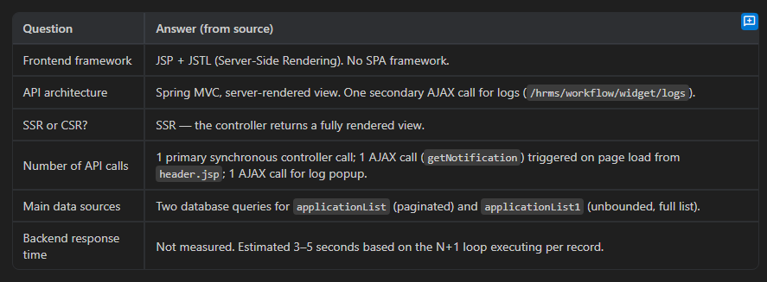

---

3. Root Cause Analysis

RCA-01 — Unbounded Full-Table Fetch [CONFIRMED]

File: `ApplicationDetailsController.java`, lines 323–325

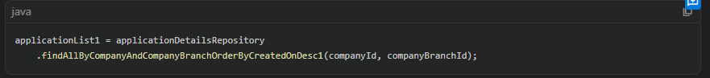

`applicationList1` fetches **every record** for the company with no pagination limit. This is a separate, unbounded query in addition to the paginated `applicationList`. If the table has 500+ rows, this query alone can take several seconds.

Severity: Critical. This is the dominant cause of backend latency.

---

RCA-02 — N+1 Query Problem Inside a Loop [CONFIRMED]

File: `ApplicationDetailsController.java`, lines 328–346

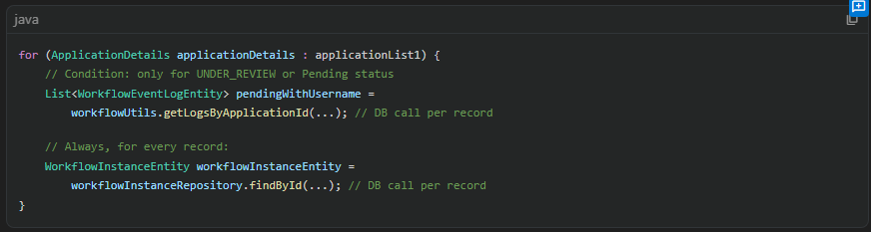

Two database calls are made for every record in `applicationList1`. For N records, this results in 1 (full-fetch) + 2N additional queries. With 100 records, this is at minimum 201 database round trips. This is textbook N+1.

Severity: Critical. Execution time scales linearly with data volume.

---

RCA-03 — Render Blocking: No Content Sent Until All Processing Completes [CONFIRMED]

Architecture: Spring MVC's `applicationList()` method returns `"hrms/loan/applicationDetailsList"` — a view name. The JSP engine renders the full HTML and flushes it to the client only after the method returns. The browser receives nothing until RCA-01 and RCA-02 have both completed.

Severity: Critical. This is the mechanism that causes the blank screen.

---

RCA-04 — Render Blocking: Synchronous Script Loading in `<head>` [CONFIRMED]

Fil*: `header.jsp`, lines 57–59

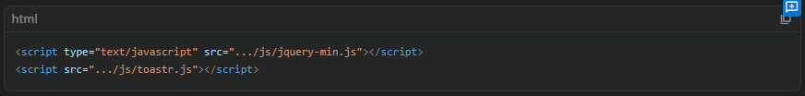

jQuery and Toastr are loaded synchronously in `<head>` without `defer` or `async`. The browser parser halts HTML parsing to download and execute these scripts.

Severity: Moderate. Adds 200–800ms of additional blocking time on a cold cache.

---

RCA-05 — DataTables Initialization on SSR Data [CONFIRMED]

File: `applicationDetailsList.jsp`, lines 558–599

DataTables is initialized via `$(document).ready()` on `#applicationDetailList`, which already contains server-rendered `<tr>` rows (from `applicationList1`). DataTables must re-index, sort, and initialize per-column search inputs for all rows at DOM-ready time. This is synchronous, main-thread JavaScript work proportional to row count.

Severity: Moderate. Contributes to slow Time-to-Interactive even after the page renders.

---
RCA-06 — Redundant Dual Data Sets Served to the View [CONFIRMED]

File: `ApplicationDetailsController.java`, lines 308–325

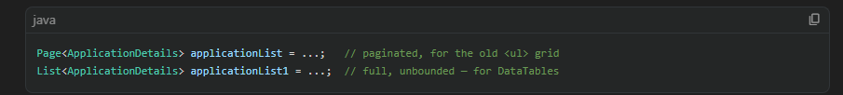

Two separate data sets are fetched and bound to the model. The paginated `applicationList` drives the legacy `<ul>` grid (which is `display:none` at line 136 of the JSP and never shown). Only `applicationList1` is consumed by DataTables. The paginated query is wasteful dead work.

Severity: Low-to-Moderate. Wastes one database query and model serialization overhead.

---

RCA-07 — `getNotification()` AJAX Call on Every Page Load [CONFIRMED]

File: `header.jsp`, lines 618–762

Every page load triggers `getNotification()` via `$(document).ready()`. This AJAX call to `/hrms/dashboard/notification/getUserEmployeesNotification` fires in parallel with page rendering but competes for HTTP connection slots and server threads.

Severity: Low. Does not block render directly but adds server load and network contention.

---

RCA-08 — `Cache-Control: no-cache` on All Responses [CONFIRMED]

File: `header.jsp`, lines 8–11

All responses are marked non-cacheable. Static assets (JS, CSS) loaded through the same filter context will not be cached by the browser, forcing full re-downloads on every navigation.

Severity: Low-to-Moderate. Should be scoped to dynamic responses only.

---

4. Optimization Strategy

Frontend

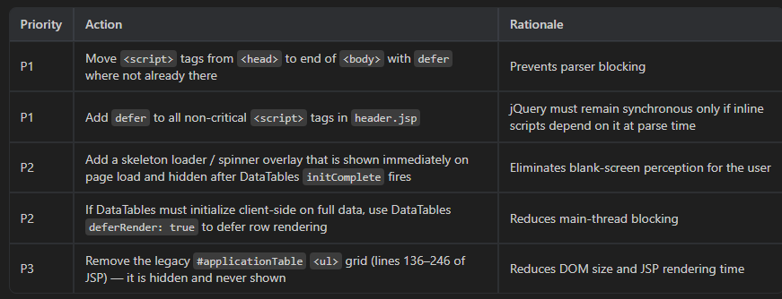

Backend

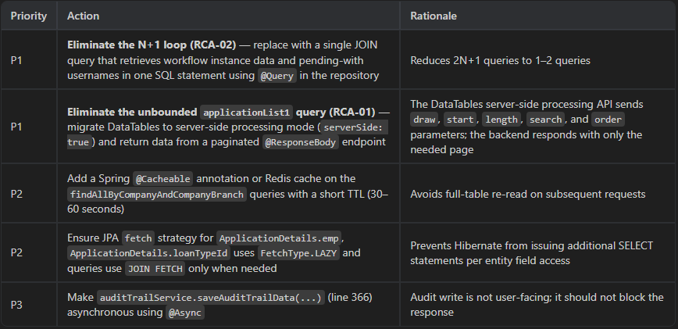

Network

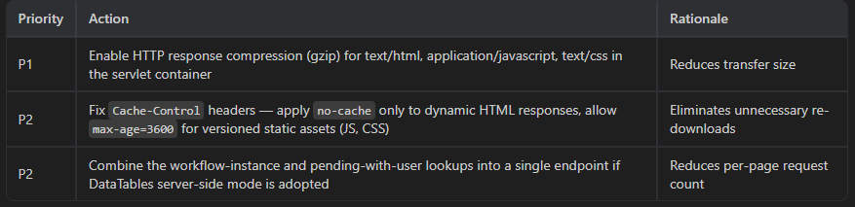

---

5. Self-Learning Section

Why pages become slow due to blocking rendering and sequential API calls

My explanation:

A web page's load time is composed of two distinct phases: the time to receive the first byte of meaningful HTML from the server (Time to First Byte, TTFB), and the time for the browser to parse and render that HTML into a visible page (Time to Interactive, TTI). In a server-side rendered architecture such as Spring MVC + JSP, TTFB is entirely determined by how long the controller method takes to execute. If that method performs database queries sequentially — especially in a loop — every additional millisecond of database processing directly increases the blank-screen duration for the user.

On the frontend, blocking `<script>` and `<link>` resources in `<head>` introduce a second penalty: even after the browser receives the HTML, it cannot render any of it until every synchronous script has been downloaded and executed, because scripts queued before the DOM is built can modify what the DOM ends up being.

The combination of a slow TTFB from the backend and render-blocking scripts on the frontend creates a compounding delay that the user experiences as a 5–6 second white screen.

Is this explanation correct? Yes, and it accurately describes this specific codebase.

---

What I Am Missing — Gaps in Understanding

1. **Hibernate lazy-loading behavior at serialization time**: Even with `FetchType.LAZY`, if JSTL EL expressions in the JSP access nested entity properties (`${applicationlist.emp.firstName}`, `${applicationlist.loanTypeId.loanName}`), Hibernate will issue additional SELECT statements during JSP rendering, not during the controller method. This "lazy loading in view" pattern is invisible to profiling the controller alone.

2. **Connection pool exhaustion**: If the N+1 queries saturate the JDBC connection pool (default HikariCP pool size is 10), subsequent requests queue and appear slow even if the database can respond quickly. This requires monitoring pool metrics, not just query count.

3. **JSP compilation time on cold start**: On first request after deployment, the JSP container compiles the `.jsp` file to a servlet. With a 681-line JSP, this adds latency once per deployment, not on every request.

---

### Real-World Examples of How Modern Applications Solve This

**Example 1 — GitHub Pull Request List Page (DataTables replaced by server-side pagination)**

GitHub renders an initial, static HTML skeleton immediately, then injects list data via a single REST API call using `fetch()`. The table skeleton is visible immediately; a spinner occupies the data area. On scroll, the next page is fetched. GitHub never sends the entire dataset to the client. Their backend returns only the rows for the current page, pre-joined with assignee and status data, eliminating any N+1 loop in the view layer.

**Example 2 — JIRA Issue Navigator (Virtual Scrolling + SSE)**

Atlassian's JIRA issue list renders an initial empty shell, makes a single API call for the first 50 issues (with all related fields pre-aggregated in the backend using PostgreSQL CTEs), and uses virtual scrolling so only visible rows are in the DOM. Workflow status is returned as a denormalized field in the issue payload — no secondary query per issue is made. For real-time updates, Server-Sent Events push badge counts rather than polling.

---

## 6. Pseudocode

### Current Flow (Problematic)

```
Controller.applicationList():
query A: fetch full applicationList (unbounded) → N rows
for each row in applicationList:
query B: fetch workflow logs → 1 DB call per row
query C: fetch workflowInstance → 1 DB call per row
→ total DB calls: 1 + 2N
render full JSP with all N rows embedded
return HTML to browser ← browser receives page only after all of the above

Browser:
parse <head>
→ block: download jquery-min.js (sync)
→ block: download toastr.js (sync)
parse <body> → render page
$(document).ready():
DataTables.init() on N rows in DOM → synchronous, main-thread
notification AJAX call → fires but competes for connections
```

### Optimized Flow (Recommended)

```
// --- BACKEND: New paginated JSON endpoint ---

@GetMapping("/applicationList/data")
@ResponseBody
DataTablesResponse getApplicationListData(DataTablesRequest dtRequest, session):

pageable = PageRequest.of(
dtRequest.start / dtRequest.length,
dtRequest.length,
Sort.by("id").descending()
)

// Single query with JOIN FETCH — eliminates N+1
page = applicationDetailsRepository
.findAllByCompanyWithWorkflowData(companyId, companyBranchId, pageable)
// Repository query uses:
// SELECT a, wi.forwardCount, wel.display_name
// FROM ApplicationDetails a
// LEFT JOIN WorkflowInstanceEntity wi ON wi.id = a.loanAppWorkflowInstanceEntity
// LEFT JOIN WorkflowEventLogEntity wel ON wel.workflowInstanceId = wi.id
// AND a.approverStatus IN ('UNDER_REVIEW', 'Pending')
// WHERE a.company.id = :companyId AND a.companyBranch.id = :companyBranchId

return DataTablesResponse(
draw = dtRequest.draw,
recordsTotal = page.totalElements,
recordsFiltered = page.totalElements,
data = page.content.map { toRowDto(it) } // flat DTO, no lazy fields
)

// --- BACKEND: View controller — returns empty shell immediately ---

@GetMapping("/applicationList")
String applicationList(model, session):
checkPermissions()
model.addAttribute("isAdd", ...)
model.addAttribute("isView", ...)
model.addAttribute("isDelete", ...)
model.addAttribute("adminStatusEdit", ...)
// No DB queries for data — controller returns in < 10ms
return "hrms/loan/applicationDetailsList"

// --- FRONTEND: JSP modifications ---

HEAD section:
<link rel="stylesheet" href=".../dataTables.css">
<!-- All <script> tags removed from <head> -->

BODY:
<!-- Skeleton loader shown immediately -->
<div id="tableSkeleton" class="skeleton-loader">
<div class="skeleton-row" repeat="5"></div>
</div>
<table id="applicationDetailList" style="display:none">
<thead>...</thead>
<tbody></tbody> <!-- Empty — DataTables fills this via AJAX -->
</table>

END OF BODY:
<script defer src=".../jquery-min.js"></script>
<script defer src=".../dataTables.js"></script>
<script defer src=".../moment.min.js"></script>

<script>
document.addEventListener('DOMContentLoaded', function() {

var table = $('#applicationDetailList').DataTable({
serverSide: true, // send draw/start/length to server
processing: true,
deferRender: true, // don't render rows until visible
ajax: {
url: contextPath + '/hrms/loan/applicationList/data',
type: 'GET',
dataSrc: 'data',
error: function() {
showErrorBanner('Failed to load applications. Please refresh.');
}
},
columns: [
{ data: 'srNo', title: 'Sr. No.' },
{ data: 'loanName', title: 'Advance Name' },
{ data: 'employeeName', title: 'Employee Name' },
{ data: 'applicationDate',title: 'Application Date' },
{ data: 'loanAmount', title: 'Advance Amount ₹' },
{ data: 'approverStatus', title: 'Approval Status',
render: function(data) { return renderStatusBadge(data); } },
{ data: 'loanStatus', title: 'Loan Status' },
{ data: 'pendingWith', title: 'Pending With' },
{ data: 'actions', title: 'Action', orderable: false,
render: function(data, type, row) { return renderActions(row); } }
],
initComplete: function() {
$('#tableSkeleton').remove(); // remove skeleton
$('#applicationDetailList').show(); // reveal table
initColumnSearch(this.api());
}
});

});

function initColumnSearch(api) {
api.columns().every(function() {
var col = this;
var input = document.createElement('input');
input.placeholder = col.header().textContent;
input.style.width = '100%';
col.header().replaceChildren(input);
input.addEventListener('keyup', function() {
col.search(this.value).draw();
});
});
}

function renderStatusBadge(status) {
var colorMap = { APPROVED: 'green', REJECTED: 'red', CANCELED: 'red' };
var label = status === 'APPROVED' ? 'Approved'
: status === 'REJECTED' ? 'Rejected'
: status === 'CANCELED' ? 'Canceled'
: 'Under Review';
return '<span style="color:' + (colorMap[status] || 'black') + '">' + label + '</span>';
}

function renderActions(row) {
var html = '<div style="display:flex">';
html += '<a onclick="popupForLog(\'' + row.workflowInstanceId + '\')" class="actionLink Info" title="Logs">...</a>';
if (row.canView) html += '<a href="' + contextPath + '/hrms/loan/viewApplicationDetails/' + row.id + '" class="actionLink Preview" title="Info">...</a>';
if (row.canEdit) html += '<a href="' + contextPath + '/hrms/loan/editApplicationDetails/' + row.id + '" class="actionLink edit" title="Edit">...</a>';
if (row.canDelete) html += '<a onclick="Delete(' + row.workflowInstanceId + ')" class="actionLink reject" title="Cancel">...</a>';
html += '</div>';
return html;
}
</script>
```

---

## 7. Final Summary

| # | Root Cause | Severity | Fix |
|---|---|---|---|
| RCA-01 | Unbounded full-table fetch (`applicationList1`) | Critical | Replace with DataTables server-side processing |
| RCA-02 | N+1 queries inside the loop (2 DB calls per row) | Critical | Single JOIN query with workflow data |
| RCA-03 | SSR blocks render until all DB processing completes | Critical | Return empty shell; fill via AJAX |
| RCA-04 | Blocking `<script>` in `<head>` | Moderate | Add `defer`; move scripts to end of `<body>` |
| RCA-05 | DataTables init on SSR full dataset | Moderate | Use `serverSide: true` + `deferRender: true` |
| RCA-06 | Paginated list query executed but never used by UI | Low | Remove dead `applicationList` model attribute |
| RCA-07 | Notification AJAX on every page load | Low | Acceptable; no change required unless pool-constrained |
| RCA-08 | `Cache-Control: no-cache` on static assets | Low | Scope no-cache to dynamic responses only |

**Expected outcome after P1 fixes (RCA-01, 02, 03):**
- TTFB: reduced from ~4–5 seconds to < 100ms (empty shell)
- DataTables initial load: one network request, returning only 10–20 rows
- Total perceived load time: < 500ms (first data visible in DataTables)
- Scalability: linear growth eliminated; performance is independent of table size

**Constraints honored**: No existing functionality is removed. DataTables server-side mode preserves all existing search, sort, pagination, and export capabilities. Permission checks (`isView`, `isEdit`, `isDelete`) are moved into the JSON DTO returned per row.

