system= is a set of initerrelated components , work together to achieve goal

subsystem=it is a managable part of system

MRP=Material Resource Planning

ERP=Enterprice Resource Planning

SAP=System Application Product

CRM=Customer Relationship Management

SCM=Supply Chain Management

Operation system= Reffered as function base system

* use in manufacturing and transformation system

difference between information and knowledge

* information is processed data whereas knowledge is information that is modeled to be useful
* you need information to be able to get knowledge
* information deals with the way data is related while knowledge examins patterns within a given set of information
* to get knowledge you need some cognitive and analytical ability while for information you do not need cognitive ability

General model of system

* Input -> process -> output

value added function

* secondary function
* transformig product into money that is Value Added Function

Technology

* technology can be defined as different ways of using resources

For management 3 things are there

* planning
* organizing
* controlling
* intersaction of these 3 basically result is management

planning

* course of action to be perform that is planning
* preparing layout or schedule that is planning
* it is like an algorithm
* flowchart is also plan
* it is not only actual system, bt it is hypothetical system also

Organizing

* if we provide some instructions and steps to the algorithm that is organization
* will have some structured view that is organizing

controlling

* it should refer outcome and analyze whether actual outcome is abstract with desired output or not

intersection of planning + controlling outcome is = Model

intersection of organizing + controlling outcome is = Behavior

Model = is nothing but hypothetical form of actual system which is not tested

----------------------------------------------------------------------------------------------------------------

Types of Model

1 verbal model

* it exists virtually
* e.g face to face discussion
* part of conceptual system also
* we don't have any evidence

2 Texual Model or written model

* writing solution on paper i.e. written model

3 architectural model

* getting some tiny house type model

4 graphical model

* some symbol, images, special shape
* creating image

5 Iconic model

* using individual signs for individual operation
* e g : sign like, school ahead, bump ahead

6 Mathematical / arithmatic/ statistical Model

* for solving some problem get some form of expression

----------------------------------------------------------------------------------------------------------------

Operation function in organization(**INTERNAL**)

1 Operation system

* the part of an organization that produces the organization physical goods or services

2 Conversion process

* the process of changing inputs of labour, capital, land and management into outputs of goods and services

3 Value added

* when blending input into product or service, increase value of output compared to the sum of values of inputs
* basically work for conversion process

4 Random Fluctuation

* Unplanned or uncontrollable environmental influences like strikes, flood etc
* that cost planned and actual output to differ

5 Feedback

* information in the control process that allow management to decide whether organizational activity need any adjustment

6. Technology

* the level of scientific sophisticated in plant, equipment and skills in the conversion process

-----------------------------------------------------------------------------------------------------------------------------------------

|  |  |  |
| --- | --- | --- |
| Points | Manufacturing | Service Operation |
|  | Tangible | Intangible |
| Nature of work | Supervising, monitoring | Just operators |
| Degree of customer contect | Very less | High |
| Customer particiation in conversion | Rare case | High |
| Measurement of performance | Better | Not perfect like simulation |

Throughputs= "Items going through the conversion process contrasted with output coming out of the conversion process"

System

* collection of object related by regular interaction and interdependence
* ex: government portfolio, subjectwise diff. department of university

subsystem

* manageble component of system
* eg=subjectwise diff. dept of university

-----------------------------------------------------------------------------------

Operations Management(Imp) (**INTERNAL**)

* management of the conversion process which converts land, labour, capital and management input into desired output of goods and services
* the operation manager 's job is is to manage process of converting input into desired outputs

1 classical management

* 1. 1 scientific mgt(management)
* productivity & efficiency(in %)
* (output/input)*100
* 1.2 process mgt
* focus is on 3 things, planning, organization, controlling

2 Behavioral mgt(management)

* 2.1 Human Relations
* basically include behavior of employees , their communication nature, teamwork
* 2.2 Behavioral science
* we need to learn about communication their requirements , facilities

3 Modeling mgt

* hypothetical form of actual system
* decision making system & arithmatic modeling

------------------------------------------------------------------------------------------------

Framework for managing operation

* planning, organizing, controlling

-------------------------------------------------------------------------------------------

problem faced by operational manager

* funding for expantion
* funding for survival
* IT infrastructure related problems
* problems regarding quality

----------------------------------------------------------------------------------------------

Stratagic roles of operations

1st step

* industry perspective: for same kind of business market analysis is required

2nd step

* organizational strategy:from analysis now we have knowledge about competiotion, so design some structure for services to gain some profit

3rd step

* Operations policy : main focus on design of conversion process
* Delivery capability : giving dealership,retailership,provide SCM
* location of facilities : how it is easy to provide services to customer, provide CRM
* processing technology : basically works for managing technology for customer

4th step

* Managing conversion operations
* 1. quality=level of sophistication to design product
* 2.efficiency=capabilities of people involve in SCM
* 3.scheduling=efficiency & scheduling is work together

5th step

* some form of outcome
* will have assesment of remark
* feedback

------------------------------------------------

General Characteristics

* quality
* cost efficiency
* dependability
* flexibility

----------------------------------------------

operations objectives(**INTERNAL**)

1 product or service characteristics

2 process characteristics

3 product or service quality

4 efficiency

4.1 effective employee relationships & cost control of labour

4.2 cost control of material

4.3 cost control in facility utilization

5 customer service

5.1 producing quantities to meet expected demand

5.2 meeting the required delivery date for goods or services

6 adaptability for future survival

-----------------------------------------------------------------------------------------

strategic planning(**INTERNAL**)

* the process of thinking through the organizations current mission and environment and then setting forth a guide for tomorrow’s decision and result

--------------------------------------

planning for operation

* establishing a program of action for converting resorces into goods or services

-----------------------------------

planning the conversion system

* establishing a program of acquiring the necessary physical facility to be used in the conversion process

--------------------------------------

strategic planning approaches for productions or operations

* 1 commercial approach
* 2 planning mode
* 3 adoptive approach

Strategic planning model

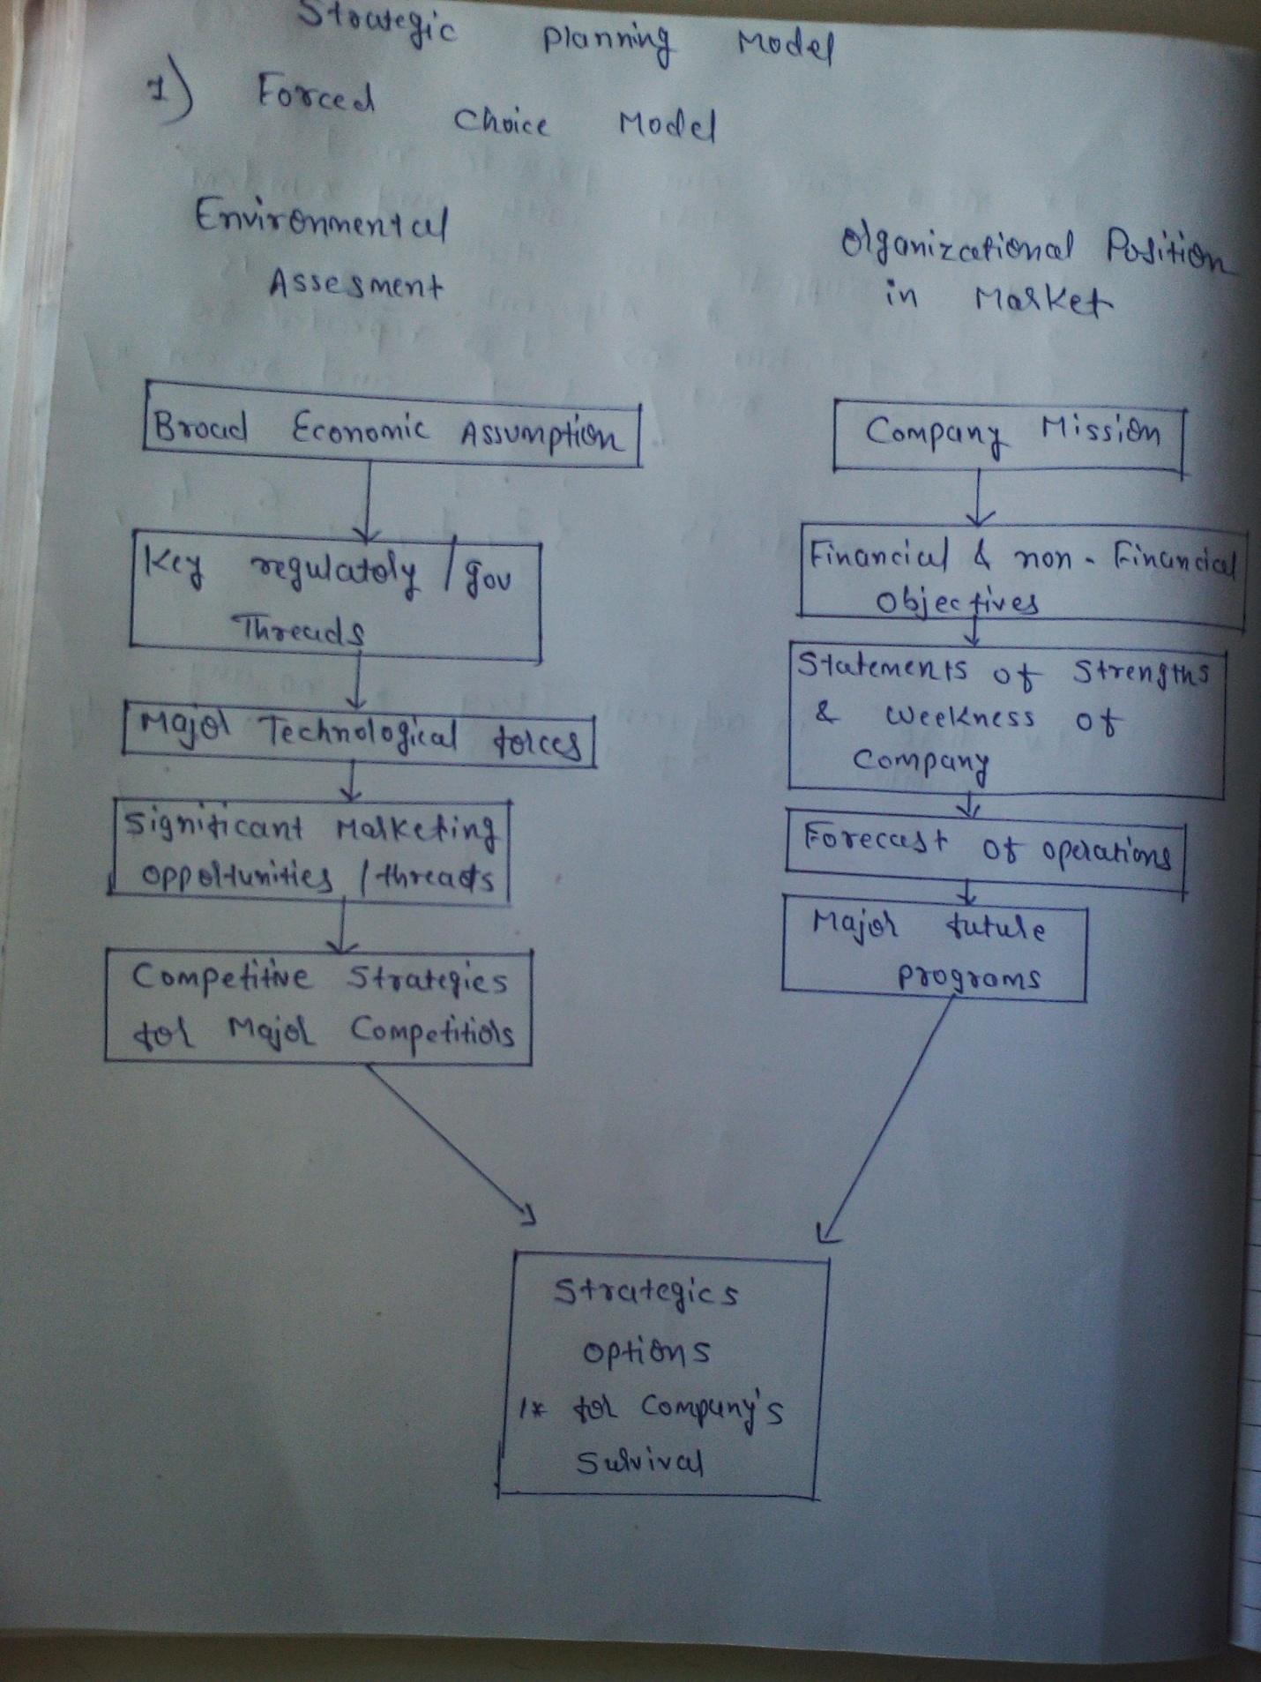

2 operatiions model

* efficiency
* dependability
* quality
* flexibility

----------------------------------------------------------------------------------------------------------

facility mission

1 process

* whatever process are going to perform is it possible to done in single component or multiple component

2 capacity

* of production unit depends on possible demand pattern

3. facilities

* facilities to customer
* related to SCM also

4 vertical integration

* identified interdependencies
* higher level to bottom level

5 infrastructure

* matter of planning

-----------------------------------------------------------

market based criteria for success(imp) (**INTERNAL**)

* efficiency
* effectiveness
* quality
* flexibility

------------------------------------------

application of data warehouse

* lack of long-term vision in industry
* not all files are up to date
* struggle between dept of company
* poor cooperation from electronic data processing dept
* legal and privacy restriction
* files are hard to connect for technical reasons
* timing problems
* interpretation problem

---------------------------------------------------------

diff.between forcast & prediction

|  |  |
| --- | --- |
| Forcast | Prediction |
| Report,record,analysis,related assesment, then have some judgements | Not have any history |
| Purely objective base, planning related to cost, manufacture | Totally subjective base, no any formulas |
| Will have some predetermine object,like we refer algo before writing program | No any predetermine way |
| Plan of next coming period | Not for planning just guess and openion without reference |
| It is any estimate of future event achieve by systematically combining and casting forword using historical data | It is an estimates of future event achieve through individual consideration other than using past data |
| It is based an objective computation | It is based on subjective consideration |
| There is a predetermine way to get conclusional decision | It is not following any predertermine way |
| It is for generating conclusion based on references | It is based on guesses, ideas, thoughts, heuristics etc |

forcasting requirements in production operation management

* industry working for short term, medium term, long term depends on industry
* everything is based on production cycle
* shortterm plan= max. 2 year
* medium term=2 to 4 year
* long term=4 to 5 year

------------------------------------------------

forcasting an operation subsystem(**INTERNAL**)

1 planning the system

* product design
* process design
* capital design
* capacity of manufacturing unit

2 scheduling the system

* scheduling operational processes
* based on demand pattern
* how to apply scheduling & optimizing them

3 controlling the system

* production, inventory,labour,overall cost
* based on inventory we have to manage row material also

--------------------------------------

time series analysis(**INTERNAL**)

* for forcasting purpose
* specifically for demand pattern
* part of statistical
* put time span on x axes on graph, starting from some level
* demand pattern
* constant demand
* trend wise demand
* seasonal demand
* in forcasting problem analysis of demand data plotted on a time scale to reveal patterns of demand

----------------------------------

demand pattern(**INTERNAL**)

* general shape of a time series, usually constant trend, seasonal or some combination of this shapes

demand stability

* tendency of time series to retain same general pattern over time

Noise

* Desperation of demand about demand pattern
* 1) low noise= means all or most of the points lie very close to the pattern
* 2) high noise=means many of the point lie relatively far away from the pattern

--------------------------------------------------

product lifecycle(**IMP**) (**INTERNAL**)

* pattern of demand through the product's life, similar pattern & stages can be identified for the useful life of the product

Characteristics of product lifecycyle(**IMP**)

---------------------------------------------------------------------

reserach & development(**IMP**) (**INTERNAL**)

* "Organizational efforts directed toward product and process innovation, which includes stages of basic research applied research, development and implementation"

components of innovation

1 basic reserach

* reserach for the advancement of scientific knowledge i.e. not intended for specific commercial user

2 applied reserach

* research for the advancement of scientific knowledge that has specific commercial uses

3 development

* technical activities concerned with translating basic, applied research result into product or processes

4 implementaion

* it is activity concerned with designing and building pilot lodels, quipment and facilities and initiating the marketing channels for product or services emerging from reserach nd debelopment

------------------------

Organization of R & D(**IMP**)

1 centralized R & D

2 Decentralized R & D

3 combination of centralized & decentralized R & D(combine)

--------------------------------

**product development process**

1 needs identification

2 advance product planning

3 advance design

4 detailed engineering design

5 production process design

6 product evolution & improvement

7 product use & support

--------------------------------------

Modular design & standardization(**IMP**) (**INTERNAL**)

-------------------------------

process technology(**IMP**)

* using equipment,machinery,knowledge of human being

types of process technology

* 1 project technology
* 2 job shop technology
* 3 batch technology
* 4 assembly line technology
* 5 continuous technology

-------------------------------------------------------

CIM(Computer integrated manufacturing) **IMP**

* we are not integrated directly computer tech. to manufacturing
* manufacturing and computer are separate thing
* CAD for perform arithmatic+geomatric
* CAM(computer aided manufacturing)

--------------------

Robot & robotics

* robot is some form of machinary which contan instructions
* robotics is scientific approach
* work fro domain specific activities

----------------------

CIM components

1 engineering design

2 manufacturing design

3 factory production

4 information mgt

----------------------------------

Layout planning (**INTERNAL**)

Layout= some form of configuration or location that we fix to carry out conversion process

eg: assigning lab to diff batch

1 process oriented layout

2 product oriented layout

3 fixed position layout

4 combination layout