Deep Learning – Case Study

# Title: FOOD CLASSIFICATION USING CNN

# Name: Nimesh A Chaudhari

# Enrollment Number: 19012012001

**Batch:** DL2

**Model:** Sequential

# Introduction

This project is about Food classification. System can download any image of any food and at that time system can predict it. Our system will automatically classify the Image and it will give you the prediction about the name of food.

# Tools & Libraries

In this topic we are going to see about tools and libraries that I am using to develop the project.

|  |  |  |
| --- | --- | --- |
| **No** | **Tools & Library Name** | **Usage** |
| 1 | Keras | We are using for deep learning tasks like creating model, predicting the object etc. |
| 2 | Glob | It is used to return all file paths that match a specific pattern. We can use glob to search for a specific file pattern, or perhaps more usefully, search for files where the filename matches a certain pattern |
| 3 | matplotlib | Matplotlib is a comprehensive library for creating static, animated, and interactive visualizations in Python |
| 4 | Numpy | We are using it for the Image matrix handling. |

# Architecture, Dataset & Workflow

* + **Architecture: -** A Sequential model is appropriate for a plain stack of layers where each layer has exactly one input tensor and one output tensor.. Hence, to let the network an “idea” about what things to color, we add ResNet.

A Sequential model is not appropriate when:

• Your model has multiple inputs or multiple outputs

• Any of your layers has multiple inputs or multiple outputs

• You need to do layer sharing

• You want non-linear topology

* + **Dataset: -** In this project we are using the “recipes” dataset from kaggle.
  + **Workflow: -** It is the fastest and accurate application of computer vision. Image dataset is added from kaggle and corrupted images are deleted. After that dataset is trained and tested and data is visualized. Then the images are structured and augmented for better understanding of machine. A function is built to check the result of trained dataset. After all these process model is trained and predicted output was displayed.

# Output

Some screenshots of our working application.

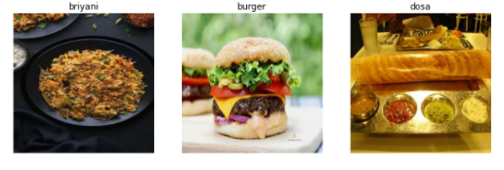

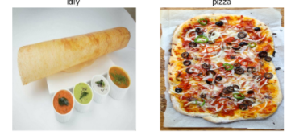

**Conclusion** – We learnt about how we can learn the machine to predict the food dishes in real world application in which normal people can interact.