

SriLanka Institute of Information Technology.

Project Proposal Report

Communicable Disease and Analytical System.

Project ID: PWE2011BIT-05

|  |  |  |
| --- | --- | --- |
| Student ID | Name | Signature |
| BIT09C1/059 | L.K.N.P Gunaskara |  |
| BIT08C2/159 | P. K Weerasekara |  |
| BIT09C1/072 | Y.W Panditha |  |
| BIT09C1/085 | N.L Hewawilladdara |  |
| BIT09C1/100 | B.T.G Mendis |  |

Supervisor: Mr.Yasas Jayaweera

Date of submission: 28/02/2011

# Abstract

*Epidemiology department is one of the main departments established under the Ministry of Healthcare and Nutrition, Who* was studying patterns of health and illness and associated factors with the population level. And *keep track those data. They still keeping those statics according to the diseases are in excel sheets in the web. And also they don’t have a more suitable method to a map those data and view it to the users who are access their web site. The significance of this project is to provide features to access easily to the statics they have and view it to the users by using a graphical information system (GIS). A GIS is an automated system for the input, storage, analysis and output (viewing) of spatial information. The main advantage of using this GIS software is the users can see how diseases are distributed geographically, and also that diseases can be viewed more easily appreciated visually. Provide statistics to help make precise decision to the department employees such as who are willing to do some research and who are doing research using those statistics. Mapping these statics according to the time vice, area vice, and disease vice automatically to the GIS system will the projects major output.*

Table of Contents

1 Abstract 1

2 List of Figures 3

3 List of Tables 3

4 Literature Review 4

4.1 Background 4

4.2 Introduction to Research Project 5

5 Research Problem 6

6 Objectives 7

6.1 Specific Objectives 7

6.2 General Objectives 7

7 Methodology 8

7.1 Planning 8

7.1.1 Business Value 9

7.1.2 Information gathering 9

7.1.3 Feasibility Study 10

7.2 Analyzing 11

7.3 Designing 12

7.4 Implementation 13

7.5 Testing 14

9 Description of personal and Facilities 15

9.1 Staff Plan 15

9.2 Users and Capabilities 16

9.3 Gantt chart 17

10 Budget 18

11 Conclusions 19

12 References 20

# List of Figures

Figure 7.1 Phased Development Methodology 8

Figure 7.2 CDCAS System Diagram 12

Figure9.1 Gantt chart 17

# List of Tables

Table 9.1 Staff Plan 15

Table 9.2 Users and Capabilities 16

# Literature Review

## Background

The HIV/AIDS, tuberculosis and Cholera, H1N1**,** herpes, malaria, mumps, influenza, chicken pox, ringworm, and whooping cough, [2, 4] Pandemics pose substantial challenges globally and to health systems in the Sri Lanka they affect.

When considering current Sri Lankan situation physicians, nurses, epidemiologists, and other public health workers lacking a background in information technology to analyze disease prevalence. When implicating diseases prevalence has yet been difficult to carryout. Often have a need for simple tools that allow the rapid creation of data collection instruments and data analysis, visualization, and reporting using epidemiologic methods.[1]

Epidemiology is the study of patterns of health and illness and associated factors at the population level. It is the method of public health research, and helps inform evidence-based medicine for identifying risk factors for disease and determining optimal treatment approaches to clinical practice and for preventative medicine. [1, 2, 6]

Department of Epidemic Diseases is the institute in Sri Lanka which responsible for gathering data, generating statistic, Educating public and planning controlling methods about communicable diseases. Currently there is no centralized automated system for these tasks. Main solution for this task is to make data available in simplified and graphical forma to be aided in decision making processes.

## Introduction to Research Project

IT solution for epidemic disease prevention and controlling is new to Sri Lanka and most of the world. There are current systems that try to achieve the goal but their use is limited due to complex nature of the problem at hand. So following are some problems we can find in current system.

* Unorganized tools for collecting data
* Manual processes to generate statistical data
* Lack of customizability of process
* Information is not visible
* Statistics are not readily available
* Unused Trend Data

Best way to prevent and control epidemic diseases is self-awareness and ability to foresee patterns in disease outbreaks. So to achieve those two facts Communicable Disease Control and Analytical System (CDCAS) integrates following technological components.

* GIS System – generates maps showing spreading of epidemic diseases maps are dynamically generated according to inputs provided ex: - time, disease [7, 8]
* Online Analytical Processing (OLAP) – To generate statistical data from the huge data trends
* Web Technologies – Deliver Interfaces to work with above mentioned technologies to end user

# Research Problem

When considering current Sri Lankan situation physicians, nurses, epidemiologists, and other public health workers lacking a background in information technology to analyze disease prevalence. When implicating diseases prevalence has yet been difficult to carryout. Often have a need for simple tools that allow the rapid creation of data collection instruments and data analysis, visualization, and reporting using epidemiologic methods.

Epidemiology is the study of patterns of health and illness and associated factors at the population level. It is the method of public health research, and helps inform evidence-based medicine for identifying risk factors for disease and determining optimal treatment approaches to clinical practice and for preventative medicine. [1]

In the study of communicable and non-communicable diseases, epidemiologists are involved in outbreak investigation to study design, data collection, statistical analysis, documentation of results and submission for publication.

National Epidemiological web site is composed only with data sheets and presentations of some communicable disease. For more data approach researchers has to go the National Epidemiological unit for data gathering. Those data has to be customized separately to be used in statistical analysis of disease prevalence. As this process takes more time and cost professionals loose interest in carrying out researches in disease prevalence which is the main aspect of calculating disease burden and also applying preventive methods.

Data is self would not attract the medical professionals for research purposes to analyze the disease impact of the community unless it is given as a visual image. If the data could be processed in a manner while entering, to represent it in geographical destitution within the county, it would provide a great benefit to the user.

Also public health data contains a large amount of information that may not be readily understood by the public. The creation of maps depicting the data in meaningful ways goes far in elucidating this inherent information. Maps are remarkably effective in communicating health information by using a common geography that is easily understood by both health specialists and the public.

A flexibly scalable data collection, advanced statistical analyses and geographic information system (GIS) mapping capability can be used for the rapid assessment of disease outbreaks for the development disease surveillance systems [7, 8]. It could be integrated with public health information systems and in the continuous education of public health professionals learning the science of epidemiology, tools, and techniques.

# Objectives

Objectives of the Communicable Disease and Analytical System (CDCAS) Can be broken down to general and specific areas.

## Specific Objectives

* The system will generate records for future references and research purposes.
* Ensuring security and access control to sensitive data – industrial standard security procedures and access control should be implemented to control the availability of sensitive data to users.
* Using GIS system and data Warehouse maximizes efficiency of decision making and planning.
* User interface should make simple as possible to be understandable by users with basic computer knowledge – system user interfaces should be contain related data and should be organized to increase reachability and readability.

## General Objectives

* Increase system quality thru product testing in applicable development phases – At designing and implementation development phases designed functionalities should be tested with test cases which specifically written to test that functionality. This would identify the bugs in the system.
* Designing system to ensure the robustness and uninterrupted flow of processes of the system – system design should include the fail safe procedures which handles the possible exceptions in the systems flow of processes to minimize the application crashes on the runtime and when an defined exception occurs system should be able to recover from that and continue the flow of procedure.
* Reduce the design complexity of the system by implementing industrial best practices and design patterns where they are applicable – clarity of the design of the system must be ensured throughout the designing process reusable and properly encapsulated units should be used and repeating of same functionality should be maintained to a minimum (should be done if there is no other simple solution) industrial best practices.
* Reduce complexity for user – user should be notified only with the data related to his/her work when using the software. Internal exceptions and errors should be handled internally and when showing them to the user they should be presented in a non-technical manner to be understandable by the general user.
* Provide an accurate system.

# Methodology

Well defined methodology enhances the project quality and accuracy. Methodology describes the flow and structure of the project, it helps the software engineers to keep the focus on the actual requirements and it’s going to be the basic wireframe structure of the project.

## Planning

In planning phase we structure the flow of Software Development Life Cycle (SDLC). This structure is then taken account when identifying risk and calculating feasibility of the project and contains applicable management and technical approaches. This can also be introduced as a bird’s eye view of Software Development Life Cycle (SDLC).

There are several methodologies which can apply for software project with Software Development Life Cycle (SDLC). The Phased Development Methodology is shown in Figure 3.1; this methodology will be used to develop the Communicable Disease Control and Analytical System (CDCAS).

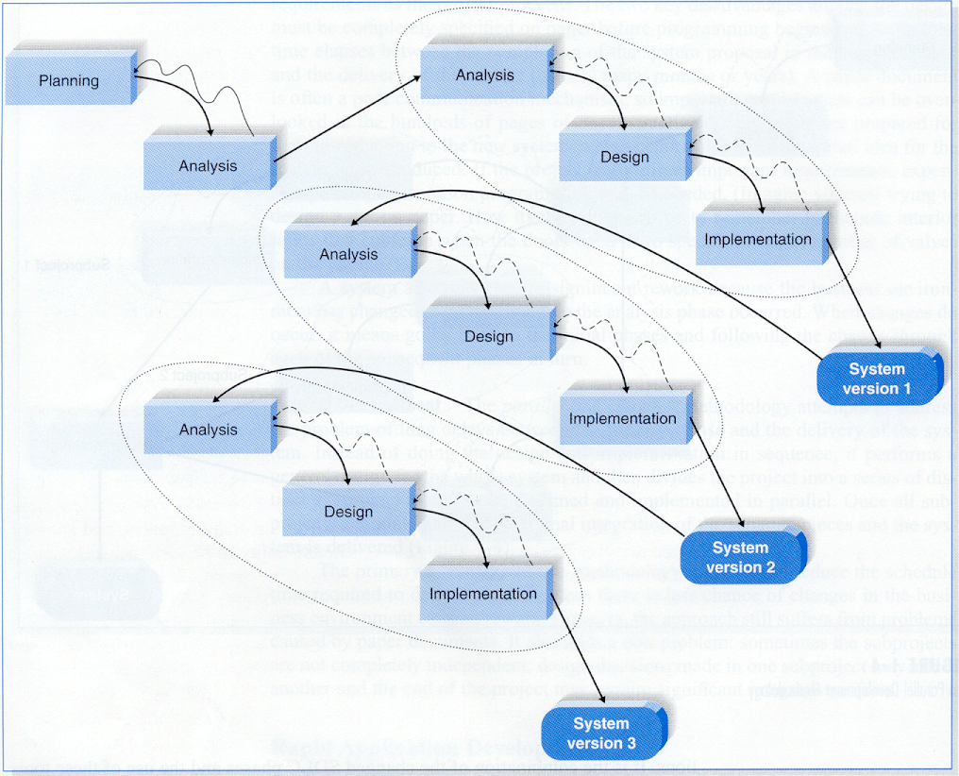

Figure 7. Phased Development Methodology

Advantages of this methodology are listed below.

* Reduced Deliver Time – Since system features are delivered in versions end user gets a usable product to work on.
* Ability to analyze live System – Because of one version in live mode while the other is built Fixes for Defects and improvements identified in live system can be applied to the version in the build.
* More Focus on Requirement – Team has to focus only on the requirements to be included in the current version.

### Business Value

Currently Department of Epidemic Disease maintains a database of raw data collected all over from Sri Lanka they use that data to generate statistics manually. And troubles that can be found in this system are.

* Lacking customizability due to manual process of generating statistics
* Degraded efficiency because of the overheads added by manual system
* Reduced Usability due to the nature of process
* Less Accuracy since humans involved in process
* Time Consuming because data volume affects the time to generate statistics

After these problems are clearly defined and clarified by the team those problems would be addressed by following solutions.

* Web application for users with controls to customize statistics
* Graphical representation of data using Charts and Graphs
* Data warehouse for support enormous data volume
* Data mining to speed up extract large data volumes.
* GIS system to plot informative maps
* Online Analytical Processing (OLAP) to generate to execute complex statistical models

### Information gathering

To gather the relevant information techniques like informal interviews and questionnaires will be used. The team will gather specific information regarding the items listed below.

* GIS Systems
* Data warehousing
* Epidemic Model
* Online Analytical Processing
* Data Mining

### Feasibility Study

**Technical feasibility –** Familiarity with the technologies

Technologies listed below will be used in order to develop the system.

**ASP.NET** – Moderate Knowledge

**SSIS** – Unfamiliar

**OLAP** – Unfamiliar

**Languages**

C# - Sound Knowledge

SQL – Sound knowledge

MDX – Unfamiliar

Project size – average

Team needs to learn unfamiliar technologies so time is allocated for KT meetings to learn and get familiarize with them.

**Economic Feasibility**

* MS SQL Server 2008 R2 Enterprise Edition
* Visual Studio 2010
* GIS System
* PC with More than 8GB and multicore processor

## Analyzing

Analysis phase describes the requirement of the systems and how they are correlated. This phase defines the problems end user faces.

**Current System (AS-IS System)**

Manual system with human assisted manual processes

**Problems**

* Lacking customizability due to manual process of generating statistics
* Degraded efficiency because of the overheads added by manual system
* Reduced Usability due to the nature of process
* Less Accuracy since humans involved in process
* Time Consuming because data volume affects the time to generate statistics

**New System (TO-BE System)**

New system is an automated system with technologies that provide customizable statistical data fast and efficiently in graphical manner.

* Web application for users with controls to customize statistics
* Graphical representation of data using Charts and Graphs
* Data warehouse for support enormous data volume
* Data mining to speed up extract large data volumes.
* GIS system to plot informative maps
* Online Analytical Processing (OLAP) to generate to execute complex statistical models

## Designing

The design describes about the functionality of the system. It describes functionality in means of hardware, software and network infrastructures.

* Since project addressing a real world problem object oriented approach is used. Because of that core language would be an object oriented language.

**Hardware**

* PC with More than 8GB and multicore processor

**Software**

* MS SQL Server 2008 R2 Enterprise Edition
* Visual Studio 2010
* GIS System

**System Diagram**

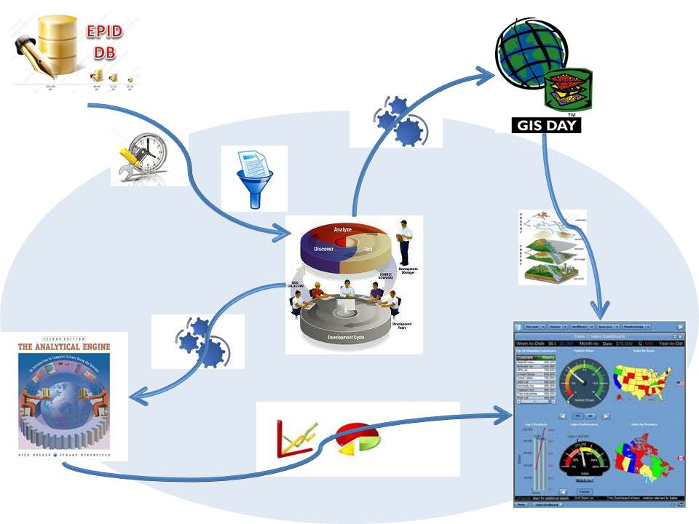

Generated Maps

SMS Alerts

OLAP

Charts/Graphs

GIS

Data Warehouse

Extracting Data

External DB

Web Interface

Figure 7.2 CDCAS System Diagram

Version 1.0 – Web Interface with map including following features

* User can set time period and disease and see affected areas over the map.

Version 2.0 – Web interface updated with following features

* User can select dimensions, time period, location and other necessary information and they can render charts and graphs.

Version 3.0 - Web interface updated with following features

* System can predict spreading of the disease selected
* SMS alerts are sent to people live in threatened areas

## Implementation

In implementation phase team develops the identified functions using selected technologies and languages to form a software solution and then the product is pushed for testing.

As per the discussions held and to fulfill the requirement project team has decided to use Rapid Application development (RAD).

RAD is a newer approach to system development that emerged in the 1990s. RAD attempts to address both weaknesses of the structured development methodology. RAD methodology adjusts the SDLC phases to get some part of the system developed quickly and into the hands of the users. In this way, the user can better understand the system and suggest revisions that bring the system closer to what is needed.

The reasons for selecting RAD methodology are stated below

* Many tools for designing and implementing
* This will allow separating the main components of the system in to two versions.
* Version one – System with GIS Integration
* Version two – System with Statistic
* Version three – SMS Gateway and predictions using epidemic model

## Testing

Out of the main testing methods in order to test the propose system unit testing, performance testing, System testing and integration testing will be used.

Unit tests focus on one unit-a program or a program module that performs a specific function that can be tested- and ensure that the module or program performs its functions as defined in the program specifications. There are two approaches in unit testing: black box and white box testing.

The reason that the project is using this testing method is because:

* Propose system will be designed integrating different sub system so integration testing is needed to test whether the sub systems are integrated well enough.
* Unit testing is useful because it eliminates defects at development phase.
* After the integration testing whole system is tested for it consistent it is called System Testing
* Since this is a web product performance testing will be useful determining the limits of system.

# 

# Description of personal and Facilities

## Staff Plan

Table 9.1 Staff Plan

|  |  |  |
| --- | --- | --- |
| Student ID | Name | Responsibilities /Task/Activities |
| BIT/09/C1/059 | L.K.N.P Gunaskara.  (Project Manager/ Tech Lead/Have excellent practical knowledge in SQL and web technologies. One year of Industrial experience.) | * Managing and leading the project team. * Recruiting project Team. * Developing and maintaining a detailed project plan. * Managing project deliverables in line with the project plan. * Allocating and utilizing resources * Code the System. * Implement Database. |
| BIT/08/C2/159 | P. K Weerasekara.  (System Analyst/ DB Designer) | * Database Design. * GSI System Design. * Code the System * Testing. |
| BIT09C1/072 | Y.W Panditha.  (Backend Developer/UI Specialist/QA Lead | * Interface Design * Implement Database * Code the System * Testing |
| BIT09C1/085 | N.L Hewawilladdara.  (QA Engineer/Frontend Developer) | * Implement Database * Code the System * Testing |
| BIT/09/C1/100 | B.T.G Mendis.  (QA Engineer/Frontend Developer/Coordinator) | * Interface Design * Implement Database * Code the System * Testing |

## Users and Capabilities

Table 9.2 Users and Capabilities

|  |  |  |
| --- | --- | --- |
| Users | Categories | Capabilities |
| Viewers | Direct user | * View System Interfaces * Query System for statistics |

## Gantt chart



Figure9.1 Gantt chart

# Budget

**Hardware Requirements**

* PC with More than 8GB and multicore processor RS 0.00

**Software Requirements**

* MS SQL Server 2008 R2 Enterprise Edition RS 951,950.62
* Visual Studio 2010 RS 60,826.45
* GIS System RS 0.00

**Total Cost** Rs 1,012,777.07

# Conclusions

The primary goal of this project proposal is to identify action initiatives that make up the Communicable Disease and Analytical System for the Epidemiology department in Sri Lanka which they still don’t have. Our analytical system order to foster a responsive climate where providing all about the communicable diseases statics and the provide information to guide interventions for the users who use the system for their educational purposes or research purposes. To that end, Communicable Disease and Analytical System have more functions to do this major task.

It has been discusses how the system are becoming leading to serious health problems. One of the main reasons given for these problems is the customizable statistical of pations affected from the communicable diseases and the critical geographical areas of the country which are in the border lines.

To develop this system we are planning to do integrating disease surveillance activities. To avoid duplication and facilitate sharing of information across all disease control programs so that valid data are available for appropriate health decision.

From the planning we use Phased Development Methodology to plan the system. Analysis phase defines the hardware, software and network infrastructure. In the implementation phase, the system problems end user faces. The design phase detailed defines on how the system will operate, in terms of modifications are installed and made operational in a production environment. For the testing propose of the system we are planning to use unit testing and integration testing criteria.

In the document we clearly defined and clarified by the team those problems and the most eligible solutions that we found in order to give a successful project output.

# References

1. “Health Programme:: Epidemic Control :: ISDP :: Objectives”, objectives of epidemic disease, 24 Feb 2011 [Online],Available:<http://www.gujhealth.gov.in/health_programmes/epidemic/idsp_obj.htm>, [Accessed:26 **Feb** 2011].
2. “Epidemic – Wikipedia, the free encyclopedia”, What is a Epidemic disease, 23 Jan 2011[online], Available:<http://en.wikipedia.org/wiki/Epidemic> , [Accessed: 26 **Feb** 2011].
3. “What is a Communicable Disease?”, communicable diseases, 11 February 2011 [online], Available:<http://www.wisegeek.com/what-is-a-communicable-disease.htm>, [Accessed: 26 **Feb** 2011].
4. “Communicable Diseases” , communicable diseases,22 February 2011[online], Available:<http://www.whosrilanka.org/EN/Section31_81.htm>, [Accessed: 26 **Feb** 2011].
5. “Welcome to Ministry of Health-Sri Lanka” , Ministry of Health in Sri Lanka, Available:<http://www.epid.gov.lk/>, [Accessed: 27 **Feb** 2011].
6. “Answer.com-What is the best way to prevent a communicable disease”, What is the best way to prevent a communicable disease[online] Available:<http://wiki.answers.com/Q/What_is_the_best_way_to_prevent_a_communicable_disease_from_spreading>,[Accessed: 27 Feb 2011].
7. “Communicable Diseases “, communicable disease [online], Available:<http://hes.ucfsd.org/gclaypo/commdise/commdise.html> ,[Accessed: 27 Feb 2011].
8. “Geographic Information System (GIS) Poster”,gis applications technology, Thu 22 Feb 2007, Available:<http://egsc.usgs.gov/isb/pubs/gis_poster/> ,[Accessed: 27 Feb 2011].
9. “GIS Application The Institute for Mapping Technology”, gis applications technology[online] Available:<http://learninggis.com/learn-about-gis/common-uses-of-gis>,[Accessed: 27 Feb 2011]
10. “HOW TO WRITE A LITERTURE REVIWE”, literature review, [online], Available:<http://www.sportsci.org/jour/9901/wghreview.html>,[Accessed: 27 Feb 2011]