

Sri Lanka Institute of information Technology

Software Requirement Specification

COMMUNICABLE DISEASE CONTROL AND ANALYTICAL SYSTEM

Bachelor of Science in Information Technology

Date of submission: 18/04/2011

**Communicable Disease and Analytical System**

Project ID: PWE2011BIT-05

We hold a copy of this assignment that I can produce if the original is lost or damaged.

We hereby certify that no part of this document has been copied from any other student’s work or from any other source except where due acknowledgement is made in the assignment. No part of this document has been written for us by another person except where such collaboration has been authorized by the subject lecturer concerned.

Project Team:

|  |  |  |
| --- | --- | --- |
| Student ID | Name | Signature |
| BIT09C1/059 | L.K.N.P Gunaskara |  |
| BIT08C2/159 | P. K Weerasekara |  |
| BIT09C1/072 | Y.W Panditha |  |
| BIT09C1/085 | N.L Hewawilladdara |  |
| BIT09C1/100 | B.T.G Mendis |  |

Signature of the supervisor:………………………………………..

( Mr.Yasas Jayaweera)

Table of Contents

1. Introduction 1

1.1 Purpose 1

1.2 Scope 1

1.3 Definitions, Acronyms, and Abbreviations 2

1.4 Overview 2

2. Overall Description 3

2.1 Product Perspective 3

2.1.1 System interfaces 3

2.1.2 User interfaces 4

2.1.3 Hardware interfaces 5

2.1.4 Software interfaces 5

2.1.5 Communication interfaces 5

2.1.6 Memory constraints 6

2.1.7 Operations 6

2.1.8 Site adaptation requirements 6

2.2 Product functions 10

2.2.1 Use Case Diagram 10

2.3 User characteristics 13

2.4 Constraints 13

2.5 Assumptions and dependencies 13

2.6 Apportioning of requirements 13

3. Specific requirements 14

3.1 External Interface Requirements 14

3.1.1 User Interfaces 14

3.1.2 Activity Diagram 15

3.1.3 Hardware Interfaces 15

3.1.4 Software Interfaces 15

3.1.5 Communication Interfaces 15

3.2 Classes and Object Diagrams 16

3.2.1 Main Class Diagram 16

3.2.2 GIS Service Layer 17

3.3 Performance requirements 17

3.4 Designing Constraints 17

3.5 Software System Attributes 18

3.5.1 Reliability requirements 18

3.5.2 Availability requirements 18

3.5.3 Security requirements 18

3.5.4 Maintainability requirements 18

3.5.5 Other requirements 19

4. References 20

**List of figures**

Figure 2‑1 Sample Login Page 4

Figure 2‑2 Sample Register Page 5

Figure 2‑7 Use Case 7

Figure 2‑3 Create Account 12

Figure 2‑4 View Maps 13

Figure 2‑5 View Statistics 14

Figure 2‑6 Send SMS 15

Figure 3‑1 Main Class Diagram 17

Figure 3‑2 GIS Service 18

# Introduction

## Purpose

The purpose of this document is to provide a detailed description of the functionality and technology of the Communicable Disease and Analytical System. Therefore this document is to establish the major requirements necessary to develop the system. It will explain the purpose and features of the system, the interfaces of the system, what the system will do, constraint under which the system must be operate. This document will also cover the research aspect that lies behind the building of the Communicable Disease and Analytical System Application.

Therefore this document is intended for both the users and the developers of the system.

## Scope

This document covers the requirements of the Communicable Disease and Analytical System

Describing applications, all the functionalities, hardware, software and research limitations that the system must adhere to.

The Communicable Disease Control and Analytical System (CDCAS) will integrate following technological components.

* GIS System will generates maps showing spreading of epidemic diseases maps are dynamically generated according to inputs provided. ex: - time, disease.
* Online Analytical Processing (OLAP) will generate statistical data from the huge data trends to the users who use this system. This data will deliver as a web interface. So this provided information’s can be used for guide interventions for the users who use the system for their educational purposes or research purposes.

## Definitions, Acronyms, and Abbreviations

**Abbreviations**

|  |  |
| --- | --- |
| API | Application programed Interface |
| CDCAS | Communicable Disease Control and Analytical System |
| OLAP | Online Analytical Processing |
| DB | Database |
| DBMS | Data Base Management System |
| GUI | Graphical User Interface |
| SQL | Structured Query Language |
| OS | Operating System |
| GIS | Graphical Information System |
| PC | Personal Computer |
| HSDPA | High Speed Downlink Packet Access |
| EULA | End User License Agreement |

## Overview

The goal of our project team is to create a web based application for handle epidemic diseases in Sri Lanka. The system will generate web application for users with controls to customize statistics, Graphical representation of data using Charts and Graphs, Online Analytical Processing (OLAP) to generate to execute complex statistical models.

Our system is a kind of a helper for users such as students, doctors, researchers, the government and etc. And also they can use this system for decision making ,get the understanding about how the epidemic diseases are spreading and the time period of the diseases and how the diseases are affected to the country. Therefore in further pages of this document will describe how the project team is planning to develop the Communicable Disease Control and Analytical System Application.

# Overall Description

## Product Perspective

* This System will provide features which will addresses the primary goal of this project is to identify action initiatives that make up the Communicable Disease and Analytical System for the Epidemiology department in Sri Lanka which they still don’t have.
* Epidemiology is the study of patterns of health and illness and associated factors at the population level. It is the method of public health research, and helps inform evidence-based medicine for identifying risk factors for disease and determining optimal treatment approaches to clinical practice and for preventative medicine.
* National Epidemiological web site is composed only with data sheets and presentations of some communicable disease. For more data approach researchers has to go the National Epidemiological unit for data gathering. Those data has to be customized separately to be used in statistical analysis of disease prevalence.
* As this process takes more time and cost professionals loose interest in carrying out researches in disease prevalence which is the main aspect of calculating disease burden and also applying preventive methods. Our analytical system order to foster a responsive climate where providing all about the communicable diseases statics and the provide information to guide interventions for the users who use the system for their educational purposes or research purposes. To that end, Communicable Disease and Analytical System have more functions to do this major task.

### System interfaces

The System requires a Windows XP operating system. Windows XP operating system provides an API to execute user application.

### User interfaces

The system will be developed with a Graphical User Interface to user for interact with the application. The Graphical User Interface provides text boxes, Buttons, and other widgets for user interaction.

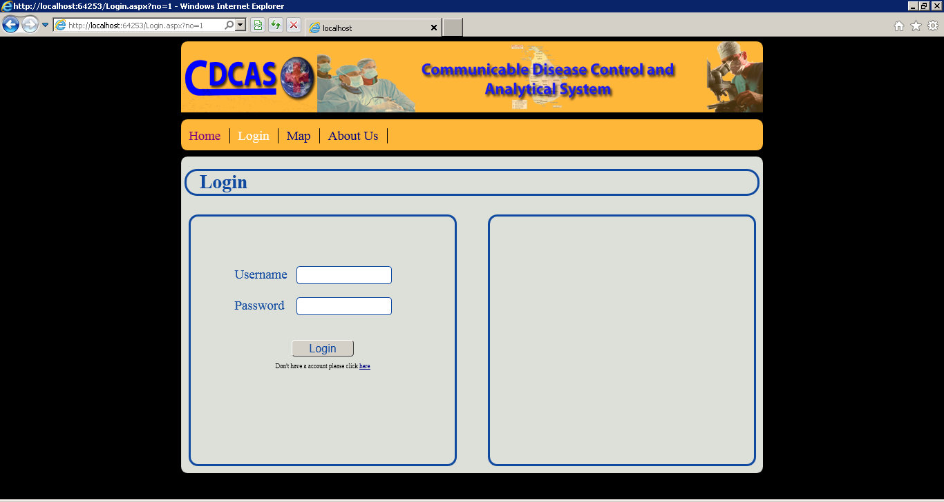

Figure ‑ Sample Login Page

Login Page – This interface for the registered user to log in to the system by using their user name and the password

Login page contains additional box to the right to include product EULA. To position items CSS3 and div tags are use so any modern browser can view the pages but IE 9 is the recommended browser.

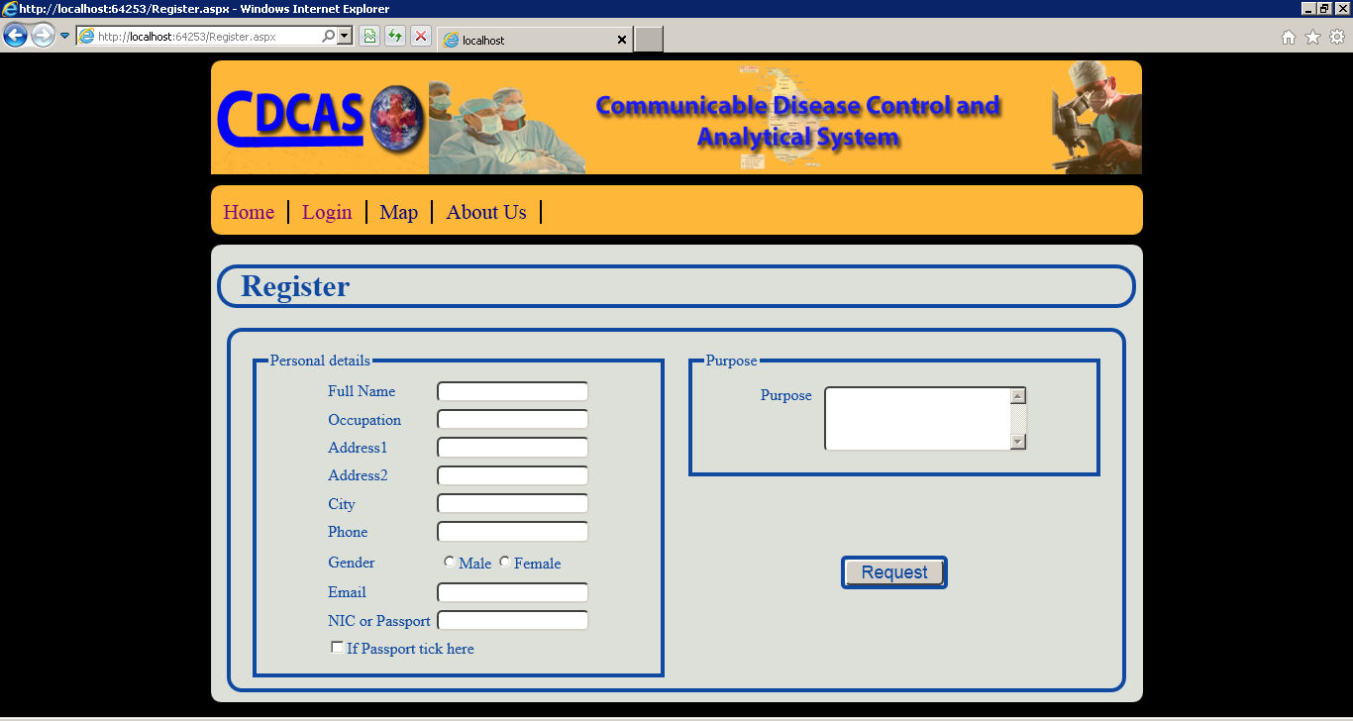

Figure ‑ Sample Register Page

Register – This interface for a new user to register in order to use the web site.

Grouping boxes are used to provide more descriptive layout and color scheme is designed not to distract the user. Spacing is done to provide more comforting simplified interfaces.

### Hardware interfaces

* System requires more than 4 GB memory
* Multi core processor
* Server grade Network Interface Card

### Software interfaces

**Database:** Microsoft SQL Server 2008.

**Application:** ASP .net (Active Server Pages), JDK 1.6

**Web Server:** IIS (Internet Information Services (IIS) is a powerful

Web server that provides a highly reliable, manageable, and scalable

Web application infrastructure), Apache Tomcat

### Communication interfaces

The Customer must connect to the Internet to access the Website:

* Dialup Modem of 52 kbps
* Broadband Internet
* Dialup or Broadband Connection with an Internet Provider.

### Memory constraints

The Communicable Disease and Analytical System, application is expected to use more than 4MB of RAM and 12MB of storage space.

### Operations

The system requires special data feeding. User should arrange daily data according to a given excel sheet and should use functions given in that excel sheet to upload data.

Integration with GIS database is unattended process this runs every night at 11.00 pm. Purpose is to synchronize data in main database with GIS database.

SMS generation is unattended process this runs every night at 11.00 pm. Purpose is to generate and send SMS to clients in endangered areas.

### Site adaptation requirements

The user should have the basic knowledge of using internet and an e-mail address is a must in order to register in the web

## Product functions

### Use Case Diagram

**Communicable Disease and Analytical System**



Figure ‑ Use Case

**Scenario 01- *Request Account***

**Actors -** User

**Pre – Condition**

* User has a valid email-address and need to find data about communicable decease

**Flow of events**

* The use case starts when the system displays the register page for user details.
* The user can now enter details with email address via keypad.
* The usesubmits the details by pressing submit button.
* The system sends these details to admin for evaluate.

**Post – Condition**

* Admin receive details of requested user.

**Scenario 02 – *Create Account***

**Actors -** Admin

**Pre – Condition**

* Admin receive valid details from Request Account

**Flow of events**

* The use case starts when Admin press the allow button.
* The system create an account with
  + User name
  + Password
* The system sends account details to data base.
* The system generate e-mail with user account details
* The system send this e-mail to user

**Post ­– Condition**

* The user receive the e-mail with valid account details

**Scenario 03– *View Map***

**Actors -** User

**Pre – Condition**

* Valid user with need of observe the map

**Flow of events**

* The use case starts when use login.
* When display the map request interface user can request
  + Area
  + Type of Decease
  + Period, etc.
* The system gets relevant date from data base
* The system generate the map
* The system display the map

**Post ­– Condition**

* The user seen the map according to his request

**Scenario 04– *View Statistic***

**Actors -** User

**Pre – Condition**

* Valid user with need of the deceases statistic

**Flow of events**

* The use case starts when use login.
* When display the statistic request interface user can request
  + Area
  + Type of Decease
  + Period, etc.
  + as map request
* The system gets relevant date from data base
* The system generate the statistics and graphs
* The system display the statistics and graphs

**Post ­– Condition**

* The user receive the statistics according to his request

**Scenario 05 – *Send SMS***

**Actors –** SMS Gateway

**Pre – Condition**

* Analyze data and Identify Critical

**Flow of events**

* The use case starts when receive the data about critical areas
* The system generate SMS with relevant information
* The system send this SMS to SMS service provider

**Post ­– Condition**

* The SMS service provider receive the SMS with decease information

## User characteristics

The Communicable Disease and Analytical System can be easily handled by users who have a basic knowledge of system. A basic knowledge of Windows XP operating system will be an advantage for the user to install the application. Basic about personal computers and internet accessibility will help the user to update the application**.**

## Constraints

This product is developed using Microsoft technologies so the product is platform dependent.

## Assumptions and dependencies

* We are going to useASP.NET to develop our system & use IIS asWeb application server.
* Therefore the system features will depend above those two things. Although thisis not a part of a large project this can has dependencies with any other systems. Example: Future versions of Communicable Disease and Analytical System shall operate on PCs running Windows 7.

## Apportioning of requirements

The basic requirements of the application going to fulfilled during first implementation of the project. Then in the next release of the application will fulfill the other requirements of the application

# Specific requirements

## External Interface Requirements

### User Interfaces

**Basic Layout:** Every user Interface should include the following format. But this format can be violated in reasonable occasions.

**Header:**

Position: Top of the page

* Description: Should Include the application title and relevant styles and background images should be static.

**Main Navigation Panel**:

Position: Top of the Page right after the Header

* Description: Includes the main categories of the site map. At login this should be invisible items in navigation panel are static.

**Sub Navigation Panel:**

Position: Left hand side of the page

* Description: Web application for users with controls to customize statistics
* Graphical representation of data using Charts and Graphs

**Application Body:**

Position: Right side of page begins after Sub Navigation Panel

* Description: Used to present data and take input from user content of this part can change rapidly. User can set time period and disease and see affected areas over the map GIS system to plot informative maps according to theset time period and disease.

**Footer:**

Position: Bottom of the page

* Description: Provide useful links and display copyright statements.

### Activity Diagram

**Create Account**



Figure ‑ Create Account



**View Maps**

Figure ‑ View Maps



**View Statistic**

Figure ‑ View Statistics



**Send SMS**

Figure ‑ Send SMS

### Hardware Interfaces

To run the software’s mentioned following no special hardware component is needed. Normal pc with following specification would be able to run the system.

Processor: *3.8*GHz

RAM: *4 GB*

HDD: *500*GB

Network Card

### Software Interfaces

Windows XP will be the operating system. GIS system and data Warehouse maximizes efficiency of decision making and planning.

Data cube, Data mining.

### Communication Interfaces

Communication protocol mainly used is HTTP. For secured connection HTTPS will be used.

## Classes and Object Diagrams

### Main Class Diagram



Figure ‑ Main Class Diagram

This class diagram represents the main web application. Class diagram is designed to be much simpler as possible to support extensions.

Most of the business logics and statistical models developed in the database using Stored Procedures and OLAP functionalities so in the “DataAccessor” class only one method is exposed that is to execute SPs.

Chart Control and Map Control are both reusable components XML configurations are used for reduce coupling and cohesion. Configuration Manager handles these XML configurations

For data accessing and logging Microsoft Enterprise Library is used to provide fine-tuned service layer.

### GIS Service Layer



Figure ‑ GIS Service

This layer is provided as JAVA web service. “geotools” library is used to provide GIS map generations.

## Performance requirements

* Must not use all the processing power of the computer and should give processing time for other applications.
* Should not take long time to load the system.
* The system is required to support to retrieve information with sufficient speed.
* Used memory must be released after when they are not being used.

## Designing Constraints

* User interface should make simple as possible to be understandable by users with basic computer knowledge – system user interfaces should be contain related data and should be organized to increase reachability and readability.
* White space should be used wisely to increase the readability.
* User interface final size should not exceed 657KB.
* Since project addressing a real world problem object oriented approach is used. Because of that core language would be an object oriented language.
* The proposed web system should be cross browser compatible. Cross-browser refers to the ability for a website, web application, HTML construct or client-side script to support all the web browsers Cross-browser is a support that allows a website or web application to properly rendered by all browsers.

## Software System Attributes

### Reliability requirements

* System design should include the fail safe procedures which handles the possible exceptions in the systems flow of processes to minimize the application crashes on the runtime and when an defined exception occurs system should be able to recover from that and continue the flow of procedure.
* Input data entered by a user must not be mixed with the data of other users.

### Availability requirements

* System contains many unattended scheduled processes so for smooth operation database should be 24/7 online.
* Web application should be online all the time and can only be stopped for critical maintenance only scheduled maintenance should display prior notice to users. This notice should display in home page.

### Security requirements

* The stored data cannot be able to access by other application such as viruses.
* Ensuring security and access control to sensitive data – industrial standard security procedures and access control should be implemented to control the availability of sensitive data to users.

### Maintainability requirements

* Server administrator should be able to maintain the application server and database. A client application will be provided with the system to do that.

### Other requirements

#### Quality requirements

* The GUI must not be very complex used in the system.
* User should be notified only with the data related to his/her work when using the software. Internal exceptions and errors should be handled internally and when showing them to the user they should be presented in a non-technical manner to be understandable by the general user.
* The system should not make the users angry, depressed and terrified when using it.

#### Safety Requirements

* There should be a scheduled task to take backup of database periodically
* Logger should be included to log all events occurred in run time.

# References

1. “Health Programme:: Epidemic Control :: ISDP :: Objectives”, objectives of epidemic disease, 24 Feb 2011 [Online],Available:<http://www.gujhealth.gov.in/health_programmes/epidemic/idsp_obj.htm>,[Accessed:26 **Feb** 2011].
2. “Epidemic – Wikipedia, the free encyclopedia”, What is a Epidemic disease, 23 Jan 2011[online],Available:<http://en.wikipedia.org/wiki/Epidemic> , [Accessed: 26 **Feb** 2011].
3. “What is a Communicable Disease?”,communicable diseases, 11 February 2011 [online],Available:<http://www.wisegeek.com/what-is-a-communicable-disease.htm>,[Accessed: 26 **Feb** 2011].
4. “Communicable Diseases” , communicable diseases,22 February 2011[online],Available:<http://www.whosrilanka.org/EN/Section31_81.htm>, [Accessed: 26 **Feb** 2011].
5. “Welcome to Ministry of Health-Sri Lanka” , Ministry of Health in Sri Lanka,Available:<http://www.epid.gov.lk/>, [Accessed: 27 **Feb** 2011].
6. “Answer.com-What is the best way to prevent a communicable disease”, What is the best way to prevent a communicable disease[online]Available:<http://wiki.answers.com/Q/What_is_the_best_way_to_prevent_a_communicable_disease_from_spreading>,[Accessed: 27 Feb 2011].
7. “Communicable Diseases “, communicable disease [online],Available:<http://hes.ucfsd.org/gclaypo/commdise/commdise.html> ,[Accessed: 27 Feb 2011].
8. “Geographic Information System (GIS) Poster”,gis applications technology, Thu 22 Feb 2007, Available:<http://egsc.usgs.gov/isb/pubs/gis_poster/>,[Accessed: 27 Feb 2011].
9. “GIS Application The Institute for Mapping Technology”, gis applications technology[online]Available:<http://learninggis.com/learn-about-gis/common-uses-of-gis>,[Accessed: 27 Feb 2011]
10. “HOW TO WRITE A LITERTURE REVIWE”, literature review,[online],Available:<http://www.sportsci.org/jour/9901/wghreview.html>,[Accessed: 27 Feb 2011]

**Supporting information**

**Appendices**