Lab Sheet 4

Create a servlet that receives user input from an HTML form and displays it back to the user.

Steps:

1. Create an HTML form to collect the user's name.

2. Create a Servlet (GetUserInputServlet) to handle the form submission and display the

user's name.

**HTML Form (index.html):**

<html>

<head>

<title>TODO supply a title</title>

<meta charset="UTF-8">

<meta name="viewport" content="width=device-width, initial-scale=1.0">

</head>

<body bgcolor ="#ffbf00">

<div><h1><center>User input</center></h1></div>

<form action="getUserInput12" method="POST">

<table style = "width:70%">

<tr> <th> <h3> Name </h3></th><th><input type="text" name="un"</tr>

<tr> <td colspan="2" align="center"><input type ="submit" value="save"</td></tr>

</form>

</table>

<tr>

<hr>

<h1>Calculate</h1>

<form action="CalculateSumServlet"method="post">

First Number:<input type="number" name="num1" required><br>

Second Number: <input type="number" name="num2" required><br>

<input type="submit" value="Calculate Sum">

</form>

</tr>

</form>

</body>

</html>

**(getUserInput12.java)**

import java.io.IOException;

import java.io.PrintWriter;

import javax.servlet.ServletException;

import javax.servlet.annotation.WebServlet;

import javax.servlet.http.HttpServlet;

import javax.servlet.http.HttpServletRequest;

import javax.servlet.http.HttpServletResponse;

/**

*

* @author student

*/

@WebServlet(urlPatterns = {"/getUserInput12"})

public class getUserInput12 extends HttpServlet {

/**

* Processes requests for both HTTP <code>GET</code> and <code>POST</code>

* methods.

*

* @param request servlet request

* @param response servlet response

* @throws ServletException if a servlet-specific error occurs

* @throws IOException if an I/O error occurs

*/

protected void processRequest(HttpServletRequest request, HttpServletResponse response)

throws ServletException, IOException {

String name = request.getParameter("un");

response.setContentType("text/html;charset=UTF-8");

try (PrintWriter out = response.getWriter()) {

/* TODO output your page here. You may use following sample code. */

out.println("<!DOCTYPE html>");

out.println("<html>");

out.println("<head>");

out.println("<title>Servlet getUserInput12</title>");

out.println("</head>");

out.println("<body>");

out.println("<h1> Input name " + name + "</h1>");

out.println("</body>");

out.println("</html>");

}

}

// <editor-fold defaultstate="collapsed" desc="HttpServlet methods. Click on the + sign on the left to edit the code.">

/**

* Handles the HTTP <code>GET</code> method.

*

* @param request servlet request

* @param response servlet response

* @throws ServletException if a servlet-specific error occurs

* @throws IOException if an I/O error occurs

*/

@Override

protected void doGet(HttpServletRequest request, HttpServletResponse response)

throws ServletException, IOException {

processRequest(request, response);

}

/**

* Handles the HTTP <code>POST</code> method.

*

* @param request servlet request

* @param response servlet response

* @throws ServletException if a servlet-specific error occurs

* @throws IOException if an I/O error occurs

*/

@Override

protected void doPost(HttpServletRequest request, HttpServletResponse response)

throws ServletException, IOException {

processRequest(request, response);

}

/**

* Returns a short description of the servlet.

*

* @return a String containing servlet description

*/

@Override

public String getServletInfo() {

return "Short description";

}// </editor-fold>

}

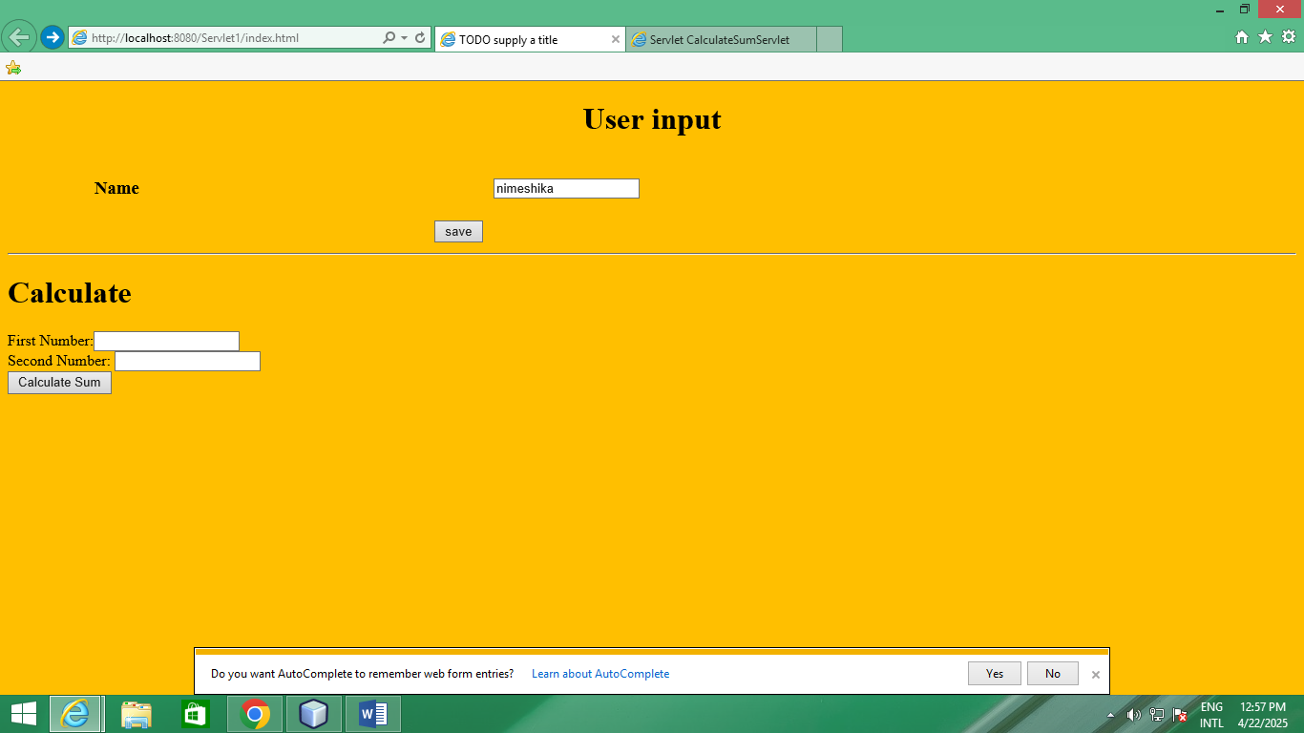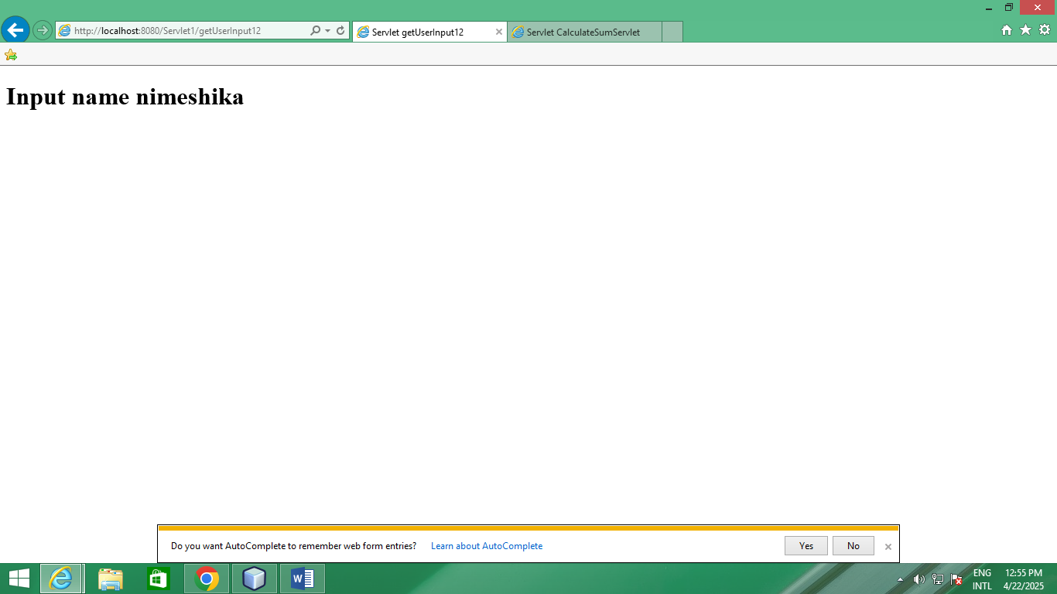

import java.io.IOException;

import java.io.PrintWriter;

import javax.servlet.ServletException;

import javax.servlet.annotation.WebServlet;

import javax.servlet.http.HttpServlet;

import javax.servlet.http.HttpServletRequest;

import javax.servlet.http.HttpServletResponse;

/**

*

* @author student

*/

@WebServlet(urlPatterns = {"/CalculateSumServlet"})

public class CalculateSumServlet extends HttpServlet {

/**

* Processes requests for both HTTP <code>GET</code> and <code>POST</code>

* methods.

*

* @param request servlet request

* @param response servlet response

* @throws ServletException if a servlet-specific error occurs

* @throws IOException if an I/O error occurs

*/

protected void processRequest(HttpServletRequest request, HttpServletResponse response)

throws ServletException, IOException {

int num1 = Integer.parseInt(request.getParameter("num1"));

int num2 = Integer.parseInt(request.getParameter("num2"));

int sum = num1 + num2;

response.setContentType("text/html;charset=UTF-8");

try (PrintWriter out = response.getWriter()) {

/* TODO output your page here. You may use following sample code. */

out.println("<!DOCTYPE html>");

out.println("<html>");

out.println("<head>");

out.println("<title>Servlet CalculateSumServlet</title>");

out.println("</head>");

out.println("<body>");

out.println("<h1> Calculate Sum</h1>");

out.println("<h3> First user input:"+num1+"</h1>");

out.println("<h3> Second user input:"+num2+"</h1>");

out.println("<h1> Answer:"+sum+"</h1>");

//out.println("<h1>The sum of " + num1 + " and " + num2 + " is: " + sum + "</h1>");

//out.println("<h1>Servlet CalculateSumServlet at " + request.getContextPath() + "</h1>");

out.println("</body>");

out.println("</html>");

}

}

// <editor-fold defaultstate="collapsed" desc="HttpServlet methods. Click on the + sign on the left to edit the code.">

/**

* Handles the HTTP <code>GET</code> method.

*

* @param request servlet request

* @param response servlet response

* @throws ServletException if a servlet-specific error occurs

* @throws IOException if an I/O error occurs

*/

@Override

protected void doGet(HttpServletRequest request, HttpServletResponse response)

throws ServletException, IOException {

processRequest(request, response);

}

/**

* Handles the HTTP <code>POST</code> method.

*

* @param request servlet request

* @param response servlet response

* @throws ServletException if a servlet-specific error occurs

* @throws IOException if an I/O error occurs

*/

@Override

protected void doPost(HttpServletRequest request, HttpServletResponse response)

throws ServletException, IOException {

processRequest(request, response);

}

/**

* Returns a short description of the servlet.

*

* @return a String containing servlet description

*/

@Override

public String getServletInfo() {

return "Short description";

}// </editor-fold>

}

