

Sri Lanka Institute of Information Technology

Bridal, Beauty Salon & Academy Management System

Project Proposal
Information Technology Project 2016

Project ID: ITP-16-B2-G5

Submitted by:

- IT15102560– De Silva S.S.R.D.M.
- IT15127174– Ranasinghe R.A.N.I.
- IT13045722– Athipola R.W.S.K.
- IT15134936– Kumarasiri S.D.D.C.
- IT15127938– Ratnayake R.M.T.U.
- IT15134554– Chathubhashini N.D.J.
- IT15134240– Kahaduwa K.K.U.S.
- IT15140562– Dolawatta I.H.

Submitted to:

…………………………..

Mr. S.M.B. Harshanath

2016/07/12

Abstract

Hasini Gunasekera Salon's (Pvt.) Limited is Sri-Lanka's pioneering Bridal, Beauty salon & Academy founded in 1978. They have become a trusted name for elegant brides. As a reputed academy in Sri Lanka it offers diplomas associated with beauty culture industry. Currently the company’s primal processes are based on manual system. As an internationally recognized company, the client requested to develop an automated system to conduct their regular processes more efficiently and conveniently. This proposed system will reduce unnecessary paper work and cover a large area related to salon and academy such as employee management, course and student management, inventory handling, finance management, bridal and salon services and handling appointments etc. This system will be developed in carefully planned steps and each step with frequent inspection of the client.

Table of Contents
Abstract I
Table of Contents II
1. Introduction 1
1.1 Problem Specification 2
1.2 Solution Outline 4
1.3 Key Benefits 5
2. Objectives 6
3. Procedure 9
3.1 Flow of the Project 9
3.2 Project Plan 13
4. Personnel and Facilities 14
5. Software and Hardware Requirements 17
6. Budget 18
7. References 19
Appendix 20

Introduction

Hasini Gunasekera’s Salon is a well-known salon in Sri Lanka for the great services they offer. They also own the International Academy of Beauticians where they offer a number of courses. Since the day it was started, they improved everything in every way but the complexity of the manual system has been a major drawback for their success.
Considering the salon, appointments handling has been a very tedious task because of keeping the records of each customer manually. As they offer their regular customers a discount on their birthdays and anniversaries they have to go through all the records each day. Their Current manual system of employee salary management, attendance, Inventory control, Salon services and finance management are also making it complex, inaccurate and inefficient. Considering the academy, managing students’ attendance, payments and courses have become really hard with the rapid increase of students.
In our system, we will do our best to accommodate solutions for all the problems mentioned above. Our system will be able to send special notices and appointment notifications. As the receptionist add an appointment, particular beautician gets a notification. This notification system is also integrated into the inventory control, financial handling, salon services and all the other necessary parts of our system. This will keep all the employees updated about specific tasks they work with. Handling salary calculations and payments will be done through the system, making payments more secure and accurate.
Our system will also accommodate several user levels such as beauticians, receptionist, manager etc. Higher user levels are able to view more detailed sales and financial reports as low user levels will also have the opportunity to view their progress.

Problem Specification

- Current situation of Hasini Gunasekera’s salon

- Managing salon services: - When customer chooses the package, receptionist will enter customer details and package details in to the sheet. After the job is done receptionist will calculate bill amount and give invoice to the customer.

- Managing the inventory: - There are many cosmetics stored in the stores. The client handles a Quick book inventory system for each item name and brand to manage details.

- Managing Employee Details and Student details: - The saloon and academy uses file based manual system to keep records of the Staff & Students. Monthly salary calculation and students’ payments also handling by manually.

- Managing Bridal services: - There are four main bridal packages in salon but currently they cannot customize as customer’s choice.

Summarized Problems in the current system

- Slow Access
Finding and retrieving a document using a paper-based system is slow. In situations where information contained in a document is required immediately to response to a customer’s request, the delay may cause customer dissatisfaction. In addition, re-filing paper documents wastes time and may result in misplacement of the files.

- Security issues
It is hard to keep track of who has used or copied which paper documents. Paper documents are often maintained with very low security control. Company risks leaking critical information to unauthorized personnel.

- Problems with keeping track of the inventory
If an inventory problem has resulted in an increase in the recorded amount of ending inventory, this means that the cost of goods sold is understated, so that profits are overstated.

- Time consuming
According to the current file based system when retrieving details have to go through all the records one by one.

- In accurate calculations
Calculate salaries and students’ payments result could be in accurate calculations because of the human errors.

Solution Outline
We are planning to develop a system that would fulfill client’s needs. The system will be implemented with more additional features that will support achieving future goals of the Salon & the Academy Management System. The system will be developed using JAVA Language with MySQL.
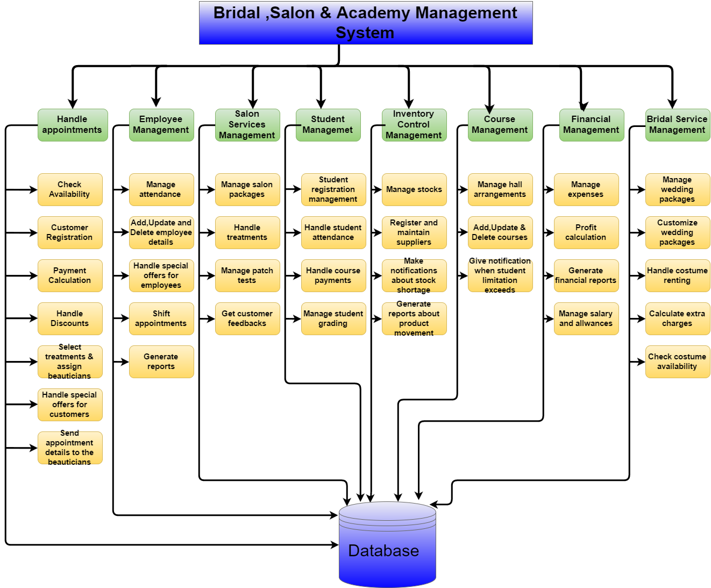
All the manually handled functions will be automated from our system. So it makes most of the procedures efficient and accurate. The system will consist of user friendly GUIs that let employees (client) to enter, retrieve and modify data. This system would also allow our client to generate reports, give notifications about reminders automatically. And most importantly through this system it will be easier to keep track of their employees, the management and the finance details of the Salon and the Academy.

Key Benefits

- Storing data in better organizing manner.
In our system all the data storing to the database and organizing it in proper way to save time when searching data. Data is not repeated several times. So it will dramatically cut costs.

- Generating accurate Reports
This system will provide monthly reports about the income and expenses and it will make easy to compare profits and losses with previous months, years. It will help management to make appropriate adjustments and take decisions. Users can also run their own reports without any issue.

- Save the cost
Searching, updating of record and organizing data can be done with less stress and effort and it will save the time and cost. The data will be well secured to the specific access. Restrictions to data can also be enhanced.

- Energy Saving
Automatically calculates overtime, salary and attendance. When it is done by manually mistakes can be happen. This will save the human power and the time currently spent on doing things manually. This will improve the accuracy, consistency and security of data.

- Improving Efficiency
Better use is made of resources and time. Cash flow will improve through better debt collection and inventory control. Databases of customers and supplier details and stock records can be carried out far more quickly than any manual processing.

Objectives

1. Eliminate unnecessary paper work and time taken for data processing
One common way to improve data processing is to eliminate unnecessary paper. Although paper is familiar and convenient for many purposes, it has major disadvantages. If it is bulky, difficult to move from place to place and extremely difficult to use for analyzing large amounts of data, it is not a good process. Storing data in computerized form takes less physical space, but that is only the beginning. It makes data easier to analyze, easier to copy or transmit, and easier to display in a flexible format.
Comparing paper bills with computerized bills, the paper bills identify inventory cost but are virtually impossible to analyze for patterns of inefficient or excessive usage.

2. Improve efficiency and accuracy in transaction processing
If we do the transaction process in proper way, we can provide data for other business processes. We can process the salon and academy data to update record about the other business operations like inventory control, payroll, account payable, account receivable etc. In manual way difficult to handle each and every details related to salon and academy. As an example, in inventory we must note down every transaction in manual way, but if we automate it we can easily handle these and reduce wastage.

3. Save customers and employees time by scheduling work
Salon Hasini faces challenges when it comes to manage customers and employees. When it is done manually, it is difficult to handle and track employees’ working hours, employees’ free slots, customer appointments etc. But when we automate it we can create a time table for employees and get the details of their free time and assign employees for special events and also we can schedule the appointments in proper way.

4. Manage customer, employee and student details efficiently
Academy is a special section in salon. There are 300 students and 12 courses are to be handled. Tracking students’ performance by attendance, exam marks, and other disciplinary activities should be maintained and these details should be manipulated to evaluate such students’ performance. Each student, employee and customer has a personal file including their personal details when registration in manually in such a situation it’s a big task to handle and store these details. Therefore, when it is done through a system we can handle following in easy way.
- Add customers, employees, students
- Update customers, employees, students
- Search customers, employees, students
- Delete customers, employees, students

5. To produce required reports to ease the decision making process
When a problem arises first it should be recognized. In order to recognize the issue, we must consider about the previous details and the progress of that. If we do manually it is very difficult and it will take long time to recognize the problem and the solution. To do that we want statistical progress of that salon. To get the statistical reports we must need a software and link our details to get reports. If we have a good system, we can easily preview the previous records and find a solution.

6. Efficient stock management
Adding new items, supplier details, updating item details like unit price, stock levels and supplier details will be a part of this component. Since small trading activities will be handled, the system will have a simple stock management. Stock levels will get updated (reduce/increase) when using products. Through the system it will help to balance inventory needs and requirements with the need to minimize cost resulting from obtaining and holding inventory.

7. Having a reliable payroll system
In this system employees consist of two different categories, Lectures and salon workers. System supports to maintain accurate records of employee salary, bonus and deductions which includes EPF, ETF and loans and allows to define formulas that can be changed to calculate Payee tax and overtime and calculating salaries by keeping track of the attendance and performance of the employees automatically. This also includes generating general and specific reports. Managing the details of employees will be handled under the employee management.

8. Notifying and informing
The system will facilitate to remind notices, such as employee work assigning details can pass to the employees within the administration circle and also can get notification about the customer’s special days. (Salon offer special discount for customers for their wedding anniversaries, birthdays and special occasions)

Procedure

This content describes about how the team has planned to conduct the development of Hasini Gunasekera’s Salon Academy Management system. There will be continuous interactions between the client and the team throughout the project development. The group leader has assigned each group member for a specific activity (like drawing class diagram, Entity Relationship (ER) diagram, structure chart etc.) to do the project in efficient way and to finish it in given time duration.

Flow of the Project

    - Feasibility study
The system we suggest to develop for salon and academy management is developed in JAVA as front end and MYSQL as back end. Available resources (Software and hardware compatibility, human resources) were analyzed and it was technically feasible for the suggested system.

    - Requirements Gathering, Analysis and Specification
- Requirements Gathering
As the initial step the team gathered some required information of how the organizational activities are being carried out from a meeting with the director. And the team visited each and every section of salon and academy for 2 days and discussed with the staff to get familiar with the responsibilities that has to be done from each of them. A study on the company’s documents were made to understand how the manual documentary process is done.
- Requirements Analysis
After the gathering was finished, the team got together and analyzed the requirements by referring to the hand written information and voice recordings of client interviews.

- Requirements Specification
With the analyzed details the team came up with functional, nonfunctional requirements and constraints to define the Software Requirement Specification (SRS) document and several diagrams as use case diagram, use case scenarios, Data Flow Diagram (DFD) etc. The team had another meeting with the company Management level, to verify the concept which was recognized by the team by getting the approval of the SRS from the client.

    - Designing
Designing phase has started by mapping functional requirements (from SRS) to structure chart to define processes and data flows. One member has drawn an ER diagram for the system to identify the attributes and the relations of each entity. Once it has finalized another group member has converted it in to the relational schema and normalization has done in order to avoid redundancy and anomalies to have a reliable database. Another group member has designed class diagram and activity diagram. Since it should be user friendly, the team hope to put more effort in this phase to design fine interfaces.

    - Implementation and Unit Testing
- Implementation
Once the designing is done, the implementation will be started. Each and every member will contribute in a responsible manner towards the function given. Database is created with the required constraints using MySQL Server. Designed interfaces are developed using JAVA and every module is coded separately.
- Unit Testing
The each and every function or the module developed by the team member is tested individually using sample data in this approach. Check for errors and if found, it will be fixed and will be unit tested again.

    - Integration and System Testing
Testing of salon and academy management system will be done to be sure the reliability of the system. All the test cases and the main objective of this phase is to give a rich, user friendly and high performed system. In each and every approach, sample data will be used to test the functionalities. Testing will be performed with referring to the SRS document.
- Integration Testing
After creating all the modules and completely unit tested, the modules will be integrated one by one. And at each and every integration the application will be tested to check how the functions behave when they are integrated.
- System Testing
System testing will be done after integrating all the modules. This will be the final and most significance testing of the system as this checks the errors or unexpected behaviors of the system as speed and how the system behaves in special test cases. The system performance is also being main criteria under this testing phase. This will be done by inputting some manual data which there are in company documents. And there the team will be testing whether the outputting value will be the same as in manual documents. In this approach the system will be tested as a one whole unit. At last the system will be implemented in the client’s location by installing necessary software and hardware components required to run the software. Team will be guided how to use the software and let the client to operate the software.

    - Maintenance
The maintenance of the system has to be done for time to time. This is to be dividing into two parts as Perfective and Corrective.
- Perfective Maintenance
Perfective maintenance will be done after the Hasini Gunasekera’s Salon (Pvt.) Limited started using the system and if they requested any changes or modifications in the system to make it more useful to them.

- Corrective Maintenance
Corrective maintenance is when the system met with new bugs. There the system should be corrected with considering the performances and customer satisfaction.

The team will meet the Supervisor-in-charge of the project, to discuss the progress of the project and to get supervisor’s feedback for developing a better system.
From this group project each and every member gets the highest experience on working with companies in the industry and will learn to take responsible in team work, to gather requirements to develop software for a client. And as to be successive IT graduates, the skill in Leadership also will be seeded among the members.

Project Plan
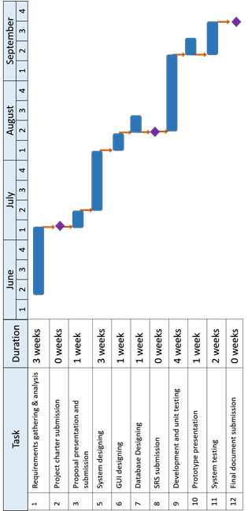

Personnel and Facilities

Name with initials | Function-in-charge | Brief Description of the Function
De Silva S.S.R.D.M | Handle appointments | The appointments of the customer will be managing by this function  - Check availability from nearest branch on specific beautician for on call customers  - Customer registration  - Payment calculation and handle discounts  - special offers (for customer’s anniversaries, birthdays and special occasions)
Ranasinghe R.A.N.I | Manage employee details | The employee’s information of the salon will be managing by this function.  - Manage attendance  - Handle employee details  - Search for specific Employee  - Special offers for employees  - Shift appointments  - Generate reports about most selected treatments and target.
Athipola R.W.S.K | Manage salon services | Salon packages will be handle by this function  - Manage salon packages  - Handle treatments  - Manage patch test issues  - Get customer feedbacks
Kumarasiri S.D.D.C | Manage student details | The student’s information of the academy will manage by this function  - Student registration management  - Student attendance handling  - Handle course payments  - Student grading
Ratnayake R.M.T.U | Manage inventory control | The inventory will manage by this section  - Manage stocks  - Register and maintain suppliers  - Make notification about stock shortage  - Generate reports about product movement
Chathubhashini N.D.J | Manage courses | The courses of the academy will manage in this section  - Arrange halls  - Add, update, delete courses  - Handle course details  - Give notification message when student limitation exceeds
Kahaduwa K.K.U.S | Handle finance and issue receipts | Finance of the salon will be managing by this function  - Manage expenses  - Profit calculations  - Generate financial reports  - Mange salary and allowances
Dolawatta I.H | Manage bridal services | Bridal packages will be managing by this section  - Manage wedding packages  - Customize wedding packages  - Costume renting  - Calculate extra charges  - Check costume availability

Software and Hardware Requirements

Development

- Software Requirements

- Java Development kit 8
- Java Runtime Environment 8
- Netbeans 8.0
- Adobe Photoshop CS6
- My SQL Server 5.5 or above
- I-reports
- Microsoft Windows 7 or above

- Hardware Requirements

- Computers with 2GB Ram ,1.5GHz or above

Client

- Software Requirements
- Java Runtime Environment 8
- My SQL Server 5.5 or above

- Hardware Requirements
- Computers with 2GB Ram ,1.5GHz or above
- Dot Matrix printer (for slips)
- Laser printer (for reports)
- Barcode Reader

Budget

Hardware Cost  - Barcode Reader  Software Cost |  |  |  | 8500.00
- Netbeans 8 |  | System design & development |  |  | 4000.00
- My SQL Server 5.5 |  | Database design & development |  |  | 700.00
- Adobe Photoshop CS6 |  | Graphic designing |  |  | 2000.00
- Transportation |  |  | 1000.00
- Other expenses |  |  | 1000.00
Total |  |  | 17200.00

References

- “IEEE reference format” [online].
Available: http://www.ieee.org/documents/ieeecitationref.pdf

- SLIIT SE lecture slides

- Deepika Gunasekara Salon website. [Online]
Available: http://www.dgs.lk/

- International Academy of Beauticians website [Online].
Available: http://www.iab.lk/

Wpi.edu, 'Undergraduate Studies: How to Write a Project Proposal - WPI', 2014. [Online]. Available: http://www.wpi.edu/academics/ugradstudies/writeproposal.html.

- “How to write software documentation” [online]
Available: http://www.techscribe.co.uk/ta/how-to-write-user-documentation.html

.

Appendix

