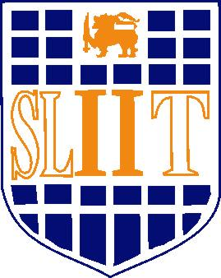

Sri Lanka Institute of Information Technology

Bridal, Beauty Salon & Academy Management System

Software Requirement Specification

Information Technology Project 2016

Project ID: ITP-16-METRO-WD-B2-G5

Submitted by:

1. IT15102560 – De Silva S.S.R.D.M.
2. IT15127174 – Ranasinghe R.A.N.I.
3. IT13045722 – Athipola R.W.S.K.
4. IT15134936 – Kumarasiri S.D.D.C.
5. IT15127938 – Ratnayake R.M.T.U.
6. IT15134554 – Chathubashini N.D.J.
7. IT15134240 – Kahaduwa K.K.U.S.
8. IT15140562 – Dolawatta I.H

Submitted to:

…………………………..

Mr. S.M.B.Harshanath

03-August-2016

