//LOGIN PAGE

<!DOCTYPE html>

<HTML>

<head>

    <meta name ="viewport" content="width=device-width", initial-scale="1">

    <style>

        body{font-family:Arial,Helvetica,sans-serif;}

        form{border:3px solid #f1f1f1;}

        input[type=text], input[type=password]{

            width:100%;

            padding:12px 20px;

            margin: 8px 0;

            display: inline-block;

            border: 1px solid #ccc;

            box-sizing: border-box;

        }

        button{

            background-color: #2db44f;

            color: white;

            padding: 14PX 20PX;

            margin: 8PX 0;

            border: none;

            cursor: pointer;

            width:100%;

        }

        button:hover{

            opacity:0.8;

        }

        .cancelbtn{

            width: auto;

            padding: 10px 18px;

            background-color: #4152b6;

        }

        .imgcontainer{

            text-align: center;

            margin: 24px 0 12px 0;

        }

        img.avatar{

            width: 40%;

            border-radius: 50%;

        }

        .container{

            padding: 16px;

        }

        span.pws{

            float: right;

            padding-top: 16px;

        }

        @media screen and (max-width:300px ){

            span.pws{

                display: block;

                float:"none";

            }

            .cancelbtn{

                width: 100%;

            }

        }

    </style>

</head>

<body>

    <h2>login form</h2>

    <form action="/action_page.php" method="post">

        <div class="imgcontainer">

            <img src="img_avatar2.png" alt="Avatar" class="avatar">

        </div>

        <div class="container">

            <label for="uname"><b>Username</b></label>

            <input type ="text" placeholder="Enter Username" name="uname" required>

            <label for="psw"><b>Password</b></label>

            <input type ="password" placeholder="Enter Password" name="psw" required>

            <button type="submit">Login</button>

            <label>

                <input type="checkbox" checked="checked" name="remember"> Remember Me </label>

        </div>

        <div class="container" style="background-color: #bbc970">

        <button type="button" class="cancelbtn">Cancel</button>

        <span class="psw">Forgot<a href="#">password?</a></span>

        </div>

     </form>

   </body>

</HTML>

Output

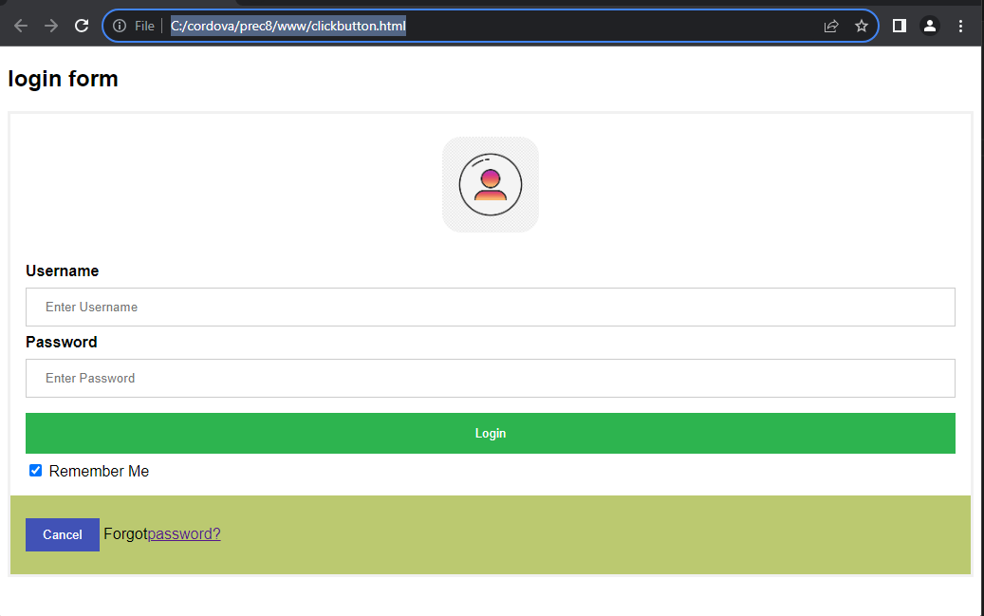

Datetime

<html>

    <body>

        <h2> My Javascript</h2>

        <button type=" button" onclick="document.getElementById('demo').innerHTML = Date()">

click me to display Date and Time.</button>

        <p id="demo"></p>

    </body>

</html>

Output

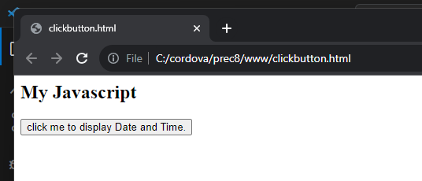

After clicking

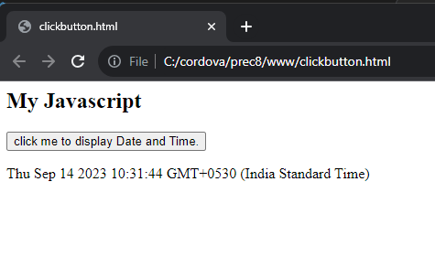

Function

<!DOCTYPE html>

<html>

    <body>

        <h1>Javascript Function</h1>

        <p>Call a function to perform a calculation and returns the result</p>

        <p id ="demo"></p>

        <script>

            function myfunction(p1,p2)

            {

                return p1*p2;

            }

            let result = myfunction (4,3);

            document.getElementById("demo").innerHTML=myfunction=result;

        </script>

    </body>

</html>

Output

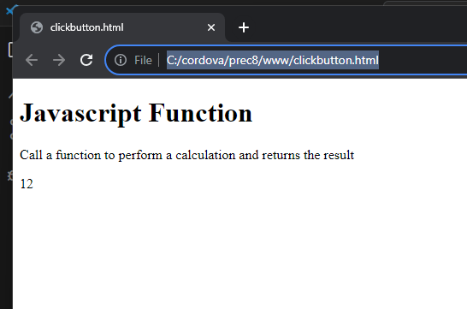

Calculator

<!DOCTYPE html>

<html lang="en">

<head>

<style>

    *{

   padding: 0;

   margin: 0;

   font-family: 'poppins', sans-serif;

}

body{

   background-color: #495250;

   display: grid;

   height: 100vh;

   place-items: center;

}

.main{

   width: 400px;

   height: 450px;

   background-color: white;

   position: absolute;

   border: 5px solid black;

   border-radius: 6px;

}

.main input[type='text'] {

   width: 88%;

   position: relative;

   height: 80px;

   top: 5px;

   text-align: right;

   padding: 3px 6px;

   outline: none;

   font-size: 40px;

   border: 5px solid black;

   display: flex;

   margin: auto;

}

.btn input[type='button']{

   width:90px;

   padding: 2px;

   margin: 2px 0px;

   position: relative;

   left: 13px;

   top: 20px;

   height: 60px;

   cursor: pointer;

   font-size: 18px;

   transition: 0.5s;

   background-color: #495250;

   border-radius: 6px;

   color: white;

}

.btn input[type='button']:hover{

   background-color: black;

   color: white;

}

</style>

<script>

    function Solve(val) {

       var v = document.getElementById('res');

       v.value += val;

    }

    function Result() {

       var num1 = document.getElementById('res').value;

       var num2 = eval(num1);

       document.getElementById('res').value = num2;

    }

    function Clear() {

       var inp = document.getElementById('res');

       inp.value = '';

    }

    function Back() {

       var ev = document.getElementById('res');

       ev.value = ev.value.slice(0,-1);

    }

 </script>

 <title>Calulator</title>

</head>

<body>

 <div class="main">

    <input type="text" id = 'res'>

    <div class="btn">

       <input type="button" value = 'C' onclick = "Clear()">

       <input type="button" value = '%' onclick = "Solve('%')">

       <input type="button" value = '←' onclick ="Back('←')">

       <input type="button" value = '/' onclick = "Solve('/')">

       <br>

       <input type="button" value = '7' onclick = "Solve('7')">

       <input type="button" value = '8' onclick = "Solve('8')">

       <input type="button" value = '9' onclick = "Solve('9')">

       <input type="button" value = 'x' onclick = "Solve('*')">

       <br>

       <input type="button" value = '4' onclick = "Solve('4')">

       <input type="button" value = '5' onclick = "Solve('5')">

       <input type="button" value = '6' onclick = "Solve('6')">

       <input type="button" value = '-' onclick = "Solve('-')">

       <br>

       <input type="button" value = '1' onclick = "Solve('1')">

       <input type="button" value = '2' onclick = "Solve('2')">

       <input type="button" value = '3' onclick = "Solve('3')">

       <input type="button" value = '+' onclick = "Solve('+')">

       <br>

       <input type="button" value = '00'onclick = "Solve('00')">

       <input type="button" value = '0' onclick = "Solve('0')">

       <input type="button" value = '.' onclick = "Solve('.')">

       <input type="button" value = '=' onclick = "Result()">

    </div>

 </div>

 <script src = 'Calc.js' ></script>

</body>

</html>

Output

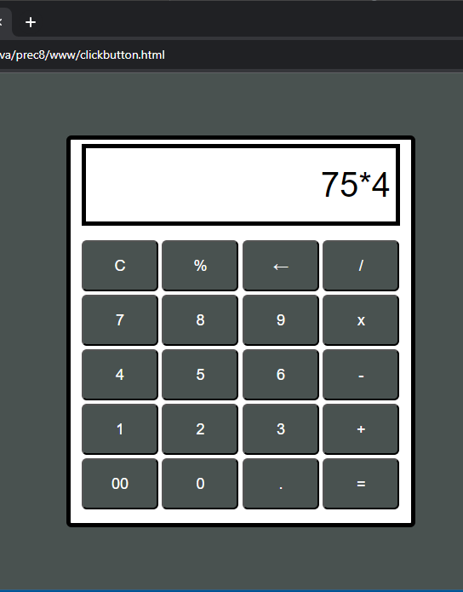

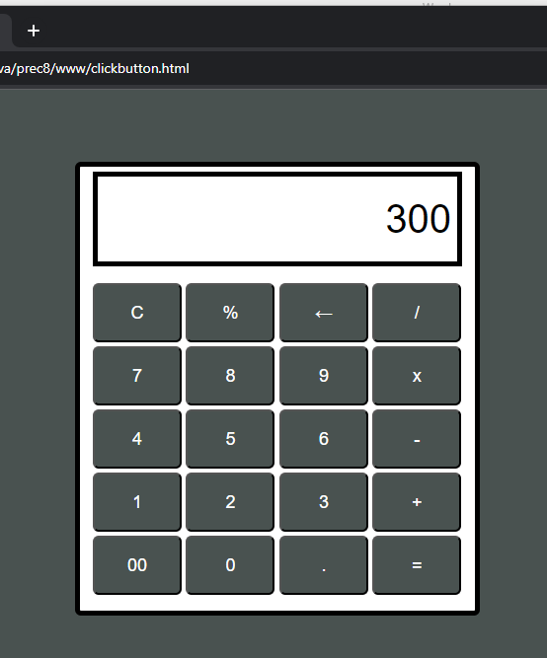

Phonebook

<html>

<head>

<meta name="viewport" content="width=device-width, initial-scale=1">

<style>

* {

  box-sizing: border-box;

}

#myInput {

  background-image: url('/css/searchicon.png');

  background-position: 10px 12px;

  background-repeat: no-repeat;

  width: 100%;

  font-size: 16px;

  padding: 12px 20px 12px 40px;

  border: 1px solid #d41a1a;

  margin-bottom: 12px;

}

#myUL {

  list-style-type: none;

  padding: 0;

  margin: 0;

}

#myUL li a {

  border: 1px solid #2f1894;

  margin-top: -1px; /* Prevent double borders */

  background-color: #c5c4d3;

  padding: 12px;

  text-decoration: none;

  font-size: 18px;

  color: black;

  display: block

}

#myUL li a:hover:not(.header) {

  background-color: #dd3450;

}

</style>

</head>

<body>

<h2>My Phonebook</h2>

<input type="text" id="myInput" onkeyup="myFunction()" placeholder="Search for names.." title="Type in a name">

<ul id="myUL">

  <li><a href="#">Anna</a></li>

  <li><a href="#">Belly</a></li>

  <li><a href="#">Jerry</a></li>

  <li><a href="#">Bobby</a></li>

  <li><a href="#">Kevin</a></li>

  <li><a href="#">Cherry</a></li>

  <li><a href="#">Lucky</a></li>

</ul>

<script>

function myFunction() {

    var input, filter, ul, li, a, i, txtValue;

    input = document.getElementById("myInput");

    filter = input.value.toUpperCase();

    ul = document.getElementById("myUL");

    li = ul.getElementsByTagName("li");

    for (i = 0; i < li.length; i++) {

        a = li[i].getElementsByTagName("a")[0];

        txtValue = a.textContent || a.innerText;

        if (txtValue.toUpperCase().indexOf(filter) > -1) {

            li[i].style.display = "";

        } else {

            li[i].style.display = "none";

        }

    }

}

</script>

</body>

</html>

Output

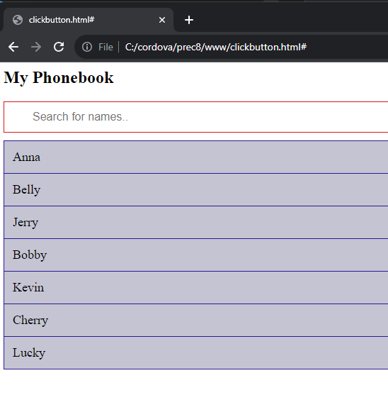

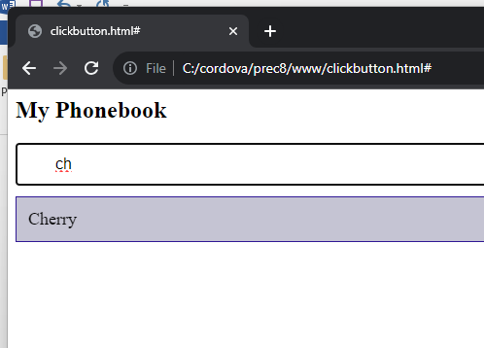

Click buttom

<!DOCTYPE html>

<html>

    <body>

        <p id="demo"> Click the button to change the layout of this paragraph</p>

        <button onclick="myFunction()">click</button>

        <script>

            function myFunction(){

                let x = document.getElementById("demo");

                x.style.fontSize = "25px";

                x.style.color = "red";

            }

        </script>

    </body>

</html>

Output

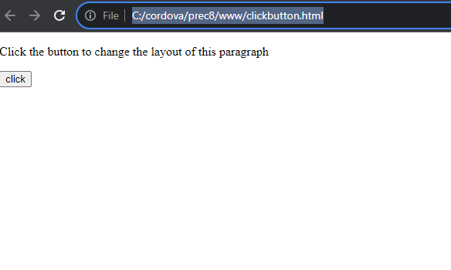

After clicking

