Name : Nimesh S V
Email : nimeshsv814@gmail.com

Assignment – 01

1) Write a shell script that uses a function to check whether a number is positive, negative, or zero using if.

Number_Positive_Negative_Zero() {
if [ $1 -gt 0 ]; then
echo "$1 is Positive Number"
elif [ $1 -lt 0 ]; then
echo "$1 is Negative Number"
else
echo "$1 is Zero"
fi
}

read -p "Enter the number to check whether Positive or Negative or Zero : " num

Number_Positive_Negative_Zero "$num"

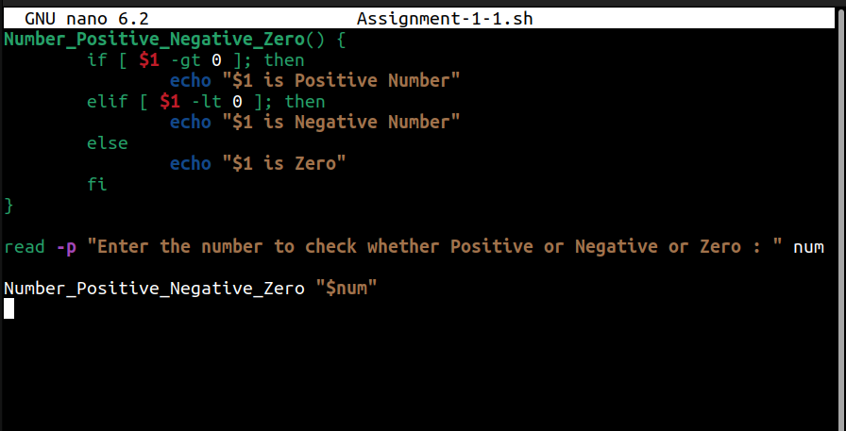

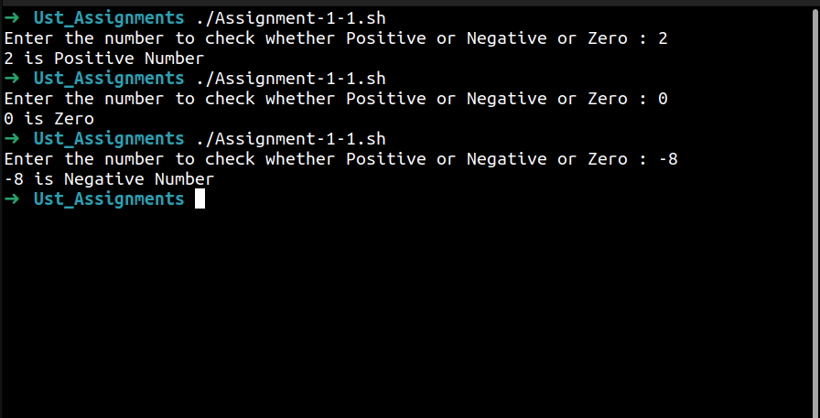
2) Write a shell script to calculate the factorial of a number using a while loop inside a function.

Factorial() {
n=$1
F=1
while [ $n -gt 1 ]
do
F=$((F * n))
n=$((n - 1))
done
echo "Factorial of $1 : $F"
}

read -p "Enter the number : " num
Factorial "$num"

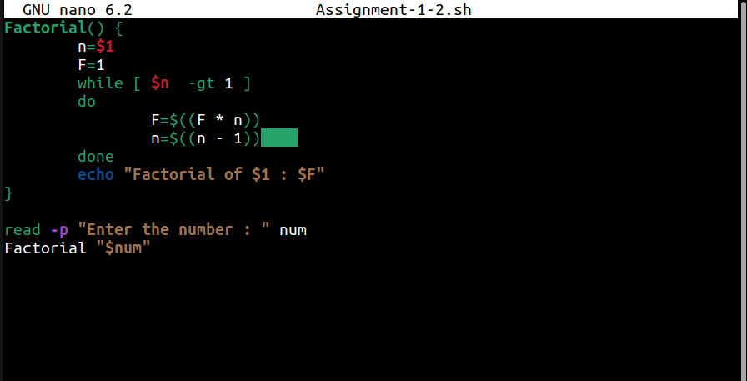
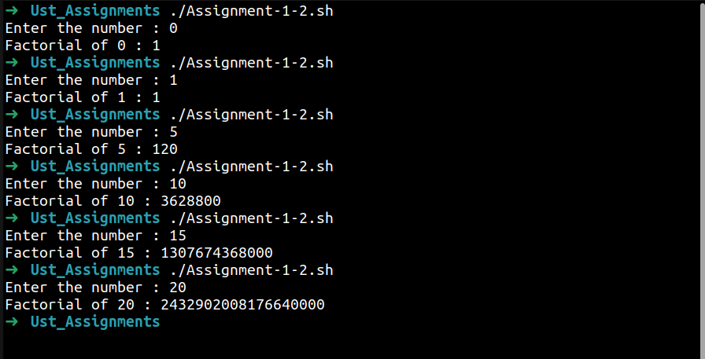
3) Write a shell script to calculate the sum of numbers from 1 to N using a for loop inside a function.

#!/bin/bash
Sum_Of_N_Numbers() {
sum=0
for (( i=1; i<=$1; i++))
do
sum=$((sum+i))
done
echo "Sum of N numbers is $sum"
}
read -p "Enter the N = " num
Sum_Of_N_Numbers "$num"

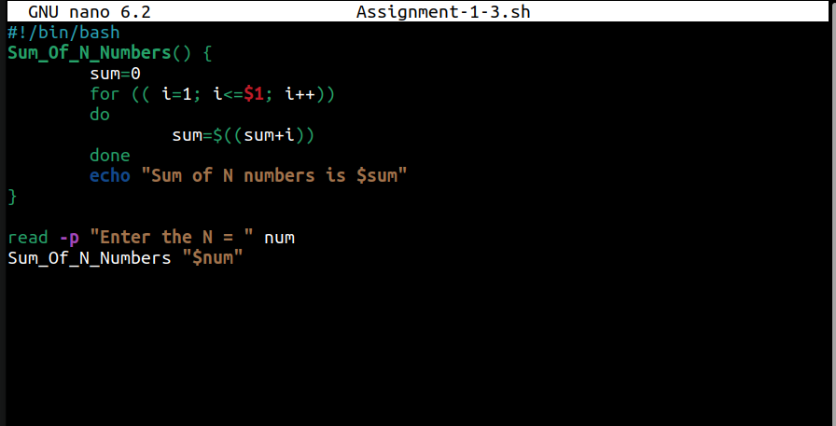
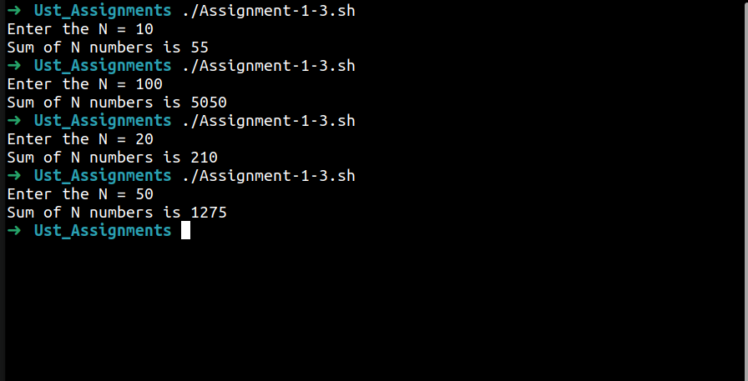
4) Write a shell script that uses a function to check whether a given number is prime using if and for.

#!/bin/bash
Prime_Check() {
flag=0
for (( i=2; i<=$1; i++ ))
do
if (( $1 % i == 0 )); then
flag=$((flag+1))
fi
done
if (( flag==1 )); then
echo "$1 is Prime Number"
else
echo "$1 is not Prime Number"
fi
}

read -p "Enter the number for Prime Check : " num
Prime_Check "$num"

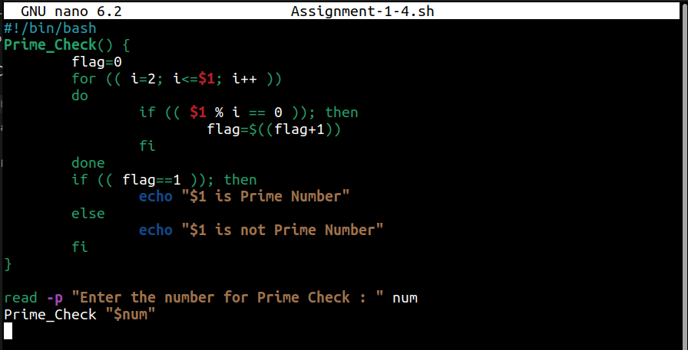
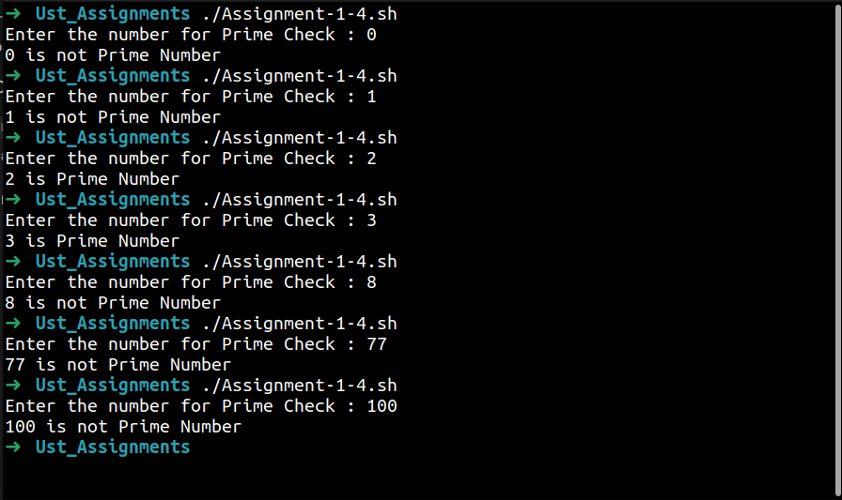
5) Write a shell script to reverse a number using a while loop and if conditions where required.

Reverse_Number() {
n=$1
result=0
while [ "$n" -ne 0 ]
do
result=$((result*10))
t=$((n%10))
n=$((n/10))
result=$((result+t))
done
echo "Reversed number is $result"
}

read -p "Enter the number to be reversed : " num
Reverse_Number "$num"

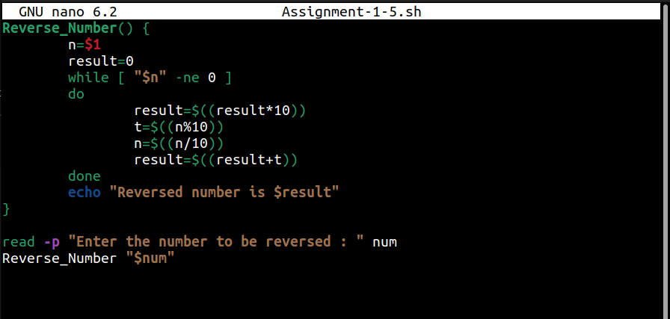
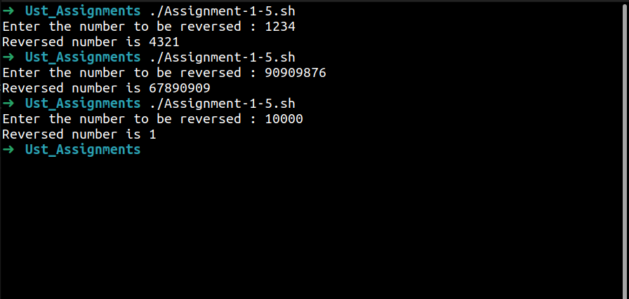
6) Write a shell script that uses a function to check if a file exists and whether it has read, write, and execute permissions.

Check_File() {
file="$1"
if [ ! -e "$file" ]; then
echo "File $file does not exist."
return
fi
echo "File $file does exist"

if [ -r "$file" ]; then
echo "Read Permission : Yes"
else
echo "Read Permission : No"
fi

if [ -w "$file" ]; then
echo "Write Permission : Yes"
else
echo "Write Permission : No"
fi

if [ -x "$file" ]; then
echo "Execute Permission : Yes"
else
echo "Execute Permission : No"
fi
}

read -p "Enter file path : " path
Check_File "$path"

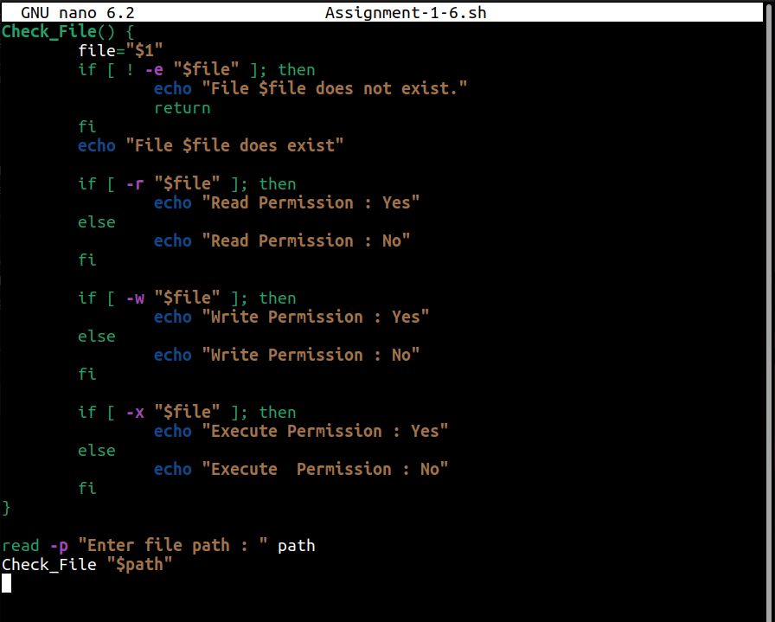

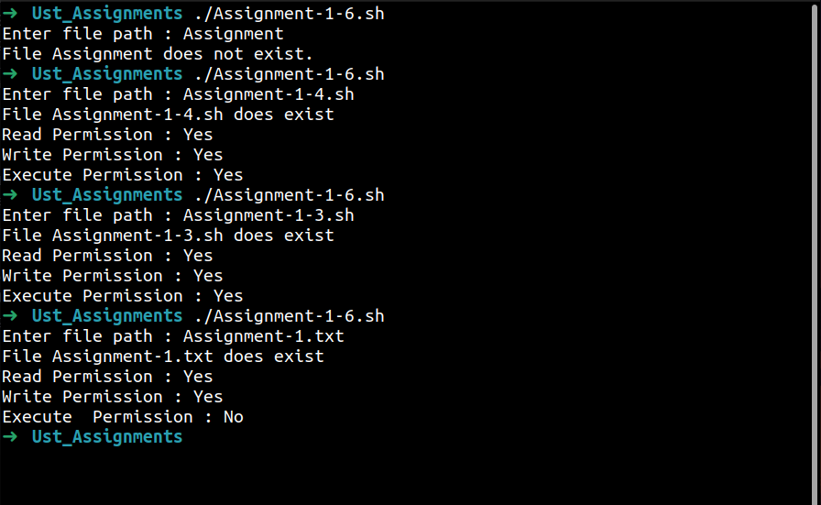
7) Write a shell script that shows a menu in a while loop and performs add, subtract, multiply, divide using functions.

#!/bin/bash
add() {
echo "Result : $(( $1 + $2 ))"
}
sub() {
echo "Result : $(( $1 - $2 ))"
}
mul() {
echo "Result : $(( $1 * $2 ))"
}
div() {
if [ "$2" -eq 0 ]; then
echo "Error:Can't divide by Zero"
else
echo "Result : $(( $1 / $2 ))"
fi
}
while true
do
echo "----------Calculator----------"
echo "1) Add"
echo "2) Subtract"
echo "3) Multiply"
echo "4) Divide"
echo "5) Exit"
read -p "Enter the option : " option

case "$option" in
1|2|3|4)
read -p "Enter first number : " a
read -p "Enter second number : " b
case "$option" in
1) add "$a" "$b" ;;
2) sub "$a" "$b" ;;
3) mul "$a" "$b" ;;
4) div "$a" "$b" ;;
esac
;;
5)
echo "Exited"
break
;;
*)
echo "Invalid option....."
esac
echo
done
