Assignment One

1. Requirements

Design, implement and test a three-tiered distributed system to view and post flights for an

airport. The system consists of the following tiers: Presentation, Business Layer and Data

Access.

* 1. Functional requirements
* Users log in. Users are redirected to the page corresponding to their role.
* Client role o A client can view on his/her page all the flights in a list or table. o A client can query for the local time of the flight arrival and departure cities computed based on cities geographical coordinates.
* Administrator role o The administrator can perform CRUD operations on flights (Create, Read, Update and Delete) .
* Each flight consists of the following information: flight number, airplane type, departure city, departure date and hour, arrival city, arrival date and hour.
* Each city has associated its geographical coordinates: latitude and longitude.
* In order to display the local time, the geographical coordinates of the city are passed to an external web service (e.g. http://new.earthtools.org/webservices.htm) which will return the actual time value.
* The simple users will not be able to enter the administrator page (e.g. by log-in and then copy-paste the admin URL to the browser).
  1. Implementation technologies

Use the following technologies: HTML, Java Servlets and Hibernate ORM.

* 1. Non-functional requirements

Security: use authentication in order to restrict users to access the administrator pages (cookies, session, etc.)

1. Conceptual architecture of the distributed system

* The system uses the layers architectural design pattern. It divides the application in three layers: the presentation layer, which is used to handle the front end of the application, the business layer which handles all the logic of the system (input handling) and the data layer which handles the connection and access to the database (the DAO’s).
* Class diagram:

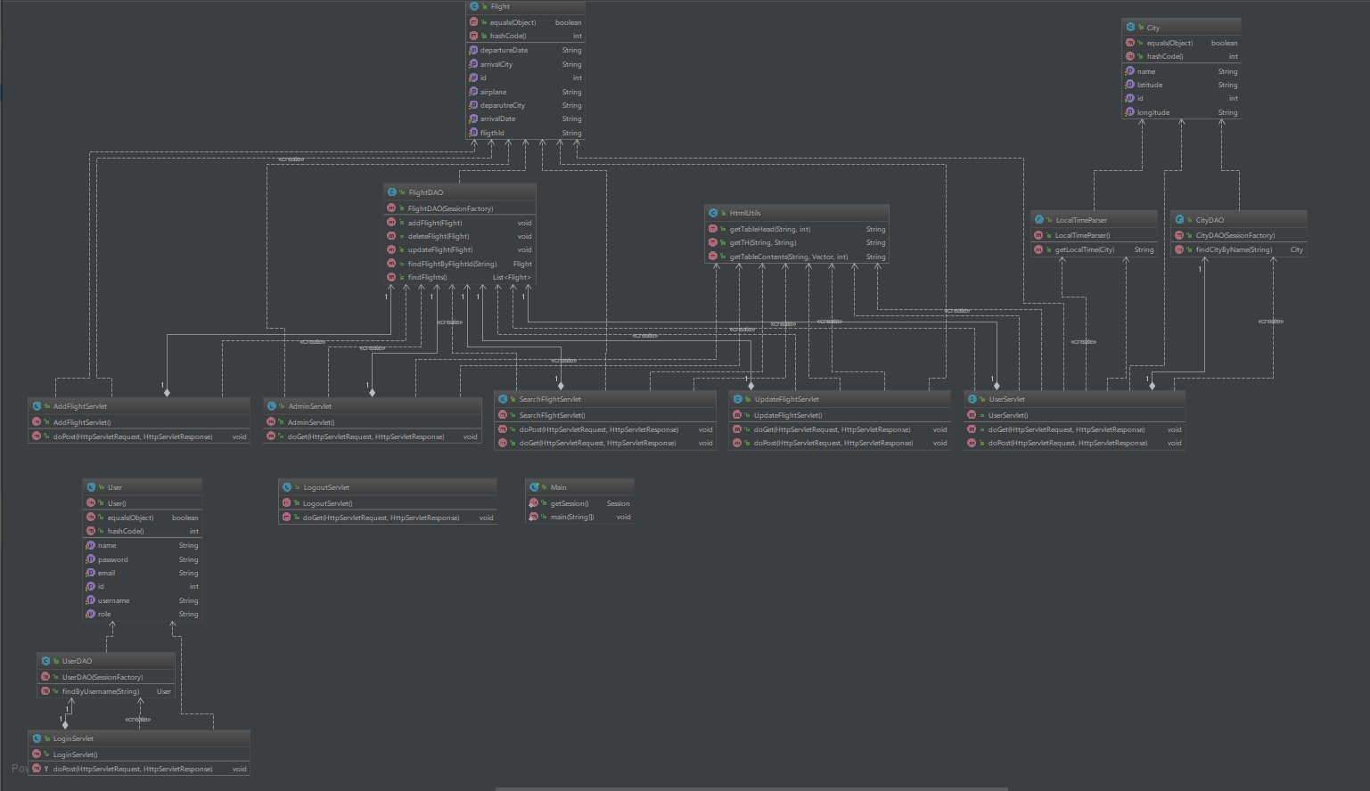

* Package diagram:

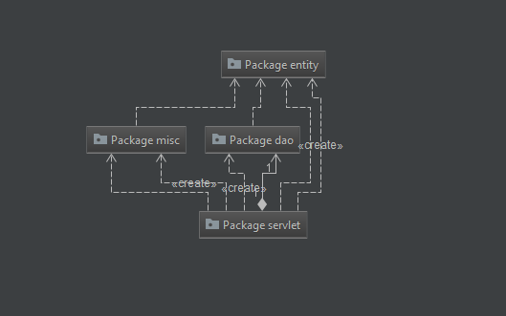

1. DB design

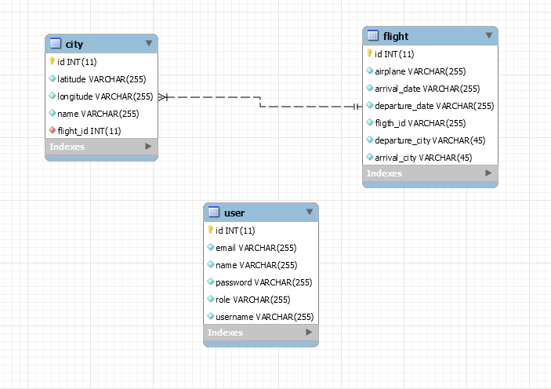

1. UML Deployment diagram

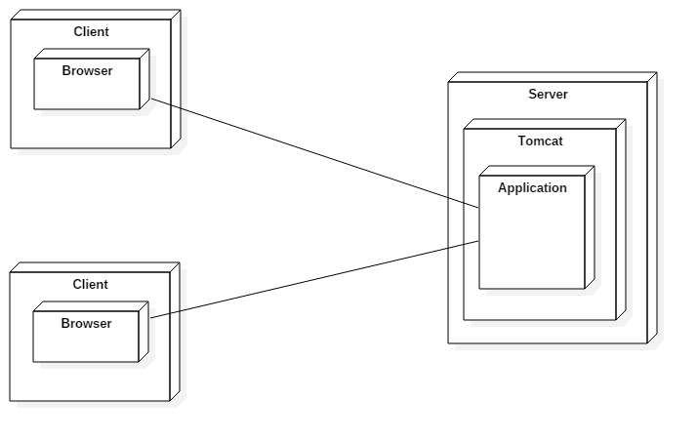

1. Readme file containing build and execution considerations

* Install instructions
* You must have java installed (<https://java.com/en/download/help/windows_manual_download.xml>)
* You must have tomcat installed

(<https://tomcat.apache.org/download-90.cgi>)

* Running and accessing the application
  + - Go to the application folder
    - Open a command window
    - Run the command: java -jar filename.jar
    - Open your browser and go to localhost:/8080 and you'll be redirected to the login page
    - You can use the following accounts:

1. Username: admin Password: admin Rights: ADMIN
2. Username: user Password: user Rights: USER