**Photography**

Nimisha T M

Photography Basics

# INTRODUCTION

Digital single-lens reflex **camera (DSLR)**

There are lot of terms that you come across while learning photography. Lets try to understand a few that can help in capturing the special moments to save for ever with a digital camera.

We will cover the following topics which are commonly needed for a photographer in this essay

1. Exposure time, Aperture and ISO (the three backbones of photography)
2. F-stop, Field-of-view, Depth-of-field
3. Crop factor
4. AE. AF locks
5. Macro photography
6. Camera modes
7. Auto and manual focus.
8. Metering
9. Rule of third
10. Focal length ranges and lens preferred for different photography.
11. Pan-shots.
12. White Balancing and retinex theory
13. What are point and shoot cameras?
14. Raw format and advantages over JPEG
15. Camera pipeline and camera mapping
16. Bayer data and Demosaicing
17. Local and global tone mapping and gamma correction
18. JPEG Compression

The three important terms you should never forget are exposure time, aperture size and ISO. An interplay of these three components plays a major role in the quality of your captured photo. Your camera has different modes for capturing photos. Most of us who are unaware of these terms put the camera in Auto mode and take photos. Auto mode decides these three component by itself prior to the shot. But this may not be optimal to get a photo equivalent to that taken by a professional. If you are eager to get such images, you need to put some effort and learn what is aperture priority mode, shutter priority mode etc in cameras.

We will go in detail of these three components:

**Exposure Time:** This can also be mentioned in terms of shutter speed. This indicates the duration of time the shutter of the camera is exposed to light (to collect the photons arriving from the scene). **Shutter** can be thought of a curtain placed before the camera sensor. The image is formed when the sensor is exposed to the light rays coming from the scene. The curtain decides the duration to which the sensor has to be exposed by allowing in light. If shutter speed is low (or exposure time is high) , more light is collected by sensor and vice-versa. In low-light scenarios keeping shutter speed low helps in capturing well lit scenes upto an extent (provided there is no camera or scene motion during the exposure time). If something moves in between the high exposure time settings, it can lead to blurry artifacts.

High exposure time is useful to capture Light streak photography (it shows the trace of light rays to bring in aesthetic effect in the photo). But as said previously you should place the camera in a tripod to avoid hand shake related blurry artifacts.

High shutter speed (low exposure time) is usually used freeze motion of objects in scene. This is used to capture bird photography were the object is moving and you want to freeze the object to get a blur free photo. If shutter speed is low, it leads to motion blur in the captured photo induced by the moving object. But this cannot be used in low light scenarios as it leads to dark images without much informations. In well lit scenarios, to capture moving objects without blur, this high shutter speed is the best option.

Shutter speeds are typically measured in fractions of a second, when they are under a second. For example 1/4 means a quarter of a second, while 1/250 means one two-hundred-and-fiftieth of a second (or four milliseconds). In DSLR cameras the available shutter speed varies in range of 1/4000th of a second to 30sceonds.

You can set the shutter speed manually by changing the mode of camera to either ‘Shutter’ Priority mode (S) or ‘Manual’ mode (M). In S mode you just need to set the shutter speed and the camera decides the aperture for you and in M mode you can set both shutter and aperture values. Within both of these modes, you can choose to set ISO manually or automatically. We will see Aperture and ISO in the succeeding sections.

Exposure time also decides the brightness of your scene. Will higher shutter speed the image will be dark and as shutter speed decreases the brightness increases in the scene. But in a well lit scenarios keeping the shutter speed low can lead to over-exposed frames.

For beginners, its suggested that you go with the ‘Aperture’ priority mode (A) and let the camera decide the shutter speed for you. This can help in avoiding motion blurs due to moving objects in the scene.

**Different modes in capturing. The black dial can be rotated to choose the mode. This particular picture shows the ‘Auto’ mode selected.**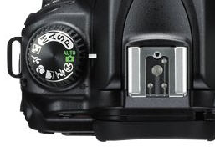

**Aperture:** Simply put, aperture is a hole within a lens, through which light travels into the camera body. Its equivalent to your eyes pupil. The opening of pupil decide the amount of light we receive similarly the aperture size decides the amount of photos collected. If the opening is high, more light is collected and vice-versa. Similar to shutter speed, aperture can also controls the brightness of the captured images. If aperture is widely open it collects more light and the image is well exposed and if aperture opening is narrowed down the picture becomes dark. For dark environments, you need to keep the aperture opening high to collect more light. This is the same our pupil dilates in low light condition. But with larger aperture there is an additional issue of defocus effect. We will study this in this effect as depth-of-field. Aperture decides the **depth-of-field** (i.e, the range of area that is in focus) in images.

**Depth-of-field:** This indicates the range of raea in focus. When aperture size is small (and exposure time relatively high to get well exposed scene) almost all points are in focus and this gives an all focussed image. When aperture is high only a small region will be in focus and rest are de-focussed. This creates ‘bokeh’ effect in captures images.

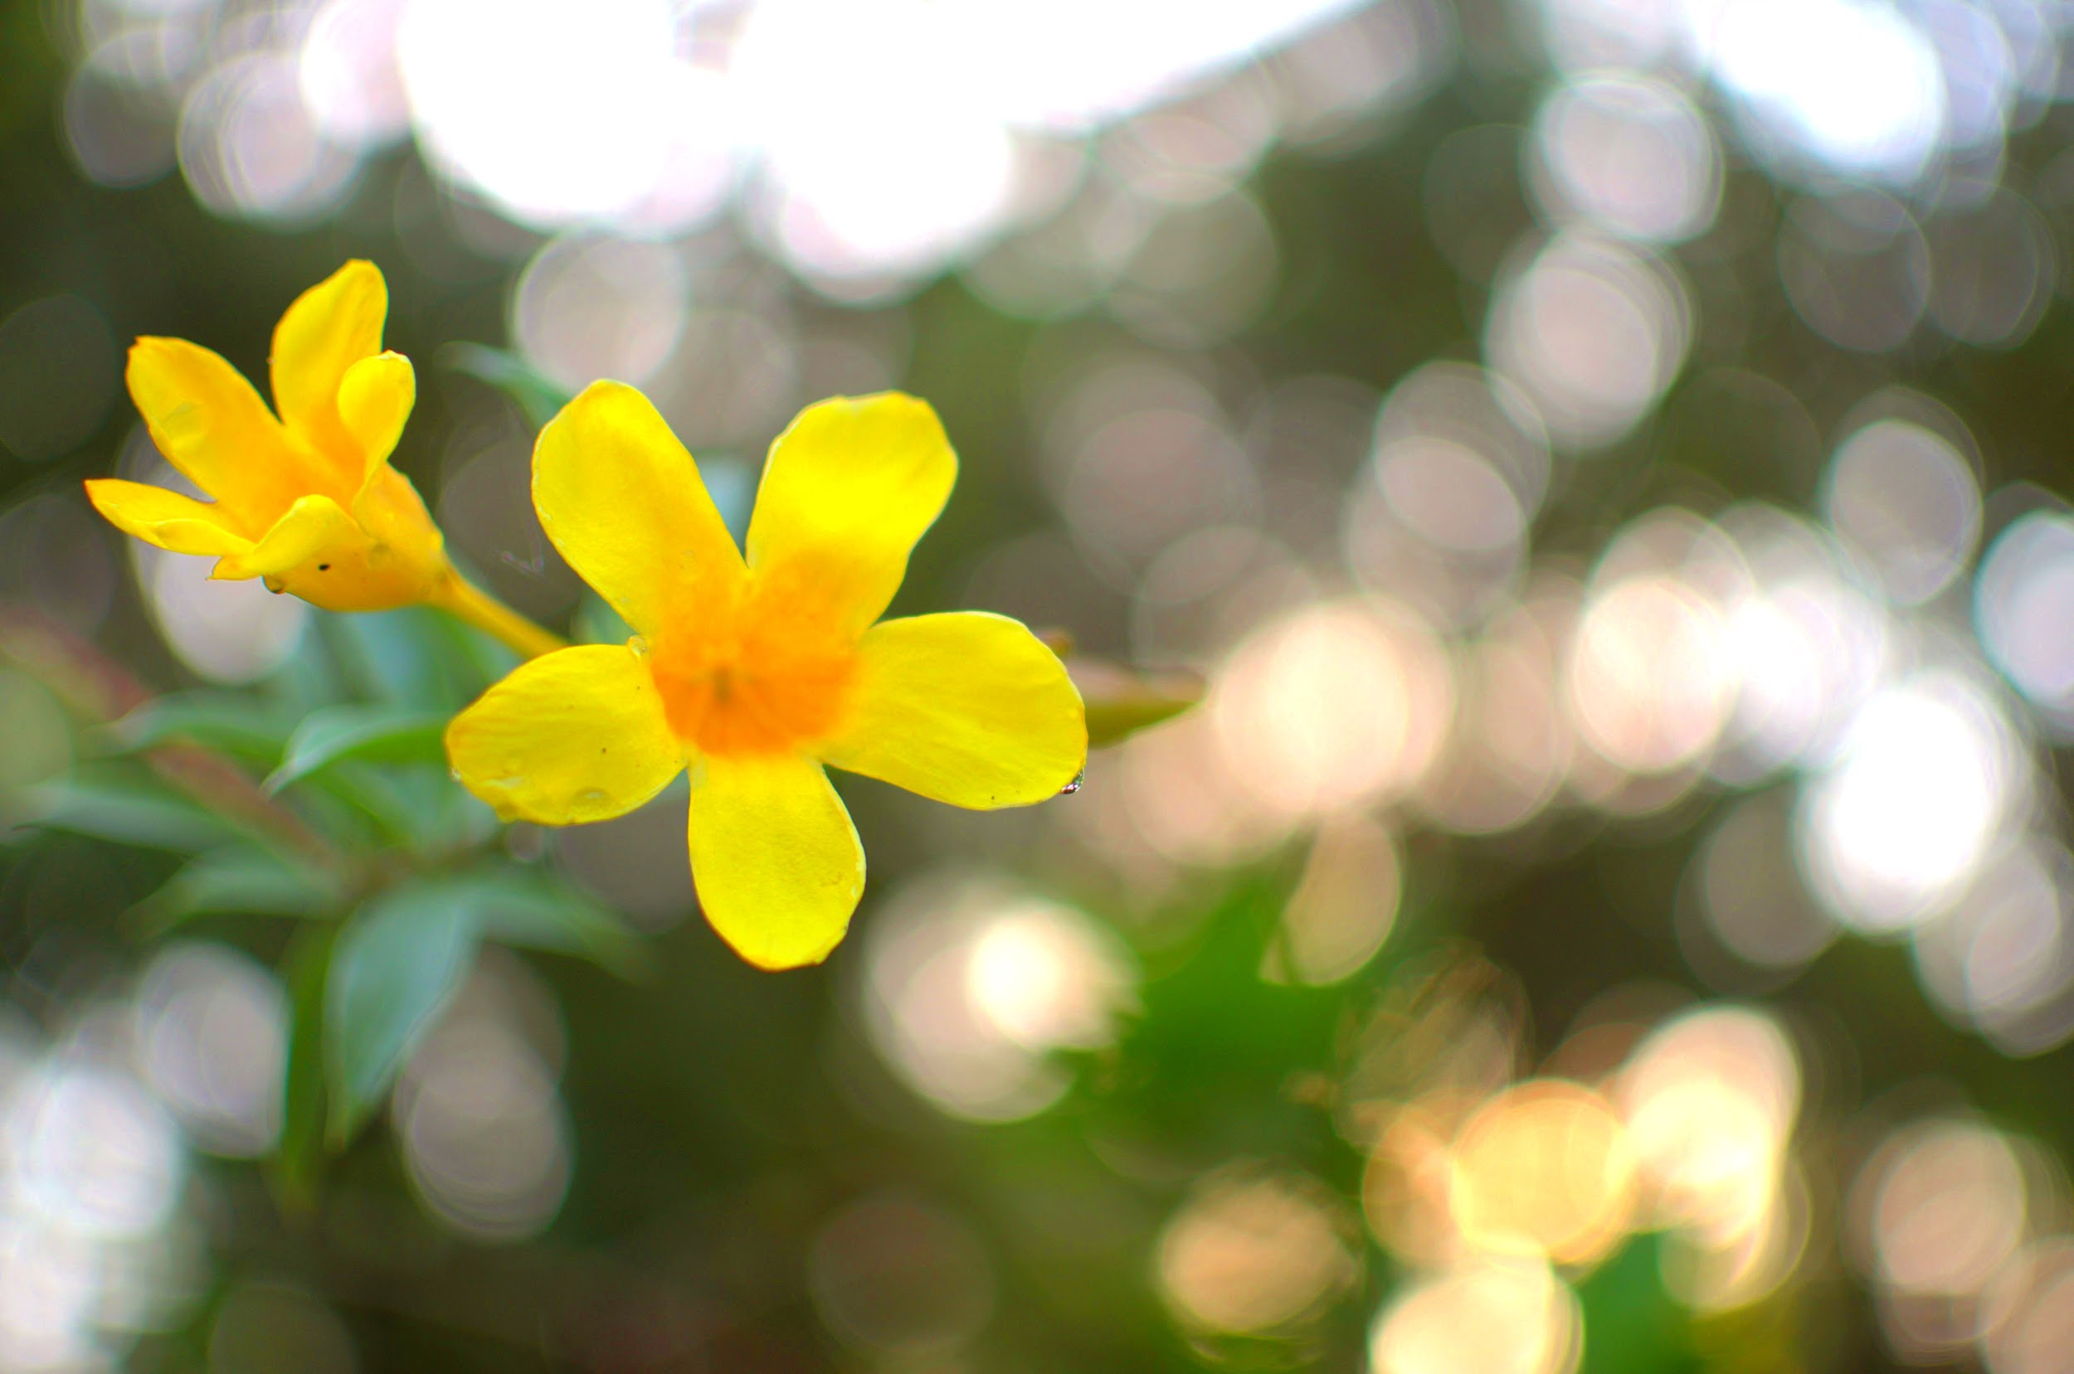

**Bokeh effect with higher aperture.**

**Portrait photography** (people faces) you go with high aperture and in **landscape photography** use a smaller aperture.

**Physics behind aperture and DOF relation:**

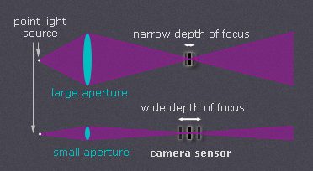**With decrease in aperture opening the circle of confusion(CoC) formed at the sensor plane decreases. And if the circle of confusion is smaller than a prespecified value, we cannot distinguish it as blurry and hence DOF increases (ie the range of distances in space getting focussed in the sensor plane widens).**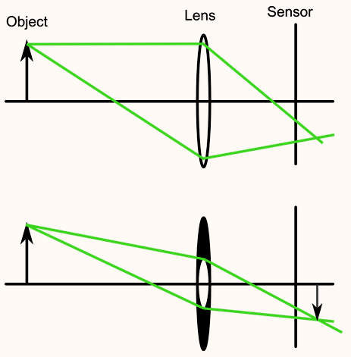

**F-stop (f-number):** the ratio of lens focal length to aperture diameter. Reducing the aperture diameter (increasing the f-number) increases the DOF. F-stop (1.4,2.8….. 11) as fstop increases aperture size decreases. It is indicated as F8,F2.8 etc in the camera which means aperture diameter size is f/8,f/2.8 where f is the focal length. Eg. a 50mm lens at f2.8 will have a aperture diameter of 50/2.8 mm.

--- **READ more Y?**  With some zoom lenses, the maximum aperture will change as you zoom in and out. For example, with the Nikon 18-55mm f/3.5-5.6 lens, the largest aperture shifts gradually from f/3.5 at the wide end to just f/5.6 at the longer focal lengths. More expensive zooms tend to maintain a constant maximum aperture throughout their zoom range, like the Nikon 24-70mm f/2.8. Prime lenses also tend to have larger maximum apertures than zoom lenses, which is one of their major benefits.

-- For a specific Fstop the light collected by the lens does not depend on the focal length. If it had differed, it would have been better to always use the highest focal length which is not the case. This is because even though the aperture diameter changes with focal length (aperture diameter=f/ab, for a fixed ab, aperture diameter increases with f), the amount of light reaching the sensor will not go up. As focal length increases light has to travel more distance and light attenuates (as per square law with distance) by the time it reaches the sensor. Hence, even with dilated aperture at higher focal lengths the light hitting the sensor remains same for a fixed f-stop.

**What are the factors that affect the DOF?**

1. **Distance of object**
2. **Focal length**
3. **Aperture size**
4. **Crop factor**

Hyperfocal distance:When the lens is focused at this distance, it will give the greatest Depth of Field. The Depth of Field extends from 1/2 this distance in front to infinity behind.

https://www.youtube.com/watch?v=6XMk9jFcnlA

MOREEEEEEEEEEEEEEEEEEEEEEEEEEEEEE. CLARIFY AND WRITE

**ISO:**ISO controls the brightness of your photos. This functionality is much exploited in low lights. But increase in ISO has a pit fall due to noise effect. With higher ISO your image certainly becomes brighter at the same time it will have grainy appearance due to the increase in noise.

In good lighting conditions go with the base ISO of 100 and at dark increase the ISO. But even in bright situations using base ISO always is not a good solution. It depends on your need. If you are to capture a moving object you need to fix a higher shutter speed (to avoid motion blur) and DOF also need to be fixed. Now to get a good shot the only way is to increase ISO.

**HOW TO TAKE A GOOD PHOTO BY TUNING THESE THREE PARAMETERS?**

1. Select the aperture setting that will provide your desired depth of field.
2. Set your ISO to its base value, and put your shutter speed to whatever setting provides a proper exposure.
3. If your subject is blurry, progressively raise your ISO and use a faster shutter speed until motion blur disappears.
4. If your ISO is getting too high and you still have the ability to use a wider aperture, open it up until the ISO gets to a more manageable level, even if it means sacrificing some of your desired depth of field.

### Megapixel and Sensor Size

The size of the sensor and the amount pixels on that sensor directly affects the potential amount of noise that can occur when you are shooting at higher ISOs. A sensor is made up of millions of tiny light-gathering receptors called pixels. One megapixel (MP) consists of one million pixels. If you have two same size sensors and one has 12MP and the other has 24MP, the 12MP sensor can have larger pixels than the 24MP sensor. The larger the pixel size, the better that pixel is in gathering light, just like the larger the beach ball, the more air it can hold. If you want to increase the number of pixels from 12MP to 24MP without decreasing the pixel size, then you would have to increase the physical sensor size. The size of the pixel in relation to the sensor size is known as the pixel pitch and is measured in microns.

**Sensor Size and Noise relation:** For the same number of pixels, a larger sensor size has less noise compared to a smaller sensor size. For larger sensor size, the size of pixel is higher and so the range of electronic noise it can withstand before going to saturation is higher when compared to a smaller pixel size.

**ISO and noise relation.**

The sensitivity of sensor increases with increase in ISO. What this means? The sensor collects red, green and blue lights and converts to a pixel value. Suppose say in well lit scenario the ISO is minimum, then it means the value the sensor considers to convert to a pixel is high. (i.e the 100% the sensor considers is high). But in low lights the sensor will never receives this high value and the images go black. So when ISO is increased the sensor decreases the maximum value it requires to convert to a good intensity. (i.e, the 100% now is much lesser intensity when compared to low ISO). So even though the light coming to sensor is low it scales it to previous low ISO range. But when this scaling is done, it scales the noise also. Noise is always there in sensor due to small magnetic fields present due to the electronic components present in the camera. But it is small amount and at low ISO since the light rays range is high the small noise is negligible but at high ISO when the sensitivity is high, the noise also scales up. This is why the effect of noise is predominant with increase in ISO. Go through a better explanation in the link provided.

<https://www.imaging-resource.com/news/2016/04/13/a-simple-guide-to-iso-what-happens-when-you-increase-your-cameras-iso>

**Field-of-view:** FOV depends on the focal length. If the focal length is small FOV is larger and if focal length higher the FOV is smaller. A wide angle lens has focal lengths of 17mm and hence larger FOV and a telephoto lens has a focal length of 400mm and hence a smaller FOV.

**Physics behind FOV and focal length**

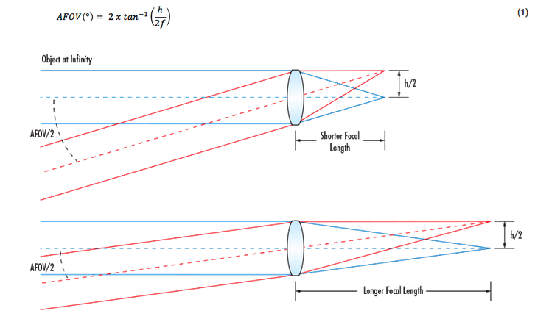

**As focal length is small the FOV increases. As you can see in the figure in top (with small focal length) two points at middle and extreme end of the sensor retraces the light rays as shown and the angle between those light rays gives the half FOV subtended by the camera.**

**CROP FACTOR:** Usually camera sensor is quoted with a reference. And this reference is 35mm (36mm X 24mm) SLR sensor size. This camera sensor was the old commonly used sensor and is called the ‘full frame’ against which the latest sensors are compared. Crop factor= diagonal measure of sensor for a 35mm sensor/ diagonal measure of the sensor you need to compare with. Crop factor decides the field of view indirectly. Suppose a 35mm sensor at 50mm focal length has a certain field of view. Now for a smaller sensor with crop factor 1.5 to achieve the same field of view the focal length should be x=33.3mm ( where x can be found as 1.5x=50mm, x=50/1.5=33.3mm).

**Metering:** Metering is how your camera determines what the correct shutter speed and aperture should be, depending on the amount of light that goes into the camera and the ISO. Most of the DSLR cameras are equipped with light “meter”, which is a sensor that measures the amount and intensity of light. If you view through the viewfinder of your camera or if you have a LCD display, you can see a bar with 0 in mid and +/- signs to each side which indicates the lighting conditions. If it is dark and proper lighting not there, the value will be more towards - and vice-versa for over exposed scenarios. 0 indicates balanced. If it is towards -ve you try to decrease the shutter time/increase exposure and ISO to balance it to 0. The camera calculates this lighting depending on the metering we choose. There are 3 types of metering.

1. **Matrix Metering (Nikon), also known as Evaluative Metering (Canon):**

The camera decides the exposure and aperture by evaluating the light coming from all sensor ponts. It go through the whole frame and divides as zones. Then depending on your focussed point, it gives more weightage to the light coming from the focussed point and less to other zones. But it decides the camera settings depending on the entire zone. This is the most preferred metering mode.

1. **Center-weighted Metering**

Irrespective of where you focus and all, this kind of metering decides the camera setting depending on the center of the frame. Use this mode when you want the camera to prioritize the middle of the frame, which works great for close-up portraits and relatively large subjects that are in the middle of the frame.

1. **Spot Metering**

Spot metering gives importance to the focussed area alone. It evaluates a single zone/cell and calculates exposure based on that single area, nothing else This metering is preferable if you are imaging a small object and you want that object to decide the exposure, so that that object is well exposed irrespective of the background.

**AE, AF lock:** Most DSLR cameras comes with these two buttons. AE lock (i.e. aperture and shutter speed) locks the exposure settings. This is very useful in taking panoramic images that is stitched to get the panorama. If exposure varies for each shots, the stitched images will be bad. With presing AE lock, the camera makes sure that the exposure settings for all the succeeding frames are same and not changed.

AF lock is used to fix the focal settings of the camera. Ie the point that need to be focussed. Once this is set and if you change the composition in the scene also the focus point is fixed. This is usually done in DSLR by pressing the shutter button halfway. This defines the focal setting now you change the camera slightly to change the composition also does not affect the focus.

**AUTO and MANUAL FOCUS:**

Camera autofocus are two types

(a)Active: Using Infrared/ultrasound waves. The camera sends some IR radiations which gets reflected back from the object. This calculates the objects distance from the camera and adjusts the focal ring (using a motor) to focus on the object. When the shutter is half pressed this evaluation happens multiple times.

Infrared sensing can have problems. For example:

* A source of infrared light from an open flame (birthday cake candles, for instance) can confuse the infrared sensor.
* A black subject surface may absorb the outbound infrared beam.
* The infrared beam can bounce off of something in front of the subject rather than making it to the subject.

One advantage of an active autofocus system is that it works in the dark, making **flash photography** much easier.

To use infrared focusing effectively, be sure the emitter and the sensor have a clear path to and from your subject, and are not blocked by a nearby fence or bars at a zoo cage. If your subject is not exactly in the middle, the beam can go right past the subject and bounce off an undesired subject in the distance, so be sure the subject is **centered**. Very bright subjects or bright lights can make it difficult for the camera to "see" the reflected infrared beam -- avoid these subjects when possible.

(b)Passive

It runs a image processing algorithm to decide the focus. This kind of method uses an autofocus sensor made of CCD strips. The microprocessor in the camera looks at the strip of pixels from this sensor (along a line) and looks at the difference in intensity among the adjacent pixels. If intensity is varying very slowly in neighbouring pixels, this means it is in out of focus. So the camera changes the focal ring and again captures this sensor image till the strip has a sudden change in intensity between the neighbouring pixels which indicates that the focus is clearly set. Passive sensors work if there are image contrast in the scene. It fails at low lights as well as if the object is textureless (like sky).

refer:<https://electronics.howstuffworks.com/autofocus3.htm>

**Where to use Auto and Manual focussing?**

Manual focus is advised if you are imaging objects with small occasions in front. If the camera is in autofocus, in these situations, the camera try to focus the occlusions rather than the object. (like animals through fences).

In macro photography keep the camera in manual focus so that the camera does not auto adjust every now and then.

In tracking an object or fast pacing objects go with autofocus if the object motion is not predictable. If the object's position can be guessed then go with manual mode.

**PAN SHOTS:** It is a photography technique which depicts the object motion in the scene.

To take such photos you need to pan your camera with the subject. And these images creates the illusion of motion in the FG. Use manual setting mode in camera so that the object is focussed and camera won’t change it regularly. (But I have read somewhere that AF mode is best in pan). Keep in shutter priority mode. Play around with your shutter speed depending on the object speed. If it too fast moving keep the shutter speed (1/100) etc and if it too slow then it is fine to keep it at ¼ etc. But shutter speed low can bring motion blur due to hand shakes as well so an optimal shutter speed is required. Good pan photography also depends on the quality of the background. BG with good color variations would be better.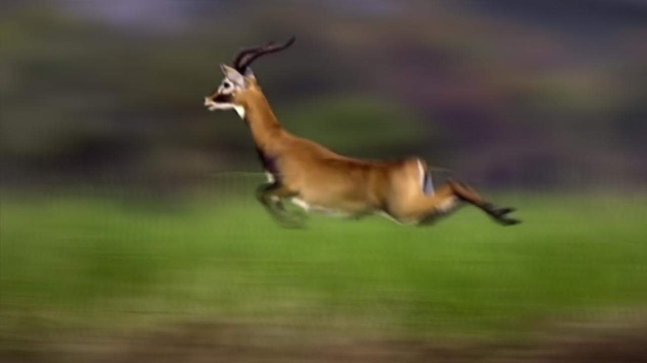

How to get it? --contents copied from blog

* **Select a slightly slower shutter speed than you normally would**. Start with 1/30 second and then play around with slower ones. Depending upon the light and the speed of your subject you could end up using anything between 1/60 and 1/8 – although at the slower end you’ll probably end up with camera shake on top of your motion blur.
* Position yourself in a place where your view of the subject will not be obstructed by anyone or anything else. Also consider the background of your shot. While it will be blurred if there are distracting shapes or colors it could prove to be distracting. Single coloured or plain backgrounds tend to work best.
* **As the subject approaches track it smoothly with your camera.** For extra support of your camera if you’re using a longer lens or are feeling a little jittery you might like to use a monopod or tripod with a swivelling head.
* **For best results you’ll probably find that setting yourself up so that you’re parallel to the path** of your object (this will help with focussing).
* **If you have a camera with automatic focus tracking** you can let the camera do the focussing for you by half pressing the shutter button (depending upon its speed and whether it can keep up with the subject)
* **If your camera doesn’t have fast enough autofocusing** you’ll need to pre-focus your camera upon the spot that you’ll end up releasing the shutter.
* **Once you’ve released the shutter** (do it as gently as possible to reduce camera shake) continue to pan with the subject, even after you’ve heard the shot is complete. This smooth follow through will ensure the motion blur is smooth from start to finish in your shot.

**Light streak photography:**

**White Balancing and Retinex Theory**

White balancing algorithm seeks to estimate the illumination color of the scene and remove its effect from the image. It aims to make the white object look white in the images. It is difficult to do this hence some assumption the scene is made either by retinex theory or gray world algorithm.

Gray world algorithms assume that the reflectance from a surface is neutral. This is done by finding the average of the individual R, G and B channels and equalizing it. (ie, assume G_avg as reference and then multiply R channel by G_avg/R_avg and blue channel by G_avg/B_avg).

**Retinex theory**: The term, "retinex" was coined by Land to indicate his belief that full color perception, with color constancy, involved all levels of visual processing, from the **retina to the visual cortex.**

[**https://courses.lumenlearning.com/austincc-physics2/chapter/26-3-color-and-color-vision/**](https://courses.lumenlearning.com/austincc-physics2/chapter/26-3-color-and-color-vision/)

**CAMERA PIPELINE**

This section is dedicated to technical content from some papers about a rough explanation of how the color images are formed in the camera and what all processing the image undergoes. Also, how colors changes from camera to camera for the same scene images under different cameras for the same camera parameter settings. **What changes then? What is camera sensitivity/camera response?**

The final image formed in a camera is after a lost of processing happening in the camera. The radiance measured from the scene undergoes a mapping (TS) to linear sRGB (cameras color space first), this is followed by a white balancing (TW) and gamut mapping. Gamut mapping (h) non-linearly maps colors (saturated ones) outside the cameras gamut to fall inside. After gamut mapping is the non-linear tone (f) mapping that maps to the final observed image (JPEG image). TS is camera dependent, TW is white balancing mode dependent, h and f are image dependent (picture style dependent). Now the scene radiance observed in the camera itself is a combination of actual scene irradiance affected by the ambient illumination spectrum and then filtered by the camera sensitivity function. Scene irradiance, illumination spectrum and camera sensitivity are functions of wavelengths.

The RAW image observed at the camera is formed by the process shown in the image. After this gamut mapping, tone-mapping, white balancing etc is done on this RAW data to produce the final rendered color image.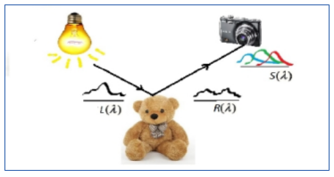

**For details refer:**

[**http://www.cse.yorku.ca/~mbrown/pdf/tpami2012_kim_preprint.pdf**](http://www.cse.yorku.ca/~mbrown/pdf/tpami2012_kim_preprint.pdf)

[**http://www.comp.nus.edu.sg/~whitebal/raw_2_raw/datasets/raw_to_raw.pdf**](http://www.comp.nus.edu.sg/~whitebal/raw_2_raw/datasets/raw_to_raw.pdf)

[**https://www.eecs.yorku.ca/~mbrown/Brown_Tutorial.pdf**](https://www.eecs.yorku.ca/~mbrown/Brown_Tutorial.pdf)

**Bayer data and Demosaicing**

Instead of collecting all three channel colors at all pixels, a color filter array (CFA) is used to collect one channel at a pixel. A common CFA is bayer filter with GR interlaced rows followed by GB rows. Our eyes are more sensitive to green color hence the bayer pattern has 50% green, 25% each orf red and blue. The image thus collected at the sensor is having only one channel active at each pixel. To get the full color image some interpolation needs to be performed on the bayer filtered image. This is called as demosaicing.

Bayer filter with interlated G B and R channels.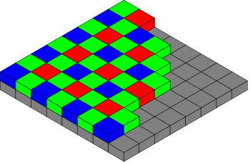

The raw data collected from a camera has this bayer image. It can be demosaiced outside using some softwares ar the entire camera pipeline has an inbuilt demosaicing.

**JPEG COMPRESSION**

Joint photographic expert group.

It is a lossy compression. The image is subdivided into 8X8 blocks and on each block a DCT is performed. It then do a quantization of the DCT coefficients. The last step is to apply encoding in the zig zag manner and do it till you find all zero.

Why DCT? Because it has good energy compactness. Ie to represent the whole signal with minimal number of coefficients.