Angular Sightly Aem App

Introduction:

This is regarding integration of Angular JS and Sightly , both of which allows modularization
and improves the performance of the application. In frontend we will create modules, define
the logic in controllers which is shown in single pages or partial views.With Angular JS
ng-templates we will inject different views or portions of HTML into a script which has the
request to server made with sightly.
The HTL component contains three things
- A link to show the information about two fruits. Here the app injects some HTML
using ng-templates , the HTML which is injected get the values from the server
using sightly
- Another link with simple input which has another template in order to show the two
way data binding functionality that angular has.

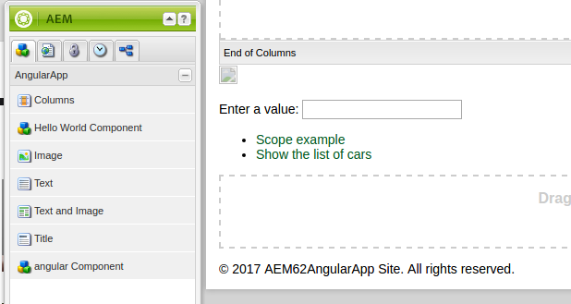
Scope example link: http://localhost:4502/content/AEM62AngularApp/en.html#/view1 –one view

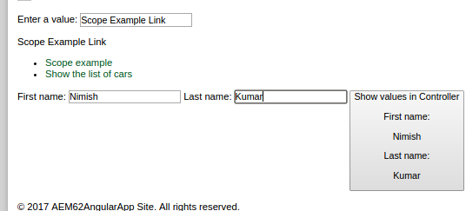
Another Link:
http://localhost:4502/content/AEM62AngularApp/en.html#/view2 --another view
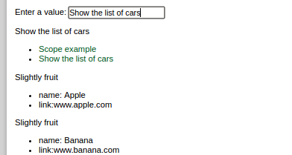

To be continued......

